LocalMeet AI Solution Design
  - Installable macOS meeting notes and personal task application
Version 1.0 | 15 October 2026 | Prepared for product planning and implementation

Purpose
This document defines a practical architecture for a local-first macOS application that records user-authorized meetings without a meeting bot, transcribes them on the device, organizes notes, and tracks personal work. Cloud AI is optional and invoked only when the user chooses a provider and approves the content to send.

Recommended decision
Build the first release as a native SwiftUI macOS application using ScreenCaptureKit, whisper.cpp, encrypted SQLite, and a separately permissioned local MCP service. Keep the recorder reliable and provider-independent. Treat iOS as a companion app first because iOS places stronger restrictions on capturing audio from other apps.
Design goal | Decision
Privacy | Local recording, transcription, storage, search, and tasks by default
Compatibility | Capture Mac system audio rather than depend on Teams, Zoom, Meet, or WhatsApp APIs
AI choice | Claude, OpenAI, Gemini, or Ollama through adapters; no provider is mandatory
Resilience | Recoverable audio chunks, crash-safe session state, auto-stop safeguards
Extensibility | Stable domain model shared later with an iOS companion and optional sync

Status: proposed target architecture. Product name is a working name.

1 Scope and requirements
  - What the first macOS release must deliver

Functional scope
Capability | Release 1 behavior | Priority
Meeting capture | System audio and microphone; start, pause, resume, stop; visible recording indicator | Must
Meeting awareness | Calendar reminder and supported-app/window detection; manual fallback for every audible app | Must
Auto-stop | Calendar end plus inactivity/app-state signals and hard maximum duration; recovery prompt if uncertain | Must
Transcription | Offline, timestamped transcription with model/language selection | Must
Meeting library | Search, filters, transcript, notes, decisions, summary, attachments, tags | Must
AI analysis | User-configured Claude, OpenAI, Gemini, or local Ollama; summary and structured action items | Must
Task board | Inbox, To do, In progress, Waiting, Done; create/edit/assign due date/link meeting | Must
Local MCP | Approved clients can list/search/read permitted meetings and tasks | Must
Speaker names | Manual correction first; diarization and learned voice labels later | Later
iOS | Companion for browsing, tasks, and recording initiated inside the app; cross-app capture not guaranteed | Later

Nonfunctional requirements
- No account, server, or subscription is required for core features.
- The app remains useful with networking disabled; cloud AI failure never blocks saving a meeting.
- A two-hour meeting must survive app interruption with no more than the current short audio chunk at risk.
- Every external disclosure is visible, scoped, auditable, and revocable.
- Target: Apple Silicon macOS 14 or later for the initial release; validate Intel support separately if required.

Explicit exclusions for Release 1
No autonomous joining of meetings, cloud synchronization, enterprise administration portal, automatic task publishing to third-party tools, or guaranteed speaker identification.

2 Target architecture
  - Local processing is the default path; network calls are optional
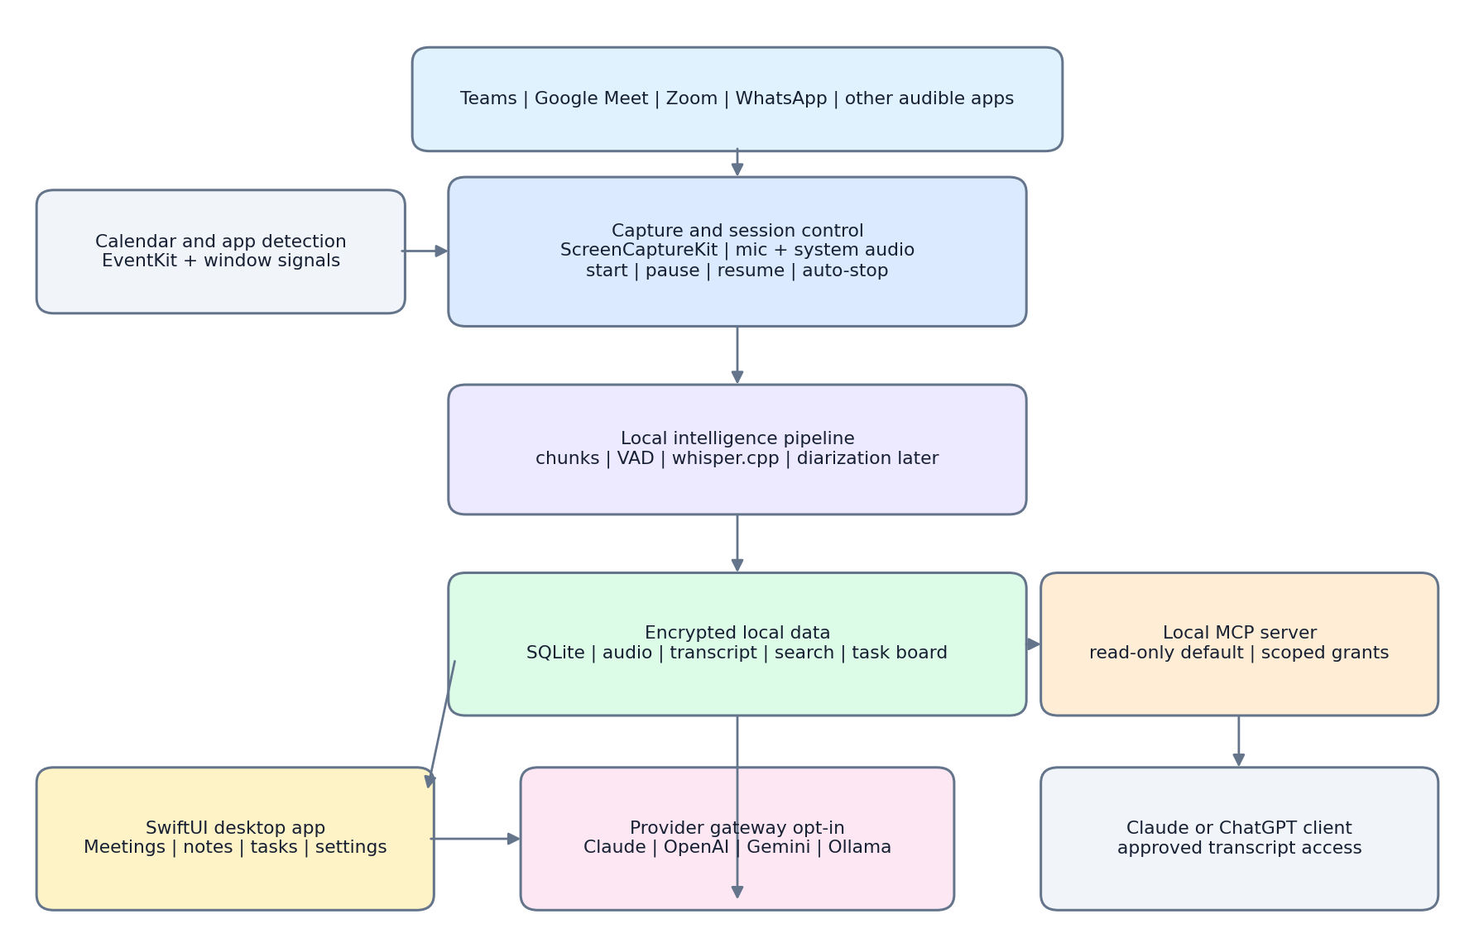
Figure 1 Logical component architecture

Component boundaries
Boundary | Responsibility | Trust rule
Desktop application | Session control, UI, local services, task board | Runs in the signed app sandbox with least privileges
Capture worker | Produces separate mic and system-audio chunks | Never initiates a network connection
Intelligence worker | VAD, transcription, indexing, optional local summary | Reads only the active meeting workspace
Provider gateway | Normalizes AI requests and structured responses | Disabled until configured; requires explicit send
MCP service | Exposes narrowly scoped local tools | Read-only default; localhost or child-process transport
Data store | Encrypted metadata, notes, tasks, audit trail and files | Accessible only to app components

Packaging
Ship a notarized universal app bundle through a signed DMG or the Mac App Store if its sandbox and entitlement constraints are compatible with the chosen capture implementation. Bundle the transcription runtime; download optional model files only after the user confirms size and license.

3 Meeting lifecycle and automation
  - A deterministic state machine prevents runaway recording

Session states
State | Entry | Exit and safeguards
Scheduled | EventKit event contains a supported meeting link or user marks it recordable | Notify 2 to 5 minutes before; never silently record by default
Ready | User selects Start or an approved rule fires | Verify screen-recording and microphone permissions
Recording | Capture mic and system audio into separate 15 to 30 second chunks | Pause, manual stop, app/call exit, silence rule, maximum duration
Paused | User pauses; timer and session remain active | Resume or stop; paused audio is not captured
Finalizing | Stop accepted or auto-stop confidence threshold reached | Flush chunks, transcribe remainder, update index atomically
Review | Transcript and extracted tasks are available | User corrects names, approves tasks, optionally invokes AI

Meeting detection
- Use EventKit, with read permission, to recognize upcoming calendar events and meeting URLs.
- Observe running application and window metadata for Teams, Zoom, browser-based Google Meet, and WhatsApp. These are hints, not hard dependencies.
- Offer a menu-bar control and global shortcut so any other meeting or phone-call app remains supported.

Auto-stop decision
Stop only when strong evidence agrees: the calendar event ended and the call window disappeared, or system audio and microphone activity remain below a threshold for a configurable grace period. A hard limit, such as four hours, protects against forgotten sessions. If evidence conflicts, show a notification and continue for a short grace period instead of cutting off the meeting.
Signal | Weight | Failure handling
User presses Stop | Authoritative | Finalize immediately
Meeting app/call window closes | Strong | Confirm with audio inactivity
Calendar end time passes | Medium | Allow overruns and extensions
Sustained silence | Medium | Ignore normal short silences
Maximum duration reached | Failsafe | Stop, preserve data, notify user

4 Technology stack
  - Native macOS first with portable domain contracts
Layer | Recommended technology | Reason
UI and app shell | Swift 6, SwiftUI, AppKit bridge | Native menu bar, accessibility, low memory use
Architecture | Modular monolith, Swift Package modules, async await | Fast first delivery without service sprawl
Audio capture | ScreenCaptureKit plus AVFoundation | Captures Mac system audio and microphone with OS consent
Audio format | Core Audio PCM working buffers; compressed M4A archival | Transcription quality with controlled storage
Speech activity | Silero VAD or lightweight native VAD | Skip silence and support auto-stop evidence
Transcription | whisper.cpp via Swift wrapper; Metal/Core ML where validated | Offline, open source, strong Apple Silicon support
Speaker diarization | Optional pyannote-compatible local worker or future native model | Keep out of MVP because packaging and quality are harder
Database | SQLite plus SQLCipher; GRDB.swift | Local relational model, migrations, full-text search
Files | Application Support directory; encrypted audio and export files | Portable recovery and clear retention controls
Secrets | macOS Keychain | API keys never stored in preferences or database
AI adapters | URLSession clients with JSON-schema outputs | Provider-neutral summaries and action items
Local AI | Ollama adapter, optional installation | Offline summarization without bundling a large LLM
MCP | Swift or TypeScript sidecar using official-compatible SDK | Local stdio first; authenticated loopback HTTP if needed
Calendar | EventKit | Upcoming meeting alerts with explicit permission
Testing | XCTest, Swift Testing, golden transcript fixtures, UI tests | Regression coverage for capture and structured AI output
Distribution | Hardened Runtime, codesign, notarization, Sparkle or App Store | Trusted installation and signed updates

Provider interface
Define one internal request contract: selected transcript, meeting metadata, analysis template, locale, user identity aliases, and redaction options. Require providers to return versioned structured JSON for summary, decisions, risks, and action items. Provider adapters map this contract to Claude, OpenAI, Gemini, or Ollama without changing the recorder or database.

5 Local data and security design
  - Protect content at rest, in use, and at every disclosure point

Core data model
Entity | Important fields | Retention
Meeting | id, title, source app, scheduled/actual times, status, tags | Until user deletes or policy expires
AudioChunk | meeting id, sequence, track, file hash, duration, state | Optional; delete after transcription by policy
TranscriptSegment | speaker label, start/end, text, confidence, revision | Primary local record
Analysis | provider, template/version, summary, decisions, risks, created time | Local; replaceable and regenerable
Task | title, description, status, priority, due date, source meeting/segment | Until archived/deleted
ProviderProfile | provider, model, endpoint, enabled features | No API secret; Keychain reference only
AccessGrant | client id, scopes, meeting/tag filters, expiry | Revocable
AuditEvent | capture, export, AI disclosure, MCP access, deletion | Configurable local retention

Security controls
Threat | Control
Lost or shared Mac | FileVault prerequisite guidance; SQLCipher database; encrypt audio with a Keychain-protected app key
API-key exposure | Store secrets in Keychain; redact logs; never return keys through MCP
Unintended cloud disclosure | Provider disabled by default; transcript preview, selection, redaction, and explicit Send action
Over-broad MCP client | Read-only scopes, per-client grants, opaque IDs, expiry, audit, local transport only
Malicious transcript text | Treat transcript as untrusted data; fixed system prompt; schema validation; no tool execution from transcript
Runaway recording | Persistent indicator, menu-bar timer, auto-stop, hard duration cap, startup recovery
Supply-chain compromise | Pinned dependencies, SBOM, signed/notarized builds, reproducible CI, dependency scanning
Residual deleted data | Secure key deletion for encrypted files; retention jobs; clear Trash and backup limitations

Consent and policy
The app must show a recording indicator and allow a configurable consent reminder. Recording law and employer policy vary; the product should help the user comply but must not claim that bot-free recording removes consent obligations.

6 AI and MCP integration
  - Optional intelligence without weakening the local-first boundary

AI analysis flow
- User opens a saved meeting and chooses Summary, Decisions, or My Action Items.
- App displays the exact transcript range, attachments, provider, model, and estimated data size.
- Optional local redaction removes emails, identifiers, or configured client terms.
- Provider gateway sends only the approved payload; response must match a versioned JSON schema.
- User reviews action ownership and due dates before tasks enter the board.
Adapter | Configuration | Privacy position
Ollama | Local base URL and model name | No cloud transfer; model quality depends on hardware/model
Anthropic Claude | API key, model, endpoint policy | Selected content leaves device after approval
OpenAI | API key, model, endpoint policy | Selected content leaves device after approval
Google Gemini | API key, model, endpoint policy | Selected content leaves device after approval

Local MCP surface
Tool | Default scope | Notes
list_meetings | meeting metadata | Date/tag filters; no transcript text
search_meetings | approved transcript index | Returns snippets and opaque meeting IDs
get_transcript | approved meetings | Supports time range and maximum character limit
list_tasks | tasks.read | Status, due date, source meeting
get_meeting_summary | analysis.read | Returns saved local analysis only
create_task or update_task | Disabled by default | Separate tasks.write grant and user confirmation

Prefer stdio when the AI client launches the MCP process. If a loopback HTTP transport is required, bind only to 127.0.0.1, require short-lived tokens or OAuth-compatible authorization, validate the intended resource, enforce scopes on every request, and block browser-origin requests unless explicitly designed and protected.

7 User experience and task board
  - One calm workspace for meetings and personal follow-through

Information architecture
Area | Primary content and actions
Today | Next meeting, active recording, overdue tasks, today’s tasks, recent notes
Meetings | Search and filters; meeting cards grouped by date; new manual recording
Meeting detail | Overview, transcript, summary, decisions, action items, files, audit
Tasks | Board and list views; quick add; drag status; due date; priority; source link
AI | Provider/model selector, analysis templates, payload preview, usage history
Settings | Capture devices, models, calendar, retention, encryption, MCP clients, exports

Recording experience
A compact always-visible controller shows title, elapsed time, microphone and system-audio meters, current state, Pause/Resume, and Stop. The menu bar mirrors essential controls. Permissions are explained before macOS prompts appear, and device changes during a meeting produce a visible warning without discarding captured chunks.

Task board rules
- New AI-extracted items enter an Inbox with a source quote and confidence, never directly into To do.
- User-created tasks may exist without a meeting; every linked task keeps a durable meeting and transcript-segment reference.
- Statuses: Inbox, To do, In progress, Waiting, Done, Archived. Keep workflow configurable later, not in MVP.
- Support due dates, priority, tags, notes, checklist, and local reminders. “My tasks” uses configured user names and aliases.

Accessibility and simplicity
Meet WCAG-aligned contrast, keyboard navigation, VoiceOver labels, scalable text, reduced motion, and clear non-color status indicators. Progressive disclosure keeps advanced model, retention, and MCP settings out of the everyday meeting workflow.

8 Delivery plan decisions and risks
  - Build reliability before advanced intelligence
Phase | Scope | Exit criteria
0 Technical spikes 2 weeks | ScreenCaptureKit mic/system audio, Bluetooth tests, chunk recovery, signing sandbox decision | 30 to 60 minute recordings survive device changes and crash simulation
1 Local recorder 4 to 6 weeks | SwiftUI shell, session state machine, pause/resume/stop, local files, transcription, meeting library | Three meeting apps and browser calls captured reliably; no network required
2 Notes and tasks 3 to 4 weeks | Search, meeting detail, action-item review, task board, retention/export | User can move from meeting to verified personal tasks
3 AI providers 2 to 3 weeks | Claude/OpenAI/Gemini/Ollama adapters, schemas, redaction, audit | Provider contract tests and explicit-disclosure UX pass
4 MCP and hardening 3 to 4 weeks | Scoped MCP, client grants, security review, notarized installer, update channel | External client reads only approved content; security tests pass
5 iOS companion later | Shared models, browse/tasks, optional sync design, in-app recording experiments | Feasibility validated without promising Mac-equivalent cross-app capture

Key risks and mitigations
Risk | Impact | Mitigation
Meeting app UI changes | Detection becomes unreliable | Calendar and window detection are hints; universal manual control remains
Bluetooth/audio routing | One side missing or distorted | Device matrix, preflight meters, separate tracks, warning and fallback
Auto-stop false positive | Meeting ending is cut off | Multi-signal confidence, grace window, recoverable chunks
Transcription errors | Wrong decisions or owners | Confidence display, glossary, editable transcript, mandatory task review
Cloud-provider policy variance | Confidentiality concern | Per-provider disclosure, endpoint controls, local option, audit
MCP data exfiltration | Sensitive transcript leakage | Read-only default, scopes, filters, confirmation, logs, kill switch
iOS platform limits | Feature parity not possible | Position iOS as companion; validate supported capture modes separately

Architecture decisions to confirm
- Minimum macOS version and whether Mac App Store distribution is mandatory.
- Whether audio is retained by default or deleted automatically after successful transcription.
- Whether Release 1 needs speaker diarization, or manual speaker labeling is acceptable.
- Whether MCP write access for tasks is required initially; recommendation is read-only first.

Reference foundations
Apple ScreenCaptureKit and EventKit documentation; whisper.cpp project documentation; Model Context Protocol authorization and local-server security guidance. Accessed 15 October 2026.

