OrgPulse
Salesforce Architecture Health & Insights — right inside VS Code
Product Overview · v1.11.0 · June 2026
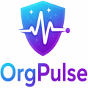
Executive Summary
OrgPulse turns a Salesforce org's hidden complexity into a clear, continuous health signal. It connects to an authenticated org through the Salesforce CLI, analyses metadata across 17 architecture dimensions, scores overall health 0–100 with an A–F grade and surfaces prioritized, actionable findings — all without leaving the developer's IDE.
Beyond static analysis, OrgPulse adds an AI layer that is model-agnostic: it works with any model available through VS Code (Claude, GPT, Codex, Gemini) or a fully local model (Ollama / LM Studio) with no cloud dependency. Architects can generate a boardroom-grade CTA Architecture Review, or use “Ask the Architect” to query the live org in plain language. Everything runs metadata-only and local-first, so sensitive data never leaves the environment without explicit consent.

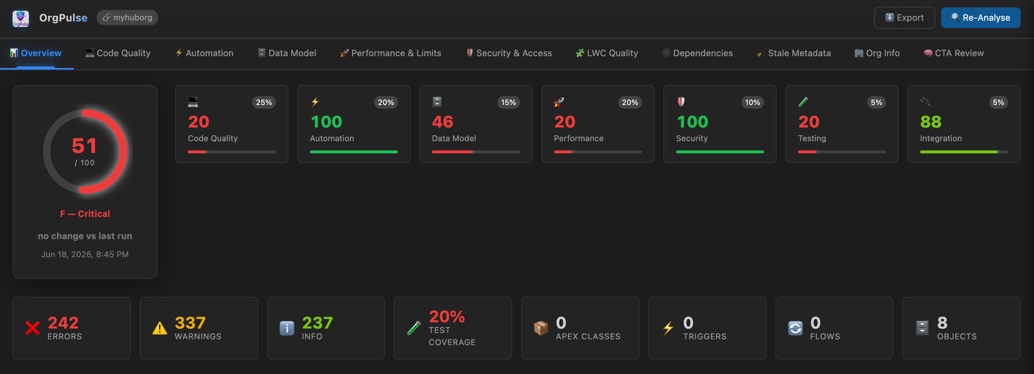

01 The Problem
Salesforce orgs accrete complexity faster than any team can manually track. Years of clicks and code leave behind systemic risk that traditional reviews miss:
▸ Hidden technical debt — trigger sprawl, SOQL/DML in loops, and unused metadata accumulate silently.
▸ Security & performance risk — over-broad permissions, exposed permissions, and non-selective queries surface in production.
▸ No continuous visibility — architecture health is a point-in-time PDF, not a living signal teams can act on.
▸ Expensive expert reviews — a Certified Technical Architect engagement is costly and infrequent — gaps go unseen between reviews.

The Solution — Before → After
Without OrgPulse | With OrgPulse
Manual reviews miss systemic patterns | Automated analysis of every class, trigger, Flow & object
Security gaps lurk in permissions | Dedicated security scanner flags risks instantly
Tech debt builds silently | Quantified health score with run-over-run trend
SOQL issues found in production | Live query selectivity (EXPLAIN) before deploy
CTA reviews are slow and periodic | CTA-grade AI review on demand, in minutes

Who Benefits
👩‍💻  Developers  Inline issues with file/line, AI fixes, quick wins. | 🏛️  Architects  CTA review, dependency graph, LDV & governor risk. | 📈  Tech Leads / Mgrs  Grade, trend, and risk at a glance — no code needed. | 🎓  CTAs / Reviewers  Repeatable, evidence-based architecture assessments.

End customers:
▸ Salesforce SIs & consulting partners — standardise delivery quality and health hand-offs across clients.
▸ AppExchange ISVs — pass Security Review faster and keep managed packages clean.
▸ Large-org enterprises — continuous architecture governance for high-volume, mission-critical orgs.
▸ Managed service providers — monitor many orgs with repeatable, exportable scorecards.

02 Features & Capabilities
🔬 17-Analyzer Engine  Apex quality, automation design, data model, query performance, test coverage, security & permissions, integrations, governor limits, LWC, dependencies, technical debt, CTA architecture & more. | 🧠 Model-Agnostic AI  Use any VS Code language model (Claude, GPT, Codex, Gemini) or a fully local model (Ollama / LM Studio) — no Copilot lock-in, no cloud requirement.
💬 Ask the Architect  Tool-augmented, read-only live Q&A — the AI runs SOQL / limits / EXPLAIN against your org to answer architecture questions grounded in real data. | 🎯 CTA Architecture Review  On-demand, boardroom-grade AI report: verdict, maturity, risk heatmap, domain findings, and prioritised recommendations.
📊 Interactive Dashboard  Health score ring + A–F grade, run-over-run trend, drill-down per issue, live governor limits, and domain tabs. | 📤 Multi-Format Export  HTML (stakeholders), JSON (tooling), SARIF 2.1.0 (GitHub code scanning / PR checks), CSV, and PDF.

Security-First by Design
🟢 Safe  100% local — no AI, no network traffic. | 🟡 Standard  AI on aggregated insights only — no raw metadata sent. | 🔴 Advanced  Deeper AI reasoning with explicit per-session consent.

Metadata-only · no record data or PII accessed · nothing stored outside your environment · AI is consent-gated and, with a local model, fully offline.
🖼 [ Screenshot placeholder — CTA Architecture Review report ]
Paste image here

🖼 [ Screenshot placeholder — Ask the Architect — live org Q&A ]
Paste image here

03 Architecture & How It Works
VS Code Extension Host (TypeScript, esbuild bundle)
Analyzers → Rules Engine → Health Score → Webview Dashboard
▲ ▼
AI Layer · model-agnostic
VS Code Language Model API (Claude / GPT / Gemini) · Local OpenAI-compatible endpoint (Ollama / LM Studio) · read-only org tools
▲ ▼
Salesforce Org · via Salesforce CLI (sf)
Tooling & Data API — metadata, EXPLAIN, limits (read-only)

Analysis Flow
1 Connect  Authenticate via sf CLI | → | 2 Fetch  Pull org metadata | → | 3 Analyse  17 analyzers + rules | → | 4 Score  0–100, A–F, trend | → | 5 Review  Dashboard · CTA · Q&A | → | 6 Export  HTML · SARIF · PDF

Tech Stack & Trust Boundary
Technology  • Language — TypeScript (strict), ES2022  • Build — esbuild single bundle; zero runtime dependencies  • Platform — VS Code Extension API + Webview dashboard  • Org access — Salesforce CLI (sf) — Tooling & Data API  • AI — VS Code LM API + local OpenAI-compatible endpoint  • CI-ready — SARIF 2.1.0 export for code scanning | 🔒 Trust Boundary  ✔ Metadata only — no records, no PII  ✔ Local-first engine — offline capable  ✔ Nothing stored outside your machine  ✔ AI consent-gated; local model = 0 egress

04 Why OrgPulse — and Why Only OrgPulse
✦ In the IDE, not a portal  Analysis, AI, and fixes where developers already work — zero context switching. | ✦ Local-first & metadata-only  No record data or PII; runs offline. Enterprise- and Security-Review-friendly by default.
✦ Truly model-agnostic  Any VS Code model or a fully local LLM — the only Salesforce health tool with no AI vendor lock-in. | ✦ CTA-grade, on demand  Repeatable architecture reviews in minutes — not a periodic, costly human engagement.
✦ Live, tool-augmented Q&A  “Ask the Architect” queries the real org (read-only) — answers grounded in data, not guesses. | ✦ CI/CD native  SARIF export plugs straight into GitHub code scanning and PR checks.

Business Value & ROI
▸ Continuous, not point-in-time — every run is a fresh scorecard with trend, so risk is caught between formal reviews.
▸ Minutes vs weeks — a CTA-grade assessment on demand instead of a multi-week expert engagement (replace with [your benchmark]).
▸ Shift-left risk — security, performance, and governor issues found pre-deploy — [your % defects caught earlier].
▸ Standardised delivery — partners & MSPs apply one consistent health bar across every org — [your orgs/month].

Get Started in Minutes
1. Install  Add the OrgPulse VSIX (or Marketplace) to VS Code 1.100+. | 2. Authenticate  Connect an org: sf org login web. | 3. Analyse  Run “OrgPulse: Run Org Health Analysis”. | 4. Act & Share  Review the dashboard, ask the architect, export HTML/SARIF/PDF.

Roadmap (Indicative)
▸ Near-term — scheduled scans & CI gate action; richer trend history & diffing.
▸ Mid-term — team dashboards / multi-org portfolio view; custom rule marketplace.
▸ Exploration — auto-fix PRs, deeper LWC analysis, and partner reporting templates.

Bring continuous architecture intelligence to every Salesforce org.
OrgPulse · [contact email] · [website] · v1.11.0

