Beamforming Application Using RFSoC 4x2

Project Members

Berke Kaan Cetinkaya 3398171

Ilkay Kerim Özküney 3397637

Table of Contents

1. Introduction
2. Project Setup
3. Contributions of Members
4. Achieved Results
5. Conclusion & Possible Improvements
6. References

1.Introduction

In this project, we implemented a digital beamforming system using the Zynq UltraScale+ RFSoC 4x2 platform and the PYNQ framework. Beamforming is a signal processing technique that enhances the reception or transmission of signals in specific directions by leveraging antenna arrays.

By utilizing the powerful capabilities of the RFSoC, including integrated data converters and programmable logic, we developed a beamforming application. The PYNQ framework facilitated the integration of high-level Python programming with the underlying hardware, enabling efficient development and testing.

This project aimed to demonstrate the feasibility and performance of digital beamforming for applications such as wireless communication and radar systems in a laboratory setting.

2. Project Setup

The project setup was designed to implement and test digital beamforming using the Zynq UltraScale+ RFSoC 4x2 board. On the transmitter side, two DAC ports were connected to two dipole antennas configured as a phased array.

This configuration allowed us to manipulate the phase of the transmitted signals, enabling directional transmission through beamforming techniques. The transmitted signals were centered at 433 MHz, a frequency commonly used in communication and sensing applications.

On the receiver side, a single dipole antenna was used to capture the transmitted signals. This receiving antenna was connected to one of the ADC ports of the RFSoC board through a 433 MHz bandpass filter.

nThe filter ensured that only signals within the desired frequency band were processed, reducing noise and enhancing system performance. This setup demonstrated the capability of phased arrays for directional signal transmission and also provided a controlled environment to evaluate the RFSoC’s integrated data converters and its suitability for real-time signal processing applications.

Illustration of The Setup

RFSOC

RFSOC

Transmitter Side

Receiver Side

Antenna

Phased Array

Bandpass Filter

3. Contributions of Members

1.Berke Kaan Cetinkaya (3398171)

- Setting up the Transmitter Side

- Designing and Building the Bandpass Filter

- Running MATLAB Simulations

2.Ilkay Kerim Özküney (3397637)

- Setting up the Receiver Side

- Running Simulations

The Transmitter Side

As mentioned in the introduction part, the transmitter side is consisting of the RFSoC 4x2 board and two antennas connected to the DAC A and DAC B ports of the board. The antennas are forming a phased array to control the direction of the radiation pattern.

PhasedArray

A phased array antenna is a configuration of multiple antennas arranged in a specific geometry to enable beamforming, which directs the signal in a desired direction without physically moving the antennas. This is achieved by adjusting the relative phase of the signals fed to each antenna element. When the signals combine constructively in certain directions and destructively in others, the array forms a directional radiation pattern. The beam's direction can be steered electronically by changing the phase differences between the antennas, allowing for rapid and precise adjustments. Phased arrays are widely used in applications like radar, wireless communication, and satellite systems due to their flexibility, efficiency, and ability to suppress interference by controlling sidelobe levels.

MATLAB Simulation

I wanted to build and simulate our experimental setup in MATLAB to thoroughly test the performance of our beamforming system before implementing it in hardware. To achieve this, I began by creating a simulation of the entire setup, which includes the transmitting and receiving antennas, phase shifting, and signal processing. I set up a phased array in MATLAB by defining the antenna elements, specifically dipole antennas, and positioning them in a uniform linear array (ULA). Each antenna was spaced half a wavelength apart, as this is a common configuration for phased arrays to ensure good radiation pattern characteristics and minimal interference between elements.

After configuring the array, I applied phase shifting to steer the beam in the desired direction. This was done by adjusting the phase of each antenna element in the array, which allows for precise control over the directionality of the transmitted signal. I also accounted for the transmission frequency, signal amplitude, and the specific properties of the bandpass filter used in our setup to match the signal characteristics.

For the receiving side, I simulated a receiving antenna connected to the array via the ADC ports. The signal propagation, phase shifting, and reception were modeled to match the real-world conditions we expect during the actual experiment. I tested several phase shift values (0°, 90°, and 180°) to observe how they affect the beamforming performance and the directivity of the system.

Here is the MATLAB code I have written to simulate the system:

array = linearArray; -> Setting up a linear phased array

array.NumElements=2; -> 2 Antennas

freq=433e6; -> Frequency is 433 MHz

c= 300000000; -> Speed of light

lambda = c/freq; -> Calculating the Wavelength

array.ElementSpacing=lambda/2; -> Distance between elements are half wavelength

array.PhaseShift=[0, 0]; -> Phase shift

pattern(array,freq); -> Drawing the 3D Radiation pattern

patternAzimuth(array,freq) -> Drawing the Azimuth pattern

Antennas are placed in a linear form, one half wavelength away from each other as below

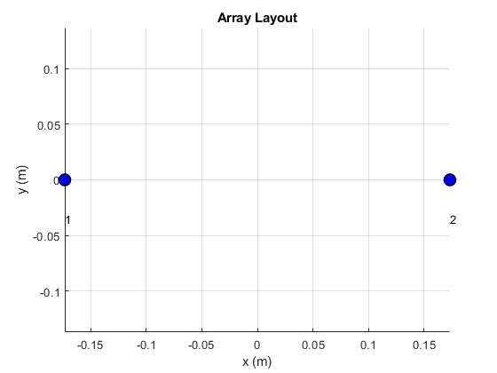

0.39m

The three-dimensional radiation pattern, as well as the Azimuth pattern of the phased array, are shown below, providing a comprehensive view of the antenna array's performance as the phase shift is applied. To better understand how the phase shifts influence the beamforming capabilities, I incrementally adjusted the phase shift of the second antenna from 0° to 90° and finally to 180°. This gradual change in phase shift allows for a clear observation of the impact on the directionality and shape of the radiation pattern.

The three-dimensional radiation pattern illustrates the spatial distribution of the radiated power, highlighting how the beam is steered and how the energy is concentrated in specific directions based on the phase shift values. The Azimuth pattern, which is a two-dimensional representation of the radiation in the horizontal plane, further emphasizes the effect of the phase shift on the signal propagation direction. By comparing the radiation patterns at different phase shifts, one can see how the beamforming mechanism of the phased array is used to adjust the signal's direction and enhance its strength in the desired orientation.

This setup provides valuable insights into the functioning of the phased array, allowing for a deeper understanding of the relationship between phase shift and beamforming effectiveness. Additionally, these patterns are essential for validating the setup and ensuring that the desired beamforming objectives are met during testing.

3D Radiation Pattern at 0 degree phase shift

Figure 1 Radiation pattern at 0 degree phase shift

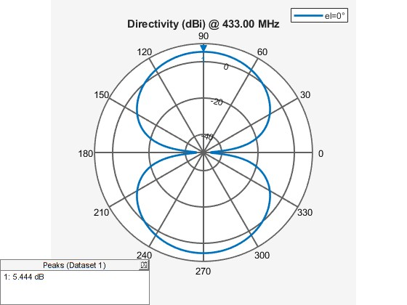

Figure 2 Azimuth pattern at 0 degree phase shift

3D Radiation Pattern at 90 degree phase shift

Figure 3 Radiation pattern at 90 degree phase shift

Figure 4 Azimuth pattern at 90 degree phase shift

3D Radiation Pattern at 180 degree phase shift

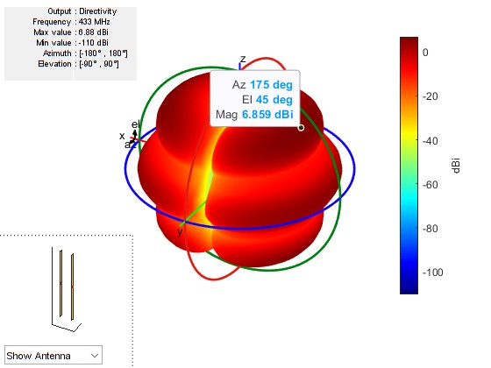

Figure 5 Radiation pattern at 180 degree phase shift

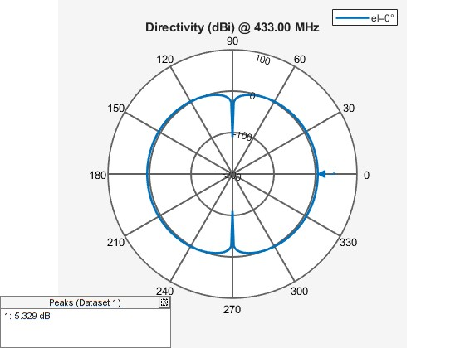

Figure 6 Azimuth pattern at 180 degree phase shift

After analyzing the images, it becomes clear that with a 180-degree phase shift, the radiation pattern achieves the maximum directivity, reaching 6.859 dB at an elevation angle of 45 degrees. This suggests that the phase shift has effectively steered the beam towards the receiving antenna, focusing the energy in the desired direction. The resulting directivity indicates that the antenna array is now radiating with enhanced precision, as we see a significant improvement in signal strength compared to the other phase shift configurations.

Receiver Side

On the receiving side, the system consisted of a single dipole antenna connected to one of the ADC ports of the RFSoC 4x2 board. To ensure proper signal isolation and accurate reception, the received signal was first passed through a 433 MHz bandpass filter before reaching the ADC. The bandpass filter was essential to remove out-of-band noise and interference, allowing only the desired frequency components to be processed. The dipole antenna was positioned to align with the transmitting array’s radiation pattern, maximizing signal reception. This setup enabled the board to digitize the received signal for further analysis, such as extracting phase and amplitude information, verifying beamforming performance, or assessing the signal quality under different conditions. Additionally, an FFT was done on the received signal to analyze it in the frequency domain. This provided a detailed view of the signal's spectral characteristics, helping to confirm the presence of the transmitted frequency components and evaluate the system's overall performance.

4. Testing The System

We have trasmitted 433MHz signal on DAC A and DAC B port of the board, and we have wanted to test if the receiving antenna was receiving any signal at all.

We received the following signal from the ADC A port of the RFSoC board:

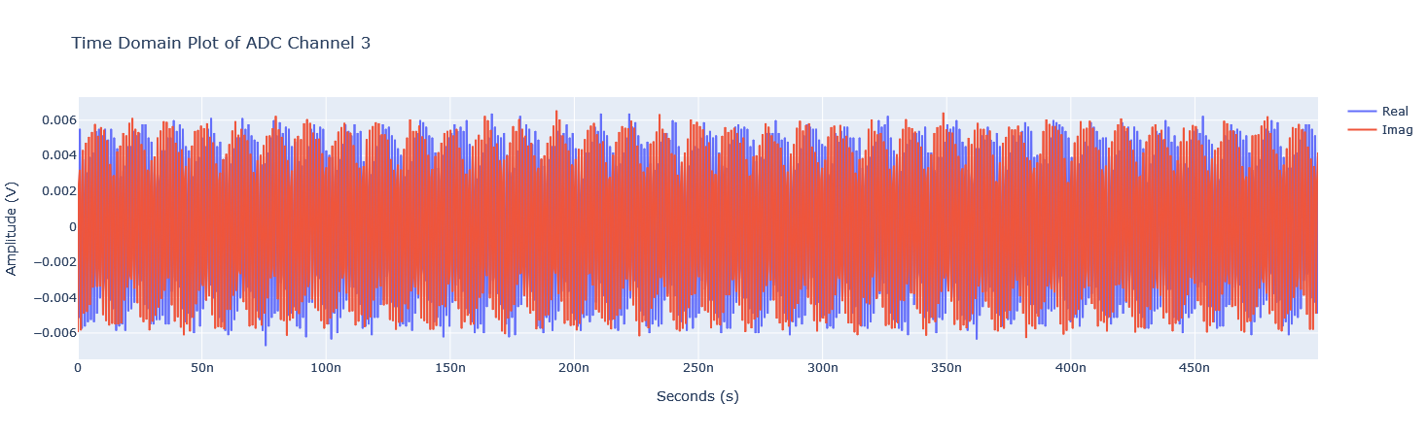

Figure 7 Signal Received At The ADC A port

We received a 6mV AC signal, but since there is a possibility of our antenna receiving a signal from another source or just picking up noise from the environment, we wanted to perform Fast Fourier Transform, and convert this signal into the frequency domain to analyze our signal.

Fast Foruier Transform

The Fast Fourier Transform (FFT) is an algorithm used to compute the Discrete Fourier Transform (DFT) efficiently. The DFT is a mathematical technique that converts a signal from the time domain into the frequency domain. It breaks down a complex signal into a series of sinusoidal components, each representing a specific frequency, amplitude, and phase. The FFT algorithm reduces the computational complexity of performing this transformation, making it much faster and more practical for real-time signal analysis. By applying the FFT to a time-domain signal, we can observe its frequency components, which is particularly useful for analyzing the spectral content of signals, filtering, and detecting specific frequencies.

After the FFT, we have received the following frequency domain graph:

1.3GHz noise

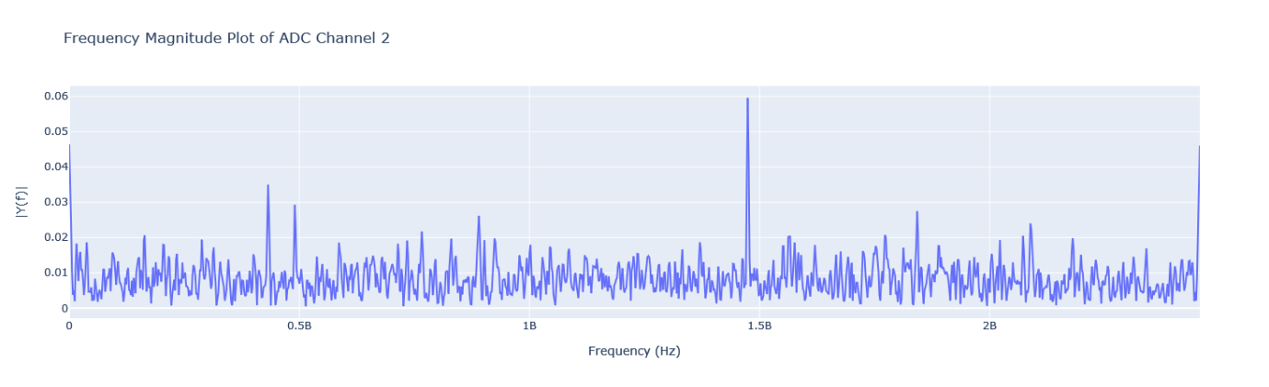

Our signal

As we have already guessed, the receiving antenna was picking up a noise in the 1.3GHz range. We have decided to get rid of it, so I (Berke) designed and and built a 433MHz bandpass filter.

Designing The Bandpass Filter

As known, bandpass filters attenuate signals below and above the desired frequency range. We need a filter that will pass the signals around 430 MHz.

After researching bandpass filter designs, considering the fact that our antenna has a 50 ohm impedance, we carefully designed and tested the circuit consisting of capacitors, inductors, that will attenuate signals below 400MHz, and above 450MHz.

We have also considered the impedance of copper lines in the PCB and tried to make it as close to 50 ohm as possible.

The Schematic and the PCB design can be seen below

Schematic

SMA connectors

SMA connectors

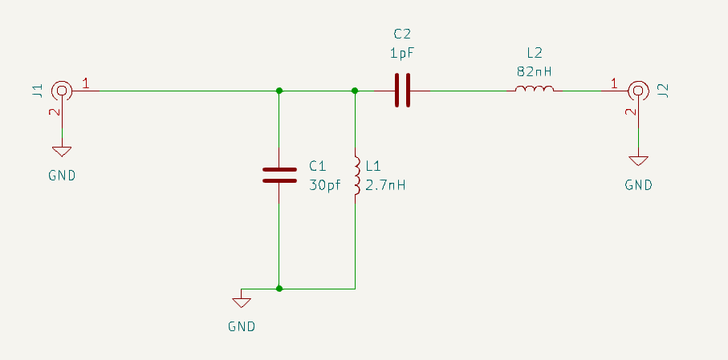

Figure 8 Schematic 433MHz bandpass filter

PCB

Figure 9 Schematic 433MHz bandpass filter

After carefully soldering all the components together, we proceeded to run the setup once again. This time, we attached the bandpass filter to the antenna, ensuring that it was properly integrated into the signal chain. The filter was then connected to the RFSoC board, which served as the central processing unit for both transmitting and receiving the signals. Once everything was connected, we powered on the system and began testing. The setup was now complete, with the filter, antenna, and RFSoC board all working. As a result, we were able to gather the following data, which demonstrated the enhanced performance of the system with the new configuration.

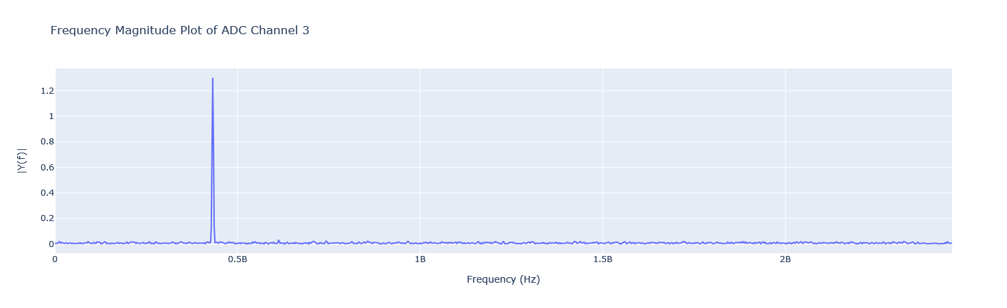

Our 433 MHz signal

Figure 9 Frequncy domain graph after the filter

It became clear that our filter was doing its job well, as almost all the noise present in the laboratory environment had been effectively eliminated. This was a critical step since the lab, with all its electronic equipment and ongoing experiments, introduced a significant amount of background noise. With the filter ensuring that the receiving side was capturing clean signals, we could confidently move forward. Knowing that the receiver would now primarily detect our own transmitted signals, we were ready to proceed to the next and most exciting stage of the project: testing the beamforming capabilities. This meant carefully aligning the system and analyzing how the transmitted beams could be manipulated and directed toward the receiver. The groundwork had been laid, and it was finally time to see the beamforming system in action.

Beamforming Test

We arranged the transmitting antennas in a linear form one half-wavelength apart from each other, and the receiving antenna in the center away from both the transmitting antennas as can be seen down below.

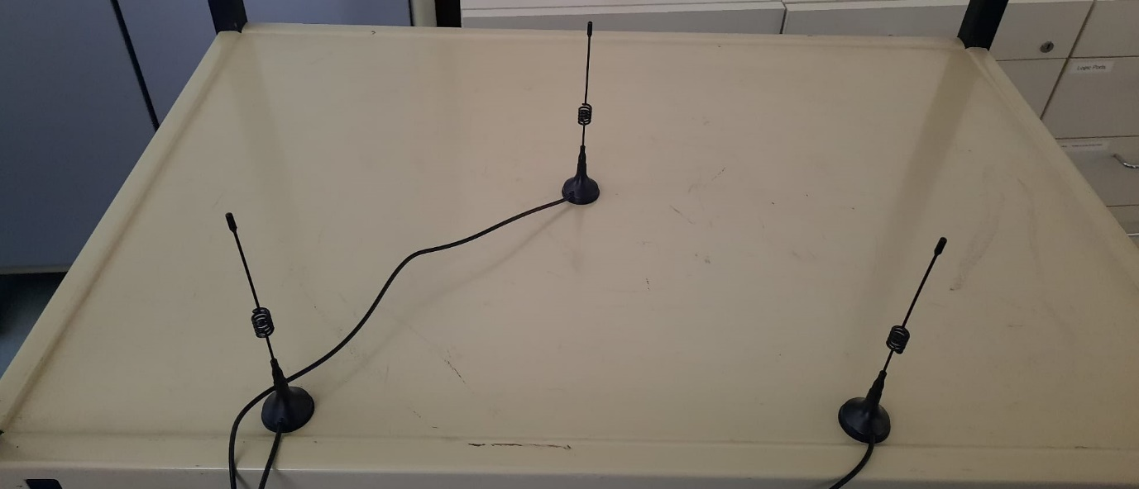

One half-wavelength distance: 39cm

Transmiting Antenna 2

Transmiting Antenna 1

Figure 10 Antenna Setup

The receiving antenna was strategically positioned at a specific location to align with the direction where the transmitting antennas would radiate their strongest signal once a phase shift was applied to the second antenna. This placement was critical to evaluate the beamforming capabilities of the system accurately. By applying a calculated phase shift to the second transmitting antenna, the combined radiation pattern of the two antennas was adjusted to focus energy toward the intended target direction. The receiving antenna was carefully placed within this target zone to ensure it captured the maximum signal strength. This setup was essential for verifying the performance and validating the theoretical expectations of our beamforming system.

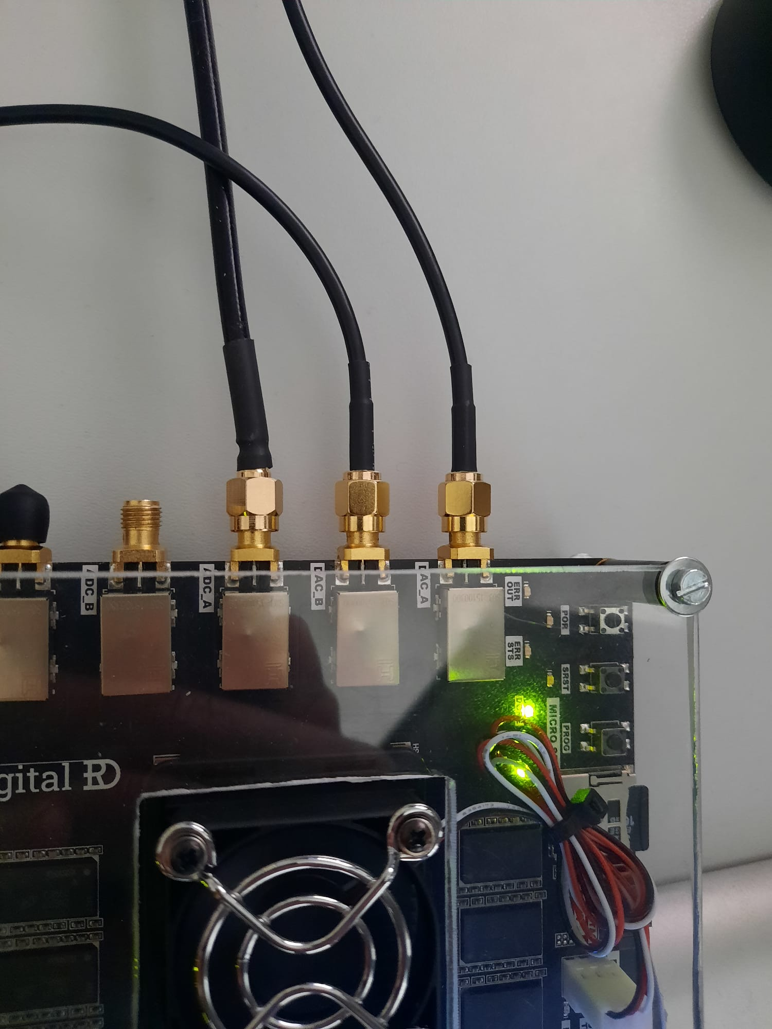

Receiving antenna through bandpass filter

Antenna 2

Antenna 1

Figure 11 Connections to the board

As shown in the Figure 11, transmitting antennas are connected to the DAC A and DAC B ports, and the receiving antenna is connected to the ADC A port through the bandpass filter.

Test 1: 0 Degrees Phase Shift

In this test, the transmitting antennas were configured without any phase shift applied between them, meaning the signals transmitted from both antennas were in phase. This setup created a radiation pattern where the maximum signal strength was directed perpendicular to the array, corresponding to the broadside direction. The receiving antenna was placed at this location to measure the transmitted signal's strength and verify the alignment of the system. The results of this test served as a baseline for comparison with subsequent tests involving phase shifts, allowing us to observe how adjusting the phase difference between the transmitting antennas affected the beam direction and radiation pattern.



Figure 12 Signal received at no phase shift

As can be seen above, the receiving *system successfully detected an AC signal, with a measured peak-to-peak voltage of 0.006 V*. This signal indicates that the transmitted beam was effectively captured by the receiving antenna, verifying the alignment and functionality of the setup. The small peak-to-peak voltage suggests that the signal strength at the receiving end is relatively low, which could be attributed to factors such as the distance between the antennas, the gain of the transmitting and receiving antennas, or potential losses in the system. Nevertheless, the presence of the AC signal confirms that the system is operational and capable of transmitting and receiving signals within the desired frequency range. This observation provides a foundation for further analysis, including the evaluation of beamforming effects and the system’s overall performance.

Test 2: 90 Degrees Phase Shift

In this test, a 90-degree phase shift was applied to the signal feeding the second transmitting antenna while the first antenna continued transmitting without any phase shift. This adjustment caused the transmitted signals from the two antennas to combine constructively and destructively at different angles, effectively steering the radiation pattern away from the broadside direction. The goal was to observe how the beam's direction shifted and whether the receiving antenna, positioned in the anticipated beam direction, could still detect the transmitted signal.

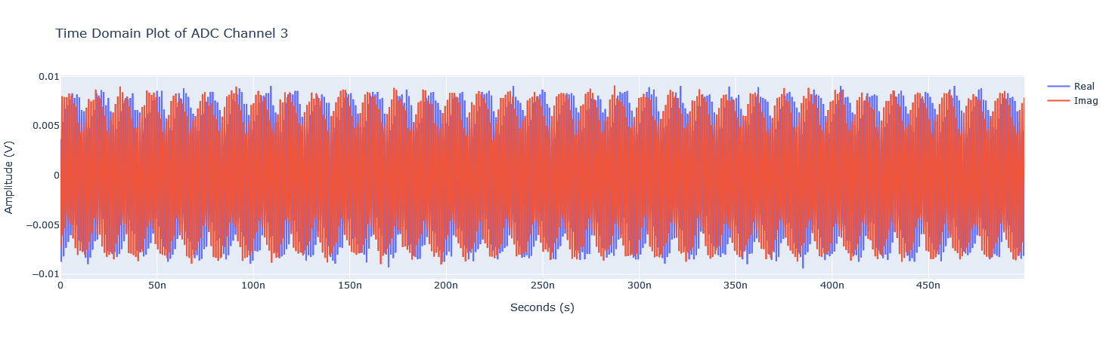

Figure 13 Received signal after applying 90 degree phase shift

*As can be seen above, applying a 90-degree phase shift significantly increased the amplitude of the received signal, rising from 0.006 V to nearly 0.01 V peak-to-peak.* This increase demonstrates the effect of constructive interference when the beam is steered toward the receiving antenna. By adjusting the phase relationship between the two transmitting antennas, the radiation pattern was redirected, resulting in a stronger signal being received in the intended direction. This observation highlights the system’s ability to enhance signal strength in specific directions through beamforming, a key advantage of phased array systems. The improved amplitude confirms the effectiveness of the phase shift in concentrating energy and steering the beam toward the target, aligning well with theoretical predictions.

Test 3: 180 Degrees Phase Shift

For this test, a 180-degree phase shift was applied between the two transmitting antennas. This caused the signals transmitted by the antennas to be completely out of phase, meaning the crest of the signal from one antenna coincided with the trough of the signal from the other. As a result, the radiation pattern of the system was significantly altered, with the main lobe of the radiation pattern pointed in the opposite direction compared to the baseline scenario (0-degree phase shift).

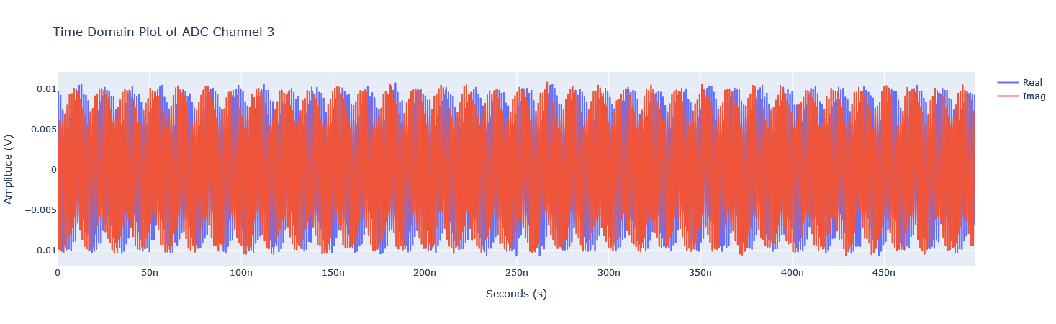

This time, we can see that the *180-degree phase shift further directed the signal toward the position of the receiving antenna, resulting in a stronger signal with a peak-to-peak voltage exceeding 0.01 V.* This increase in signal strength indicates that the destructive interference effect observed in previous tests was now countered by constructive interference at the receiving antenna’s location. The 180-degree phase shift essentially steered the radiation pattern in a way that enhanced the signal strength in the direction of the receiver. This confirms that the system is capable of dynamically focusing the transmitted energy toward specific areas, further validating the effectiveness of phase control in beamforming applications. The received signal’s increased amplitude highlights the precision with which the phase shifts influenced the beam’s directionality and power distribution.

5. Conlusion & Possible Improvements

Conclusion

In this project, we successfully demonstrated the capabilities of the phased array system in controlling the directionality and amplitude of the transmitted signal through phase shifts. Starting with a 0-degree phase shift as the baseline, we observed the expected radiation pattern and received signal strength. With the application of a 90-degree phase shift, we saw a noticeable increase in the received signal's amplitude, confirming the system's ability to steer the beam in a specific direction and enhance signal strength through constructive interference. When a 180-degree phase shift was applied, the system's beam was further directed toward the receiving antenna, resulting in an even stronger received signal due to constructive interference.

These results validate the effectiveness of phase shifting in beamforming applications and highlight the precision with which the RFSoC board, along with the dipole antennas, can control the direction and strength of the transmitted signal. The ability to dynamically adjust the radiation pattern allows for optimized signal reception in specific directions, which is essential for applications requiring high precision and control, such as wireless communications and radar systems. This experiment provides a solid foundation for future work in more complex phased array systems and beamforming techniques.

Possible Improvements

To further enhance the system's performance, several improvements could be made. One potential upgrade would be to increase the number of antennas in the phased array, transitioning from a two-antenna setup to a larger array. By adding more antennas, the beamforming capability would be significantly improved, allowing for more precise steering of the radiation pattern and potentially increasing the overall gain of the system. This would help to concentrate more energy in the desired direction, improving signal strength and reception over greater distances, but this is not possible with the RFSoC 4x2 board since it only has 2 DAC ports.

Another improvement could involve using a Yagi antenna on the receiving side. Yagi antennas offer higher directivity and gain compared to dipole antennas, making them ideal for capturing weaker signals from a focused source. By incorporating a Yagi antenna, the receiver could have a better signal-to-noise ratio and enhanced performance in challenging environments, especially for applications where signal clarity and range are critical. Combining both these improvements would result in a more robust and efficient phased array system, suitable for more advanced applications such as high-precision communications and radar systems.

6. References

[1] Phased Array Antennas, *Microwaves101*. [Online]. Available: <https://www.microwaves101.com/encyclopedias/phased-array-antennas>. [Accessed: Jan. 10, 2025].

[2] "linearArray MATLAB documentation," *MathWorks*. [Online]. Available: <https://de.mathworks.com/help/antenna/ref/lineararray.html>. [Accessed: Jan. 10, 2025].

[3] "Designing an LNA with bandpass filter," *Alicja Space*. [Online]. Available: <https://alicja.space/blog/designing-lna-with-bandpass-filter>. [Accessed: Jan. 10, 2025].

[4] "LC Filter Design Tool," *Marki Microwave*. [Online]. Available: <https://markimicrowave.com/technical-resources/tools/lc-filter-design-tool/>. [Accessed: Jan. 10, 2025].

[5] "Fast Fourier Transformation FFT - Basics," *NTI Audio*. [Online]. Available: <https://www.nti-audio.com/en/support/know-how/fast-fourier-transform-fft>. [Accessed: Jan. 10, 2025].

[6] Xilinx. "Zynq UltraScale+ RFSoC 4x2 introduction." [Online]. Available: [https://github.com/Xilinx/RFSoC-PYNQ/blob/master/boards/RFSoC4x2/base/notebooks/rfdc/01_rf_dataconverter_introduction.ipynb](https://github.com/Xilinx/RFSoC-PYNQ/blob/master/boards/RFSoC4x2/base/notebooks/rfdc/01_rf_dataconverter_introduction.ipynb%20) [Accessed: Jan. 10, 2025].

[7] Xilinx. "Zynq UltraScale+ RFSoC 4x2 Spectrum Analysis." [Online]. Available: [https://github.com/Xilinx/RFSoC-PYNQ/blob/master/boards/RFSoC4x2/base/notebooks/rfdc/02_rf_spectrum_analysis.ipynb](https://github.com/Xilinx/RFSoC-PYNQ/blob/master/boards/RFSoC4x2/base/notebooks/rfdc/02_rf_spectrum_analysis.ipynb%20) [Accessed: Jan. 10, 2025].

[8] R. P. Gupta, "Phased Array Antennas," *IEEE Spectrum*, [Online]. Available: [https://ieeexplore.ieee.org/document/4130008/?](https://ieeexplore.ieee.org/document/4130008/?utm_source=chatgpt.com) . [Accessed: Jan. 10, 2025].

[9] patternAzimuth, *MathWorks* ", [Online]. Available: [https://de.mathworks.com/help/antenna/ref/cavity.patternazimuth.html?utm_source=chatgpt.com](https://de.mathworks.com/help/antenna/ref/cavity.patternazimuth.html?utm_source=chatgpt.com%20) [Accessed: Jan. 10, 2025].