**Worksheet - EOSC 340 - Day 3**

**Good absorbers are good emitters**

The two walls shown below are initially at the same temperature, though they have different emissivities as shown. Assume the transmissivity is 0 for both walls. The space between the walls is a vacuum. Recall that σ=5.67x10-8 W/m2/K4. Note that the right wall absorbs everything that hits it (it’s a blackbody), while the left wall partially absorbs some radiation and reflects the rest.

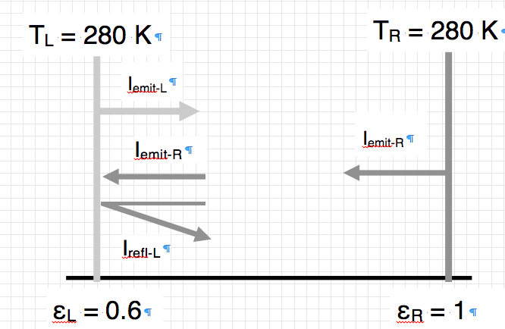

1. On average, is there a net heat transfer between the two walls? If so, which way does it go? Provide reasoning, but **do not** do any math at this point.
2. Do either or both of the walls change their temperature with time? If so, which becomes warmer with time, and which cools down with time? Again, don’t do any math at this point.
3. What is the radiative flux (in W/m2) emitted by the   
   a) the right wall, and  
   b) the left wall?
4. How much flux is absorbed at the left wall, assuming Kirchoff’s law is true?
5. **Kirchhoff’s Law** states that *abs* = ε. Show algebraically that this must be true at the left wall. Do not use numeric values! Assume that the left wall can’t change temperature, so that all the arrows at the wall have to cancel out. Remember that the wall is absorbing and reflecting, but not transmitting.