**­­Worksheet - EOSC 340 - Day 3**

**PART 1: Good absorbers are good emitters**

The two walls shown below are initially at the same temperature, though they have different emissivities as shown. Assume the transmissivity is 0 for both walls. The space between the walls is a vacuum, . Recall that σ=5.67x10-8 W/m2/K4. Note that the right wall absorbs everything that hits it (it’s a blackbody), while the left wall partially absorbs some radiation nd reflects the rest.

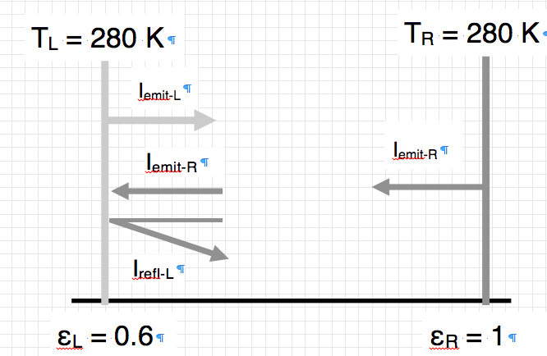

1. On average, is there a net heat transfer between the two walls? If so, which way does it go? Provide reasoning, but **do not** do any math at this point.

Name:

The 2nd law of thermodynamics says that the temperature can’t change without some process doing work, so the net transfer has to be zero at both walls.

1. Do either or both of the walls change their temperature with time? If so, which becomes warmer with time, and which cools down with time? Again, don’t do any math at this point.

No temperature change for either wall.

1. What is the radiative flux (in W/m2) emitted by the   
   a) the right wall, and  
   b) the left wall?

Right wall: Iright = σT4 =348.5 W/m2

Left wall: Ileft=εσT4 = 0.6x348.5=209 W/m2

1. How much flux is absorbed at the left wall, assuming Kirchoff’s law is true?

If abs=ε then absIright = εIright = 209 W/m2

1. **Kirchhoff’s Law** states that *abs* = ε. Show algebraically that this must be true at the left wall. Do not use numeric values! Assume that the left wall can’t change temperature, so that all the arrows at the wall have to cancel out. Remember that the wall is absorbing and reflecting, but not transmitting.

Since the 2nd law says temperature can’t change, that means the fluxes in and out have to balance. If we use a minus sign for outbound fluxes and and plus sign for inbound fluxes, then the balance at the left wall is:

1. Iemit-R – Iemit-L – Irefl-L=0

Also, since the wall is absorbing and reflecting, but not transmitting, we have:

1. Irefl-L = (1 – abs)Iemit-R

Filling in the rest of the values we can rewrite the equation(1) as:

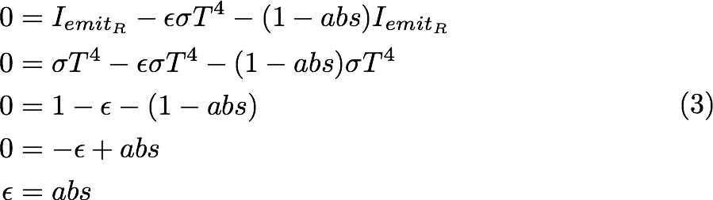

Where we’ve used the fact that both walls have to be at temperature T so that Iemit-R = σT4