**Metasploit**

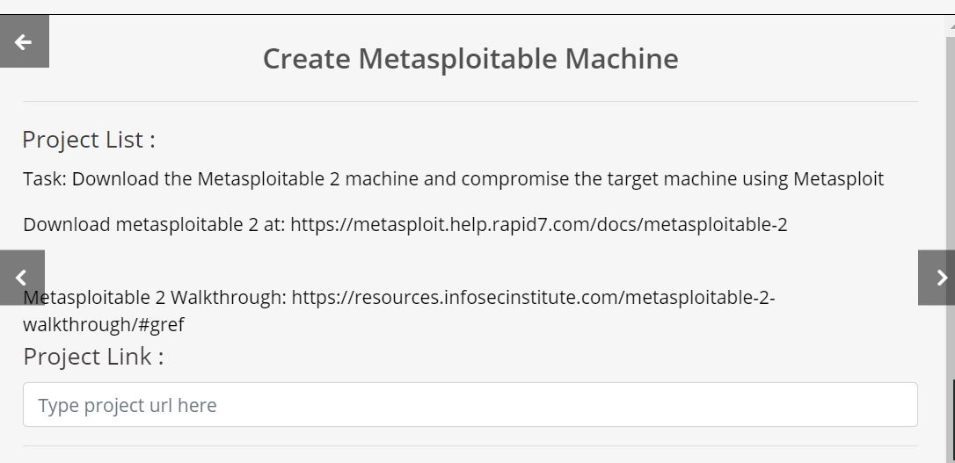

**Metasploitable machine IP : 192.168.225.134**

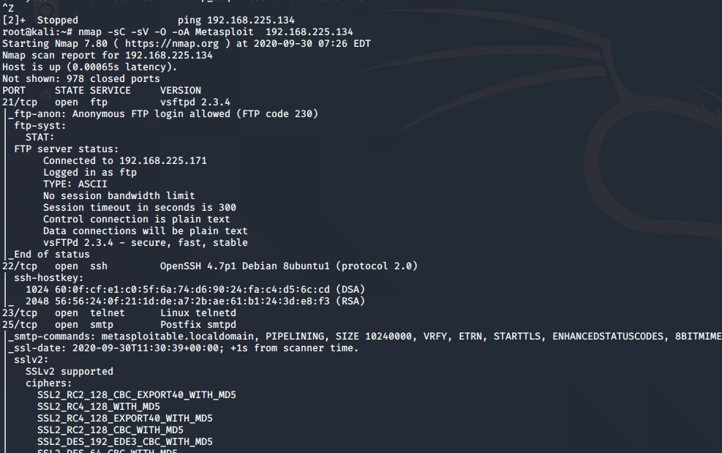



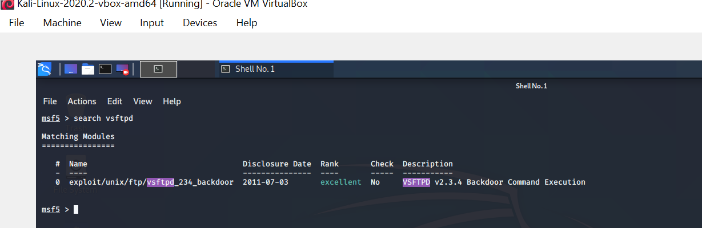

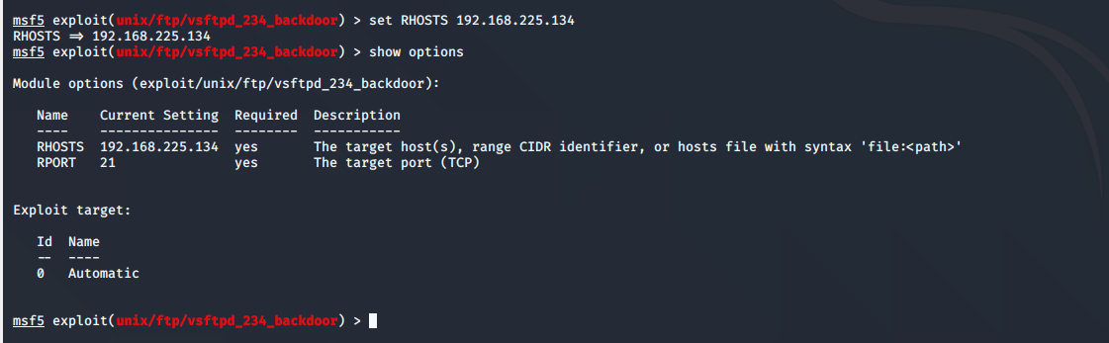

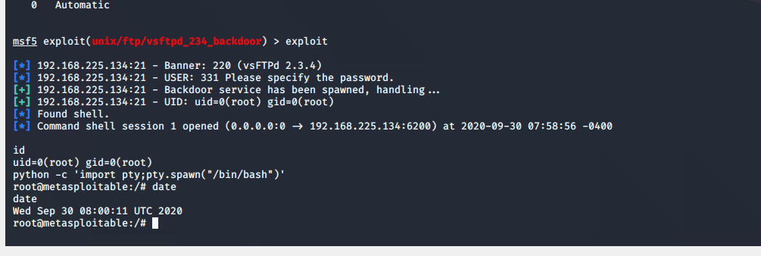

Sucessfully targeted the metasploitable machine and entered via root

**Kali linux machine :**

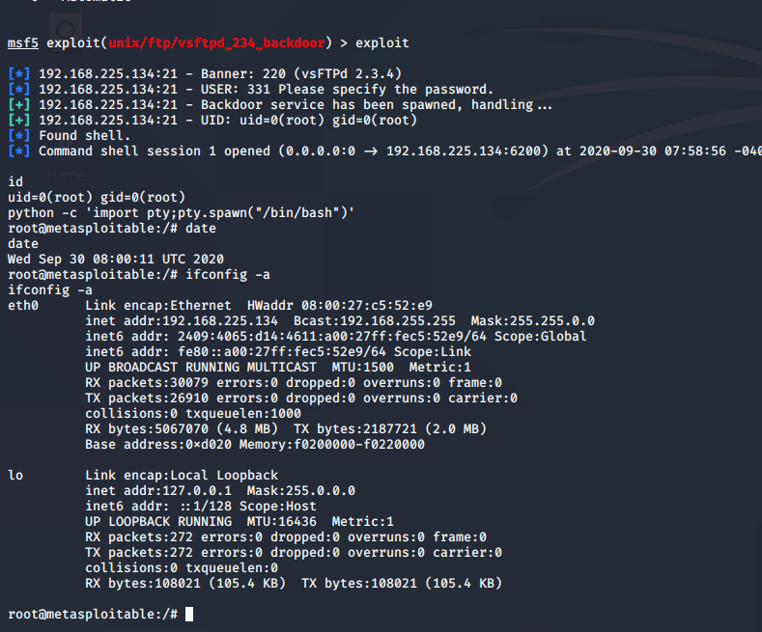

**Metasploitable machine :**

