Today, organizations need reliable access to data across the board. This is not only important for small businesses but enterprises are even more pressured to acquire the best possible data management processes and ensure stable development. The astonishing potential that enterprise software (ES) has introduced to the world by the power of technology has not only shifted how businesses grow, but also how they keep their operational and strategic initiatives under control and up to date. Streamlining large-scale data requires large-scale software and, in this article, you will find out everything you need to know – from the [best BI tools](https://www.datapine.com/articles/best-bi-tools-software-review-list) on the market to project management and web analytics software.

We will start by clearing the enterprise software definition, explain what kind of benefits a business can obtain by utilizing ES and what are the best enterprise software companies that offer solutions crucial to compete in our cutthroat environment. At the end, you will see how taking advantage of the names on our list can prove beneficial for your enterprise, whether small or large.

**1) What Is Enterprise Software?**

**Enterprise software** is a term used to describe applications and technologies that companies use in order to support their operational and strategic initiatives by focusing on the whole organization rather than single user. Examples include CRM and business intelligence.

Such software can be found in large industries, governments, retailers, hospitals, and departments such as sales, marketing, customer service and finance, among others. This kind of software obviously requires interdisciplinary methods and processes to manage large data scales – numerous solutions on the market provide just that. For example, an enterprise software application focused on human resources will have numerous HR features that will enable professionals to access one single solution and generate information simultaneously.

To easily automate numerous processes, tasks, and add value into your business operations, we will take a detailed look at the best enterprise software tools for 2020, where we will discuss different areas and provide an example tool of each. We will also consider [Capterra](https://www.capterra.com/) ratings as one of the leading websites for software reviews that can provide you with additional information.

**2) What Are The Best Enterprise Software Applications On The Market?**

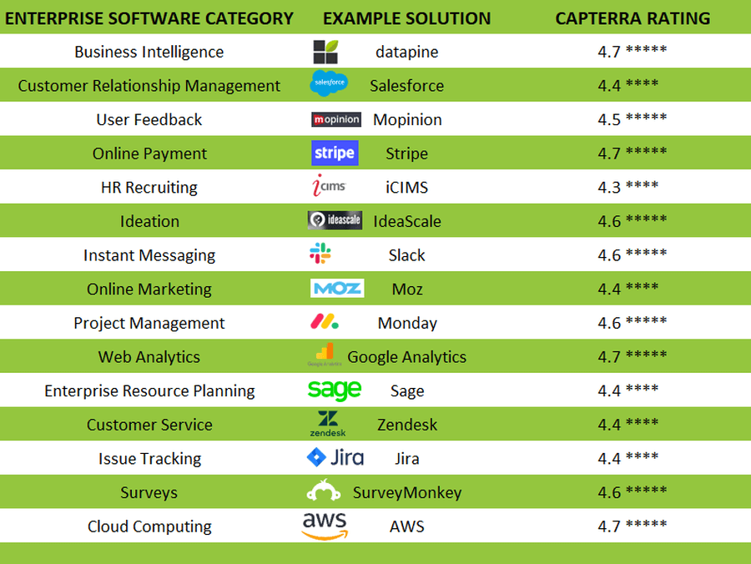

Since we have elaborated on basic definitions and benefits that enterprise business applications possess, we will now take a detailed look into our enterprise software list comprised of the most popular solutions on the market. We will go through business intelligence tools, CRM software, user feedback software, ERP, online marketing, web analytics, customer service and many other tools that will, ultimately, accumulate a list of the top 15. Each solution will be presented with a visual example and key features with an explanation of the tool and what is best used for. Hopefully, after passing through our list, you will have a better impression on what each of these solutions can do for your organization and why it’s useful to incorporate them into your daily operations and strategic initiatives.

**1. Business intelligence (BI) software and tools**

Business intelligence is the modern epitome of successful data analysis, management, monitoring and smart reporting. BI gathers a multitude of benefits and software providers have disrupted the industry by offering an ample of solutions for enterprise requirements. Let’s take a look at an industry example.

**datapine**

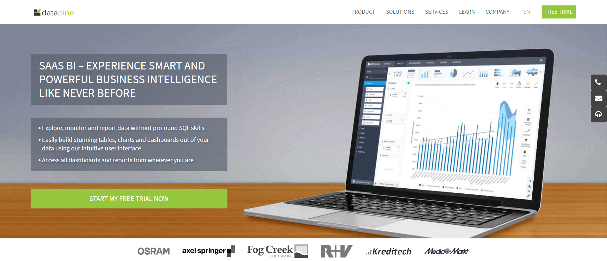

**KEY FEATURES:**

Beginner and advanced data analysis for every industry and department

Modern data visualizations through interactive [business dashboards](https://www.datapine.com/dashboard-examples-and-templates/)

Numerous sharing options (via public URL, automated reports, e-mail, embedding)

[datapine](https://www.datapine.com/) is an enterprise software company focused on delivering business intelligence solutions to industries and companies across the world. Users can simply connect their data source(s) and explore various enterprise possibilities such as data analysis via drag-and-drop interface or advanced SQL mode, an extensive [dashboard software](https://www.datapine.com/articles/best-dashboard-software-features), automated reporting and numerous sharing possibilities, hence the whole organization will stay connected at all times. Embedding their solution into your own is fairly easy so you can use datapine as your own product and scale their features as your business scenarios require. With an impressive 4.7-star rating on Capterra, the company has risen into a solution worth testing and utilizing in your enterprise operations.

**2. CRM software and tools**

Customer relationship management (CRM) is one of the most important factors in the business pipeline no matter the company’s size. Looking through customer data to be able to make better sales decisions and track customers’ activities, CRM is an indispensable enterprise tool to manage and optimize interactions while building relationships with prospects.

**Salesforce**

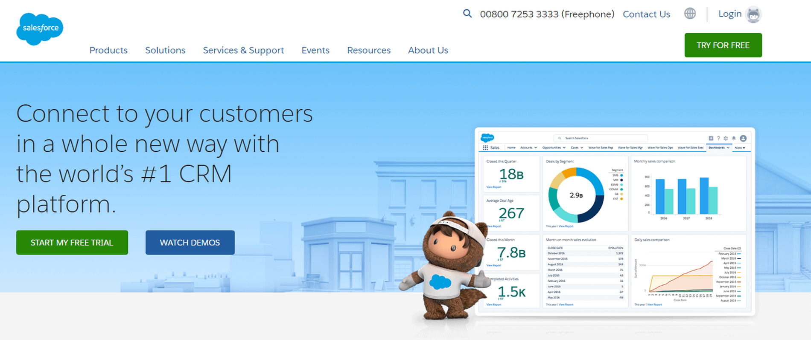

**KEY FEATURES:**

Centralized, cloud-based software for all CRM efforts

Customer 360 products that contain 12 core solutions

AI-based functions such as predictive scoring and intelligent automation

Often referred as the industry standard for CRM, [Salesforce](https://www.salesforce.com/) delivers a cloud solution focused on finding, winning and keeping customers based on various products in their portfolio such as their sales and service platform, ecommerce solutions, app integrations and personalized marketing for potential customers. In essence, Salesforce offers 12 solutions in their customer 360 products, all of which have their respective focus on different areas of customer management. Capterra gives this company a rating of 4.4 stars, making it a great CRM solution for companies looking to unify their sales and customer undertakings.

**3. User feedback software and tools**

Looking at opinions of your users is an insightful activity that can lead to better customer experience by understanding what your customers want, utilizing data and analytics to create a feedback ecosystem that will enable you to proactively improve your product and share your findings across the company. One of those solutions is Mopinion.

**Mopinion**

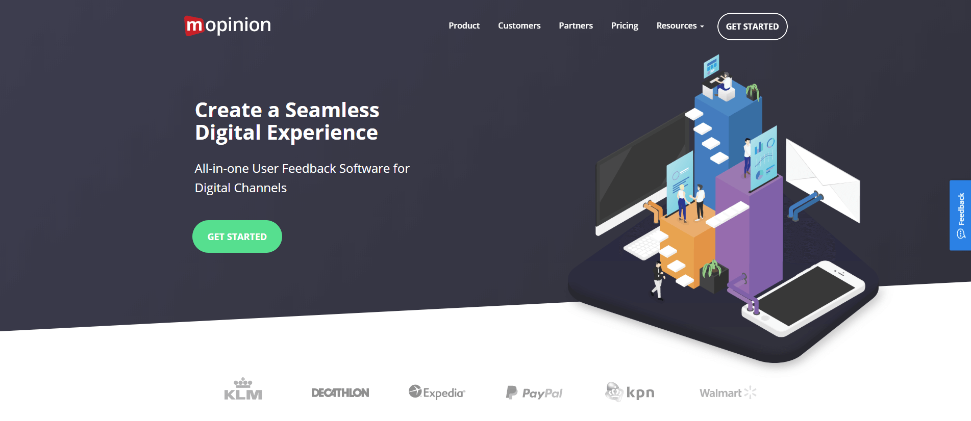

**KEY FEATURES:**

Customizable feedback forms for websites, native apps and Emails

Easy integration with other CRM, project management or web analytics applications

Real-time customer feedback and statistics and the analysis of open texts and values

An all-in-one user feedback platform, [Mopinion](https://mopinion.com/) helps digital enterprises to manage all digital touchpoints (web, mobile, and e-mail) related to understanding customers’ behaviors. The software enables its users to create customizable feedback forms, including visual user feedback that offers automated screenshots. Triggering forms based on user behavior, device type and demographics can give you useful information on your site visitors and their position in your conversion funnel. It also includes visualizations through customizable dashboards as well as easy import your data through Excel and CSV. A high rating on Capterra, with 4.5 stars, makes Mopinion a software worth looking into.

**4. Online payment software and tools**

The payment processing and fintech industry heavily rely on online payment software and tools. With the world being more connected than ever before, enterprises need to look after their payments by choosing solutions that are easy to manage and reachable both by merchants and customers anywhere around the globe. Let’s see an example of this category of enterprise tools.

**Stripe**

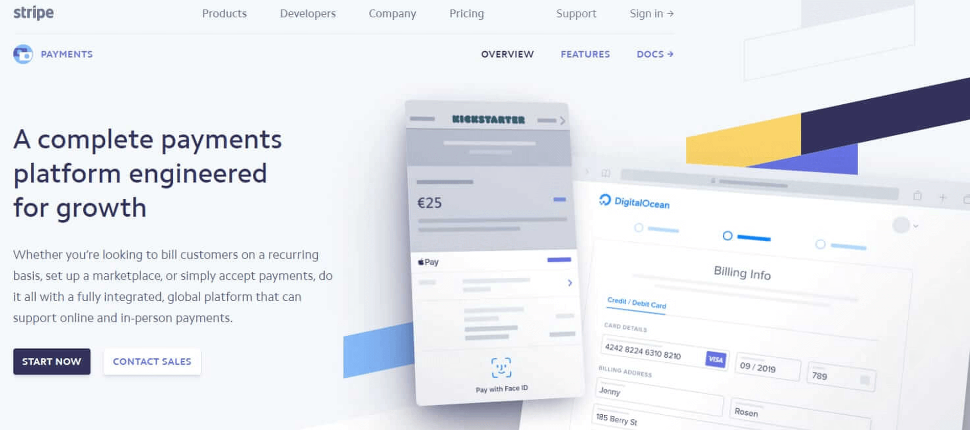

**KEY FEATURES:**

Simple, usage-based pricing model with no setup or monthly costs or hidden fees

Intelligent billing and subscription management and complex payment flows for marketplaces

Over 100 functions cover all important areas in the entire payment procedure

A global leader in online payments, [Stripe](https://stripe.com/) has disrupted the industry and its technology became a benchmark in smooth payments, fraud detection, subscription management, etc. It’s fairly easy to use and offers recurring payments that some companies might find useful. Stripe charges a small fee on each payment so you don’t have to invest large sums into different payment methods. It offers various partnership options with other sites that make it easy to implement Stripe to billing software, for example. Capterra gave this solution an extremely high rating of 4.7 stars, hence, Stripe is worth testing out to explore all the features on your own.

**5. HR recruiting software and tools**

Recruiting has become digitalized more than ever. With the ever-changing human resources demands to screen thousands of candidates and handling all the data that gets collected along the way, an enterprise software system is needed to help in recruiting, connecting, and onboarding potential employees. This is where a solution such as iCIMS can make a strong impact with a strong 4.3 rating on Capterra.

**iCIMS**

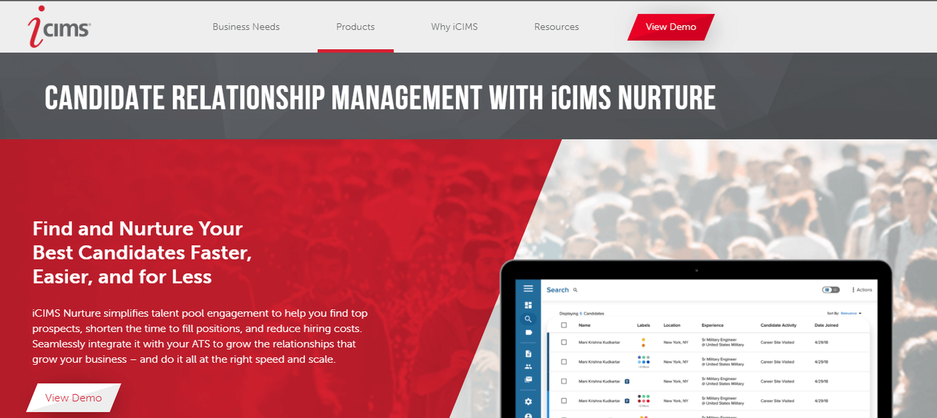

**KEY FEATURES:**

Robust suite focused on recruitment marketing, communications and hiring

Management, analysis and optimization of all relevant steps of the recruitment life cycle

Smart preboarding features to ease the candidate’s beginnings into the new company

Also, one of the cloud-based software solutions, [iCIMS](https://www.icims.com/) promises “seamless candidate journeys, from application to offer to preboarding.” An enterprise recruitment platform, this software offers a range of automated workflows, analytics, and tracking solutions to ultimately shorten the hiring cycle and optimize the complete HR department. They provide a complete suite for candidate relationship management, advanced communications and hiring suite alongside with a partner ecosystem that lets you integrate other recruiting solutions via their marketplace.

**6. Ideation software**

Brainstorming, innovation and generating ideas often connects people across the company. Feedback, comments, voting systems and gathering insights from employees, important stakeholders and external partners is run by technologies that facilitate continuous improvement and keeping full transparency – databases can be accesses by anyone in the company. One of the most popular software is [IdeaScale](https://ideascale.com/) with a rating of 4.6 on Capterra.

**IdeaScale**

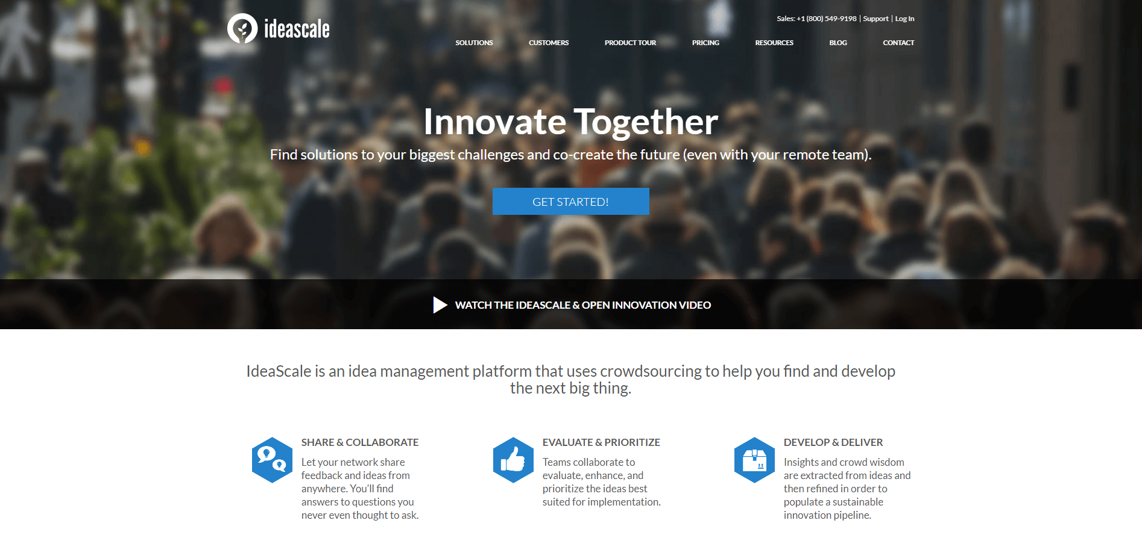

**KEY FEATURES:**

Comprehensive innovation management platform with 3 pillars of innovation: collaboration, evaluation & development

Offers numerous tools for integrating crowdsourcing within the innovation process

Multiple reporting and analytics options through IdeaScale dashboards

This enterprise management system software can be used for employee engagement that enables teams to ask important questions in one, centralized place. It’s extremely useful for enterprises that have disparate and large teams since communication processes can often seem difficult. Involving the public is also a feature that makes this solution perfect for exploring untapped ideas that can generate indispensable value. Focused on collecting ideas and providing a platform to vote, IdeaScale also supports other means of innovation, including workflow automation, team building, idea collaboration, and many more.

**7. Instant messaging software and tools**

Team communication in the form of instant messaging has become a standard process in companies in our digital age. Even though instant messaging has its origins more in the private sphere (ISQ, MSN Messenger, Whatsapp etc.), modern enterprise messengers offer numerous advantages for corporate communication and can usually be easily integrated into existing operating software. Among other things, they provide accurate documentation, enable quick reactions and topic- or project-specific group chats, which ultimately leads to higher productivity and better business decisions. Let us now take a look at our selected example.

**Slack**

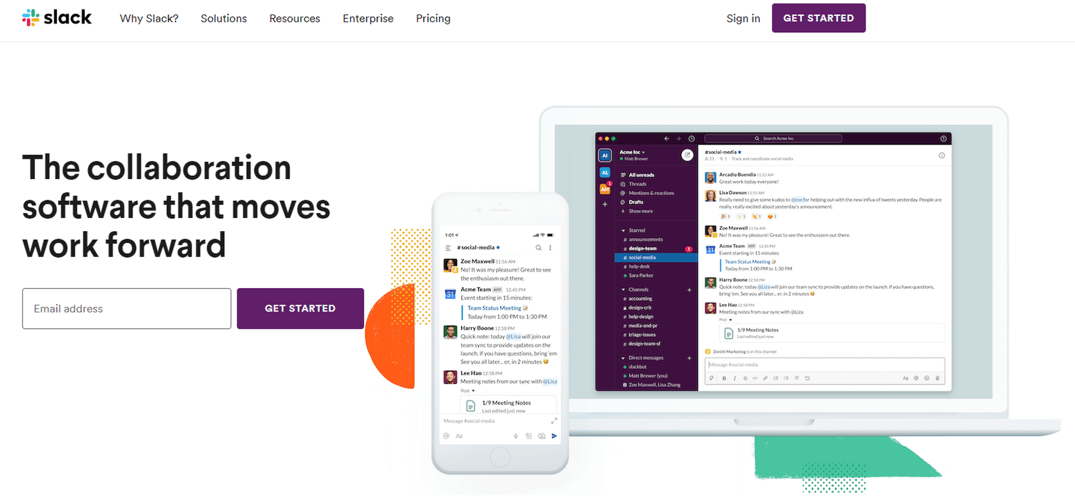

**KEY FEATURES:**

Organized conversations into channels and direct messages

Searchable history that makes finding information from previous conducted chats quite easy

Uncomplicated integration with other enterprise software (e.g. Jira, Gmail, Outlook, Zendesk, Monday etc.)

[Slack](https://slack.com/) is used by enterprises across the globe and it gained a stable rating of 4.6 stars on Capterra. This enterprise software features communication collaboration, integration with various external tools and files while organizing messages into direct and clean channels. There are different subscription plans so your enterprise can scale Slack based on different business needs while enabling efficient and time-saving teamwork. Their built-in security and compliance guarantees that companies will have 11 different enterprise-level security features, and the possibility to connect with other solutions such as Salesforce, Zendesk, OneDrive or Google Drive, among others, will ensure that teams have access to multiple tools from a single place.

**8. Project management software and tools**

Project management (PM) is an indispensable tool for teams looking to complete projects on time and on budget. Whether there is project alignment needed, agile management in focus, or simply better collaboration, there are some enterprise software applications examples that provide numerous project management features crucial to deliver the best possible results. Let’s see this through Monday that obtained a rating of 4.6 stars on Capterra.

**Monday**

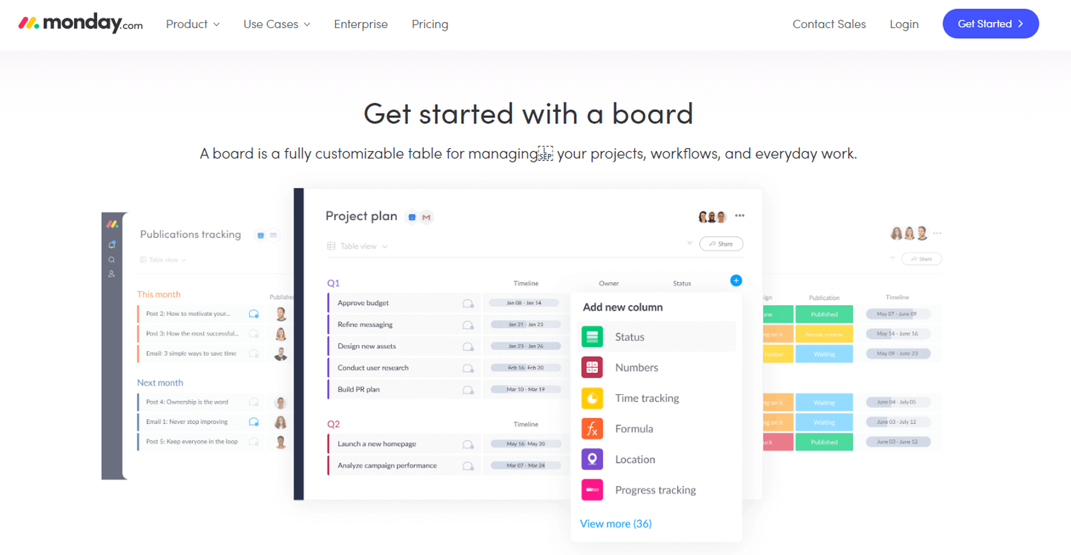

**KEY FEATURES:**

Customizable boards and available templates for managing all project aspects

Workflow automation without the need to develop or implement any code

Integration with more than 50 other tools such as Zoom, Slack, Zendesk, etc.

One of project management tools that have a focus also on visual representation, [Monday](https://monday.com/) helps enterprise teams to manage workflows, everyday tasks and projects through customizable boards that visualize the workload and timeline of everyone involved. Planning the team’s work visually, utilizing dashboards and charts to consolidate all the parts of the project and easily reviewing results makes Monday one of the big players in the industry. Integration with other tools such as Slack, Zendesk, Mailchimp, Hubspot and more than 50 other tools enables enterprises to bring various data in one, central hub.

**9. ERP software and tools**

Enterprise resource planning (ERP) software help enterprises to integrate all management aspects of inventory management, accounting, CRM, human resources, advertising and man more in order to share information through a single database that enables users to access data from different business units as well as their own. [Sage](https://www.sage.com/) is one of the leading providers in the industry with a Capterra rating of 4.4 stars.

**Sage**

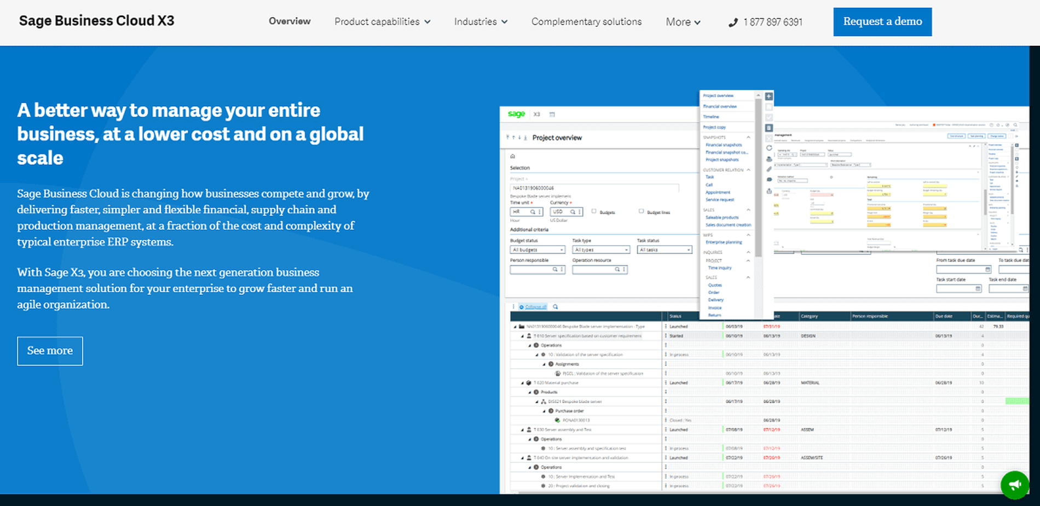

**KEY FEATURES:**

Main product capabilities include financial and production management, supply chain, etc.

Built-in marketplace for extending the product based on your needs

Complementary solutions developed directly by Sage or their partners

Sage ERP works as a cloud solution divided into 3 core products: Sage 100cloud, Sage 300cloud and Sage X3. By utilizing their solution, each enterprise can control all aspects of a business, from financial, supply chain, production management to sales. Their goal is to provide an agile solution to businesses looking to grow and manage their data from a single business enterprise software solution. They also offer a marketplace where you can connect with other apps and scale your ERP system even more.

**10. Online marketing software and tools**

Marketing has developed in so many different areas that without software, companies would not be able to manage all the data points and develop successful strategies. From web analytics, content marketing, advertising and social media, among others, marketing tools and software enable users to take full control of their data, track, monitor, analyze and evolve promotional efforts. Here we will focus on [Moz](https://moz.com/) as a complete inbound marketing solution that received a Capterra rating of 4.4 stars.

**MOZ**

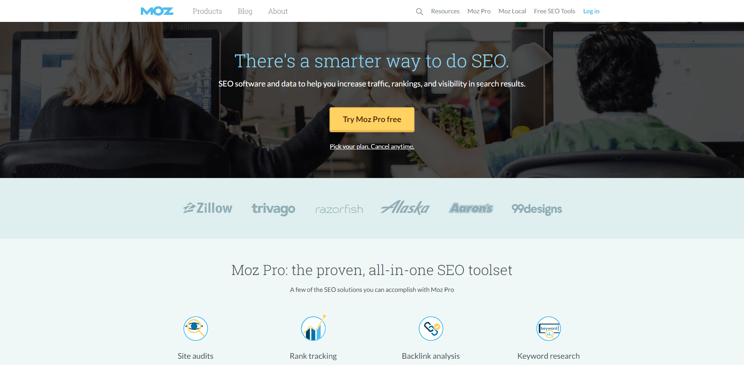

**KEY FEATURES:**

All-in-one inbound and SEO tool for tracking, monitoring and analyzing enterprise inbound efforts

Numerous features include keyword tracking, site audits, backlink analysis and keyword research

Supports a variety of country specific search engines from Google, Yahoo and Bing

Whether your enterprise needs keyword tracking, monitoring or link analytics, Moz is designed to bring all SEO and inbound data under one roof. With features such as site audits, rank tracking, backlink analysis and keyword research, this enterprise application software takes care of all your enterprise SEO and inbound efforts. The online data for hundreds of locations are easily managed via their enterprise solution, including listings, reviews, and store locators. Additionally, they offer free educational materials that can upscale any project and ensure your websites are ranking.

**11. Web analytics software and tools**

Various types of enterprise software wouldn’t be complete without web analytics. A website is a powerful tool in today’s digital environment, and without it, enterprises would be nearly invisible. But all that website data needs to be analyzed in order to successfully optimize a company’s presence, and that’s why web analytics software and tools such as Google Analytics are needed more than ever. With a stable rating of 4.7 stars on Capterra, [Google Analytics](https://marketingplatform.google.com/about/analytics/) proves to be the go-to solution when it comes to website analysis.

**Google Analytics**



**KEY FEATURES:**

World's most popular free web analytics platform for monitoring and analyzing website performance

Fast implementation, automatic data collection and customizable reporting options

Easy integration with other Google tools such as Google Ads or Google Search Console

One of the most popular software on the market, Google Analytics lets you track all digital analytics that your online marketing efforts are focused on, whether paid, organic, social or referral, among others. Numerous basic and advanced features will let you know where your traffic is coming from, track your lead generation processes and inspect demographic information needed to optimize and exceed your enterprise digital metrics across search engines. Not only designed for small businesses, this tool is one of the business software applications that companies shouldn’t ignore.

**12. Customer Service software and tools**

Closely connected with CRM, comprehensive customer service (CS) software will deliver a broad range of possibilities to effectively manage customer data and deliver the best possible customer experience. Enterprises need to include a proper CS solution to keep an eye on the ever-evolving customer expectations and demands. One of the enterprise software tools that can suitably manage all customer relevant data is [Zendesk](https://www.zendesk.com/) with 4.4 stars gained on Capterra.

**Zendesk**



**KEY FEATURES:**

Various enterprise software packages for customer support, sales and customer engagement

Provides professional customer care tools, help center and live chats

Enables you to reduce support costs and increase productivity and customer satisfaction

By helping enterprises in managing a globally dispersed customer service team, Zendesk offers customized solutions for support processes and workflow configuration in a single place. They offer omnichannel support solutions for e-mail, chat, phone or self-service, providing a platform for seamless conversations and support systems. This is an excellent example of what is enterprise technology offering by managing customer support no matter the location of the team. With 3 core plans, starting at 5€ an agent, Zendesk products and platforms mean better customer experience and, ultimately, profit.

**13. Issue tracking software and tools**

Software teams need to have a clear overview the development process and of all bugs and their status. Issue tracking and bug reporting software helps them in tracking, recording and finding all bugs that need attention and provide a platform that will help team leaders assign the issue to the person who needs to resolve it. That way, teams can easily prioritize and communicate more effectively while any potential software issues can be addressed immediately.

**Jira**

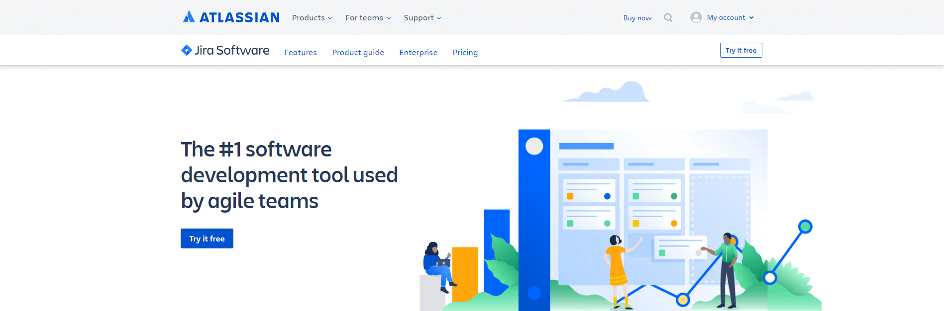

**KEY FEATURES:**

Helps IT teams plan, track and release great software

Detailed filtering and analysis options for tickets as well as the creation of reports and dashboards

Easy connection to hundreds of other developer tools such as GitHub or Bitbucket

[Jira](https://www.atlassian.com/software/jira) is one of our examples of enterprise applications that are fairly easy to use in terms of functionality and that’s why is very popular among the IT community. Teams can easily create custom boards depending on the needs but also different perspectives such as for developers, CTOs, tracking, etc. Connecting with other developer tools such as GitHub and Bitbucket and seeing which code is behind the ticket is also possible with Jira, among many other invaluable IT features. Capterra reviewer have given this solution an average rating of 4.4 stars.

**14. Survey software and tools**

Enterprises use survey software to support any aspect that connects them with an audience, no matter if there are clients or customers in question, or business partners. Surveys can provide insights for marketing campaigns, helpdesk, satisfaction levels of employees, or general feedback about specific business questions. [SurveyMonkey](https://www.surveymonkey.com/) leads the way and on Capterra performs quite well with a rating of 4.6 stars.

**SurveyMonkey**

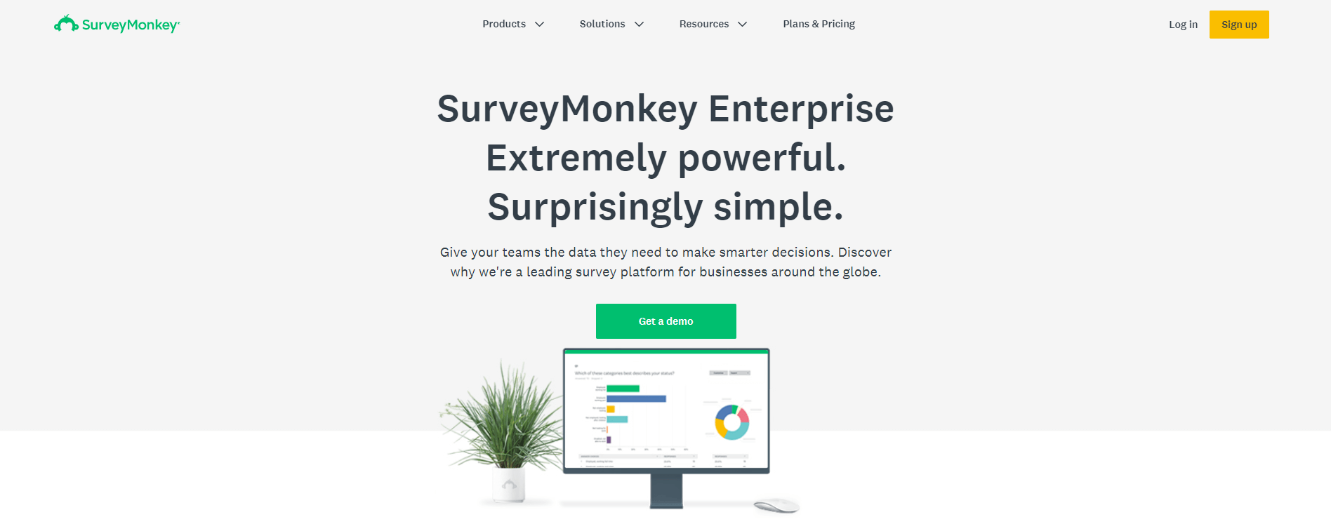

**KEY FEATURES:**

One of the most popular survey platforms worldwide for any target group

Surveys can be conducted via weblink, e-mail or chat, and in social media

Powerful analysis functions & fast export of results in various formats

From many types of enterprise application software, SurveyMonkey claims to be trusted by 98% of Fortune 500 companies and is one of the most popular solution on the market. It offers a centralized admin dashboard and audit logs for managing and tracking user activity but also easy onboarding and enterprise-level security. You can also integrate your survey data into more than 80 external apps such as Salesforce, Marketo or Oracle Marketing Cloud.

**15. Cloud computing platforms and tools**

Cloud services are used by enterprises that need heavy computing power and search for solutions that enable them to avoid building their own IT infrastructure, usually quite expensive. Some of our enterprise applications examples have the cloud as the option to access your data online, no matter the location or time. [Amazon Web Service (AWS)](https://aws.amazon.com/) is one of the most popular cloud platforms in the world and its average rating of 4.7 stars for different products on Capterra makes this solution high on the list of choosing a cloud platform.

**Amazon Web Services**

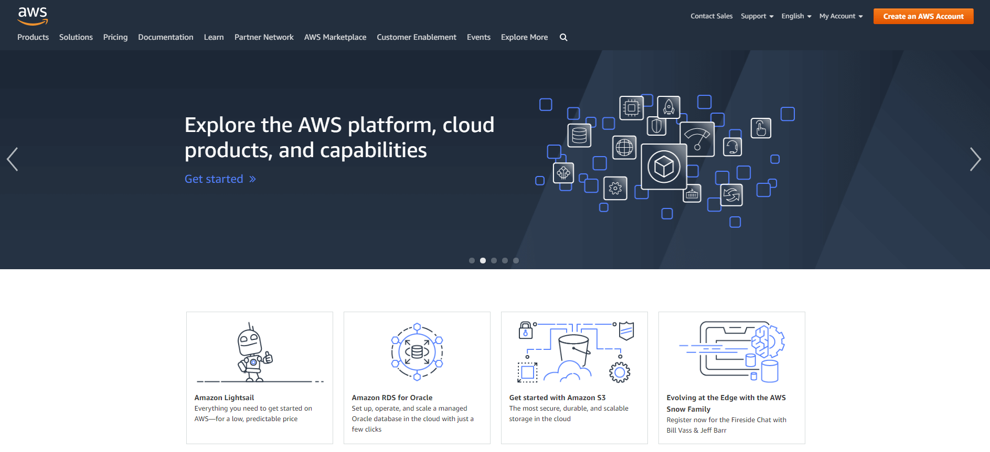

**KEY FEATURES:**

Leading international provider with a broad product portfolio that includes over 160 cloud services

Services include databases, data processing, developer tools and machine learning

Transparent, usage-based prices with volume discounts and short notice periods

AWS offers a wide range of cloud computing platforms such as data storage, compute on demand services, and networking. With an impressive market share of 35%, Amazon offers its services to enterprises across the world. Subscribers can utilize virtual hardware configuration (CPUs, GPUs for processing, SSD for storage and RAM for memory), operating system and apps such as CRM.

**Key Takeaways & Guidance**

We have explained the enterprise software applications definition, showed the benefits that this kind of software can bring to your organization, and provided a comprehensive list of enterprise tools that will help your company in connecting teams across your business. Each solution has its own specific features and, as any enterprise, you might want to consider just one or several. We hope that this list has given you an overview of what to expect from each category and examples that put things into a more detailed perspective. By utilizing enterprise software, you can definitely increase your productivity levels and make your operations run smoothly and cohesively. We believe we have helped you in the process.