Installation

Installing Node Js(if already installed ignore this step):

## Windows:

<https://nodejs.org/en/download/>

* download the latest windows Installer and run the MSI with admin privileges

## Mac Os:

* Download the latest package and install from the same site as mentioned above

Download Git repository

* Now download the Git repository
* Navigate to the location folder where the codes resides (like below picture)

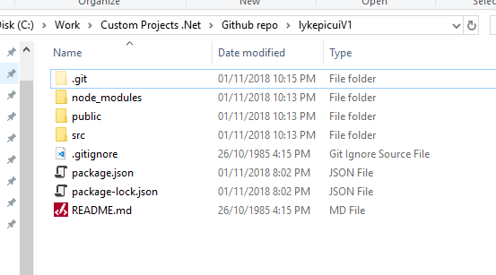

Build

* Open cmd/powershell/terminal
* Navigate to the location
* Run the command “npm install”

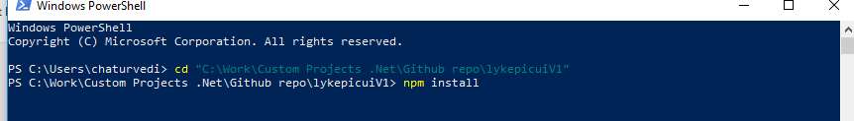

* Now node will install all the dependencies automatically
* After successful installation
* Run the below command “npm run build”
* Output looks like below picture

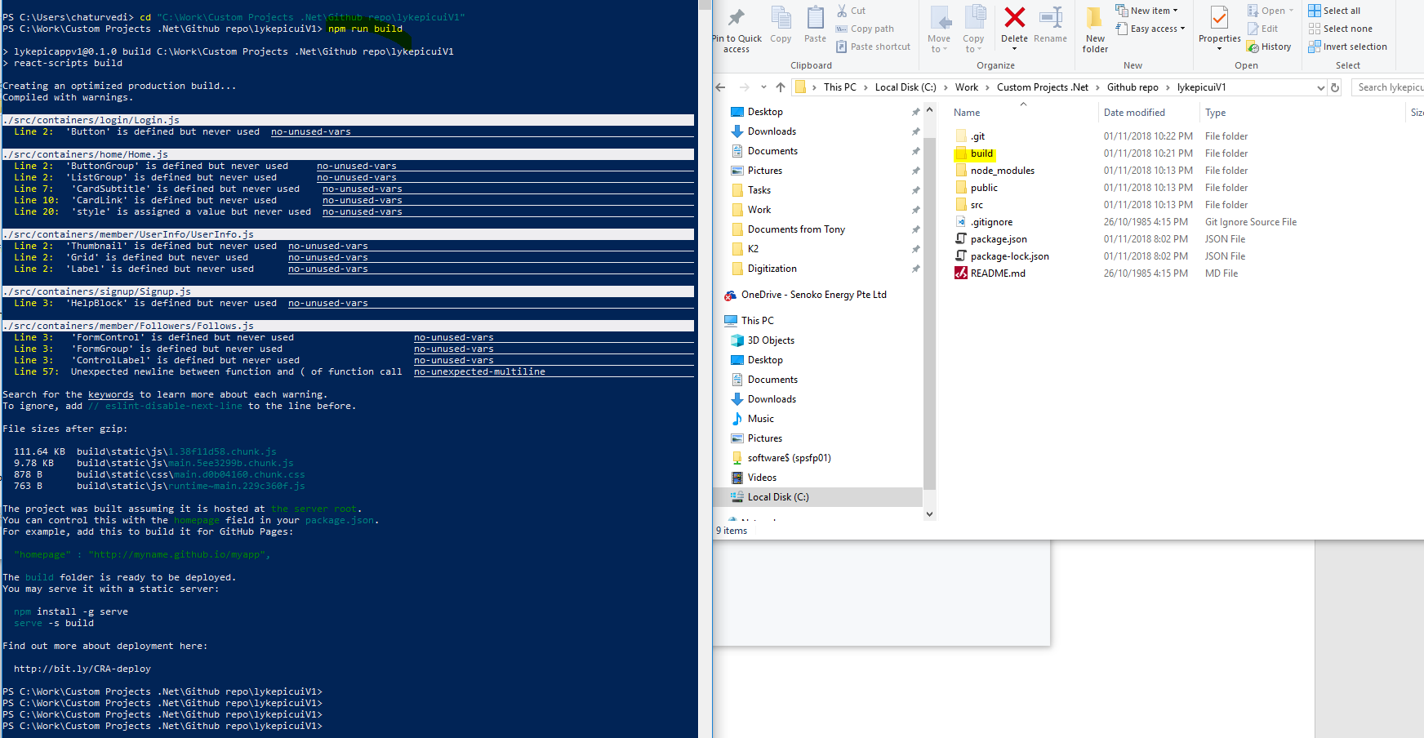

* A new folder will be created as show in the above picture “build”

This is the package to be deployed under any server as a regular html application

Update API Url

Before proceeding with build

Open file config.js , Under “lykepicuiV1\src\containers\”

Change the

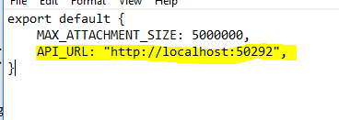

API_URL to the deployed API url.