Laboratory 11 Report

Book Title : Nibble Rabbit Makes More Friends

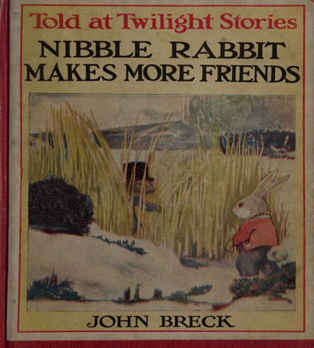

Book Author : John Breck  
  
  
Peter Bilolo Badibake

Ploting page

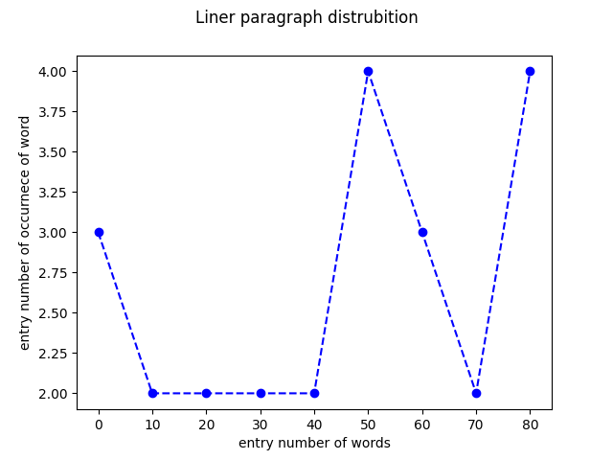

The dictionary storing sorted datais as follow  
0 0 0 10 10 20 20 30 30 40 40 50 50 50 50 60 60 60 70 70 80 80 80 80  
The minimum number of words is 0  
  
The maximum number of words is 80  
  
The average number of words is 40.0