Conditional Symbology Procedure (CSP) Diagrams

Contents
Contents 1
5 ECDIS Display Concept 2
13.2.1 Conditional Symbology Procedure CLRLIN01 3
13.2.2 Conditional Symbology Procedure DATCVR02 3
13.2.1 Conditional Symbology Procedure DEPARE03 4
13.2.2 Conditional Symbology Procedure DEPCNT03 10
13.2.3 Conditional Symbology Procedure DEPVAL02 13
13.2.6 Conditional Symbology Procedure LEGLIN03 16
13.2.4 Conditional Symbology Procedure LIGHTS06 17
13.2.6 Conditional Symbology Procedure OBSTRN07 26
13.2.7 Conditional Symbology Procedure QUAPOS01 39
13.2.8 Conditional Symbology Procedure QUALIN01 41
13.2.9 Conditional Symbology Procedure QUAPNT02 44
13.2.10 Conditional Symbology Procedure RESARE04 47
13.2.11 Conditional Symbology Procedure RESTRN01 60
13.2.12 Conditional Symbology Procedure RESCSP02 62
13.2.13 Conditional Symbology Procedure SAFCON01 69
13.2.14 Conditional Symbology Procedure SLCONS04 74
13.2.15 Conditional Symbology Procedure SEABED01 77
13.2.16 Conditional Symbology Procedure SNDFRM04 80
12.2.17 Conditional Symbology Procedure SOUNDG03 86
13.2.18 Conditional Symbology Procedure SYMINS02 88
13.2.19 Conditional Symbology Procedure TOPMAR01 90
13.2.20 Conditional Symbology Procedure UDWHAZ05 95
13.2.21 Conditional Symbology Procedure WRECKS05 102
Table of figures 112

5 ECDIS Display Concept
Figure 1 ECDIS Display Concept
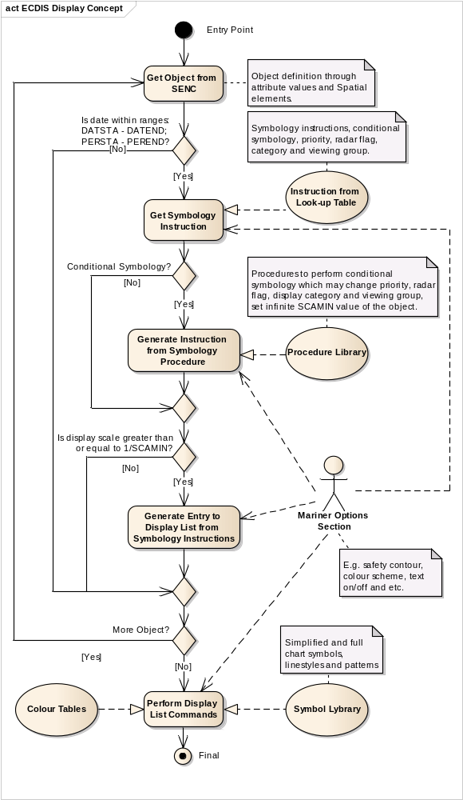
Entry Point | Clipped portion of ENC to be displayed on the ECDIS screen. Perform for each SENC object.
Get Object from SENC | Object definition through attribute values and Spatial elements.
Is date within ranges: DATSTA - DATEND; PERSTA - PEREND? | Is the current date of presentation within the range of existence of the object?  I.e. if there are values of the attributes' pairs DATSAT - DATEND or PERSTA - PEREND then the current date is more than Start date and less than End date of the existence period of the object.
Get Symbology Instruction | Get symbology instructions, conditional instructions, priority value, radar flag, display category and viewing group from the appropriate line of the Look-up table file.
Instruction from Look-up Table | Take the Look-up Table file according to geometry type of the object and mariner parameters ('simplify point', 'pattern area boundaries')
Conditional Symbology? | Does a Conditional Symbology Procedure exist?
Generate Instruction from Symbology Procedure | Execute the conditional symbology procedure to get Symbology Instructions with parameters of presentations.
Procedure Library | Procedures to perform conditional symbology which may change priority, radar flag, display category and viewing group, set infinite SCAMIN value of the object.
Is display scale greater than or equal to 1/SCAMIN? | Is the current display scale greater than or equal to 1/SCAMIN value from the object?
Generate Entry to Display List from Symbology Instructions | Add graphical primitives to the display list taking into account Presentation parameters (priority, radar flag, display category and viewing group)
More Object? | Are there more objects in the SENC? If it is, go to the next object.
Perform Display List Commands
Mariner Options Section | E.g. safety contour, colour scheme, text on/off and etc.
Symbol Lybrary | Simplified and full chart symbols, linestyles and patterns
Colour Tables | Colour tokens with XYL values for different palettes (Day, Dusk and Night palettes)
Final | Final presentation of the SENC

13.2.1 Conditional Symbology Procedure CLRLIN01

13.2.2 Conditional Symbology Procedure DATCVR02

13.2.1 Conditional Symbology Procedure DEPARE03

Applies to: S-57 Object Class "depth area" (DEPARE)
S-57 Object Class "dredged area" (DRGARE)

Spatial Object(s): Area only.

Relation(s) used: Adjacency of DEPARE/DRGARE objects with group 1 objects.

Attribute(s) used: "depth range value 1" (DRVAL1); "depth range value 2" (DRVAL2)

Defaults: Display Priority given by look-up table
OVERRADAR priority given by look-up table
Display Category given by look-up table
Viewing Group given by look-up table

Required ECDIS SAFETY_CONTOUR. The manufacturer is responsible for setting the SAFETY_CONTOUR to startup value 30 metres. This value should stay in operation until the mariner decides to select another safety contour.

Remarks: An object of the class "depth area" is coloured and covered with fill patterns according to the mariners selections of shallow contour, safety contour and deep contour. This requires a decision making process provided by the sub-procedure "SEABED01" which is called by this symbology procedure. Objects of the class "dredged area" are handled by this routine as well to ensure a consistent symbolization of all areas that represent the surface of the seabed.

The safety contour will be constructed using the edges of the DEPARE and DRGARE objects. The safety contour may be labeled at the request of the mariner using sub-procedure “SAFCON01”.

Based on the safety contour value entered by the mariner (see IMO PS [2]), the edges that make up the safety contour must be shown under all circumstances. But, while the mariner is free to enter any safety contour depth value that he thinks is suitable for the safety of his ship, the SENC only contains a limited choice of depth contours. This symbology procedure examines each edge of the DEPARE/DRGARE object to see if it falls between safe and unsafe water. If it does, that edge will represent the safety contour selected, or the next deeper contour if the selected contour is not available. It is highlighted as the safety contour and put in DISPLAYBASE. Note that this procedure will also detect the need for a safety contour at the edge of non-navigable rivers, canals or docks which must have a LNDARE or UNSARE under them, (UOC 4.6.6.3, 4.6.6.5, 4.7.6, 4.7.8 and 4.8.1 remarks 2 etc), as well as at another DEPARE/DRGARE edge.
The procedure also checks whether the edge has a ‘QUAPOS’ value indicating unreliable positioning, and if so symbolizes it with a double dashed line.

Figure 2 DEPARE03 conditional symbology procedure
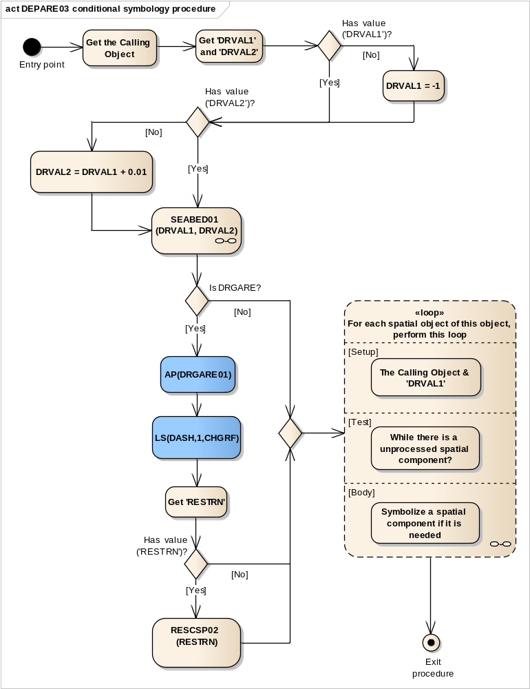
Entry point | Entry to the symbology procedure.
Get the Calling Object | Get the object which is calling this procedure.  DEPARE or DRGARE Areas
Get 'DRVAL1' and 'DRVAL2' | Get the value of the attributes:  'Depth range value 1' (DRVAL1)  'Depth range value 2' (DRVAL2)  and assign local variables 'DRVAL1' and 'DRVAL2' accordingly.
Has value ('DRVAL1')? | Is the value of the attribute 'DRVAL1' given?
DRVAL1 = -1 | Assign local variable 'DRVAL1' =-1 m.  This is above low water line as fail safe to ensure the default colour is 'DEPIT' (intertidal area)
Has value ('DRVAL2')? | Is the value of the attribute 'DRVAL2' given?
SEABED01 (DRVAL1, DRVAL2) | Perform the symbology sub-procedure to symbolize this area object , see “13.2.20 Conditional Symbology Procedure SEABED01
DRVAL1 | - input parameter - value of the local variable pass from the main procedure
DRVAL2 | - input parameter - value of the local variable pass from the main procedure
DRVAL2 = DRVAL1 + 0.01 | Assign local variable DRVAL2 = DRVAL1 + 0.01 m.
Is DRGARE? | Is the calling object of the class DRGARE?
AP(DRGARE01) | Draw the area pattern 'DRGARE01' from the symbol library and show it on top of the area's colour fill.
LS(DASH,1,CHGRF) | Symbolize the boundary with a dashed line, 1 unit wide colour 'CHGRF'
Get 'RESTRN' | Get the value of the attribute 'Restriction' (RESTRN).
Has value ('RESTRN')? | Is the value of the attribute 'RESTRN' given?
RESCSP02 (RESTRN) | Perform the symbology sub-procedure to complete the symbolization of 'DRGARE', see '13.2.12 Conditional Symbology Procedure RESCSP02'.
RESTRN value | - input value
Loop for each spatial object of this object, perform this loop | DEPARE03 CONTINUATION A and B  Setup - the Calling Object and 'DRVAL1' value  Test - while there is a unprocessed spatial component.  Body - to symbolize a spatial component if it is needed.
Exit procedure | Symbolization is finished

Figure 3 DEPARE03 Continuations A and B
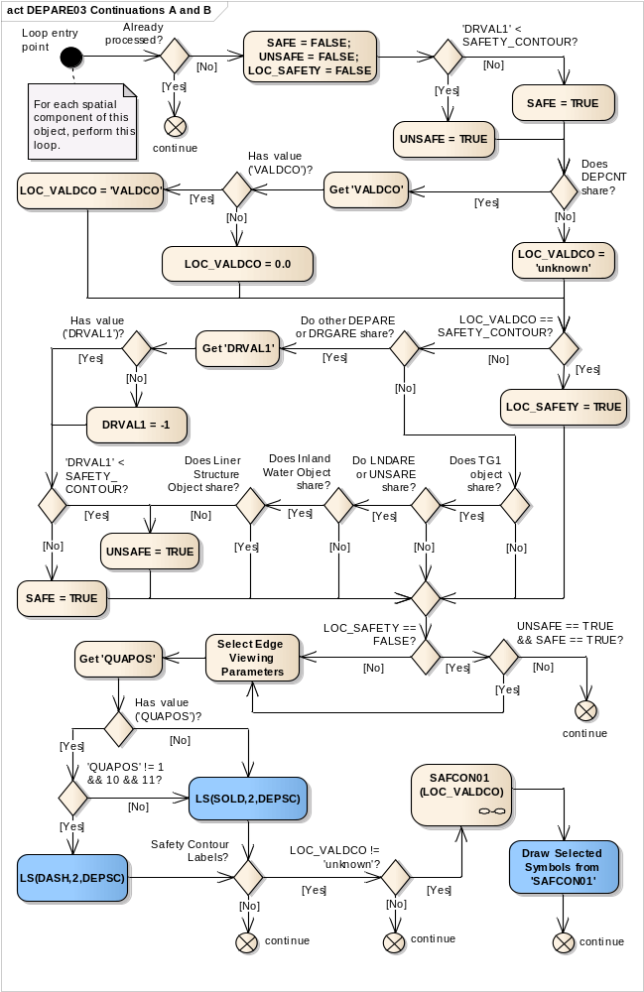

Loop entry point | For each spatial component of this object, perform this loop.
Already processed? | In order to make this algorithm efficient, the manufacturer should keep track of which spatial objects have already been processed to eliminate the need for testing lines more than once.
continue | Go to the next spatial component
SAFE = FALSE; UNSAFE = FALSE; LOC_SAFETY = FALSE | set local SAFE to the default (FALSE)  set local UNSAFE to the default (FALSE)  set local LOC_SAFETY to the default (FALSE)
'DRVAL1' < SAFETY_CONTOUR? | Is the attribute 'DRVAL1' value of the calling object is less SAFETY_CONTOUR?
UNSAFE = TRUE | Set the local variable 'UNSAFE' as TRUE.
SAFE = TRUE | Set the local variable 'SAFE' as TRUE.
Does DEPCNT share? | Is the spatial component shared by a 'DEPCNT' (Depth contour) object?
Get 'VALDCO' | Get the value of the attribute "Value of depth contour" (VALDCO) from the object DEPCNT coincided with the spatial component.
Has value ('VALDCO')? | Is the value of the attribute 'VALDCO' given?
LOC_VALDCO = 'VALDCO' | Set the local variable LOC_VALDCO equal to 'VALDCO' value.
LOC_VALDCO = 0.0 | Set the local variable LOC_VALDCO equal to 0.0 m.
LOC_VALDCO = 'unknown' | Set the local variable LOC_VALDCO equal to 'unknown' value
LOC_VALDCO == SAFETY_CONTOUR? | Is LOC_VALDCO equal to the value of the safety contour?
LOC_SAFETY = TRUE | We are certain the edge belongs to the safety contour.  Set local variable 'LOC_SAFETY' to TRUE
Do other DEPARE or DRGARE share? | Is the spatial object shared by other DEPARE (DRGARE) object?
Get 'DRVAL1' | Get the value of the attribute "Depth range value 1" (DRVAL1) from the object DEPARE or DRGARE sharing the checked spatial object.
Has value ('DRVAL1')? | Is the value of the attribute 'DRVAL1' given in the object DEPARE(DRGARE) coincided with the spatial component?
DRVAL1 = -1 | Set the local variable DRVAL1 as -1.
'DRVAL1' < SAFETY_ CONTOUR? | Is the value DRVAL1 less the value of the safety contour?
UNSAFE = TRUE | Set the local variable 'UNSAFE' as TRUE.
SAFE = TRUE | Set the local variable 'SAFE' as TRUE.
Does TG1 object share? | Is the spatial object shared by another Group1 object?
Do LNDARE or UNSARE share? | Is the other Group1 object a LNDARE or an UNSARE?
Does Inland Water Object share? | Is the spatial object shared by a RIVERS, LAKARE, CANALS, LOKBSN or DOCARE object?
Does Liner Structure Object share? | Is the spatial object shared by at least one of the linear objects:  - LNDARE, GATCON or DAMCON  - SLCONS or CUSWAY with WATLEV=1, 2, 6 or empty.
LOC_SAFETY == FALSE? | Is the variable LOC_SAFETY equal to FALSE?
UNSAFE == TRUE && SAFE == TRUE? | Are the values of the local variables 'UNSAFE' and 'SAFE' equal to TRUE?
continue | If ‘No’, go to the next spatial component.
Select Edge Viewing Parameters | Make sure the contour is shown at all scales (Attribute 'SCAMIN' equals 'infinite') Include this edge in the category:
Select Edge Viewing Parameters | Display Priority | 8
Select Edge Viewing Parameters | Radar Flag | OVERRADAR
Select Edge Viewing Parameters | Display Group | Displaybase
Select Edge Viewing Parameters | Viewing Group | 13010
Get 'QUAPOS' | Get the value of the attribute 'QUAPOS' of the current spatial component
Has value ('QUAPOS')? | Is the value of the attribute 'QUAPOS' given?
LS(SOLD,2,DEPSC) | Symbolize the line object with a solid line 2 units wide, colour 'DEPSC'
'QUAPOS' != 1 && 10 && 11? | Does the value of attribute 'QUAPOS' equal to neither of the following values: '1', '10', and '11'?
LS(DASH,2,DEPSC) | Symbolize the line object with a dashed line (2 units wide, colour 'DEPSC')
Safety Contour Labels? | Has the mariner chosen to display Safety Contour Labels by used of selection of viewing group 33021?
continue | If ‘No’, go to the next spatial component
LOC_VALDCO != 'unknown'? | Is the local variable 'LOC_VALDCO' set?
continue | IF ‘No’, go to the next spatial component
SAFCON01 (LOC_VALDCO) | Perform the symbology sub-procedure to symbolize the safety contour label, see '13.2.13 Conditional Symbology Procedure'
LOC_VALDCO | input parameter
List of Selected Symbols | output parameter
Draw Selected Symbols from 'SAFCON01' | Draw the symbols that were returned by 'SAFCON01' at the centre of the run-length of the line.  Symbols must be displayed upright with respect to the screen borders and not aligned along the contour.
continue | Go to the next spatial component

13.2.2 Conditional Symbology Procedure DEPCNT03

Applies to: S-57 Object Class "depth contour" (DEPCNT)

Spatial Object(s): Line

Attribute(s) used: "value of depth contour" (VALDCO)

Parameter(s): Object to be symbolized from SENC

Output Defaults: Display Priority given by look-up table,
OVERRADAR priority given by look-up table,
Display Category given by look-up table,
Viewing Group given by look-up table

Remarks: This procedure symbolizes contours, identifies any line segment of the spatial object that has a 'QUAPOS' value indicating unreliable positioning and symbolizes it with a dashed line, and labels the value of the contour on demand by the Mariner.
The contour may be labelled at the request of the Mariner using sub-procedure “SAFCON01”.
Spatial Component line definition

Figure 4 DEPCNT03 conditional symbology procedure
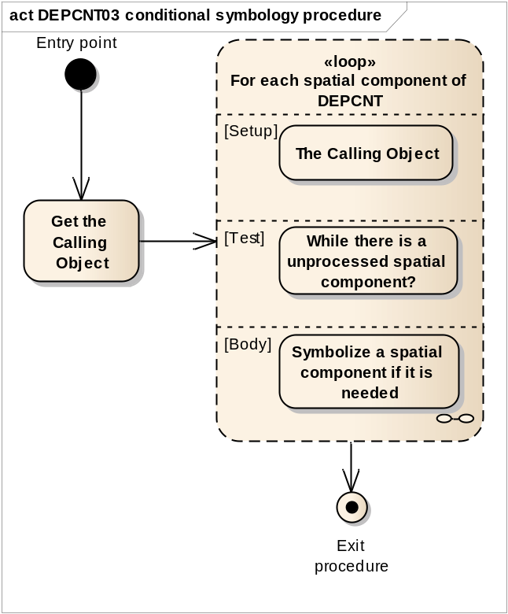
Entry point | Entry to the symbology procedure.
Get the Calling Object | Get the object which is calling this procedure.
Loop for each spatial component of DEPCNT | For each spatial component of the object, perform this loop:  Setup - the Calling Object  Test - while there is a unprocessed spatial component.  Body - to symbolize a spatial component if it is needed.
Exit procedure | Symbolization is complete

Figure 5 Loop for each spatial component of DEPCNT
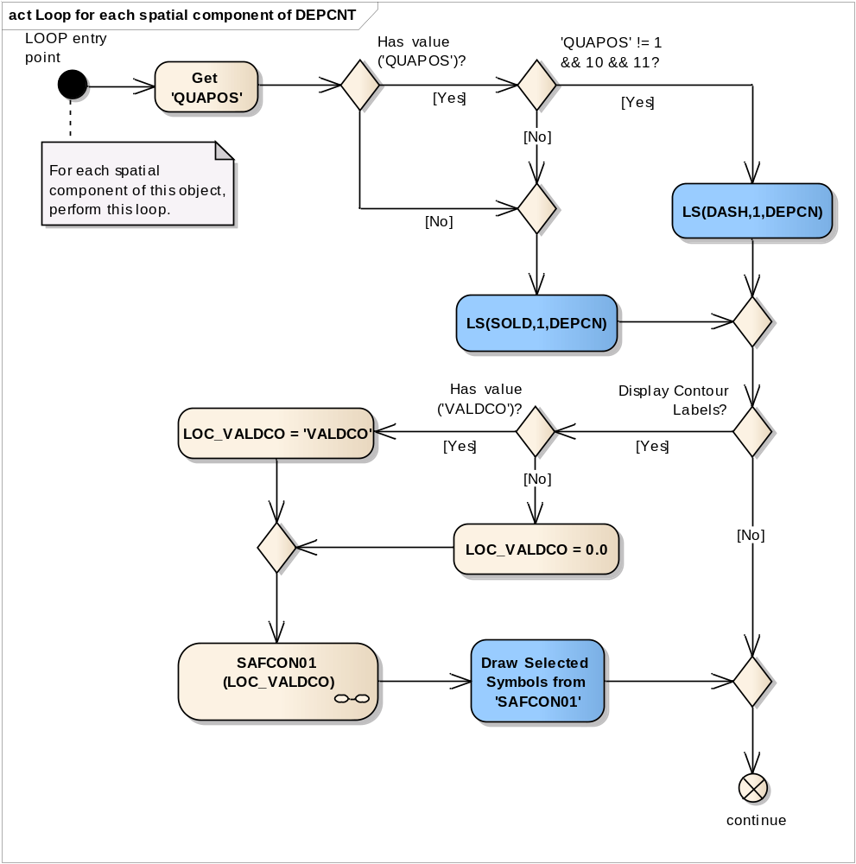
LOOP entry point | For each spatial component of this object, perform this loop.
Get 'QUAPOS' | Get the value of the Attribute 'QUAPOS' of the current spatial component
Has value ('QUAPOS')? | Is the value of the attribute 'QUAPOS' given?
'QUAPOS' != 1 && 10 && 11? | Does the value of attribute 'QUAPOS' equal to neither of the following values: '1', '10', and '11'?
LS(DASH,1,DEPCN) | Symbolize the line with a dashed line, 1 unit wide, colour 'DEPCN'.
LS(SOLD,1,DEPCN) | Symbolize the line with a solid line, 1 unit wide, colour 'DEPCN'.
Display Contour Labels? | Has the mariner chosen to display contour labels by used of selection of viewing group 33022?
Has value ('VALDCO')? | Is the value of the attribute 'VALDCO' given?
LOC_VALDCO = 'VALDCO' | Set the local variable 'LOC_VALDCO' equal to 'VALDCO' value.
LOC_VALDCO = 0.0 | Set the local variable LOC_VALDCO equal to 0.0 m.
SAFCON01 (LOC_VALDCO) | Perform the symbology procedure 'SAFCON01' to symbolize the contour label. Pass the value of local variable 'LOC_VALDCO' to 'SAFCON01'. A list of symbols is returned.
LOC_VALDCO | - input parameter
List of Symbols | - output parameter
Draw Selected Symbols from 'SAFCON01' | Draw the symbols that were returned by 'SAFCON01' at the centre of the run-length of the line.  Symbols must be displayed upright with respect to the screen borders and not aligned along the contour.
continue | Go to the next spatial component.

13.2.3 Conditional Symbology Procedure DEPVAL02

Note that this is a sub-procedure called by procedures OBSTRNnn and WRECKSnn
Applies to: OBSTRN, UWTROC, WRECKS objects called the main procedures OBSTRNnn and WRECKSnn

Spatial Object(s): Point, line, area

Relation(s) used: Common parts of overlapping area objects

Attribute(s) used: "depth range value" DRVAL1;
"water level" (WATLEV);
"exposure of sounding" (EXPSOU)

Parameter(s): Object to be symbolized from SENC. Any overlapped DEPARE or UNSARE objects
The procedure returns local variables 'LEAST_DEPTH' and 'SEABED_DEPTH'.

Defaults: Return to main program for defaults

Remarks: If the value of the attribute VALSOU for a wreck, rock or obstruction is missing/unknown, CSP DEPVAL will establish a default 'LEAST DEPTH' from the attribute DRVAL1 of the underlying depth area, and pass it to conditional procedures OBSTRN and WRECKS. However this procedure is not valid if the value of EXPSOU for the object is 2 (object is shoaler than the DRVAL1 of the surrounding depth area), or is unknown. It is also not valid if the value of WATLEV for the object is other than 3 (object is always underwater). In either of these cases the default procedures in conditional procedures OBSTRN and WRECKS are used.
Figure 6 DEPVAL02 conditional symbology sub-procedure
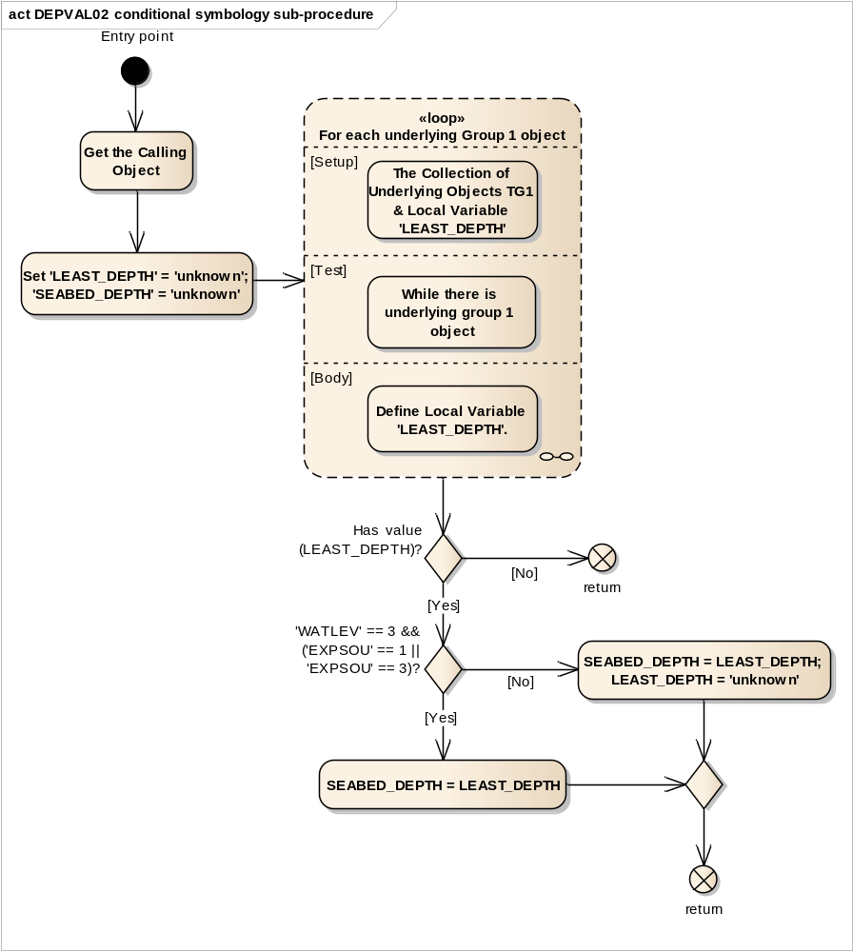
Entry point | Entry to the symbology sub-procedure with values of the attributes WATLEV and EXPSOU passed from the calling procedures.
Get the Calling Object | Get the object which is calling this procedure.
Set 'LEAST_DEPTH' = 'unknown'; 'SEABED_DEPTH' = 'unknown' | Set the local variable 'LEAST_DEPTH' equal to 'unknown'.  Set the local variable 'SEABED_DEPTH' equal to 'unknown'.
Loop for each underlying Group 1 object | For each underlying group 1 object which is wholly or partially covered by the calling object, perform this loop to establish a default value for the local variable 'LEAST_DEPTH'.  Setup - The collection of underlying objects TG1 and the local variable 'LEAST_DEPTH';  Test - While there is underlying group 1 object;  Body - Define Local Variable 'LEAST_DEPTH'.
Has value (LEAST_DEPTH)? | Does the local variable 'LEAST_DEPTH" have a value?
return | If ‘No’, return to the calling procedure with the value of the Local variables 'LEAST_DEPTH' and 'SEABED_DEPTH'
'WATLEV' == 3 && ('EXPSOU' == 1 || 'EXPSOU' == 3)? | Is the attribute value for 'WATLEV' equal to 3 (underwater) and is the attribute value for 'EXPSOU' equal to '1' (within the range of depth of the surrounding depth area) or '3' (deeper than the range of depth of the surrounding depth area)?
SEABED_DEPTH = LEAST_DEPTH; LEAST_DEPTH = 'unknown' | Set the local variable 'SEABED_DEPTH' equal to 'LEAST_DEPTH' value  Set the local variable 'LEAST_DEPTH' equal to 'unknown'
SEABED_DEPTH = LEAST_DEPTH | Set the local variable 'SEABED_DEPTH' equal to 'LEAST_DEPTH' value.
return | Return to the calling procedure with the value of the Local variables 'LEAST_DEPTH' and 'SEABED_DEPTH'

Figure 7 Loop for each underlying group 1 object
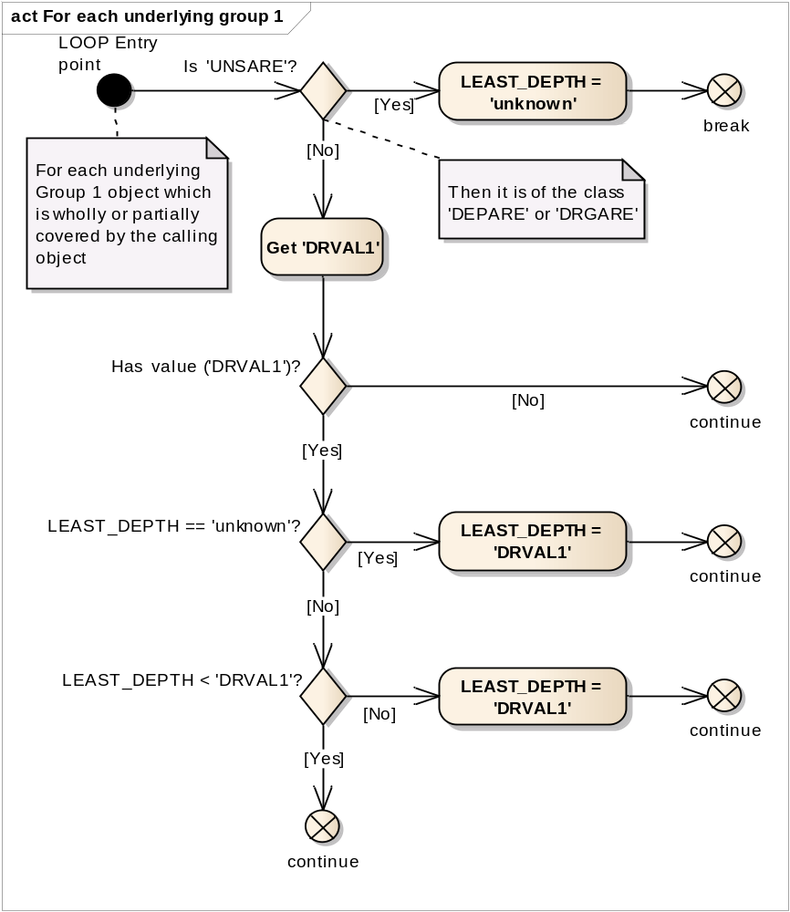
LOOP Entry point | For each underlying Group 1 object
Is 'UNSARE'? | Is the underlying group 1 object of the class 'UNSARE' (unsurveyed area)?
LEAST_DEPTH = 'unknown' | Set the local variable 'LEAST_DEPTH' equal to 'unknown' value.
break | Exit loop.
DRVAL1 missing or unknown? | Is the value of the underlying object's attribute 'DRVAL1' missing or unknown?
Get 'DRVAL1' | Get the value of the attribute "Depth range value 1" (DRVAL1) of the underlying object?
Has value ('DRVAL1')? | Is the value of the attribute 'DRVAL1' given in the underlying object DEPARE(DRGARE)?
continue | If ‘No’, go to the next found Group 1 object.
LEAST_DEPTH == 'unknown'? | Is the value of the local variable 'LEAST_DEPTH' unknown?
continue | go to the next found Group 1 object.
LEAST_DEPTH = 'DRVAL1' | Set the value of the local variable 'LEAST_DEPTH' equal to 'DRVAL1'.
LEAST_DEPTH < 'DRVAL1'? | Is the value of the local variable 'LEAST_DEPTH' less than the value of 'DRVAL1'?
continue | go to the next found Group 1 object.
LEAST_DEPTH = 'DRVAL1' | Set the value of the local variable 'LEAST_DEPTH' equal to 'DRVAL1'
continue | go to the next found Group 1 object.

13.2.6 Conditional Symbology Procedure LEGLIN03

13.2.4 Conditional Symbology Procedure LIGHTS06

Light flares, light sectors & light coverage (S-57)
Applies to: S-57 Object Class "light" (LIGHTS)
Spatial Object(s): Point
Spatial Relation(s): Point objects at identical location
Attribute(s) used: "colour" (COLOUR); "category of light" (CATLIT); "sector 1" (SECTR1); "sector 2" (SECTR2); «orientation» (ORIENT) "visibility of light" (LITVIS); "value of nominal range" (VALNMR)
Parameter(s): Object to be symbolized from SENC
User parameters: Show full length leg lines.
Defaults: Display Priority given by look-up table;
OVERRADAR priority given by look-up table;
Display Category given by look-up table;
Viewing Group given by look-up table
Remarks: A light is one of the most complex S-57 objects. Presentation depends on whether it is a light on a floating or fixed platform, range, colour etc. This conditional symbology procedure derives the correct presentation from these parameters and also generates an area that shows the coverage of the light.
Notes on light sectors:
- The radial leg-lines defining the light sectors are normally drawn to only 25mm from the light to avoid clutter (see continuation B). However, the mariner should be able to select «full light-sector lines» and have the leg-lines extended to the nominal range of the light (VALMAR).
- Continuation of this procedure symbolizes the sectors at the light itself. In addition, it should be possible, upon request, for the mariner to be capable of identifying the colour and sector limit lines of the sectors affecting the ship even if the light itself is off the display.
Further note: The sub-procedure LITDSN02, which generates the light description text-string, is provided as a descriptive narrative.
Figure 8 LIGHTS06 conditional symbology procedure
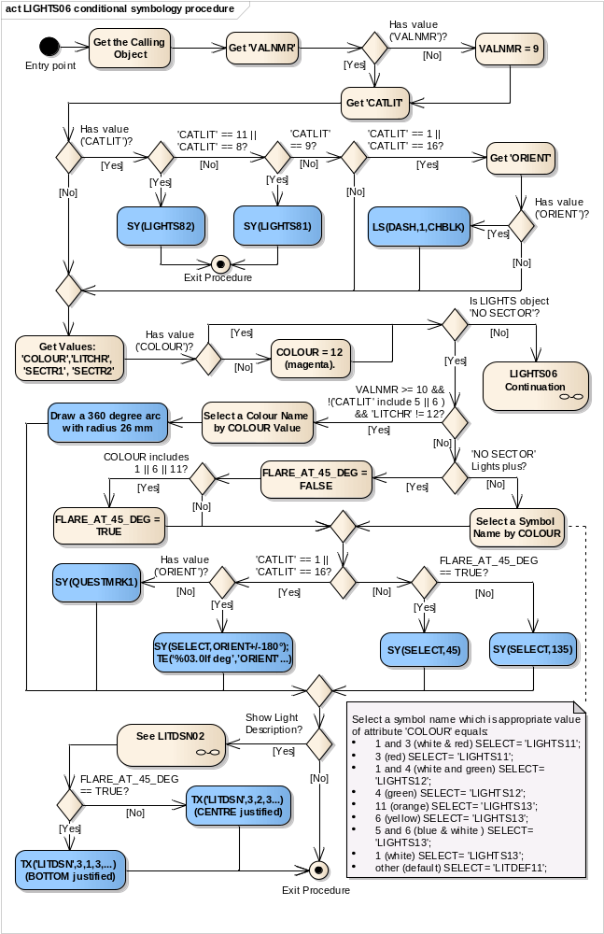
Entry point | Entry to the symbology procedure.
Get the Calling Object | Get the object which is calling this procedure.
Get 'VALNMR' | Get the value of the attribute 'Value of nominal range' (VALNMR).
Has value ('VALNMR')? | Is the value of the attribute 'VALNMR' given?
VALNMR = 9 | Set local variable 'VALNMR' equal to 9 M
Get 'CATLIT' | Get the value of the attribute 'Category of light' (CATLIT).
Has value ('CATLIT')? | Is the value of the attribute 'CATLIT' given?
'CATLIT' == 11 || 'CATLIT' == 8? | Does the value of the attribute 'CATLIT' equal to 8 (floodlight) or 11 (spotlight)?
SY(LIGHTS82) | Draw symbol 'LIGHTS82' at the calling object's location.
'CATLIT' == 9? | Does the value of the attribute 'CATLIT' equal 9 (strip light)?
SY(LIGHTS81) | Draw symbol 'LIGHTS81' at the calling object's location.
Exit Procedure | Symbolization is finished
'CATLIT' == 1 || 'CATLIT' == 16? | Does the value of the attribute 'CATLIT' equal 1 (directional) or 16 (moire effect)?
Get 'ORIENT' | Get the value of the attribute 'Orientation' (ORIENT).
Has value ('ORIENT')? | Is the value of the attribute 'ORIENT' given?
LS(DASH,1,CHBLK) | Draw the direction marked by the light as defined by the attribute 'ORIENT'.  Remember that this is the bearing from seaward. It means the start point is at sea and the end point is at the calling object's location.  Draw a line equal in length to the value of attribute 'VALNMR'.  Symbolize as follows:  'LS(DASH, 1, CHBLK)'
Get Values: 'COLOUR','LITCHR', 'SECTR1', 'SECTR2' | Get the values of the following attributes used for next analyzing:  - 'Colour' (COLOUR);  - 'Sector limit one' (SECTR1);  - 'Sector limit two' (SECTR2);  - 'Light characteristic' (LITCHR).
Has value ('COLOUR')? | Is the value of the attribute 'COLOUR' given?
COLOUR = 12 (magenta). | Assume the value of the 'COLOUR' is '12' (magenta)
Is LIGHTS object 'NO SECTOR'? | Is the attributes 'SECTR1' (sector limit one) or 'SECTR2' (sector limit two) values absent, or does their difference equal zero degrees, or do they equal to 0.00 and 360.00 correspondingly in the object which is calling this procedure?
LIGHTS06 Continuation | If ‘No’, go to ‘LIGHTS06 Continuation’. It describes the sector lights showing its line legs and arcs.  Input values of the attributes 'SECTR1', 'SECTR2', 'COLOUR' of the calling object and local variable 'VALNMR'. See Figure 9 ‘LIGHTS06 Continuation’
VALNMR >= 10 && !('CATLIT' include 5 || 6 ) && 'LITCHR' != 12? | Check whether this is a major light:  Is the value of 'VALNMR' greater or equal to 10 nautical miles? AND  Does the value of 'CATLIT' not include '5' (aero light) or 6 (air obstruction light)? AND  Does the value of 'LITCHR' not equal '12' (morse)?
Select a Colour Name by COLOUR Value | Select a colour name which is appropriate value of attribute 'COLOUR' equals:
 | 1 and 3 (white & red) | SELECT= 'LITRD';
 | 3 (red) | SELECT ='LITRD';
 | 1 and 4 (white and green) | SELECT ='LITGN';
 | 4 (green) | SELECT ='LITGN';
 | 11 (orange) | SELECT ='LITYW';
 | 6 (yellow) | SELECT ='LITYW';
 | 5 and 6 (blue & yellow) | SELECT ='LITYW';
 | 1 (white) | SELECT ='LITYW';
 | other (default) | SELECT ='CHMGD';
Draw a 360 degree arc with radius 26 mm | First symbolize a 360 degree arc with a solid line,  4 units wide, COLOUR OUTLW;  then symbolize a 360 degree arc with a solid line,  2 units wide, COLOUR as selected above.  The center of the arc is the calling object location.  The radius of the arc on the display is 26 mm.
'NO SECTOR' Lights plus? | Is there any 'No Sector' lights located at the same point as the calling object?
FLARE_AT_45_DEG = FALSE | Set the local variable 'FLARE AT 45 DEGREES' to 'FALSE'
COLOUR includes 1 || 6 || 11? | Does the calling object COLOUR include 1 (white) or 6 (yellow) or 11 (orange)?
FLARE_AT_45_DEG = TRUE | Set local variable 'FLARE AT 45 DEGREES' to 'TRUE'
Select a Symbol Name by COLOUR | Select a symbol name which is appropriate value of attribute 'COLOUR' equals:
 | 1 and 3 (white & red) | SELECT= 'LIGHTS11';
 | 3 (red) | SELECT= 'LIGHTS11';
 | 1 and 4 (white and green) | SELECT= 'LIGHTS12';
 | 4 (green) | SELECT= 'LIGHTS12';
 | 11 (orange) | SELECT= 'LIGHTS13';
 | 6 (yellow) | SELECT= 'LIGHTS13';
 | 1 (white) | SELECT= 'LIGHTS13';
 | 5 and 6 (blue & yellow) | SELECT= 'LIGHTS13';
 | other (default) | SELECT= 'LITDEF11';
'CATLIT' == 1 || 'CATLIT' == 16? | Does the value of the attribute 'CATLIT' equal to '1' (directional) or '16' (moire)?
Has value ('ORIENT')? | Is the value of the attribute 'ORIENT' given?
SY(SELECT,ORIENT+/-180°); TE(‘%03.0lf deg’,’ORIENT’...) | Draw the selected symbol at the calling object's location rotated in the direction as defined by the attribute 'ORIENT' +/- 180° (ORIENT is direction from seaward), and write the direction from seaward at the light as follows:  "TE(‘%03.0lf deg’,’ORIENT’, 3,3,3, '15110', 3,1, CHELK, 23)"
SY(QUESTMRK1) | Draw the symbol 'QUESTMRK1' at the calling object's location
FLARE_AT_45_DEG == TRUE? | Is 'FLARE AT 45 DEGREES' set to TRUE?
SY(SELECT,45) | Draw the selected symbol with a rotation of 45 degrees from upright at the position where the object which was calling the procedure is located.
SY(SELECT,135) | Draw the selected symbol with a rotation of 135 degrees from upright at the position where the object which was calling the procedure is located.
Show Light Description? | Have the mariner selected viewing of light descriptions? (text group 23).
See LITDSN02 | Pass on to this procedure the attributes:  'CATLIT', 'LITCHR', 'SIGGRP', 'COLOUR', 'SIGPER', 'HEIGHT', 'VALNMR', 'STATUS'.  This procedure constructs a text string for the light description. This string is returned as the argument 'LITDSN'.  Note: previous version of the presentation library provided c-code that enabled the building of light description text strings for presentation on the ECDIS chart display. Version 4 of the presentation library has now removed the c-code and textual description of how light description should be constructed is provided
FLARE_AT_45_DEG == TRUE? | Is 'FLARE AT 45 DEGREES' set to TRUE?
TX('LITDSN',3,1,3,...) (BOTTOM justified) | Write the returned text string 'LITDSN" as follows:  TX('LITDSN', 3,1,3, '15110', 2,-1, CHBLK, 23)
TX('LITDSN',3,2,3...) (CENTRE justified) | Write the returned text string 'LITDSN" as follows:  TX('LITDSN', 3,2,3, '15110', 2,0, CHBLK, 23)
Exit Procedure | Symbolization is finished

Figure 9 LIGHTS06 Continuation describes the sector lights showing its line legs and arcs.
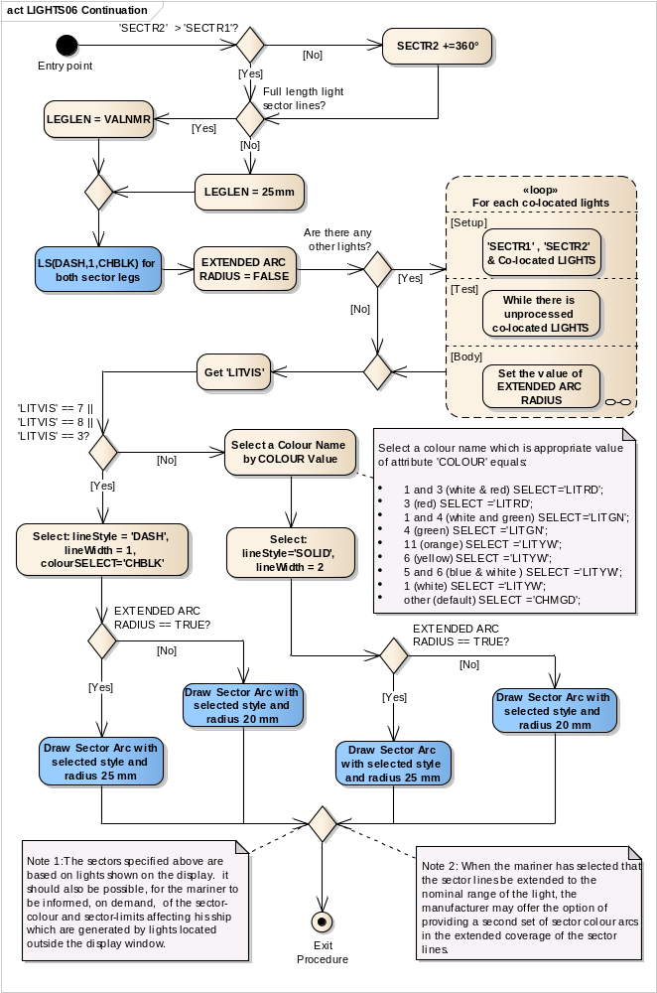
Entry point | Entry to the continuation of symbology procedure LIGHTS06.
'SECTR2' > 'SECTR1'? | The value 'SECTR2' greater than the value of 'SECTR1'?
SECTR2 +=360° | Add 360 degrees to the local value of 'SECTR2'.
Full length light sector lines? | Has the mariner selected full length light sector lines?
LEGLEN = VALNMR | Set local variable 'LEGLEN' equal to length (in mm) of 'VALNMR' value in the scale of ECDIS display.
LEGLEN = 25mm | Set the local variable 'LEGLEN' equal to 25mm in the scale of the ECDIS display.
LS(DASH,1,CHBLK) for both sector legs | Draw both sector legs by symbology instruction 'LS(DASH, 1, CHBLK)'.  Start the legs the position where the light object which was calling the procedure is located. Show the sector legs in the directions which are defined by 'SECTR1' and 'SECTR2'. Do not forget to reverse the sector values (+/- 180 degrees) since the values are given from seaward; Use LEGLEN from the step above.  (The LITDSN text string is not used for sector lights because it would cause clatter).
EXTENDED ARC RADIUS = FALSE | Set the value of local variable 'EXTENDED ARC RADIUS' to 'FALSE' by default
Are there any other lights? | Is there any other 'LIGHTS' object located at the same point as the calling objects?
Loop for each co-located lights | For each occurrence of the object class 'LIGHTS' which is co-located with the calling object perform this loop to detect and symbolize overlapping sectors with an extended arc radius for the smaller sector.  Setup - the input values are the values 'SECTR1' and 'SECTR2' of the calling object and the collection of the co-located LIGHTS object.  Test - While there is unprocessed co-located LIGHTS object,  Body - Set the output values is the local variable 'EXTENDED ARC RADIUS'. See Figure 10 Loop for co-located lights objects
Get 'LITVIS' | Get the value of the attribute "Light visibility" (LITVIS) from the calling object.
'LITVIS' == 7 ||'LITVIS' == 8 ||'LITVIS' == 3? | Does the value of the attribute 'LITVIS' (visibility of light) equal '7' (obscured) or '8' (partially obscured) or '3' (faint)?
Select: lineStyle ='DASH', lineWidth = 1, colourSELECT= 'CHBLK' | Select the simple dashed linestyle, 1 units wide, colour 'CHBLK'
EXTENDED ARC RADIUS == TRUE? | Is the local variable 'EXTENDED ARC RADIUS' equal to 'TRUE'
Draw Sector Arc with selected style and radius 25 mm | Draw the sector arc: colour, linestyle, line width as selected above. Radius on the display is 25mm.
Draw Sector Arc with selected style and radius 20 mm | Draw the sector arc: colour, linestyle, line width as selected above. Radius on the display is 20 mm.
Select a Colour Name by COLOUR Value | Select a colour name which is appropriate value of attribute 'COLOUR' equals:
 | 1 and 3 (white & red) | SELECT= 'LITRD';
 | 3 (red) | SELECT ='LITRD';
 | 1 and 4 (white and green) | SELECT ='LITGN';
 | 4 (green) | SELECT ='LITGN';
 | 11 (orange) | SELECT ='LITYW';
 | 6 (yellow) | SELECT ='LITYW';
 | 5 and 6 (blue & yellow) | SELECT ='LITYW';
 | 1 (white) | SELECT ='LITYW';
 | other (default) | SELECT ='CHMGD';
Select: lineStyle='SOLID', lineWidth = 2 | Select the simple solid linestyle, 2 units wide.
EXTENDED ARC RADIUS == TRUE? | Is the local variable 'EXTENDED ARC RADIUS' equal to 'TRUE'
Draw Sector Arc with selected style and radius 25 mm | First symbolize the Arc with a solid line,  4 units wide, COLOUR OUTLW;  then symbolize the Arc with the COLOUR, linestyle and linewidth selected above.  Radius on the display is 25mm.
Draw Sector Arc with selected style and radius 20 mm | First symbolize the Arc with a solid line,  4 units wide, COLOUR OUTLW;  then symbolize the Arc with the COLOUR, linestyle and linewidth selected above.  Radius on the display is 20mm.
Exit Procedure | Symbolization is finished

Figure 10 Loop for co-located lights objects
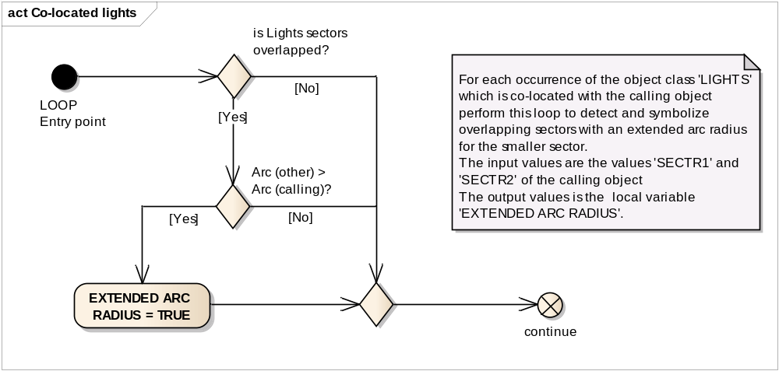
LOOP Entry point | For each occurrence of the object class 'LIGHTS' which is co-located with the calling object perform this loop
is Lights sectors overlapped? | Does the other 'LIGHTS' object overlap the sector of the calling object? ('SECTR1' and/or 'SECTR2' of the other 'LIGHTS' falls between 'SECTR1' and 'SECTR2' of the calling object) or ('SECTR1' and/or 'SECTR2' of the calling object falls between 'SECTR1' and 'SECTR2' of the other 'LIGHTS' object).
Arc (other) > Arc (calling)? | Is the ARC ('SECTR2' - 'SECTR1') of the other object larger that the sector ARC of the calling object?
EXTENDED ARC RADIUS = TRUE | Set local variable 'EXTENDED ARC RADIUS' to TRUE.
continue | Go to next co-located light object.

13.2.6 Conditional Symbology Procedure OBSTRN07

Applies to: S-57 Object Class "obstruction" (OBSTRN);
S-57 Object Class "under water rock" (UWTROC)

Spatial Object(s): Point, Line, Area.
Attribute(s) used: "value of sounding" (VALSOU);
"water level" (WATLEV);
"exposure of sounding" (EXPSOU);
Parameter(s): Object to be symbolized from SENC
Defaults: Display Priority given by look-up table; OVERRADAR priority by look-up table; Display Category given by look-up table; Viewing Group given by look-up table; Area Color fill from underlying ‘DEPARE’ or ‘UNSARE’;
Remarks: Obstructions or isolated underwater dangers of depths less than he safety contour which lie within the safe waters defined by the safety contour are to be presented by a specific isolated danger symbol and put in IMO category "DISPLAY BASE" (see IMO Performance Standard for ECDIS [2]). This task is performed by the most recent edition of sub-procedure UDWHAZnn which is called by this symbology procedure. Objects of the class "under water rock" are handled by this routine as well to ensure a consistent symbolization of isolated dangers on the seabed.
The current UDWHAZnn also allows the mariner the option of displaying isolated dangers in the waters between the safety contour and the zero metre line.
In the case that the value of attribute VALSOU for this object is unknown, the most recent edition of sub-procedure DEPVALnn is called. This will provide a default 'least_depth' from the DRVAL1 of the underlying depth area on condition that the value of attribute EXPSOU is not 2 (shoaler than the depth area), and the value of attribute WATLEV is 3 (always underwater).
Figure 11 OBSTRN07 conditional symbology procedure
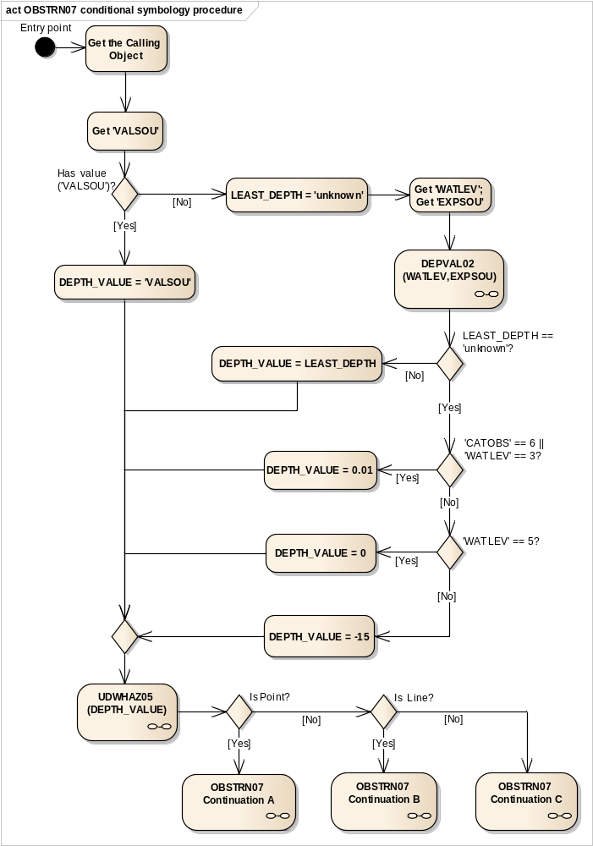
Entry point | Entry to the symbology procedure.
Get the Calling Object | Get the object which is calling this procedure.
Get 'VALSOU' | Get the value of the attribute 'Value of sounding' (VALSOU) of the calling object
Has value ('VALSOU')? | Is the value of the attribute 'VALSOU' given?
DEPTH_VALUE = 'VALSOU' | Set the local variable 'DEPTH_VALUE' equal to 'VALSOU'.  Set the viewing group to 34051.
LEAST_DEPTH = 'unknown' | Set the local variable 'LEAST_DEPTH' equal to 'unknown' value.
Get 'WATLEV';  Get 'EXPSOU' | Get the value of the attributes 'Water level effect' (WATLEV) and 'Exposition of sounding' (EXPSOU) of the calling object.
DEPVAL02 (WATLEV,EXPSOU) | Performs the symbology sub-procedure 'DEPVAL02' which returns a value for the local variables 'LEAST_DEPTH' and 'SEABED_DEPTH'.  Pass attributes 'WATLEV and EXPSOU' on to it  Note: 'SEABED_DEPTH' is returned from "DEPVAL02' but is not used by this procedure.
'WATLEV' | - input parameter
‘EXPSOU’ | - input parameter
'LEAST_DEPTH' | - output parameter
'SEABED_DEPTH' | - output parameter
LEAST_DEPTH == 'unknown'? | Is the value of the local variable 'LEAST_DEPTH' equal to ‘unknown’?
DEPTH_VALUE = LEAST_DEPTH | Set the local variable 'DEPTH_VALUE' equal to the local variable 'LEAST_DEPTH'.
'CATOBS' == 6 || 'WATLEV' == 3? | Is the value of 'CATOBS' equal to '6' OR 'WATLEV' equla to '3'?
DEPTH_VALUE = 0.01 | Set the local variable 'DEPTH_VALUE' = 0.01 m to a fail-safe depth based on the value of the attribute 'CATOBS'=6:
'WATLEV' == 5? | Is the value of 'WATLEV' equal to '5'?
DEPTH_VALUE = 0 | Set the local variable 'DEPTH_VALUE'=0 to a fail-safe depth based on the value of the attribute WATLEV'=5:
DEPTH_VALUE = -15 | Set the local variable 'DEPTH_VALUE' to a fail-safe depth based on the value of the attribute WATLEV' or by default  if 'WATLEV'=4 (covers and uncovers) OR 'WATLEV'=1 OR 'WATLEV'= 2 (always dry) OR 'WATLEV'=' ' (unknown or missing) then 'DEPTH_VALUE'=-15m else default
UDWHAZ05 (DEPTH_VALUE) | Performs the symbology sub-procedure 'UDWHAZ05' which returns a flag indicating whether or not to display the ISOLATED DANGER SYMBOL [IMO PS App.2 1.3] and the selected symbol.  Pass 'DEPTH_VALUE' on to it.  Return: - selected symbol name ‘ISODRG01’;  - parameters presentation: SCAMIN, DISPLAY MODE, PRIORITY, RADAR FLAG, VIEWING GROUP if they are changed.
DEPTH_VALUE | - input parameter
ISOLATED DANGER SYMBOL message | - output parameter
Is Point? | Is the calling object of type point?
OBSTRN07 Continuation A | Point objects, underwater rocks (UWTROC) and obstructions (OBSTRN)
Is Line? | Is the calling object of type line?
OBSTRN07 Continuation B | Geometry type is line.
OBSTRN07 Continuation C | Geometry type is area.
Figure 12 OBSTRN07 Continuation A. Points objects, underwater rocks (UWTROC) and obstruction (OBSTRN)
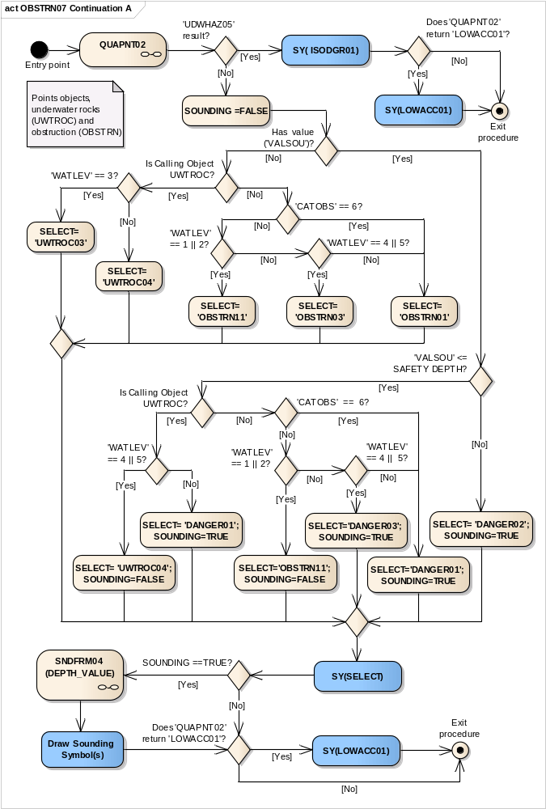
Entry point | Entry to the continuatopn A of symbology procedure with a point object: underwater rocks (UWTROC) or obstructions (OBSTRN)
QUAPNT02 | Performs the symbology sub-procedure 'QUAPNT02' which returns a flag indicating whether or not to display the LOW ACCURACY SYMBOL and returns the selected symbol name 'LOWACC01'. See Conditional Symbology Procedure QUAPNT02
'UDWHAZ05' result? | Has the procedure 'UDWHAZ05' indicated the Isolated danger symbol should be shown?
SY( ISODGR01) | Draw the 'ISODGR01' symbol with the set presentation parameters selected by 'UDWHAZ05' at the calling objects location
Does 'QUAPNT02' return 'LOWACC01'? | Is the symbol 'LOWACC01' selected by the procedure 'QUAPNT02'?
SY(LOWACC01) | If so indicated by the procedure 'QUAPNT02', draw the returned low accuracy symbol 'LOWACC01' with the set presentation parameters selected by 'UDWHAZ05' at the calling object's location.
Exit procedure | Symbolization is finished
SOUNDING =FALSE
Has value ('VALSOU')? | Is the value of the attribute 'VALSOU' given in the calling object?
Is Calling Object UWTROC? | Is the calling object of the class 'UWTROC'?
'WATLEV' == 3? | Is the value of the attribute 'WATLEV' equal to '3' given in the calling object?
SELECT= 'UWTROC03' | Select symbol name SELECT='UWTROC03'
SELECT= 'UWTROC04' | Select symbol name SELECT='UWTROC04' by default.
'CATOBS' == 6? | Calling object must be of the class 'OBSTRN'.  Is the value of the attribute 'CATOBS' equal to '6' given in the calling object?
SELECT= 'OBSTRN01' | Select symbol name SELECT='OBSTRN01', if 'CATOBS'=6 (foul area) OR WATLEV=no equal to 1,2,4 OR 5.
'WATLEV' == 4 || 5? | Is the value of the attribute 'WATLEV' equal to '4' or '5' given in the calling object?
SELECT= 'UWTROC04'; SOUNDING=FALSE | if 'WATLEV'=4 (covers and uncovers) OR 'WATLEV'=5 (awash)then select symbol name SELECT='UWTROC04' and set the local variable 'SOUNDING' equal to FALSE
SELECT= 'DANGER01'; SOUNDING=TRUE | If attribute 'WATLEV' has any value except 4 and 5, <unknown> or missed then select symbol name SELECT='DANGER01' and set the local variable 'SOUNDING' equal to TRUE
'CATOBS' == 6? | Calling object must be of the class 'OBSTRN'.  Is the value of the attribute 'CATOBS' equal to '6' given in the calling object?
'WATLEV' == 1 || 2? | Is the value of the attribute 'WATLEV' equal to '1' or '2' given in the calling object?
SELECT= 'OBSTRN11' | Select symbol name SELECT='OBSTRN11' if 'WATLEV'=1 (partially submerged of HW) or 2 (always dry).
'WATLEV' == 4 || 5? | Is the value of the attribute 'WATLEV' equal to '4' or '5' given in the calling object?
SELECT= 'OBSTRN03' | Select symbol name SELECT='OBSTRN03' if 'WATLEV'=4 (covers and uncovers) or 5 (awash).
'VALSOU' <= SAFETY DEPTH? | Is the value of the attribute 'VALSOU' less than or equal to SAFETY DEPTH?
SELECT= 'DANGER02'; SOUNDING=TRUE | Select symbol name SELECT='DANGER02' and set the local variable 'SOUNDING' equal to TRUE
Is Calling Object UWTROC? | Is the calling object of the class 'UWTROC'?
'WATLEV' == 1 || 2? | Is the value of the attribute 'WATLEV' equal to '1' or '2' given in the calling object?
SELECT='OBSTRN11'; SOUNDING=FALSE | Select symbol name SELECT='OBSTRN11' 'if 'WATLEV'=1 (partially submerged of HW) or 2 (always dry). Set the local variable 'SOUNDING' equal to FALSE
'WATLEV' == 4 || 5? | Is the value of the attribute 'WATLEV' equal to '4' or '5' given in the calling object?
SELECT='DANGER03'; SOUNDING=TRUE | Select symbol name SELECT='DANGER03' 'if 'WATLEV'=(covers and uncovers) or 5 (awash). Set the local variable 'SOUNDING' equal to TRUE
SELECT='DANGER01'; SOUNDING=TRUE | Select symbol name SELECT='DANGER01' and set the local variable 'SOUNDING' equal to TRUE if 'CATOBS' equal to '6' (foul area) or 'WATLEV' no equal to 1,2,4 OR 5.
SY(SELECT) | Draw the selected symbol at the calling object's location.
SOUNDING ==TRUE? | is the local variable 'SOUNDING' equal to TRUE
SNDFRM04 (DEPTH_VALUE) | Perform the symbology sub-procedure which returns a list of sounding symbols.  Pass 'DEPTH_VALUE' on to it.  Remember the SOUNDING SYMBOL(S)
DEPTH_VALUE | Input parameter
Sounding Symbols List | Output parameter
Draw Sounding Symbol(s) | Draw the sounding symbol(s) returned from 'SNDFRM04' at the calling object's location.
Does 'QUAPNT02' return 'LOWACC01'? | Is the symbol 'LOWACC01' selected by the procedure 'QUAPNT02'?
SY(LOWACC01) | If so indicated by the procedure 'QUAPNT02', draw the returned low accuracy symbol 'LOWACC01' at the calling object's location.
Exit procedure | Symbolization is finished

Figure 13 OBSTRN07 Continuation B Line objects, obstructions (OBSTRN)
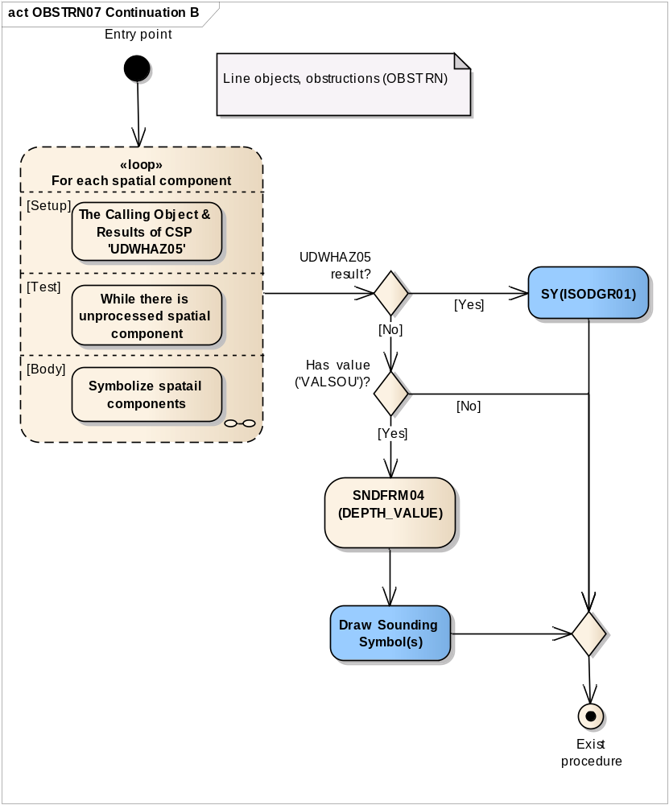
Entry point | Entry to the continuation of symbology procedure with a line object, obstructions (OBSTRN)
Loop for each spatial component | Setup - The Calling Object & Results of CSP 'UDWHAZ05'  Test - While there is unprocessed spatial component  Body - to symbolize a spatial component if it is needed.  See Figure 14 Loop for each spatial component of the object
UDWHAZ05 result? | Has the procedure 'UDWHAZ05' indicated the Isolated danger symbol should be shown?
SY(ISODGR01) | Draw isolated danger symbol 'ISODRG01' at the midpoint of the line with the set presentation parameters selected by 'UDWHAZ05' CSP
Has value ('VALSOU')? | Is the value of the attribute 'VALSOU' given?
SNDFRM04 (DEPTH_VALUE) | Perform the symbology sub-procedure which returns a list of sounding symbols.  Pass 'DEPTH_VALUE' on to it.  Remember the SOUNDING SYMBOL(S)
DEPTH_VALUE | Input parameter
Sounding Symbols List | Output parameter
Draw Sounding Symbol(s) | Draw the sounding symbol(s) returned from 'SNDFRM04' at the middle point of the line.
Exist procedure | Symbolization is finished

Figure 14 Loop for each spatial component of the object
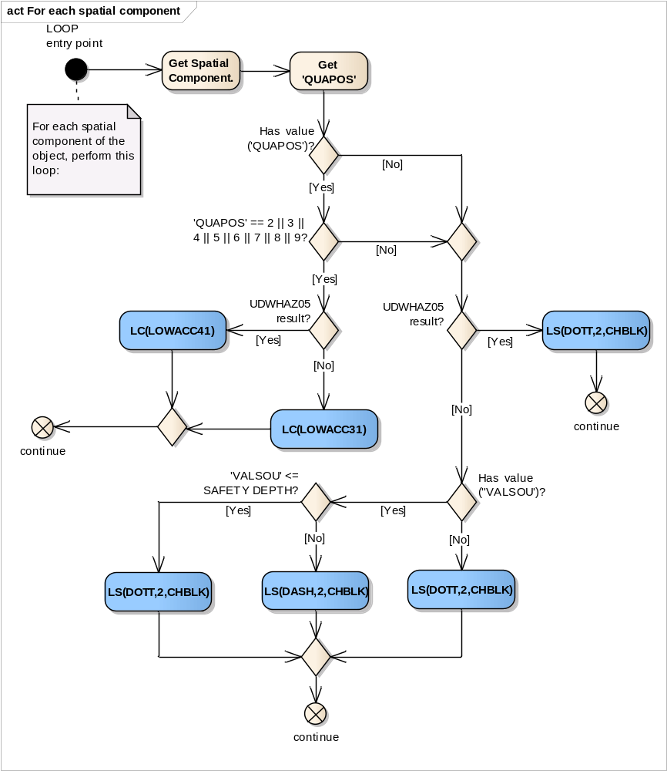
LOOP entry point | For each spatial component of this object, perform this loop.
Get Spatial Component. | Get next spatial component of the calling object.
Get 'QUAPOS' | Get the value of the attribute 'Quality of position' (QUAPOS) of the current spatial component
Has value ('QUAPOS')? | Is the value of the attribute 'QUAPOS' given?
'QUAPOS' == 2 || 3 || 4 || 5 || 6 || 7 || 8 || 9? | Does the value of the attribute 'QUAPOS' equal to one of the following values: '2', '3', '4', '5', '6', '7', '8' or '9'?
UDWHAZ05 result? | Has the procedure 'UDWHAZ05' indicated the isolated danger symbol should be shown?
LC(LOWACC41) | Draw the line with a complex line style 'LOWACC41' at the spatial component with the set presentation parameters selected by 'UDWHAZ05' CSP
LC(LOWACC31) | Draw the line with a complex line style 'LOWACC31' at the spatial component
continue | Go to the next spatial component
UDWHAZ05 result? | Has the procedure 'UDWHAZ05' indicated the isolated danger symbol should be shown?
LS(DOTT,2,CHBLK) | Draw the line with a dotted line, 2 units wide, colour 'CHBLK' at the spatial component with the set presentation parameters selected by 'UDWHAZ05' CSP
Has value (''VALSOU')? | Is the value of the attribute 'VALSOU' given in the calling object?
LS(DOTT,2,CHBLK) | Draw the line with a dotted line, 2 units wide, colour 'CHBLK' at the spatial component.
'VALSOU' <= SAFETY DEPTH? | Is the value of the attribute 'VALSOU' less than or equal to SAFETY DEPTH?
LS(DOTT,2,CHBLK) | Draw the line with a dotted line, 2 units wide, colour 'CHBLK' at the spatial component
LS(DASH,2,CHBLK) | Draw the line with a dashed line, 2 units wide, colour 'CHBLK' at the spatial component.
continue | Go to the next spatial component
Figure 15 OBSTRN07 Continuation C Area objects, obstructions (OBSTRN)
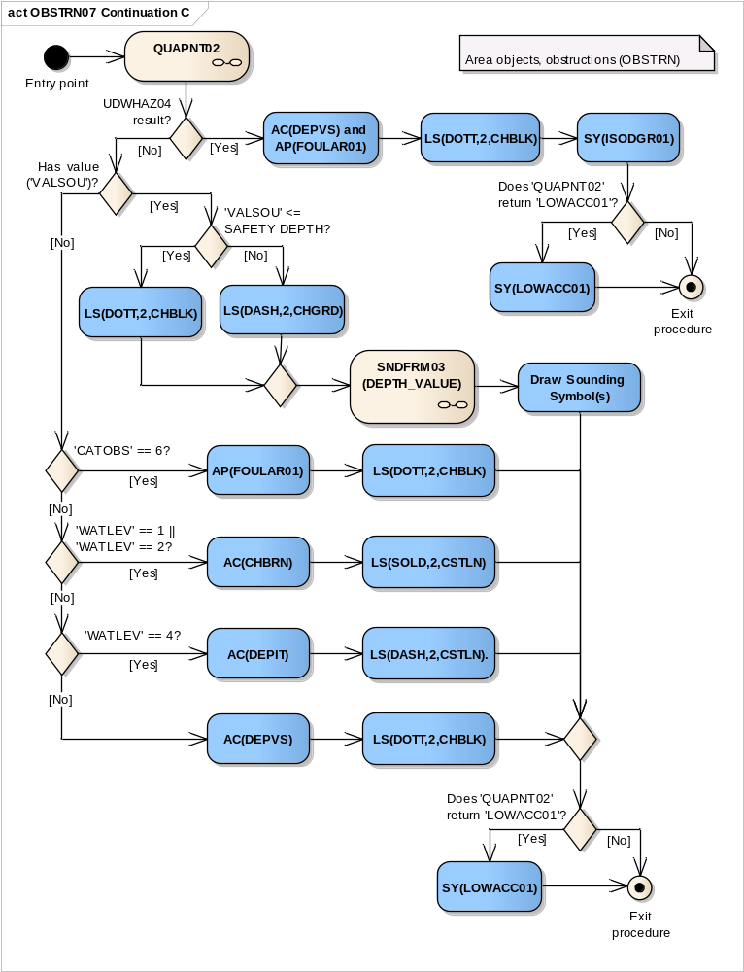
Entry point | Entry to the continuation of symbology procedure with a area object, obstructions (OBSTRN)
QUAPNT02 | Performs the symbology sub-procedure 'QUAPNT02' which returns a flag indicating whether or not to display the LOW ACCURACY SYMBOL and returns the selected symbol.
UDWHAZ05 result? | Has the procedure 'UDWHAZ05’ indicated the Isolated danger symbol should be shown?
AC(DEPVS) and AP(FOULAR01) | Draw the area object with an opaque colour fill with the colour 'DEPVS', and the area pattern 'FOULAR01' with the set presentation parameters selected by 'UDWHAZ05' CSP
LS(DOTT,2,CHBLK) | Draw the area boundary as a dotted line, 2 units wide, in the colour 'CHBLK' with the set presentation parameters selected by 'UDWHAZ05' CSP
SY(ISODGR01) | Draw the isolated symbol 'ISODGR01' with the set presentation parameters returned by 'UDWHAZ05' in the centre of the area.
Does 'QUAPNT02' return 'LOWACC01'? | Is the symbol 'LOWACC01' selected by the procedure 'QUAPNT02'?
SY(LOWACC01) | If so indicated by the procedure 'QUAPNT02', draw the returned low accuracy symbol 'LOWACC01' in the centre of the area with the set presentation parameters selected by 'UDWHAZ05' CSP
Exit procedure | Symbolization is finished
Has value ('VALSOU')? | Is the value of the attribute 'VALSOU' given?
'VALSOU' <= SAFETY DEPTH? | Is the value of the attribute 'VALSOU' less than or equal to SAFETY DEPTH?
LS(DOTT,2,CHBLK) | Draw the area boundary as a dotted line, 2 units wide, in the colour 'CHBLK'.
LS(DASH,2,CHGRD) | Draw the area boundary as a dashed line, 2 units wide, in the colour 'CHGRD'.
SNDFRM04 (DEPTH_VALUE) | Perform the Symbology Procedure which returns a list of sounding symbols.  Pass 'DEPTH_VALUE' on to it.  Remember the SOUNDING SYMBOL(S)
DEPTH_VALUE | Input parameter
Sounding Symbols List | Output parameter
Draw Sounding Symbol(s) | Draw the sounding symbol(s) returned from 'SNDFRM04' in the centre of the area
'CATOBS' == 6? | Is the value of attribute 'CATOBS' equal to '6' (foul area)?
AP(FOULAR01) | Draw the area object with the area pattern 'FOULAR01'.
LS(DOTT,2,CHBLK) | Draw the area boundary as a dotted line, 2 units wide, in the colour 'CHBLK' LS(DOTT, 2, CHBLK).
'WATLEV' == 1 || 'WATLEV' == 2? | Is the value of attribute 'WATLEV' equal to '1' (partly submerged at HW) or '2' (always dry)?
AC(CHBRN) | Draw the area object with an opaque colour fill with the colour 'CHBRN'
LS(SOLD,2,CSTLN) | Draw the area boundary as solid line, 2 units wide, in the colour 'CSTLN' LS(SOLD, 2, CSTLN).
'WATLEV' == 4? | Is the value of attribute 'WATLEV' equal to '4' (covers and uncovers)?
AC(DEPIT) | Draw the area object with an opaque colour fill with the colour 'DEPIT'
LS(DASH,2,CSTLN). | Draw the area boundary as a dashed line, 2 units wide, in the colour 'CSTLN' LS(DASH, 2, CSTLN).
AC(DEPVS) | Draw the area object with an opaque colour fill with the colour 'DEPVS'
LS(DOTT,2,CHBLK) | Draw the area boundary as a dotted line, 2 units wide, in the colour 'CHBLK' LS(DOTT, 2, CHBLK).
Does 'QUAPNT02' return 'LOWACC01'? | Is the symbol 'LOWACC01' selected by the procedure 'QUAPNT02'?
SY(LOWACC01) | If so indicated by the procedure 'QUAPNT02' draw the returned low accuracy symbol at the centre of the area.
Exit procedure | Symbolization is finished

13.2.7 Conditional Symbology Procedure QUAPOS01

Applies to: S-57 Object Class "land area" (LNDARE), as point and line;
S-57 Object Class “coast line” (COALNE), line only;
Spatial Object(s): Point, Line
Attribute(s) used: Spatial attribute QUAPOS
Parameter(s): Object to be symbolized from SENC
User Parameters: Show low accuracy symbol.
Defaults: Symbolization given by the look-up table;
Display Priority given by ook-up table;
OVERRADAR priority given by look-up table;
Display Category given by look-up table;
Viewing Group given by look-up table
Remarks: The attribute QUAPOS, which identifies low positional accuracy, is attached to the spatial object, not the feature object. This procedure passes the object to procedure QUALINnn or QUAPNTnn, which examines the spatial attributes, and returns the appropriate symbolization to QUAPOSnn.
Figure 16 QUAPOS01 conditional symbology procedure
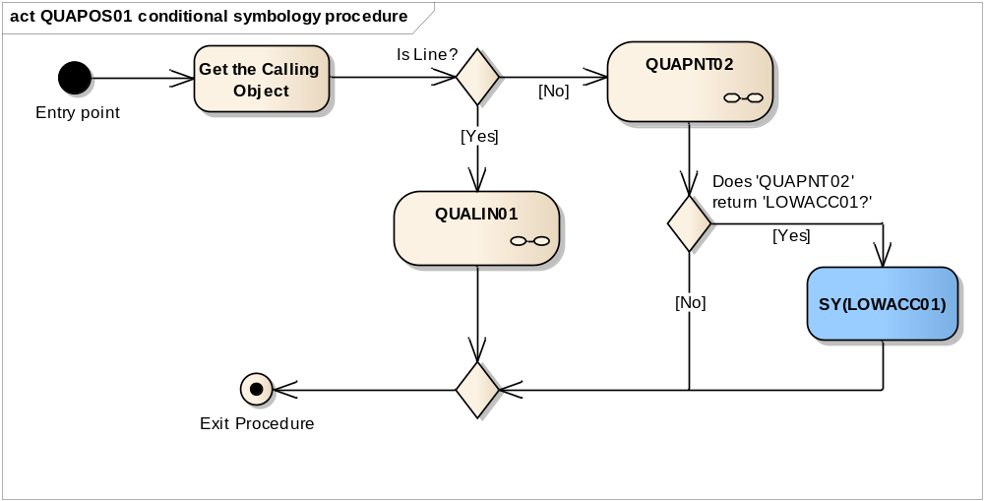
Entry point | Entry to the symbology procedure.
Get the Calling Object | Get the object which is calling this procedure.
Is Line? | Is the calling object of type line?
QUALIN01 | Perform the symbology sub-procedure 'QUALIN01' which symbolizes lines based on the spatial object's attribute 'QUAPOS' , see “13.2.8 Conditional Symbology Procedure QUALIN01”
Calling Object | - input parameter
QUAPNT02 | Perform the symbology sub-procedure 'QUAPNT02' which returns a flag indicating whether or not to display the low accuracy symbol and returns the selected symbol 'LOWACC01', see “13.2.9 Conditional Symbology Procedure QUAPNT02”
Calling Object | - input parameter
LOWACC01 | - output parameter
Does 'QUAPNT02' return 'LOWACC01?' | Is the symbol 'LOWACC01' selected by the procedure 'QUAPNT02'?
SY(LOWACC01) | Draw the low accuracy symbol 'LOWACC01' if so indicated by the procedure 'QUAPNT02' at the calling object location.
Exit Procedure | Symbolization is finished

13.2.8 Conditional Symbology Procedure QUALIN01

(Note that this is called as a sub-procedure by QUAPOSnn).
Applies to: S-57 Object Class land area (LNDARE) as line;
S-57 Object Class coastline (COALNE) line only.
Spatial primitive(s): Line;
Spatial operations: Separate a line into its component edges.
Attribute(s) used: Spatial attribute QUAPOS
Parameter(s): Object to be symbolised from SENC.
Defaults: Display Priority given by look-up table;
OVERRADAR priority given by look-up table;
Display Category given by look-up table;
Viewing Group given by look-up table;
Remarks: The attribute QUAPOS, which identifies low positional accuracy, is attached only to the spatial component(s) of an object. A line object may be composed of more than one spatial components. This procedure looks at each of the spatial components, and symbolizes the line according to the positional accuracy.
Figure 17 QUALIN01 conditional symbology sub-procedure
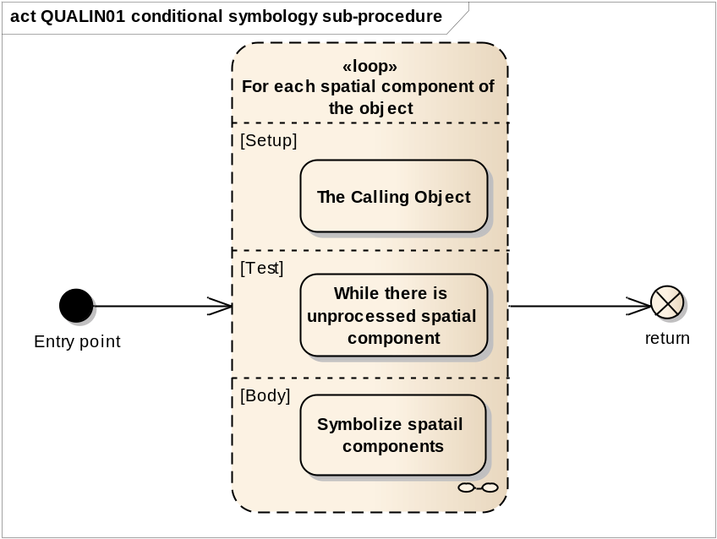
Entry point | Entry from the main conditional procedure 'QUAPOS01' with the calling object
Loop for each spatial component of the object | Loop for each spatial component of the object  Setup - The Calling Object  Test - While there is unprocessed spatial component  Body - Symbolize spatial components if it is needed.
return | Return to the calling procedure 'QUAPOS01'

Figure 18 Loop for each spatial component of the object
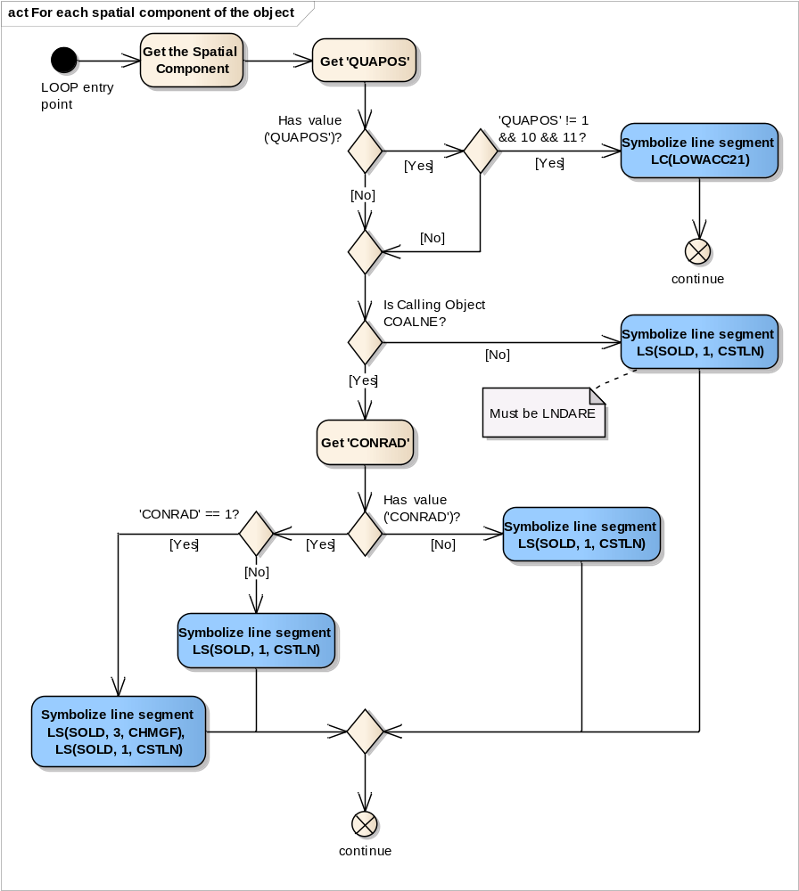
LOOP entry point | For each spatial component of this object, perform this loop.
Get the Spatial Component | Get the next spatial component (edge) of the calling object.
Get 'QUAPOS' | Get the value of the attribute 'Quality of position' (QUAPOS) of the current spatial component
Has value ('QUAPOS')? | Is the value of the attribute 'QUAPOS' given?
'QUAPOS' != 1 && 10 && 11? | Does the value of attribute 'QUAPOS' equal to neither of the following values: '1', '10', and '11'?
Symbolize line segment LC(LOWACC21) | Symbolize the line segment (edge) with the pattern line 'LOWACC21'
continue | go to the next spatial component of the calling object
Is Calling Object COALNE? | Is the calling objects of class COALNE?
Symbolize line segment LS(SOLD, 1, CSTLN) | Symbolize the line segment (edge) with a solid line, 1 unit wide, colour 'CSTLN'
Get 'CONRAD' | Get the value of the attribute 'Conspicuous, radar' (CONRAD) of the calling object
Has value ('CONRAD')? | Is the value of the attribute 'CONRAD' given?
Symbolize line segment LS(SOLD, 1, CSTLN) | Symbolize the line segment (edge) with a solid line, 1 unit wide, colour 'CSTLN'
'CONRAD' == 1? | Does the value of the attribute 'CONRAD' equal to '1' (radar consp.)?
Symbolize line segment LS(SOLD, 1, CSTLN) | Symbolize the line segment (edge) with a solid line, 1 unit wide, colour 'CSTLN'
Symbolize line segment LS(SOLD, 3, CHMGF), LS(SOLD, 1, CSTLN) | Symbolize the line segment (edge) with a solid line, 3 units wide, colour 'CHMGF' and symbolize the same line segment (edge) with a solid line, 1 unit wide, colour 'CSTLN'
continue | go to the next spatial component of the calling object

13.2.9 Conditional Symbology Procedure QUAPNT02

Quality of position of point and area objects (S-57) Conditional Symbology Procedure for additional symbology for point and area objects when positional accuracy is low. (Note that this is called as a sub-procedure by OBSTRNnn, QUAPOSnn, SLCONSnn, WRECKSnn).
Applies to: S-57 Object Class "Land area" (LNDARE) as point;
S-57 Object Class "Obstruction" (OBSTRN) as point and area;
S-57 Object Class "Shoreline construction" (SLCONS) as point;
S-57 Object Class "Wrecks" (WRECKS) as point and area.
S-57 Object Class "Under water rock" (UWTROC) as point.
Spatial Object(s): Point, Area.
Attribute(s) used: Spatial attribute QUAPOS
Parameter(s): Object to be symbolized from SENC.
User Parameters: View low accuracy symbols.
Defaults: Symbolization given by the look-up table:
Display Priority given by look-up table;
OVERRADAR priority given by look-up table;
Display Category given by look-up table;
Viewing Group given by look-up table
Remarks: The attribute QUAPOS, which identifies low positional accuracy, is attached only to the spatial component(s) of an object.
This procedure checks whether the mariner has requested that the symbol SY(LOWACC01) is to be shown; retrieves any QUAPOS attributes; and returns the appropriate symbols to the calling procedure.
Figure 19 QUAPNT02 conditional symbology sub-procedure
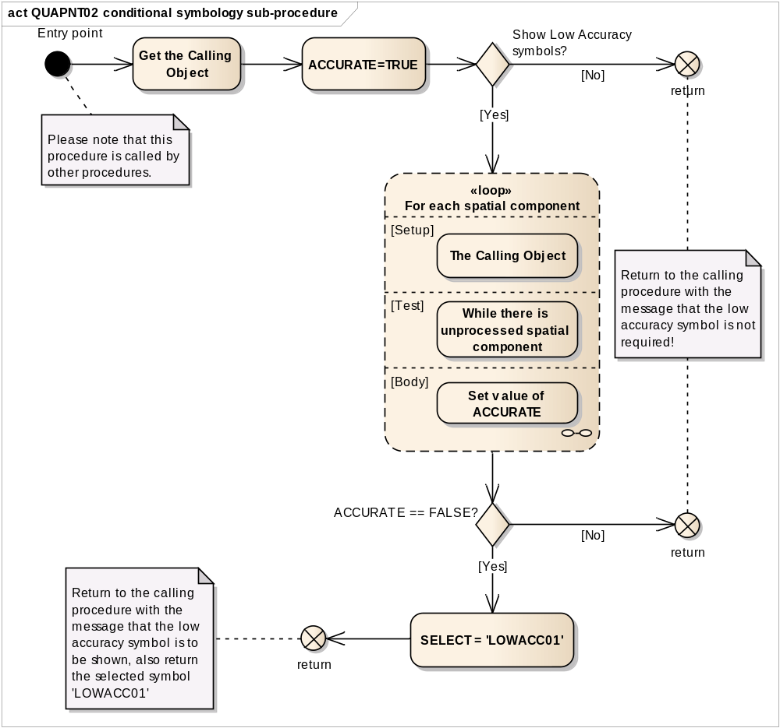
Entry point | Entry from the calling conditional procedure.
Get the Calling Object | Get the object which is calling this procedure.
ACCURATE=TRUE | Set local variable 'ACCURATE' equal to true.
Show Low Accuracy symbols? | Has the mariner chosen to view the low accuracy symbols (LOWACC01) (i.e. viewing group equals 31011)?
return | If ‘No’, return to the calling procedure with the message that the low accuracy symbol is not required!
Loop for each spatial component | For each spatial component of the object perform this loop
ACCURATE == FALSE? | Is the local variable 'ACCURATE' set to 'FALSE?
return | If ‘No’, return to the calling procedure with the message that the low accuracy symbol is not required.
SELECT = 'LOWACC01' | Select the 'Low Accuracy' symbol 'LOWACC01' Return to the calling procedure.
return | Return to the calling procedure with the message that the low accuracy symbol is to be shown, also return the selected symbol ‘LOWACC01’.

Figure 20 Loop for each spatial component
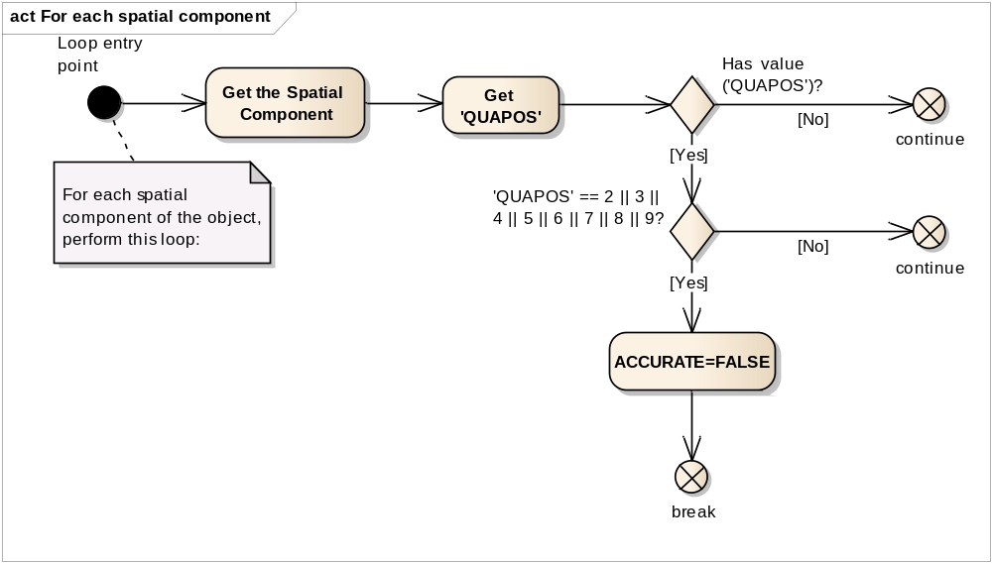
Loop entry point | For each spatial component of the object, perform this loop:
Get the Spatial Component | Get the next spatial component of the calling object.
Get 'QUAPOS' | Get the value of the attribute 'Quality of position' (QUAPOS) of the current spatial component
Has value ('QUAPOS')? | Is the value of the attribute 'QUAPOS' given?
continue | If ‘No’, go to the next spatial component of the calling object.
'QUAPOS' == 2 || 3 || 4 || 5 || 6 || 7 || 8 || 9? | Does the value of the attribute 'QUAPOS' equal to one of the following values: '2', '3', '4', '5', '6', '7', '8' or '9'?
continue | If ‘No’, go to the next spatial component of the calling object.
ACCURATE=FALSE | Set local variable 'ACCURATE'='FALSE'.
break | Loop by spatial componetns

13.2.10 Conditional Symbology Procedure RESARE04

Applies to: S-57 objects of class Restricted Area (RESARE)
Spatial Object(s): Area
Attribute(s) used: CATREA, RESTRN (List-type)
User Parameters: “Symbolized Area Boundaries”.
Defaults: Display priority given by look-up table;
OVERRADAR priority given by look-up table;
Display category given by look-up table;
Viewing group given by look-up table.
Remarks: A list-type attribute is used because an area of the object class RESARE may have more than one category attribute (CATREA). For example an inshore traffic zone might also have fishing and anchoring prohibition and a prohibited area might also be a bird sanctuary or a mine field.
This conditional procedure is set up to ensure that the categories of most importance to safe navigation are prominently symbolized, and to pass on all given information with minimum clutter. Only the most significant restriction is symbolized, and an indication of further limitations is given by a subscript "!" or "i". Further details are given under conditional symbology procedure RESTRNnn
Other object classes with attribute RESTRN are handled by conditional symbology procedure RESTRNnn.
Figure 21 RESARE04 conditional symbology procedure
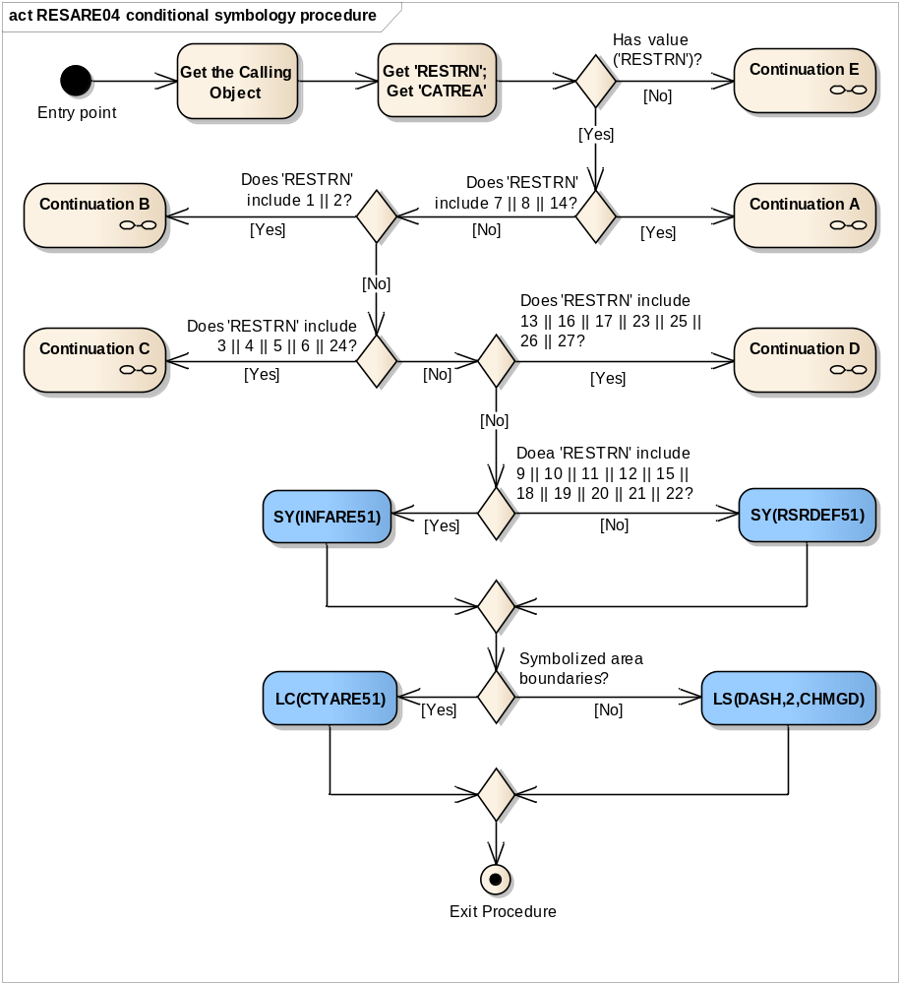
Entry point | Entry to the symbology procedure.
Get the Calling Object | Get the object which is calling this procedure.
Get 'RESTRN'; Get 'CATREA' | Get the values of the attributes 'Restriction' (RESTRN) and 'Category of restricted area' (CATREA) from the calling object
Has value ('RESTRN')? | Is the value of the attribute 'RESTRN' given?
Continuation E | If ‘No’, RESARE04 Continuation E. See Figure 26 RESARE04 Continuation E No 'RESTRN' applies
Does 'RESTRN' include 7 || 8 || 14? | Does the value of the attribute 'RESTRN' include '7' (entry prohibited) and/or '8' (entry restricted) and/or '14' (area to be avoided)?
Continuation A | RESARE04 Continuation A
Does 'RESTRN' include 1 || 2? | Does the value of the attribute 'RESTRN' include '1' (anchoring prohibited) and/or '2' (anchoring restricted)?
Continuation B | RESARE04 Continuation B
Does 'RESTRN' include 3 || 4 || 5 || 6 || 24? | Does the value of the attribute 'RESTRN' include '3' (fishing prohibited) and/or '4' (fishing restricted) and/or '5' (trawling prohibited) and/or 6 (trawling restricted) and/or '24' (dragging prohibited)?
Continuation C | RESARE04 Continuation C
Does 'RESTRN' include 13 || 16 || 17 || 23 || 25 || 26 || 27? | Does the value of 'RESTRN' include '13' (no wake area) and/or '16' (discharging prohibited) and/or '17' (discharging restricted) and/or '23' (lightering prohibited) and/or '25' (stopping prohibited) and/or '26' (landing prohibited) and/or '27' (speed restricted)?
Continuation D | RESARE04 Continuation D
Does 'RESTRN' include 9 || 10 || 11 || 12 || 15 || 18 || 19 || 20 || 21 || 22? | Does the value of the attribute 'RESTRN' include '9' (dredging prohibited) and/or '10' (dredging restricted) and/or '11' (diving prohibited) and/or '12' (diving restricted) and/or '15' (construction prohibited) and/or '18' (development prohibited) and/or '19' (development restricted) and/or '20' (drilling prohibited) and/or '21' (drilling restricted) and/or '22' (removing artifacts prohibited)?
SY(INFARE51) | Draw the symbol 'INFARE51' in the centre of the visible part of the calling object area.
SY(RSRDEF51) | Draw the symbol 'RSRDEF51' in the centre of the visible part of the calling object area.
Symbolized area boundaries? | Has the mariner selected symbolized area boundaries?
LC(CTYARE51) | Symbolize area boundary with the line pattern 'CTYARE51'.
LS(DASH,2,CHMGD) | Symbolize area boundary with the dash line with width 2 and colour 'CHMGD'.
Exit Procedure | Symbolization is finished.

Figure 22 RESARE04 Continuation A. Entry restricted or prohibited
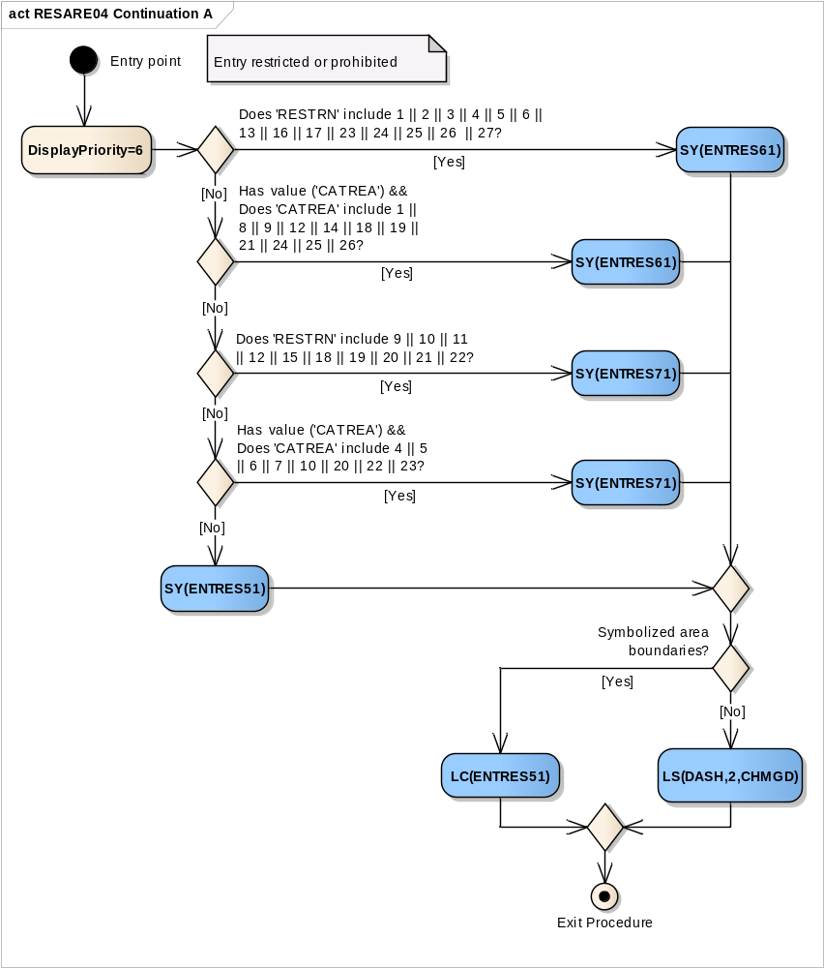
Entry point | The checking of 'Entry Restricted or Prohibited'
DisplayPriority=6 | Set 'Display Priority' parameter equal to '6' for the follow-up symbolization.
Does 'RESTRN' include 1 || 2 || 3 || 4 || 5 || 6 || 13 || 16 || 17 || 23 || 24 || 25 || 26 || 27? | Does the value of the attribute 'RESTRN' include '1' (anchoring prohibited) and/or '2' (anchoring restricted) and/or '3' (fishing prohibited) and/or '4' (fishing restricted) and/or '5' (trawling prohibited) and/or '6' (trawling restricted) and/or '13' (no wake area) and/or '16' (discharging prohibited) and/or '17' (discharging restricted) and/or '23' (lightering prohibited) and/or '24' (dragging prohibited) and/or '25' (stopping prohibited) and/or '26' (landing prohibited) and/or '27' (speed restricted)?
SY(ENTRES61) | Draw the symbol 'ENTRES61' in the center of the visible part of the calling object area.
Has value ('CATREA') && Does 'CATREA' include 1 || 8 || 9 || 12 || 14 || 18 || 19 || 21 || 24 || 25 || 26? | Is the value of the attribute 'CATREA' given and does it include '1' (offshore safety zone) and/or '8' (degaussing area) and/or '9' (military area) and/or '12' (navigation aid safety zone) and/or '14' (minefield) and/or '18' (swimming area) and/or '19' (waiting area) and/or '21' (dredging area) and/or '24' (no wake area) and/or '25' (swinging area) and/or '26' (water skiing area)?
SY(ENTRES61) | Draw the symbol 'ENTRES61' in the center of the visible part of the calling object area.
Does 'RESTRN' include 9 || 10 || 11 || 12 || 15 || 18 || 19 || 20 || 21 || 22? | Does the value of the attribute 'RESTRN' include '9' (dredging prohibited) and/or '10' (dredging restricted) and/or '11' (diving prohibited) and/or '12' (diving restricted) and/or '15' (construction prohibited) and/or '18' (development prohibited) and/or '19' (development restricted) and/or '20' (drilling prohibited) and/or '21' (drilling restricted) and/or '22' (removing artefacts prohibited)?
SY(ENTRES71) | Draw the symbol 'ENTRES71' in the center of the visible part of the calling object area.
Has value ('CATREA') && Does 'CATREA' include 4 || 5 || 6 || 7 || 10 || 20 || 22 || 23? | Is the value of the attribute 'CATREA' given and does it include '4' (nature reserve) and/or '5' (bird sanctuary) and/or '6' (game preserve) and/or '7' (seal sanctuary) and/or '10' (historic wreck) and/or '20' (research area) and/or '22' (fish sanctuary) and/or '23' (ecological reserve)?
SY(ENTRES71) | Draw the symbol 'ENTRES71' in the center of the visible part of the calling object area.
SY(ENTRES51) | Draw the symbol 'ENTRES51' in the center of the visible part of the calling object area.
Symbolized area boundaries? | Has mariner selected Symbolized Area Boundaries?
LC(ENTRES51) | Symbolize area boundary with the pattern line 'ENTRES51'
LS(DASH,2,CHMGD) | Symbolize area boundary with the dash line with the width '2' and color 'CHMGD'.
Exit Procedure | Symbolization is finished. Exit from procedure.

Figure 23 RESARE04 Continuation B Anchoring restricted or prohibited.
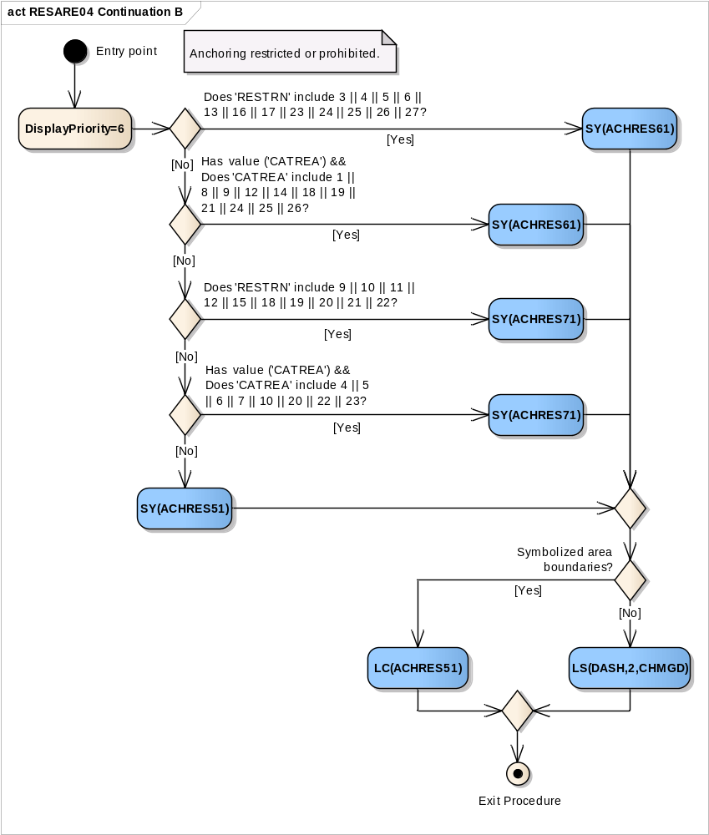
Entry point | The checking of 'Anchoring Restricted or Prohibited'.
DisplayPriority=6 | Set display priority equal to 6 for the follow-up symbolization.
Does 'RESTRN' include 3 || 4 || 5 || 6 || 13 || 16 || 17 || 23 || 24 || 25 || 26 || 27? | Does the value of the attribute 'RESTRN' include '3' (fishing prohibited) and/or '4' (fishing restricted) and/or '5' (trawling prohibited) and/or '6' (trawling restricted) and/or '13' (no wake area) and/or '16' (discharging prohibited) and/or '17' (discharging restricted) and/or '23' (lightering prohibited) and/or '24' (dragging prohibited) and/or '25' ( stopping prohibited) and/or '26' (landing prohibited) and/or '27' (speed restricted)?
SY(ACHRES61) | Draw the symbol 'ACHRES61' in the center of the visible part of the calling object area.
Has value ('CATREA') && Does 'CATREA' include 1 || 8 || 9 || 12 || 14 || 18 || 19 || 21 || 24 || 25 || 26? | Is the value of the attribute 'CATREA' given and does it include '1' (offshore safety zone) and/or '8' (degaussing area) and/or '9' (military area) and/or '12' (navigation aid safety zone) and/or '14' (minefield) and/or '18' (swimming area) and/or '19' (waiting area) and/or '21' (dredging area) and/or '24' (no wake area) and/or '25' (swinging area) and/or '26' (water skiing area)?
SY(ACHRES61) | Draw the symbol 'ACHRES61' in the center of the visible part of the calling object area.
Does 'RESTRN' include 9 || 10 || 11 || 12 || 15 || 18 || 19 || 20 || 21 || 22? | Does the value of the attribute 'RESTRN' include '9' (dredging prohibited) and/or '10' (dredging restricted) and/or '11' (diving prohibited) and/or '12' (diving restricted) and/or '15' (construction prohibited) and/or '18' (development prohibited) and/or '19' (development restricted) and/or '20' (drilling prohibited) and/or '21' (drilling restricted) and/or '22' (removing artefacts prohibited)?
SY(ACHRES71) | Draw the symbol 'ACHRES71' in the center of the visible part of the calling object area.
Has value ('CATREA') && Does 'CATREA' include 4 || 5 || 6 || 7 || 10 || 20 || 22 || 23? | Is the value of the attribute 'CATREA' given and does it include '4' (nature reserve) and/or '5' (bird sanctuary) and/or '6' (game preserve) and/or '7' (seal sanctuary) and/or '10' (historic wreck) and/or '20' (research area) and/or '22' (fish sanctuary) and/or '23' (ecological reserve)?
SY(ACHRES71) | Draw the symbol 'ACHRES71' in the center of the visible part of the calling object area.
SY(ACHRES51) | Draw the symbol 'ACHRES51' in the center of the visible part of the calling object area.
Symbolized area boundaries? | Has mariner selected Symbolized Area Boundaries?
LC(ACHRES51) | Symbolize area boundary with the pattern line 'ACHRES51'
LS(DASH,2,CHMGD) | Symbolize area boundary with the dash line with the width '2' and the color 'CHMGD'.
Exit Procedure | Symbolization is finished. Exit from procedure.

Figure 24 RESARE04 Continuation C Fishing restricted or prohibited
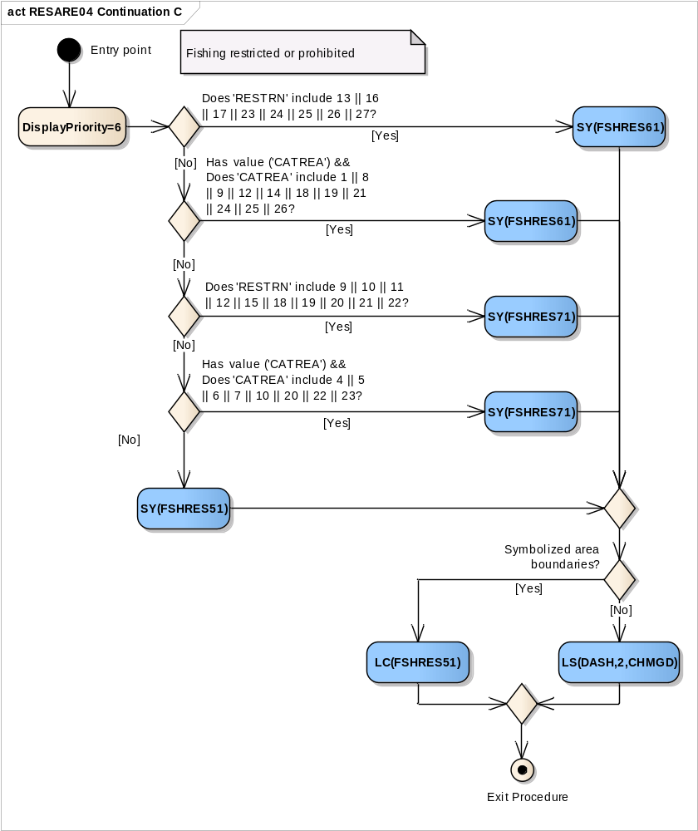
Entry point | The checking of Fishing restricted or prohibited
DisplayPriority=6 | Set display priority equal to 6 for the follow-up symbolization.
Does 'RESTRN' include 13 || 16 || 17 || 23 || 24 || 25 || 26 || 27? | Does the value of the attribute 'RESTRN' include '13' (no wake area) and/or '16' (discharging prohibited) and/or '17' (discharging restricted) and/or '23' (lightering prohibited) and/or '24' (dragging prohibited) and/or '25' (stopping prohibited) and/or '26' (landing prohibited) and/or '27' (speed restricted)?
SY(FSHRES61) | Draw the symbol 'FSHRES61' in the center of the visible part of the calling object area.
Has value ('CATREA') && Does 'CATREA' include 1 || 8 || 9 || 12 || 14 || 18 || 19 || 21 || 24 || 25 || 26? | Is the value of the attribute 'CATREA' given and does it include '1' (offshore safety zone) and/or '8' (degaussing area) and/or '9' (military area) and/or '12' (navigation aid safety zone) and/or '14' (minefield) and/or '18' (swimming area) and/or '19' (waiting area) and/or '21' (dredging area) and/or '24' (no wake area) and/or '25' (swinging area) and/or '26' (water skiing area)?
SY(FSHRES61) | Draw the symbol 'FSHRES61' in the center of the visible part of the calling object area.
Does 'RESTRN' include 9 || 10 || 11 || 12 || 15 || 18 || 19 || 20 || 21 || 22? | Does the value of the attribute 'RESTRN' include '9' (dredging prohibited) and/or '10' (dredging restricted) and/or '11' (diving prohibited) and/or '12' (diving restricted) and/or '15' (construction prohibited) and/or '18' (development prohibited) and/or '19' (development restricted) and/or '20' (drilling prohibited) and/or '21' (drilling restricted) and/or '22' (removing artefacts prohibited)?
SY(FSHRES71) | Draw the symbol 'FSHRES71' in the center of the visible part of the calling object area.
Has value ('CATREA') && Does 'CATREA' include 4 || 5 || 6 || 7 || 10 || 20 || 22 || 23? | Is the value of the attribute 'CATREA' given and does it include '4' (nature reserve) and/or '5' (bird sanctuary) and/or '6' (game preserve) and/or '7' (seal sanctuary) and/or '10' (historic wreck) and/or '20' (research area) and/or '22' (fish sanctuary) and/or '23' (ecological reserve)?
SY(FSHRES71) | Draw the symbol 'FSHRES71' in the center of the visible part of the calling object area.
SY(FSHRES51) | Draw the symbol 'FSHRES51' in the center of the visible part of the calling object area.
Symbolized area boundaries? | Has mariner selected Symbolized Area Boundaries?
LC(FSHRES51) | Symbolize area boundary with the pattern line 'FSHRES51'
LS(DASH,2,CHMGD) | Symbolize area boundary with the dash line with the width '2' and the color 'CHMGD'.
Exit Procedure | Symbolization is finished. Exit from procedure.

Figure 25 RESARE04 Continuation D Own ship restrictions
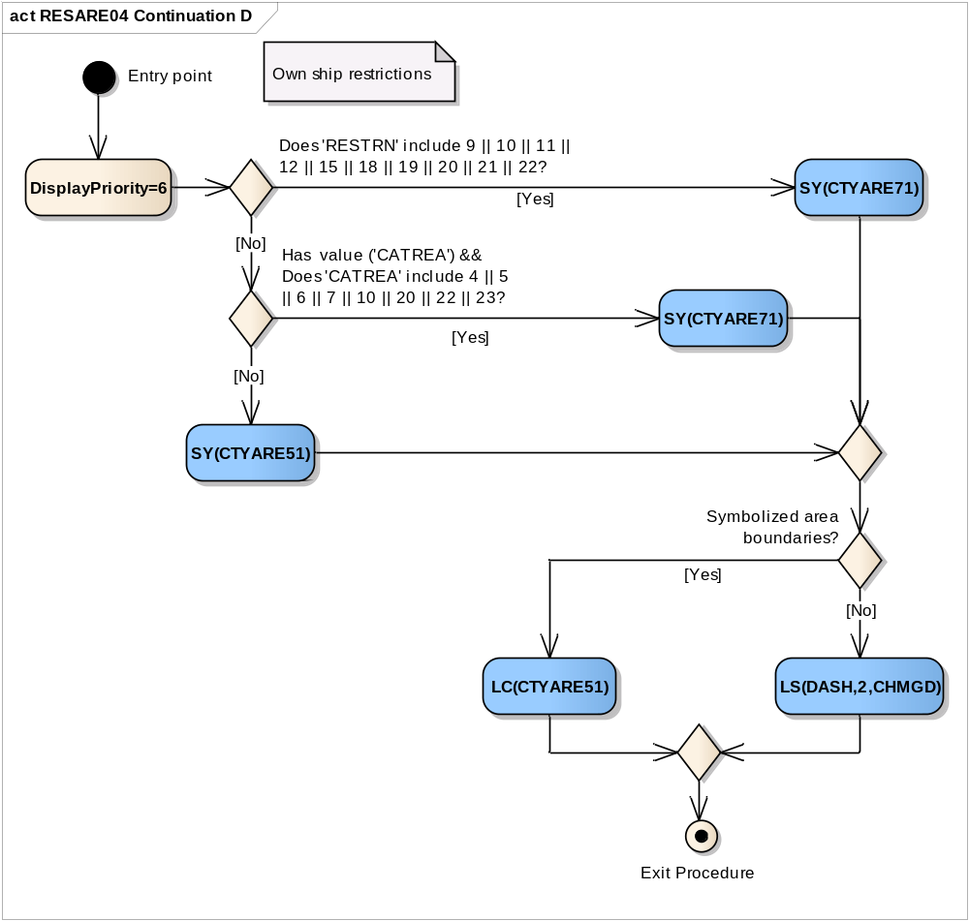
Entry point | The checking of 'Own ship restrictions'
DisplayPriority=6 | Set display priority equal to 6 for the follow-up symbolization.
Does 'RESTRN' include 9 || 10 || 11 || 12 || 15 || 18 || 19 || 20 || 21 || 22? | Does the value of the attribute 'RESTRN' include '9' (dredging prohibited) and/or '10' (dredging restricted) and/or '11' (diving prohibited) and/or '12' (diving restricted) and/or '15' (construction prohibited) and/or '18' (development prohibited) and/or '19' (development restricted) and/or '20' (drilling prohibited) and/or '21' (drilling restricted) and/or '22' (removing artefacts prohibited)?
SY(CTYARE71) | Draw the symbol 'CTYARE71' in the center of the visible part of the calling object area.
Has value ('CATREA') && Does 'CATREA' include 4 || 5 || 6 || 7 || 10 || 20 || 22 || 23? | Is the value of the attribute 'CATREA' given and does it include '4' (nature reserve) and/or '5' (bird sanctuary) and/or '6' (game preserve) and/or '7' (seal sanctuary) and/or '10' (historic wreck) and/or '20' (research area) and/or '22' (fish sanctuary) and/or '23' (ecological reserve)?
SY(CTYARE71) | Draw the symbol 'CTYARE71' in the center of the visible part of the calling object area.
SY(CTYARE51) | Draw the symbol 'CTYARE51' in the center of the visible part of the calling object area.
Symbolized area boundaries? | Has mariner selected Symbolized Area Boundaries?
LC(CTYARE51) | Symbolize area boundary with the pattern line 'CTYARE51'
LS(DASH,2,CHMGD) | Symbolize area boundary with the dash line with the width '2' and the color 'CHMGD'.
Exit Procedure | Symbolization is finished. Exit from procedure.

Figure 26 RESARE04 Continuation E No 'RESTRN' applies
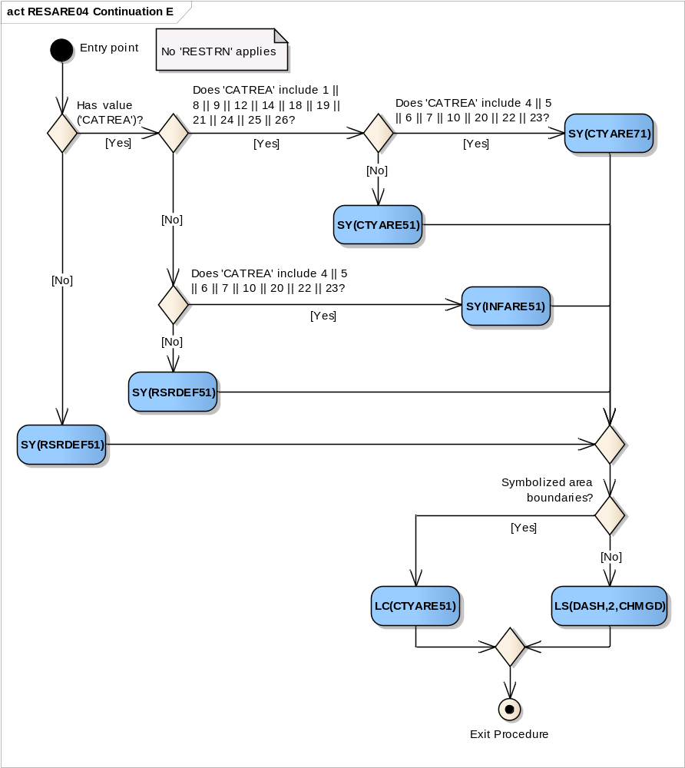
Entry point | The checking 'No RESTRN applies'
Has value ('CATREA')? | Is the value of the attribute 'CATREA' given?
SY(RSRDEF51) | If ‘No', draw the symbol 'RSRDEF51' in the center of the visible part of the calling object area.
Does 'CATREA' include 1 || 8 || 9 || 12 || 14 || 18 || 19 || 21 || 24 || 25 || 26? | Is the value of the attribute 'CATREA' given and does it include '1' (offshore safety zone) and/or '8' (degaussing area) and/or '9' (military area) and/or '12' (navigation aid safety zone) and/or '14' (minefield) and/or '18' (swimming area) and/or '19' (waiting area) and/or '21' (dredging area) and/or '24' (no wake area) and/or '25' (swinging area) and/or '26' (water skiing area)?
Does 'CATREA' include 4 || 5 || 6 || 7 || 10 || 20 || 22 || 23? | Does the value of the attribute 'CATREA' include '4' (nature area) and/or '5' (bird sanctuary) and/or '6' (game preserve) and/or '7' (seal sanctuary) and/or '10' (historic wreck) and/or '20' (research area) and/or '22' (fish sanctuary) and/or '23' (ecological reserve)?
SY(CTYARE71) | Draw the symbol 'CTYARE71' in the center of the visible part of the calling object area.
SY(CTYARE51) | Draw the symbol 'CTYARE51' in the center of the visible part of the calling object area.
Does 'CATREA' include 4 || 5 || 6 || 7 || 10 || 20 || 22 || 23? | Does the value of the attribute 'CATREA' include '4' (nature area) and/or '5' (bird sanctuary) and/or '6' (game preserve) and/or '7' (seal sanctuary) and/or '10' (historic wreck) and/or '20' (research area) and/or '22' (fish sanctuary) and/or '23' (ecological reserve)?
SY(INFARE51) | Draw the symbol 'INFARE51' in the center of the visible part of the calling object area.
SY(RSRDEF51) | An unrecognized value of 'CATREA" was given. Draw the symbol 'RSRDEF51' in the center of the visible part of the calling object area.
Symbolized area boundaries? | Has mariner selected Symbolized Area Boundaries?
LC(CTYARE51) | Symbolize area boundary with the pattern line 'CTYARE51'
LS(DASH,2,CHMGD) | Symbolize area boundary with the dash line with the width '2' and the color 'CHMGD'.
Exit Procedure | Symbolization is finished. Exit from procedure.

13.2.11 Conditional Symbology Procedure RESTRN01

Applies to: The following S-57 Object Class objects, but only when they carry the attribute RESTRN:
TSSLPT, TSSRON, TSSCRS, DWRTPT, PRCARE, ISTZNE;FAIRWAY, DRGARE, ACHARE; CBLARE, PIPARE, DMPGRD, MARCUL; OSPARE, SUBTLN, SPLARE, MIPARE, ICNARE; TESARE.
Spatial Object(s): Area
Attribute(s) used: RESTRN (passed on to sub procedure RESCSPnn)
User Parameter(s): Symbolize Area Boundaries (used by sub procedure RESCSPnn)
Defaults: Display Priority given by look-up table; OVERRADAR priority given by look-up table; Display Category given by look-up table; Viewing Group given by look-up table.
Remarks: Objects subject to RESTRNnn are actually symbolised in sub-process RESCSPnn, since the latter is also be accessed from other conditional symbology procedures. RESTRNnn merely acts as a “signpost” for RESCSPnn.
Object class RESARE is symbolised for the effect of attribute RESTRN in a separate conditional symbology procedure called RESAREnn.
Since many of the areas concerned cover shipping channels, the number of symbols used is minimised to reduce clutter. To do this, values of RESTRN are ranked for significance as follows:
“Traffic Restriction” values of RESTRN:
- RESTRN 7,8: entry prohibited or restricted
- RESTRN 14: IMO designated «area to be avoided» part of a TSS
- RESTRN 1,2: anchoring prohibited or restricted
- RESTRN 3,4,5,6: fishing or trawling prohibited or restricted
- “Other Restriction” values of RESTRN are:
    - RESTRN 9,10: dredging prohibited or restricted,
    - RESTRN 11, 12: diving prohibited or restricted,
    - RESTRN 13: no wake area.
Note: Unlike all other originators of conditional symbology procedures, RESTRN is an attribute, not an object class. It is therefore not possible to provide viewing groups for the restrictions it imposes without creating undesirable complications in the procedure.
Figure 27 RESTRN01 conditional symbology procedure
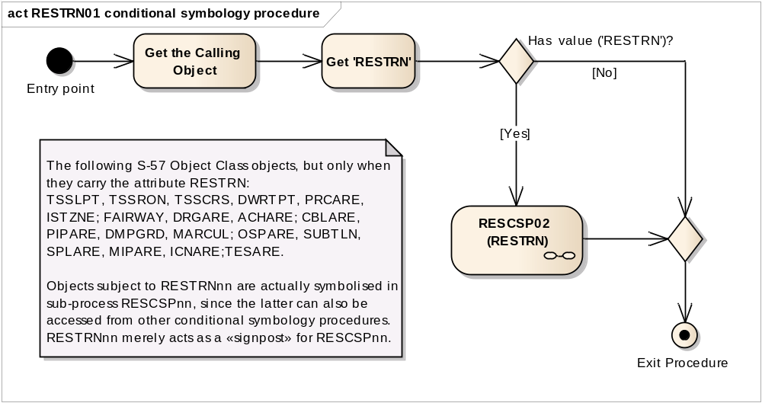
Entry point | Entry to the symbology procedure.
Get the Calling Object | Get the object which is calling this procedure
Get 'RESTRN' | Get the values of the attributes 'Restriction' (RESTRN) from the calling object
Has value ('RESTRN')? | Is the value of the attribute 'RESTRN' given?
RESCSP02 (RESTRN) | Perform the sub-procedure to draw symbology of restrictions in the area object, see “ 13.2.12 Conditional Symbology Procedure RESCSP02”
RESTRN | Input parameter – value of RESTRN attribute of the calling object
Exit Procedure | Symbolization is finished.

13.2.12 Conditional Symbology Procedure RESCSP02

Note that this is called as a sub-procedure by DEPAREnn and RESTRNnn
Applies to: Applies to the following S-57 Object Classes, but only when they carry the attribute RESTRN: TSSLPT, TSSRON, TSSCRS, DWRTPT, PRCARE, ISTZNE; FAIRWAY, DRGARE, ACHARE; CBLARE, PIPARE, DMPGRD, MARCUL; OSPARE, SUBTLN, SPLARE, MIPARE, ICNARE; TESARE;
Spatial Object(s): Area
Parameter(s): Object to be symbolised from ENC.
Attribute(s) used: The attribute 'RESTRN' value is passed on to this procedure by the calling procedure.
Defaults: Symbolization given by the look-up table;
Display Priority given by look-up table;
OVERRADAR priority given by look-up table;
Display Category given by look-up table;
Viewing Group given by look-up table.
Remarks: See procedure RESTRNnn
Figure 28 RESCSP02 (RESTRN) conditional symbology sub-procedure
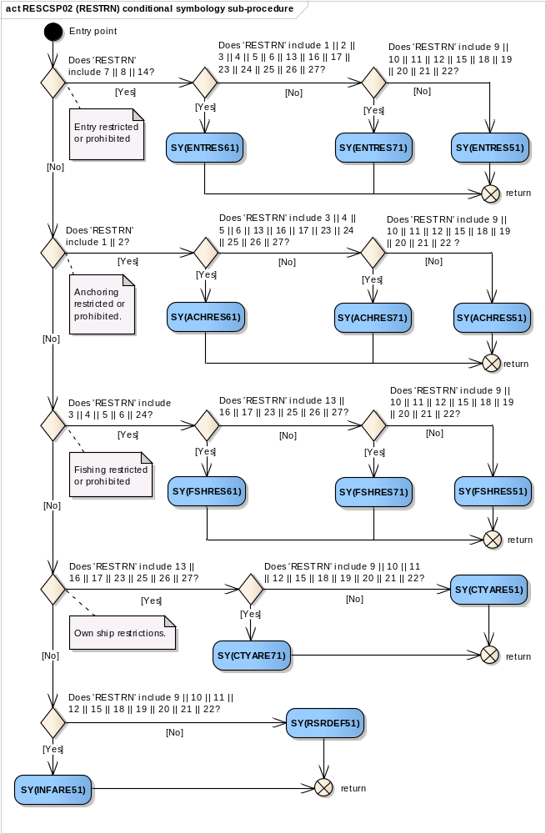
Entry point | For all objects having the attribute 'RESTRN'.  The attribute 'RESTRN' value is passed on to this procedure by the calling procedure.
Does 'RESTRN' include 7 || 8 || 14? | Does the value of the attribute RESTRN include  '7' (entry prohibited) ADN/OR  '8' (entry restricted) AND/OR  '14' (area to be avoided)?
Does 'RESTRN' include 1 || 2 || 3 || 4 || 5 || 6 || 13 || 16 || 17 || 23 || 24 || 25 || 26 || 27? | Does the value of the attribute RESTRN include  '1' (anchoring prohibited) AND/OR  '2' (anchoring restricted) AND/OR  '3' (fishing prohibited) AND/OR  '4' (fishing restricted) AND/OR  '5' (trawling prohibited) AND/OR  '6' (trawling restricted) AND/OR  '13' (no wake area) AND/OR  '16' (discharging prohibited) AND/OR  '17' (discharging restricted) AND/OR  '23' (lightering prohibited) AND/OR  '25' (stopping prohibited) AND/OR  '24' (dragging prohibited) AND/OR  '26' (landing prohibited) AND/OR  '27' (speed restricted)?
SY(ENTRES61) | Draw the symbol 'ENTRES61' in the center of the visible part of the calling object area.
Does 'RESTRN' include 9 || 10 || 11 || 12 || 15 || 18 || 19 || 20 || 21 || 22? | Does the value of the attribute RESTRN include  '9' (dredging prohibited) AND/OR  '10' (dredging restricted) AND/OR  '11' (diving prohibited) AND/OR  '12' (diving restricted) AND/OR  '15' (construction prohibited) AND/OR  '18' (development prohibited) AND/OR  '19' (development restricted) AND/OR  '20' (drilling prohibited) AND/OR  '21' (drilling restricted) AND/OR  '22' (removing artifacts prohibited)?
SY(ENTRES71) | Draw the symbol 'ENTRES71' in the center of the visible part of the calling object area.
SY(ENTRES51) | Draw the symbol 'ENTRES51' in the center of the visible part of the calling object area.
return | to the calling procedure
Does 'RESTRN' include 1 || 2? | Does the value of the attribute RESTRN include  '1' (anchoring prohibited) ADN/OR  '2' (anchoring restricted) ?
Does 'RESTRN' include 3 || 4 || 5 || 6 || 13 || 16 || 17 || 23 || 24 || 25 || 26 || 27? | Does the value of the attribute RESTRN include  '3' (fishing prohibited) AND/OR  '4' (fishing restricted) AND/OR  '5' (trawling prohibited) AND/OR  '6' (trawling restricted) AND/OR  '13' (no wake area) AND/OR  '16' (discharging prohibited) AND/OR  '17' (discharging restricted) AND/OR  '23' (lightering prohibited) AND/OR  '24' (dragging prohibited) AND/OR  '25' (stopping prohibited) AND/OR  '26' (landing prohibited) AND/OR  '27' (speed restricted)?
SY(ACHRES61) | Draw the symbol 'ACHRES61' in the center of the visible part of the calling object area.
Does 'RESTRN' include 9 || 10 || 11 || 12 || 15 || 18 || 19 || 20 || 21 || 22 ? | Does the value of the attribute RESTRN include  '9' (dredging prohibited) AND/OR  '10' (dredging restricted) AND/OR  '11' (diving prohibited) AND/OR  '12' (diving restricted) AND/OR  '15' (construction prohibited) AND/OR  '18' (development prohibited) AND/OR  '19' (development restricted) AND/OR  '20' (drilling prohibited) AND/OR  '21' (drilling restricted) AND/OR  '22' (removing artifacts prohibited)?
SY(ACHRES71) | Draw the symbol 'ACHRES71' in the center of the visible part of the calling object area.
SY(ACHRES51) | Draw the symbol 'ACHRES51' in the center of the visible part of the calling object area.
return | to the calling procedure
Does 'RESTRN' include 3 || 4 || 5 || 6 || 24? | Does the value of the attribute RESTRN include  '3' (fishing prohibited) ADN/OR  '4' (fishing restricted) AND/OR  '5' (trawling prohibited) ADN/OR  '6' (trawling restricted) AND/OR  '24' (dragging prohibited)?
Does 'RESTRN' include 13 || 16 || 17 || 23 || 25 || 26 || 27? | Does the value of the attribute RESTRN include  '13' (no wake area) AND/OR  '16' (discharging prohibited) AND/OR  '17' (discharging restricted) AND/OR  '23' (lightering prohibited) AND/OR  '25' (stopping prohibited) AND/OR  '26' (landing prohibited) AND/OR  '27' (speed restricted)?
SY(FSHRES61) | Draw the symbol 'FSHRES61' in the center of the visible part of the calling object area.
Does 'RESTRN' include 9 || 10 || 11 || 12 || 15 || 18 || 19 || 20 || 21 || 22? | Does the value of the attribute RESTRN include  '9' (dredging prohibited) AND/OR  '10' (dredging restricted) ADN/OR  '11' (diving prohibited) AND/OR  '12' (diving restricted) ADN/OR  '15' (construction prohibited) AND/OR  '18' (development prohibited) ADN/OR  '19' (development restricted) AND/OR  '20' (drilling prohibited) ADN/OR  '21' (drilling restricted) AND/OR  '22' (removing artifacts prohibited)?
SY(FSHRES71) | Draw the symbol 'FSHRES71' in the center of the visible part of the calling object area.
SY(FSHRES51) | Draw the symbol 'FSHRES51' in the center of the visible part of the calling object area.
return | to the calling procedure
Does 'RESTRN' include 13 || 16 || 17 || 23 || 25 || 26 || 27? | Does the value of the attribute RESTRN include  '13' (no wake area) AND/OR  '16' (discharging prohibited) AND/OR  '17' (discharging restricted) AND/OR  '23' (lightering prohibited) AND/OR  '25' (stopping prohibited) AND/OR  '26' (landing prohibited) AND/OR  '27' (speed restricted)?
Does 'RESTRN' include 9 || 10 || 11 || 12 || 15 || 18 || 19 || 20 || 21 || 22? | Does the value of the attribute RESTRN include  '9' (dredging prohibited) AND/OR  '10' (dredging restricted) ADN/OR  '11' (diving prohibited) AND/OR  '12' (diving restricted) ADN/OR  '15' (construction prohibited) AND/OR  '18' (development prohibited) ADN/OR  '19' (development restricted) AND/OR  '20' (drilling prohibited) ADN/OR  '21' (drilling restricted) AND/OR  '22' (removing artifacts prohibited)?
SY(CTYARE71) | Draw the symbol 'CTYARE71' in the center of the visible part of the calling object area.
SY(CTYARE51) | Draw the symbol 'CTYARE51' in the center of the visible part of the calling object area.
return | to the calling procedure
Does 'RESTRN' include 9 || 10 || 11 || 12 || 15 || 18 || 19 || 20 || 21 || 22? | Does the value of the attribute RESTRN include  '9' (dredging prohibited) AND/OR  '10' (dredging restricted) ADN/OR  '11' (diving prohibited) AND/OR  '12' (diving restricted) ADN/OR  '15' (construction prohibited) AND/OR  '18' (development prohibited) ADN/OR  '19' (development restricted) AND/OR  '20' (drilling prohibited) ADN/OR  '21' (drilling restricted) AND/OR  '22' (removing artifacts prohibited)?
SY(INFARE51) | Draw the symbol 'INFARE51' in the center of the visible part of the calling object area.
SY(RSRDEF51) | An unknown value of 'RESTRN' was given. Draw the symbol 'RSRDEF51' in the center of the visible part of the calling object area.
return | to the calling procedure.

13.2.13 Conditional Symbology Procedure SAFCON01
Note that this is called as a sub-procedure by DEPAREnn and DEPCNTnn
Applies to: symbolize edges that are part of the safety contour and depth contours.
Spatial Object(s): Line
Parameter(s): Input parameter is the local variable 'DEPTH_VALUE' passed from the called procedure. A list of symbols is returned.
Remarks: This conditional procedure will create a list of symbols name selected that will be displayed at the mid-point of the edge.
Note: The contours symbolization of 100 meters and deeper is manufacturer-optional. The symbols required are contained in the digital version of the Symbol Library, but are not contained in the man-readable version.
Figure 29 SAFCON01 conditional symbology sub-procedure
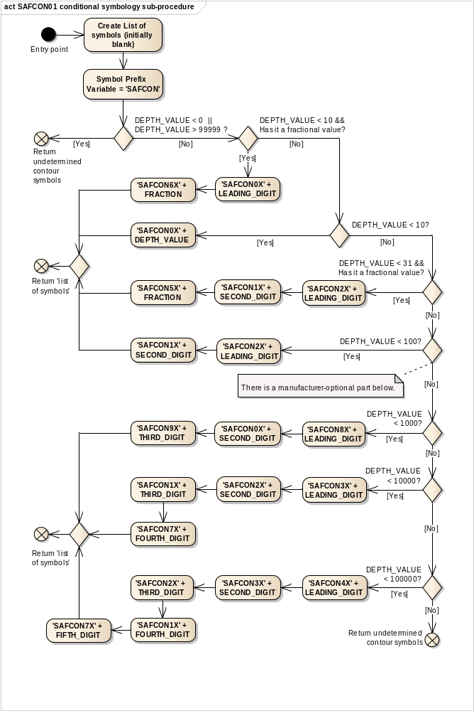
Entry point | The symbology sub-procedure is called by other procedure. Pass the local variable DEPTH_VALUE.
Create List of symbols (initially blank) | Create a 'list of symbols' to be presented at the position of the contour label. This list is initially blank.
Symbol Prefix Variable = 'SAFCON' | Set the symbol prefix variable to 'SAFCON'.
DEPTH_VALUE < 0 || DEPTH_VALUE > 99999 ? | Is the local variable DEPTH_VALUE less than 0 or greater than 99999 metres?
Return undetermined contour symbols | Return to the calling procedure indicating that the contour symbols could not be determined
DEPTH_VALUE < 10 && Has it a fractional value? | Is the local variable DEPTH_VALUE less than 10 metres and has it a fractional value?
'SAFCON0X' + LEADING_DIGIT | Isolate 'LEADING_DIGIT' of 'DEPTH_VALUE'. Create symbol name by adding '00' + 'LEADING_DIGIT' to 'SYMBOL_PREFIX' (e.g. 3.6 metres - isolate '3' and create 'SAFCON03').  Add this symbol name to the 'list of symbols' to be presented.
'SAFCON6X' + FRACTION | Isolate 'FRACTION' of 'DEPTH_VALUE' and multiply by 10. Truncate all digits after the decimal. Do not round up.  Create symbol name by adding '60' + 'FRACTION' to 'SYMBOL_PREFIX'.  Add this symbol name to the 'list of symbols' to be presented.
DEPTH_VALUE < 10? | Is the local variable DEPTH_VALUE less than 10 metres?
'SAFCON0X' + DEPTH_VALUE | Create symbol name by adding '00' + 'DEPTH_VALUE' to 'SYMBOL_PREFIX'.  Add this symbol name to the 'list of symbols' to be presented.
DEPTH_VALUE < 31 && Has it a fractional value? | Is the local variable DEPTH_VALUE less than 31 metres and has it a fractional value?  (Note: common practice in hydrography is to show fractions of a depth value up to 30 metres depth).
'SAFCON2X' + LEADING_DIGIT | Isolate 'LEADING_DIGIT' of 'DEPTH_VALUE'.  Create symbol name by adding '20' + 'LEADING_DIGIT' to 'SYMBOL_PREFIX'.  Add this symbol name to the 'list of symbols' to be presented.
'SAFCON1X' + SECOND_DIGIT | Isolate 'SECOND_DIGIT' of 'DEPTH_VALUE'.  Create symbol name by adding '10' + 'SECOND_DIGIT' to 'SYMBOL_PREFIX'.  Add this symbol name to the 'list of symbols' to be presented.
'SAFCON5X' + FRACTION | Isolate 'FRACTION' of 'DEPTH_VALUE' and multiply by 10.  Truncate all digits after the decimal. Do not round up.  Create symbol name by adding '50' + 'FRACTION' to 'SYMBOL_PREFIX'.  Add this symbol name to the 'list of symbols' to be presented.
DEPTH_VALUE < 100? | Is the local variable DEPTH_VALUE less than 100 metres?
'SAFCON2X' + LEADING_DIGIT | Isolate 'LEADING_DIGIT' of 'DEPTH_VALUE'/  Create symbol name by adding '20' + 'LEADING_DIGIT' to 'SYMBOL_PREFIX'.  Add this symbol name to the 'list of symbols' to be presented.
'SAFCON1X' + SECOND_DIGIT | Isolate 'SECOND_DIGIT' of 'DEPTH_VALUE'.  Create symbol nmae by adding '10' + 'SECOND_DIGIT' to 'SYMBOL_PREFIX'.  Add this symbol name to the 'list of symbols' to be presented.
Return 'list of symbols' | Return to the calling procedure with the 'List of Symbols' which were selected.
Note: the following routine is manufacturer-optional.
DEPTH_VALUE < 1000? | Is the local variable DEPTH_VALUE less than 1000 metres?
'SAFCON8X' + LEADING_DIGIT | Isolate 'LEADING_DIGIT' of 'DEPTH_VALUE'/  Create symbol name by adding '80' + 'LEADING_DIGIT' to 'SYMBOL_PREFIX'.  Add this symbol name to the 'list of symbols' to be presented.
'SAFCON0X' + SECOND_DIGIT | Isolate 'SECOND_DIGIT' of 'DEPTH_VALUE'.  Create symbol name by adding '00' + 'SECOND_DIGIT' to 'SYMBOL_PREFIX'.  Add this symbol name to the 'list of symbols' to be presented.
'SAFCON9X' + THIRD_DIGIT | Isolate 'THIRD_DIGIT' of 'DEPTH_VALUE'.  Create symbol name by adding '90' + 'THIRD_DIGIT' to 'SYMBOL_PREFIX'.  Add this symbol name to the 'list of symbols' to be presented.
DEPTH_VALUE < 10000? | Is the local variable DEPTH_VALUE less than 10000 metres?
'SAFCON3X' + LEADING_DIGIT | Isolate 'LEADING_DIGIT' of 'DEPTH_VALUE'/  Create symbol name by adding '30' + 'LEADING_DIGIT' to 'SYMBOL_PREFIX'.  Add this symbol name to the 'list of symbols' to be presented.
'SAFCON2X' + SECOND_DIGIT | Isolate 'SECOND_DIGIT' of 'DEPTH_VALUE'.  Create symbol name by adding '20' + 'SECOND_DIGIT' to 'SYMBOL_PREFIX'.  Add this symbol name to the 'list of symbols' to be presented.
'SAFCON1X' + THIRD_DIGIT | Isolate 'THIRD_DIGIT' of 'DEPTH_VALUE'.  Create symbol name by adding '10' + 'THIRD_DIGIT' to 'SYMBOL_PREFIX'.  Add this symbol name to the 'list of symbols' to be presented.
'SAFCON7X' + FOURTH_DIGIT | Isolate 'FOURTH_DIGIT' of 'DEPTH_VALUE'.  Create symbol name by adding '70' + 'FOURTH_DIGIT' to 'SYMBOL_PREFIX'.  Add this symbol name to the 'list of symbols' to be presented.
DEPTH_VALUE < 100000? | Is the local variable DEPTH_VALUE less than 100 000 metres?
Return undetermined contour symbols | If ‘No’, return to the calling procedure indicating that the contour symbols could not be determined
'SAFCON4X' + LEADING_DIGIT | Isolate 'LEADING_DIGIT' of 'DEPTH_VALUE'/  Create symbol name by adding '40' + 'LEADING_DIGIT' to 'SYMBOL_PREFIX'.  Add this symbol name to the 'list of symbols' to be presented.
'SAFCON3X' + SECOND_DIGIT | Isolate 'SECOND_DIGIT' of 'DEPTH_VALUE'.  Create symbol name by adding '30' + 'SECOND_DIGIT' to 'SYMBOL_PREFIX'.  Add this symbol name to the 'list of symbols' to be presented.
'SAFCON2X' + THIRD_DIGIT | Isolate 'THIRD_DIGIT' of 'DEPTH_VALUE'.  Create symbol nmae by adding '20' + THIRD_DIGIT to 'SYMBOL_PREFIX'.  Add this symbol name to the 'list of symbols' to be presented.
'SAFCON1X' + FOURTH_DIGIT | Isolate 'FOURTH_DIGIT' of 'DEPTH_VALUE'.  Create symbol name by adding '10' + 'FOURTH_DIGIT' to 'SYMBOL_PREFIX'.  Add this symbol name to the 'list of symbols' to be presented.
'SAFCON7X' + FIFTH_DIGIT | Isolate 'FIFTH_DIGIT' of 'DEPTH_VALUE'.  Create symbol name by adding '70' + 'FIFTH_DIGIT' to 'SYMBOL_PREFIX'.  Add this symbol name to the 'list of symbols' to be presented.
Return 'list of symbols' | Return to the calling procedure with the 'List of Symbols' which were selected.

13.2.14 Conditional Symbology Procedure SLCONS04

Applies to: S-57 Object Class "shoreline construction" (SLCONS)
Spatial Object(s): Point, Line, Area
Attribute(s) used: S57 object attributes: (CATSLC, CONDTN, WATLEV). Spatial attribute QUAPOS
User Parameter(s): None.
Defaults: Display Priority given by look-up table; OVERRADAR priority given by look-up table; Display Category given by look-up table; Viewing Group given by look-up table. Note these parameters may vary depending on the feature’s geometric primitive.
Remarks: Shoreline construction objects which have a QUAPOS attribute on their spatial component indicating that their position is unreliable are symbolized by a special linestyle in the place of the varied linestyles normally used. Otherwise this procedure applies the normal symbolization.

Figure 30 SLCONS04 conditional symbology procedure
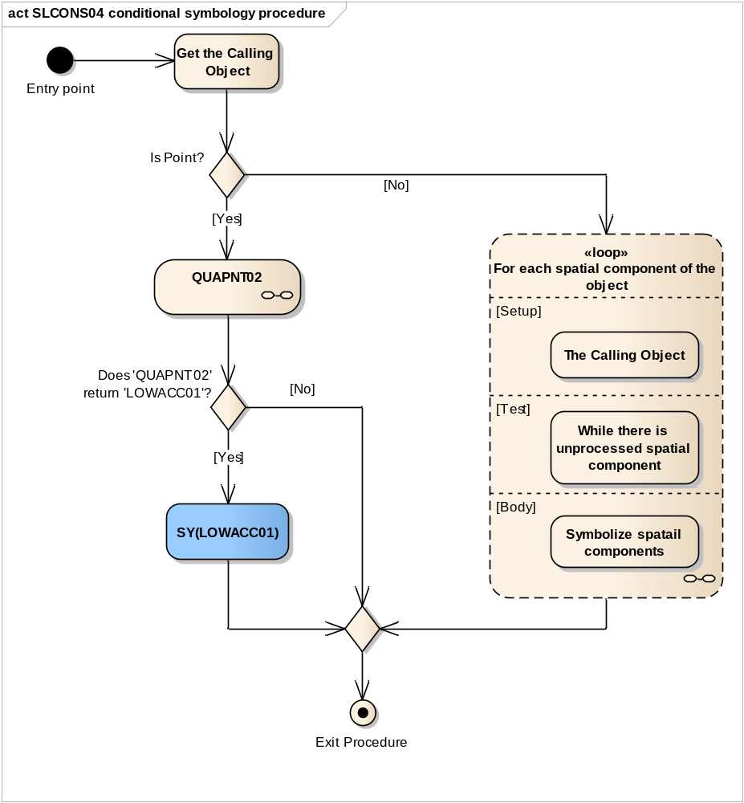
Entry point | The calling Shoreline Construction object.
Is Point? | Is the calling object type Point?
QUAPNT02 | Perform the symbology procedure 'QUAPNT02' which returns a flag indicating whether or not to display the low accuracy symbol and returns the selected symbol 'LOWACC01'. It happens if the attribute 'QUAPOS' of the spatial object equal one of the following values: '2', '3', '4', '5', '6', '7', '8' or '9'.
Calling Object | Input parameter
LOWACC01 | Output parameter
Does 'QUAPNT02' return 'LOWACC01'? | Is the symbol 'LOWACC01' selected by the procedure 'QUAPNT02'?
SY(LOWACC01) | If so indicated by the procedure 'QUAPNT02', draw the returned low accuracy symbol 'LOWACC01' at the calling object's location in the viewing group 31011
Loop for each spatial component of the object | Loop for each spatial component of the calling object:  Setup - The Calling Object.  Test - While there is unprocessed spatial component  Body - Symbolize spatial components
Exit Procedure | Symbolization is finished

Figure 31 Loop for each spatial component of area and line SLCONS object
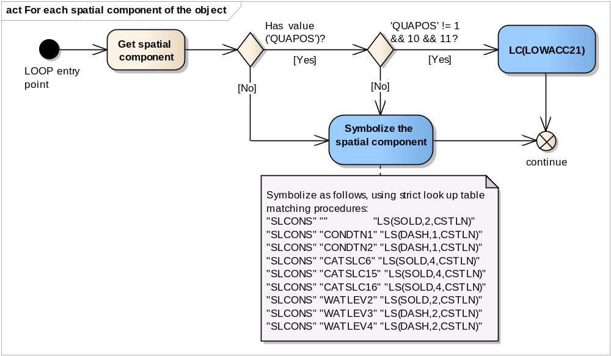
LOOP entry point | Spatial components of the calling object.
Get spatial component | Get the next spatial component of the calling object.
Has value ('QUAPOS')? | Is the value of the attribute 'QUAPOS' given?
'QUAPOS' != 1 && 10 && 11? | Does the value of attribute 'QUAPOS' equal to neither of the following values: '1', '10', and '11'?
LC(LOWACC21) | Draw spatial component with line pattern 'LOWACC21'
Symbolize the spatial component | Symbolize the spatial component with as follows, using strict look up table matching procedures:  "SLCONS" "" "LS(SOLD,2,CSTLN)"  "SLCONS" "CONDTN1" "LS(DASH,1,CSTLN)"  "SLCONS" "CONDTN2" "LS(DASH,1,CSTLN)"  "SLCONS" "CATSLC6" "LS(SOLD,4,CSTLN)"  "SLCONS" "CATSLC15" "LS(SOLD,4,CSTLN)"  "SLCONS" "CATSLC16" "LS(SOLD,4,CSTLN)"  "SLCONS" "WATLEV2" "LS(SOLD,2,CSTLN)"  "SLCONS" "WATLEV3" "LS(DASH,2,CSTLN)"  "SLCONS" "WATLEV4" "LS(DASH,2,CSTLN)"
continue | Go to the next spatial component of the object.

13.2.15 Conditional Symbology Procedure SEABED01

(Note that this is a sub-procedure called by DEPAREnn)
Applies to: Symbolization of areas that form the seabed
Remarks: This conditional procedure will create a Colour fill for depth areas (S-57)
Spatial Object(s): Area
Parameter(s):
- DRVAL1 (minimum depth) passed from calling procedure
- DRVAL2 (maximum depth) passed from calling procedure
- SHALLOW_CONTOUR depth value selected by the mariner
- SAFETY_CONTOUR depth value selected by the mariner
- DEEP_CONTOUR depth value selected by the mariner
Required User parameters: The following ECDIS user parameters are required in the procedure. The manufacturer is responsible for setting default values as shown in square brackets.:
- SHALLOW_CONTOUR = 2.0 [2 metres] (referred to as “SHC” in the diagrams).
- DEEP_CONTOUR = 30.0 [30 metres]
- SAFETY_CONTOUR = 30.0 [30 metres] (referred to as “SFC” in the diagrams)
- TWO_SHADES [default = on] - flag selected by the mariner (TWO_SHADES 'on' draws 2 depth area colour shades, 'off' draws 4)
- SHALLOW_PATTERN = [default = off] - flag selected by the mariner («optional»)
The default values should stay in operation until the mariner decides to select other parameters.
Note: The requirement to show four depth shades is not mandatory. However the requirement to for ECDIS to have the ability to display the shallow pattern is now mandatory.
In addition the following local variables are used by the procedure:
- COLOUR
- SHALLOW
Figure 32 SEABED01(DRVAL1,DRAVL2) conditional symbology sub-procedure
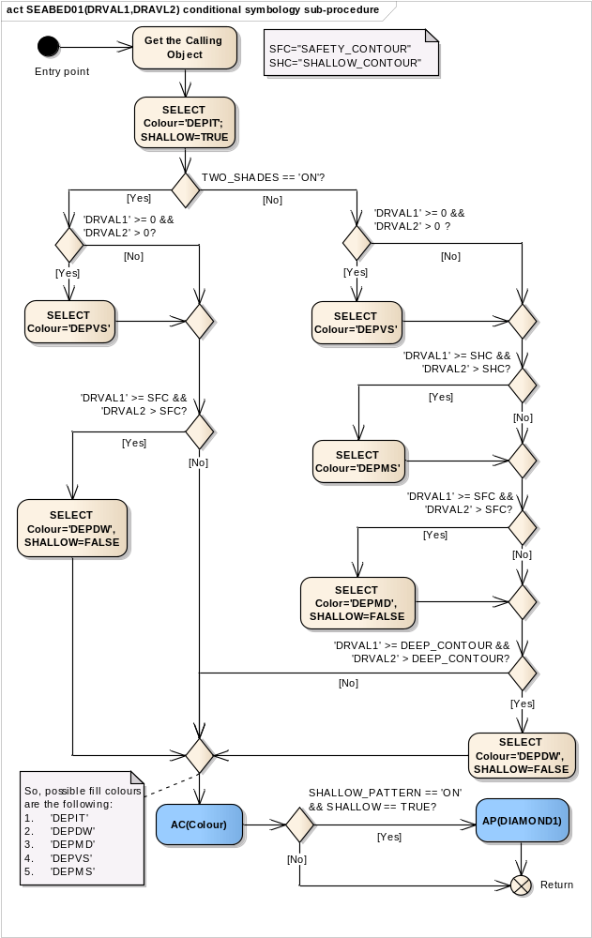
Entry point | Entry from the calling conditional procedure.  DRVAL1 and DRVAL2 are passed from the calling procedure
Get the Calling Object | Get the object which is calling main procedure DEPARE03 and input parameters DRVAL1 and DRVAL2
TWO_SHADES == 'ON'? | Has the mariner selected the 'two-colour shading' for depth zones?
'DRVAL1' >= 0 && 'DRVAL2' > 0? | Is 'DRVAL1' greater than or equal to '0' metres (low water line) and is 'DRVAL2' greater than '0' metres?
SELECT Colour='DEPVS' | Select colour name 'DEPVS'
'DRVAL1' >= SFC && 'DRVAL2 > SFC? | Is 'DRVAL1' greater than or equal to the value of the 'SAFETY CONTOUR' as selected by the mariner and is 'DRVAL2' greater than the value of the 'SAFETY CONTOUR'?
SELECT Colour='DEPDW', SHALLOW=FALSE | Select colour name 'DEPDW' and set local variable SHALLOW equal to 'FALSE'
SELECT Colour='DEPIT'; SHALLOW=TRUE | Select colour name 'DEPIT' (intertidal area) and set local variable SHALLOW equal to 'TRUE'.
'DRVAL1' >= 0 && 'DRVAL2' > 0 ? | Is 'DRVAL1' greater than or equal to '0' metres (low water line) and is 'DRVAL2' greater than '0' metres?
SELECT Colour='DEPVS' | Select colour name 'DEPVS'
'DRVAL1' >= SHC && 'DRVAL2' > SHC? | Is 'DRVAL1' greater than or equal to the value of the 'SHALLOW CONTOUR' as selected by the mariner and is 'DRVAL2' greater than the value of the 'SHALLOW CONTOUR'?
SELECT Colour='DEPMS' | Select colour name 'DEPMS'
'DRVAL1' >= SFC && 'DRVAL2' > SFC? | Is 'DRVAL1' greater than or equal to the value of the 'SAFETY CONTOUR' as selected by the mariner and is 'DRVAL2' greater than the value of the 'SAFETY CONTOUR'?
SELECT Color='DEPMD', SHALLOW=FALSE | Select colour name 'DEPMD' and set local variable SHALLOW=FALSE
'DRVAL1' >= DEEP_CONTOUR && 'DRVAL2' > DEEP_CONTOUR? | Is 'DRVAL1' greater than or equal to the value of the DEEP_CONTOUR as selected by the mariner and is 'DRVAL2' greater than the value of the DEEP_CONTOUR?
SELECT Colour='DEPDW', SHALLOW=FALSE | Select colour name 'DEPDW' and set local variable SHALLOW=FALSE
AC(Colour) | Draw the area object with an opaque colour fill.  Use the colour which was selected last.
SHALLOW_PATTERN == 'ON' && SHALLOW == TRUE? | Has the mariner decided to make shallow areas more prominent ('SHALLOW_PATTERN' on) and is 'SHALLOW' set to true?
AP(DIAMOND1) | Draw the fill pattern 'DIAMOND1' from the symbol library and show it on top of the area's colour fill.
Return | Return to the calling procedure

13.2.16 Conditional Symbology Procedure SNDFRM04
(Note that this is a sub-procedure called by SOUNDGnn, OBSTRNnn, and WRECKSnn)
Applies to: Symbolization of depth values. It formats the passed value into a sounding form.
Spatial Object(s): Point
Parameter(s):
- DEPTH_VALUE passed from calling procedure;
- QUAPOS of the spatial objects and QUASOU, TECSOU and STATUS of the object that are calling the main procedure
Required ECDIS parameters: SAFETY_DEPTH selected by the mariner The manufacturer is responsible for setting the SAFETY_DEPTH to 30 meters (see also conditional symbology procedures "DEPAREnn" and "DEPCNTnn"). This value should stay in operation until the mariner decides to select another safety depth.
Remarks: Soundings differ from plain text because they have to be readable under all circumstances and their digits are placed according to special rules and according to the location of the feature object. This conditional symbology procedure accesses a set of carefully designed sounding symbols provided by the symbol library and compiles them into sounding labels. It also symbolizes swept depth and special symbols representing low reliability as indicated by attributes QUASOU, TECSOU, STATUS and QUAPOS.

Figure 33 SNDFRM04 conditional symbology sub-procedure
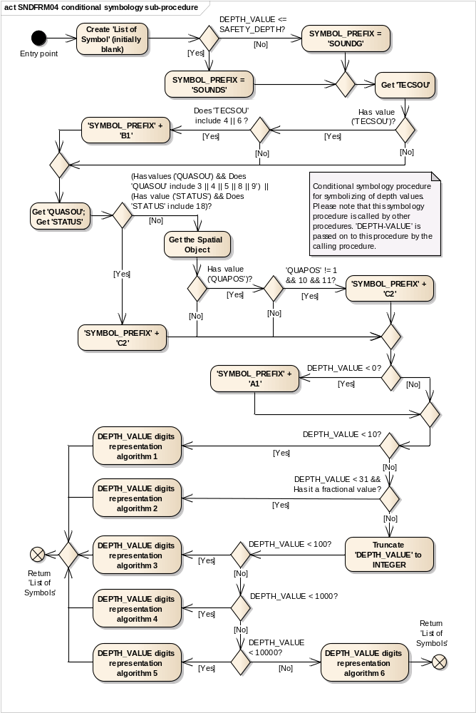
Entry point | 'DEPTH_VALUE' is passed on to this procedure by the calling procedure.
Create 'List of Symbol' (initially blank) | Create 'List of Symbols' to be presented at the position of the sounding  This list is initially blank.
DEPTH_VALUE <= SAFETY_DEPTH? | Is the DEPTH_VALUE equal or LESS than the value of 'SAFETY_DEPTH' that was selected by the mariner?
SYMBOL_PREFIX = 'SOUNDS' | Set local variable 'SYMBOL_PREFIX' to 'SOUNDS' (SOUNDing - Shallow).  (Note: all sounding symbols with dominant colour have that prefix).  [IMO PS 3.7]
SYMBOL_PREFIX = 'SOUNDG' | Set local variable 'SYMBOL_PREFIX' to 'SOUNDG'. (SOUNDing - General)  (Note: all sounding symbols with faint colour have that prefix).
Get 'TECSOU' | Get the value of the calling object's attribute 'Technique of sounding measurement' (TECSOU).
Has value ('TECSOU')? | Is the value of the attribute 'TECSOU' given?
Does 'TECSOU' include 4 || 6 ? | Does the attribute 'TECSOU' include '4' (found by diver) or '6' (swept depth)?
'SYMBOL_PREFIX' + 'B1' | Create symbol name: 'SYMBOL_PREFIX' + 'B1' (i.e. 'SOUNDSB1' or 'SOUNDGB1').  Add this symbol name to the list of symbols to be presented.
Get 'QUASOU'; Get 'STATUS' | Get the value of the object's attributes 'QUASOU' and 'STATUS'.  (Attribute 'QUAPOS' is on the spatial object).
(Has values ('QUASOU') && Does 'QUASOU' include 3 || 4 || 5 || 8 || 9') ||  (Has value ('STATUS') && Does 'STATUS' include 18)? | Is the value of the attribute 'QUASOU' given and does it include '3','4','5','8' or '9' AND/OR  Is the value of the attribute 'STATUS' given and does it include '18' (uncertain sounding)?
'SYMBOL_PREFIX' + 'C2' | Create symbol name: 'SYMBOL_PREFIX' + 'C2' (i.e. SOUNDSC2' or 'SOUNDGC2').  Add this symbol to the 'List of symbols' to be presented.
Get the Spatial Object | Get the corresponding spatial object of the calling object.
Has value ('QUAPOS')? | Is the value of the attribute 'QUAPOS' given?
'QUAPOS' != 1 && 10 && 11? | Does the value of attribute 'QUAPOS' equal to neither of the following values: '1', '10', and '11'?
'SYMBOL_PREFIX' + 'C2' | Create symbol name: 'SYMBOL_PREFIX' + 'C2' (i.e. SOUNDSC2' or 'SOUNDGC2').  Add this symbol to the 'List of symbols' to be presented.
DEPTH_VALUE < 0? | Is 'DEPTH_VALUE' less than zero meters?
'SYMBOL_PREFIX' + 'A1' | Create symbol name: 'SYMBOL_PREFIX' + 'A1' (i.e. SOUNDSA1').  Add this symbol to the 'List of symbols' to be presented.
DEPTH_VALUE < 10? | Is 'DEPTH_VALUE' less than 10 meters?
DEPTH_VALUE digits representation algorithm 1 | Isolate 'LEADING_DIGIT' of 'DEPTH_VALUE'.  Set 'LEADING_DIGIT' to positive value.  Create symbol name by adding '10' + 'LEADING_DIGIT' to 'SYMBOL_PREFIX' (e.g. 3.6 metres - isolate the '3' and create either 'SOUNDS13' or 'SOUNDG13').  Add this symbol name to the list of symbols to be presented.  Isolate 'FRACTION' of 'DEPTH_VALUE' and multiply by 10.  Truncate all digits after the decimal. Do not round up. Create symbol name by adding '50' + 'FRACTION' to 'SYMBOL_PREFIX' (e.g. 3.6 metres - isolate the '6' and create either 'SOUNDS56' or 'SOUNDG56').  Add this symbol name to the list of symbols to be presented.
DEPTH_VALUE < 31 && Has it a fractional value? | Is 'DEPTH_VALUE' less than 31 metres and has it a fractional value?  (Note: common practice in hydrography is to show fractions of a depth value up to 30 metres depth)
DEPTH_VALUE digits representation algorithm 2 | Isolate 'LEADING_DIGIT' of 'DEPTH_VALUE'.  Create symbol name by adding '20' + 'LEADING_DIGIT' to 'SYMBOL_PREFIX' (e.g. 26.7 metres - isolate the '2' and create either 'SOUNDS22' or 'SOUNDG22').  Add this symbol name to the list of symbols to be presented.  Isolate 'SECOND_DIGIT' of 'DEPTH_VALUE'.  Create symbol name by adding '10' + 'SECOND_DIGIT' to 'SYMBOL_PREFIX' (e.g. 26.7 metres - isolate the '6' and create either 'SOUNDS16' or 'SOUNDG16').  Add this symbol name to the list of symbols to be presented.  Isolate 'FRACTION' of 'DEPTH_VALUE' and multiply by 10.  Truncate all digits after the decimal. Do not round up. Create symbol name by adding '50' + 'FRACTION' to 'SYMBOL_PREFIX' (e.g. 26.7 metres - isolate the '7' and create either 'SOUNDS57' or 'SOUNDG57').  Add this symbol name to the list of symbols to be presented.
Truncate 'DEPTH_VALUE' to INTEGER | Truncate 'DEPTH_VALUE' to integer. Do not round up
DEPTH_VALUE < 100? | Is 'DEPTH_VALUE' less than 100 meters?
DEPTH_VALUE digits representation algorithm 3 | Isolate 'LEADING_DIGIT' of 'DEPTH_VALUE'.  Create symbol name by adding '10' + 'LEADING_DIGIT' to 'SYMBOL_PREFIX'.  Add this symbol name to the list of symbols to be presented.  Isolate 'SECOND_DIGIT' of 'DEPTH_VALUE'.  Create symbol name by adding '00' + 'SECOND_DIGIT' to 'SYMBOL_PREFIX'.  Add this symbol name to the list of symbols to be presented.
DEPTH_VALUE < 1000? | Is 'DEPTH_VALUE' less than 1000 meters?
DEPTH_VALUE digits representation algorithm 4 | Isolate 'LEADING_DIGIT' of 'DEPTH_VALUE'.  Create symbol name by adding '20' + 'LEADING_DIGIT' to 'SYMBOL_PREFIX'.  Add this symbol name to the list of symbols to be presented.  Isolate 'SECOND_DIGIT' of 'DEPTH_VALUE'.  Create symbol name by adding '10' + 'SECOND_DIGIT' to 'SYMBOL_PREFIX'.  Add this symbol name to the list of symbols to be presented.  Isolate 'LAST_DIGIT' of 'DEPTH_VALUE'.  Create symbol name by adding '00' + 'LAST_DIGIT' to 'SYMBOL_PREFIX'.  Add this symbol name to the list of symbols to be presented.
DEPTH_VALUE < 10000? | Is 'DEPTH_VALUE' less than 10 000 meters?
DEPTH_VALUE digits representation algorithm 5 | Isolate 'LEADING_DIGIT' of 'DEPTH_VALUE'.  Create symbol name by adding '20' + 'LEADING_DIGIT' to 'SYMBOL_PREFIX'.  Add this symbol name to the list of symbols to be presented.  Isolate 'SECOND_DIGIT' of 'DEPTH_VALUE'.  Create symbol name by adding '10' + 'SECOND_DIGIT' to 'SYMBOL_PREFIX'.  Add this symbol name to the list of symbols to be presented.  Isolate 'THIRD_DIGIT' of 'DEPTH_VALUE'.  Create symbol name by adding '00' + 'THIRD_DIGIT' to 'SYMBOL_PREFIX'.  Add this symbol name to the list of symbols to be presented.  Isolate 'LAST_DIGIT' of 'DEPTH_VALUE'.  Create symbol name by adding '40' + 'LAST_DIGIT' to 'SYMBOL_PREFIX'.  Add this symbol name to the list of symbols to be presented.
Return 'List of Symbols' | Return to the calling procedure with the 'List of Symbols' which were selected.
DEPTH_VALUE digits representation algorithm 6 | Isolate 'LEADING_DIGIT' of 'DEPTH_VALUE'.  Create symbol name by adding '30' + 'LEADING_DIGIT' to 'SYMBOL_PREFIX'.  Add this symbol name to the list of symbols to be presented.  Isolate 'SECOND_DIGIT' of 'DEPTH_VALUE'.  Create symbol name by adding '20' + 'SECOND_DIGIT' to 'SYMBOL_PREFIX'.  Add this symbol name to the list of symbols to be presented.  Isolate 'THIRD_DIGIT' of 'DEPTH_VALUE'.  Create symbol name by adding '10' + 'THIRD_DIGIT' to 'SYMBOL_PREFIX'.  Add this symbol name to the list of symbols to be presented.  Isolate 'FOURTH_DIGIT' of 'DEPTH_VALUE'.  Create symbol name by adding '00' + 'FOURTH_DIGIT' to 'SYMBOL_PREFIX'.  Add this symbol name to the list of symbols to be presented.  Isolate 'LAST_DIGIT' of 'DEPTH_VALUE'.  Create symbol name by adding '40' + 'LAST_DIGIT' to 'SYMBOL_PREFIX'.  Add this symbol name to the list of symbols to be presented.
Return 'List of Symbols' | Return to the calling procedure with the 'List of Symbols' which were selected.

12.2.17 Conditional Symbology Procedure SOUNDG03

Applies to: S-57 Object Class "soundings" (SOUNDG)
Spatial Object(s): 3D Edge (the array of points with three coordinates)
ECDIS Parameter(s):
Defaults: Display Priority given by look-up table;
OVERRADAR priority given by look-up table;
Display Category given by look-up table;
Viewing group given by look-up table.
Remarks: In S-57 soundings are elements of sounding arrays rather than individual objects. Thus this conditional symbology procedure examines each sounding of a sounding array one by one. To symbolize the depth values it calls the procedure SNDFRM04 which in turn translates the depth values into a set of symbols to be shown at the soundings position.
Figure 34 SOUNDG03 conditional symbology procedure
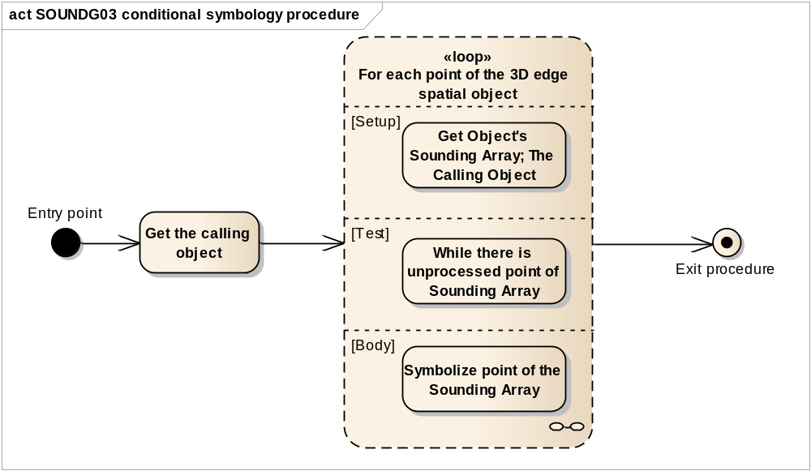
Entry point | The calling object SOUNDG
Get the calling object | Get the object which is calling this procedure.
Loop for each point of the 3D edge spatial object | Perform the loop for each spot sounding that is point (vertex) of the 3D edge spatial object.  Setup - Get Object's Sounding Array; The Calling Object.  Test - While there is unprocessed point of Sounding Array  Body - Symbolize point of the Sounding Array
Exit procedure | Symbolization is finished

Figure 35 Loop for each Spot Sounding
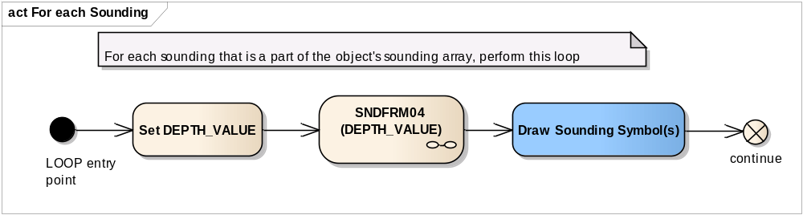
LOOP entry point | For each sounding that is a part of the object's sounding array, perform this loop
Set DEPTH_VALUE | Get the depth value of the spot sounding from 3D edge vertex of the spatial object that is currently examined and set it to the local variable DEPTH_VALUE.
SNDFRM04 (DEPTH_VALUE) | Perform the symbology sub-procedure 'SNDFRM04 to select symbols to draw the depth value.  Pass the value of the local variable DEPTH_VALUE, the calling object and attributes of spatial objects on to 'SNDFRM04'.  A list of symbols is returned
DEPTH_VALUE | Input parameter
Sounding Symbols List | Output parameter
Draw Sounding Symbol(s) | Draw the symbols which were selected by 'SNDFRM04'. Place them at the position which is given by the currently examined spot sounding.
continue | Go to the next point of the 3D Edge spatial object.

13.2.18 Conditional Symbology Procedure SYMINS02

Applies to: S-57 (Edition 3.1.1) Object Class "New Object" (NEWOBJ)
Attribute used: "Symbol Instruction" (SYMINS)
Parameter(s): Object to be symbolized from SENC
Defaults: Display Priority given by look-up table, OVERRADAR priority given by look-up table, Display Category given by look-up table, Viewing Group given by look-up table, Area colour fill from underlying DEPARE or UNSARE
Remarks: The ‘New Object’ feature object class has been included in order to cater for possible future requirements of the IMO that affects safety of navigation which cannot adequately be encoded by any existing object class. It shall not be used unless approved by the Transfer Standard Maintenance and Application Development Working Group (TSMAD) and the Colours and Symbols Maintenance Working Group (CSMWG) and issued as an ENC Encoding Bulletin.
Figure 36 SYMINS02 conditional symbology procedure
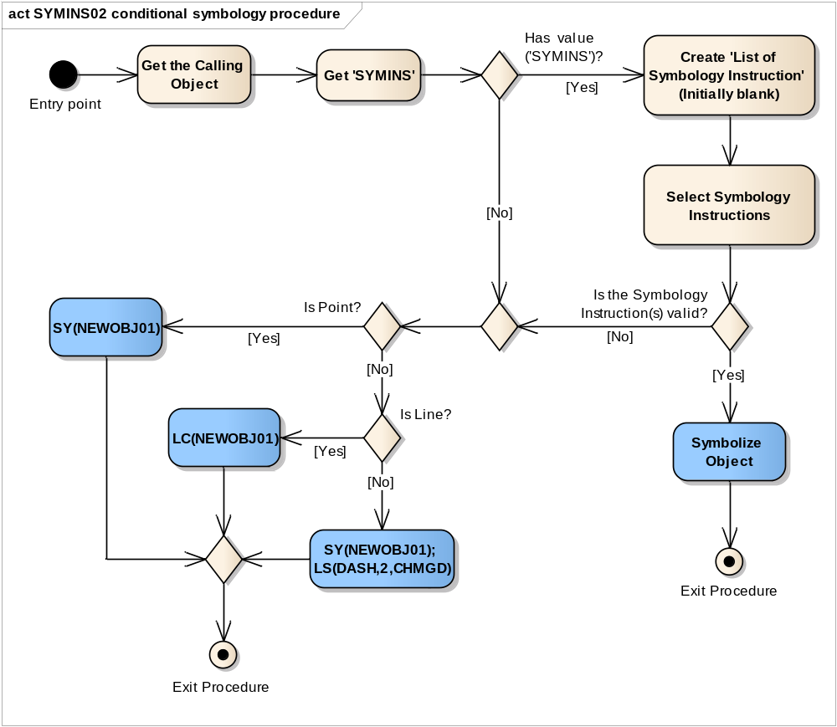
Entry point | Entry to the symbology procedure with the calling 'New Object'
Get the Calling Object | Get the object which is calling this procedure
Get 'SYMINS' | Get the value of the attribute 'Symbol Instruction' (SYMINS)
Has value ('SYMINS')? | Is the value of the attribute 'SYMINS' given?
Create 'List of Symbology Instruction' (Initially blank) | Create 'List of Symbology Instructions' to be presented at the position of the calling object. This list is initially blank.
Select Symbology Instructions | Select Symbology instruction(s) from the value of 'SYMINS' to the 'List of Symbology Instructions'.  There can be: AC(); AP(); LS(); LC(); SY(); TX(); TE().  The symbology instructions have to be added to the list in the order as they are in the SYMINS attribute value.  The symbology instruction must not be added in selected list if:  - it is not recognized as symbology instruction;  - it calls a invalid symbology name;  - it has invalid symbology parameters;  - it cannot be implemented for the calling object geometry (e.g. line symbology instructions for point object and etc.)
Is the Symbology Instruction(s) valid? | Is the List of Symbiology Instructions empty?  (i.e. the previous Action could not select the correct symbology instructions from the value of 'SYMINS').
Symbolize Object | Using the selected Symbology Instruction(s) from the list to symbolize the calling object according to its geometry.  Point symbolization (i.e. SY(), TX() and TE()) have to be drawn in the middle point of the line or in the area center of the calling object.
Exit Procedure | Symbolization is finished
Is Point? | Is the object of type point?
SY(NEWOBJ01) | Draw the symbol 'NEWOBJ01' at the location of the calling object.
Is Line? | Is the object of type line?
LC(NEWOBJ01) | Symbolize area boundary with the line pattern 'NEWOBJ01'.
SY(NEWOBJ01); LS(DASH,2,CHMGD) | Draw the symbol 'NEWOBJ01' in the centre of the calling area object.  Draw the area boundary as a dashed line, 2 units wide, in the colour 'CHMGD'.
Exit Procedure | Exit from the procedure with default symbolization

13.2.19 Conditional Symbology Procedure TOPMAR01

Applies to: S-57 Object Class "top mark" (TOPMAR)
Spatial Object(s): Point
Relation(s) used: Point objects at identical location
Attribute(s) used: "shape of topmark" (TOPSHP)
Parameter(s): Object to be symbolized from SENC
Defaults: Display Priority given by look-up table
OVERRADAR priority given by look-up table
Display Category given by look-up table
Viewing Group given by look-up table.
This procedure is only used in traditional symbology – the simplified symbology does not have separate topmark display.
Remarks: Topmark objects are to be symbolized through consideration of their platforms e.g. a buoy. Therefore this conditional symbology procedure searches for platforms by looking for other objects that are located at the same position.. Based on the finding whether the platform is rigid or floating, the respective upright or sloping symbol is selected and presented at the objects location. Buoy symbols and topmark symbols have been carefully designed to fit to each other when combined at the same position. The result is a composed symbol that looks like the traditional symbols the mariner is used to.

Figure 37 TOPMAR01 conditional symbology procedure
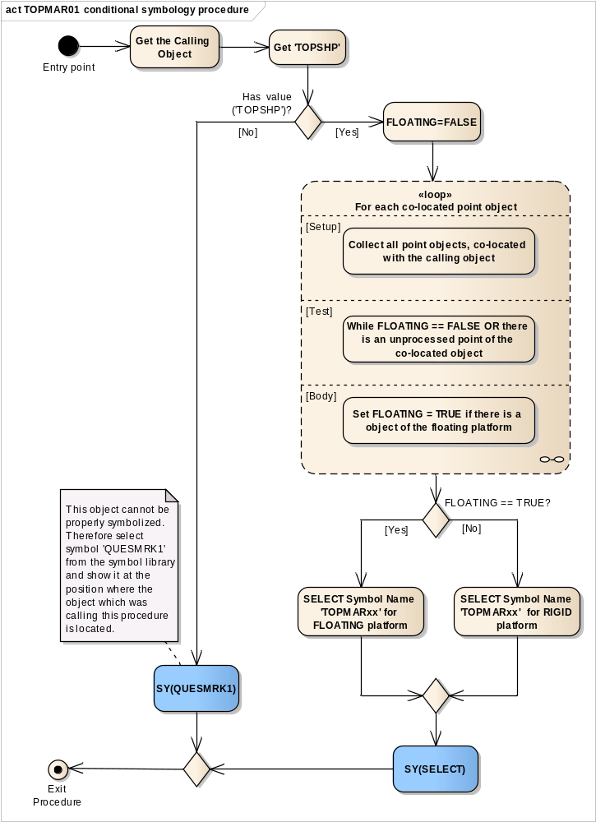
Entry point | Entry to the symbology procedure with the calling 'Topmark'
Get the Calling Object | Get the object which is calling the procedure.
Get 'TOPSHP' | Get the value of the object's attribute 'Topmark/daymark shape' (TOPSHP).
Has value ('TOPSHP')? | Is the value of the attribute 'TOPSHP' given?
SY(QUESMRK1) | If ‘No’, this object cannot be properly symbolized therefore draw symbol 'QUESMRK1' from the symbol library at the position where the object which was calling this procedure is located.
FLOATING=FALSE | Set local variable 'FLOATING' equal to FALSE as default value.  It means there is one of the following object of the rigid platform: 'BCN...', 'BRIDGE', 'BUISGL','DAYMAR', 'LNDMRK', 'MORFAC without CATMOR=7', 'OFSPLF', 'PILPNT', 'SLCONS', 'CRANES', 'FLODOC', 'FORSTC', 'FSHFAC', 'HULKES', 'PONTON', 'OBSTRN', 'PYLONS', 'SILTNK' and 'WRECKS'.
Loop for each co-located point object | Loop for each point object which is located at the same position as the object which is calling this procedure. the value of local variable 'FLOATING' is returned.  Setup - Collect all point objects, co-located with the calling object;  Test –While FLOATING == FALSE OR there is an unprocessed point of the co-located object;  Body - Set FLOATING = TRUE if there is a object of the floating platform
FLOATING == TRUE? | Is the object with a topmark sitting on top of a floating platform ('FLOATING' equals 'TRUE')?
SELECT='TOPMARxx' for FLOATING platform | Select appropriate symbol name depends on the attribute 'TOPSHP' value for floating platform a buoys, light float or Light vessel, see table below
SELECT='TOPMARxx' for RIGID platform | Select appropriate symbol name depends on the attribute 'TOPSHP' value for rigid platform a beacons, day marks or land marks or etc. see table below

TOPSHP Value | FLOATING Symbol Name | RIGID Symbol Name
1 | TOPMAR02 | TOPMAR22
2 | TOPMAR04 | TOPMAR24
3 | TOPMAR10 | TOPMAR30
4 | TOPMAR12 | TOPMAR32
5 | TOPMAR13 | TOPMAR33
6 | TOPMAR14 | TOPMAR34
7 | TOPMAR65 | TOPMAR85
8 | TOPMAR17 | TOPMAR86
9 | TOPMAR16 | TOPMAR36
10 | TOPMAR08 | TOPMAR28
11 | TOPMAR07 | TOPMAR27
12 | TOPMAR14 | TOPMAR14
13 | TOPMAR05 | TOPMAR25
14 | TOPMAR06 | TOPMAR26
15 | TMARDEF2 | TOPMAR88
16 | TMARDEF2 | TOPMAR87
17 | TMARDEF2 | TMARDEF1
18 | TOPMAR10 | TOPMAR30
19 | TOPMAR13 | TOPMAR33
20 | TOPMAR14 | TOPMAR34
21 | TOPMAR13 | TOPMAR33
22 | TOPMAR14 | TOPMAR34
23 | TOPMAR14 | TOPMAR34
24 | TOPMAR02 | TOPMAR22
25 | TOPMAR04 | TOPMAR24
26 | TOPMAR10 | TOPMAR30
27 | TOPMAR17 | TOPMAR86
28 | TOPMAR18 | TOPMAR89
29 | TOPMAR02 | TOPMAR22
30 | TOPMAR17 | TOPMAR86
31 | TOPMAR14 | TOPMAR14
32 | TOPMAR10 | TOPMAR30
33 | TMARDEF2 | TMARDEF1
Default | TMARDEF2 | TMARDEF1

SY(SELECT) | Draw the selected symbol at the calling object's location.
Exit Procedure | Symbolization is finished

Figure 38 Loop for each co-located point object
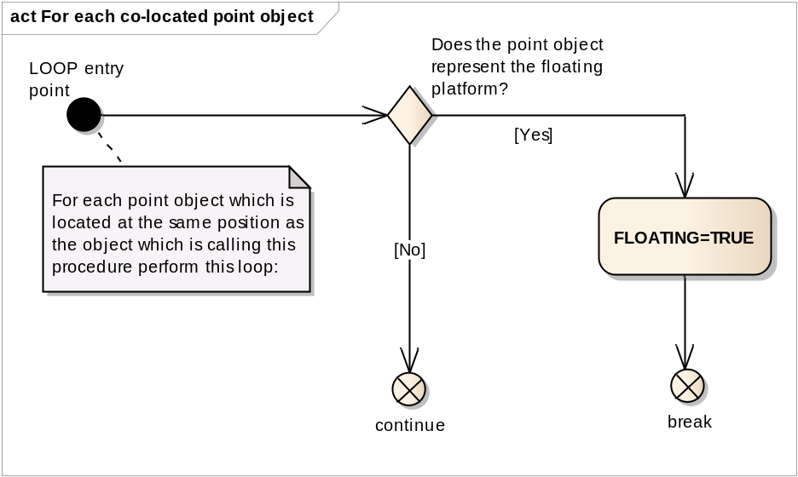
LOOP entry point | The point object which is located at the same position as the object which is calling this procedure.
Does the point object represent the floating platform? | Is the point object of a class which represents a floating platform: 'LITFLT', 'LITVES' or 'BOY...' or MORFAC with CATMOR=7?
continue | If ‘No’, get the next point object
FLOATING=TRUE | Set the local variable 'FLOATING' equal to TRUE.
break | Stop examining point objects at the same location.

13.2.20 Conditional Symbology Procedure UDWHAZ05

Applies to: Underwater hazards of all kinds encoded by S-57 Object Class: “obstruction” (OBSTRN), “underwater rock” (UWTROC) and “wreck” (WRECKS).
Spatial Object(s): Point, Line, Area
Spatial Operations used: adjacency, intersection or coverage of areas and areas with line; location of point objects within areas
Attribute(s) used: "depth range value1" (DRVAL1); water level effect (WATLEV)
ECDIS Parameter(s): SAFETY_CONTOUR (SFC) depth value selected by the mariner;
DEPTH_VALUE passed in by calling procedure.
SHOW_ISOLATED_DANGERS_IN_SHALLOW_WATERS (sub procedure?).
The manufacturer is responsible for setting the SAFETY_CONTOUR to 30 meters (see also conditional symbology procedure “DEPAREnn”). This value should stay in operation until the mariner decides to select another safety contour.
Defaults: Display Priority given by look-up table;
OVERRADAR priority given by look-up table;
Display Category given by look-up table;
Viewing Group given by look-up table.
Remarks: This procedure covers “Isolated dangers in general that endanger own ship (S-57)” (def?) (Note that this is a sub procedure called by OBSTRNnn and WRECKSnn). Obstructions or isolated underwater dangers of depths less than the safety contour which lie within the safe waters defined by the safety contour are to be presented by a specific isolated danger symbol as hazardous objects. They are then put in IMO category “DISPLAY BASE” (see IMO Performance Standards for ECDIS [2]).
In addition, if the mariner selects the option "show isolated dangers in shallow water", this procedure will highlight with the isolated danger symbol all rocks, wrecks, obstructions, which lie in 'unsafe' shallow waters between the safety contour and the drying line, putting them in IMO category STANDARD. This option is provided in case the mariner is forced by circumstances to navigate in waters shallower than the safety contour shown on the display (for example, if the safety contour should default to a value much deeper than that preferred by the mariner).
Note: In this procedure the term “safety contour” refers to the safety contour selected by the mariner, as distinct from the safety contour shown on the display (which may be a default value).
Figure 39 UDWHAZ05 conditional symbology sub-procedure
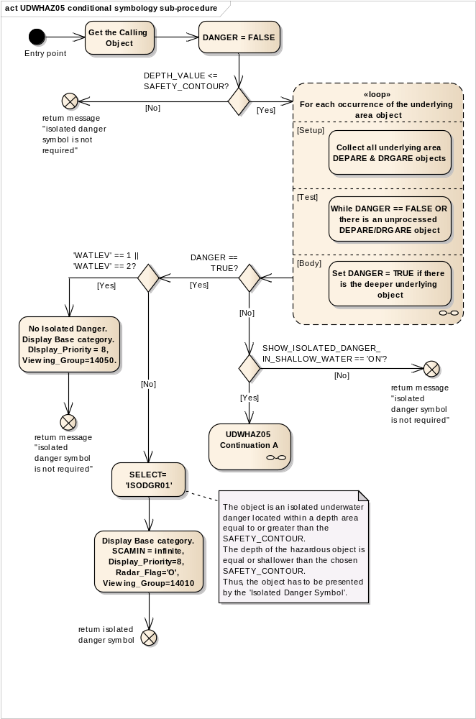
Entry point | The calling object and the local variable 'DEPTH_VALUE' are passed from the calling procedure.
Get the Calling Object | Get the object which is calling this procedure
DANGER = FALSE | Set the local variable 'DANGER', which will indicate is the object is an isolated danger or not, to 'FALSE'.
DEPTH_VALUE <= SAFETY_CONTOUR? | Is 'DEPTH_VALUE' less than or equal to the value of the SAFETY_CONTOUR selected by the mariner?
return message "isolated danger symbol is not required" | If ‘No’, return to the calling procedure with the message that Isolated Danger Symbol is not required.
Loop for each occurrence of the underlying area object | For each occurrence of the object classes 'DEPARE' and 'DRGARE' which intersects or includes the location of this object, perform this loop to find out if it deeper than the Safety Contour. If so, it changes local variable 'DANGER' to TRUE  Setup - Collect all underlying area DEPARE & DRGARE objects;  Test - While DANGER == FALSE OR there is an unprocessed underlying DEPARE/DRGARE object;  Body - Set DANGER = TRUE if there is the deeper underlying object
DANGER == TRUE? | Is the local variable DANGER equal TRUE?
'WATLEV' == 1 || 'WATLEV' == 2? | Is the value of attribute 'WATLEV' 1 or 2 in the calling object?
No Isolated Danger.  Display Base category. DIsplay_Priority = 8, Viewing_Group=14050. | Object is an isolated above water danger, and is in own ship safe water and should be 'DISPLAYBASE' with no isolated danger symbol.
 | Display Category | DISPLAYBASE
 | Display Priority | 8
 | Viewing Group | 14050
return message "isolated danger symbol is not required" | Return to the calling procedure with the message that Isolated Danger Symbol is not required.
SELECT= 'ISODGR01' | The object is an isolated underwater danger located within a depth area equal to or greater than the safety contour.  The depth of the hazardous object is equal or shallower than the chosen Safety Contour.  Thus, the object has to be presented by the 'Isolated Danger Symbol'.  Select symbol name 'ISODGR01'
Display Base category. SCAMIN = infinite, Display_Priority=8, Radar_Flag='O', Viewing_Group=14010 | Set SCAMIN (minimum scale) attribute to infinite.
 | Display Category | DISPLAYBASE
 | Display Priority | 8
 | Radar Flag | OVERRADAR
 | Viewing Group | 14010
return isolated danger symbol | Return to the calling procedure with the message that Isolated Danger Symbol is to be drawn. Also return the selected symbol name and presentation parameters.
SHOW_ISOLATED_DANGER_ IN_SHALLOW_WATER == 'ON'? | Has the mariner selected 'SHOW_ISOLATED_DANGER_IN_SHALLOW_WATER' option?
UDWHAZ05 Continuation A | UDWHAZ05 Continuation A
return message "isolated danger symbol is not required" | Return to the calling procedure with the message that Isolated Danger Symbol is not required.

Figure 40 Loop for each occurrence of the underlying deep area object DEPARE,DRGARE
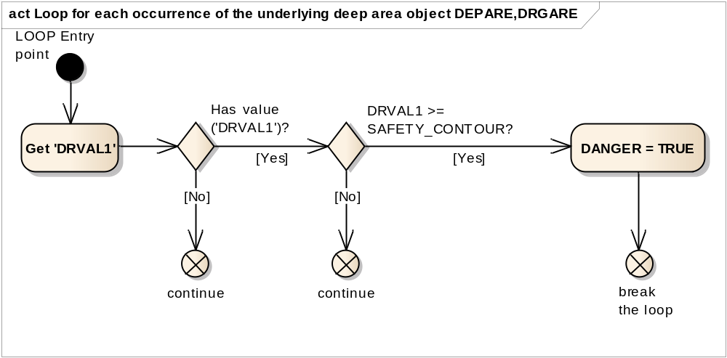
LOOP Entry point | The area DEPARE or DRGARE object which intersects or includes the location of the calling object.
Get 'DRVAL1' | Get the attribute 'DRVAL1' value of the examined object 'DEPARE' or 'DRGARE'.
Has value ('DRVAL1')? | Is the value of the attribute DRVAL1 given in the object DEPARE(DRGARE) ?
continue | Get the next object DEPARE or DRGARE which intersects or includes the location of the calling object because we consider empty 'DRVAL1' or <unknown> as always less than SAFETY_CONTOUR
DRVAL1 >= SAFETY_CONTOUR? | Is the value of the attribute 'DRVAL1' greater than or equal to the value of the SAFETY_CONTOUR?
continue | Get the next object DEPARE or DRGARE which intersects or includes the location of the calling object because the current one is shallower SAFETY_CONTOUR.
DANGER = TRUE | Set value of the local variable DANGER equal to TRUE.
break the loop | Stop examining area objects. End loop.

Figure 41 UDWHAZ05 Continuation A
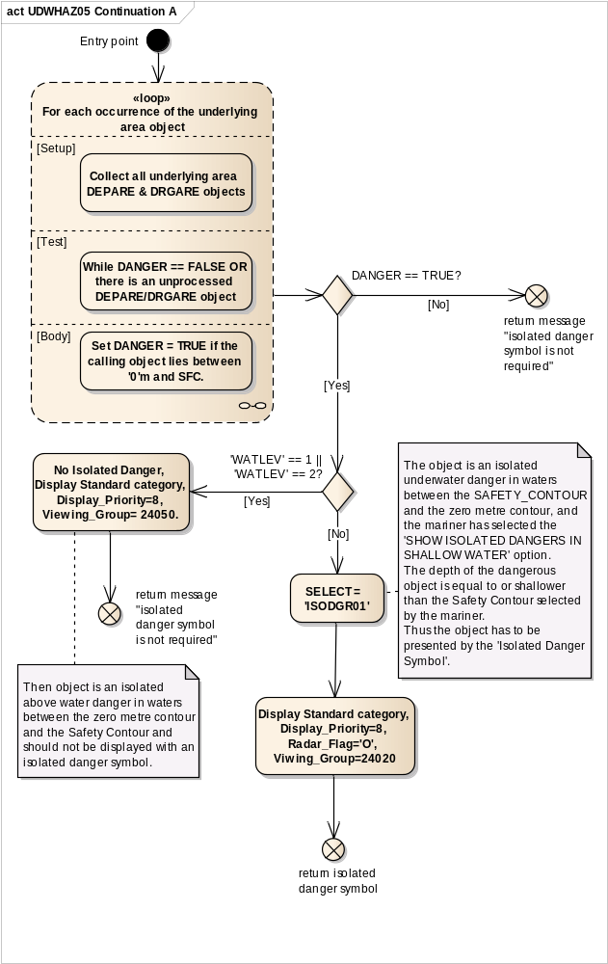
Entry point | The calling object and the local variable 'DANGER' are passed from the calling procedure.
Loop for each occurrence of the underlying area object | For each occurrence of the object classes 'DEPARE' and 'DRGARE' which intersects or includes the location of this object, perform this loop to find out if it lies between the zero metre contour and the Safety Contour.  Setup - Collect all underlying area DEPARE & DRGARE objects;  Test - While DANGER == FALSE OR there is an unprocessed underlying DEPARE/DRGARE object;  Body - Set DANGER = TRUE if the calling object lies between '0'm and SAFETY CONTOUR.
DANGER == TRUE? | Is the local variable DANGER equal TRUE?
return message "isolated danger symbol is not required" | If ‘No’, return to the calling procedure with the message that Isolated Danger Symbol is not required.
'WATLEV' == 1 || 'WATLEV' == 2? | Is the value of attribute 'WATLEV' equal to 1 or 2 in the calling object?
No Isolated Danger, Display Standard category, Display_Priority=8, Viewing_Group= 24050. | Then object is an isolated above water danger in waters between the zero metre contour and the Safety Contour and should not be displayed with an isolated danger symbol.
 | Display Category | STANDARD
 | Display Priority | 8
 | Viewing Group | 24050
return message "isolated danger symbol is not required" | Return to the calling procedure with the message that Isolated Danger Symbol is not required.
SELECT = 'ISODGR01' | The object is an isolated underwater danger in waters between the Safety Contour and the zero metre contour, and the mariner has selected the 'Show isolated dangers in shallow water' option.  The depth of the dangerous object is equal to or shallower than the Safety Contour selected by the mariner.  Thus the object has to be presented by the 'Isolated Danger Symbol'.
Display Standard category, Display_Priority=8, Radar_Flag='O', Viwing_Group=24020 | Set presentation parameters of the calling object :
 | Display Category | STANDARD
 | Display Priority | 8
 | Radar Flag | OVERRADAR
 | Viewing Group | 24020
return isolated danger symbol | Return to the calling procedure with the message that the Isolated Danger Symbol is to be shown. Also return the Selected symbol and the parameters of presentation.

Figure 42 Loop for each occurrence of the underlying shallow area object DEPARE, DRGARE
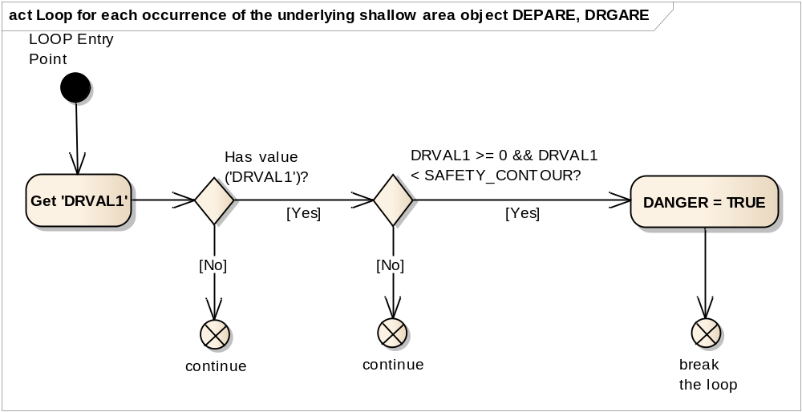
LOOP Entry Point | The area DEPARE or DRGARE object which intersects or includes the location of the calling object.
Get 'DRVAL1' | Get the attribute 'DRVAL1' value of the examined object 'DEPARE' or 'DRGARE'.
Has value ('DRVAL1')? | Is the value of the attribute 'DRVAL1' given in the object DEPARE(DRGARE) ?
continue | If there is no an explicit value, get the next underlying area object. If the attribute 'DRVAL1' presents but there is no a value, it means that is intertidal area.
DRVAL1 >= 0 &&  DRVAL1 < SAFETY_ CONTOUR? | Is the value of the attribute 'DRVAL1' greater than or equal to the ZERO metre contour and less than the SAFETY_CONTOUR?
continue | Get the next underlying area object because the current one is deeper than SAFETY_CONTOUR.
DANGER = TRUE | Object is an isolated danger. Set local variable 'DANGER' to TRUE.
break the loop | Stop examining area objects. End loop.

13.2.21 Conditional Symbology Procedure WRECKS05

Applies to: S-57 Object Class "wrecks" (WRECKS)
Spatial Object(s): Point, Area
Attribute(s) used: "value of sounding" (VALSOU); "category of wreck" (CATWRK); "water level" (WATLEV); "exposition of sounding" (EXPSOU)
User Parameter(s):
Defaults: Display Priority given by look-up table;
OVERRADAR priority given by look-up table;
Display Category given by look-up table;
Viewing Group given by look-up table;
Area colour fill from underlying DEPARE or UNSARE.
Remarks: Wrecks of depths less than the safety contour which lie within the safe waters defined by the safety contour are to be presented by a specific isolated danger symbol and put in IMO category “DISPLAY BASE” (see IMO Performance Standards for ECDIS [2]). This task is performed by the sub-procedure “UDWHAZnn” which is called by this symbology procedure.
CSP "UDWHAZnn" also allows the mariner the option of displaying isolated dangers in the waters between the safety contour and the zero metre line.
In the case that the value of attribute VALSOU for the wreck is unknown, sub-procedure "DEPVALnn” is called. This will provide a return value for 'LEAST_DEPTH', the default for which is the DRVAL1 of the underlying depth area, but only on condition that the value of attribute EXPSOU is not 2 (shoaler than the depth area) or unknown, and the value of attribute WATLEV is 3 (always underwater). For the case that a wreck of unknown VALSOU lies in deep water, sub-procedure 'DEPVAL' also provides the DRVAL1 of the underlying depth area as the 'SEABED_DEPTH' for use in calculating a 'safe clearance depth' over the wreck in accordance with IHO publication M-4 appendix to specification B-422.7.
Figure 43 WRECKS05 conditional symbology procedure
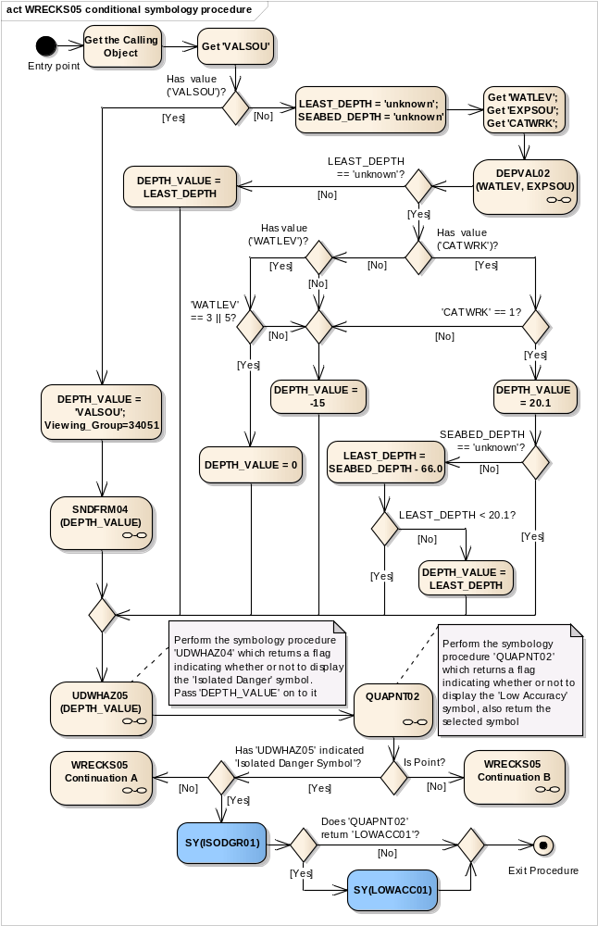
Entry point | Entry to the continuation of symbology procedure with a object, wrecks (WRECKS)
Get the Calling Object | Get the object which is calling this procedure.
Get 'VALSOU' | Get the value of the attribute 'Value of sounding' (VALSOU) of the calling object
Has value ('VALSOU')? | Is the value of the attribute 'VALSOU' given?
DEPTH_VALUE = 'VALSOU'; Viewing_Group=34051 | Set the local variable 'DEPTH_VALUE' equal to 'VALSOU'.  Set the viewing group to 34051 for all presentation object.
SNDFRM04 (DEPTH_VALUE) | perform the symbology sub-procedure 'SNDFRM04' which symbolizes depth values.  Pass 'DEPTH_VALUE' and the calling object on to it.  A list of symbols is returned. Remember the Sounding Symbol(s)
DEPTH_VALUE | Input parameter
Sounding Symbols List | Output parameter
LEAST_DEPTH = 'unknown'; SEABED_DEPTH = 'unknown' | Set the local variable 'LEAST_DEPTH' equal to 'unknown' value.  Set the local variable 'SEABED_DEPTH' equal to 'unknown' value.
Get 'WATLEV'; Get 'EXPSOU'; Get 'CATWRK'; | Get the value of the attributes 'Water level effect' (WATLEV), 'Exposition of sounding' (EXPSOU) and 'Category of wreck' (CATWRK) of the calling object.
DEPVAL02 (WATLEV, EXPSOU) | Performs the symbology sub-procedure 'DEPVAL02' which returns a value for the local variables 'LEAST_DEPTH' and 'SEABED_DEPTH'.  Pass attributes 'WATLEV and EXPSOU' on to it.
WATLEV | Input parameter
EXPSOU | Input parameter
LEAST_DEPTH | Output parameter
SEABED_DEPTH | Output parameter
LEAST_DEPTH == 'unknown'? | Is the value of the local variable 'LEAST_DEPTH' equal to 'unknown'?
DEPTH_VALUE = LEAST_DEPTH | Set the local variable 'DEPTH_VALUE' equal to the local variable 'LEAST_DEPTH'.
Has value ('CATWRK')? | Is the value of the attribute 'CATWRK' given?
'CATWRK' == 1? | Does the value of the attribute 'CATWRK' = 1 (non-dangerous wreck)?
DEPTH_VALUE = 20.1 | Set value of the local variable 'DEPTH_VALUE' equal to 20.1 m
SEABED_DEPTH == 'unknown'? | Is the local variable 'SEABED_DEPTH' equal to 'unknown'?
LEAST_DEPTH = SEABED_DEPTH - 66.0 | Set the local variable 'LEAST_DEPTH' equal to (SEABED_DEPTH - 66.0)
LEAST_DEPTH < 20.1? | Is the local variable 'LEAST_DEPTH' less then 20.1?
DEPTH_VALUE = LEAST_DEPTH | Set the local variable 'DEPTH_VALUE' equal to 'LEAST_DEPTH'
Has value ('WATLEV')? | Is the value of the attribute 'WATLEV' given?
'WATLEV' == 3 || 5? | Is the attribute 'WATLEV' value equal to 3 (always underwater) or 5 (awash of low water)?  Else 'WATLEV' is equal to other values.
DEPTH_VALUE = 0 | IF 'WATLEV'='3' (always underwater) or 'WATLEV'='5' (... at low water)  THEN set value of the local variable 'DEPTH_VALUE' equal to '0'.
DEPTH_VALUE = -15 | If 'WATLEV' is unknown/undefined OR 'WATLEV' is not equal '3' or '5' OR 'CATWRK' is not equal '1', set value of the local variable 'DEPTH_VALUE' equal to '-15'm
UDWHAZ05 (DEPTH_VALUE) | Performs the symbology sub-procedure 'UDWHAZ05' which returns a flag indicating whether or not to display the ISOLATED DANGER SYMBOL [IMO PS App.2 1.3] and the selected symbol.  Pass 'DEPTH_VALUE' on to it.  Return: selected symbol name 'ISODGR01';  Parameters presentation: SCAMIN, DISPLAY MODE, PRIORITY, RADAR FLAG, VIEWING GROUP if they are changed.
DEPTH_VALUE | Input parameter
'Isolated Danger Symbol' | Output parameter
QUAPNT02 | Perform the symbology sub-procedure 'QUAPNT02' which returns a flag indicating whether or not to display the low accuracy symbol and returns the selected symbol 'LOWACC01'
'Low Accuracy Symbol' | Output parameter
Is Point? | Is the calling object of type point?
WRECKS05 Continuation B | Area objects, wrecks (WRECKS). Pass the list of selected symbols from 'UDWHAZ05', 'SNDFRM04' and 'QUAPNT02' sup-procedures, values of 'VALSOU' attribute if they are.
Has 'UDWHAZ05' indicated 'Isolated Danger Symbol'? | Has the procedure 'UDWHAZ05' indicated that the isolated danger symbol should be drawn?
WRECKS05 Continuation A | Symbolization of point objects "wreck" (WRECKS) without 'Isolated Danger Symbol'.  Pass the list of selected symbols from SNDFRM04 and QUAPNT02 sup-procedures, values of 'VALSOU' attribute if they are.
SY(ISODGR01) | Draw the selected symbol 'ISODGR01'  (isolated dange) at the calling object's location.
Does 'QUAPNT02' return 'LOWACC01'? | Is the symbol 'LOWACC01' selected by the procedure 'QUAPNT02'?
SY(LOWACC01) | If so indicated by the procedure 'QUAPNT02', draw the returned low accuracy symbol 'LOWACC01' at the calling object's location.
Exit Procedure | Symbolization is finished.

Figure 44 WRECKS05 Continuation A
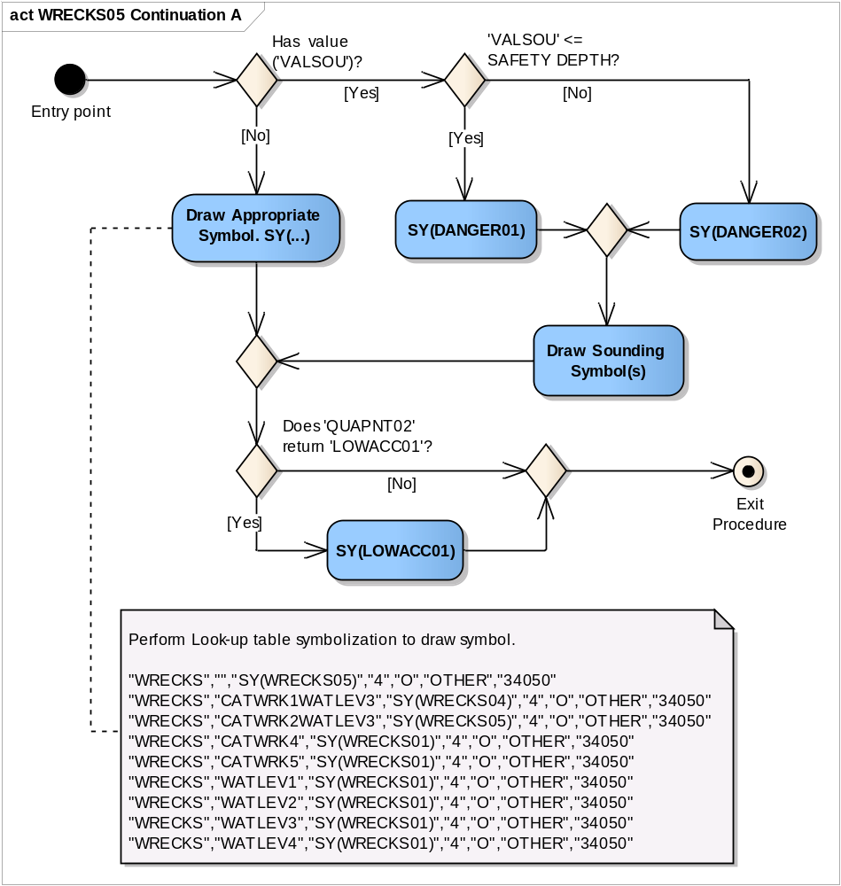
Entry point | The calling object and lists of selected symbols from SNDFRM04 and QUAPNT02 sup-procedures are passed from the calling procedure.
Has value ('VALSOU')? | Is the value of the attribute 'VALSOU' given?
'VALSOU' <= SAFETY DEPTH? | Is the value of the attribute 'VALSOU' less than or equal to SAFETY DEPTH?
SY(DANGER01) | Draw the symbol 'DANGER01' at the calling object's location.
SY(DANGER02) | Draw the symbol 'DANGER02' at the calling object's location.
Draw Sounding Symbol(s) | Draw the sounding symbol(s) returned from 'SNDFRM04' on top at the calling object's location.
Draw Appropriate Symbol. SY(...) | Perform Look-up table symbolization to draw symbol.  The values of presentation parameters ( Display Priority; Over Radar Flag; Display Category and Viewing Group) must be taken in according to assigned values in 'UDWHAZ05' sub-procedure or default values:  "WRECKS","","SY(WRECKS05)","4","O","OTHER","34050"  "WRECKS","CATWRK1WATLEV3","SY(WRECKS04)","4","O","OTHER","34050"  "WRECKS","CATWRK2WATLEV3","SY(WRECKS05)","4","O","OTHER","34050"  "WRECKS","CATWRK4","SY(WRECKS01)","4","O","OTHER","34050"  "WRECKS","CATWRK5","SY(WRECKS01)","4","O","OTHER","34050"  "WRECKS","WATLEV1","SY(WRECKS01)","4","O","OTHER","34050"  "WRECKS","WATLEV2","SY(WRECKS01)","4","O","OTHER","34050"  "WRECKS","WATLEV3","SY(WRECKS01)","4","O","OTHER","34050"  "WRECKS","WATLEV4","SY(WRECKS01)","4","O","OTHER","34050"
Does 'QUAPNT02' return 'LOWACC01'? | Is the symbol 'LOWACC01' selected by the procedure 'QUAPNT02'?
SY(LOWACC01) | If so indicated by the procedure 'QUAPNT02', draw the returned low accuracy symbol 'LOWACC01' at the calling object's location.
Exit Procedure | Symbolization is Finished

Figure 45 WRECKS05 Continuation B
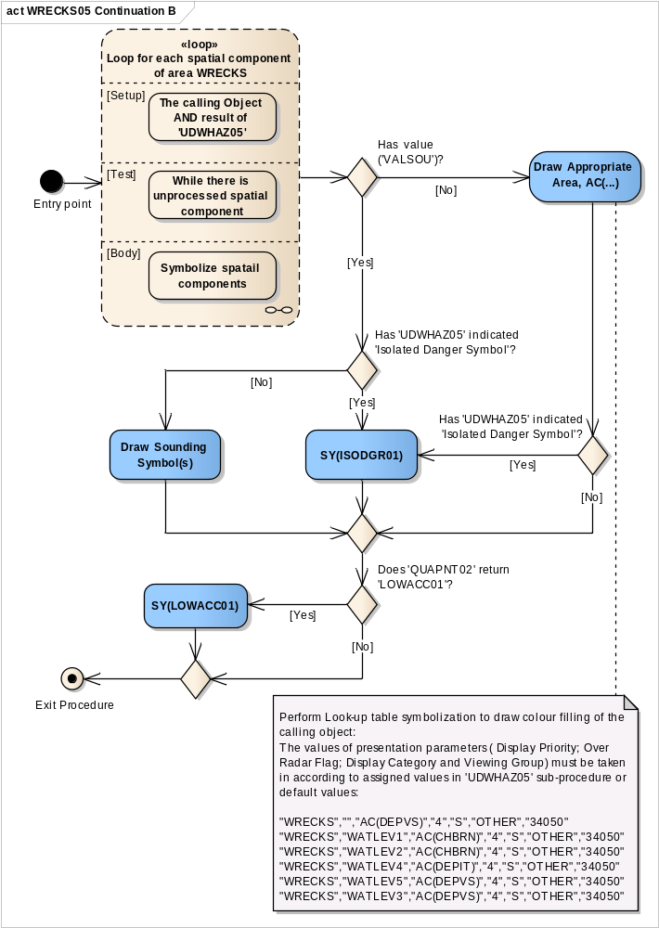
Entry point | The calling object and lists of selected symbols from SNDFRM04, UDWHAZ05 and QUAPNT02 sup-procedures are passed from the calling procedure.
Loop for each spatial component of area WRECKS | For each spatial component of area WRECKS perform this loop.  Setup - The Calling Object AND results of 'UDWHAZ05'  Test - While there is unprocessed spatial component  Body - to symbolize a spatial component if it is needed.
Has value ('VALSOU')? | Is the value of the attribute 'VALSOU' given?
Has 'UDWHAZ05' indicated 'Isolated Danger Symbol'? | Has the procedure 'UDWHAZ05' indicated that the isolated danger symbol should be shown?
SY(ISODGR01) | Draw the selected symbol 'ISODGR01' returned by 'UDWHAZ05' in the centre of the area.
Draw Sounding Symbol(s) | Draw the sounding symbol(s) returned from 'SNDFRM04' at the centre of the area
Draw Appropriate Area, AC(...) | Perform Look-up table symbolization to draw colour filling of the calling object.  The values of presentation parameters ( Display Priority; Over Radar Flag; Display Category and Viewing Group) must be taken in according to assigned values in 'UDWHAZ05' sub-procedure or default values:  "WRECKS","","AC(DEPVS)","4","S","OTHER","34050"  "WRECKS","WATLEV1","AC(CHBRN)","4","S","OTHER","34050"  "WRECKS","WATLEV2","AC(CHBRN)","4","S","OTHER","34050"  "WRECKS","WATLEV4","AC(DEPIT)","4","S","OTHER","34050"  "WRECKS","WATLEV5","AC(DEPVS)","4","S","OTHER","34050"  "WRECKS","WATLEV3","AC(DEPVS)","4","S","OTHER","34050"
Has 'UDWHAZ05' indicated 'Isolated Danger Symbol'? | Has the procedure 'UDWHAZ05 indicated that the isolated danger symbol should be shown?
Does 'QUAPNT02' return 'LOWACC01'? | Has the procedure 'QUAPNT02' indicated that the quality of position symbol should be shown?
SY(LOWACC01) | Draw the selected symbol 'LOWACC01' returned by 'QUAPNT02' in the centre of the area.
Exit Procedure | Symbolization is finished

Figure 46 Loop for each spatial component of area WRECKS
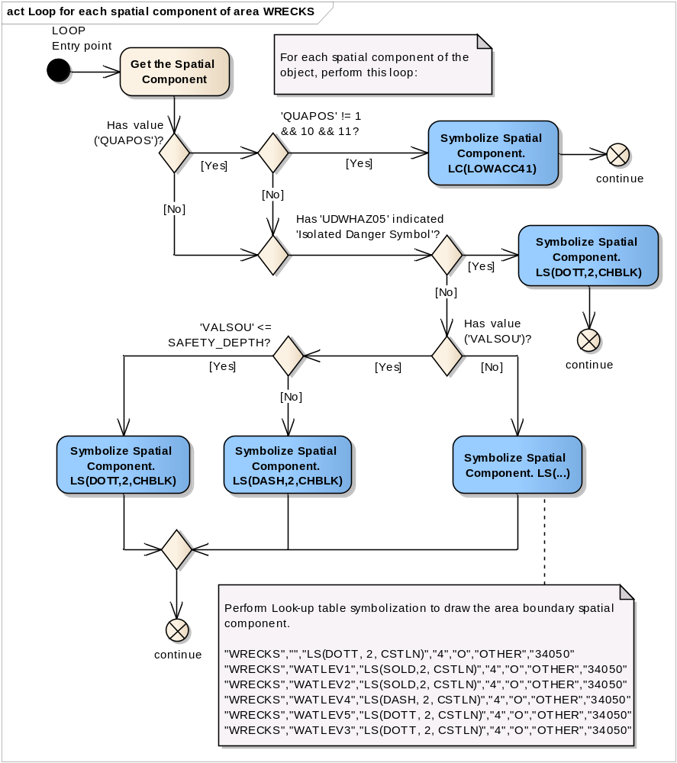
LOOP Entry point | The spatial components of the calling object.
Get the Spatial Component | Get the next spatial object (edge) of the calling object.
Has value ('QUAPOS')? | Is the spatial attribute 'QUAPOS' given?
'QUAPOS' != 1 && 10 && 11? | Does the value of attribute 'QUAPOS' equal to neither of the following values: '1', '10', and '11'?
Symbolize Spatial Component. LC(LOWACC41) | Symbolize the area boundary spatial component with 'LC(LOWACC41)'
continue | go to the next spatial component.
Has 'UDWHAZ05' indicated 'Isolated Danger Symbol'? | Has the procedure 'UDWHAZ05' indicated that the isolated danger symbol should be shown?
Symbolize Spatial Component. LS(DOTT,2,CHBLK) | Symbolize the area boundary spatial component with a dotted line, 2 units wide, colour 'CHBLK'  The values of presentation parameters ( Display Priority; Radar Flag; Display Category and Viewing Group) must be taken in according to assigned values in 'UDWHAZ05' sub-procedure.
continue | go to the next spatial component.
Has value ('VALSOU')? | Is the value of the attribute 'VALSOU' given?
'VALSOU' <= SAFETY_DEPTH? | Is the value of the attribute 'VALSOU' less than or equal to SAFETY_DEPTH?
Symbolize Spatial Component. LS(DOTT,2,CHBLK) | Symbolize the area boundary spatial component with a dotted line, 2 units wide, colour 'CHBLK'
Symbolize Spatial Component. LS(DASH,2,CHBLK) | Symbolize the area boundary spatial component with a dashed line, 2 units wide, colour 'CHBLK'
Symbolize Spatial Component. LS(...) | Perform Look-up table symbolization to draw the area boundary spatial component.  "WRECKS","","LS(DOTT, 2, CSTLN)","4","O","OTHER","34050"  "WRECKS","WATLEV1","LS(SOLD,2, CSTLN)","4","O","OTHER","34050"  "WRECKS","WATLEV2","LS(SOLD,2, CSTLN)","4","O","OTHER","34050"  "WRECKS","WATLEV4","LS(DASH, 2, CSTLN)","4","O","OTHER","34050"  "WRECKS","WATLEV5","LS(DOTT, 2, CSTLN)","4","O","OTHER","34050"  "WRECKS","WATLEV3","LS(DOTT, 2, CSTLN)","4","O","OTHER","34050"
continue | go to the next spatial component.

Table of figures
Figure 1 ECDIS Display Concept 2
Figure 2 DEPARE03 conditional symbology procedure 5
Figure 3 DEPARE03 Continuations A and B 7
Figure 4 DEPCNT03 conditional symbology procedure 10
Figure 5 For each spatial component 11
Figure 6 DEPVAL02 conditional symbology sub-procedure 14
Figure 7 Loop for each underlying group 1 object 15
Figure 8 LIGHTS06 conditional symbology procedure 18
Figure 9 LIGHTS06 Continuation describes the sector lights showing its line legs and arcs. 22
Figure 10 Loop for co-located lights objects 24
Figure 11 OBSTRN07 conditional symbology procedure 27
Figure 12 OBSTRN07 Continuation A. Points objects, underwater rocks (UWTROC) and obstruction (OBSTRN) 30
Figure 13 OBSTRN07 Continuation B Line objects, obstructions (OBSTRN) 33
Figure 14 Loop for each spatial component of the object 34
Figure 15 OBSTRN07 Continuation C Area objects, obstructions (OBSTRN) 36
Figure 16 QUAPOS01 conditional symbology procedure 39
Figure 17 QUALIN01 conditional symbology sub-procedure 41
Figure 18 Loop for each spatial component of the object 42
Figure 19 QUAPNT02 conditional symbology sub-procedure 45
Figure 20 Loop for each spatial component 46
Figure 21 RESARE04 conditional symbology procedure 48
Figure 22 RESARE04 Continuation A. Entry restricted or prohibited 50
Figure 23 RESARE04 Continuation B Anchoring restricted or prohibited. 52
Figure 24 RESARE04 Continuation C Fishing restricted or prohibited 54
Figure 25 RESARE04 Continuation D Own ship restrictions 56
Figure 26 RESARE04 Continuation E No 'RESTRN' applies 58
Figure 27 RESTRN01 conditional symbology procedure 61
Figure 28 RESCSP02 (RESTRN) conditional symbology sub-procedure 63
Figure 29 SAFCON01 conditional symbology sub-procedure 69
Figure 30 SLCONS04 conditional symbology procedure 74
Figure 31 Loop for each spatial component of area and line SLCONS object 75
Figure 32 SEABED01(DRVAL1,DRAVL2) conditional symbology sub-procedure 77
Figure 33 SNDFRM04 conditional symbology sub-procedure 80
Figure 34 SOUNDG03 conditional symbology procedure 85
Figure 35 Loop for each Spot Sounding 86
Figure 36 SYMINS02 conditional symbology procedure 87
Figure 37 TOPMAR01 conditional symbology procedure 90
Figure 38 Loop for each co-located point object 92
Figure 39 UDWHAZ05 conditional symbology sub-procedure 95
Figure 40 Loop for each occurrence of the underlying deep area object DEPARE,DRGARE 97
Figure 41 UDWHAZ05 Continuation A 98
Figure 42 Loop for each occurrence of the underlying shallow area object DEPARE, DRGARE 100
Figure 43 WRECKS05 conditional symbology procedure 102
Figure 44 WRECKS05 Continuation A 105
Figure 45 WRECKS05 Continuation B 107
Figure 46 Loop for each spatial component of area WRECKS 109

