Step 1: Created a repository in GitHub
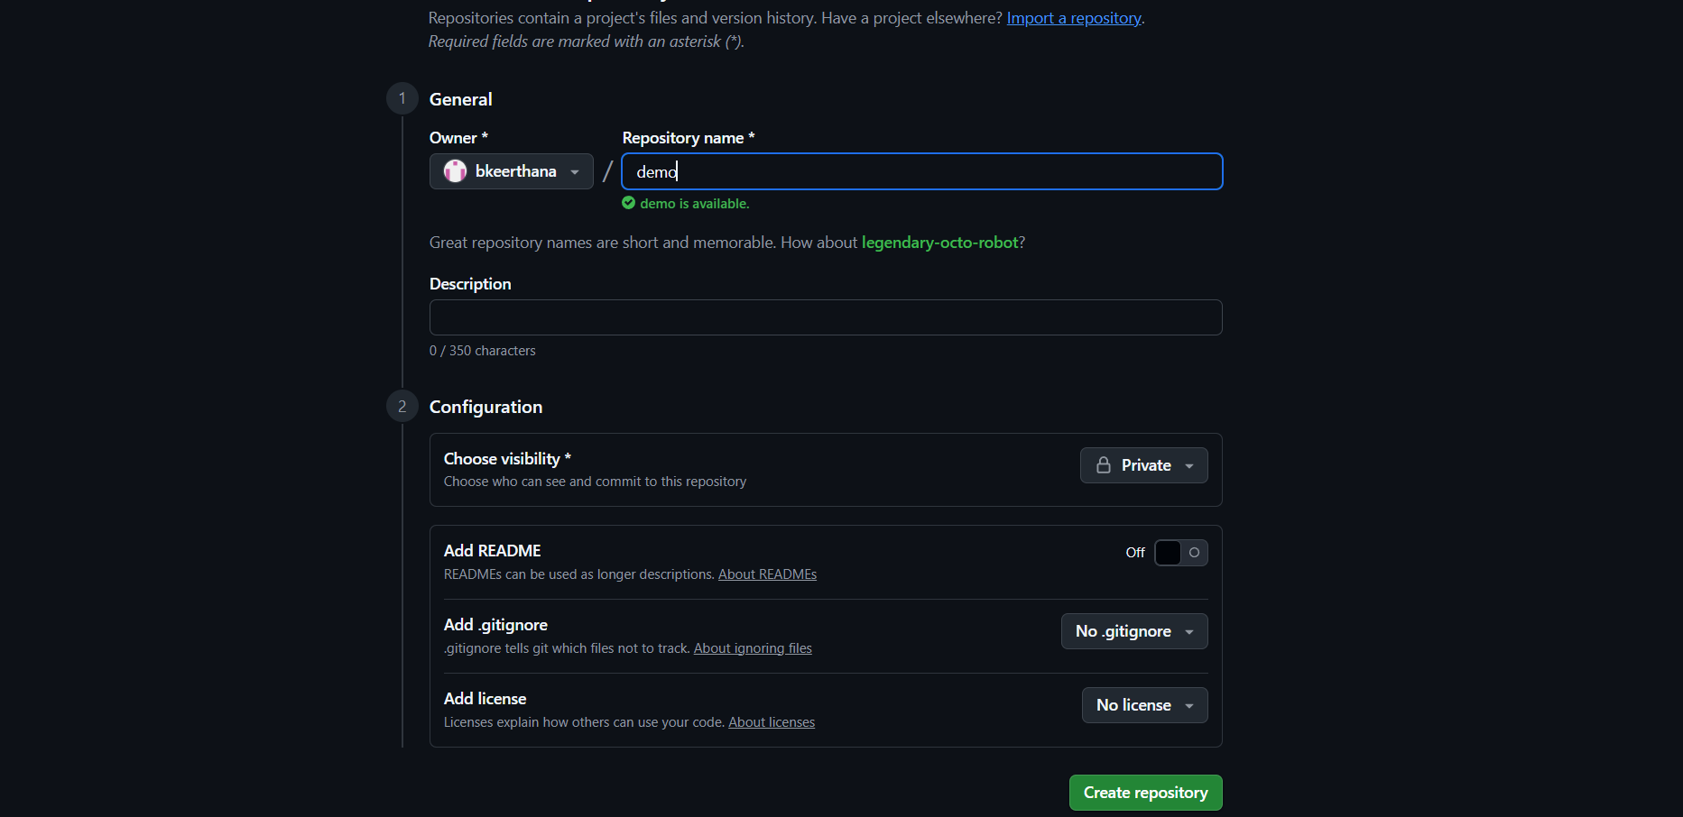
Note: make sure choose visibility private
Step 2:
Note down the git remote origin
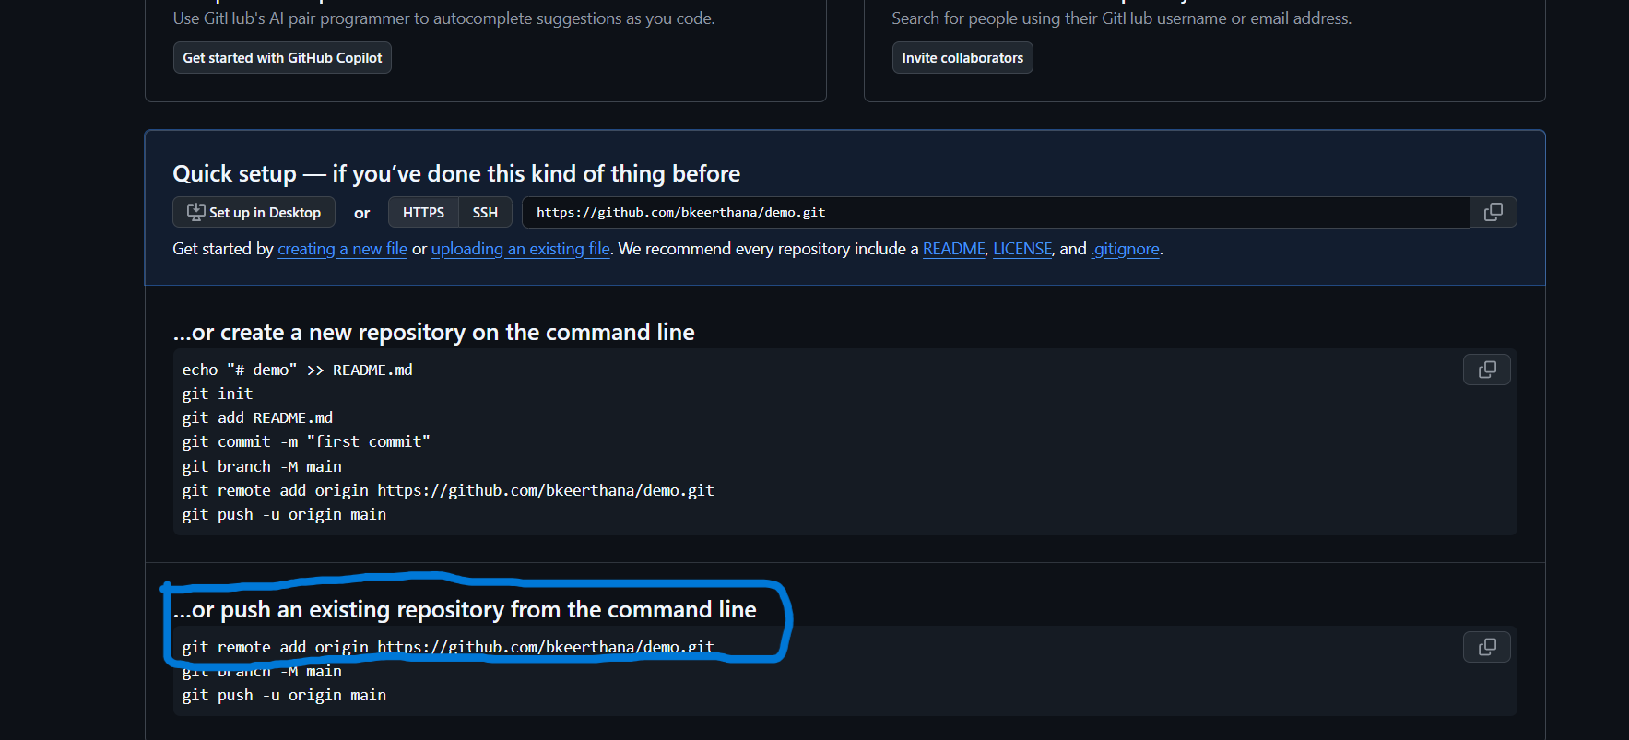

Step 3:
Created a folder called “try” , initialized git, added files and commit
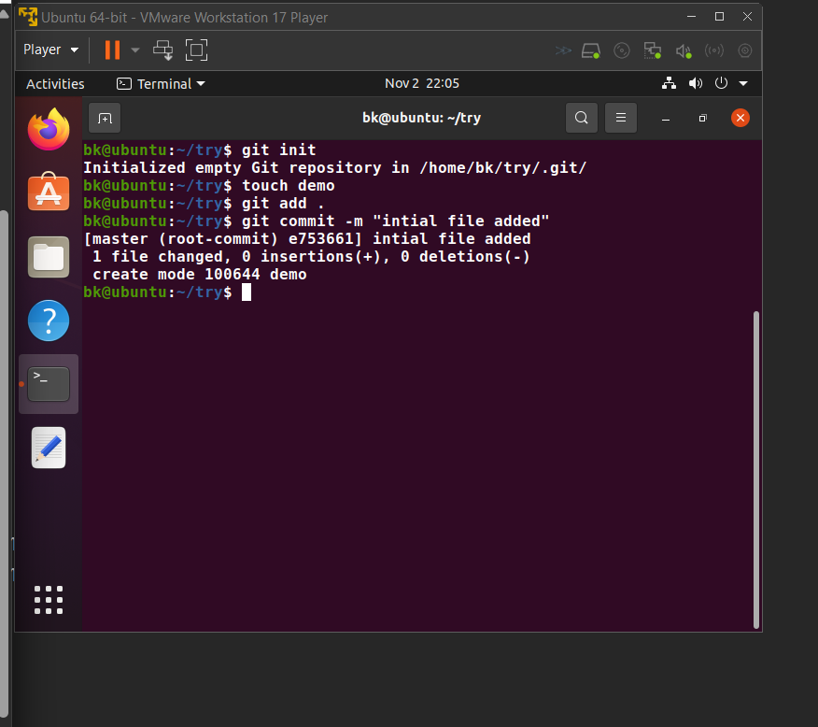
Step 4:
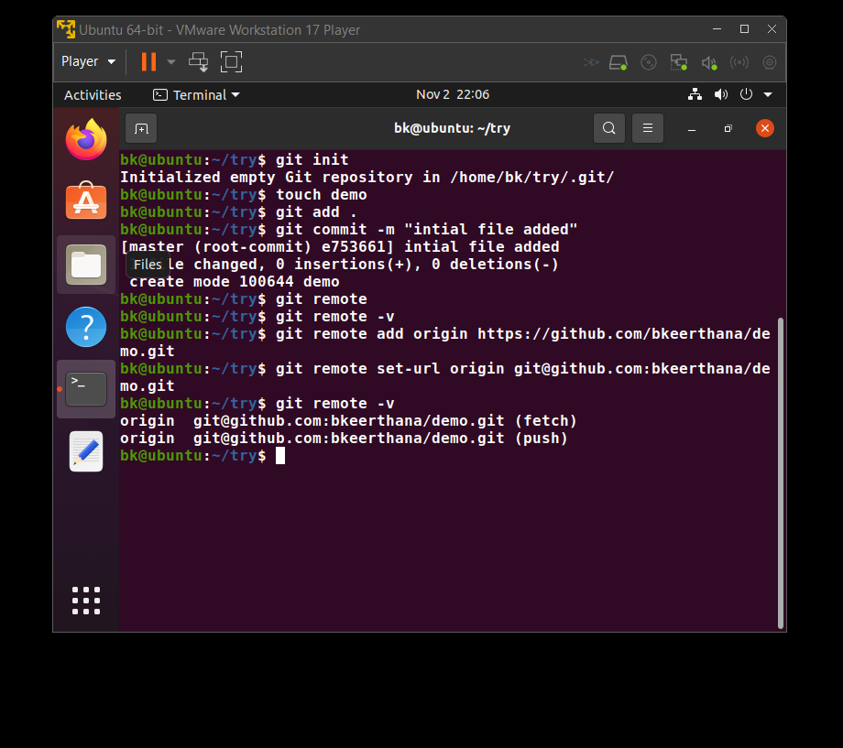
In the terminal :
Check the remote : git remote
List the remotes : git remote -v
Add the remote: git remote add origin (from the step 2 )
Set the url : git remote set-url origin <path>
Check by typing : git remote -v

Step 5:
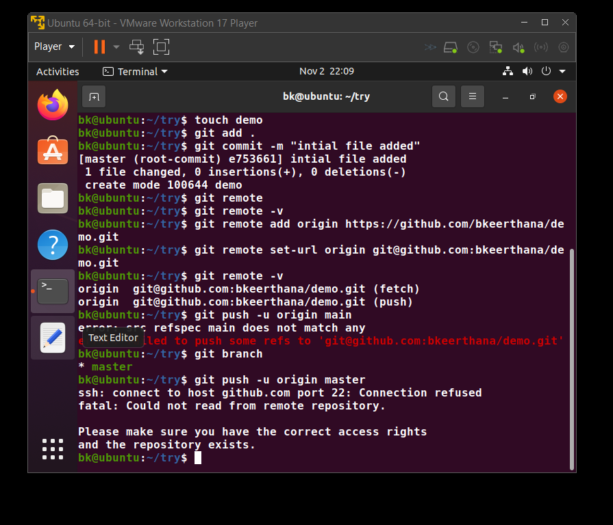
Find the branch name: git branch
Enter : git push -u origin master
Note: use your hotspot to connect, otherwise it will throw error

Step 6:
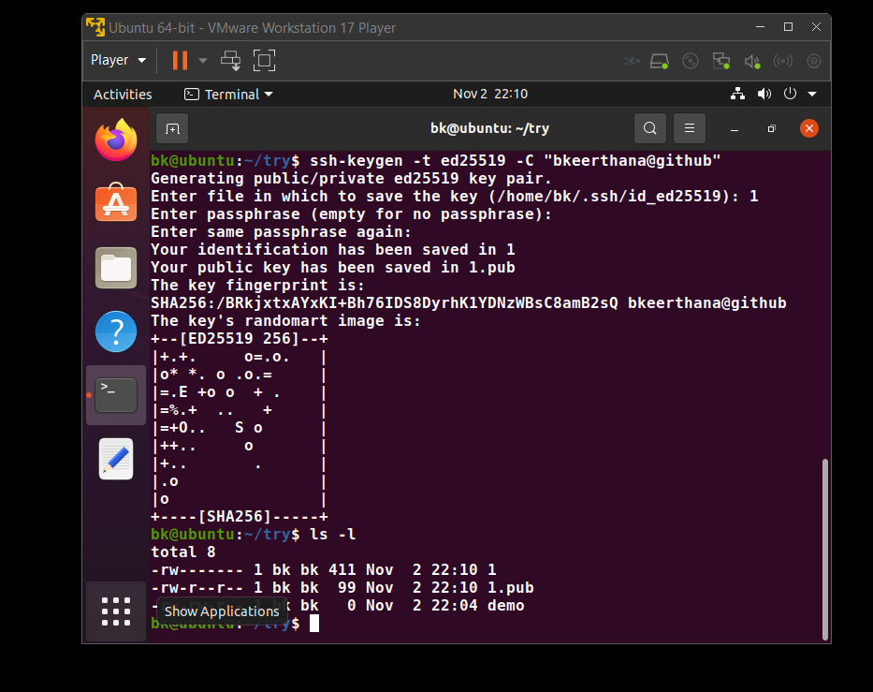
Authentication steps
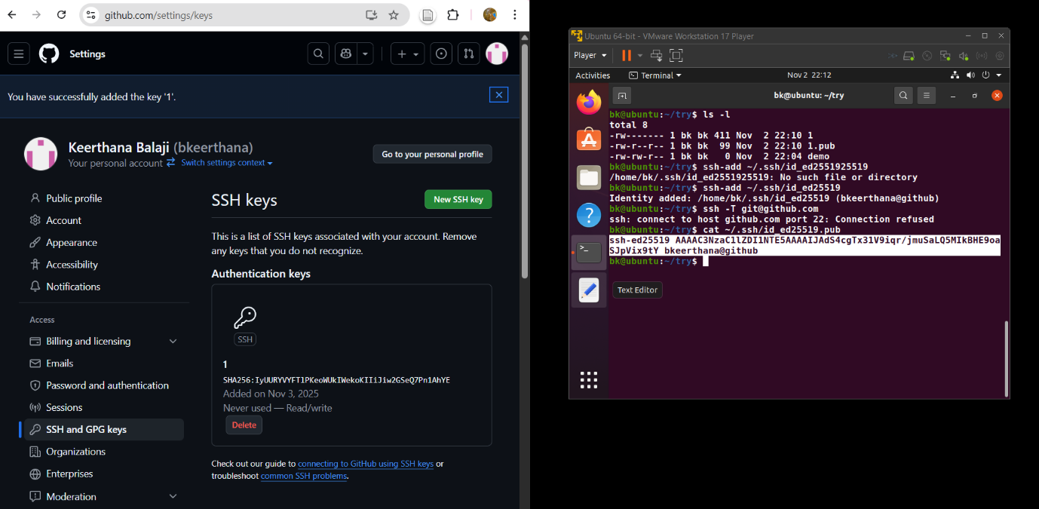
Copy the public key in github – in SSH and GPG Keys

Step 7:
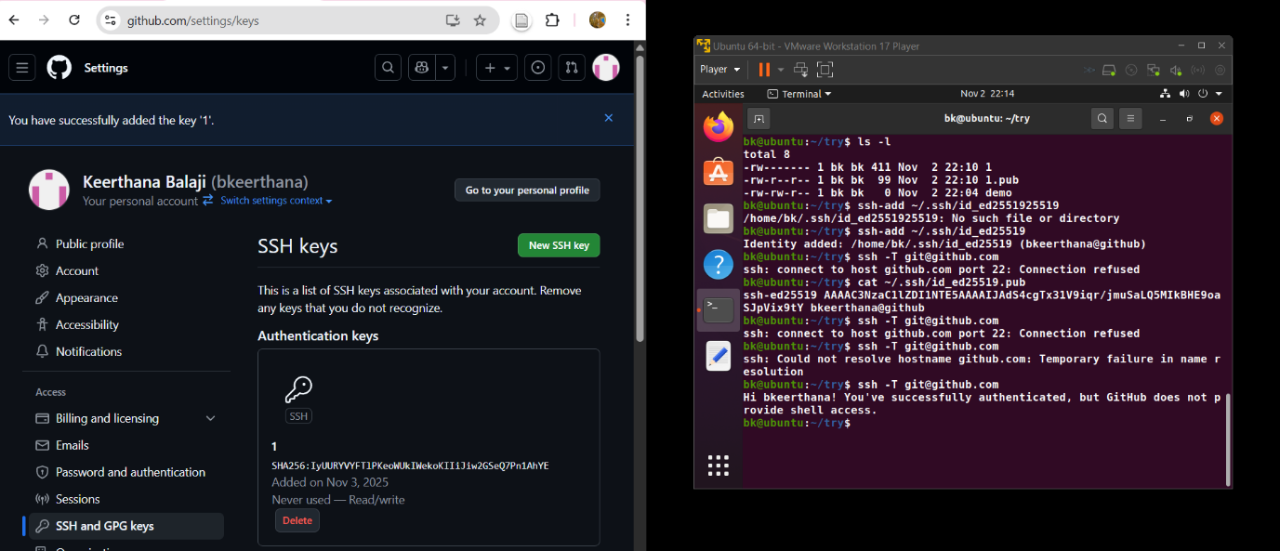
Check the welcome message to check, link between local and remote

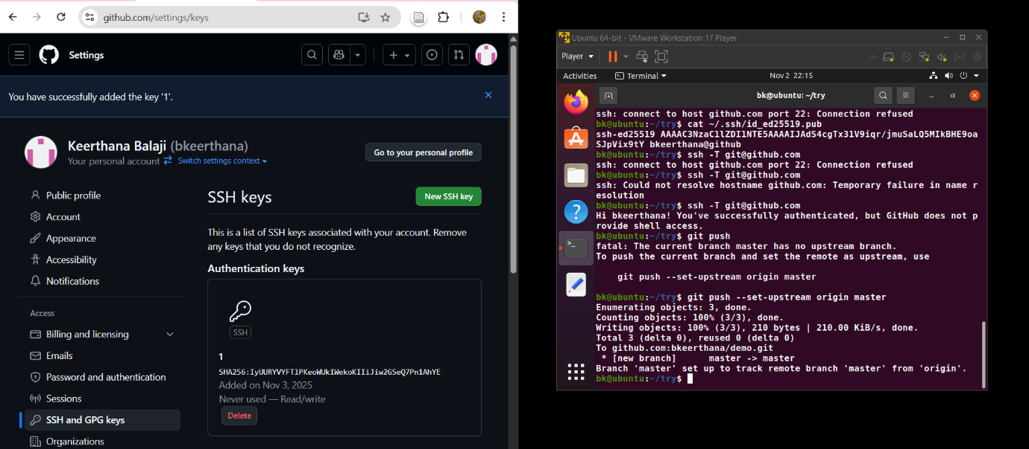
Push the file to the remote by typing :
Git push –set-upstream origin master
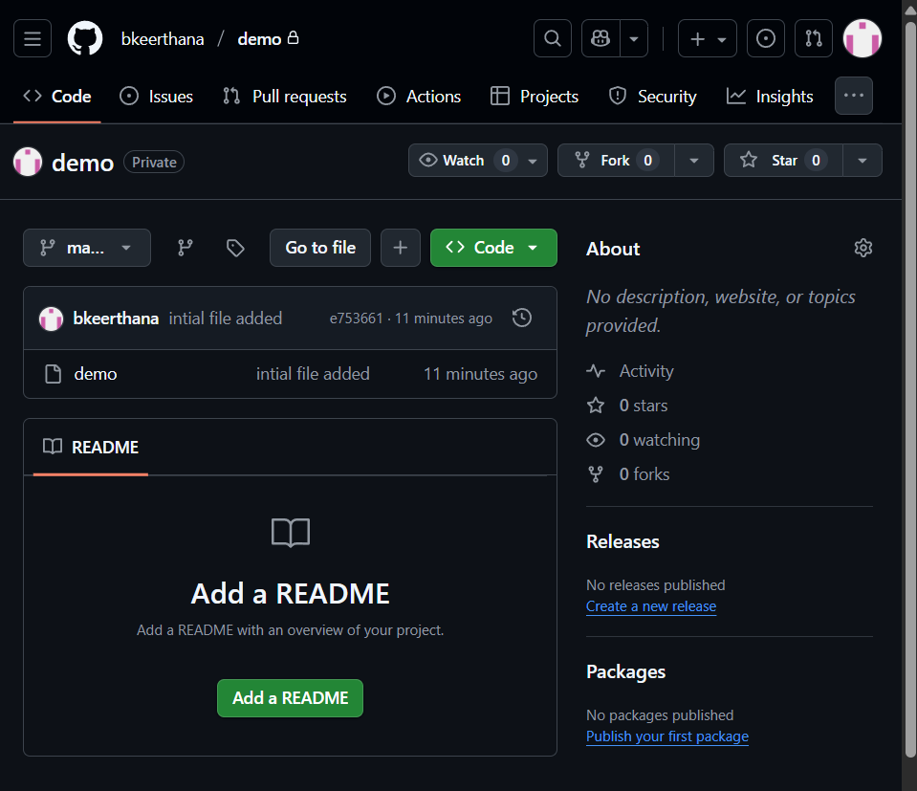
The file is pushed in the github

