Rail Fence

1. Encrypt the message "Enjoy your Journey" using Rail Fence with depth 2 and 3
2. Encrypt the message as per your choice using Rail Fence with depth 2 and 3
3. Decrypt the cipher "EOCSNYUWLEJYREASONS" , encrypted using Rail fence with depth 4.
4. Decrypt the cipher "BOOIGUYUBOSNUUTYRKAS", encrypted using Rail fence with depth 3.
5. Decrypt the cipher "SEMSERTISINCMOO" encrypted using Rail fence with depth 2.

Permutation
1. Encrypt the following message "We are discovered " using the key "53124"

DES

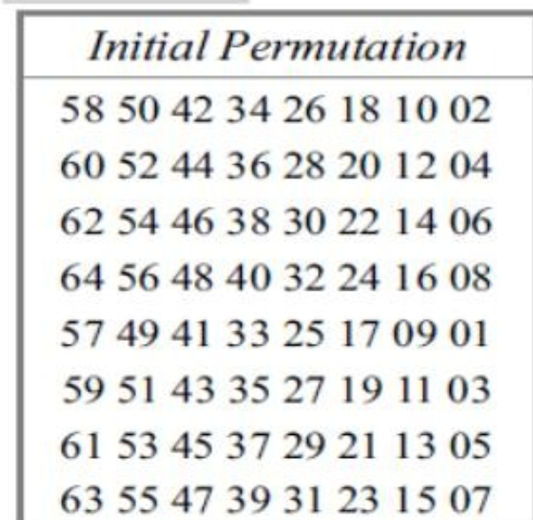

- Using the initial permutation table, determine the output of the initial permutation box when the input is given in hexadecimal as: 0X0002 0000 0000 0001

- Given the 4-bit binary Plaintext (M) 1101 and the Key (K) 1011, calculate the resulting Ciphertext (C) using a bitwise Exclusive-OR (XOR) operation. Show your bit-by-bit work.
- Plaintext (M): 1101 (binary)
- Key (K): 1011 (binary)

- The input to S-box 1 is 000000.What is the output?

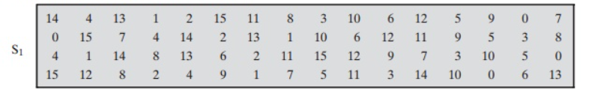

Product Cipher
Explore ADFGVX cipher

Self-belief is the primary boundary to achievement.
Wayne Dyer
Fact: The rail fence cipher is a very old encryption scheme, pre-dating the Middle Ages. It was used as a field cipher by both sides in the US Civil War.

Posted: 05.09.2026
Deadline: 19.09.2026

