Flint and Steel
Character Concept

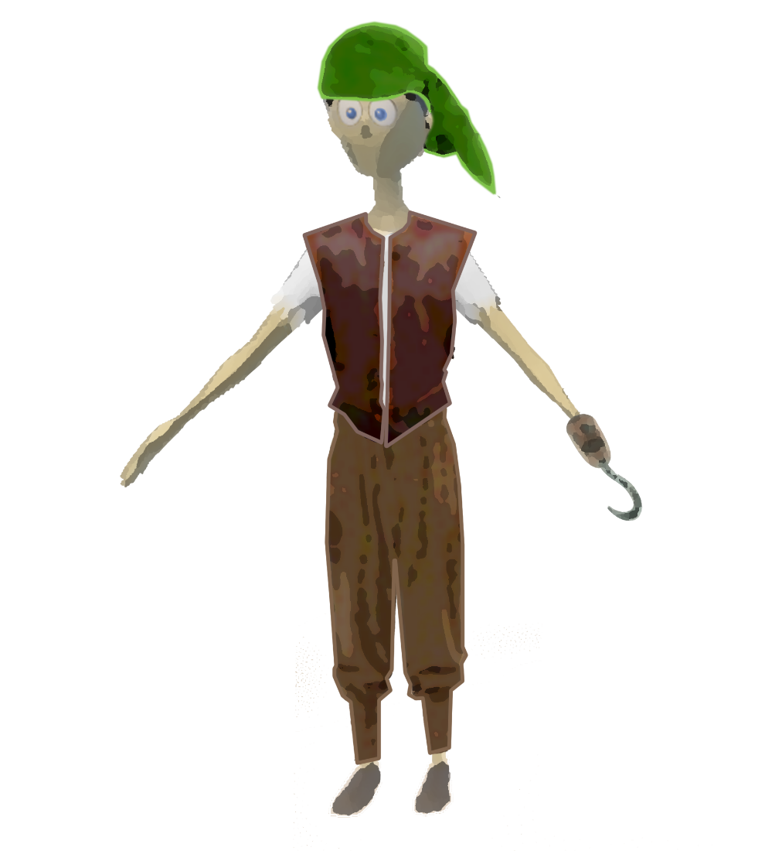

Scally Wagburn:
- We will be adding models for clothing items such as a bandana to the default Liam player model as well as retexturing the Liam player model.
- Multiple clothing features that will be added over top of the “Liam” player model will include:
  - A bandana over the top of the head.
  - Changing the red shirt colour to a white colour. Also making the shirt look a little more tattered and worn down/abused.
  - A leather vest over top of his shirt with the middle open to reveal more of his clothing.
  - Light brown-coloured pants.
  - Boots will stay the same.
- Scally will be holding the two main items, Flint and Steel, in his left hand and right hand respectively.

Flint:
- The hook will be a prefab overtop of prefab overtop of Scally’s hand. This will not directly interfere with the player model.
- Will have a subtle green glow and green flames whenever he is talking because he is a cursed object.
- 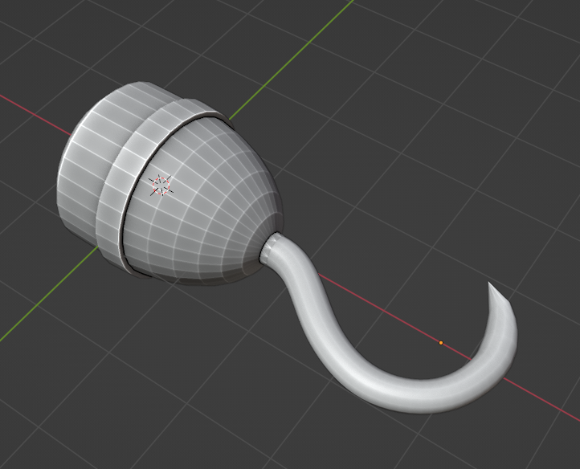

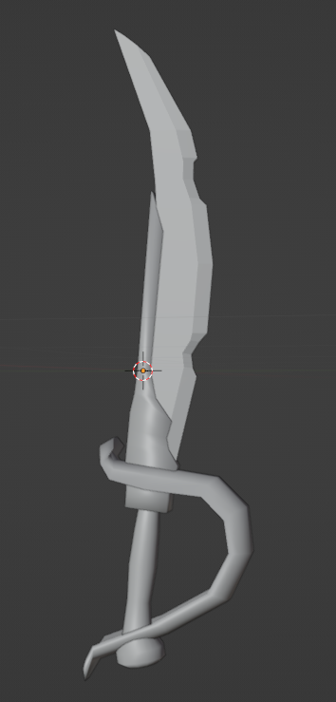
Steel:
- Like the hook. The sword will be a prefab held in the right hand of Scally. It will not interfere with anything related to the player model.
- Cracked, old, antique-looking.
- Will have a subtle green glow and green flames whenever he is talking because he is a cursed object. His green glow and flames will be stronger than Flint’s because he is a stronger cursed object than him.

Our Plan:
The overall changes made to the default “Player Liam” character are simple paint overs of his textures. Minor clothing items will be added to give him character as a pirate. We will try to make models for as much of his clothing as we can, but we understand where we can run into problems with that, that’s why we will make a model for his bandana, Flint, and Steel, and the rest (vest, pants), will be paint overs if we can’t make models for them. The default character not having a mouth will be unchanged due to us believing the players will not be solely focusing on the aesthetics of Scally and more drawn to Flint and Steel. They will pop out more from the character since Scally is made to look like an average everyday pirate with no over-the-top outfit. For our enemies, they will be retextures of Scally to have a more evil colour scheme such as red or dark colours.

