Flint and Steel
Level Maps


By Jolly Rogers

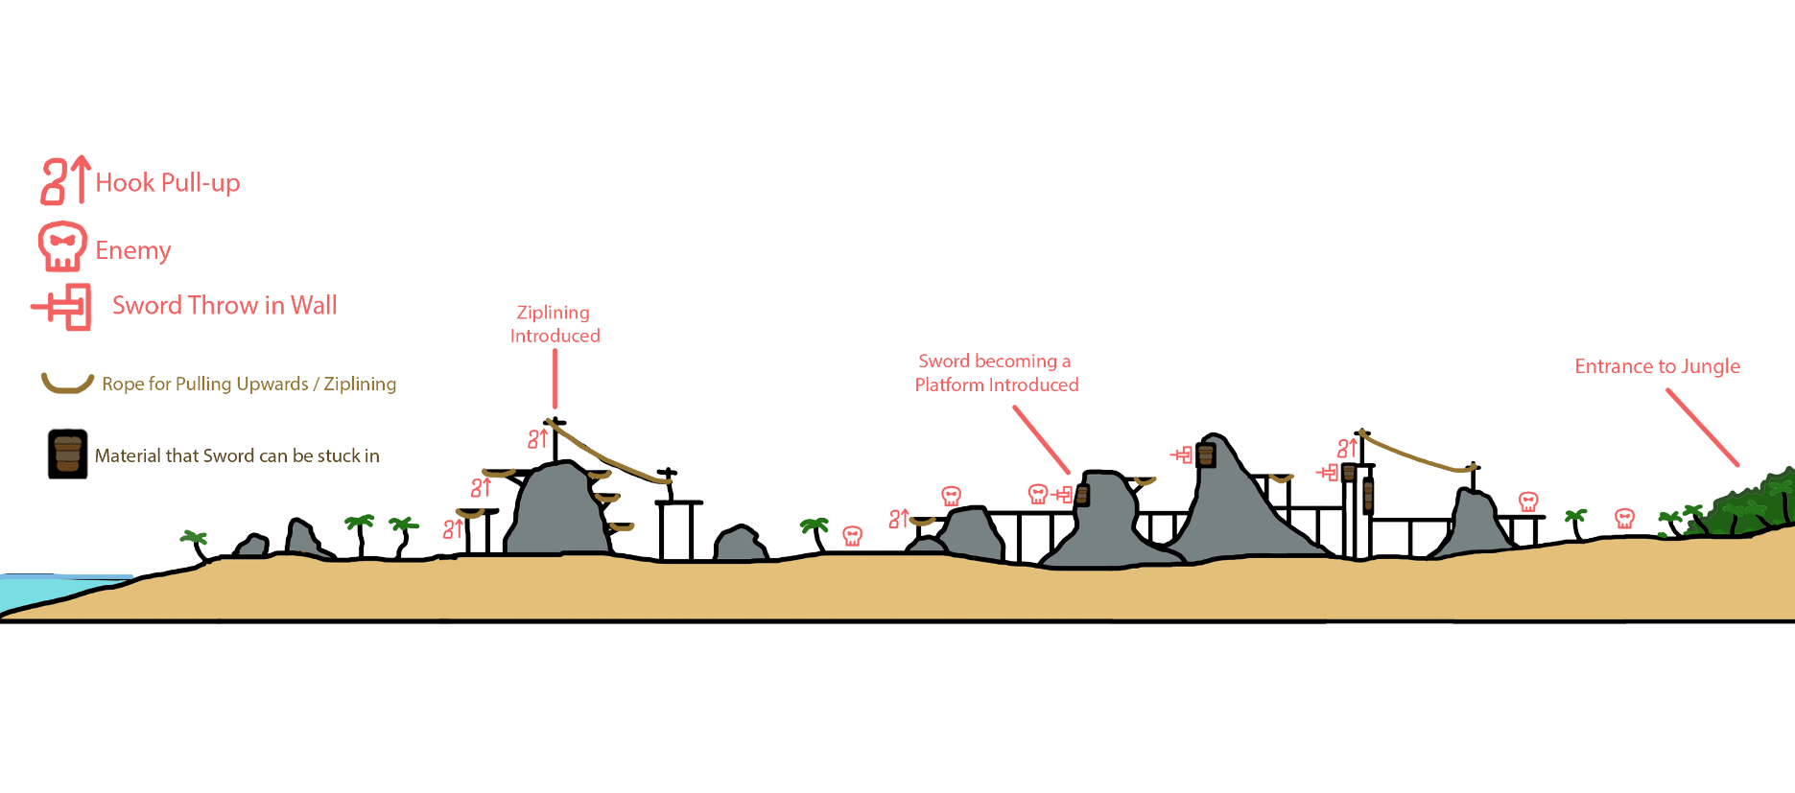
Level 1 Beach Map:

1

4
2 3 5 6 7 8 9

- 1. The Beach level introduces mechanics before applying them in more complex ways in the second level.
- 2. The player will learn to jump over the rocks
- 3 The player will learn to hook to the rope and pull himself up.
- 4. The player learns that he can use his hook to zipline himself across spaces with long ropes.
- 5. The player discovers a sword sticking into a rock and picks it up. He now has the ability to attack enemies.
- 6. The player encounters the enemy for the first time and learns to throw his sword.
- 7. The player learns that his sword can only kill one enemy and pass through him to an obstacle behind him. He also learns that his sword can stick to the wooden planked walls
- 8. He makes sure that it only works on the wooden planked walls
- 9. He learns that he will have to zipline and throw his sword back to back to defeat enemies at certain points.

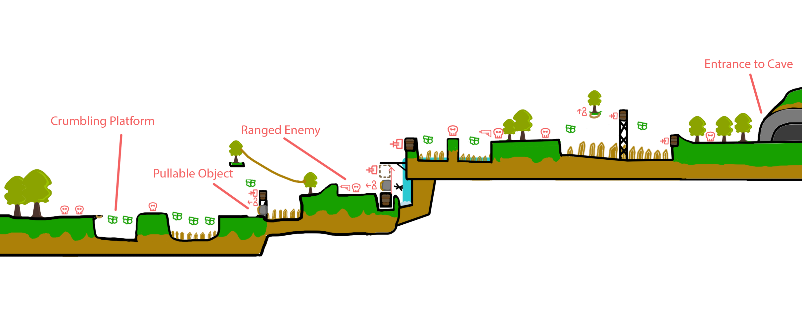
Level 2 Jungle Map:

5
1 2 3 4

- The player learns that platforms that look weak and cracked will crumble after a second or two.
- The player learns that he can pull and move objects that have rope attached to it.
- The player is introduced to the ranged enemy who has a gun.
- The player sees a puzzle and upon solving it learns that it is a trigger for certain things like moving boulders or opening gates.
- The player uses the crumbling platform, rope grab mechanic, and the sword throw mechanic one after another.
* The player will pull the boulder off the rising platform. Once the platform hits the ceiling, they can throw their sword and use it as a platform. The platform will be attached to a pulley system so it doesn’t look like it is floating.

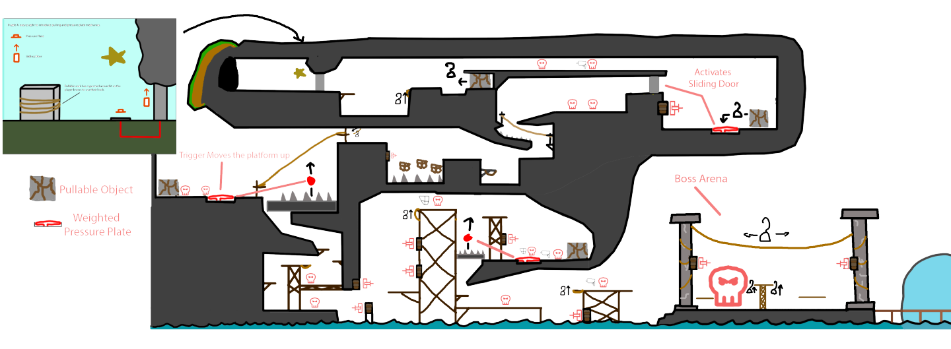
Level 3 Pirate Outpost Map:

1 2 3

4
5
6

- Player learns that pressing the pressure plate on the ground lifts the entrance door but only if it is pressed down, so pulling the stone with ropes on it keeps the door open.
- The next area the Player uses his hook to get up and pull the stone to create a way up and encounters two enemies.
- The Player uses the pressure plate mechanic they learned earlier and pulls the stone on the pressure plate open the sliding door and uses the sword mechanic to make a way up to the door.
- The Player fights enemies and uses the pressure plate mechanic to keep the platform up so he can go below it and progress further in the level.
- Player uses pressure plate mechanic to progress further.
- Player enters the boss battle and can use their sword to make platforms to get above the boss for some movement using his hook, the player can climb up the middle platform using the hook.

