

Flint and Steel
Art Style Document


By Jolly Rogers
Art Style Overview
For our game, we will use a bright, vibrant, cartoony, stylized art style similar to games like Sea of Thieves. We will focus on having bright and semi-realistic lighting, and we will be working with shaders and animated objects to bring the scenes to life. We will add foreground, midground, and background objects to our game to give it a 3D look, and we will also create a satisfying parallax effect for realism.
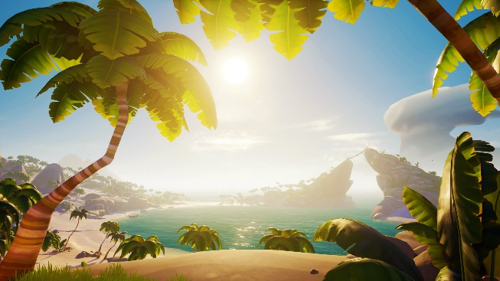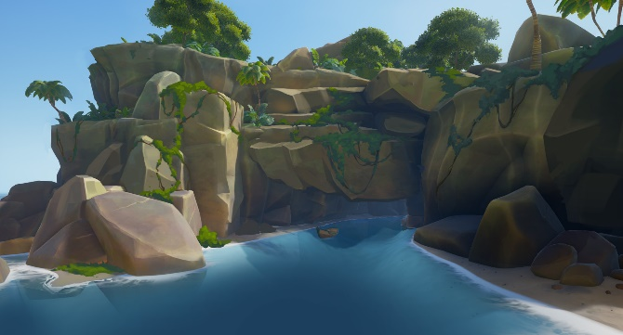
Shape Language
For the shape language in our game, we will mostly go with round, smooth shapes for objects that are safe for the player to touch, such as platforms, rocks, or other background elements. For objects that can harm the player, we will use sharp, jagged, triangular shapes, and we will make sure to include the colour red somewhere on that object so that it gives off a sense of “danger.”
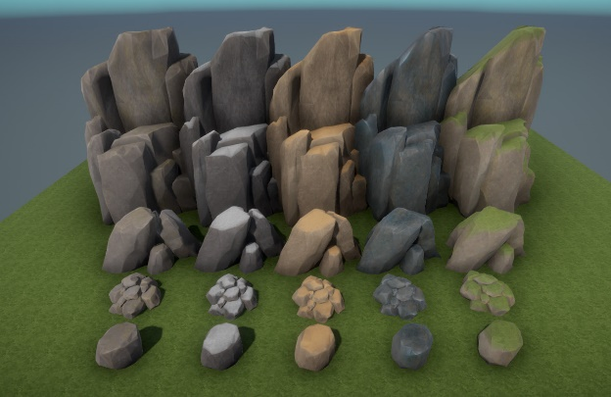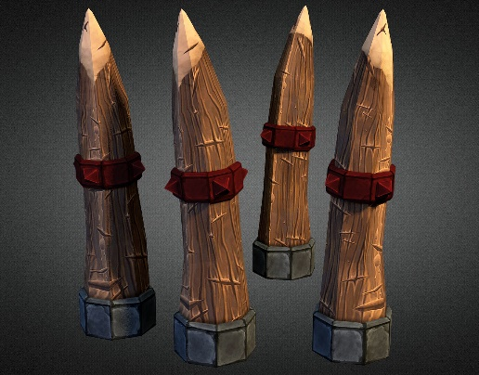

Colour Palette
For our colour palette, we will go with bright, saturated colours that go towards yellow as they get brighter and purple as they get darker. This is meant to simulate cold shadows and warm highlights.

SHADERS
We will be utilizing Unity’s shadergraph to make detailed and pleasing shaders for the game. Some examples of objects that could use shaders are:
Water | Requires editing of vertices to simulate waves, change in colour the deeper the water is, foam effects where the water collides with other objects, and possible refraction and displacement depending on how complicated we want to make it. | 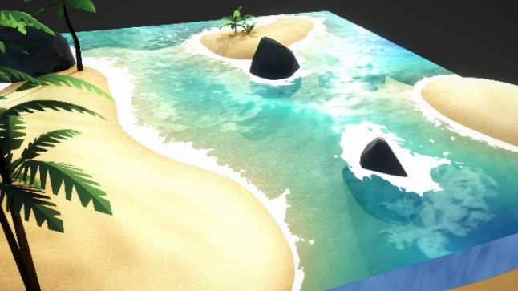
Trees and Foliage | Using shadergraph, we can make trees and foliage sway in the wind without needing to create an animation for it. This can greatly speed up development time and make the level look much more interesting. | 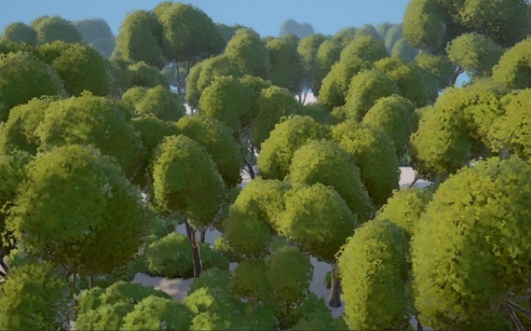
Sand | We could make a sand shader that blends into objects colliding with it. We could also potentially add footsteps wherever the player walks on it, but that would be low priority. | 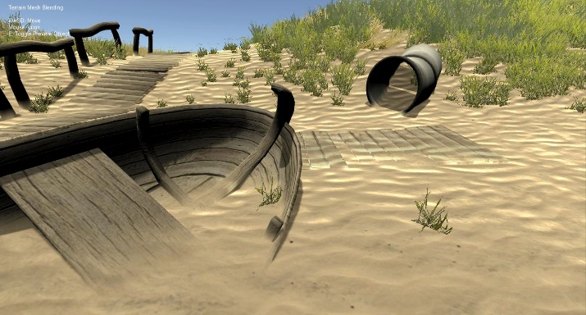

GAMEPLAY LAYER
The gameplay layer will consist of multiple different types of 3D terrain. Some examples of terrain would be sand, rock, grass, wooden planks, etc.

For the colour palette, the gameplay layer will have more brighter and vibrant colours compared to the background to create a clear distinction between what the player is able to walk on and what the player cannot. Textures in the gameplay layer will also be much more detailed than textures that are in the background.

We will mostly use 3D art for all the assets in the gameplay layer, but we were planning to use 2D art for most of the foliage and grass. By placing these 2D textures together we can still make the foliage look 3D.
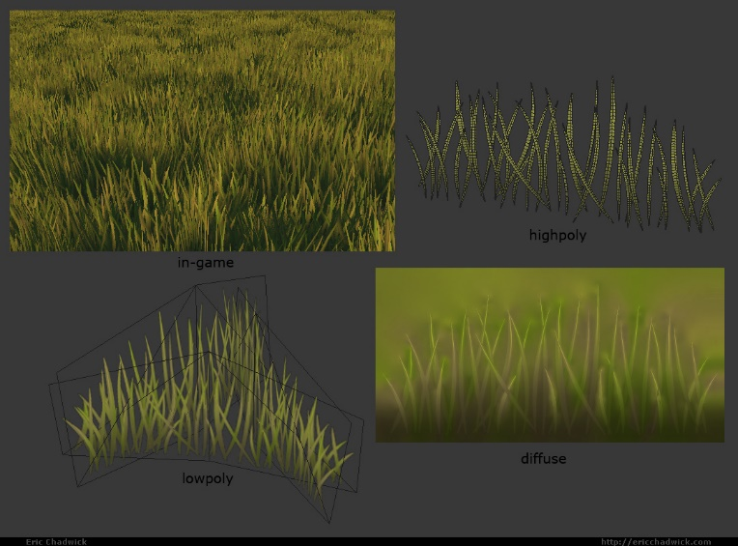

We will use light to guide players on where to go, like for example light could shine through breaks in the leaves of trees and highlight pathways.
There will be a sun in the background, however we will probably have a separate light that shines from overhead to prevent having too many shadows in the gameplay layer. Since the game takes place on an island, the lighting will be bright.
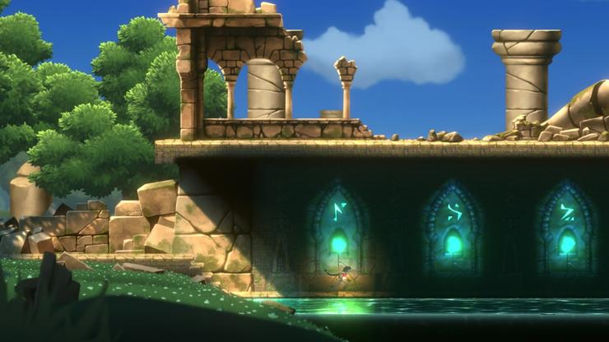

For effects, we will include sun rays, lens flares, and bloom effects. Fire will have an orange glow, treasure would glimmer and shine, caustics could reflect off water in dark areas, and much more. Water caustics would just be a 2D animated texture casted from a spotlight in Unity. Objects you can pick up will have an animated glow.
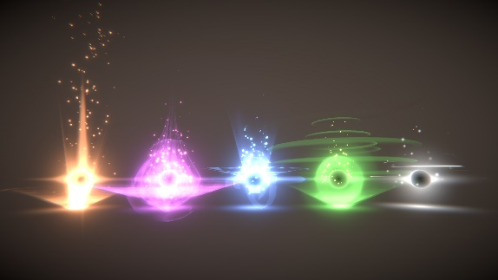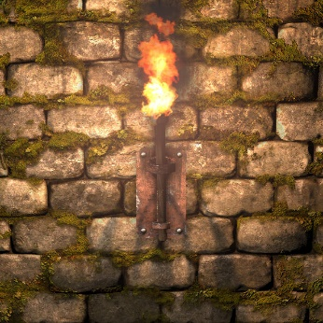

BACKGROUND LAYER
The background layer will consist of a vast ocean, beautiful mountains, boat docks, sandy beaches, volcanos, and jungle areas. We can use the same background objects for both the beach level and the jungle level, and just make the jungle background denser with trees. The background terrain will be made of 3D objects, but we can have some effects like animated birds that are 2D. The sun will also be in the background with subtle lens flares. Some terrain in the background will connect to the gameplay layer’s terrain.
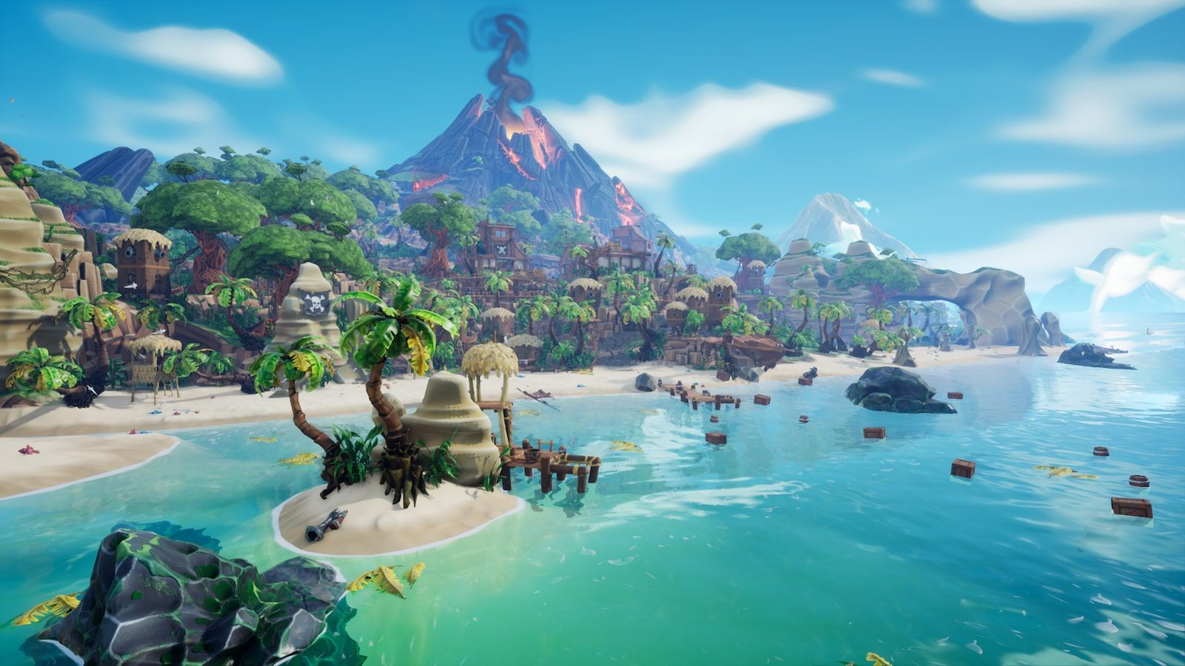
The final area of our game takes place in a cave, so the background will be dark, deep, and show off other cave systems and rock formations. There will be glowing crystals in the distance that act as light sources. Small pirate outposts will also be present in the background.
