Flint and Steel
Story Overview

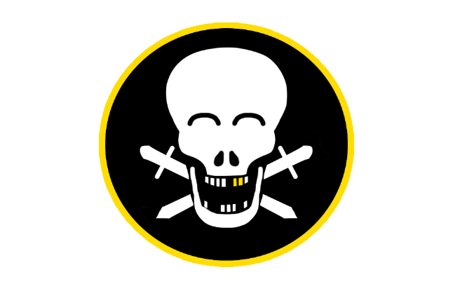
By Jolly Rogers

Intro: Scally Wagburn, a newbie pirate thirsty for adventure, has travelled the seas with his trusty companion, “Flint” ever since he was a boy. Flint is the name of Scally’s hook hand, and Scally believes there is a cursed spirit inside of it that can speak to him.
One day, while travelling through the Lost Isles, Scally and Flint stumble upon an ancient map. The map shows the location of the “Legendary World-Renowned Gold-Plated Ruby Hook” tm c. Scally sets sail on his creaking ship, the salty breeze carrying whispers of the riches that await him. The journey begins at a tropical beach, the gateway to the mysteries hidden within the heart of the Lost Isles.
During the Game: Upon arriving at the beach, Scally soon realizes that the beach is filled with enemy pirates, however he doesn’t know how to fight and being a newbie pirate, he is unarmed. Within the sand he notices a weird glowing sword, desperate for a weapon he pulls it from the sand. Unknown to Scally, he just bound himself to this cursed sword. Echoes of a strange voice can be heard coming from the cursed sword, and Scally determines that the sword is named Steel. Flint and Steel don’t like each other very much.
Scally's new sword, Steel, becomes his trusted companion, not only in combat but also a versatile tool for traversing the environment. Scally has never fought with a sword before, but he is good at throwing! So instead of trying to master close-combat, Scally sticks to what he’s good at and decides he’ll just throw the sword.
Soon after picking up Steel, Scally runs into members of a deadly pirate gang called “The Dread Beards” lead by the greedy “Captain Buck A. Neerwater”. He throws Steel straight through the pirates and to Scally and Flint’s surprise, Steel reappears in Scally’s hand after being thrown!
Steel’s cursed recall ability has been revealed, Scally now realizes that this sword is more special than he thought and so he begins to use it in more unique ways, like using it as a base to stand on. The newfound cursed sword helps Scally Wagburn travel through beach and into the Jungle.
As Scally enters the jungle, he is greeted with more challenges where Scally is forced to use Flint and Steel together to progress further into the Jungle, Flint and Steel don’t get along but being forced to work together, they start to develop a bond. Overcoming challenges, puzzles, and enemies, Scally makes his way through the jungle and into a cave.
The cave leads to a cove which is being used as a pirate outpost where the Dread Beards are guarding the Legendary World-Renowned Gold-Plated Ruby Hook. Making it through this cave won’t be easy for Scally, as it is filled with Dread Beards, traps, and puzzles.
Once Scally makes it to the end of the cove, he will be greeted by Captain Buck A. Neerwater, where they engage in an intense battle to the death! With the help of Flint and Steel, Scally emerges victorious.
Outro: After defeating the Dread Beard’s leader, Scally then claims the Ruby Hook as his own. Scally is about to switch out Flint for this new Gold-Plated Ruby Hook but pauses for a moment and reminisces about his adventures with Flint. Ultimately, Scally Wagburn decides to keep Flint and sell the newly obtained Ruby Hook for a vast amount of riches that’ll last a lifetime.

