
Flint and Steel
Jolly Rogers
Team:
Evan Keyes: Team Lead: My goal is to help every team member stay on the same page. As well as making sure everyone (including myself), has something to do. I will mostly help with programming and designing, and I will try my best to help out in any area if it is needed.
Allan Mathew: Programmer, Designer: My main role is going to be creating scripts for player movements and for other objects. I will also help make the level layout and try to make the game as simple and as enjoyable as possible for all players. I am also going to provide support wherever it is required.
Jordan Lewies: Programmer, Artist, Designer: My team role is to work on scripts and fill out necessary parts of the project. I’ll be working directly with the lead designer, artist, programmer to take part of the workload onto myself.
Matthew Keyes: Lead Artist: My goal is to make the game look as aesthetically pleasing as possible by creating high quality textures, shaders, and 3D models. The artwork in our game will also work as a guide for the player, like making explosive objects red, for example. I will also work and communicate with designers and programmers.
Brandon Keller: Lead Designer: I am dedicated to creating a compelling game world. Focused on maintaining the core function of the games systems, rules, levels, and gameplay. I will also help with the world building to ensure that it is fun and playable. My goal is to help design a world that is engaging for all audiences. I will also be helping my other teammates with programming and minor art details.
Justin Hills: Lead Programmer: My role will be to ensure that all necessary scripts work smoothly together, making sure all scripts are optimized and functional, to ensure our game’s overall performance and functionality. Also, I will contribute to providing scripts too as that is my focus.
Team Name: Jolly Rogers
Game Name: Flint and Steel
One-Liner: In the vibrant and dangerous seas of the Lost Isles, a young pirate thief named Scally Wagburn, sets on a quest to make a name for himself in search of the legendary Ruby Hook within the Lost City.

The Hook (mechanic): Armed with a cursed sword and hook for a hand. Scally uses his blade to fight his foes and traverse the terrain. The cursed blade is bound to Scally, and he can recall his blade when used in battle or to overcome obstacles.
Throw your sword into a wall and use it as a platform or use your hook to grab onto it and swing yourself upwards. The player can use the mouse to aim where the sword is thrown. The sword will only stick into certain materials like how Portal only allows portals on certain spots. If there is an overhead vine or rope, the player can grab onto it using the Hook Hand and use it as a zipline. While using the hook as a zipline, the sword can still be thrown. There will be some cases where the player must throw the sword at something while using a zipline to progress further. Some jumps may require you to stand on your sword, jump off, recall your sword, and throw it again mid-air so you have a platform to land on. After being thrown, your sword will also stick out perpendicular to the surface.

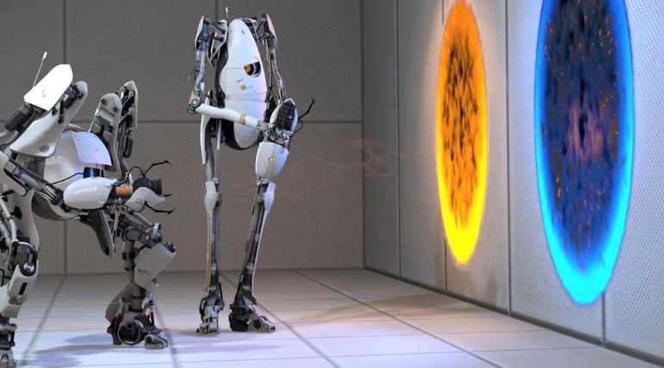
Genres: Action, Puzzle, Platformer. Fast input and precise aim will not only be required to defeat the enemies in this game, but it will also be required to solve puzzles and parkour sections. This fast-paced puzzle mechanic would be like the Portal games; however, it will differ due to the unique sword and hook mechanics of our game. Players would create their own platforms with their swords, pull objects or slide down zip lines with their hook, and on top of this, they must also avoid enemies or deadly traps.
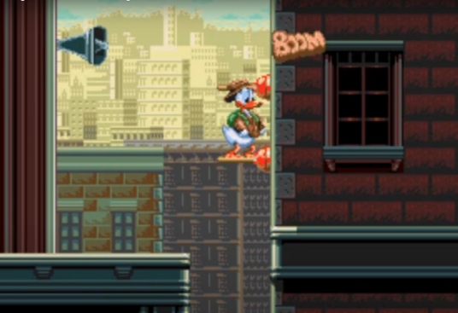
Target Audience: This game is targeted to those who are 10 and up, pirate fans, and fans of platformers with unique puzzles and movement systems. People who have enjoyed games such as: Gunbrella, Flinthook, or Quackshot will have a fun time playing Flint and Steel.
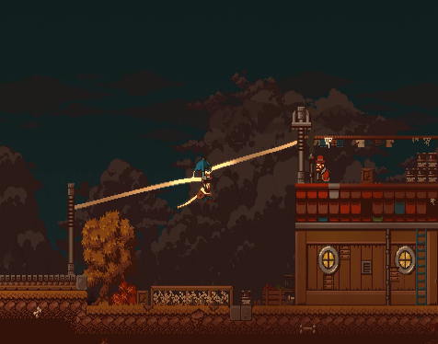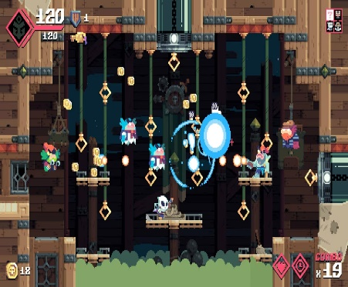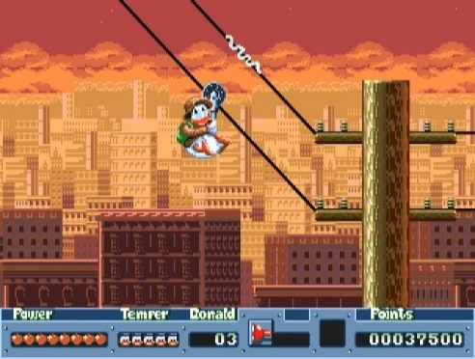
Gameplay Modes: Main menu, pause menu, walking and jumping, ziplining, death screen. These modes will work with each other, and the player will often be required to quickly switch between some of these modes during gameplay. For example, the player might have to constantly switch between running and jumping to ziplining or aiming their sword. This will stand out from other games in the genre because the player will be required to use quick inputs to solve puzzles while using these different modes together.
Interaction Model and Camera: Avatar Based, Side Scrolling
Core Pillars:
- Adventure:
The Lost Isles offer a large variety of environmental obstacles each requiring different strategies for its combat and exploration. The enemies and traps within the world create a dynamic challenge that keeps the gameplay fresh and engaging.
- Movement:
Scally’s agility and unique abilities with his sword and hook for a hand emphasizes movement and precision platforming and allows for creative ways for navigating.
- Comedy:
Using humour and jokes to engage and connect with the players. Witty pirate themed jokes and puns keep the game fresh and not stale.
- Story telling:
Scally’s story unfolds throughout the world as he dives deeper into the Lost Isles, ultimately revealing the deep lore behind Flint and Steel, and the treasure of the Lost City.
Challenges: Simple enemies (walking back and forth, cannons, projectiles), parkour and puzzle challenges (throw the sword in the correct spot). Some enemies will in die in one shot which will send the sword straight through, while some enemies will have armour, which makes the sword bounce off them. The enemies belong in the game to provide an extra challenge. Parkour and puzzles belong in the game so that the player is forced to use the throwing sword and hook hand mechanic in creative ways.
Summary of Levels and Story: Scally Wagburn discovers an ancient map that hints towards the Lost City treasure. Drawn by the thought of unimaginable wealth, Scally sets sail for the mysterious Lost City and its Legendary World Renown Gold Plated Ruby Hook. Scally wields a mystical sword cursing him with powers that originate from the Lost City. This blade can be used in combat and thrown in walls, sticking out to create platforms for Scally to traverse the environment. The sword can be recalled back to Scally discovering new ways to fight enemies.

The Lost Isles present a dynamic and ever-changing environment, from tropical jungles to treacherous caves and overgrown temple ruins. Scally’s journey is filled with platforming challenges, puzzles, and encounters with dangerous wildlife and enemy pirate foes. Scally’s pursuit of the Ruby Hook leads him to the heart of the Lost City, where a legendary treasure awaits him. However, claiming the treasure requires the ultimate challenge, a final boss that pushes Scally’s skills to their limits. Will Scally Wagburn succeed? Or become another lost tale.

Level 1: The game starts on a beach where he learns all the movements and mechanics.
Level 2: The player eventually ventures into a dense jungle where the movements and mechanics can be applied in more complex ways.
Level 3: Finally, the player wanders into a temple area where he must solve puzzles using the previously established mechanics and find the gold-plated ruby hook!

Art Style: We will create a bright, vibrant, cartoony, stylized look like Sea of Thieves. We are going to be experimenting with shaders to create refreshing-looking water. We will focus on making different layers of background as well as scenery in the foreground to create a satisfying parallax effect.
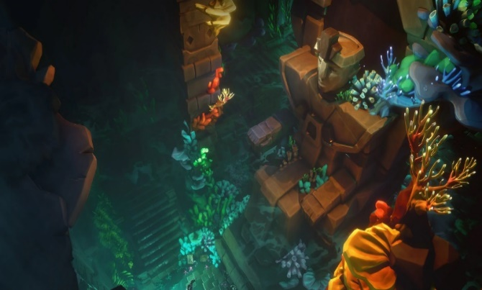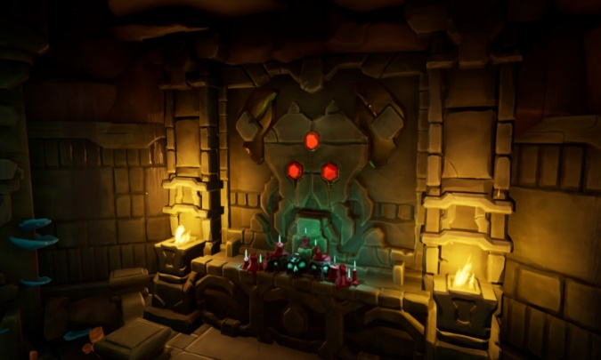
Character: Newbie Pirate Scally Wagburn, he’s fast, lean, and has a unique pirating style!

