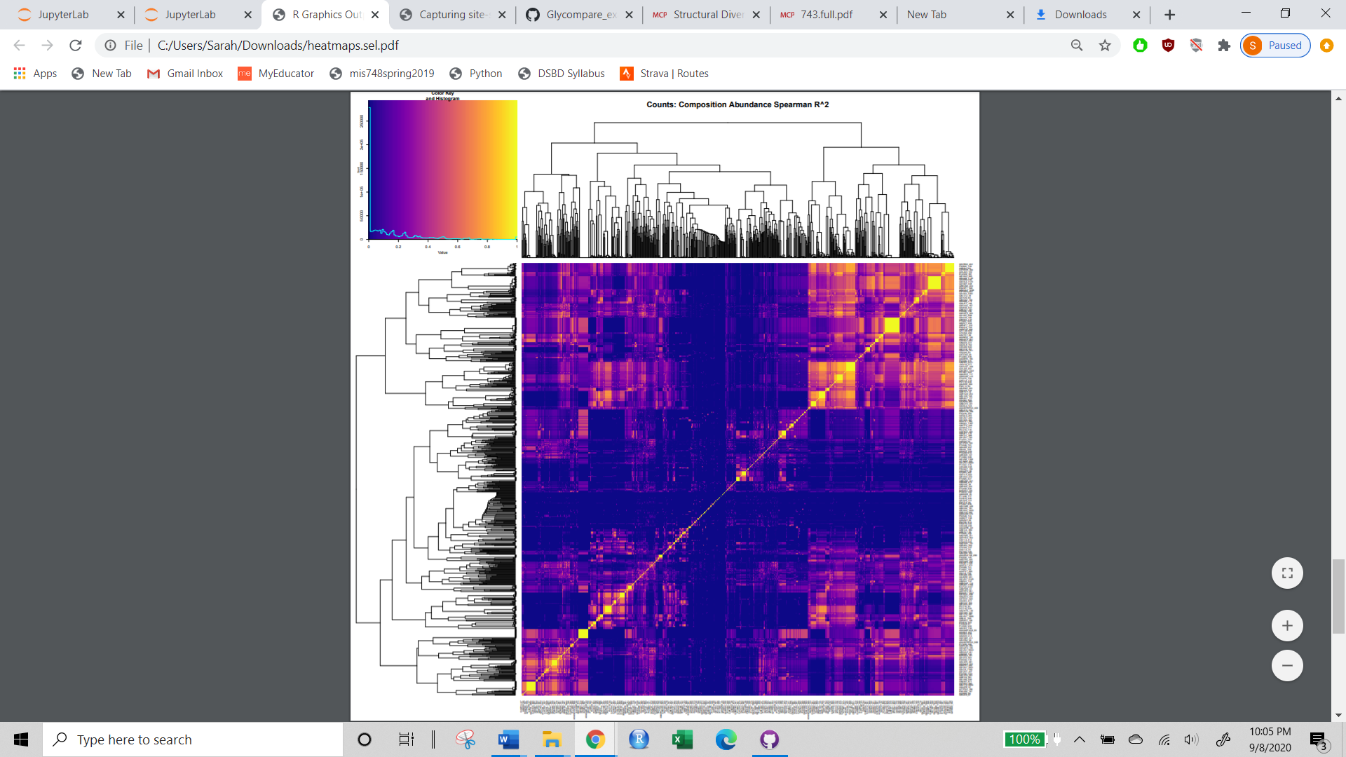

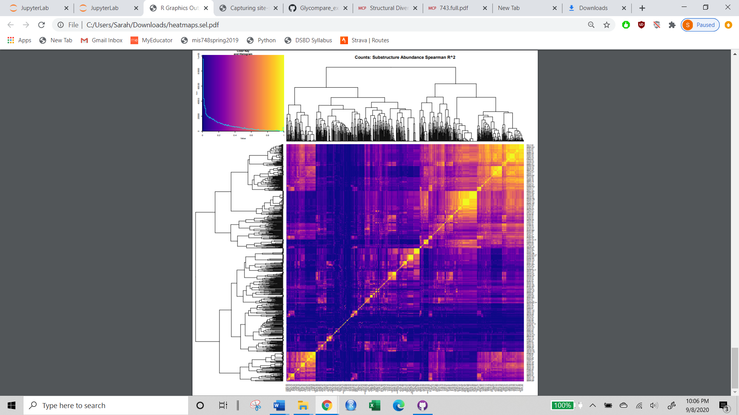

* Decreased final branch length
* More clusters, borders are more crisply defined
* Final branches split more closely to the leaves
* Several well defined off-diagonal effects

Median R^2 of substructure abundance correlation is twice compositional correlation