GoldPredict AI
Machine Learning Gold Price Prediction Application

Barbara Kendall
Computer Science 311 - Assignment 1
September 22, 2026

Name and Purpose
I present to you my app, GoldPredict AI. The goal of the project was to build a Python-based machine learning application that uses historical gold market data to estimate the next trading day's closing price. I chose gold because it is a commodity with a large amount of historical market data available, and I thought it would be interesting to see how well a machine learning model could follow its short-term price movement.
The app actually does two things. The main Random Forest regression model predicts the next-day percentage return and converts that prediction back into a dollar closing price. I also tested a separate Random Forest classification model to see whether a model focused only on direction could do a better job predicting whether gold would move up or down the next day.

Algorithms
The main algorithm I used was Random Forest regression. A Random Forest combines predictions from many decision trees instead of relying on one tree. I used 500 trees with a fixed random state so the results would be reproducible. Instead of asking the model to predict the raw gold price directly, I trained it to predict the next day's percentage return. I then multiplied that return by the current closing price to calculate a predicted next-day closing price.
I originally tried predicting the raw price directly, but that version did not perform well on newer prices. Changing the target to next-day return made the model much more useful. I also used a Random Forest classifier as a small follow-up experiment. Its target was binary: 1 if the next day's price increased and 0 if it stayed the same or decreased.
Because this is time-series data, I did not randomly shuffle the records. I used the earlier 80% of the usable observations for training and the most recent 20% for testing. This better represents the real situation where a model learns from the past and is evaluated on later data.

Dataset
The application downloads five years of daily Gold Futures data using Yahoo Finance through the yfinance Python library. In my final run, it downloaded 1,258 daily records covering September 22, 2021 through September 22, 2026. The raw fields used were Open, High, Low, Close, and Volume.
I created 11 model features from that data: 1-day return, 2-day return, 5-day return, the current price relative to 5-, 10-, and 20-day moving averages, 5- and 20-day volatility, the daily high-low range, the opening-to-closing change, and the change in volume. After feature engineering and removing records without known future outcomes, there were 1,229 modeling records. The chronological split produced 983 training records and 246 testing records. The newest feature row was kept separately so the program could make a genuine future prediction.

Libraries
I used pandas for working with the dataset, NumPy for numerical calculations, yfinance for downloading the historical gold data, scikit-learn for the Random Forest models and evaluation metrics, Matplotlib for the graphs, pathlib for file paths, and Python's warnings module to keep the program output cleaner.

Design and Implementation
I organized the program into separate functions so each part of the machine learning process has one clear job. The program first downloads and saves the historical data. It then creates the technical features, separates records with known targets from the newest prediction-only row, and performs a chronological train/test split.
The regression model is trained on next-day returns. During testing, each predicted return is converted back into a predicted closing price. The program calculates Mean Absolute Error (MAE), Root Mean Squared Error (RMSE), R-squared (R²), and directional accuracy. It also saves the test predictions to a CSV file.
For the direction experiment, I trained a separate Random Forest classifier using the same input features. I compared its accuracy with a simple majority-class baseline. I included this baseline because an accuracy above 50% does not automatically mean a classifier is useful if one direction occurs more often than the other.
Finally, the application uses the newest available feature row to produce a next-trading-day price prediction and an experimental UP/DOWN classification. It also automatically creates an actual-versus-predicted chart and a feature-importance chart.

How to Run the Application
I ran the project with Python 3.12 in a virtual environment. From the GoldPredict_AI project folder, the required packages can be installed with:
pip install -r requirements.txt
The program can then be started with:
python gold_price_predictor.py
The application downloads the data, trains and evaluates both models, prints the results in the terminal, makes the next-day prediction, and saves the CSV and PNG output files in the project folder.

Results
The final regression model had an MAE of $60.22 and an RMSE of $85.59. This means the next-day price predictions were about $60 away from the actual price on average, while RMSE gave more weight to the larger errors. The model's R² was 0.9430, so its predicted price levels followed the actual price levels in the test period closely.
The regression model's directional accuracy was 48.78%. I then tested the separate direction classifier, which increased direction accuracy to 51.63%. However, the majority-class baseline was 54.47%, so the classifier did not beat the simple baseline. I therefore would not consider the classifier reliable for predicting whether gold will go up or down.
In the final run, the latest available trading date was September 22, 2026 and the closing price returned by the data source was $4,401.80. The regression model predicted a next-day return of +0.316% and a next closing price of $4,415.71. The classifier predicted UP and returned a model probability of 67.40% for UP. Since the classifier did not beat the baseline during testing, I do not interpret that 67.40% value as a reliable real-world probability.
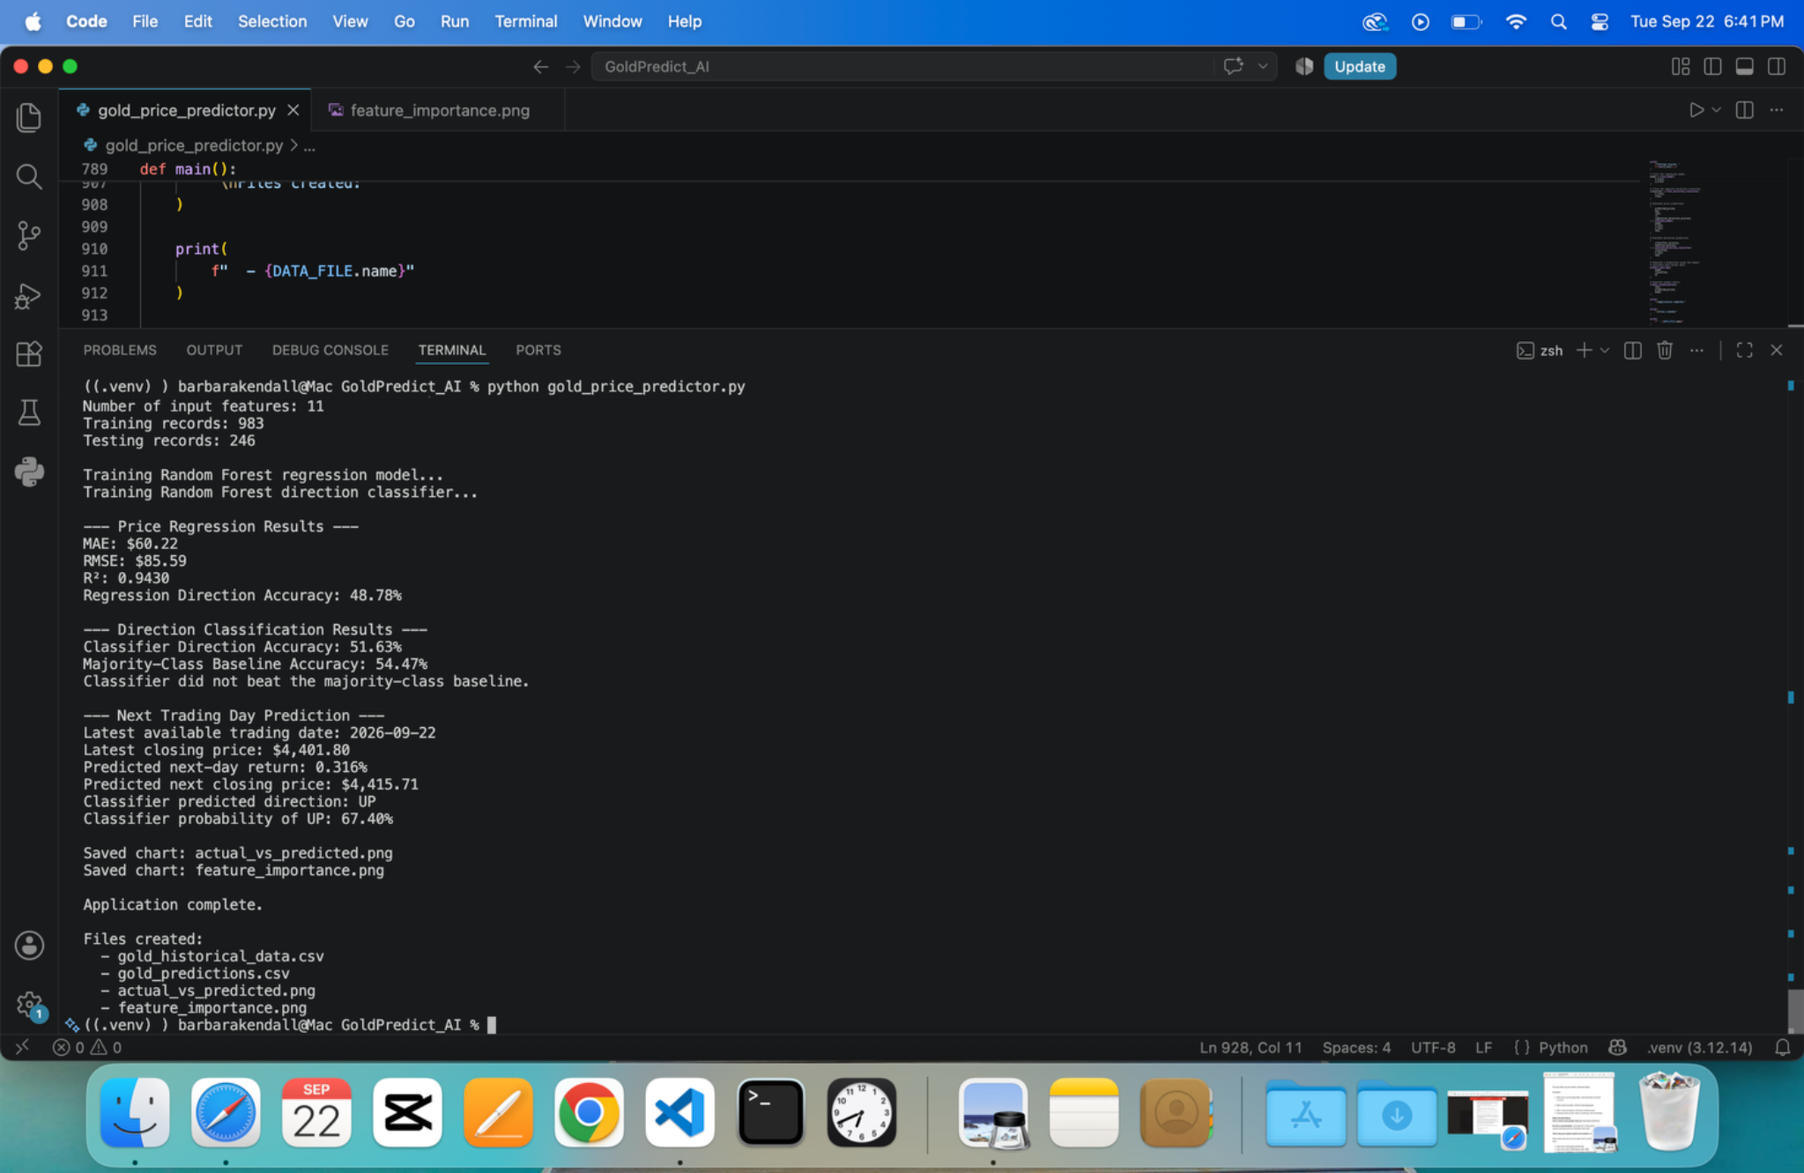
Figure 1. Final terminal output showing regression results, direction-classification results, and the next-day prediction.
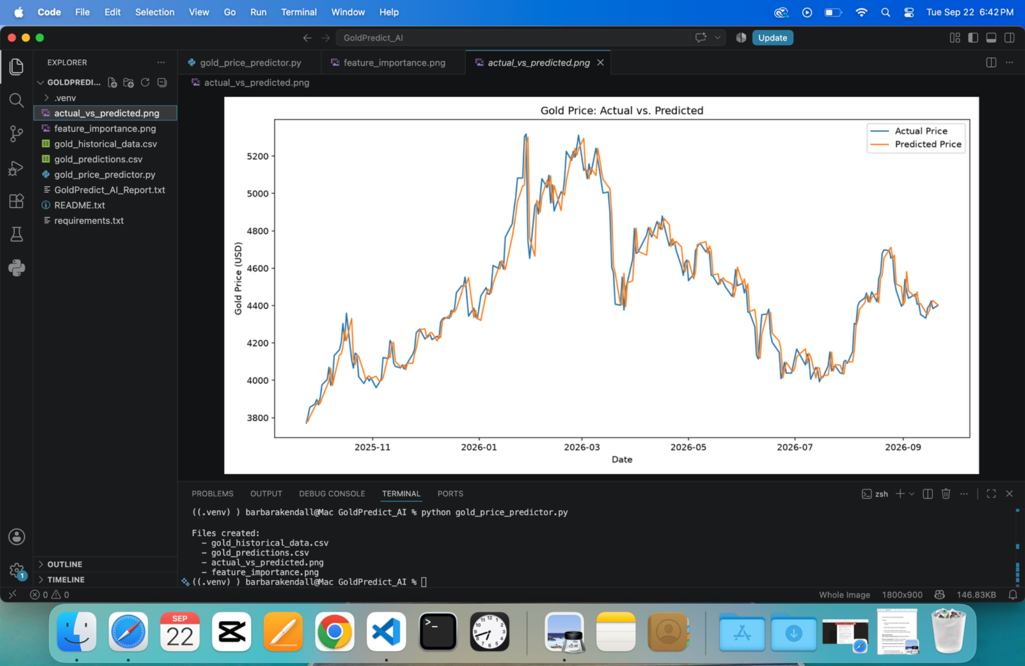
Figure 2. Actual versus predicted gold prices on the chronological test set.
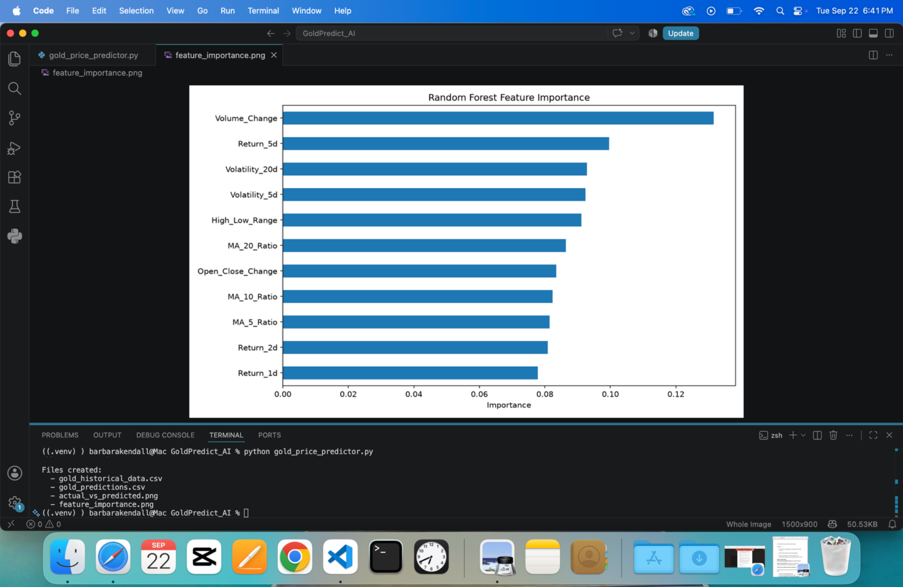
Figure 3. Random Forest feature importance for the regression model.

Discussion
Overall, I was happy with how the regression part of the project turned out, especially because my first approach did not work well. My original model tried to predict the raw future price and had an R² of -3.7400 with an MAE of about $689.57. That result made it clear that I needed to rethink the target instead of just accepting the first model. Predicting the next-day return and then converting it back to a price reduced the MAE to $60.22 and produced an R² of 0.9430.
At the same time, the direction results were a good reminder that a strong R² does not mean the model is 94.3% accurate at predicting the market. Tomorrow's gold price is usually fairly close to today's price, so a model can follow the overall price level closely while still getting the direction of small daily changes wrong. The 48.78% regression direction accuracy and 51.63% classifier accuracy show that short-term direction was much harder to predict with these features.
If I continued the project, I would add walk-forward validation and compare the regression model with a simple persistence model that predicts tomorrow's closing price will equal today's closing price. I would also test outside variables that can affect gold, such as interest rates, inflation, and U.S. dollar movements. Another option would be to compare Random Forest with other regression methods. I would keep the test period separate while making those changes so I would not accidentally tune the model to one test set.
The biggest thing I learned from this project was that evaluating a machine learning model takes more than looking at one number. The graphs, regression metrics, direction accuracy, and baseline comparison each told a different part of the story. The final application is useful as an educational example of the complete machine learning workflow, but I would not use its predictions by themselves to make real investment decisions.

References
Breiman, L. (2001). Random forests. Machine Learning, 45, 5-32. https://doi.org/10.1023/A:1010933404324
Scikit-learn developers. (n.d.). RandomForestRegressor. Scikit-learn. https://scikit-learn.org/stable/modules/generated/sklearn.ensemble.RandomForestRegressor.html
Scikit-learn developers. (n.d.). RandomForestClassifier. Scikit-learn. https://scikit-learn.org/stable/modules/generated/sklearn.ensemble.RandomForestClassifier.html
Yahoo Finance. (n.d.). Gold futures (GC=F) historical data. https://finance.yahoo.com/quote/GC=F/history/

