**EZ Recipes**

**Website**

**User’s Manual**

**Bellarmine University Computer Science Department**

**E-Commerce Technologies Project**

**By**

**Brooke Kennedy**

**Carson Blevins**

**April 2017**

**Table of Contents**

**Introduction**

**Chapter I**

**Navigation through the EZ Recipes Website**

* 1. **General Navigation**

**Chapter II**

**The EZ Recipes Website**

**2.1 Home**

**2.2 Categories**

**2.3 Tools**

**2.4 Go to Recipe**

**2.5 Grocery Store**

**2.6 Shopping Cart**

**2.7 Search functionality**

**Introduction**

**Purpose:**

The purpose of this user’s manual is to help guide users through the various pages and functions of the EZ Recipes website to allow for smooth transactions.

**Background:**

People are always looking for the easiest and most convenient way of doing tasks. Our EZ Recipes platform will eliminate the need of searching for specific ingredients in multiple locations, allowing for a convenient way to successfully try new recipes and get the necessary ingredients.

**About the Developers:**

The developers for this project are Brooke Kennedy and Carson Blevins. Both are senior computer science majors at Bellarmine University. This site has been developed as the final project for the class E-Commerce Technologies.

**The Web Site:**

The EZ Recipes web site (<http://www>.) is a database driven e-commerce site. All pages except for help page and checkout page are dynamic and database driven.

The dynamic pages include:

* **Home** page contains links to various categories of recipes, along with tools to view recipes under different criteria. The home page also includes a navigation bar that allows search of recipe title, recipe ingredient, grocery item, or recipe categories. The home page also includes the top six trending recipes in our database.
* **Go To Recipe** page will include the title of the recipe, the recipe picture, recipe ingredients, recipe directions, and a link to all grocery items associated with the recipe.
* The **Vegetarian**, **Italian,** **American**, and **Drinks** pages listed under Categories will include all recipes associated with the specific category.
* The **All Recipes** and **Popular Recipes** listed under Tools will display all recipes and popular recipes, respectively. **The I’m Feeling Lucky** page will generate a random recipe and be displayed in the same fashion as the Go to Recipe page.
* **Grocery Store** page includes all grocery items for sale on EZ Recipes.
* **Shopping Cart** page will show all grocery items added to the cart. It will also allow for updating quantities and removal of items from your shopping cart. The shopping cart page will show the total value of what is in the cart, and give options to continue shopping or proceed to checkout.

The static pages include:

* **Help** page will display text similar to this user’s manual that will help users navigate the site.
* **Checkout** page will display a form where a user would input their information to complete their checkout. However, for the scope of this project, the checkout page is static and will not process any information.

**Chapter II**

**The EZ Recipes Website**

**2.1 Home**

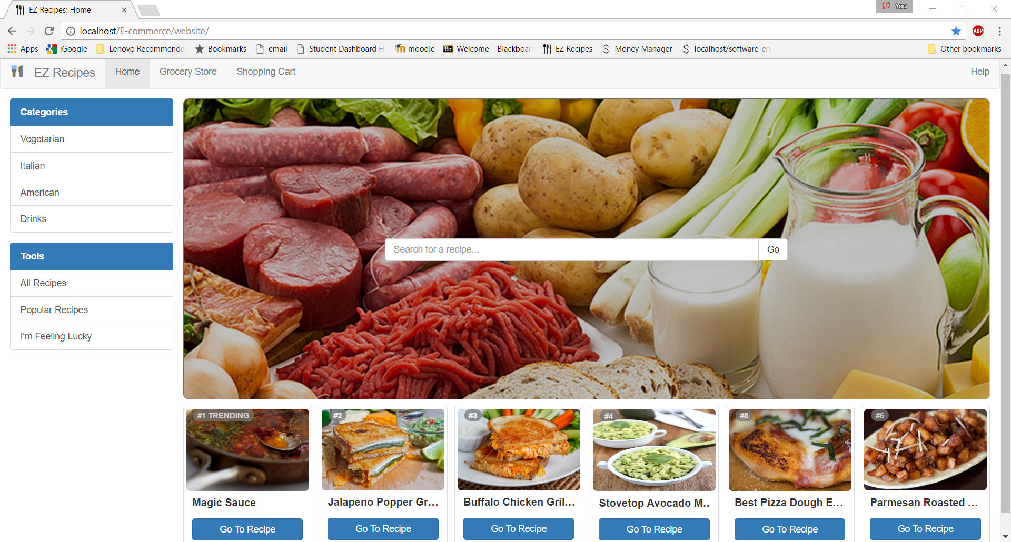

**What does this page contain?**

EZ Recipes home page contains the following information:

Navigation bar- The navigation bar contains links to four pages that will be present throughout the site. The first button is “Home” which will lead you to the home page. The second button “Grocery Store” leads to EZ Recipes’ virtual grocery store. The third button is “Shopping Cart”. The shopping cart contains the quantities and prices of grocery items you have added to the cart. Lastly, the navigation bar contains the “Help” button. The help page will display general information on how to navigate the site.

Side bar- The side bar contains links to display specific categories of recipes, a link to see all recipes, a link to see popular recipes, and the “I’m feeling lucky” button to randomly generate a recipe from EZ Recipes.

Search- The search bar allows for the user to search by title of recipe, ingredient of recipe, category of recipe, or grocery item.

Trending- The trending section located below the search displays the top six trending recipes from EZ Recipes.

**2.2 Categories**

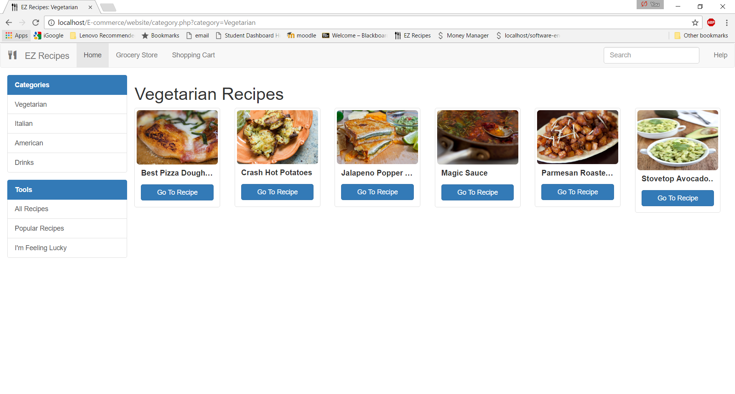

**What does this section contain?**

The categories section includes links to navigate to pages displaying vegetarian recipes, Italian recipes, American recipes, and drink recipes. Above is an example of the Vegetarian recipes page. Each categories page will follow the same format.

**2.3 Tools**

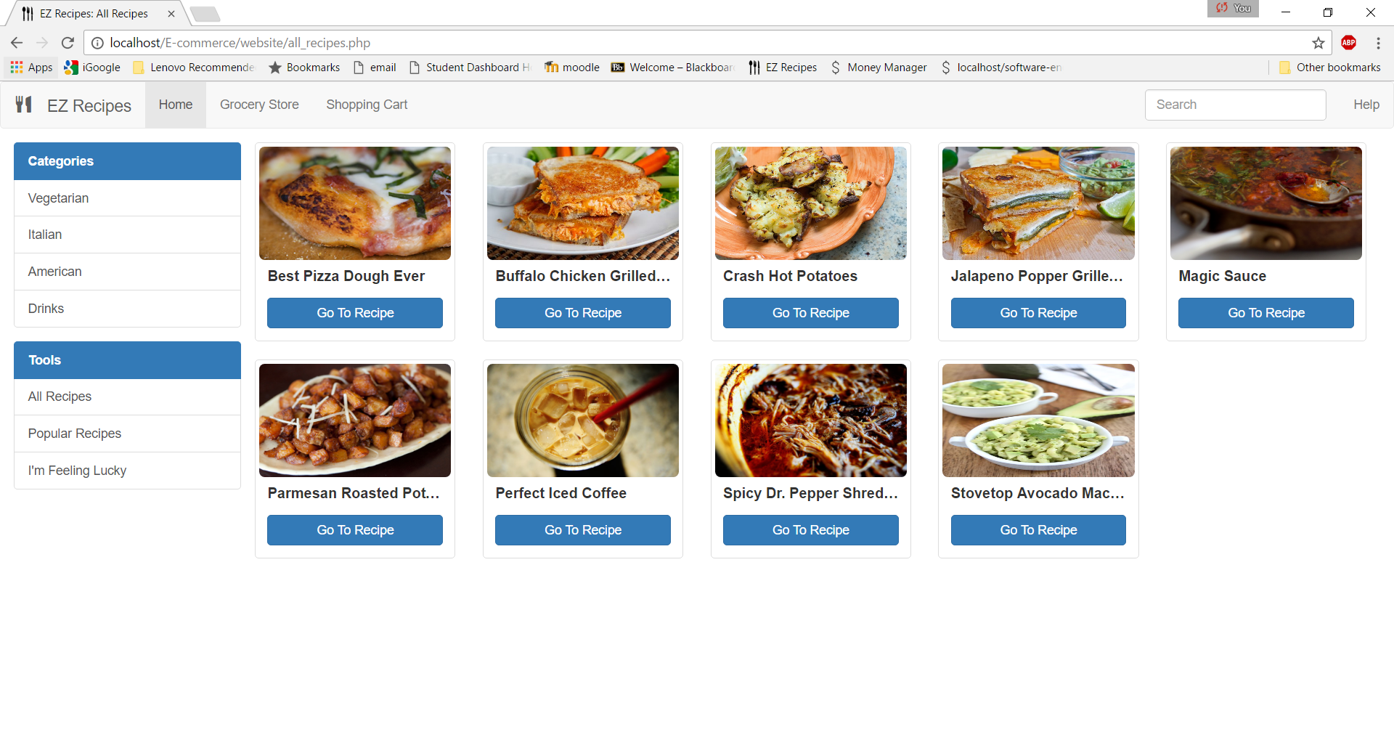

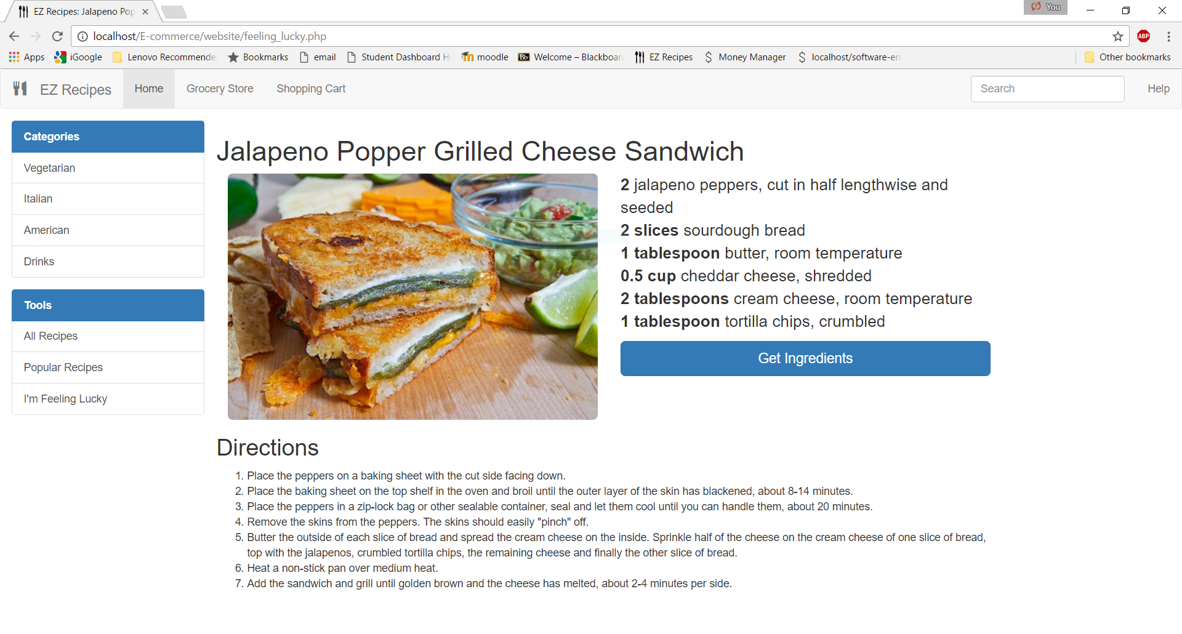

**What does this section contain?**

The tools section contains links to view all recipes in the EZ Recipes database, along with popular recipes, and a link to randomly generate a recipe from the EZ Recipes database. The first picture above is the “All Recipes” page. The “Popular Recipes” page will follow the same format. The second picture shows an example of the “I’m Feeling Lucky” page. This generates a random recipe and displays the ingredients needed and quantities, along with directions to make the recipe. It also contains the “Get Ingredients” link which will pull up all the grocery items needed to make the recipe, from which you can then add to car.