***Project Charter***

*Money Manager*

*Bellarmine University Software Design & Development*

*2/20/2017*

*Brooke Kennedy*

*James Kelly*

Contents

1. Project Description……………………………………………………. 3
2. Project Purpose…………………………………………………………3
3. Business Case…………………………………………………………..3
4. Project Deliverables…………………………………………………….3
5. Project Milestones………………………………………………………3
6. Project Roles and Responsibilities……………………………………...3
7. Project Life Cycle Methodology and Tools…………………………….3
8. Production Fees and total Cost………………………………………….4
9. Project Description

The project is to develop an Android application that will allow users to track their profits and expenditures. The app will also provide future predictions and projections of financial standing based on user input patterns.

1. Project Purpose

The purpose of the project is to provide a platform so users can easily manage their finances through visual aids and understand their spending habits through financial projections.

1. Business Case

People need a simple platform that allows them to visually see their expenditures and profits and project long-term patterns allowing users to easily set and reach financial goals.

1. Project Deliverables

The focus will be on developing an android app that will allow users to input their expenditures and profits along with the associated categories. Our application will let users set financial goals, such as reaching a target balance over a specified time period and displaying areas the user can improve upon in order to reach this goal. Our application will provide financial projections in the form of various visual charts, based on user defined parameters.

1. Project Milestones

Phases:

1. Business case and charter
2. Modeling
3. Develop architecture to allow user input and storage of information
4. Develop algorithms that generate projections
5. Incorporate graphics
6. Testing
7. Beta
8. Deployment
9. Project Roles and Responsibilities

Brooke Kennedy – Developer, Tester

James Kelly – Communicator, Developer, Tester

1. Project Life Cycle Methodology and Tools

We will use the Agile Methodology which will allow us to complete our project in weekly phases. This approach will allow for unexpected changes we incur along the way and provide adaptability.

1. Production Fees and total Cost

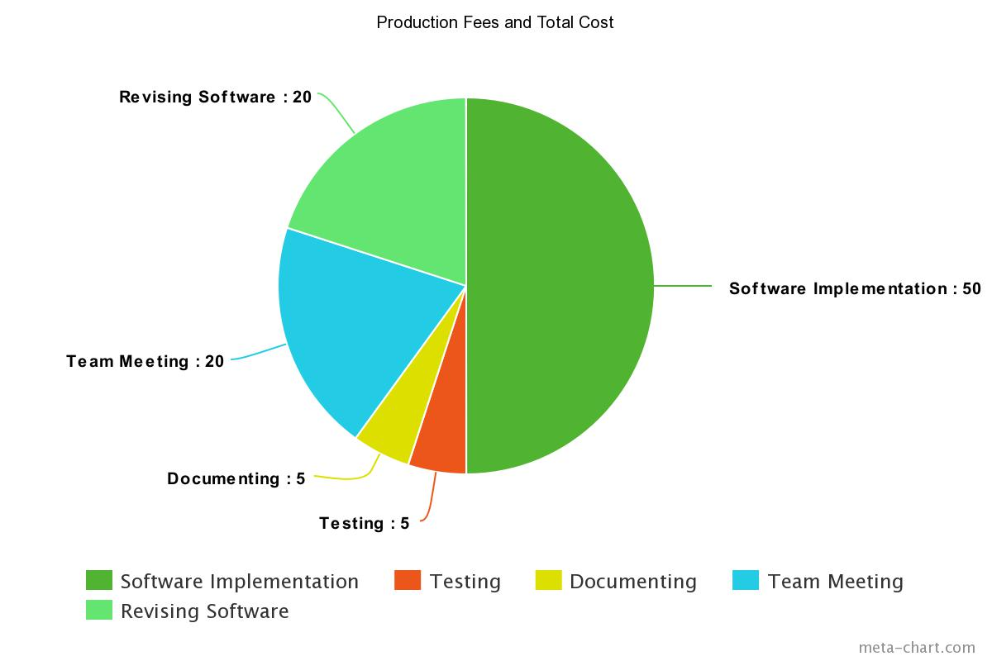

|  |  |  |  |
| --- | --- | --- | --- |
| Labor | Hours | Rate | Total |
| Brooke Kennedy | 60 | $100/hour | $6,000 |
| James Kelly | 60 | $100/hour | $6,000 |
| **Total** |  |  | **$12,000** |