**Money Manager**

**Website**

**User’s Manual**

**Bellarmine University Computer Science Department**

**Software Engineering Project**

**By**

**Brooke Kennedy**

**James Kelly**

**April 2017**

**Table of Contents**

**Introduction**

**Chapter I**

**Navigation through the Money Manager Website**

* 1. **General Navigation**

**Chapter II**

**The Money Manager Website**

**2.1 Login**

**2.2 Register**

**2.3 Home**

**2.4 Add Goals**

**2.5 Add Transactions**

**2.6 Update Account Balance**

**Introduction**

**Purpose:**

The purpose of this user’s manual is to help guide users through the various pages and functions of the Money Manager website to allow for smooth transactions and use of the site.

**Background:**

The purpose of the project is to provide a platform so users can easily manage their finances and understand their spending habits through visual aids.

**About the Developers:**

The developers for this project are Brooke Kennedy and James Kelly. Both are seniors at Bellarmine University. Brooke is a computer science major and James is a physics major. This site has been developed as the final project for the class Software Engineering.

**The Web Site:**

The Money Manager web site (<http://www>.moneymanager.pro) is a database driven site. All pages except for the help page are dynamic, database driven pages.

The dynamic pages include:

* **Home** page displays transaction history in the form of a table, it displays progress bars for goals set, a line graph of account balance over time, a bar graph of profits vs expenditures each month, and a pie chart of spending by category.
* **Add Goals** page allows the user to enter a goal to be displayed on the home screen.
* **Add Transactions** page allows the user to enter their transactions.
* **Update Account Balance** page allows the user to manually set or update their account balance.
* **Login** page allows the user to enter their credentials or register for an account.
* The **Logout** page ends the user’s session and takes them back to the login page.

The static pages include:

* **Help** page will display text similar to this user’s manual that will help users navigate the site.

**Chapter II**

**The Money Manager Website**

**2.1 Login**

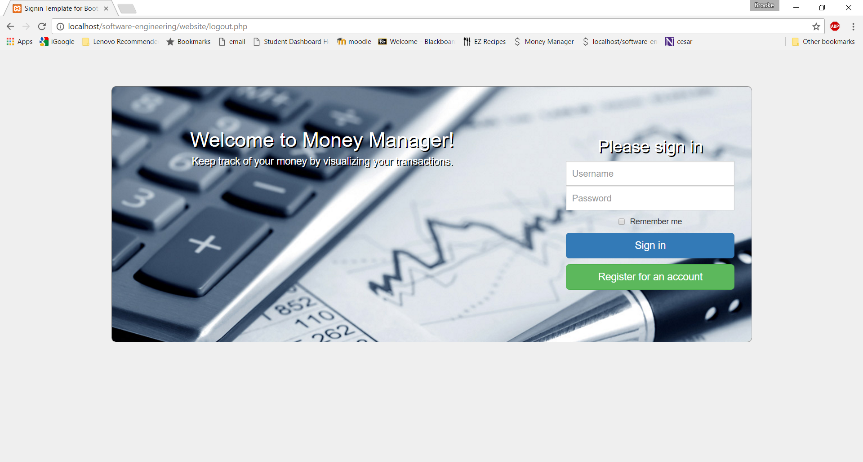

**What does this page contain?**

The Money Manager login page contains an area for users to login or register for an account. If the username and password entered do not match a registered account the user will be navigated to a page showing account not found and a link back to the login page. If the user is not yet registered for an account, they have the option to navigate to the “register for an account” page.

**2.2 Register**

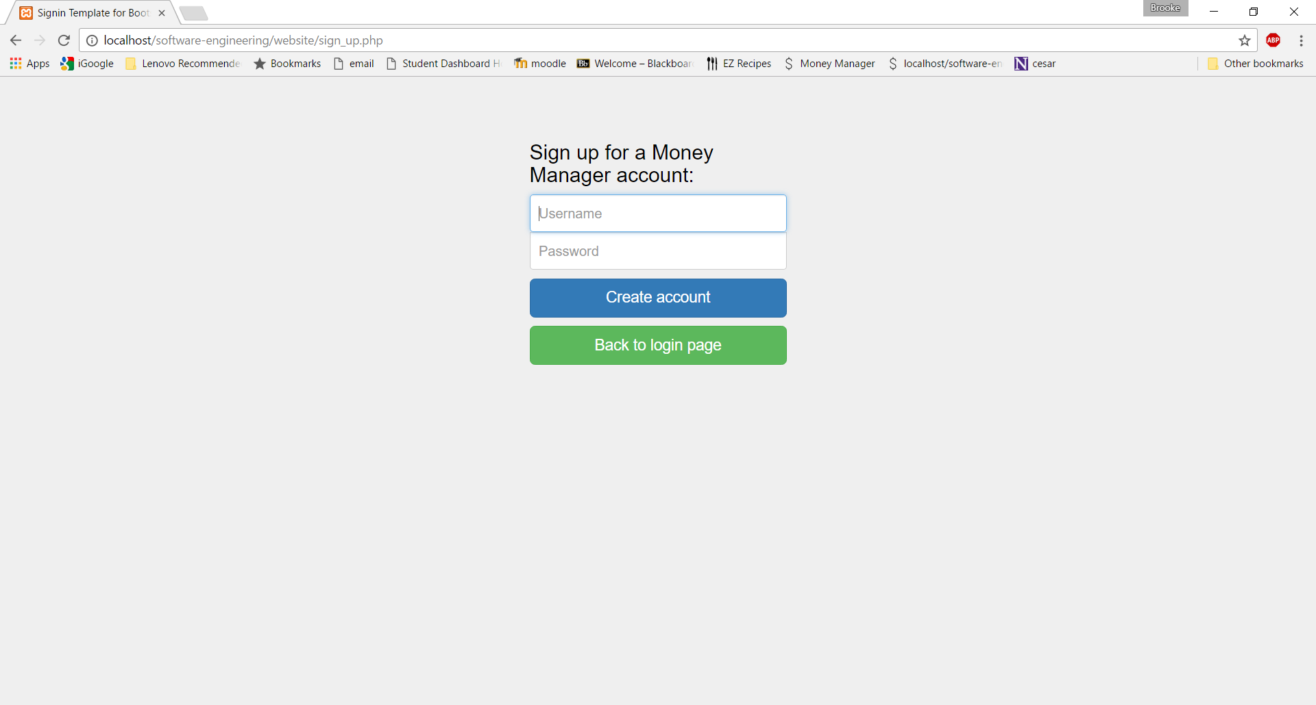

**What does this page contain?**

The Money Manager register page allows new users to create an account. This page can be navigated to from the login page. After entering a unique username and password and upon successful account creation the user will be navigated to a page stating the account has been created successfully and a link to the login page. If the username is already taken the user will be prompted to try again.

**2.3 Account Home**

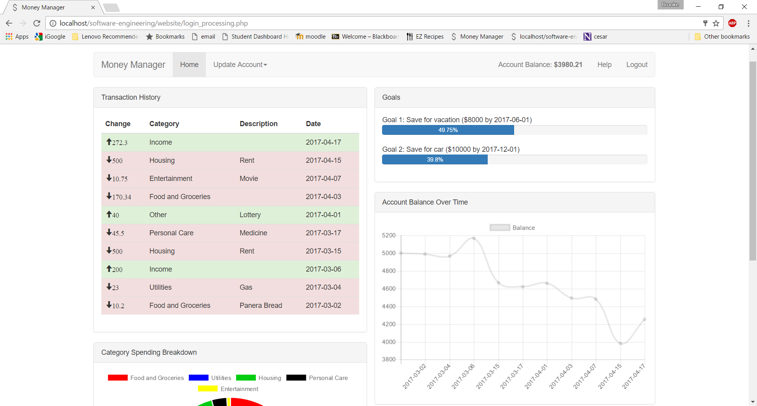

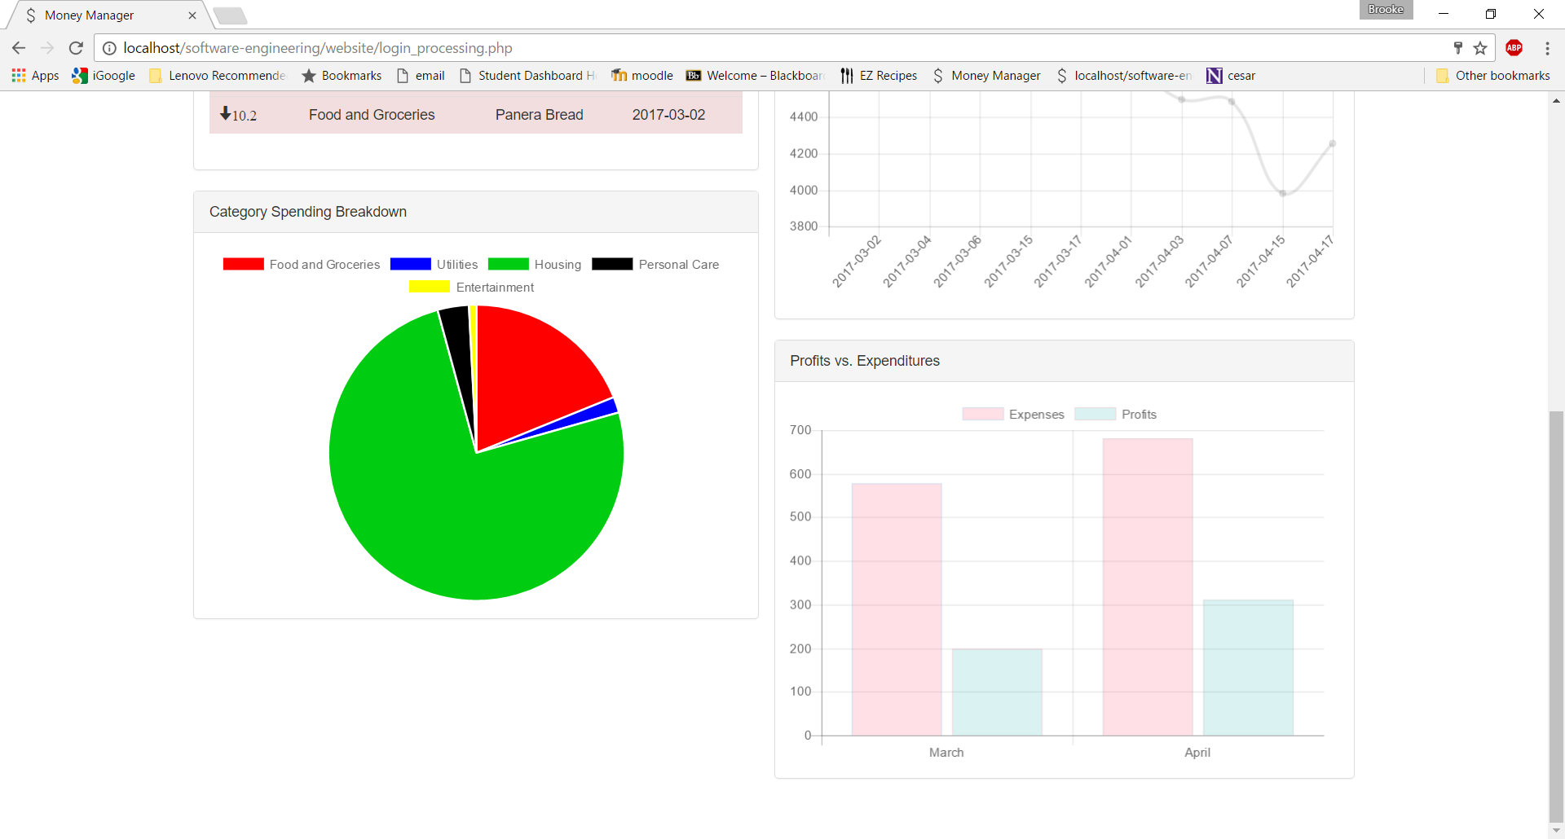

**What does this page contain?**

The home page contains all account visual aids. In the upper right hand corner, the current account balance is displayed. The user will find a color-coded table of their transactions, progress bars of all goals, a line graph of account balance lifetime trends, a pie chart of spending by category, and a bar chart of expenditures vs profits broken down by month. All graphs are interactive, so the user can click on the legend to determine what they want displayed. Under the update account dropdown on the navigation, users will find links to pages where they can update or add account information. Also located in navigation is the logout button which will return the user back to the login screen and the help button which will link the user to the user manual.

**2.4 Add Goals**

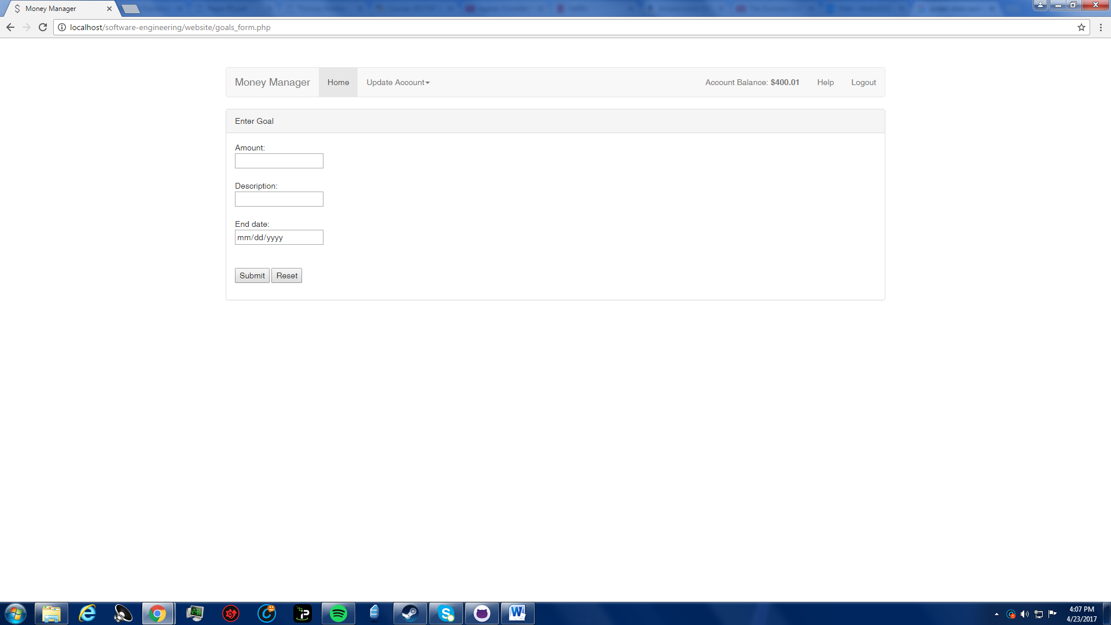

**What does this page contain?**

The add goals page allows the user to enter desired goals as milestones that they would like to accomplish in a given time frame. The user will be asked to provide the account balance goal they would like to create (for example, $500), a description of the goal (for example, concert tickets), and the end date they would like to have the goal accomplished. Once submitted, the goal will be visible on the home page and the user will be able to keep track of the progress they are making toward completing the goal based on the amount of funds the user has saved. Below is an example of how goals will be displayed.

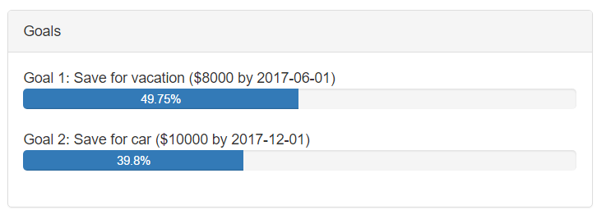

**2.5 Add Transactions**

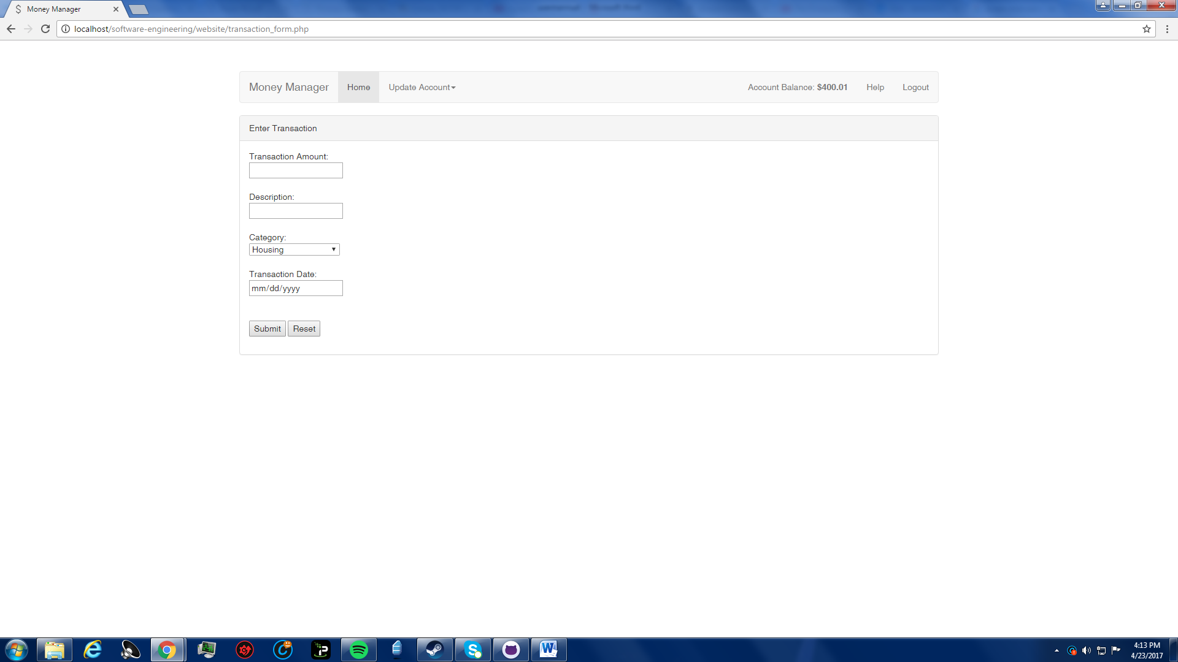

**What does this page contain?**

The add transactions page allows the user to enter a transaction that they have made in order to update their account. The user will be asked to provide the transaction amount (for example, 200 or -170.50), an optional user-defined description of the transaction (for example, paycheck or bill for utilities), select a predefined category of which the transaction would be classified as (for example, income or utilities), and the date of which the transaction occurred. Once submitted, the information will be filed into the database and the home page will have the transactions table and charts updated with the new data. Below is an example of how the transactions will be displayed on the home page.

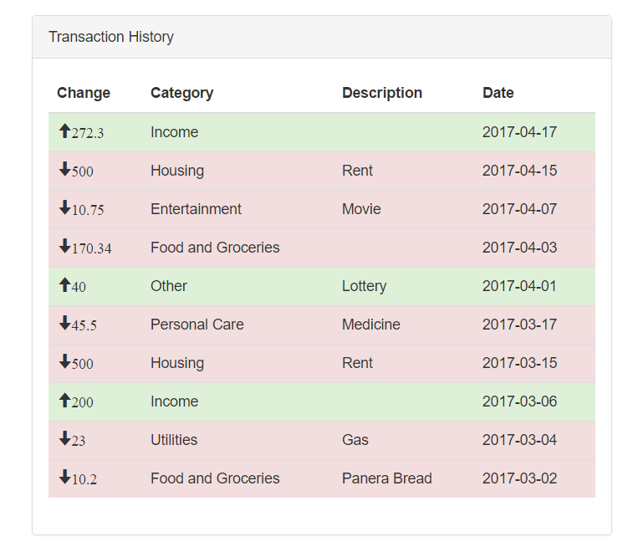

**2.6 Update Account Balance**

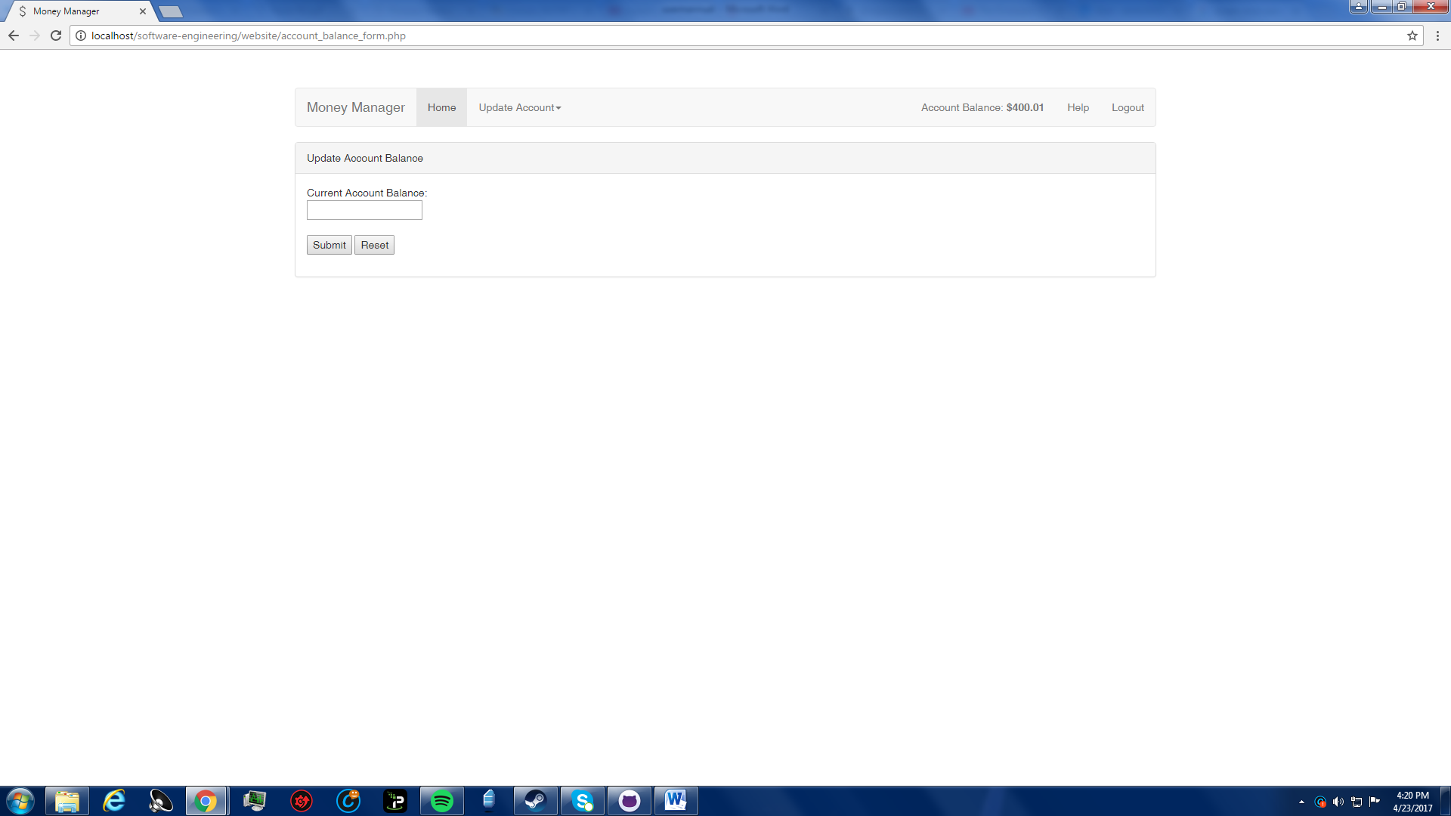

**What does this page contain?**

The update account balance page allows the user to manually define their new account balance. In the event that the user forgets to enter a transaction, or goes through a period of many small transactions where the individual amounts are negligible but added together may be significant, the user may decide they would rather save time by manually updating their new account balance instead of putting in every small transaction that they make. Upon submitting, the new account balance will be shown at the top right of the pages and the account balance on the home page will be updated accordingly. Below is an example of how the updated account balance will be displayed.

