C.D.I. Technical Note No. 16-12

AGDISP Version 8.29 User Manual

Prepared by:

Milton E. Teske

Thomas B. Curbishley

Continuum Dynamics, Inc.

34 Lexington Avenue

Ewing, NJ 08618

Prepared for:

Harold W. Thistle

USDA Forest Service

180 Canfield Street

Morgantown, WV 36505

December 2016

Table of Contents

Section Page

Table of Contents ……………..……………………………………………………. i

AGDISP Modifications …………………….……………………………………….. iii

1. Introduction ……………………….……..…………………….……..…………… 1

1.1. Model History …….……………………..………………………………….... 1

1.2. Model Installation ……….…………….…………………………………….. 2

1.3. ASABE Drop Size Standard S-572.1 …………...……..…………………..….. 2

1.4. Units ………………………………….………………………………………. 3

2. Glossary of Terms …………………………………………………………………. 5

3. Program Operation ………………………………………………………………… 12

3.1. General Program Operation ..………………………………..……………….. 12

3.2. Model Inputs .………..……………..…………………………………………. 12

3.2.1. Title …………………………………………………………………….. 12

3.2.2. Application Method ……………………………………………………. 12

3.2.2.1. **Aircraft** …………………………………………………………… 15

3.2.2.1.1. Aircraft Type ……………………………………………….. 15

3.2.2.1.2. Properties …………………………………………………… 17

3.2.2.2. Spray Line **Reps** …………………………………………………. 18

3.2.3. Application Technique ………………………………………………… 18

3.2.3.1. **Nozzles** (Liquid) Input Screen …………………………..………. 18

3.2.3.1.1. Nozzle Installation Properties ……………………………… 20

3.2.3.1.2. Generate Regular Distribution …………………………….. 20

3.2.3.1.3. Nozzles …………………………………………………….. 20

3.2.3.2. **DSD** (Liquid) Input Screen ………………………………………. 20

3.2.3.2.1. Drop Distribution Name …………………………………… 20

3.2.3.2.2. Drop Distribution Type ……………………………………. 20

3.2.3.2.3. Drop Distribution ………………………………………….. 25

3.2.3.3. **Details** (Dry) Input Screen ………………………………………. 25

3.2.3.3.1. Particle Distribution Name …………………………………. 26

3.2.3.3.2. Material Property …………………………………………… 26

3.2.3.3.3. Application Type …………………………………………… 26

3.2.3.3.4. Spreader Location …………………………………………. 28

3.2.3.3.5. Equivalent Particle Distribution …………………………… 28

3.2.4. Swath …………………………………………………………………… 28

3.2.5. Meteorology ……………………………………………………………. 28

3.2.6. Spray Material …………………………………………………………. 29

3.2.6.1. Properties ………………………………………………………… 29

3.2.6.2. Fractions …………………………………………………………. 30

3.2.6.3. Tank Mix …………………………………………………………. 31

3.2.7. Atmospheric Stability ………………………………………………….. 31

3.2.8. Surface …………………………………………………………………. 31

3.2.8.1. Canopy Name ……………………………………………………. 32

3.2.8.2. Canopy Type ……………………………………………………… 32

3.2.8.3. Properties …………………………………………………………. 32

3.2.8.4a. Story Canopy Properties ………………………………………… 32

3.2.8.4b. LAI Canopy Properties …………………………………………. 32

3.2.8.5. Preview …………………………………………………………… 32

3.2.9. Transport ………………………………………………………………. 35

3.2.10. Advanced Settings …………………………………………………….. 35

3.3. Menu Bar Operation ………………………………………………………….. 36

3.3.1. File ……………………………………………………………………… 36

3.3.2. Edit ……………………………………………………………………... 39

3.3.3. View ……………………………………………………………………. 40

3.3.3.1. Numerical Values ………………………………………………… 40

3.3.3.2. Plots ………………………………………………………………. 42

3.3.3.3. Plot Options Input Screen ……………………………………….. 44

3.3.4. Run …………………………………………………………………….. 45

3.3.5. Toolbox ………………………………………………………………… 47

3.3.5.1. Deposition Assessment …………………………………………… 47

3.3.5.2. Spray Block Statistics …………………………………………….. 49

3.3.5.3. Stream Assessment ……………………………………………… 50

3.3.5.4. Multiple Application Assessment ……………………………….. 52

3.3.5.5. Trajectory Details ………………………………………………… 55

3.3.5.6. Gaussian Far-Field Extension …………………………………… 56

3.3.6. Help ……………………………………………………………………. 58

4. Interpretation of Model Predictions ………….……………………………………. 59

4.1. Numerical Results from Calculations ………………………………………… 59

4.2. Plotted Results from Calculations …………………………………………… 60

4.3. Toolbox Results ……………………………………………………………… 62

5. References …………………………………………………………………………. 64

Appendix of Available Plot Options in AGDISP ………………………………….. 68

AGDISP Modifications

The following changes have been made to AGDISP since the release of Version 8.28:

* Extend error limits on input variables to include continuing after min/max limits; this extension changes the error code for successful review of input variables from 3 to 4
* Replace USDA ARS Nozzle Models
* Extend ASABE Reference Nozzles to include Extra Coarse to Ultra Coarse
* Remove obsolete FS Library
* Add CALPUFF output capability
* Remove conversion from PMS to Malvern
* Change default Maximum Time to 6000 sec
* Run AGDISP internally to 4000 m downwind for consistent deposition results
* Insert quadratic evaporation model simulating spray cloud effects
* Droplet sizes below 2 m removed from analysis
* Modify Stream Assessment Toolbox and Riparian Interception Factor screens
* Expand plotting capability in Trajectory Toolbox
* Correct Gaussian Far-Field Extension Toolbox for high release heights

1. Introduction

1.1. Model History

For aerial spraying the prediction of spray deposition and drift with a computer model requires an approximation of the background atmospheric and aircraft wake behavior, in an effort to determine the effects of the atmosphere and aircraft wake on the released spray material. The approaches considered when aerial spray models were first developed included both Gaussian and Lagrangian formulations.

By the late 1960s provision had been made in the U. S. Army’s Gaussian modeling techniques to account for the loss of material by gravitational setting of droplets from elevated spray clouds, and to predict the resulting surface deposition patterns. Additional algorithms considered the penetration of droplets into canopies, simple expressions for wake effects of spray aircraft, and droplet evaporation. This work was largely a collaboration by the USDA Forest Service and the U. S. Army with H. E. Cramer and his associates (Cramer et al. 1972; Dumbauld et al. 1977, 1980). The computer code that resulted was called FSCBG (for Forest Service Cramer-Barry-Grim after its developers), detailed in Teske et al. (1993).

In 1979 Continuum Dynamics, Inc. began developing a Lagrangian model for the dispersal of spray material, utilizing the equations for particle motion first suggested by Reed (1953), culminating in a model for NASA (Bilanin and Teske 1984) known as AGDISP (for AGricultural DISPersal). This approach included models for aircraft wake effects (vortices, propellers, and jet engines) and evaporation (Bilanin et al. 1989), and subsequently became the near-wake model for FSCBG. Further development and refinement by the Spray Drift Task Force (SDTF) led to its regulatory version AgDRIFT (Teske et al. 2002a), and to the latest versions of AGDISP (Teske et al. 2003c, 2011, 2016).

AGDISP origins can be traced to 1981, when the USDA Forest Service contracted with Ketron, Inc. to review the potential for developing and implementing a consistent and inclusive aerial spray model, using as a basis the first released version of FSCBG. The final report (Weeks et al. 1982) is impressive for the vision included in its recommendations. Those familiar with the model at that time were perhaps unaware of its potential in the areas suggested, especially as a predictive platform for the development of decision support. Subsequent tasking – funded for the most part by the USDA Forest Service – implemented many of the report’s suggestions, and brought model development to an operational level that permitted subsequent and ongoing model extension.

Concurrent with model development has been an emphasis on model validation. A summary of such activities from the perspective of the USDA Forest Service may be found in Teske et al. (1998b). A companion analysis of SDTF field studies may be found in Bird et al. (2002), in addition to ongoing model development reported at ASABE meetings and described as part of AGDISP inputs.

AGDISP is an ongoing development project supported by the USDA Forest Service. Comments and suggestions for improvements and additional features are welcome, by contacting [agdisp@continuum-dynamics.com](mailto:agdisp@continuum-dynamics.com). AGDISP is distributed by the USDA Forest Service and may be obtained by contacting Harold W. Thistle ([hthistle@fs.fed.us](mailto:hthistle@fs.fed.usa)).

1.2. Model Installation

The AGDISP model is used to generate deposition predictions from aerial and ground applications of spray material. The present version includes canopy and long-range effects.

The model is installed within the Microsoft Windows environment by invoking the command SETUP (with setup.exe) from the unzipped program distribution files (in all that follows, it is assumed that the user is knowledgeable about the operation of applications written for the Microsoft Windows environment). AGDISP is a 32-bit application. If a previous version of AGDISP is installed on the computer, that version should first be removed with Add or Remove Programs from the Control Panel.

Model installation will install the program and all of its auxiliary files (these files may include Windows files already on the computer, in which case the installation routine will skip over them). Model installation will include two drop size distribution libraries and a Multiple Application Assessment library, containing site location data for one of the toolbox functions available in the model, developed in cooperation with the U. S. Environmental Protection Agency. If these libraries are not compatible with the model version installed, AGDISP will generate a warning or error message, depending on the severity of the mismatch.

AGDISP is a model that predicts the motion of spray material released from aircraft and ground sprayer booms, including the mean position of the material and the position variance about the mean as a result of turbulent fluctuations, pointing toward a prediction of spray drift. Enhancements include an exact solution to the droplet equations of motion, an in-memory computation of horizontal deposition and vertical flux as the solution proceeds (eliminating the need for intermediate disk storage in data files), an extension to a maximum of 200 drop size categories and 60 nozzles, deposition smoothing, improvements to the evaporation model, and extensive validation based on aerial treatments performed during field trials by the SDTF. AGDISP operates efficiently and rapidly in the personal computer Microsoft Windows environment through a user interface developed in Microsoft Visual Basic and scientific programming in Microsoft FORTRAN. Model details may be found in Teske et al. (2003c).

1.3. ASABE Drop Size Standard S572.1

Drop size distribution is widely agreed to be the primary application variable in controlling off-site drift of pesticides (Bird et al. 1996). For this reason a reference set of drop size distributions exist in AGDISP, namely those droplet regimes classified as Extra Fine to Very Fine, Very Fine to Fine, Fine to Medium, Medium to Coarse, Coarse to Very Coarse, Very Coarse to Extra Coarse, and Extra Coarse to Ultra Coarse, based on ASABE S572.1 (2009). Figure 1.3.1 shows the ASABE reference threshold curves with droplet diameters in micrometers (m) as a function of cumulative volume fraction. Properties of these spray distributions at release, including Dv0.1, Dv0.5, Dv0.9, and fraction of driftable material, are summarized near the bottom of Table 1.3.1, which contains other reference values used in AGDISP.



Figure 1.3.1. Droplet categories of Extra Fine to Very Fine (XF/VF), Very Fine to Fine (VF/F), Fine to Medium (F/M), Medium to Coarse (M/C), Coarse to Very Coarse (C/VC), Very Coarse to Extra Coarse (VC/XC), and Extra Coarse to Ultra Coarse (XC/UC) are based on the nozzle categorization scheme developed in ASABE S572.1.

1.4. Units

AGDISP maintains two sets of units, selected in the Preferences screen as English or metric. This distinction is maintained on nearly all program screens, with several exceptions: (1) concentration is defined in ng/L; (2) Multiple Application Assessment identifies Maximum Wind Speed in integer values of m/sec; (3) Spray Material Evaporation Rate is given in m2/°C/sec; and (4) CALPUFF parameters are given only in metric.

All units referenced in this user manual (and in Help) include both English and metric equivalence where appropriate.

Table 1.3.1. Default Reference Variables

GENERAL PARAMETERS

Aircraft Description / Operation

Type Air Tractor AT-401

Weight of Aircraft 26683 N (5998 lb)

Wing Semispan 7.48 m (24.5 ft)

Spraying Speed 53.6 m/s (120 mph)

Release Height 30.5 m (100 ft)

Nozzle Setup

Number 42

Vertical Offset -0.35 m (-14 in)

Horizontal Offset -0.25 m (-10 in)

Boom Span ±5.7 m (±18.7 ft)

Nozzle Spacing (even) 0.23 m (9 in)

Meteorology

Wind Speed @ 3 m (6.28 ft) 2.24 m/s (5 mph)

Wind Direction Perpendicular to Flight Path

Surface Roughness 0.0075 m (0.3 in)

Stability Overcast

Relative Humidity 50%

Temperature 18.33°C (65°F)

Test Substance / Application

Specific Gravity 1.0

Nominal Application Rate 18.71 L/ha (2 gal/ac)

Swath Width 18.29 m (60 ft)

Nonvolatile Fraction 0.03

Number of Flight Lines 20

|  |  |  |  |  |  |
| --- | --- | --- | --- | --- | --- |
| **Reference**  **Droplet Size** | **Dv0.1 (m)** | **Dv0.5 (m)**  **(VMD)** | **Dv0.9 (m)** | **Fraction**  **< 141 m** | **Drift**  **Potential** |
|  |  |  |  |  |  |
| XF/VF | 20.6 | 47.8 | 98.0 | 0.9844 | 0.4562 |
| VF/F | 62.4 | 137.2 | 237.0 | 0.5215 | 0.1758 |
| F/M | 113.8 | 254.7 | 443.7 | 0.1586 | 0.0514 |
| M/C | 156.6 | 340.9 | 560.1 | 0.0755 | 0.0262 |
| C/VC | 209.0 | 439.3 | 785.5 | 0.0470 | 0.0074 |
| VC/XC | 241.5 | 521.3 | 830.3 | 0.0249 | 0.0046 |
| XC/UC | 309.2 | 658.8 | 1139.2 | 0.0142 | 0.0 |

2. Glossary of Terms

This section of the AGDISP user manual collects useful definitions of the parameters found in the model.

Active Fraction: the fractional amount of active material in the tank mix.

Airborne Drift: the amount of active material that remains aloft beyond the maximum downwind distance.

Aircraft Drag Coefficient: a typical aircraft drag coefficient, 0.1.

Ambient Pressure: measured or assumed atmospheric pressure, typically 1013 mb.

Application Efficiency: a measure of how much active material lands on the spray block.

Application Layout: a plot showing the deposition from inside the spray block to a short distance downwind.

Aquatic Area: a defined water body for Deposition Assessment.

Atmospheric Stability: well-accepted meteorological classification categories for defining the stability of the atmosphere, broken into daylight (solar insolation) and nighttime (cloud cover conditions).

Average Droplet Diameter: volume-averaged droplet size between lower and upper drop size bins.

Biplane Separation: vertical distance between wings on a biplane.

Blade Angle: angle setting on a rotary atomizer.

Boom Forward: horizontal distance ahead of the trailing edge of the wing to the spray boom, measured positive forward from the wing and thus typically a negative number.

Boom Vertical: vertical distance above the trailing edge of the wing to the spray boom, measured positive upward from the wing and thus typically a negative number.

Bucket Spreader Swing Distance: the maximum side-to-side movement of the bucket spreader.

Canopy Deposition: the amount of active material that deposits within the canopy.

Canopy Displacement: estimated from 0.7 times the canopy height (Stanhill 1969) as the zero-plane displacement height of the canopy.

Canopy Roughness: estimated from 0.14 times the canopy height (Kung 1961) as the effective roughness height of the canopy.

Carrier: nonvolatile tank mix spray material.

Carrier Evaporated: a measure of how much tank mix evaporates.

Cloud Cover: the level of clouds, applicable from sunset to one hour after sunrise and including the three categories of Overcast, Thinly Overcast, and Less Than 3/8th Cloud Cover.

Coefficient of Variation: relative standard deviation of the deposition pattern in the spray block. Literature suggests an optimal value of 0.3.

Cumulative Volume Fraction: summation of drop size volume in lower drop size bins.

Deposition: spray material predicted to land on the ground, canopy, or discrete receptors.

Displacement Thickness: zero-plane displacement is the height above the ground at which zero wind speed is achieved as a result of canopy structure.

Distance Accountancy: summary of the behavior of the released spray material as a function of distance downwind.

Distance Downwind: measurement from the edge of the application area.

Downwind Deposition: the amount of active material that lands between the edge of the application area and the maximum downwind distance.

Drop Size Distribution: discrete description of the droplet sizes that make up the released spray material.

Driftable Fraction: the fraction of spray volume that tends to drift off the application area; most researchers agree that the fraction is between 100 and 200 m; a convenient early definition places the fraction at the upper bound of the middle size class on the Malvern 2600, a common drop size measurement device (141 m).

Drift Potential: a measure of the amount of spray that can drift over the edge of the application area (Teske et al. 2003b).

Dv0.1: droplet diameter size marking where ten percent of the spray volume is reached.

Dv0.5: droplet diameter size marking where fifty percent of the spray volume is reached; also known as the volume median diameter (VMD).

Dv0.9: droplet diameter size marking where ninety percent of the spray volume is reached.

Edge of Application Area: user-defined location relative to the most downwind spray line.

Element Size: the catch size of the receptor that will collect spray material.

Element Type: receptor geometry represented by a flat plate, cylinder, or sphere.

Engine Forward: horizontal location of the aircraft engine propeller relative to the trailing edge of the wing, measured positive forward and thus typically a positive distance.

Engine Horizontal: horizontal location of the aircraft engine centerline relative to the centerline of the aircraft, measured positive to the right of the pilot and thus zero or a positive distance.

Engine Vertical: vertical location of the aircraft engine centerline relative to the trailing edge of the wing, measured positive upward.

Equivalent Nozzles: in dry delivery the venture, radial, and bucket spreaders all define a particle release pattern that is approximated by the release of spray material from a set of uniformly spaced nozzles.

Equivalent Particle Diameter: in Dry Material applications, the diameter of a sphere with the same volume as the dry particle; thus, its equivalent diameter will be smaller than its apparent diameter.

Evaporation Rate: the evaporation rate of the volatile materials in the spray.

Flight Direction: spray aircraft are assumed to be flying into the AGDISP screen, with the wind blowing from left to right downwind.

Flow Rate: the application rate of the tank mix.

Fraction Aloft: the fraction of active spray material aloft at the most downwind computed location (Maximum Downwind Distance in Advanced Settings).

Ground Reference: the assumed height of the surface, typically 0 m (ft).

Half Boom Effect: some applications turn off the right wing spray nozzles on the most downwind spray line (next to the Edge of the Application Area) and turn off the left wing spray nozzles on the most upwind spray line.

Height Accountancy: summary of the behavior of the released spray material as a function of height from the ground.

Height for Wind Speed Measurement: the height for the Single Height wind speed.

Incremental Volume Fraction: fraction of spray material in a single drop size bin.

Instream Chemical Decay Rate: in the Stream Assessment Toolbox, the first order decay rate assumed.

Leaf Area Index (LAI): the ratio of total upper leaf surface of vegetation divided by the surface area of the spray block. Typical values are 0 for bare ground and 6 for dense forest.

Maximum Computational Time: the maximum simulation time for the AGDISP calculation, typically 6000 sec.

Maximum Downwind Distance: the maximum downwind distance for the AGDISP calculation, typically 795 m (2600 ft).

Mean Deposition: average deposition in the spray block, computed as a function of swath width between spray lines.

Nonvolatile Fraction: the fractional amount of nonvolatile material in the tank mix.

Nozzle Extent: percentage of wing span covered by nozzles on the spray boom.

Nozzle Orientation: the spray angle of the nozzles relative to the spray vehicle direction, where 0° is straight back and 90° is down.

Nozzle RPM: rotation rate of a rotary atomizer.

Nozzle Spacing: distance between nozzles on a spray boom.

Number Deposition: downwind deposition reported in drops/cm2.

One Hour Average Concentration: average concentration of active spray material through a vertical plane at the Transport Distance.

Particle Sphericity: in Dry Material applications, the ratio of the surface area of a sphere with the same volume as the dry particle, to the surface area of the dry particle; thus, particle sphericity will always be less than or equal to 1.

Planform Area: the surface area of the aircraft wing.

Porosity: in the Stream Assessment Toolbox, the porosity of the riparian barrier, with a solid wall = 0 and no barrier = 1.

Probability of Penetration: the ability of the spray to pass through the height without impacting the canopy, between 0 and 1.

Propeller Efficiency: a typical propeller efficiency value, 0.8.

Radial Spreader Disc Radius: the radius of the rotary spreader.

Radial Spreader Rotation Rate: the rotation rate of the rotary spreader.

Recharge Rate: in the Stream Assessment Toolbox, the flow rate per distance for fresh water entering the stream.

Relative Span: (Dv0.9 - Dv0.1)/Dv0.5

Release Height: the height of the spray boom or dry spreader above the ground.

Reference Distributions: industry-accepted drop size distributions.

Riparian Interception Factor: in the Stream Assessment Toolbox, the fraction of active material removed from the air by the presence of vegetation upwind of the stream.

Rotation Rate: rotation rate of propellers.

Semispan: one-half the wingspan of an aircraft.

Settling Velocity: the terminal velocity of a droplet falling under gravity.

Sideslope Angle: the ground may be represented by a simple sideslope, where a positive terrain sideslope means that the right side of the aircraft or sprayer is closer to the ground than the left side (the spray boom is horizontal), while a negative terrain sideslope means that the left side is closer to the ground than the right side.

Solar Insolation: the intensity level of the incoming solar radiation incident on the earth’s surface, applicable from one hour after sunrise to sunset and including the four categories of Strong, Moderate, Slight, and Weak Insolation.

Specific Gravity (Carrier, Active/Additive): the ratio of carrier or active/additive liquid density to that of water.

Spray Block: the surface area to be sprayed.

Spray Block Area Coverage: the level of coverage in the spray block, referred to the spray application rate. A value of 1.0 would indicate uniform coverage at the desired application rate.

Spray Block Deposition: deposition pattern within the spray block.

Spray Line Length: in the Stream Assessment Toolbox, the length of the field in the flight direction, assumed to be parallel to the stream when loading the stream.

Spray Lines: the number of spray lines located a swath width (lane separation) apart assumed in the simulation.

Spray Volume: the volumetric rate at which the tank mix is pumped through the spray booms and nozzles, or the dry material is spread.

Stand Density: the number of trees per area.

Surface Roughness: a corrective measure to account for the effect of the roughness of a surface on wind flow over it. The effective roughness height of the ground cover.

Swath Displacement: the horizontal distance along the ground from the farthest downwind spray line to the edge of the application area.

Swath Offset: an additional swath displacement fixing the centerline of the spray vehicle when referenced to the edge of the application area.

Swath Width: the effective lane separation, or track spacing, between adjacent spray lines.

Tank Mix: the ingredients (active/additive and carrier) that make up the spray material.

Terrestrial Area: a surface area downwind of the edge of the application area.

Time Accountancy: summary of the behavior of the released spray material as a function of simulation time.

Total Accountancy: summary of the behavior of the released spray at the conclusion of calculations.

Transport Aloft: horizontal flux of active spray material through a vertical plane positioned at the Transport Distance entered by the user on the main screen.

Transport Distance: the horizontal distance downwind of the edge of the application area at which to compute the vertical transport.

Turn-Around Time: in the Stream Assessment Toolbox, the time to change from one flight line to the next.

Typical Speed (Air Speed): the assumed typical flight speed of the spray aircraft.

Upslope Angle: the ground may be represented by a simple up or downslope, where a terrain upslope angle (positive) means that the aircraft or sprayer is moving uphill, while a terrain downslope angle (negative) means the aircraft or sprayer is moving downhill.

Venturi Spreader Edge Angle: the maximum angle of the venturi spreader exit relative to straight back.

Venturi Spreader Exit Speed: the particle exit speed from the venturi spreader.

Venturi Spreader Exit Width: the width of the venturi spreader exit.

Vortex Decay Rate IGE/OGE: the In-ground effect (IGE) and out-of-ground effect (OGE) vortex decay rates (Teske and Thistle 2003), typically 0.56 and 0.15 m/s respectively (1.84 and 0.50 ft/s).

Weight: the assumed empty weight of an aircraft plus one-half of its loaded spray tank weight.

Wind Direction: the direction the wind is blowing from; in its default condition the wind is blowing from left to right across the spray block, a wind direction of -90°. Wind Direction is measured relative to Flight Direction.

Wind Rose: a graphic tool that relates average wind speed with wind direction at a particular location.

Wind Speed: the crosswind speed at the Height for Wind Speed Measurement specified in Advanced Settings.

Wing Vertical: the vertical distance between the wing tip and the wing root at the centerline of the aircraft, positive upward.

3. Program Operation

3.1. General Program Operation

The AGDISP icon is double-clicked to begin program operation. The first screen to appear is the About AGDISP screen, shown in Figure 3.1.1. The **General Operating Instructions** button will open to a screen that briefly summarizes program behavior (Figure 3.1.2). Exit from the About AGDISP screen (**OK**) brings the user to the main input screen (Figure 3.1.3). Default input parameters comprise the “default” data. Data being examined by the user in any input screen is considered “current” data; data saved by the user in data files is considered “saved” data. A cross section of the field of application is given in Figure 3.1.4.

In certain versions of Windows, the entries on the main screen in AGDISP may occasionally be blanked from the screen. Should this happen, simply diminish the screen and enlarge it.

3.2. Model Inputs

Input data may be entered on the main input screen, or on any subsidiary input screen, for the general data areas of Title, Application Method, Application Technique, Swath, Meteorology, Spray Material, Atmospheric Stability, Surface, Transport, and Advanced Settings. Each data area is described below.

3.2.1. Title

The user may enter a Title for the calculation. This title will be displayed on all output generated by AGDISP.

3.2.2. Application Method

The user may select an Application Method of either Aerial or Ground. If Aerial is selected, an **Aircraft** button is used to describe the spray aircraft (Figure 3.1.3). If Ground is selected (Figure 3.2.1), the user further selects (1) Nozzle Type, either Flat Fan or Air Injection (these are the two nozzle types supported by field studies, as described in Teske et al. 2009); and (2) Boom Pressure (in bar or psig).

In either aerial or ground, the user also enters Release Height and number of Spray Lines.

The **Reps** button is used to define the spray line pattern if a uniform swath width separation is not used.

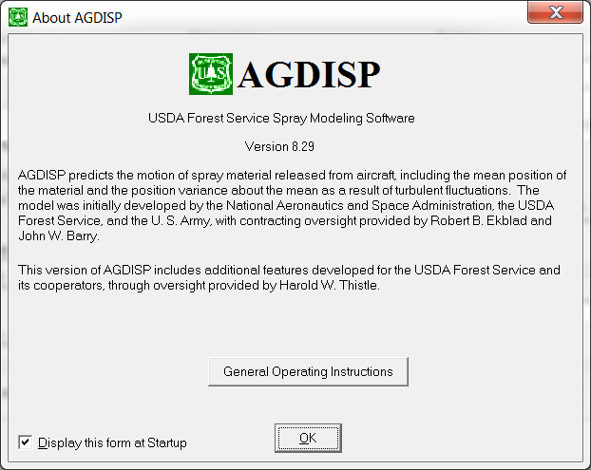

Figure 3.1.1. The About AGDISP screen.

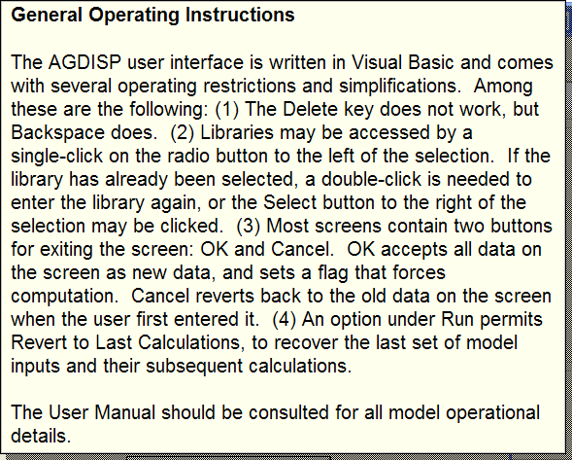

Figure 3.1.2. The General Operating Instructions screen.

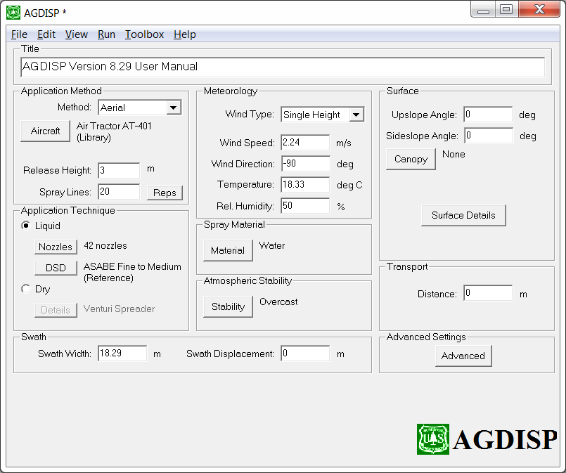

Figure 3.1.3. The AGDISP main input screen containing the program menu bar (with File, Edit, View, Run, Toolbox, and Help), and input sections for Title, Application Method, Application Technique, Swath, Meteorology, Spray Material, Atmospheric Stability, Surface, Transport, and Advanced Settings.



Figure 3.1.4. Application cross section. In the AGDISP simulation, the aircraft or ground sprayer moves into the paper, along spray lines labeled by 1, 2, 3, etc., upwind, separated by a Swath Width each, and displaced by a Swath Displacement from the Edge of the Application Area. The wind blows from left to right, downwind.

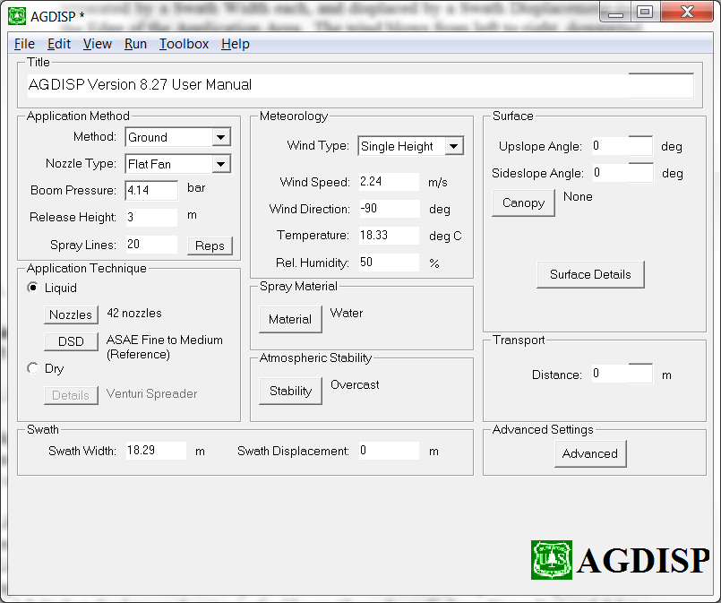

Figure 3.2.1. Application Method appearance when Ground is selected.

3.2.2.1. **Aircraft**

The **Aircraft** button opens to a screen (Figure 3.2.2) showing a table containing the current aircraft characteristics (Properties), and displaying several options.

3.2.2.1.1. Aircraft Type

*User-defined* is invoked whenever the user changes any of the aircraft Properties. *Library* contains descriptions for aircraft typically used in agricultural spraying, collected by Hardy (1987) and updated by Kilroy et al. (2003).

User Library connects the user to a library specifically created by the user, and initialized in Preferences. *User-defined* gives the user access to the aircraft portion of this library (Aircraft User Library). The **Add Current** button adds the current aircraft properties to the library (making sure the Aircraft Name is unique), and the **Select From/Modify** button opens a screen (Figure 3.2.3) that displays each entry in the library (from the pull-down Name list) and deletes the displayed entry with the **Delete Entry** button.

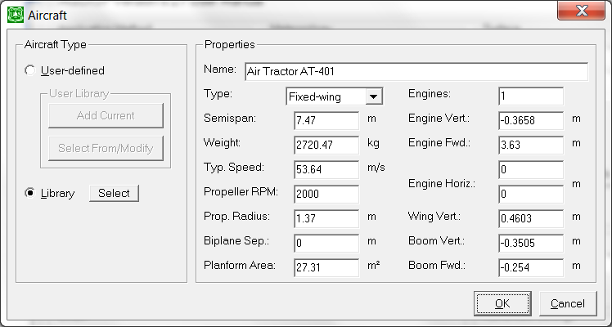

Figure 3.2.2. The Aircraft input screen, with Aircraft Type and Properties.

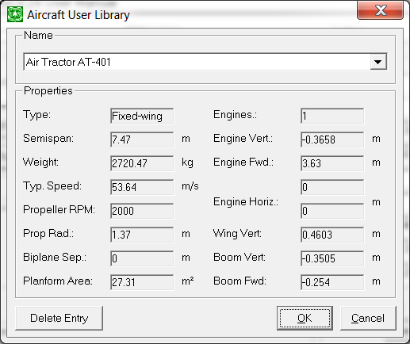

Figure 3.2.3. The Aircraft User Library screen, with Name and Properties.

Library (from Figure 3.2.2) opens to the Aircraft Library screen (Figure 3.2.4). A pull-down list within the Filter section is available to select the aircraft by name, with the first three name entries by type (Any, Any Fixed Wing, Any Helicopter). The applicable matches may be examined in the Browse Filtered Entries section, with buttons for **1st**, **Prev**, **Next** and **Last**. Pressing **OK** moves the selected entry from the library into the edit window of the aircraft screen. Pressing **Cancel** exits the library without changing any data.

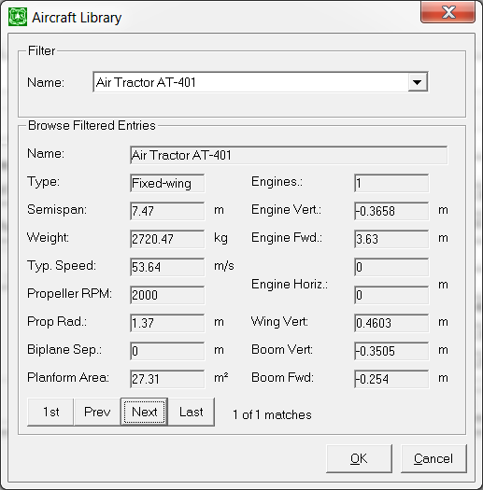

Figure 3.2.4. The Aircraft Library screen, with a Filter for Aircraft Name and the Browse Filtered Entries for each selection.

If the user changes the aircraft type or any aircraft parameter, and exits the Aircraft screen, an information screen will appear, indicating for liquid Application Technique that AGDISP will automatically replace the current nozzle locations with a nozzle distribution consistent with a Boom Length of 65% and a nozzle spacing of 22.9 cm (9 in), and for dry Application Technique that the relative location of the spreader should be confirmed by the user. The user may decline the nozzle adjustment and disregard the spreader warning.

3.2.2.1.2. Properties

Properties (from Figure 3.2.2) displays the Aircraft Name, Type, and Properties detailing the aircraft: Semispan or Rotor Radius, Weight, Typical Flying Speed, Propeller or Rotor RPM, Propeller Radius, Biplane Separation Distance, Planform Area, Number of Engines, Engine Vertical Distance, Engine Forward Distance, Engine Horizontal Distance, Wing Vertical Distance, Boom Vertical Distance, and Boom Forward Distance. A wing and boom schematic is shown in Figure 3.2.5 for clarification of some of these distances. Pressing **OK** moves the selected entry into the current data. Pressing **Cancel** exits the Aircraft screen without changing any data.



Figure 3.2.5. Schematic of aircraft wing and boom details.

3.2.2.2. Spray Line **Reps**

The **Reps** button (from Figure 3.1.3) opens to a screen (Figure 3.2.6) with a table containing the current number of reps assigned to each spray line, beginning with the spray line closest to the edge of the application area (spray line number 1) and moving upwind. The location of the first spray line is set by the Swath Displacement and Default Swath Offset. Reps represents the number of times a spray line is sprayed over the spray block. The user may set the number of reps to 0 (removing that particular spray line, except the first spray line) or to any realistic positive number. The user may also check the Optimize Reps for Uniform Deposition box, to permit AGDISP to determine the best number of reps at each spray line location to achieve the most uniform deposition pattern in the spray block. However, if the number of reps is set to zero by the user, the optimization routine will not spray that line. The **Reset** button returns all spray line reps to 1.

3.2.3. Application Technique

The radio buttons (from Figure 3.1.3) select either *Liquid* or *Dry* applications, and the **Nozzles**, **DSD**, and **Details** buttons open to the appropriate input data.

3.2.3.1. **Nozzles** (Liquid) Input Screen

The **Nozzles** button opens to a screen (Figure 3.2.7) which controls the locations of the nozzles on the spray boom. Screen sections include Nozzle Installation Properties, Generate Regular Distribution, and Nozzles.

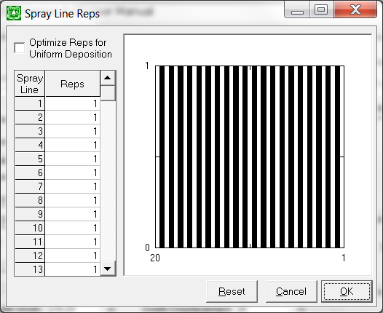

Figure 3.2.6. The Spray Line Reps screen, with Spray Line Number, Number of Reps, graphical display, and check box for Optimization.

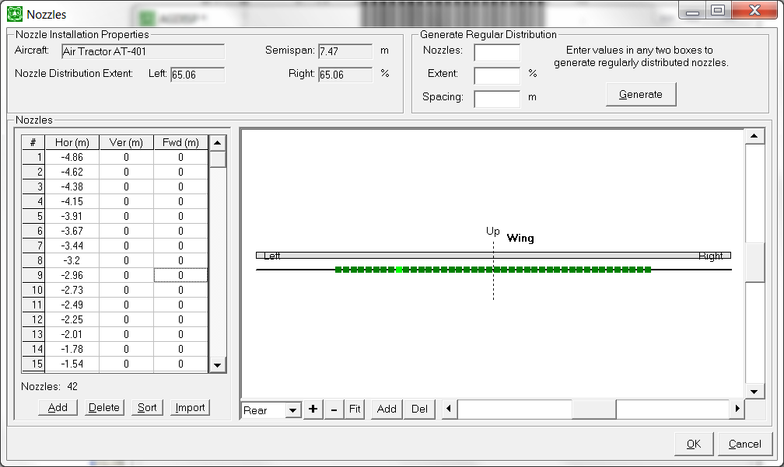

Figure 3.2.7. The Nozzles screen, with Nozzle Installation Properties, Generate Regular Distribution, and Nozzles. Nozzle locations are displayed as green squares when looking from behind the aircraft or ground sprayer.

3.2.3.1.1. Nozzle Installation Properties

Default values (entered elsewhere in AGDISP) are displayed here for reference, including Aircraft name and Semispan for Aircraft Application Method, or Vehicle name and ½ Swath Width for Ground Application Method, and Nozzle Distribution Extent (farthest location of nozzles from the centerline of the aircraft or ground sprayer) Left and Right as a percentage of the Semispan or ½ Swath Width.

3.2.3.1.2. Generate Regular Distribution

Current nozzle locations can be overwritten with uniform spacing between nozzles by using the Generate Regular Distribution entries of number of Nozzles, percentage Extent of nozzles (left and right), and the uniform Spacing between nozzles. Only two of these entries are needed to generate new nozzle locations with the **Generate** button.

3.2.3.1.3. Nozzles

This section of the screen permits the user to refine nozzle locations manually. Nozzles may be edited by the **Add** or **Delete** buttons, in addition to on-screen modification of the Horizontal, Vertical, and Forward locations. The user may **Sort** the nozzles or **Import** nozzle locations from an ASCII file. All dimensions in an import file must be in meters. Any comment line in the import file must begin with “#” in column one to separate it from the data.

Each nozzle may also be moved manually by dragging its green icon to any position desired. Rear and Top views may be selected. The screen diagram may be expanded (**+**), diminished (**-**), or **Fit** to the screen space available. Boom position is generally rearward and below the trailing edge of a fixed-wing aircraft, and on the skids below the rotor blade hub of a helicopter, and is changed in the Aircraft screen. Pressing **OK** moves the nozzle locations on this screen into current data. Pressing **Cancel** exits the screen without changing any data.

3.2.3.2. **DSD** (Liquid) Input Screen

The **DSD** button (from Figure 3.1.3) opens to a screen (Figure 3.2.8) containing Drop Distribution Name, Drop Distribution Type, and Drop Distribution.

3.2.3.2.1. Drop Distribution Name

A unique name may be attached to any drop size distribution.

3.2.3.2.2. Drop Distribution Type

This screen section controls the source of the drop size distribution used in AGDISP. It contains *User-defined*, *Reference Distributions*, *USDA ARS Nozzle Models*, and *FS Rotary Atomizer Models*.

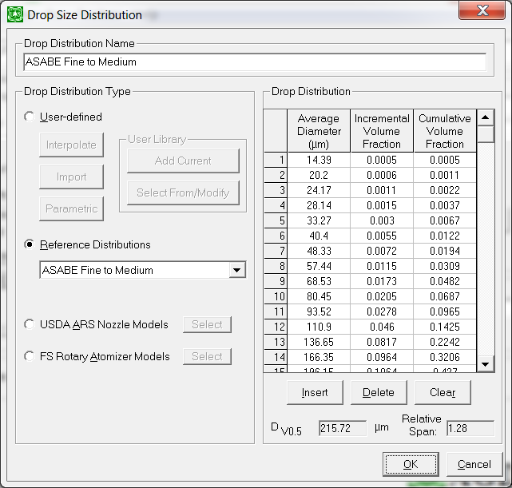

Figure 3.2.8. The Drop Size Distribution screen, with Drop Distribution Name, Drop Distribution Type, and Drop Distribution.

*User-defined* includes three options: **Interpolate**, **Import**, and **Parametric**, and provides entry to the User Library to **Add Current** and **Select From/Modify**.

The **Interpolate** button invokes the Root Normal approach (Simmons 1977) to fill out the current drop size distribution.

The **Import** button opens the File Browser to enter a drop size distribution previously stored by the user in an ASCII file. Because table entry in AGDISP is laborious, it is anticipated that ASCII file entry will be used whenever possible, and **Import** will be an important option. All drop size categories in AGDISP are specified by their Average Diameter (volume averaged with the approach found by Herdan 1960); however, the user may enter drop size distributions by Upper Diameters as well. Typically, the ASCII data are in two columns (diameters and volume fractions). Any comment line in the import file must begin with “#” in column one to separate it from the data. If the first line of the file contains a diameter with a volume fraction of zero, AGDISP will assume that this value is the lower diameter of the first size class, and that all subsequent diameters are upper diameters; AGDISP will compute the Average Diameters. In addition, by testing the maximum and sum of the volume fractions in the ASCII file, AGDISP will determine whether the entries are in Incremental or Cumulative Volume Fractions, and whether the volume entries are fractions or percentages.

The **Parametric** button opens to a menu screen for entering Dv0.5 (in m) and Relative Span; the Root Normal approach is then used to generate the drop size distribution. This screen (Figure 3.2.9) permits the user to condition the output from the drop size distribution generation (this feature is also available on the USDA ARS Nozzle Models screen and the FS Rotary Atomizer Models screen). The computed drop size distribution may be replaced by the most representative *Drop Size Classification*, either one of the ASABE S572.1 drop size distributions or one interpolated between each available drop size distribution, or partitioned into drop size categories that capture the total spray volume (*Drop Size Distribution*).

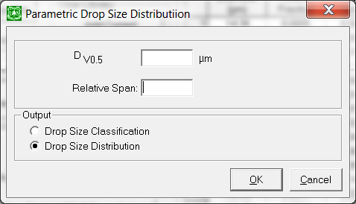

Figure 3.2.9. The Parametric Drop Size Distribution screen, with Output.

User Library opens to the drop size distribution portion of the user library. The **Add Current** button adds the current drop size distribution to the library (making sure the Drop Distribution Name is unique), and the **Select From/Modify** button opens to a screen (Figure 3.2.10) that displays each entry in the library (from the pull-down Name menu) and deletes the displayed entry with the **Delete Entry** button.

*Reference Distributions* displays the available drop size distributions in a pull-down list, interpolated distributions between all ASABE S572.1 distributions, and the precursor BCPC distributions.

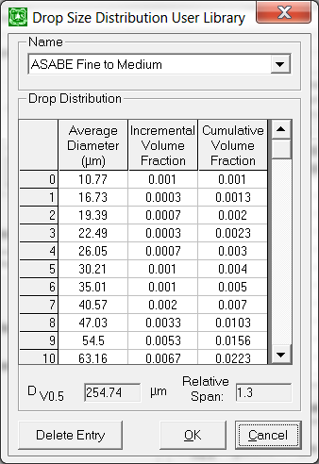

Figure 3.2.10. The Drop Size Distribution User Library, with Name and Drop Distribution.

*USDA ARS Nozzle Models* provides an additional input screen for the inputs needed to run the USDA ARS Nozzle Models and construct a drop size distribution from them (Fritz and Hoffmann 2015, 2016). The input screen is shown in Figure 3.2.11, with the sections Nozzle, Spray Material, Spray Data, Data Conversion, and Output. Invoking **OK** will, after reviewing the input data on this screen, generate a drop size distribution consistent with that data.

Nozzle identifies the Name of the nozzle and its Orifice Size. There are 15 USDA ARS nozzle models.

Spray Material is Tap Water with 0.25% v/v Triton X-100 at a Specific Gravity of 1.0.

Spray Data shows the Air Speed (defined in Aircraft) and permits entry of the remaining inputs to the nozzle model: Nozzle Body Angle or Deflector Angle (depending on nozzle selected) and Pressure. AGDISP will provide a computational warning if the Specific Gravity or Air Speed in USDA ARS Nozzle Models exceeds the modeled limits.

The computed drop size distribution may be replaced by the most representative *Drop Size Classification*, either one of the ASABE S572.1 drop size distributions or one interpolated between each available drop size distribution, or partitioned into drop size categories that capture the total spray volume (*Drop Size Distribution*).

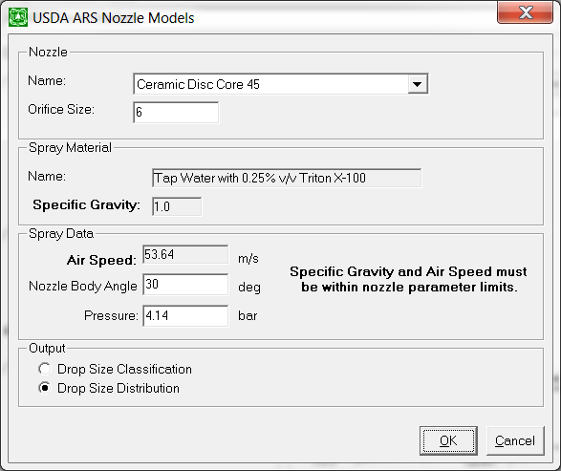

Figure 3.2.11. The USDA ARS Nozzle Models screen, with Nozzle (Name and Orifice Size), Spray Material, Spray Data (Nozzle Body Angle or Deflector Angle, and Pressure), and Output.

Pressing **OK** enables USDA ARS Nozzle Models to compute its curve-fitting parameters and reconstruct the drop size distribution with the Root Normal interpolation method. These results are moved into the Drop Distribution side of the Drop Size Distribution screen (Figure 3.2.8).

*FS Rotary Atomizer Models* provides an additional input screen for the inputs needed to run the FS Rotary Atomizer Models and construct a drop size distribution from them (Teske et al. 2005). The input screen is shown in Figure 3.2.12, with the sections Atomizer Name, Spray Material Name, Spray Data, and Output. Invoking **OK** will, after reviewing the input data on this screen, generate a drop size distribution consistent with that data.

Atomizer Name selects either the Micronair AU4000 or AU5000 from the pull-down list.

Spray Material Name selects either Water or Foray 76B neat (for the AU4000), or Water, Water with 1% w/w Sta-Put, Water with 0.25% w/w Hasten, or Foray 76B neat (for the AU5000) from the pull-down list.

Spray Data permits entry of the remaining inputs to the nozzle model: Blade Angle (AU5000 only) and Rotation Rate. Air Speed and Flow Rate are entered elsewhere in AGDISP and are shown for information purposes.

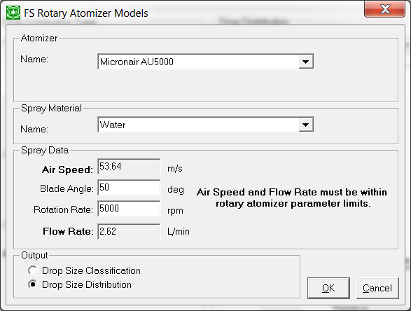

Figure 3.2.12. The FS Rotary Atomizer Models screen, with Atomizer Name, Spray Material Name, Spray Data (Blade Angle and Rotation Rate), and Output.

The computed drop size distribution may be replaced by the most representative *Drop Size Classification*, either one of the ASABE S572.1 drop size distributions or one interpolated between each available drop size distribution, or partitioned into drop size categories that capture the total spray volume (*Drop Size Distribution*). Pressing **OK** enables FS Rotary Atomizer Models to compute its curve-fitting parameters and reconstruct the drop size distribution with the Root Normal interpolation method. These results are moved into the Drop Distribution side of the Drop Size Distribution screen (Figure 3.2.8).

3.2.3.2.3. Drop Distribution

Clicking on a table entry (from Figure 3.2.8) places an invisible cursor at the right of the number; the user then manipulates this value. The **Insert** button places a blank row above the current row, the **Delete** button removes the highlighted row, and the **Clear** button blanks the highlighted entries. Dv0.5 and Relative Span are shown for information purposes.

Pressing **OK** moves the Drop Distribution back to the main screen.

3.2.3.3. **Details** (Dry) Input Screen

The **Details** button (from Figure 3.1.3) opens to a screen (Figure 3.2.13) containing Particle Distribution Name, Material Property (Particle Sphericity), Application Type, Spreader Location, and Equivalent Particle Distribution. A detailed discussion of dry material physical characteristics may be found in Teske et al. (2007).

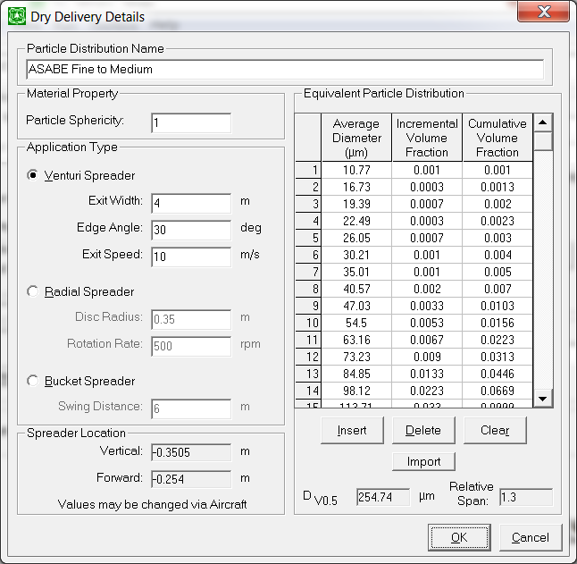

Figure 3.2.13. The Details screen, with Particle Distribution Name, Material Property (Particle Sphericity), Application Type, and Equivalent Particle Distribution.

3.2.3.3.1. Particle Distribution Name

A unique name may be attached to any particle size distribution.

3.2.3.3.2. Material Property

Particle Sphericity is entered here.

3.2.3.3.3. Application Type

Three spreader model types are available in AGDISP, from Teske et al. (2003a) and shown schematically in Figure 3.2.14. *Venturi Spreader* inputs include Exit Width, designated Y in Figure 3.2.14a, positioned along line A-A at the Boom Vertical and Forward Distances on the Aircraft screen; Edge Angle, designated  in Figure 3.2.14a; and Exit Speed. *Radial Spreader* inputs include Disc Radius, designated R in Figure 3.2.14b, positioned along line A-A at the Boom Vertical and Forward Distances on the Aircraft screen; and Rotation Rate. *Bucket Spreader* input is Swing Distance, designated Y in Figure 3.2.14c, positioned at the Boom Vertical and Forward Distances on the Aircraft screen.



Figure 3.2.14. Spreader model schematics for Venturi Spreader (top), Radial Spreader (middle), and Bucket Spreader (bottom).

3.2.3.3.4. Spreader Location

Spreaders are positioned along the centerline of the aircraft and on the Aircraft screen relative to the Boom Vertical Distance and the Boom Forward Distance.

3.2.3.3.5. Equivalent Particle Distribution

Clicking on a table entry (from Figure 3.2.13) places an invisible cursor at the right of the number (the user then manipulates this value). The **Insert** button places a blank row above the current row, the **Delete** button removes the highlighted row, the **Clear** button blanks the highlighted entries, and the **Import** button invokes the File Browser to enter an equivalent particle size distribution previously stored by the user in an ASCII file. The construction of this file is identical to the construction of an import file for drop size distribution.

3.2.4. Swath

Model inputs in this section of the main input screen (from Figure 3.1.3) include Swath Width and Swath Displacement. All calculations add the Swath Displacement entered here to the Default Swath Offset specified in Advanced Settings.

3.2.5. Meteorology

Model inputs in this section of the main input screen (from Figure 3.1.3) include:

Wind Type is selected as either Single Height or Table. If Table is selected, a **Details** button appears (Figure 3.2.15).

Wind Speed: For Single Height the wind speed at the height specified in Advanced Settings. For Table the **Details** button opens to an additional screen (Figure 3.2.16) to give a table that can be used to specify the wind speed as a function of height above the ground. The **Insert** button places a blank row above the current row, the **Delete** button removes the highlighted row, and the **Clear** button blanks the highlighted entries.

Wind Direction (shown in Figure 3.2.17), Temperature, and Relative Humidity.

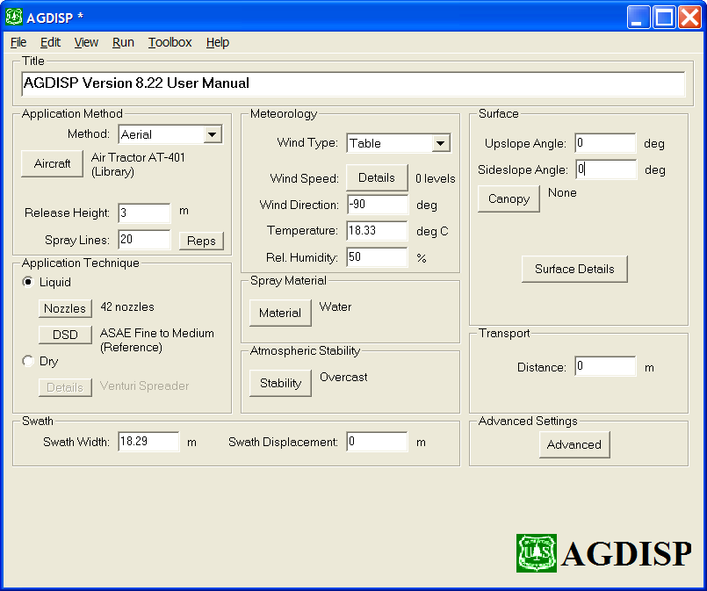

Figure 3.2.15. Meteorology appearance when Table is selected.

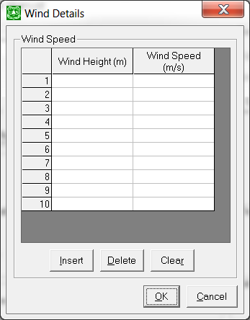

Figure 3.2.16. Wind Details input screen.



Figure 3.2.17. Wind directions (as viewed from above) relative to the spray block and distance downwind.

3.2.6. Spray Material

The **Material** button (from Figure 3.1.3) opens to a screen (Figure 3.2.18) describing Properties, Fractions, Tank Mix, and Calculation Control.

3.2.6.1. Properties

A unique Name may be attached to any Spray Material.

A checkbox is used to specify whether the Spray Material Evaporates. The rate of evaporation of the volatile material follows the diameter-squared evaporation law, corrected for low relative wind speeds (Teske et al. 1998a). The evaporation rate is entered in Advanced Settings.

3.2.6.2. Fractions

The user may specify the application fractions (Active Fraction and Nonvolatile Fraction), with the *Fractions* button pressed in the Calculation Control section to re-compute the spray mixture components.

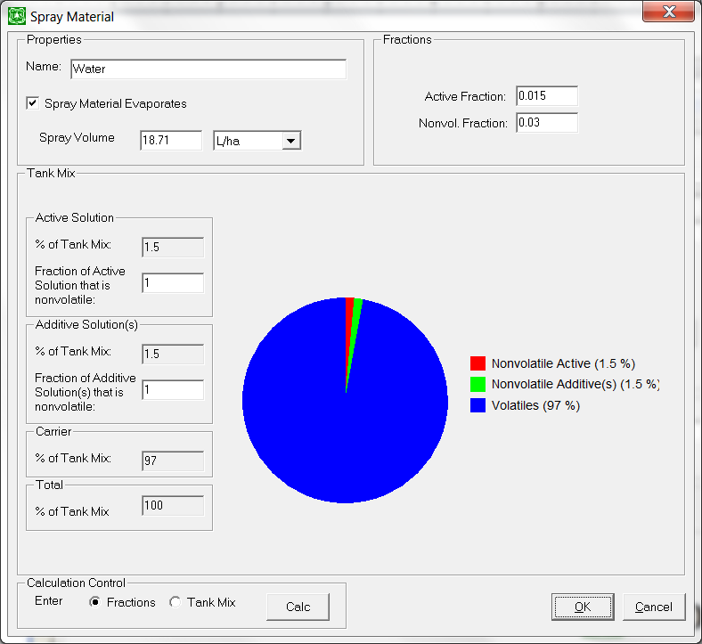

Figure 3.2.18. The Spray Material screen, with Properties, Fractions, Tank Mix (Active Solution, Additive Solution(s), Carrier, and Total), and Calculation Control.

3.2.6.3. Tank Mix

The user may specify the tank mix components, with *Tank Mix* selected in the Calculation Control section to re-compute the spray mixture components.

The Tank Mix is composed of Active Solution, Additive Solution(s), and Carrier. Entries for Active Solution and Additive Solution(s) are % of Tank Mix and Fraction of Active Solution or Additive Solution(s) that is nonvolatile. The Carrier % of Tank Mix and the Active and Nonvolatile Fractions are computed from the entries supplied, by invoking the **Calc** button in Calculation Control. A pie chart graphic illustrates the makeup of the tank mix.

3.2.7. Atmospheric Stability

The **Stability** button (from Figure 3.1.3) opens to a screen (Figure 3.2.19) describing the stability level of the atmosphere. The two selections are *Day*, permitting the user to select a Solar Insolation level from a pull-down list; and *Night*, permitting the user to select a Cloud Cover level from a pull-down list.

At run time, the wind speed profile, background turbulence level, and vortex decay rate are modified consistent with the stability selection (Teske and Thistle 2002).

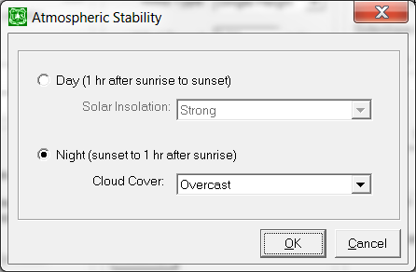

Figure 3.2.19. The Atmospheric Stability screen, selecting *Day* (specifying Solar Insolation) or *Night* (specifying Cloud Cover).

3.2.8. Surface

The Surface section (from Figure 3.1.3) describes the terrain, the canopy, and surface details. Upslope Angle specifies the slope in the spraying direction, while Sideslope Angle specifies the slope relative to horizontal.

The **Canopy** button opens to a screen (Figure 3.2.20) which enables the user to specify details on the structure of the canopy, including Canopy Name, Canopy Type, Story or LAI Canopy Properties, Properties, and Preview. In AGDISP, calculations are carried through the canopy to the ground if the canopy is well defined.

3.2.8.1. Canopy Name

A unique Canopy Name may be attached to any canopy description.

3.2.8.2. Canopy Type

Canopy options include *None*, *Height*, *Story*, or *LAI*. In the *Height* option the user enters only the Canopy Height. In this option calculations will stop when the canopy height is reached by the spray material. The Canopy option may be turned off by setting Canopy Height to zero or selecting the *None* button.

3.2.8.3. Properties

For either canopy the user must specify Element Size and Element Type, along with the Temperature and Relative Humidity within the canopy.

3.2.8.4a. Story Canopy Properties

On the Story screen (Figure 3.2.20, top) the user enters the Stand Density and Tree Height (from the ground up), Tree Diameter, and Probability of Penetration.

3.2.8.4b. LAI Canopy Properties

On the LAI screen (Figure 3.2.20, bottom) the user may select from a library of values or user-define the canopy.

*Library* is a compilation of 16 Eastern hardwoods (Witcosky et al. 1999; Yang et al. 1999) and Western conifers and additional hardwoods (Teske and Thistle 2004b). A Quality of “High” implies that LAI height data were available to compute the overall LAI; a Quality of “Medium” implies that only Canopy Height and LAI were available, and a Quality of “Low” implies that only Canopy LAI was available. Averaged parameters were used to complete the data needed for a Quality of “Medium” or “Low”. Two additional *Library* entries (Generic Deciduous and Generic Conifers) were determined by averaging all hardwoods and conifers, respectively. With a library entry selected, the user also enters the Canopy *Height* and the Canopy *LAI* (Library Default values are provided), to scale library results to the specific problem of interest.

*User-defined* permits the user to enter Tree Height and Cumulative LAI.

3.2.8.5. Preview

A normalized plot of Tree Height (vertical scale) and Tree Diameter (for Story canopy) or Cumulative LAI (for LAI canopy) is drawn.

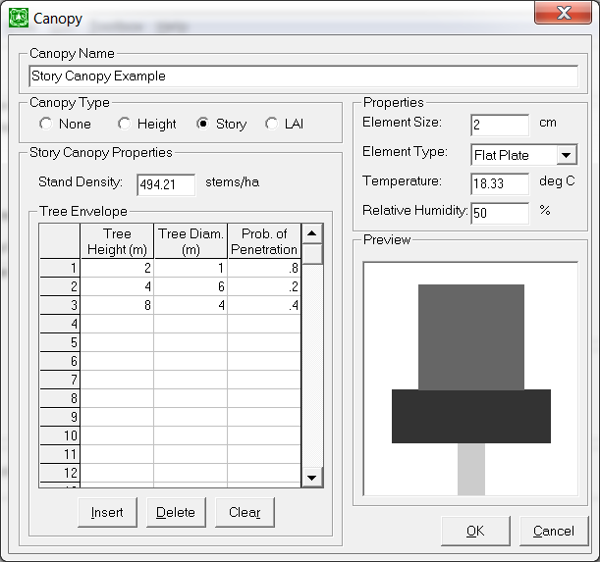

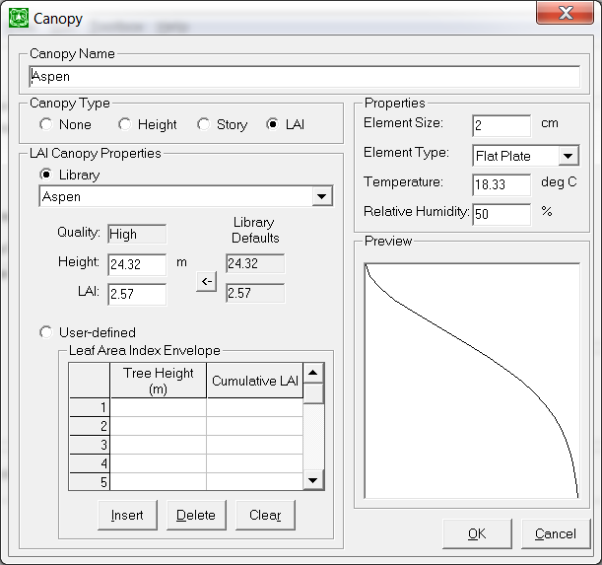

Figure 3.2.20. The Canopy input screen in AGDISP: Story (top); LAI (bottom).

The **Surface Details** button (from Figure 3.1.3) opens to a screen (Figure 3.2.21) that permits entry of Surface Roughness (without canopy) or Canopy Roughness and Canopy Displacement (with canopy). Typical Surface Roughness values are given in the **Show Cover Types** button (Figure 3.2.22).

If a nonzero canopy height is selected, the wind speed above the canopy is adjusted up to a height which is twice the canopy height, at a value consistent with the Height to Wind Speed Measurement (found in Advanced Settings) and the Surface Roughness.

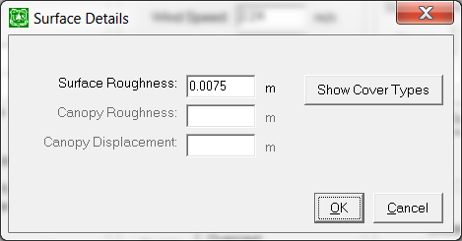

Figure 3.2.21. The Surface Details screen, with entries of Surface Roughness (Show Cover Types), Canopy Roughness, and Canopy Displacement.

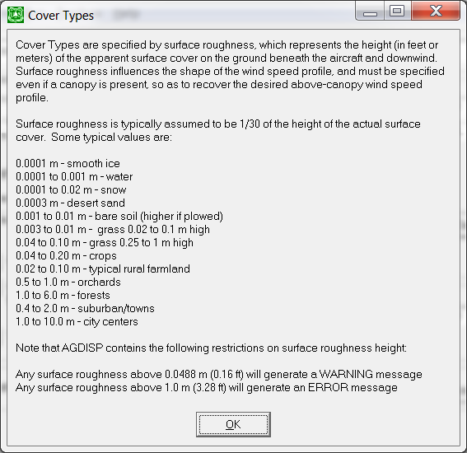

Figure 3.2.22. The Show Cover Types screen.

3.2.9. Transport

The model input in this section of the main input screen (Figure 3.1.3) includes Distance.

3.2.10. Advanced Settings

Model-specific inputs on the **Advanced** screen (Figure 3.2.23) include the Height for Wind Speed Measurement, the Maximum Computational Time, the Maximum Downwind Distance, Vortex Decay Rate OGE, Vortex Decay Rate IGE, Aircraft Drag Coefficient, Propeller Efficiency, Ambient Pressure, Ground Reference, checkboxes for Save Trajectory Files, Save CALPUFF Data, and Half-Boom Effects, push buttons for Default Swath Offset, Specific Gravity (Carrier), Specific Gravity (Active and Additive), and Evaporation Rate.

Save Trajectory Files: If checked, up to 200 text files will be created, with the names dsb001, dsb002, … , dsb200, overwriting existing files, if any exist in the subdirectory. The first line of each file contains the droplet number, the maximum number of droplets, the number of nozzles, and the volume fraction associated with this droplet size. Following text lines are grouped such that the first line in each group contains the time (in sec) and succeeding lines each contain the nozzle number, the (X, Y, Z) location of the droplet (in m, where X points behind the aircraft, Y points to the right, and Z points upward), the spread  of the droplet (in m), and the diameter of the droplet (in m). NOTE: to use this option, you must first save your input file in the directory that you wish the trajectory files to appear; otherwise, the trajectory files will not be saved.

Save CALPUFF Data: CALPUFF is an advanced non-steady-state meteorological and air quality modeling system. Its structured spray emission file SPEMARB.DAT – containing specialized output generated from AGDISP predictions – serves as an input file to CALPUFF, which in this application provides the location and material fraction of spray lines followed in AGDISP until aircraft vortical effects decay and droplet evaporation completes (AGDISP stops at this point). If the CALPUFF box is checked, AGDISP will save (to the local file CALPUFF.txt) the data needed to initialize a CALPUFF calculation (Scire et al. 1990; Teske 2015). These data can then be exported, modified, and used as an input file into CALPUFF.

Half Boom Effect: Normally, the most downwind flight line is positioned upwind of the edge of the application area by the swath displacement, with nozzles operating on both the left and right sides of the boom. If Half Boom Effect is checked, the aircraft will be moved ½ swath width downwind and only the upwind nozzles will operate on the first flight line.

Default Swath Offset: This setting combines with Swath Displacement to position the spray vehicle with reference to the edge of the application area. If the *½ Swath* button is active, the most downwind spray line will be moved an additional half swath width upwind of the edge of the application area; if the *0 Swath* button is active, the most downwind spray line will be determined by the Swath Displacement alone.

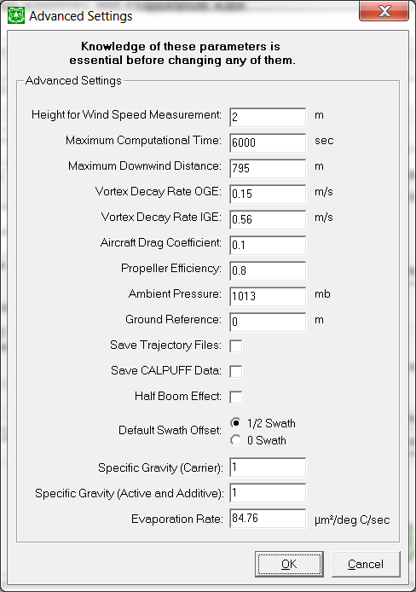

Figure 3.2.23. The Advanced Settings screen, with model-specific default input for Height for Wind Speed Measurement, Maximum Computational Time, Maximum Downwind Distance, Vortex Decay Rate OGE, Vortex Decay IGE, Aircraft Drag Coefficient, Propeller Efficiency, Ambient Pressure, and Ground Reference height; checkboxes to Save Trajectory Files, Save CALPUFF Data, and Half Boom Effect; selection of Default Swath Offset; and model-specific default input for Specific Gravity (Carrier), Specific Gravity (Active and Additive), and Evaporation Rate.

3.3. Menu Bar Operation

The main menu bar (from Figure 3.1.3) contains **File**, **Edit**, **View**, **Run**, **Toolbox**, and **Help**.

3.3.1. File

Menu bar options under **File** include the following:

|  |  |
| --- | --- |
| **OPTION** | **ACTION** |
|  |  |
| New | Begin with a new set of current data (set to the default data) |
| Open | Open a previously saved data file |
| Save | Save the current data into an existing data file |
| Save As | Save the current data into a new data file |
| Export | Save AGDISP results into an ASCII file for import into other graphics packages or analyses after exiting AGDISP |
| Export CALPUFF Data | Configure AGDISP results into an ASCII file for import into CALPUFF after exiting AGDISP |
| Print Preview | Examine potential output before sending it to an attached printer |
| Print Setup | Examine printer characteristics |
| Print | Send the selected data to an attached printer |
| Exit | Exit AGDISP |

The default data file extension in AGDISP is ag; however, the user may override the default extension (not recommended) when in the File Browser.

The **Export** option opens to a screen (Figure 3.3.1) that includes Notes (to record pertinent information about the AGDISP run), Results for Export (selecting one or more of the available model outputs), Options (whether an identifying header is added at the top of the file), and Delimiter (selecting the separator between columns of output, either *Tab*, *Space*, *Comma*, *User-defined Other Character*, or *Fixed Width Columns*). An **OK** brings up the File Browser. The export file always contains an AGDISP identification line. All comment lines (generated by notes, header, and/or run ID) in the export file begin with “#” in column one to separate them from data.

The **Export CALPUFF Data** option opens to a screen (Figure 3.3.2) that includes inputs that configure the AGDISP output into the reference frame for the subsequent CALPUFF calculation. These inputs include Spray Line Beginning X Coordinate, Spray Line Beginning Y Coordinate, Base Z Elevation, Spray Line Length, and Flight Direction. Typical values are shown in the figure.

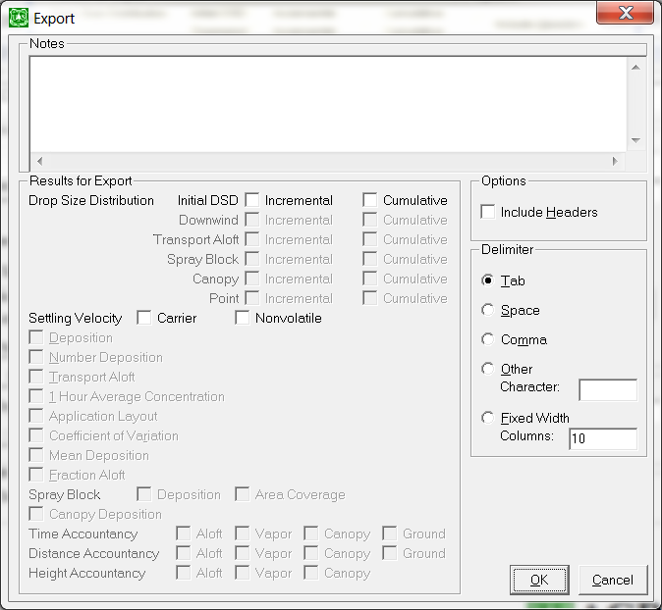

Figure 3.3.1. The Export screen, with the options for Notes, Results to Export, Options (Include Headers), and Delimiter.

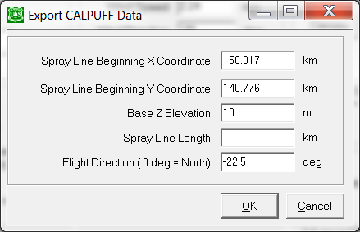

Figure 3.3.2. The Export CALPUFF Data screen, with inputs for Spray Line Beginning X and Y Coordinates, Base Z Elevation, Spray Line Length, and Flight Direction.

3.3.2. Edit

Menu bar options under **Edit** include the following:

|  |  |
| --- | --- |
| **OPTION** | **ACTION** |
|  |  |
| Cut | Highlight data values and move the information to the Clipboard |
| Copy | Highlight data values and copy the information to the Clipboard |
| Paste | Move the Clipboard information to the cursor location |
| Clear | Delete the highlighted data values |
| Preferences | Modify program operation parameters |

The **Preferences** option opens to a screen (Figure 3.3.3) that contains several default settings for the model, and allows the user to change them. These Preferences include:

System: selecting *English* or *Metric units*.

Deposition: selecting the numerator and denominator units from a pull-down list of units, or selecting Fraction of Applied with the checkbox.

Flux: selecting the numerator and denominator units from a pull-down list of units, or selecting Fraction of Applied with the checkbox.

Miscellaneous: checkboxes that control AGDISP behavior, such as Pausing calculations before they begin (to review inputs), Suppressing calculation warnings (to maintain program flow), Suppressing calculation errors (when an input goes outside reasonable data bounds), Suppressing model feature warnings (whenever the user selects Dry Delivery, Stability, Optical Canopy, or Riparian Barrier), and Showing the About screen on program startup.

User Library: defining the name of the user library containing aircraft and drop size distribution data.

Preferences are stored in the file Agdisp.ini, located in the same directory or folder as the Agdisp.exe file.

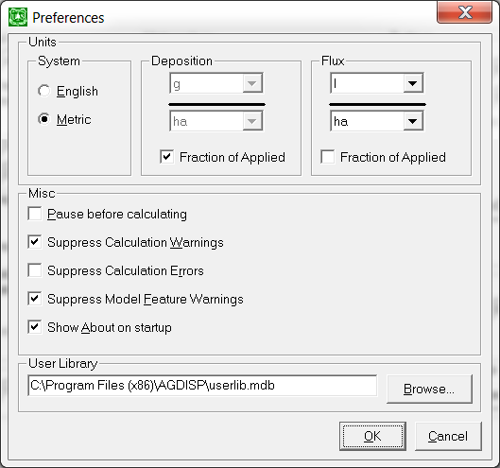

Figure 3.3.3. The Preferences screen, with the options for setting Units (for System, Deposition, and Flux), Miscellaneous program menu behavior, and User Library.

3.3.3. View

Menu bar options under **View** include the following:

|  |  |
| --- | --- |
| **OPTION** | **ACTION** |
|  |  |
| Notes | Place to compile information about the current AGDISP run |
| Input Summary | Listing of AGDISP inputs selected by the user |
| Numerical Values | A display of specific numerical results from AGDISP |
| Calculation Log | Record of the AGDISP run |

3.3.3.1. Numerical Values

This **View** option opens to a screen (Figure 3.3.4) that summarizes the results from several sections of the AGDISP calculation.

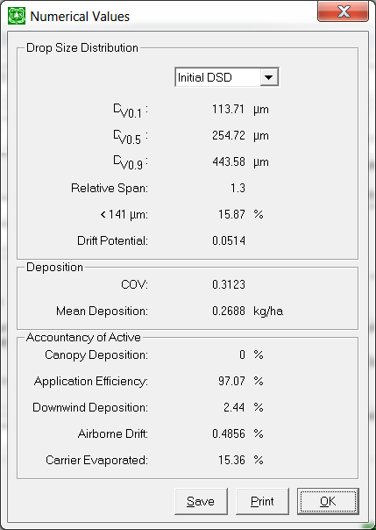

Figure 3.3.4. The Numerical Values screen, presenting summary information for Drop Size Distribution, Deposition, and Accountancy of Active.

The selected drop size distribution is examined to construct Dv0.1, Dv0.5, and Dv0.9 droplet sizes (in m), Relative Span, volume fraction of material < 141 m, expressed as a percentage of the total spray volume, and Drift Potential. Coefficient of Variation (COV)andMean Deposition within the spray block are also shown, along with Canopy Deposition, Application Efficiency, Downwind Deposition, Airborne Drift, and Carrier Evaporated, all in percent. **Print** prints the Numerical Values screen on an attached printer. **Save** permits the user to save the data present on the screen to an ASCII file. Note that some of these numbers are not available until after an AGDISP calculation.

3.3.3.2. Plots

The **View** menu bar options also include the following plots:

|  |  |
| --- | --- |
| **PLOT NAME** | **PLOT CONTENTS** |
|  |  |
| Drop Size Distribution | Various DSD plots |
| Settling Velocity | For Carrier and Active/Additive; depends on Specific Gravity |
| Deposition | Downwind from the Edge of the Application Area |
| Number Deposition | Downwind drops/cm2 from the Edge of the Application Area |
| Transport Aloft | Horizontal flux through a vertical plane positioned at the Transport Distance |
| 1 Hour Average Concentration | Average concentration passing through the vertical plane |
| Application Layout | Deposition pattern from 200 m upwind to 300 m downwind of the Edge of the Application Area |
| Coefficient of Variation | A measure of the effectiveness of spray block coverage as a function of swath width (an ideal value of COV = 0.3) |
| Mean Deposition | A measure of spray block deposition effectiveness as a function of swath width |
| Fraction Aloft | Amount of spray material that remains aloft, as a function of distance downwind from the Edge of the Application Area |
| Spray Block Deposition | Deposition within the spray block |
| Spray Block Area Coverage | Effectiveness of spray block application coverage |
| Canopy Deposition | Deposition through the canopy |
| Time Accountancy | Time history of tank mix, for the amount still Aloft, the amount evaporated (Vapor), the amount deposited through the Canopy, and the amount deposited on the Ground. |
| Distance Accountancy | Distance behavior of tank mix |
| Height Accountancy | Height behavior of tank mix |
| Total Accountancy | Overall tank mix behavior |

Drop Size Distribution options include Initial (the DSD entered by the user), Downwind (the DSD of material reaching the surface between the Edge of the Application Area and the Transport Distance), Transport Aloft (the DSD of material passing through the vertical plane positioned at the Transport Distance), Spray Block (the DSD of material reaching the surface between the Edge of the Application Area and the most upwind spray line), Canopy (the DSD of material deposited on the canopy), and Point (the DSD of material deposited on the surface at the Transport Distance).

Figure 3.3.5 gives an example of a typical plot screen; the Appendix provide examples of each of the plot options available.

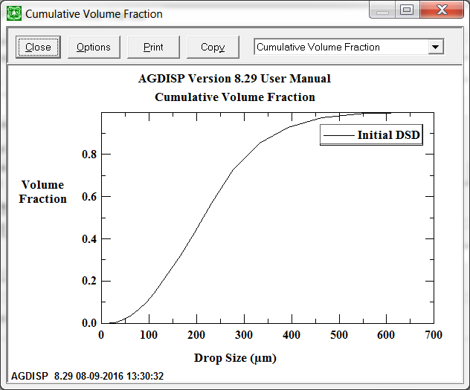

Figure 3.3.5. A typical plot screen

On any plot screen the horizontal X-axis (labeled “Drop Size (m)” in Figure 3.3.5) and the vertical Y-axis (labeled “Volume Fraction” in Figure 3.3.5), as well as the two lines of plot title (“AGDISP Version 8.29 User Manual” and “Cumulative Volume Fraction” in Figure 3.3.5), may be changed by clicking on them; within the label and title screens, the font may be changed by opening the **Font** screen.

Buttons across the top of the plot screen identify **Close**, **Options**, **Print**, and **Copy**. **Close** returns the user to the main input screen; **Options** opens to an Options screen (Figure 3.3.6), **Print** prints the selected plot to an attached printer; and **Copy** copies the selected plot into the Clipboard for pasting into other applications. The top of the plot screen also contains a pull-down list of the available plots.

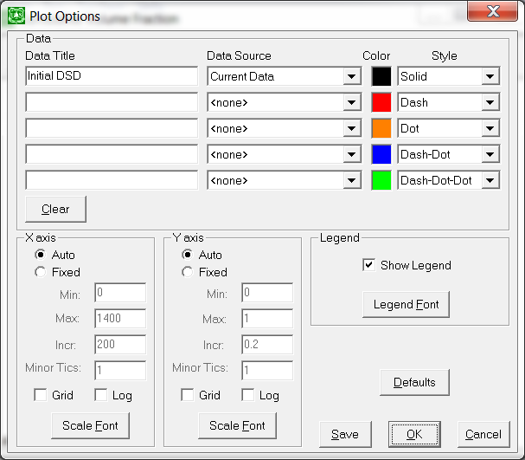

Figure 3.3.6. The Plot Options screen reached from the plot screen. Plot Options include additional Data by Data Title, Data Source, Color, and Style, manipulation of the X axis (horizontal on the screen) and Y axis (vertical on the screen), and Legend.

3.3.3.3. Plot Options Input Screen

The **Options** button opens to a screen (Figure 3.3.6), which includes sections for modifying the content of the plot, the X and Y axes, and the Legend. Up to five curves may be plotted on the same plot, from Data Source (the pull-down list includes Current Data and Saved Results), Data Title gives the associated identifier of the Data Source, Color, and Line Style. The **Clear** button removes all data from the plot. The X and Y axes are adjusted automatically, depending on the data plotted, but the checkboxes permit the user to set the scale details in each direction (Fixed), add a Grid, plot the scale Logarithmically, or change the **Scale Font**. The Legend checkbox includes or removes the Legend from the plot, and **Legend Font** changes its appearance. The buttons at the bottom right of the screen do the following: **Defaults** reinstates the default settings for this specific plot; **Save** saves these plot settings to the file Agdisp.ini for future use; **OK** exits the screen; and **Cancel** nullifies anything done while on this screen.

3.3.4. Run

Menu bar options under **Run** include the following:

|  |  |
| --- | --- |
| **OPTION** | **ACTION** |
|  |  |
| Run Calculations | Runs AGDISP with inputs selected by the user |
| Revert to Last Calculations | Recovers the last set of inputs and calculations |
| Batch Operations | Runs a series of AGDISP input files sequentially |

The user must run the model to generate results. An **AGDISP Calculations** screen (Figure 3.3.7) appears during the computations. The Messages section of the screen summarizes the model inputs. All inputs into AGDISP must fall within reasonable bounds, otherwise a warning or error message will be generated (some inputs may be specified beyond their error limits). Calculation status is shown by a moving bar, which also displays the droplet size being processed and the percentage of droplet sizes completed. Calculations may be aborted with the **Stop** button.

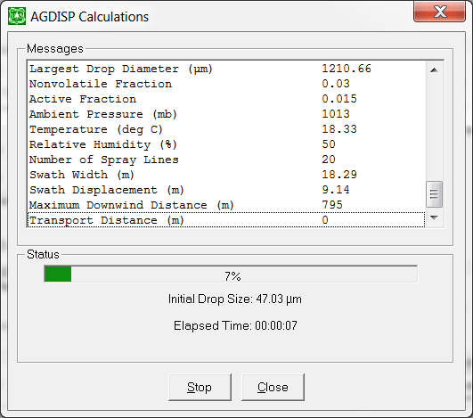

Figure 3.3.7. The AGDISP Calculation screen. The bar near the bottom of the screen illustrates the completion of the calculation by the number of drop sizes examined.

A **Batch Operations** screen (Figure 3.3.8) opens if the user decides to run a series of AGDISP calculations sequentially. The top portion of the screen identifies the Files to Process during the calculation (these files must have already been saved in AGDISP format; filenames are added to or deleted from the list with the **Add** and **Remove** buttons, respectively). The middle portion of the screen indicates Messages pertaining to the current file and the operational status of the calculation. Status is shown in the bottom portion of the screen.

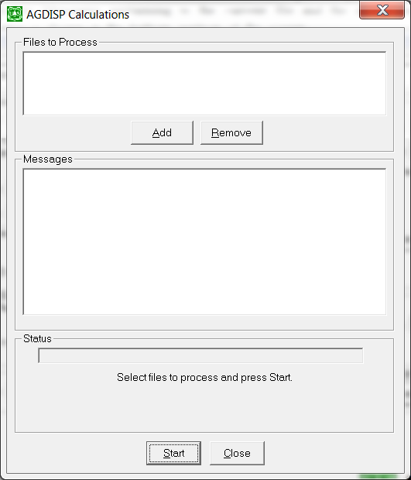

Figure 3.3.8. The Batch Operations screen template. Input file names are entered in the upper portion of the screen; operation status is given in the lower portion.

3.3.5. Toolbox

Menu bar options under **Toolbox** include the following:

|  |  |
| --- | --- |
| **OPTION** | **ACTION** |
|  |  |
| Deposition Assessment | Evaluate the deposition profile |
| Spray Block Statistics | Compute deposition statistics within the spray block |
| Stream Assessment | Evaluate the impact of deposition on a downwind stream |
| Multiple Application Assessment | Evaluate repeated applications to a spray block |
| Trajectory Details | Plot droplet trajectories |
| Gaussian Far-Field Extension | Extend AGDISP solutions downwind to the far field |

3.3.5.1. Deposition Assessment

This calculator (Figure 3.3.9) contains Deposition Area Definition and Calculations. All calculations are based on the current deposition profile. Deposition Area Definition permits selection of an Aquatic Area, a Terrestrial Point location, or a Terrestrial Area. Aquatic Area (shown schematically in Figure 3.3.10) defines a water body by its Downwind Width and Average Depth. Terrestrial Area (also shown schematically in Figure 3.3.10) defines the Downwind Width of the area. The default downwind width is 63.61 m (208.7 ft).

In Calculations the user enters a value for either the Distance to the Water Body, Point, or Area Average from the Edge of the Application Area, the Initial Average Deposition, or, for an Aquatic Area, the Initial Average Concentration (in ng/L or ppt). The user-entered number is highlighted in red. The **Calc** button is pushed for computation of the other parameters. The **Print** button prints the results to an attached printer. For an Aquatic or Terrestrial Area the user may also **Plot** the equivalent averaged deposition and **Export** it (Figure 3.3.11).

Inputs entered into this assessment will generate an error (identified by the short message “out of range”) if any of the following should happen:

1. The Downwind Water Body Width or the Downwind Area Average Width input value is less than 1 cm or greater than the Maximum Downwind Distance specified in Advanced Settings.

2. The Average Depth of the Aquatic Area input value is less than 1 cm or greater than 100 m.

3. The Distance to Water Body, Point, or Area Average from the Edge of Application Area input value is greater than the Maximum Downwind Distance specified in Advanced Settings.

4. The Initial Average Deposition or Concentration is less than 0.0.

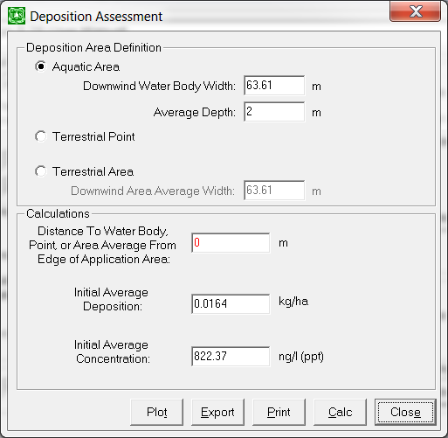

Figure 3.3.9. The Deposition Assessment Calculator screen with Deposition Area Definition and Calculations.





Figure 3.3.10. Schematics of the cross sections of the water body (top) and terrestrial field (bottom), and downwind location relative to the edge of the application area.

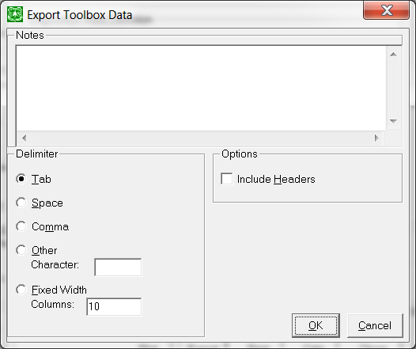

Figure 3.3.11. The Toolbox Export screen, showing Notes, Delimiter, and Options (Headers).

3.3.5.2. Spray Block Statistics

This calculator (Figure 3.3.12) computes two of the following parameters within the spray block, given the input of one of the parameters (the user-entered number is highlighted in red): Coefficient of Variation (COV) within the spray block, Effective Swath Width, and Mean Deposition within the spray block. The **Calc** button computes the other two parameters, based on the current deposition profile. The **Print** button prints the screen to an attached printer. A minimum COV of 0.3 is suggested by the work of Parkin and Wyatt (1982) and Quantick (1985).

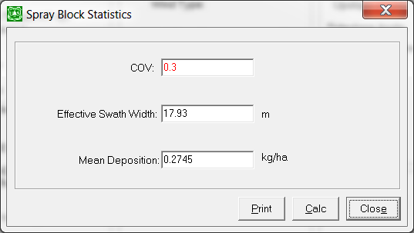

Figure 3.3.12. The Spray Block Statistics screen, calculating the Coefficient of Variation (COV), Effective Swath Width, and Mean Deposition within the spray block.

3.3.5.3. Stream Assessment

This calculator (Figure 3.3.13) contains Geometry data entry and calculation Control sections. Geometry permits entry of all needed inputs, most of which are straightforward, including Spray Line Length, Turn-Around Time, Stream Width, Stream Depth, Stream Flow Rate (with a computation of Stream Flow Speed), Distance from edge of application area to center of stream, Distance from edge of application area to riparian barrier, Riparian Interception Factor (the **Compute** button may be used to obtain this value), Instream Chemical Decay Rate, and Recharge Rate.

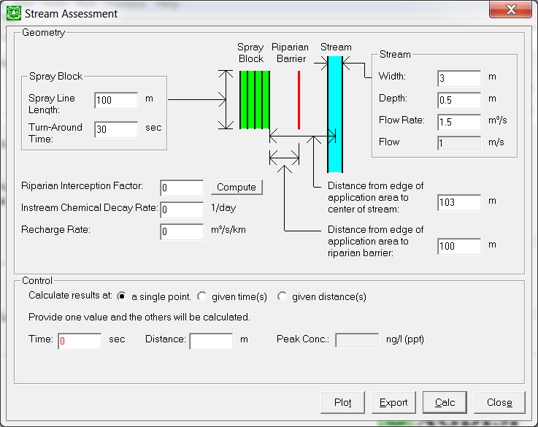

Figure 3.3.13. The Stream Assessment Calculator screen, defining the needed Geometry details and specifying the Controls for the output.

The **Compute** button opens to the Riparian Barrier screen (Figure 3.3.14). These inputs include the Height (the height of the riparian barrier), Porosity, Element Size, and Element Type. The riparian barrier is established relative to the edge of the application area and its distance to the center of the stream.

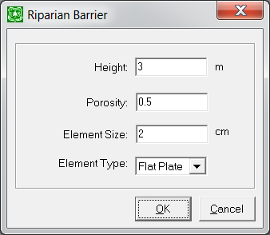

Figure 3.3.14. The Riparian Barrier screen, with entries for barrier Height, Porosity, Element Size, and Element Type.

An **OK** computes the reduction in spray material that either makes it through the barrier or slides over the barrier and the stream. Details are examined in Teske et al. (2002b).

These inputs drive the stream equation once AGDISP has been run to generate the integrated deposit on the surface of the stream (the stream equation formulation is summarized in Teske and Ice 2002). Results (in the Control section of Figure 3.3.13) may be recovered by either time or distance plots, choosing the distance increment and times desired, or the time increment and distances desired, with the buttons *a single point*, *given time(s)*, and *given distance(s)*. The model will generate appropriate time and distance values if so requested (Automatically set distance/time values), based on built-in plotting increments. The single-point answer is also available (entering Time or Distance, and recovering Distance or Time and Peak Concentration). The user may then freely change these values and rerun the calculation (with the **Calc** button), **Plot** the results, and **Export** them. A typical plotted result is shown in Figure 3.3.15.

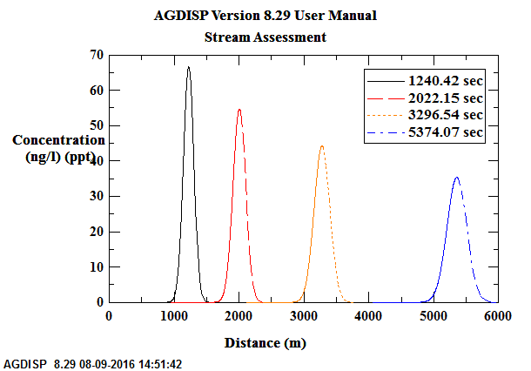

Figure 3.3.15. Stream Assessment for the ASAE S572.1 Fine to Medium drop size distribution. The 0 m location locates the center of the spray block in the flight direction.

3.3.5.4. Multiple Application Assessment

The Multiple Application Assessment toolbox allows the user to determine the consequences of spraying the same spray block several times a year for several years. This calculator (Figure 3.3.16) contains several input sections. The Wind Rose may be either developed from meteorological data available at a *Library* site entry or *User-defined* from an ASCII file containing the needed information. This file is constructed with a first line of two entries for the average temperature (in °C) and relative humidity (%), a second line containing the number of wind speeds, and succeeding lines beginning with an integer wind speed and 36 numbers representing the frequency of occurrence within each ten-degree increment in wind direction (from 10 to 360°, with the wind rose centered about 180° as directly downwind of the spray block), for each wind speed sequentially from 3 m/s to the maximum examined. The sum of all frequencies of occurrences across all wind speeds must equal 1.0.

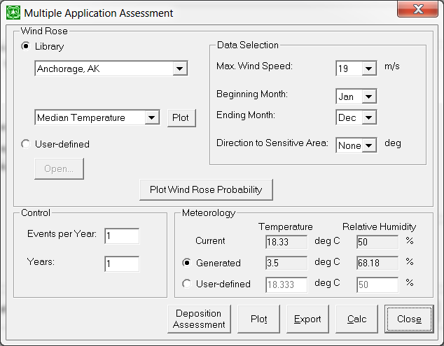

Figure 3.3.16. The Multiple Application Assessment Calculator screen, defining the details needed to assemble and compute multiple applications to the same spray block.

*Library* entries are recovered from the NREL (National Renewable Energy Laboratory) 30-year compendium of meteorological data at 339 sites within the United States (1961-1990 National Solar Radiation Data Base, Version 1.0, Solar and Meteorological Surface Observational Network [SAMSON]) and 30 sites recovered from Canadian Climatological Surface Data. Library entries also contain median temperature, relative humidity, and wind speed, along with dominant wind direction. These results may be plotted with the smaller **Plot** button.

The Data Selection section permits the user to limit the maximum wind speed examined, select the month increment for the generation of the wind rose, and set the direction from the field to the sensitive area. By default, the wind rose is initially positioned so that the maximum weighted wind direction blows directly downwind of the spray block over the sensitive area (Figure 3.3.17). The “from” direction can be set by setting the direction to the sensitive area. The resultant wind rose may be displayed with the **Plot Wind Rose Probability** button (Figure 3.3.18).

The Control section of the MAA screen (Figure 3.3.16) enables the user to select the number of applications (events) per year and the number of years for multiple applications. The Meteorology section permits the user to select temperature and relative humidity values from Current data, *Generated* data (recovered from the Library), or *User-defined* data.



Figure 3.3.17. Layout for Multiple Application Assessment, with a dominant wind direction from 340° (in this example) and a sensitive area located 180° to the spray block.

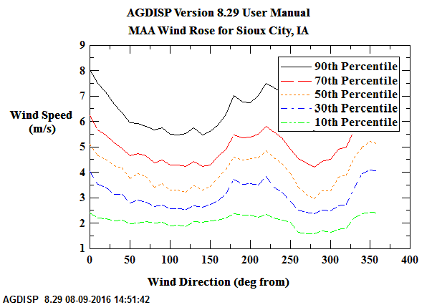

Figure 3.3.18. Wind rose for Sioux City, IA.

Calculations are performed with the **Calc** button. These calculations involve repeated AGDISP runs for incrementally increasing values of wind speed, until the maximum desired wind speed is reached. Wind rose data are accessed for controlled sampling of wind speed and wind direction, to recover the 95th percentile deposition pattern from multiple applications to the field. A discussion of the overall approach may be found in Teske (2000). The summary deposition profiles may be plotted or exported. The averaged deposition may be examined with **Deposition Assessment**. A typical result is shown in Figure 3.3.19.

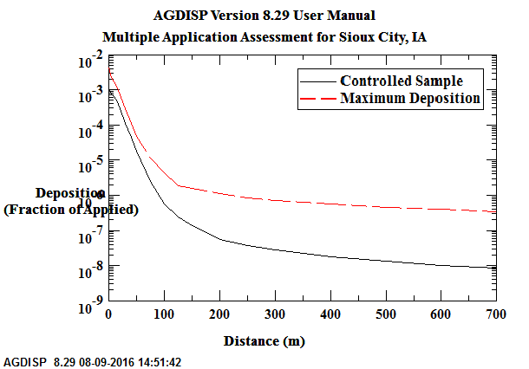

Figure 3.3.19. Multiple Application Assessment for a wind rose for Sioux City, IA. The two curves are the average multiple application deposition pattern and the maximum deposition pattern recovered across the wind speed range selected by the user. Ten events per year were assumed.

3.3.5.5. Trajectory Details

This screen (Figure 3.3.20) permits the user to enter an initial droplet size, then plot either of the three cardinal views of the Lagrangian trajectories developed by the model (from the Rear of the aircraft, from Above the aircraft, or from the Right side of the aircraft looking back toward the aircraft). Push buttons activate the terrain coordinate transformation (*Terrain Coordinates* or *Aircraft Coordinates*). The Options button allows the user to modify the plot scales (Figure 3.3.21).

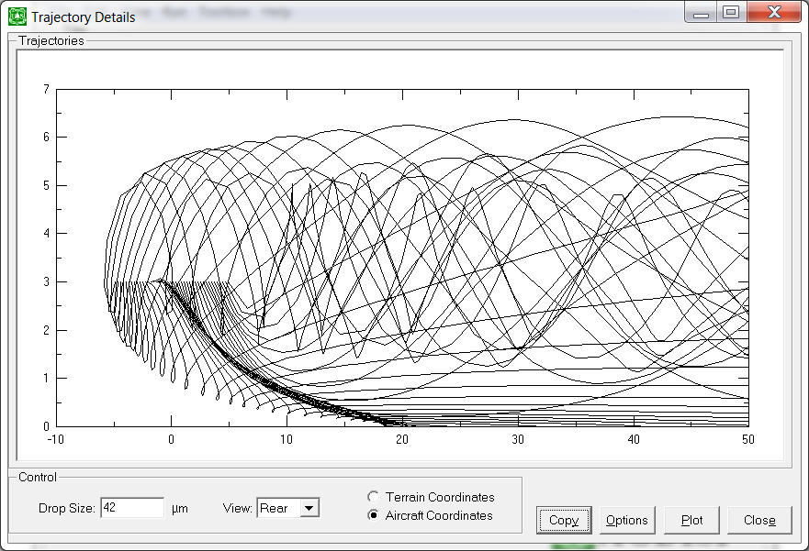

Figure 3.3.20. Trajectory Details screen and plot for a 42 m droplet. The centerline of the aircraft is at 0 m on the horizontal scale shown here.

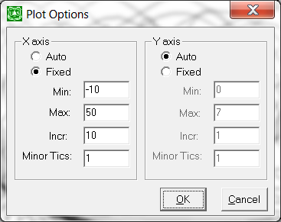

Figure 3.3.21. The Plot Options in the Trajectory Details toolbox.

3.3.5.6. Gaussian Far-Field Extension

This calculator (Figure 3.3.22) permits the user to specify the inputs needed to compute a Gaussian model extension to the Lagrangian model in AGDISP. Inputs on this screen include Handoff Options (Automatic or user-specified) and Surface Layer Mixing Height Option (Automatic or user-specified). Handoff occurs at the downwind distance where the aircraft vortices are no longer important; AGDISP computes that value based on the program inputs of vortex decay rate, aircraft semispan or rotor radius, and wind speed. Mixing Height defaults to the value assumed for the atmospheric stability specified in the program, but the user may change the height as desired.

Calculations are performed with the **Calc** button, following the model discussed in Teske and Thistle (2004a). Additional buttons allow the user to **Plot** the result (as shown in Figure 3.3.23), **Export** the result, or examine the result further with **Deposition Assessment**.

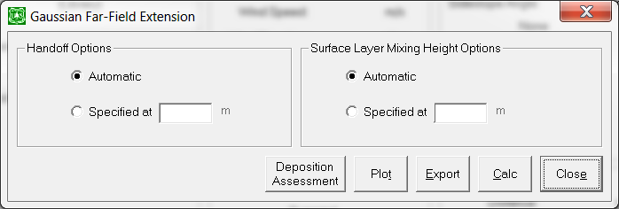

Figure 3.3.22. The Gaussian Far-Field Extension toolbox screen, with Handoff Options and Surface Layer Mixing Height Options.

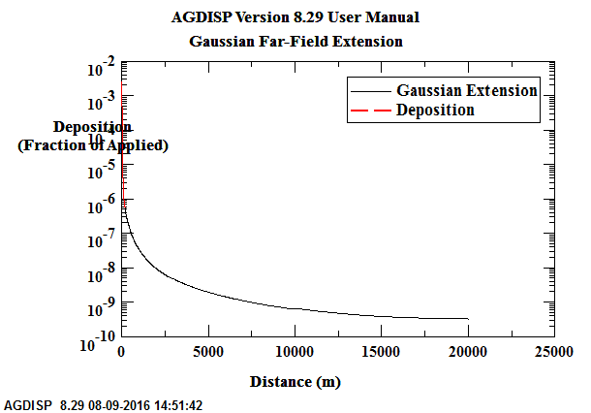

Figure 3.3.23. Ground deposition results from the Gaussian Far-Field Extension, overlaid with the deposition results from the main program. Logarithmic scales are used to illustrate the downwind features, including the reflection off the mixing height.

3.3.6. Help

The user may enter the **Help** facility at the menu bar or from any entry box or screen in the program with the F1 function key. The **About AGDISP** screen (previously shown in Figure 3.1.1) is found here as well.

The Help facility has been modified to run on Windows 7 and above.

4. Interpretation of Model Predictions

AGDISP produces a number of outputs that are presented to the user in either plot or tabular form (plot data may also be exported for further analysis or plotting). This section of the User Manual seeks to bring a deeper understanding to what is plotted or what is shown by the model, beyond the summary information provided in previous sections when the screens were first displayed.

4.1. Numerical Results from Calculations

Under **View** on the main menu bar, the user can recover various numerical values, including:

**Drop Size Distribution** displays six parameters that are typically used to summarize the character of the distribution: the droplet size at ten percent of the cumulative spray volume (Dv0.1), the droplet size at fifty percent of the cumulative spray volume (Dv0.5, alternately known as the volume median diameter), the droplet size at ninety percent of the cumulative spray volume (Dv0.9), the Relative Span (Dv0.9 – Dv0.1)/Dv0.5, the cumulative spray volume of spray material below 141 m, and the Drift Potential. Figure 4.1.1 illustrates how these values are recovered (in this case, for the ASABE S572.1 Fine to Medium drop size distribution curve): 0.1, 0.5, and 0.9 volume fractions (on the vertical scale) intercept at 95.1, 215.7, and 372.0 m on the horizontal scale, and 141 m on the horizontal scale intercepts at 0.236 volume fraction on the vertical. Relative Span equals 1.28. Drift Potential is shown in Figure 4.1.2.



Figure 4.1.1. Cumulative spray volume for the ASABE S572.1 Fine to Medium drop size distribution, plotted as a function of the average droplet diameter in each size class.



Figure 4.1.2. Comparison of Drift Potential for the default drop size distributions.

**Deposition** shows the COV and Mean Deposition within the spray block.

**Accountancy of Active** summarizes where all of the released spray material goes, by computing five values: Canopy Deposition, Application Efficiency, Downwind Deposition, Airborne Drift, and Carrier Evaporated. Canopy Deposition gives the percentage of active spray material that landed within the canopy; Application Efficiency gives the percentage that landed in the spray block; Downwind Deposition gives the percentage that landed between the edge of the application area and the downwind end of the computation grid (792.5 m or 3600 ft is the default here); Airborne Drift indicates the percentage aloft over the downwind end of the computation grid. These four numbers will always add up to 100 percent, recovering total accountancy of active spray material released. Application Efficiency multiplied by Active Rate yields the effective application rate applied to the spray block. The total active spray material applied to the spray block may be obtained by multiplying the Application Efficiency by the Active Rate by the swath width by the number of swaths by the length of the flight lines. This value must be conserved in the calculation.

Also included in this section is Carrier Evaporated, the percentage of total released carrier (volatile material, as opposed to the nonvolatile material that includes the active material) that evaporated from the point of release at the aircraft to deposit within the spray block, downwind of the spray block, or aloft at the downwind end of the computation grid.

4.2. Plotted Results from Calculations

Under **View** the user can recover one or more of the following plots:

**Drop Size Distribution** plots the volume fraction of spray material contained in each drop size category, either incrementally (with the fraction of material assigned to that category) or cumulatively (with the sum of the fraction of material assigned to that category and to all smaller drop size categories). The total cumulative volume fraction must equal one. AGDISP contains an algorithm that interpolates within these drop size categories to create additional representative droplet sizes such that no category contains more than one percent of the volume fraction. The behavior of these droplets is then traced through the wake of the aircraft with the Lagrangian solution technique.

Drop Size Distribution plots are available for the initial spray material, spray material that deposits between the edge of the application area and the transport distance (Downwind), spray material that transports through the flux plane (Transport Aloft), spray material that deposits in the spray block (Spray Block), spray material that deposits in the canopy (Canopy), and spray material that deposits at the ground at the transport distance (Point).

**Deposition** plots the deposit of active spray material downwind of the edge of the application area (the zero distance on the horizontal scale). The distance between the edge of the application area and the centerline of the spray aircraft is the swath offset (Figure 4.2.1).

**Number Deposition** plots the number density deposited by the spray material downwind of the edge of the application area. This figure may be skewed toward the smaller droplet size categories, as these may contain most of the droplets. Only numbers of droplets are plotted, irrespective of what the droplet sizes are.

**Transport Aloft** plots the vertical transport through a flux plane positioned downwind of the edge of the application area at the Transport Distance. The flux plane accounts for all of the active spray material aloft at the location specified; the plot is from the ground to a height where no appreciable transport exists.

**1 Hour Average Concentration** plots similar to Transport Aloft, but presents the cloud concentration (ng/L). The calculation for Average Concentration requires a division by the ambient wind speed, which at the surface is 0.0 m/s (0.0 mph). For this reason Average Concentration is not computed at the surface.

**Application Layout** plots the deposit of active spray material some distance upwind from the edge of the application are (into the spray block) and some distance downwind of the edge of the application area. In this way the overall predicted spray pattern may be seen.

**Coefficient of Variation** plots the behavior of the Effective Swath Width as a function of the relative standard deviation (COV) of the multiple flight line deposition pattern within the spray block. Within AGDISP the single flight line prediction is overlapped with itself at fixed intervals across the spray block; statistics are then generated to determine how uniform the deposition pattern is (that statistic is COV). It is generally agreed that COV = 0.3 is a minimum acceptable value to achieve adequate coverage and control.

**Mean Deposition** plots the Mean Deposition as a function of the Effective Swath Width of the multiple flight line deposition pattern within the spray block.

**Fraction Aloft** plots the fraction of released active spray material aloft as a function of distance downwind of the edge of the application area. At the edge of the application area the Fraction Aloft will equal the sum of the Numerical Values for Downwind Deposition and Airborne Drift; at the downwind edge of the computation, the fraction aloft will equal the Airborne Drift.

**Spray Block Deposition** plots the deposit of active spray material within the spray block, from the edge of the application area upwind to beyond the most upwind spray line.

**Spray Block Area Coverage** plots the normalized level of deposition across the spray block, by comparing the active spray material deposited to the ideal spray material that should deposit (found by multiplying the Spray Volume rate by the active fraction).

**Canopy Deposition** plots the deposit of active spray material through the canopy, as a function of canopy height.

**Time Accountancy** plots the amount of spray volume aloft, deposited on the ground, deposited through the canopy, or evaporated, as a function of calculation time.

**Distance Accountancy** plots the amount of spray volume aloft, deposited on the ground, deposited through the canopy, or evaporated, as a function of distance downwind from the edge of the application area.

**Height Accountancy** plots the amount of spray volume aloft, deposited on the ground, deposited through the canopy, or evaporated, as a function of vertical height.

**Total Accountancy** plots the accumulated amount of spray volume aloft, deposited on the ground, deposited through the canopy, or evaporated.

4.3. Toolbox Results

Under **Toolbox** the user can enter one or more of the following screens:

**Deposition Assessment** permits the definition of an aquatic pond, a terrestrial field point, or a terrestrial area average, and calculations pertaining to the loading to that pond, point, or field by the current calculations. The deposition curve is analyzed to recover results when one input is specified: Distance to Water Body, Point, or Area Average from Edge of Field; Initial Average Deposition across the width of the field, or (for aquatic pond) Initial Average Concentration.

**Spray Block Statistics** accepts the input of either COV, Effective Swath Width, or Mean Deposition within the spray block, and recovers the other two parameters from the appropriate Coefficient of Variation curves.

**Stream Assessment** permits an analysis of the deposition to a stream located downwind of the spray block, and the decay of the initial concentration to the stream as a function of time and distance downstream. The Geometry section of the screen is where the characteristics of the stream and the application to the field are specified. The important, special stream parameters are the Riparian Interception Factor (the fraction of material about to deposit in the stream, but captured by vegetation just upwind of the stream), the Instream Chemical Decay Rate (the time constant for the active ingredients to decay in water to one-half their effectiveness), and Recharge Rate (the amount of fresh water entering the stream downstream of the spray block).

In Single Point mode the Stream Assessment Toolbox will return values at the point specified (in either time or distance). In Distance range or Time range mode, multiple curves will be generated. These curves represent the concentration profile in the stream, at the times and distances selected, and are an additive function of each of the flight lines depositing active spray material within the spray block. The plots become more disperse (spread out) as time or distance increase. The distance of zero represents the center of the spray block in the flight line direction; the time of zero occurs when the active spray material first enters the stream from the most downwind flight line (the one assumed to be sprayed first).

**Multiple Application Assessment** (MAA) permits an analysis of multiple depositions resulting from more than one event. MAA modifies the crosswind speed to analyze variations in wind speed and direction for multiple events per year and/or multiple years. The Wind Rose section of the screen develops the statistical profile for the wind speed and wind direction. The user can restrict the maximum wind speed and the months when applications are made. Temperature and relative humidity are displaced for the selected period. The user may adjust the input temperature and relative humidity values for MAA analysis. AGDISP first generates the incremental wind speed deposition profiles needed for MAA analysis, then uses the controlled sampling technique to recover the specified wind speeds and wind directions. Summary deposition patterns may be plotted, and may be further analyzed within Deposition Assessment.

**Trajectory Details** plots the spray trajectory paths from the nozzles downwind.

**Gaussian Far-Field Extension** permits an analysis of deposition to 20 km downwind of the application area.

5. References

ANSI/ASAE S572.1. 2009. Spray Nozzle Classification by Droplet Spectra.

Bilanin, A. J. and M. E. Teske. 1984. Numerical Studies of the Deposition of Material Released from Fixed and Rotary Wing Aircraft. NASA CR 3779. Langley, VA.

Bilanin, A. J., M. E. Teske, J. W. Barry and R. B. Ekblad. 1989. AGDISP: The Aircraft Spray Dispersion Model, Code Development and Experimental Validation. *Transactions of the ASAE* 32(1): 327-334.

Bird, S. L., D. M. Esterly and S. G. Perry. 1996. Off-Target Deposition of Pesticides from Agricultural Aerial Spray Applications. *Journal of Environmental Quality* 25(5): 1095-1104.

Bird, S. L., S. G. Perry, S. L. Ray and M. E. Teske. 2002. Evaluation of the AGDISP Aerial Spray Algorithms in the AgDRIFT Model. *Environmental Toxicology and Chemistry* 21(3): 672-681.

Cramer, H. E., J. R. Bjorklund, F. A. Record, R. K. Dumbauld, R. N. Swanson, J. E. Faulkner and A. G. Tingle. 1972. Development of Dosage Models and Concepts. Report No. DTC-TR-72-609-I. U. S. Army Dugway Proving Ground: Dugway, UT.

Dumbauld, R. K., J. E. Rafferty and J. R. Bjorklund. 1977. Prediction of Spray Behavior Above and Within a Forest Canopy. Report No. TR-77-308-01. USDA Forest Service: Portland, OR.

Dumbauld, R. K., J. R. Bjorklund and S. F. Saterlie. 1980. Computer Model for Predicting Aircraft Spray Dispersion and Deposition Above and Within Forest Canopies: Users Manual for the FSCBG Computer Program. Report No. 80-11. USDA Forest Service: Davis, CA.

Fritz, B. K. and W. C. Hoffmann. 2015. Update to the USDA-ARS Fixed Wing Spray Nozzle Models. *Transactions of the ASABE* 58(2): 281-295.

Fritz, B. K. and W. C. Hoffmann. 2016. Update to the USDA-ARS Rotary Wing Spray Nozzle Models. *Applied Engineering in Agriculture* (in preparation).

Hardy, C. E. 1987. Aerial Application Equipment. Report No. 8734-2804 MEDC. USDA Forest Service Equipment Development Center: Missoula, MT.

Herdan, G. 1960. Small Particle Statistics. Buttersworths, London. p. 33.

Kilroy, W., R. Karsky and H. W. Thistle. 2003. Aerial Application Equipment Guide 2003. Report No. FHTET-0302. USDA Forest Service: Morgantown, WV.

Kung, E. C. 1961. Derivation of Roughness Parameters from Wind-Profile Data over Tall Vegetation. Report on Studies of the Three-Dimensional Nature of the Planetary Boundary Layer. Department of Meteorology: University of Wisconsin.

Parkin, C. S. and J. C. Wyatt. 1982. The Determination of Flight-Line Separations for the Aerial Application of Herbicides. *Crop Protection* 1(3): 309-321.

Quantick, H. R. 1985. Aviation in Crop Protection, Pollution and Insect Control. Collins, London. pp. 256-270.

Reed, W. H. 1953. An Analytical Study of the Effect of Airplane Wake on the Lateral Dispersion of Aerial Sprays. NACA TN 3032. Langley, VA.

Scire, J. S., D. G. Strimaitis and R. J. Yamartino. 2000a. A User’s Guide for the CALPUFF Dispersion Model (Version 5). Earth Tech, Inc. Concord, MA.

Simmons, H. C. 1977. The Correlation of Drop-Size Distributions in Fuel Nozzle Sprays. *Transactions of the ASME Journal of Engineering for Power* 99: 309-314.

Stanhill, G. 1969. A Simple Instrument for the Field Measurement of Turbulent Diffusion Flux. *Journal of Applied Meteorology* 8(4): 509-513.

Teske, M. E., J. F. Bowers, J. E. Rafferty and J. W. Barry. 1993. FSCBG: An Aerial Spray Dispersion Model for Predicting the Fate of Released Material Behind Aircraft. *Environmental Toxicology and Chemistry* 12(3): 453-464.

Teske, M. E., C. G. Hermansky and C. M. Riley. 1998a. Evaporation Rates of Agricultural Spray Material at Low Relative Wind Speeds. *Atomization and Sprays* 8(4): 471-478.

Teske, M. E., H. W. Thistle and B. Eav. 1998b. New Ways to Predict Aerial Spray Deposition and Drift. *Journal of Forestry* 96(6): 25-31.

Teske, M. E. 2000. Multiple Application Assessment in AgDRIFT 2.0. Technical Note No. 00-02. Continuum Dynamics, Inc.: Ewing, NJ.

Teske, M. E., S. L. Bird, D. M. Esterly, T. B. Curbishley, S. L. Ray and S. G. Perry. 2002a. AgDRIFT: A Model for Estimating Near-Field Spray Drift from Aerial Applications. *Environmental Toxicology and Chemistry* 21(3): 659-671.

Teske, M. E. and G. G. Ice. 2002. A One-Dimensional Model for Aerial Spray Assessment in Forest Streams. *Journal of Forestry* 100(3): 40-46.

Teske, M. E., G. G. Ice and H. W. Thistle. 2002b. The Influence of a Riparian Barrier on a Forest Stream. Paper No. 022047. ASAE Annual International Meeting: Chicago, IL.

Teske, M. E. and H. W. Thistle. 2002. Atmospheric Stability Effects in Aircraft Near-Wake Modeling. *AIAA Journal* 40(7): 1467-1469.

Teske, M. E., A. J. Hewitt and G. G. Ice. 2003a. Characterizing Granular Material in Aerial Applications. *Pesticide Formulations and Application Systems: 23rd International Symposium, ASTM STP 1449*. G. Volgas, R. Downer and H. Lopez (Eds.). ASTM International: West Conshohocken, PA. 198-212.

Teske, M. E., A. J. Hewitt and D. L. Valcore. 2003b. Drift and Nozzle Classification Issues with ASAE Standard S572 Aug99 Boundaries. Paper No. AA03-001. ASAE/NAAA Technical Session: Reno, NV.

Teske, M. E. and H. W. Thistle. 2003. Release Height and Far-Field Limits of Lagrangian Aerial Spray Models. *Transactions of the ASAE* 46(4): 977-983.

Teske, M. E., H. W. Thistle and G. G. Ice. 2003c. Technical Advances in Modeling Aerially Applied Sprays. *Transactions of the ASAE* 46(4): 985-996.

Teske, M. E. and H. W. Thistle. 2004a. Aerial Application Model Extension into the Far Field. *Biosystems Engineering* 89(1): 39-36.

Teske, M. E. and H. W. Thistle. 2004b. A Library of Forest Canopy Structure for Use in Interception Modeling. *Forest Ecology and Management* 198: 341-350.

Teske, M. E., H. W. Thistle, A. J. Hewitt, I. W. Kirk, R. W. Dexter and J. H. Ghent. 2005. Rotary Atomizer Drop Size Distribution Database. *Transactions of the ASAE* 48(3): 917-921.

Teske, M. E., H. W. Thistle and I. J. Grob. 2007. Determination of Dry Material Physical Characteristics for Use in Dispersion Modeling. *Transactions of the ASABE* 50(4): 1149-1156.

Teske, M. E., P. C. H. Miller, H. W. Thistle and N. B. Birchfield. 2009. Initial Development and Validation of a Mechanistic Spray Drift Model for Ground Boom Sprayers. *Transactions of the ASABE* 52(4): 1089-1097.

Teske, M. E., H. W. Thistle and R. J. Londergan. 2011. Modification of Droplet Evaporation in the Simulation of Fine Droplet Motion Using AGDISP. *Transactions of the ASABE* 54(2): 417-421.

Teske, M. E. 2015. AGDISP Modifications with Application to CALPUFF and its Spray Emission File SPEMARB.DAT. Continuum Dynamics, Inc. Technical Note No. 15-13.

Teske, M. E., H. W. Thistle, C. M. Riley and A. J. Hewitt. 2016. Initial Laboratory Measurements of the Evaporation Rate of Droplets Inside a Spray Cloud. *Transactions of the ASABE* 59(2): 487-493.

Weeks, J. A., H. R. Blacksten and S. D. Coffey. 1982. Recommended Development Plan for an Aerial Spray Planning and Analysis System (ASPAS). Report No. FPM 82-2. USDA Forest Service: Davis, CA.

Witcosky, J. J., X. H. Yang and D. R. Miller. 1999. The Vertical Canopy Structure of Hardwood Forests in the Eastern United States. Report No. FHTET-97-08. USDA Forest Service: Morgantown, WV.

Yang, X. H., J. J. Witcosky and D. R. Miller. 1999. Vertical Overstory Canopy Architecture of Temperate Deciduous Hardwood Forests in the Eastern United States. *Forest Science* 45(3): 1-10.

Appendix of Available Plot Options in AGDISP

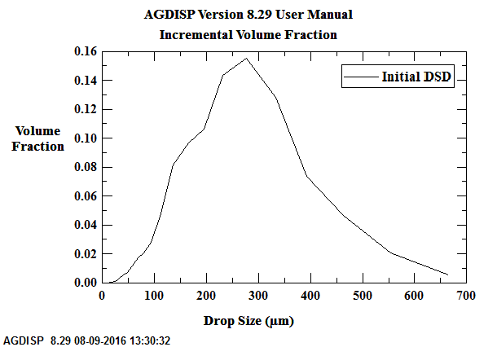

Figure A.1. Incremental plot of the ASAE S572.1 Fine to Medium drop size distribution. The horizontal scale is drop size and the vertical scale is volume fraction contained in each drop size class.

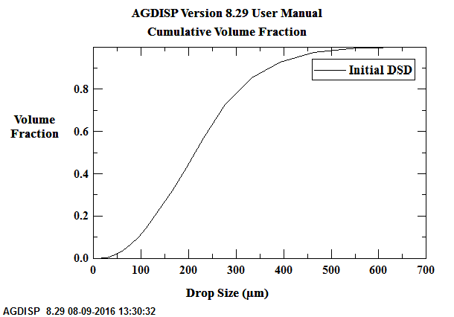

Figure A.2. Cumulative plot of the ASAE S572.1 Fine to Medium drop size distribution. The horizontal scale is drop size and the vertical scale is the sum of all volume fractions contained in lower drop size classes.

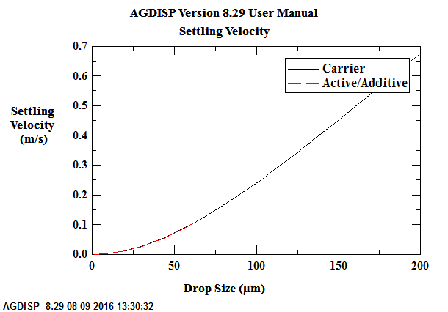

Figure A.3. Settling velocity as a function of drop size, for the carrier and nonvolatile fraction assumed. The horizontal scale is drop size and the vertical scale is droplet velocity. The two curves are different only if the specific gravities of the carrier and the nonvolatile fraction are different.

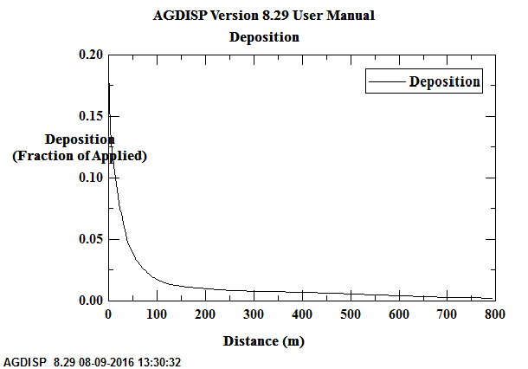

Figure A.4. Plot of the ground deposition for the ASAE S572.1 Fine to Medium drop size distribution. The horizontal scale is distance downwind from the edge of the application area, and the vertical scale is deposition in the units specified by the user in Preferences.

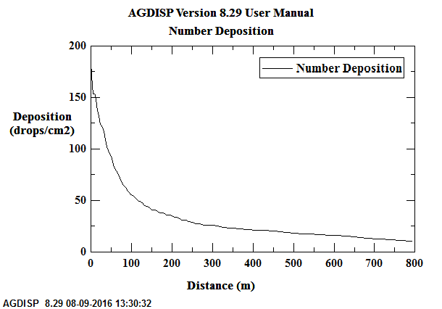

Figure A.5. Number deposition ground deposition for the ASAE S572.1 Fine to Medium drop size distribution. The horizontal scale is the distance downwind from the edge of the application area, and the vertical scale is droplet deposition in drops/cm2.

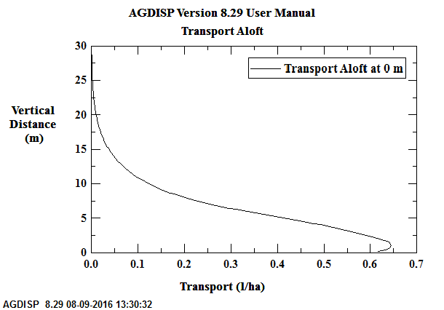

Figure A.6. Transport aloft through a flux plane positioned at the Transport Distance specified by the user on the main input screen (in this example, at the Edge of the Application Area). The horizontal scale is the amount aloft and the vertical scale is height.

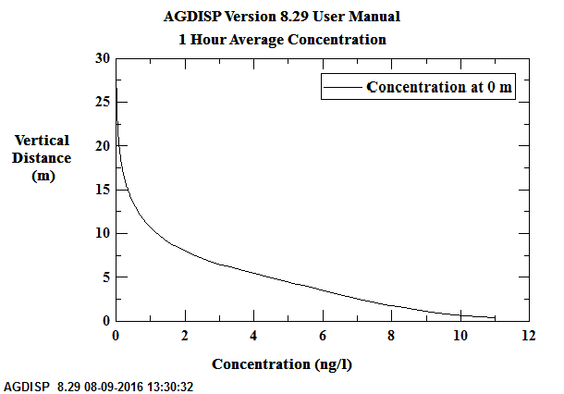

Figure A.7. One hour average concentration through a flux plane positioned at the Transport Distance specified by the user on the main input screen (in this example, at the Edge of the Application Area). The horizontal scale is the concentration aloft and the vertical scale is height.

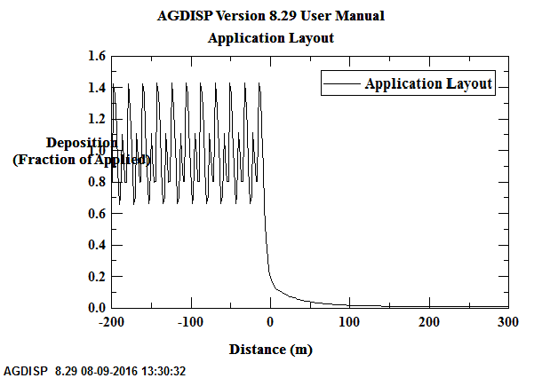

Figure A.8. Application layout, combining the spray block deposition to 200 m upwind of the edge of the application area (at 0 m) and the downwind deposition to 300 m. The horizontal scale is distance downwind and the vertical scale is deposition in the units specified by the user in Preferences.

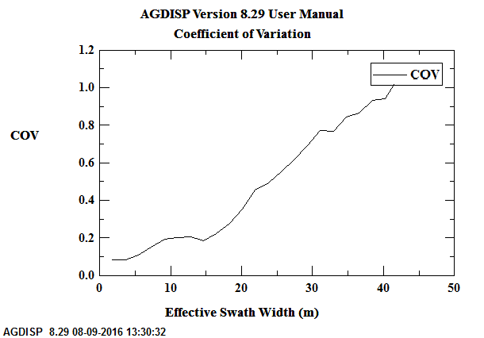

Figure A.9. Coefficient of Variation as a function of Swath Width. The horizontal scale is Effective Swath Width and the vertical scale is COV.

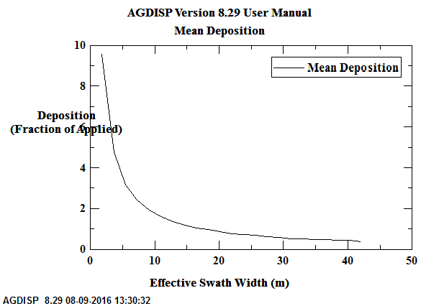

Figure A.10. Mean Deposition within the spray block as a function of Swath Width. The horizontal scale is Effective Swath Width and the vertical scale is Mean Deposition in units specified by the user in Preferences.

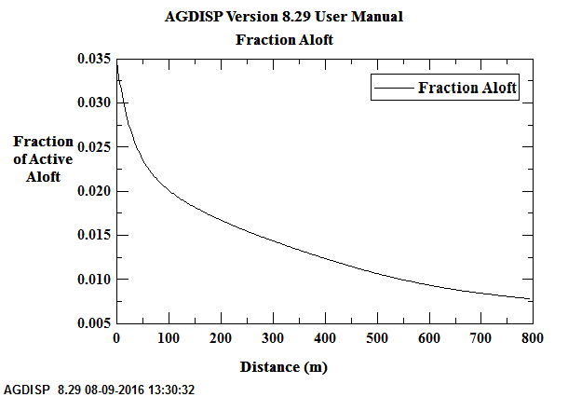

Figure A.11. Fraction Aloft. The horizontal scale is distance downwind from the edge of the application area and the vertical distance is the fraction of active spray material still aloft at those distances.

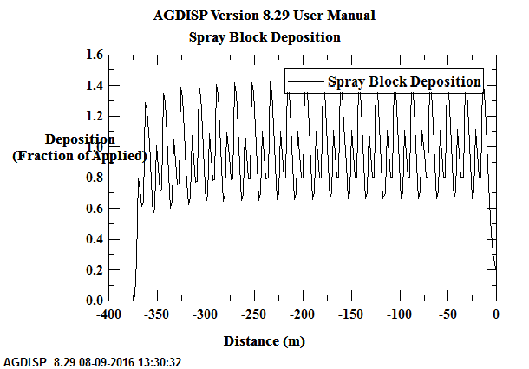

Figure A.12. Spray block deposition pattern, measured from the edge of the application area (at 0 m) upwind into the spray block (20 flight lines assumed in this example). The horizontal scale is distance and the vertical scale is deposition in units specified by the user in Preferences.

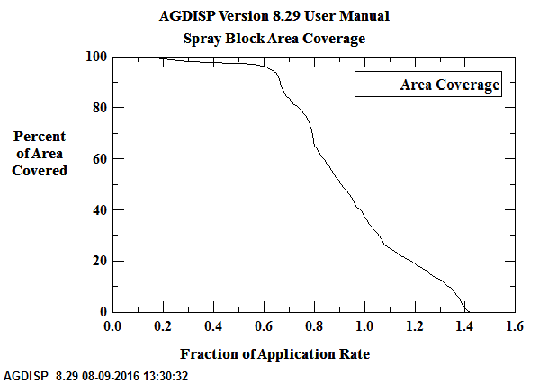

Figure A.13. Spray block area coverage, indicating how much area is covered by specified levels of application rate. The horizontal scale is the fraction of application rate (the release rate is 1.0), and the vertical scale is the percentage of spray block area covered by the specific application rate fraction.

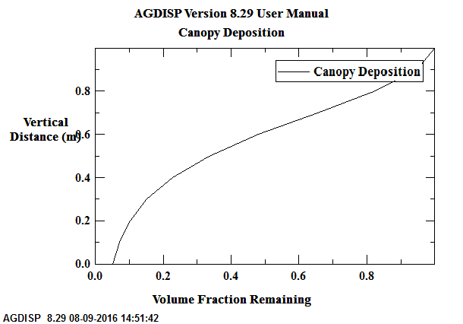

Figure A.14. Canopy deposition profile. The horizontal scale is the spray volume fraction remaining and the vertical scale is height. The volume fraction at the top of the canopy is normalized to 1.0, and fraction remaining indicates the fraction that has not been captured by the canopy.

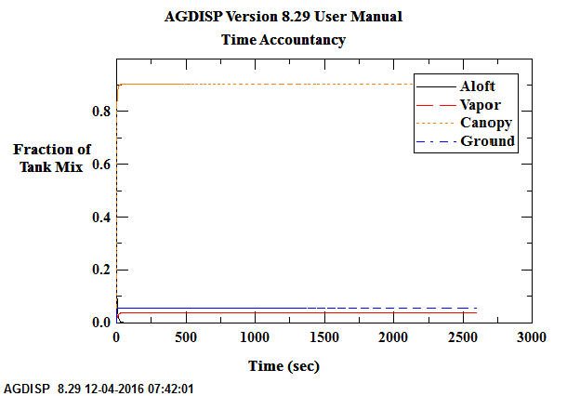

Figure A.15. Total accountancy of the released tank mix material, as a cumulative function of time after release. The horizontal scale is time and the vertical scale is fraction of tank mix. Up to four curves chart fraction aloft, fraction evaporated, fraction captured on the canopy, and fraction reaching the ground.

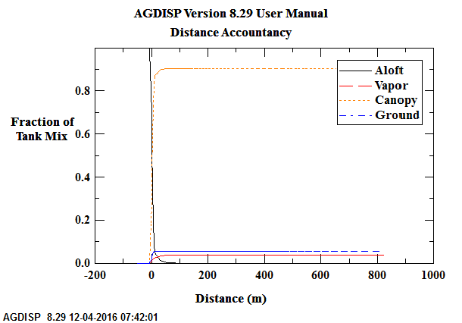

Figure A.16. Total accountancy of the released tank mix material, for the most downwind flight line, as a cumulative function of distance. The horizontal scale is distance downwind from the centerline of the spray vehicle and the vertical scale is fraction of tank mix.

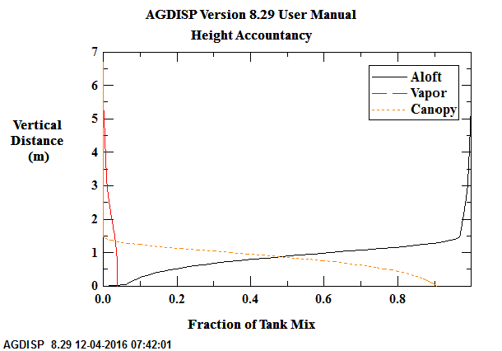

Figure A.17. Total accountancy of the released tank mix material, as a cumulative function of height. The horizontal scale is fraction of tank mix and the vertical scale is height.

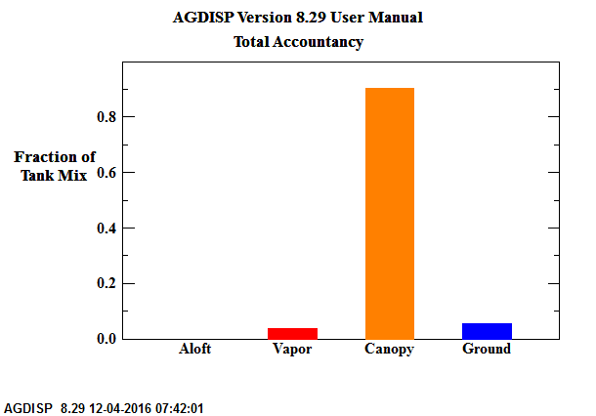

Figure A.18. Total accountancy of the released tank mix material. The bar chart gives fraction aloft, fraction evaporated, fraction captured on the canopy, and fraction reaching the ground.