Reproducing published wastewater metagenomic ARG results: a preregistered secondary analysis
Krzysztof Gizynski · 2 November 2026
Metagenomic read counts rebuilt from Taylor et al. (2025), with a detection-level comparison against the published qPCR calls

Summary
A metagenomic analysis pipeline based on the tools and settings reported by Taylor et al. (2025), with documented assumptions where details were not stated, met all registered pass/fail criteria on 18 held-out wastewater samples. Agreement was strong at gene level. Discrepancies in ermB counts and uncertainty about the published 16S normalisation limited complete reproduction.
- Registered reproduction (R1). Per-sample totals were 0.911 to 0.991 of the published counts (17 of 18 inside the registered band 0.93 to 1.07) and below the published value in 18 of 18 samples. At gene level, 68 of 70 gene-sample comparisons were within 10%.
- Where it failed. ermB in effluent: ratios 0.73, 0.22 and 0.71 in three of nine effluent samples. Exploratory tests show that competing, closely related reference sequences change KMA assignments, a plausible explanation; why our assignments differ from the authors' remains unresolved because their reference files were unavailable.
- Detection (project RQ3, descriptive). Metagenomic presence/absence reproduces Table 1 of the paper in all 20 cells and its Table S5 in 165 of 165 sample-gene pairs. Against the published qPCR calls, metagenomics finds 26 of 36 positive calls in pond and sediment; for the 10 missed calls the KMA analysis assigned no reads to the gene family, and no threshold from 1 to 100 changes this.
- Not reproduced. The paper's ARG-per-16S values (Fig. 1c) are about 100 times our ratio. Scaling by 100 matches influent within about 5%, but effluent and pond differ in opposite directions. The scaling is a possible explanation, not a verified unit conversion, and the authors did not reply.
All predictions, including the failures, are reported. Day 1 (9 samples) was used for development; Days 2 and 3 (18 samples) stayed closed until the registration was frozen and were scored once. Sections 6 to 9 are exploratory and do not change the registered verdict.

1 Background and questions
Taylor et al. (2025, BMC Research Notes 18:5, doi:10.1186/s13104-024-07027-9) compared shotgun metagenomic sequencing (MGS) with quantitative PCR (qPCR) for five antibiotic-resistance genes (ermB, sul1, tetA, tetQ, tetW) at one wastewater treatment plant: influent (INF), effluent (EFF), a treatment pond (POND) and pond sediment (SED). Reads were deposited under BioProject PRJNA904380.
This project is a secondary analysis of those public data. The aim is not to find fault with the paper but to test whether its metagenomic results can be rebuilt from the published description, and to say exactly where they can and cannot.
The project proposal (v1.3) defines four research questions: RQ1, consistency of ARG calls and abundance estimates across analytical strategies; RQ2, the effect of sequencing depth and normalisation, including gene-length correction; RQ3, agreement of metagenomic estimates with qPCR; and RQ4, exploratory ARG-to-taxon attribution. Those identifiers are kept. This report covers the first registered study, the reproduction arm (R1), whose questions are labelled R1-a to R1-c, and the detection-level part of RQ3.
Label | Question | Relation to the project questions | Status (section)
R1-a | Does a pipeline built from the stated tools and settings reproduce the published ARG read counts (totals, gene level, subtype level) on held-out samples? | Reference analysis for RQ1 | Registered, decides the verdict (3, 5)
R1-b | Why does ermB fall short in some effluent samples? | Follow-up to R1-a | Exploratory (6)
RQ3, detection level | How do metagenomic and published qPCR presence/absence calls agree, and how does the detection rule matter? | RQ3, the part testable from public data | Descriptive (7)
R1-c | Do ARG-per-16S ratios and sediment results agree with the paper? | Touches RQ2 (normalisation) only descriptively | Exploratory (8, 9)
RQ2 (depth, gene length), RQ4 (taxa) | Not addressed in this report

2 Data and samples
The analysis set is the 33 metagenomic runs whose ENA sample alias equals a paper sample ID (369.6 Gbp in total, 9.5 to 14.3 Gbp per sample). Six further runs (3 extraction blanks, 3 runs labelled *000) were left out of the core analysis. Every FASTQ file was checked against the md5 published by ENA before use.
Set | Samples | Role
Development (Day 1) | 9 liquid: INF R001, R006, R011; EFF E001, E006, E011; POND P001, P006, P011 | Used to set open choices (thresholds, 16S rule)
Evaluation (Days 2 and 3) | 18 liquid: 6 each of INF, EFF, POND | Closed until the registration was frozen; scored once; decides the verdict
Sediment (Days 2 and 3) | 6 SED | Closed with the evaluation set; descriptive only, because no sediment was available for development
The samples are three replicates per sample type per day, on three consecutive days. They are not independent experiments: samples from one day are dependent, and the pond samples come from a different campaign date than influent and effluent. The evaluation download was 118.4 GB over a mobile connection, which needed a chunked, checksum-verified download method (section 10).

3 Preregistration and design
The design separates what was tuned from what was tested. Open choices were set on the nine Day-1 samples only; the criteria were then written down, committed and tagged (R1-registered, commit ad97ff6, 2026-10-30 09:33) before any Day-2/3 or sediment file was opened.
- A first draft of the registration was reviewed independently; version 2 was written after that review and the Day-1 results.
- The development results showed that the first definition of P3 (subtype recall) could be passed by a pipeline that detects nothing useful, and that subtype labels swap between near-identical alleles. P3 was redefined at gene level before the freeze; the change is logged in the registration (section 6a).
- The registration, scoring script and checksums were committed and tagged, then the evaluation data were run through the pipeline once and scored once with the frozen script (09_score_R1.py, checked unchanged against the tagged commit).
- Every change after the tag is listed in a deviation table; all entries were made before any evaluation result was seen.
ID | Registered criterion (verdict) | Band
P1 | Per-sample total ratio, ours / published | 0.93 to 1.07 in at least 16 of 18, and at least 5 of 6 per type
P2 | Same ratio below 1.00 (direction only) | at least 15 of 18
P3 | Gene-sample pairs with ratio in band | 0.90 to 1.10 in at least 90% of pairs
P3b | False-positive genes | at most 2
P4 | Median subtype ratio per sample | 0.90 to 1.10 in at least 16 of 18
Reported but outside the verdict: P3c (subtype recall at least 0.90, at most 18 extra subtypes) and P5 (share of 16S reads on organelle and eukaryote templates ordered POND > EFF > INF). Sediment, the ARG-per-16S comparison, and all exploratory analyses are outside the verdict by design.
Limits stated in advance: the hold-out is imperfect because Table S6 and the paper's results were known beforehand and all days come from the same plant and season; the 18 evaluation samples are not independent; subtype labels among near-identical alleles are not reliably identifiable from short reads; and the authors' 16S denominator was not reproduced on development data.

4 Methods
Each sample went through one fixed path: adapter and quality trimming with bbduk 38.90 (maxns=0 minlength=75 qtrim=r trimq=20, paired output so orphaned reads are dropped), then read mapping with KMA 1.4.9 (-ipe -mem_mode -ef -1t1 -cge -nf -vcf) against two databases: ResFinder 2.1.1 (all.fsa, 3,146 sequences) for ARGs and SILVA 138.1 SSURef NR99 for 16S. The SILVA index needs 37.6 GB to build, so it was built on a temporary cloud machine and verified by checksum after transfer.
Assumptions the paper does not state. The adapter options for bbduk; the SILVA variant (NR99 chosen); the ResFinder tag and default index settings; and the meaning of "read count". We took it to be KMA readCount, which agreed with the published values in 28 of 28 subtypes in one test sample. This is a voting count, not the number of reads aligned along the gene. Subtypes are called at a count of at least 50, inclusive, because Table S6 contains an exact 50. No coverage or identity filter was applied on the ARG side, because the paper publishes counts for templates covered over only 8%.
Two numerators, kept apart.
- S6 numerator (reproduction of Table S6): the count of the template named as each published subtype, kept if at least 50.
- G numerator (gene level): the sum over all ResFinder templates of the gene family with count at least 50, whether or not that subtype was published. The family is the name before the first underscore of the published subtype names; this is a simplification, disclosed in section 10.
16S denominator (rule D13, chosen on development data by reasoning, not by agreement with Fig. 1c). SILVA readCount summed over Bacteria and Archaea templates, excluding Chloroplast, Mitochondria and Eukaryota. Six alternative rules were computed and reported (all templates; Bacteria only; organelles included; fragment count; aligned-read count; 16S template coverage at least 90%).
Software provenance. Scripts are numbered in the repository (bin/); the registered pipeline is 06_trim_kma.sh, run per sample by 10_run_set.sh, and scoring is 09_score_R1.py. Exploratory scripts (11 to 16) never write to the registered output folder.
Nomenclature. Italic gene symbols (ermB, sul1, tetA, tetQ, tetW) name a biological gene, or a gene family summed over all its reference templates. Reference identifiers are literal ResFinder database names, kept exactly as KMA reports them (erm(B)_2, tet(A)_6, sul1_9). Software names are upright and script names are in monospace.

5 Results of the registered analysis (RQ1/RQ2)
All registered pass/fail criteria (P1, P2, P3 with its sub-criterion P3b, and P4) were met on the 18 held-out samples; the secondary ordering P5 was also met. The pipeline ran once per sample (24 of 24 runs complete, no reruns), and the evaluation was scored once.
ID | Criterion | Development (n = 9) | Evaluation (n = 18) | Met
P1 | Total ratio in 0.93 to 1.07 | 9 of 9 (0.967 to 0.986) | 17 of 18 (INF 6/6, EFF 5/6, POND 6/6); range 0.911 to 0.991; outside: E021 0.911 | Yes
P2 | Ratio below 1.00 | 9 of 9 | 18 of 18 | Yes
P3 | Gene-sample pairs in 0.90 to 1.10 | 35 of 36 (97%) | 68 of 70 (97.1%); outside: E021 ermB 0.22, E036 ermB 0.71 | Yes
P3b | False-positive genes (max 2) | 0 | 0 | Yes
P4 | Median subtype ratio in 0.90 to 1.10 | 9 of 9 | 17 of 18; outside: P036 (median 0.00) | Yes
P3c | Subtype recall at least 0.90, extras at most 18 (reported) | 0.955, 5 extras | 0.934, 9 extras | Level reached
P5 | Organelle/eukaryote share POND > EFF > INF (reported) | one day | Day 2: 0.10, 0.29, 0.58; Day 3: 0.11, 0.27, 0.57 (INF, EFF, POND) | Yes
The 70 gene-sample comparisons in P3 (36 of 45 on development) are the pairs for which the paper reports a non-zero value, since a ratio needs a non-zero published denominator; the remaining pairs enter P3b (false positives).
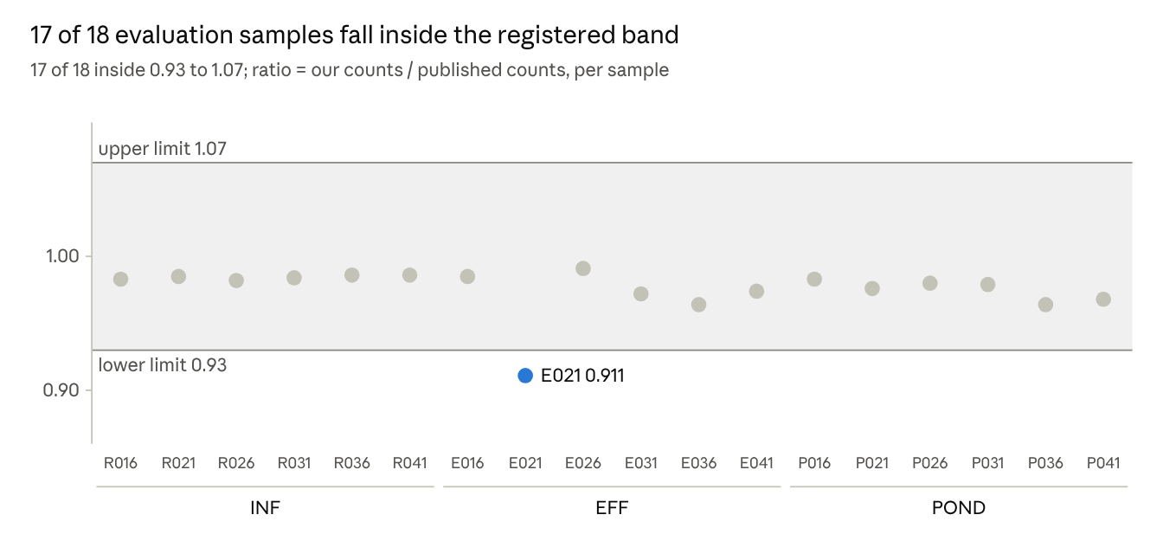
Figure 1. Our-to-published total count ratio per evaluation sample (results/score_R1_eval.txt, 18 liquid samples)
E021 is the only sample outside the band; its shortfall comes from ermB (section 6).
Direction. Our totals are 0.91 to 0.99 of the published counts, always below them (P2). The assumed adapter options are one candidate cause; a controlled trimming comparison was not done, so this remains a hypothesis.
What the single misses are. On development, E011 ermB (0.73) was the only gene pair outside the band; on evaluation, E021 and E036 ermB are the two. They are one problem, analysed in section 6. P036 fails P4 because it has only three published positive subtypes, and two of them were assigned to a sibling allele.
Subtype labels are unstable between near-identical alleles. Counts swap between tet(W)_1 and tet(W)_5 (E016), sul1_9 and sul1_2 and tet(A)_6 and tet(A)_4 (P036), and erm(B)_2 and erm(B)_10 or _20 (E036, E021). The gene totals are unaffected. The share of subtypes within 10% of the published count (not a criterion) is 0.47 to 0.68 for influent, 0.62 to 0.93 for effluent and 0 to 0.75 for pond, although the medians are close to 1.
Influent erm(B). Published erm(B)_1 and erm(B)_10 counts such as 1,575 in R031 appear here as small counts (22 and 14), yet the ermB gene totals agree (0.96 to 0.99): the reads sit on other erm(B) templates.

6 The ermB shortfall (exploratory)
Exploratory analyses show that competing, closely related reference sequences substantially affect KMA read assignments, a plausible explanation for the ermB shortfall in three effluent samples (E011 0.73, E021 0.22, E036 0.71). The precise cause of the difference from the published results remains unresolved, because the authors' reference files and indexing configuration were unavailable; in the tests done, trimming did not explain the missing erm(B)_2 block. In the other six effluent samples ermB agrees within 2 to 4%, and the other four genes agree in the same samples. The registered verdict is unchanged. This section was done after the freeze, following an independent review, under a stop rule agreed in advance.
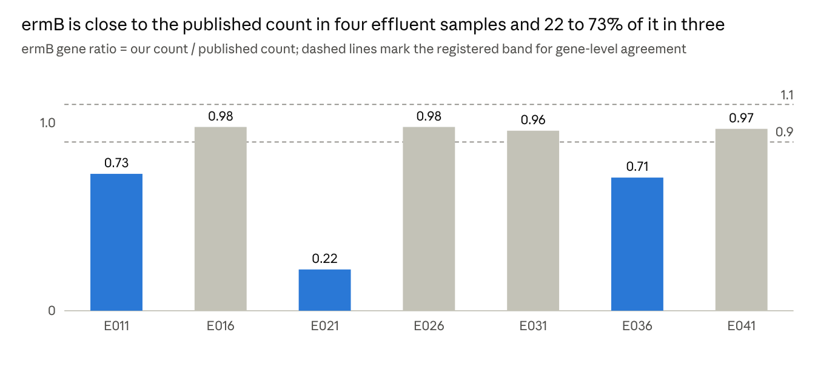
Figure 2. ermB gene ratio in seven effluent samples (E011 development, others evaluation; E001 and E006 not shown; results/score_R1_eval.txt and the development scoring)
What the mapper's counts are. The 'read count' behaves as a voting count. Some erm(B)_2 counts are 672 to 780 reads, yet cover only 26 to 52% of the gene with 2 to 5 aligned reads; other erm(B) templates in the same samples have whole-gene support (for example E011 erm(B)_18: 557 reads, 99.7% covered). Neighbouring erm genes show the same thin pattern (erm(38) 2,856 to 3,534 reads at 14 to 26% coverage).
Three tests.
- Existing outputs, nine effluent samples. Whole-gene-supported ermB reads (about 550 in E011 and E036) are present in the shortfall samples but sit on a sibling template, while the thin erm(B)_2 block is absent from E011, E021 and E036.
- Raw reads without trimming, E021 against control E026. The erm(B)_2 block is still absent in E021 and present in E026 (816 raw, 698 trimmed). Trimming changes counts by 2 to 17% and does not create or remove the block.
- Index containing erm(B)_2 alone. E021 has 899 reads and E026 906, with all 738 positions covered. With no competing template the two samples are alike; in the full database E021 has none on erm(B)_2 and E026 698.
Hypothesis | Status | Evidence
Reference competition between similar alleles | Supported | Test 3
Assumed adapter options in bbduk | No effect on the missing block in the samples tested | Test 2
Different reference content or index in the authors' run | Unresolved | Needs the authors' files
Sample mix-up or hidden unpaired reads | Not supported | Other four genes agree; two files per run; md5 verified
Error in Table S6 | Not supported | E021 ermB/sul1 ratio 0.61 lies in the normal range 0.44 to 0.78
Caution. The single-template count is an upper bound: reads from related erm genes can also map to a lone template. It shows similar sequence is present, not its abundance. The paper also says a whole-gene coverage threshold was required, yet its published counts include thin blocks like these. Counts below whole-gene support should not be read as abundance.

7 Detection level (RQ3)
Metagenomic presence/absence is reproduced exactly, and against qPCR the only systematic gap is that metagenomics misses 10 of 36 qPCR-positive calls in pond and sediment, because the KMA analysis assigned no reads to those gene families in those samples. A gene counts as detected when any template of its family has a count at or above the threshold (50 in the registered rule). This part is descriptive and used all 33 samples.
Reproduction of the paper. All 20 sample-type by gene cells of Table 1 are equal to the published percentages (for example POND tetA 7/9 = 77.8%, SED tetA 4/6 = 66.7%, SED tetW 1/6 = 16.7%; ermB, tetQ and tetW not detected in pond). At sample level, 165 of 165 sample-gene pairs agree with the paper's own metagenomic calls in Table S5, which also confirms the mapping between replicate numbers and sample IDs.
Agreement with qPCR. qPCR calls are the authors' presence/absence from Table S5; the qPCR detection limit was about 50 copies/µL (signals below it excluded; four technical replicates), but per-sample quantitative values are not public, so this is agreement, not accuracy.
Rule | Subset | qPCR+ found by MGS | qPCR+ missed | qPCR- called by MGS | Agreement
Any template, count at least 1 to 100 | All 33 samples | 116 | 10 | 1 | 93.3%
Any template, count at least 1 to 100 | Pond + sediment (15) | 26 | 10 | 1 | 85.3%
Any template, count at least 200 | All 33 samples | 114 | 12 | 1 | 92.1%
As above, plus template coverage at least 90% | All 33 samples | 94 | 32 | 0 | 80.6%
As above, plus template coverage at least 90% | Pond + sediment (15) | 11 | 25 | 0 | 66.7%
- No threshold effect. Calls are identical for every threshold from 1 to 100: a gene is either undetected or present with well over 100 reads.
- Where they disagree. The 10 missed calls are tetA in P016, P026, S001, S026; ermB and tetQ in P036 and P041; tetW in P036 and S006. Even a threshold of 1 recovers none, so the gap is not caused by the detection rule. Low abundance relative to sequencing depth is a plausible contributor; reference matching and the qPCR target definitions may also matter. The one extra metagenomic call is tetW in S026, which is also in the paper's Table S5.
- No whole-gene coverage rule. Requiring 90% template coverage removes 22 influent and effluent calls that both qPCR and the paper confirm, so the paper's detection calls cannot have used it.

8 ARG per 16S ratios (RQ4, exploratory)
The paper's Fig. 1c ARG-per-16S values were not reproduced in absolute terms: they are about 100 times our ratio, and after scaling by 100 the match holds for influent only. Our ratio is the G-numerator total of the five genes divided by the 16S count of rule D13; the ordering INF > EFF > POND holds under D13 and under four of the six alternative rules (all templates, Bacteria only, organelles included, fragment count). The aligned-read rule puts Day-3 pond (0.011) above effluent (0.007), and the 90%-coverage rule puts influent (0.11 to 0.15) below effluent (0.18 to 0.22).
Our ratios (reads of ARG per 16S read, rule D13, group means of three replicates).
Type | Day 1 | Day 2 | Day 3
INF | 0.022 | 0.019 | 0.020
EFF | 0.016 | 0.016 | 0.017
POND | 0.007 | 0.005 | 0.010
SED | not sampled | 0.011 | 0.011
Comparison with Fig. 1c (nine development samples). The figure values were read off the published graph and are good to about 0.1, so the pond comparison is the least certain.
Type | Ours x 100 | Fig. 1c | Paper relative to ours
INF | 2.2 to 2.4 | 2.25 to 2.45 | within about 5%
EFF | 1.6 | 1.95 to 2.1 | about 25% higher
POND | 0.7 to 0.8 | 0.4 to 0.55 | about 30 to 40% lower
- Unit. The vertical axis of Fig. 1c reads 'per 16S rRNA' without a percent sign (Fig. 1d is explicitly in percent). Multiplying our ratio by 100 is a possible explanation for the factor of about 100, not a verified unit conversion.
- Type-dependent residual. Because effluent and pond deviate in opposite directions, the difference is not a single scale factor: the paper's 16S counting rule or reference must differ from ours in a way that depends on sample type. Gene-length correction would change the ratio by about 1.3 times, not 100 times; none of our six alternative rules fixes effluent and pond together.
- Consistent with the paper's text. The paper says metagenomics found INF and EFF levels 'comparable', which we see (0.022 against 0.016). A comparison with the qPCR ratios is not possible, because per-sample qPCR values are not public.
The authors were asked about the sample mapping and per-sample qPCR values (2026-10-27) and have not replied, so this is closed as unresolved, with a fixed reporting rule: ratios are given as ARG reads per 16S read and as percent, with rule D13 stated.

9 Sediment (descriptive)
The six sediment samples were run with the same pipeline but not scored, because the development set had no sediment; the reproduction there is as close as in liquid samples, with no pattern of loss.
- Numerators against Table S6. sul1 0.94 to 1.07 (three of six samples above 1, by up to 7%), tetA 0.98 to 0.99, tetW 0.98. The 'always below the published count' pattern (P2) therefore holds for the liquid samples only.
- Detection. sul1 in 6 of 6, tetA in 4 of 6, tetW in 1 of 6, ermB and tetQ in none, as published. Against qPCR, 3 sediment calls are missed (S001 tetA, S006 tetW, S026 tetA) and one is extra (S026 tetW).
- ARG per 16S. 0.005 to 0.014 reads per 16S read (rule D13); group means 0.011 on both days.

10 Deviations, limitations and open questions
The reproduction held on every registered criterion, but four things are not settled and several limits shape how far the result can be read.
Deviations after the freeze. Three changes were made after the tag and before any evaluation result was seen. None changed counts.
Date | Change | Effect
2026-10-30 to 11-01 | Evaluation reads downloaded in 32 MB chunks, each file checked against the live ENA md5 (the earlier method failed over mobile broadband) | None; files identical to ENA
2026-11-01 | 06_trim_kma.sh: guard changed to accept evaluation runs only when ALLOW_EVAL=1; processing steps unchanged | None on counts
2026-11-01 | 10_run_set.sh added to run the script once per sample | None
Open questions.
- The authors' 16S denominator and the units of Fig. 1c (section 8).
- Why the thin erm(B)_2 block is missing in E011, E021 and E036, and why the published Table S6 gives the same value (659) for erm(B)_2 in E011 and E021. A difference in the authors' reference files is not testable without them.
- The paper's 'whole-gene coverage threshold', which its own published counts do not seem to follow.
- The cause of the direction P2 (totals always below the published ones): assumed adapter options are one candidate, not tested.
Limitations.
- The hold-out is imperfect: the published values were known beforehand, and all samples come from one plant and season; Day 1 and Days 2/3 differ in campaign date.
- The 18 evaluation samples are not independent. Pond samples come from a different date than influent and effluent, so the ordering in P5 is not attributed to treatment stage.
- The G numerator's gene family is the name before the first underscore of the published subtype names. A published subtype's family could include templates that the authors did not count, so G is an own rule, not a reproduction.
- Subtype labels among near-identical alleles cannot be told apart from short reads (for example tetA(P)_1 and _3 differ at 2 of 1,263 positions).
- The qPCR comparison is at presence/absence level only: per-sample quantitative qPCR values and the handling of the four technical replicates are not public (the detection limit, about 50 copies/µL, is stated in the supplement).
- Software versions and settings for steps the paper does not state (adapter options, SILVA variant, ResFinder index settings) are our choices.

11 Conclusions
- The registered reproduction criteria were met on the 18 held-out evaluation samples: totals within 0.91 to 0.99 of the published counts and 68 of 70 gene-sample comparisons within 10%.
- Reference-dependent subtype assignments, the ermB shortfall in some effluent samples and the unresolved 16S denominator limit exact reproduction and the interpretation of ARG-per-16S values.
- Presence/absence calls were reproduced exactly, and metagenomics agreed with the published qPCR calls except for 10 positive calls in pond and sediment, with no effect of the detection threshold.
- The findings show why mapping rules, reference databases and normalisation choices have to be documented when shotgun metagenomics is used for antimicrobial-resistance surveillance.

12 Reproducibility and data availability
Everything except the raw reads and the paper's supplementary tables is in the public repository bkhimek/Wastewater_AMR_Metagenomics. The reads are public at ENA under PRJNA904380.
Item | Value
Registration | REGISTRATION_R1_reproduction_arm.md (version 2), tag R1-registered (commit ad97ff6)
Evaluation scored | tag R1-eval-scored (commit f669449)
Exploratory ermB work | tag R1-exploratory-ermB (commit af490fc)
Detection analyses | commits ef2050a and ce46cca
Software | KMA 1.4.9, bbduk 38.90, ResFinder db 2.1.1, SILVA 138.1 SSURef NR99
Main scripts | 06_trim_kma.sh, 10_run_set.sh, 09_score_R1.py, 11_ratio_16S.py, 15_detection_vs_table1.py, 16_threshold_vs_qpcr.py
Not committed | Raw reads, results folders, Table S6 and Table S5 as CSV (supplement licence unconfirmed); these are rebuilt from the sources above
Cloud cost | One temporary machine to build the SILVA index: USD 5.88 for the month; key pair and machine deleted
To repeat the evaluation: download and verify the reads (03c_fetch_set.sh), run ALLOW_EVAL=1 bash bin/10_run_set.sh eval liquid, then python3 bin/09_score_R1.py --set eval. The scoring script refuses to run unless exactly the 18 expected liquid evaluation samples have complete results.

References
- Taylor W, Bohm K, Dyet K, Weaver L, Pattis I. 2025. Comparative analysis of qPCR and metagenomics for detecting antimicrobial resistance in wastewater: a case study. BMC Research Notes 18:5. doi:10.1186/s13104-024-07027-9
- Clausen PTLC, Aarestrup FM, Lund O. 2018. Rapid and precise alignment of raw reads against redundant databases with KMA. BMC Bioinformatics 19:307.
- Zankari E, et al. 2012. Identification of acquired antimicrobial resistance genes. Journal of Antimicrobial Chemotherapy 67:2640-2644.
- Quast C, et al. 2013. The SILVA ribosomal RNA gene database project. Nucleic Acids Research 41:D590-D596.
- Bushnell B. BBTools (BBDuk), version 38.90.

