**Date Submitted: 12/02/18**

**Task 01: Set up Project in SCS**

The purpose of Task 01 is to set up and create the example SCS project within SCS. In this task, the responsibility is to generate the Sensor Controller driver from the SCS project. Below is the window that is seen when generating the Sensor Controller Driver.

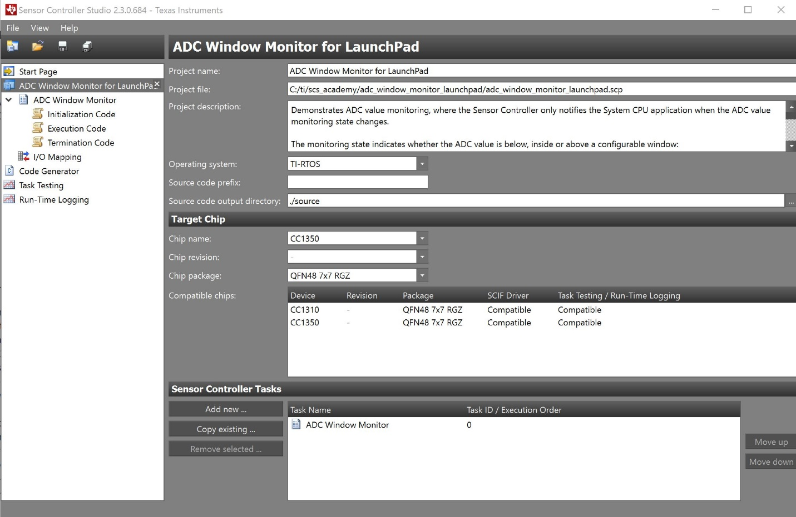

The next image below shows the project called “adc_window_monitor_launchpad_tirtos”.

This was found using the generated code from SCS. Files in regards to the SCIF driver and framework should appear as well within the project.

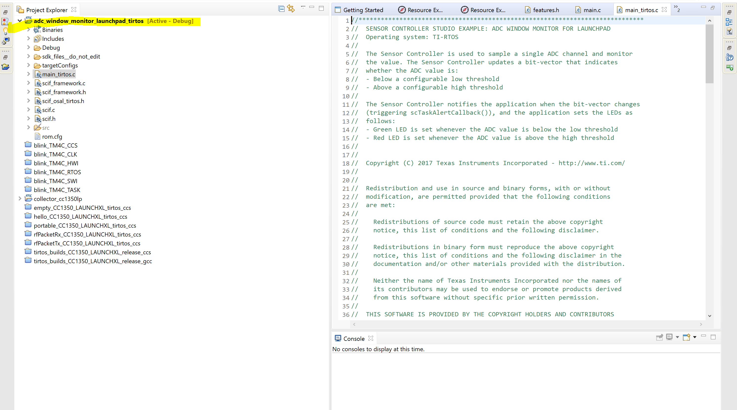

**Task 02: Download and Debug with CCS**

Youtube Link: <https://www.youtube.com/watch?v=Y4iCGR5b0D8>

The purpose of Task 2 is to ensure that the program is working efficiently after importing it from SCS to CCS. When the program is running the Red LED will light up indicating that the ADC input is above the high threshold and the green LED will indicate that the ADC input is below low threshold.

Modified Code (main_tirtos.c) :

//*****************************************************************************

// SENSOR CONTROLLER STUDIO EXAMPLE: ADC WINDOW MONITOR FOR LAUNCHPAD

// Operating system: TI-RTOS

//

// The Sensor Controller is used to sample a single ADC channel and monitor

// the value. The Sensor Controller updates a bit-vector that indicates

// whether the ADC value is:

// - Below a configurable low threshold

// - Above a configurable high threshold

//

// The Sensor Controller notifies the application when the bit-vector changes

// (triggering scTaskAlertCallback()), and the application sets the LEDs as

// follows:

// - Green LED is set whenever the ADC value is below the low threshold

// - Red LED is set whenever the ADC value is above the high threshold

//

//

// Copyright (C) 2017 Texas Instruments Incorporated - http://www.ti.com/

//

//

// Redistribution and use in source and binary forms, with or without

// modification, are permitted provided that the following conditions

// are met:

//

// Redistributions of source code must retain the above copyright

// notice, this list of conditions and the following disclaimer.

//

// Redistributions in binary form must reproduce the above copyright

// notice, this list of conditions and the following disclaimer in the

// documentation and/or other materials provided with the distribution.

//

// Neither the name of Texas Instruments Incorporated nor the names of

// its contributors may be used to endorse or promote products derived

// from this software without specific prior written permission.

//

// THIS SOFTWARE IS PROVIDED BY THE COPYRIGHT HOLDERS AND CONTRIBUTORS

// "AS IS" AND ANY EXPRESS OR IMPLIED WARRANTIES, INCLUDING, BUT NOT

// LIMITED TO, THE IMPLIED WARRANTIES OF MERCHANTABILITY AND FITNESS FOR

// A PARTICULAR PURPOSE ARE DISCLAIMED. IN NO EVENT SHALL THE COPYRIGHT

// OWNER OR CONTRIBUTORS BE LIABLE FOR ANY DIRECT, INDIRECT, INCIDENTAL,

// SPECIAL, EXEMPLARY, OR CONSEQUENTIAL DAMAGES (INCLUDING, BUT NOT

// LIMITED TO, PROCUREMENT OF SUBSTITUTE GOODS OR SERVICES; LOSS OF USE,

// DATA, OR PROFITS; OR BUSINESS INTERRUPTION) HOWEVER CAUSED AND ON ANY

// THEORY OF LIABILITY, WHETHER IN CONTRACT, STRICT LIABILITY, OR TORT

// (INCLUDING NEGLIGENCE OR OTHERWISE) ARISING IN ANY WAY OUT OF THE USE

// OF THIS SOFTWARE, EVEN IF ADVISED OF THE POSSIBILITY OF SUCH DAMAGE.

//****************************************************************************/

**#include** "ex_include_tirtos.h"

**#include** "scif.h"

**#define** BV(n) (1 << (n))

// Display error message if the SCIF driver has been generated with incorrect operating system setting

**#if** !(defined(SCIF_OSAL_TIRTOS_H) || defined(SCIF_OSAL_TIDPL_H))

**#error** "SCIF driver has incorrect operating system configuration for this example. Please change to 'TI-RTOS' or 'TI Driver Porting Layer' in the Sensor Controller Studio project panel and re-generate the driver."

**#endif**

// Display error message if the SCIF driver has been generated with incorrect target chip package

**#ifndef** SCIF_TARGET_CHIP_PACKAGE_QFN48_7X7_RGZ

**#error** "SCIF driver has incorrect target chip package configuration for this example. Please change to 'QFN48 7x7 RGZ' in the Sensor Controller Studio project panel and re-generate the driver."

**#endif**

// Task data

Task_Struct myTask;

Char myTaskStack[1024];

// Semaphore used to wait for Sensor Controller task ALERT event

**static** Semaphore_Struct semScTaskAlert;

**void** **scCtrlReadyCallback**(**void**) {

} // scCtrlReadyCallback

**void** **scTaskAlertCallback**(**void**) {

// Wake up the OS task

Semaphore_post(Semaphore_handle(&semScTaskAlert));

} // scTaskAlertCallback

PIN_Config pLedPinTable[] = {

Board_GLED | PIN_GPIO_OUTPUT_EN | PIN_GPIO_LOW | PIN_PUSHPULL | PIN_DRVSTR_MAX,

Board_RLED | PIN_GPIO_OUTPUT_EN | PIN_GPIO_LOW | PIN_PUSHPULL | PIN_DRVSTR_MAX,

PIN_TERMINATE

};

PIN_State ledPinState;

**void** **taskFxn**(UArg a0, UArg a1) {

PIN_Handle hLedPins;

// Enable LED pins

hLedPins = **PIN_open**(&ledPinState, pLedPinTable);

// Initialize the Sensor Controller

scifOsalInit();

scifOsalRegisterCtrlReadyCallback(scCtrlReadyCallback);

scifOsalRegisterTaskAlertCallback(scTaskAlertCallback);

scifInit(&scifDriverSetup);

scifStartRtcTicksNow(0x00010000 / 8);

// Configure and start the Sensor Controller's ADC window monitor task (not to be confused with OS tasks)

scifTaskData.adcWindowMonitor.cfg.adcWindowHigh = 800;

scifTaskData.adcWindowMonitor.cfg.adcWindowLow = 400;

scifStartTasksNbl(BV(SCIF_ADC_WINDOW_MONITOR_TASK_ID));

// Main loop

**while** (1) {

// Wait for an ALERT callback

Semaphore_pend(Semaphore_handle(&semScTaskAlert), BIOS_WAIT_FOREVER);

// Clear the ALERT interrupt source

scifClearAlertIntSource();

// Indicate on LEDs whether the current ADC value is high and/or low

**if** (scifTaskData.adcWindowMonitor.output.bvWindowState & SCIF_ADC_WINDOW_MONITOR_BV_ADC_WINDOW_LOW) {

**PIN_setOutputValue**(hLedPins, Board_GLED, 1);

} **else** {

**PIN_setOutputValue**(hLedPins, Board_GLED, 0);

}

**if** (scifTaskData.adcWindowMonitor.output.bvWindowState & SCIF_ADC_WINDOW_MONITOR_BV_ADC_WINDOW_HIGH) {

**PIN_setOutputValue**(hLedPins, Board_RLED, 1);

} **else** {

**PIN_setOutputValue**(hLedPins, Board_RLED, 0);

}

// Acknowledge the alert event

scifAckAlertEvents();

}

} // taskFxn

**int** **main**(**void**) {

Task_Params taskParams;

// Initialize the board

Board_initGeneral();

**#ifdef** Board_shutDownExtFlash

Board_shutDownExtFlash();

**#endif**

// Configure the OS task

Task_Params_init(&taskParams);

taskParams.stack = myTaskStack;

taskParams.stackSize = **sizeof**(myTaskStack);

taskParams.priority = 3;

Task_construct(&myTask, taskFxn, &taskParams, NULL);

// Create the semaphore used to wait for Sensor Controller ALERT events

Semaphore_Params semParams;

Semaphore_Params_init(&semParams);

semParams.mode = Semaphore_Mode_BINARY;

Semaphore_construct(&semScTaskAlert, 0, &semParams);

// Start TI-RTOS

BIOS_start();

**return** 0;

} // main

**Task 03: Download and Debug with SCS**

Youtube Link: <https://www.youtube.com/watch?v=Uwds4nVldaE>

This task is responsible for actually debugging within the Sensor Controller Studio rather than debugging within the Code Composer Studio. Below is a screenshot of the actual Debugging session within the Sensor Controller Studio and it displays the register values such as the CPU registers in regards to the breakpoint in the debugging session.

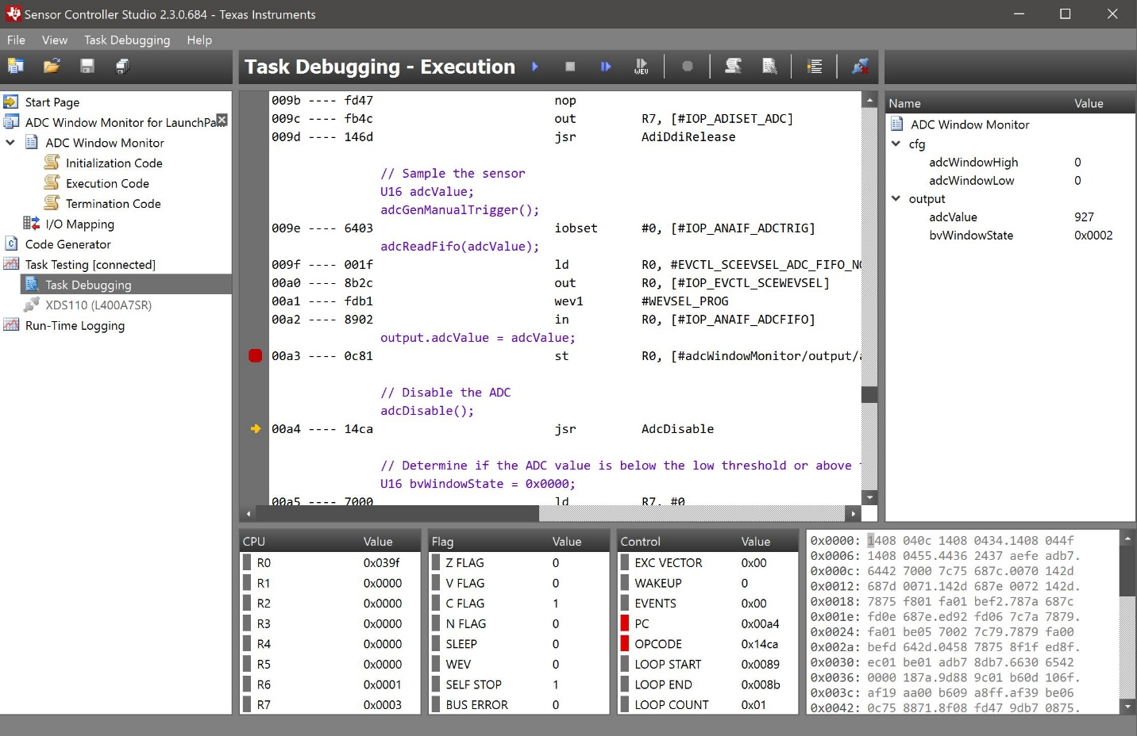

**Task 04: Understand**

The purpose of Task 04 is to get a better understanding of the basic flow of the ADC Window Monitor example. It is imperative to understand why this Lab is important and how it can reflect future projects. This Task is also requiring to review the code that has been generated and gives detail descriptions on the icons/panels that are within Sensor Controller Studio.