**Date Submitted: 12/02/18**

**Task 00: Install the needed software and apps**

Task 00 is a preparation for the rest of the lab. This is needed to ensure that the correct software is up to date and that all the software and hardware needed to present this lab will have no issues.

**Task 01: Update CC1350 LaunchPad firmware**

This task is important in updating the firmware on the CC1350 Launchpad.

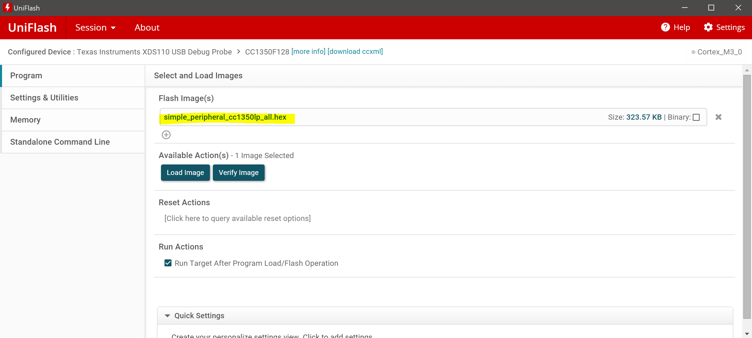

Above is a screenshot of what is needed to update the firmware on the CC1350. A software program called, UniFlash will recognize a device that is plugged in. Once that device has been recognized a session can be started. The next step is to ensure that the right bin or hex file has been included. Once that is finished press Load Image and it shall update the firmware.

**Task 02: OAD download sub-1GHz firmware images**

The next step is to download the firmware images for the sub-1GHz WSN Coordinator and one sub-1GHz/BLE beacon WSN Node. After using the iOS/Android application called SimpleLink Starter by TI this is the expected result:

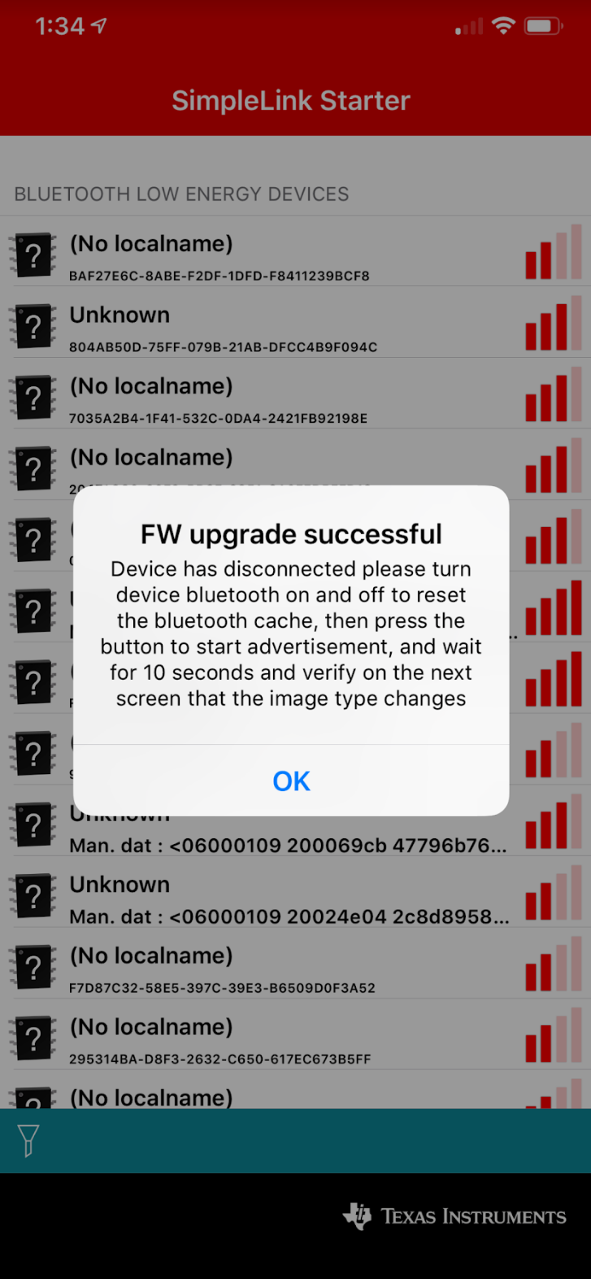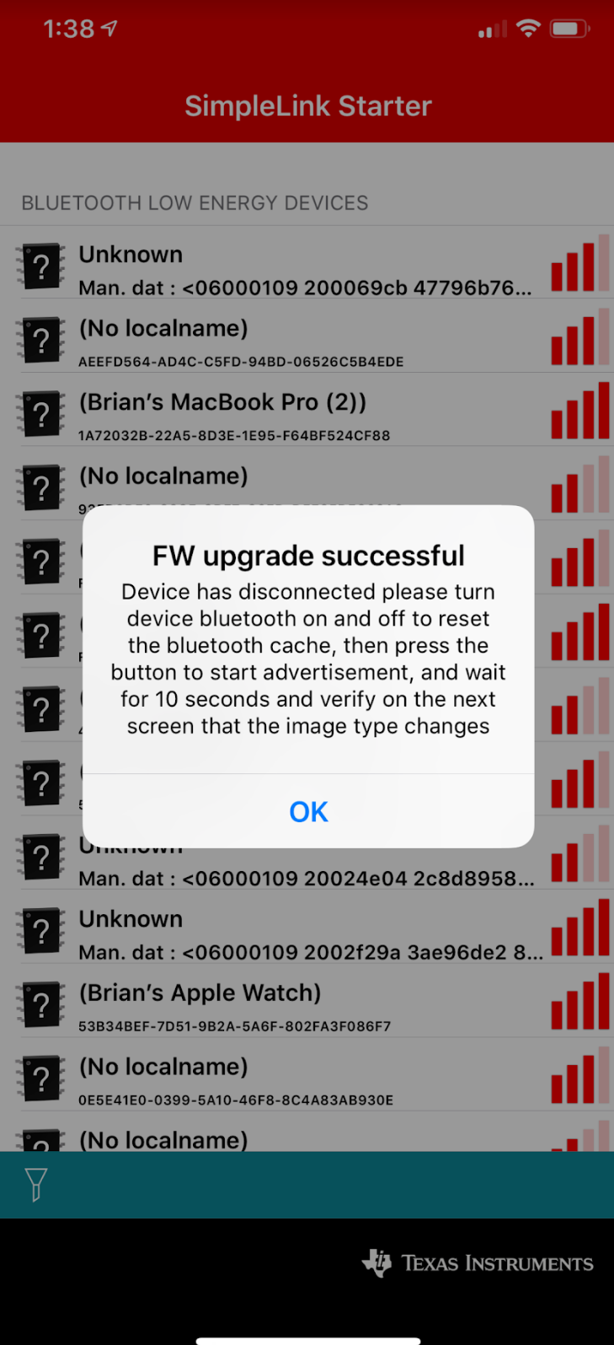

**Task 03: Running the sub-1GHz firmware images**

Task 3 is the implementation needed to power on the concentrator and to power on the node that will be sending ADC messages. After installing the firmware to both device, we get an output on the terminal from the Concentrator that displays this:

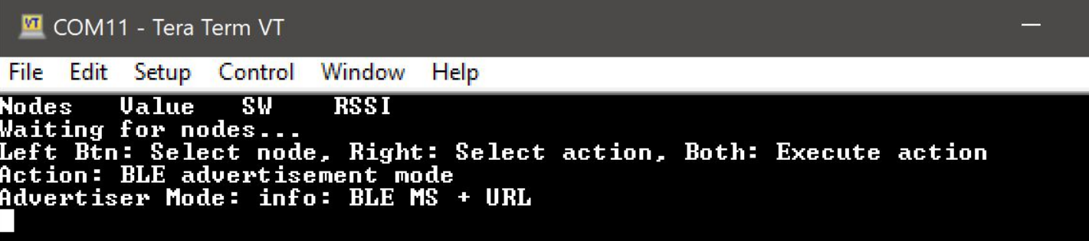

This indicates that the concentrator is looking for specific nodes which is very crucial for this lab.