**Date Submitted: 10/4/2018 8:04 PM**

**Task 00: Execute provided code**

**Youtube Link: No Submission required for Task 00**

**------------------------------------------------------------------------------------**

**Task 01:** Change the toggle of the GPIO at 2 Hz using Timer0 with 75% duty cycle and verify the waveform generated.

Youtube Link: <https://www.youtube.com/watch?v=q1mD8run9Qo>

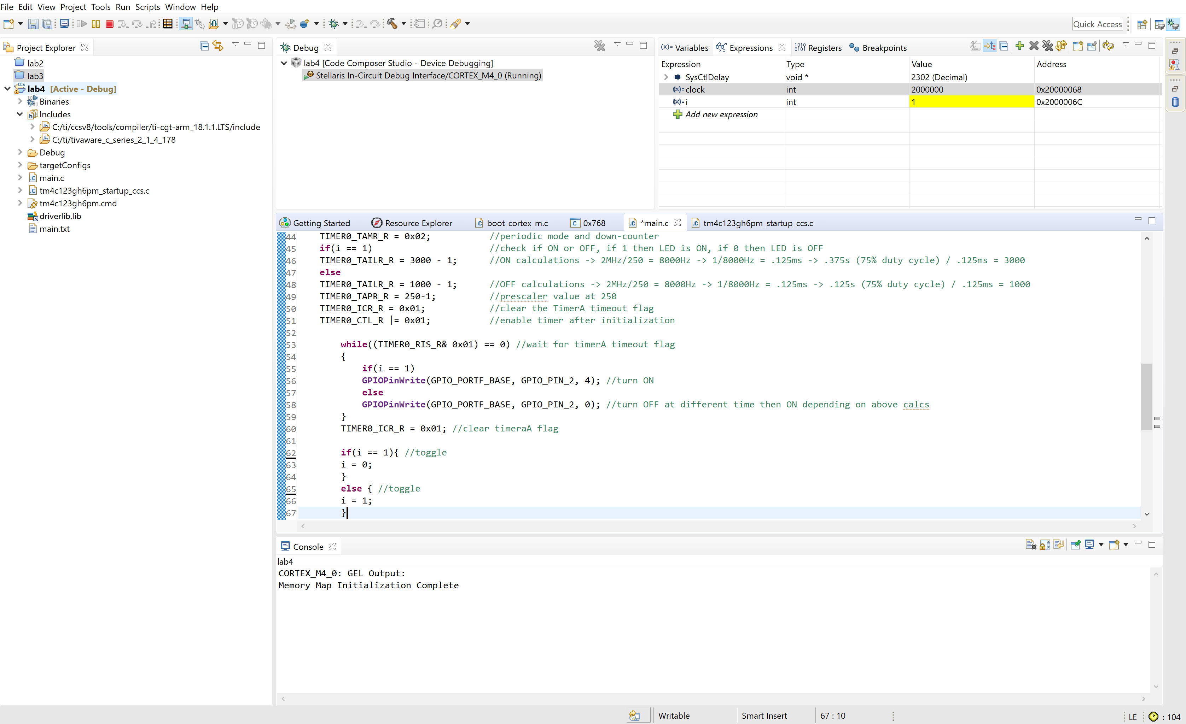

Above is a screenshot when debugging has begun. To verify the clock frequency the function SysCtlClockGet() was used for the int variable “clock”. On the top right we can see that the clock variable has a value of 2 x 10^6 which would approximately be 2MHz. I used the calculations within the code to figure out how long 75% duty cycle would be at .375s (ON) and 0.125s (OFF).

**Modified Code:**

**#include** <stdint.h>

**#include** <stdbool.h>

**#include** "inc/tm4c123gh6pm.h"

**#include** "inc/hw_memmap.h"

**#include** "inc/hw_types.h"

**#include** "driverlib/sysctl.h"

**#include** "driverlib/interrupt.h"

**#include** "driverlib/gpio.h"

**#include** "driverlib/timer.h"

**int** clock; //check clock freq

**int** i; //global variable

**int** **main**(**void**)

{

uint32_t ui32Period;

**SysCtlClockSet**(SYSCTL_SYSDIV_2|SYSCTL_USE_PLL|SYSCTL_XTAL_4MHZ|SYSCTL_OSC_MAIN); //4MHz/2 = 2MHz

**SysCtlPeripheralEnable**(SYSCTL_PERIPH_GPIOF);

**GPIOPinTypeGPIOOutput**(GPIO_PORTF_BASE, GPIO_PIN_1|GPIO_PIN_2|GPIO_PIN_3);

**SysCtlPeripheralEnable**(SYSCTL_PERIPH_TIMER0);

**TimerConfigure**(TIMER0_BASE, TIMER_CFG_PERIODIC);

ui32Period = (**SysCtlClockGet**() / 10) / 2;

**TimerLoadSet**(TIMER0_BASE, TIMER_A, ui32Period -1);

**IntEnable**(INT_TIMER0A);

**TimerIntEnable**(TIMER0_BASE, TIMER_TIMA_TIMEOUT);

**IntMasterEnable**();

**TimerEnable**(TIMER0_BASE, TIMER_A);

**while**(1)

{

}

}

**void** **Timer0IntHandler**(**void**)

{

**while**(1)

{

clock = **SysCtlClockGet**(); //double check clock freq at 2MHz

**TimerIntClear**(TIMER0_BASE, TIMER_TIMA_TIMEOUT); //clear the timer interrupt

SYSCTL_RCGCTIMER_R |= 0x01; //Activate Timer0

TIMER0_CTL_R = 0; //disable timer before initialization

TIMER0_CFG_R = 0x04; //16 - bit option

TIMER0_TAMR_R = 0x02; //periodic mode and down-counter

**if**(i == 1) //check if ON or OFF, if 1 then LED is ON, if 0 then LED is OFF

TIMER0_TAILR_R = 3000 - 1; //ON calculations -> 2MHz/250 = 8000Hz -> 1/8000Hz = .125ms -> .375s (75% duty cycle) / .125ms = 3000

**else**

TIMER0_TAILR_R = 1000 - 1; //OFF calculations -> 2MHz/250 = 8000Hz -> 1/8000Hz = .125ms -> .125s (75% duty cycle) / .125ms = 1000

TIMER0_TAPR_R = 250-1; //prescaler value at 250

TIMER0_ICR_R = 0x01; //clear the TimerA timeout flag

TIMER0_CTL_R |= 0x01; //enable timer after initialization

**while**((TIMER0_RIS_R& 0x01) == 0) //wait for timerA timeout flag

{

**if**(i == 1)

**GPIOPinWrite**(GPIO_PORTF_BASE, GPIO_PIN_2, 4); //turn ON

**else**

**GPIOPinWrite**(GPIO_PORTF_BASE, GPIO_PIN_2, 0); //turn OFF at different time then ON depending on above calcs

}

TIMER0_ICR_R = 0x01; //clear timeraA flag

**if**(i == 1){ //toggle

i = 0;

}

**else** { //toggle

i = 1;

}

}

}

**------------------------------------------------------------------------------------**

**Task 02:** Task 02: Include a GPIO Interrupt to Task 02 from switch SW2 to turn ON and the LED for 1.5 sec. Use a Timer1 to calculate the 1.5 sec delay. The toggle of the GPIO is suspended when executing the interrupt.

Youtube Link: <https://www.youtube.com/watch?v=8Oq5vfw7LnA>

The below code is to implement the above Task 01 by toggling an LED in the ON state at 0.375s to the OFF state at 0.125s. While Timer0 is handling the LED toggling, there is another interrupt for SW2. When SW2 is pressed, the toggling will stop and another LED will stay ON for 1.5s using Timer1 and then after, the toggling will continue with Timer0.

**Modified Code:**

**#define** PART_TM4C123GH6PM

**#include** <stdint.h>

**#include** <stdbool.h>

**#include** "stdlib.h"

**#include** "inc/hw_ints.h"

**#include** "inc/hw_memmap.h"

**#include** "inc/hw_uart.h"

**#include** "inc/hw_gpio.h"

**#include** "inc/hw_pwm.h"

**#include** "inc/hw_types.h"

**#include** "driverlib/timer.h"

**#include** "driverlib/gpio.h"

**#include** "driverlib/interrupt.h"

**#include** "driverlib/pin_map.h"

**#include** "driverlib/rom.h"

**#include** "driverlib/rom_map.h"

**#include** "driverlib/sysctl.h"

**#include** "driverlib/uart.h"

**#include** "driverlib/udma.h"

**#include** "driverlib/pwm.h"

**#include** "driverlib/ssi.h"

**#include** "driverlib/systick.h"

**#include** <string.h>

**#include** "inc/tm4c123gh6pm.h"

**int** clock; //check clock freq

**int** i; //global variable

**#define** LED_PERIPH SYSCTL_PERIPH_GPIOF

**#define** LED_BASE GPIO_PORTF_BASE

**#define** RED_LED GPIO_PIN_1

**#define** BLUE_LED GPIO_PIN_2

**#define** GREEN_LED GPIO_PIN_3

**#define** Button_PERIPH SYSCTL_PERIPH_GPIOF

**#define** ButtonBase GPIO_PORTF_BASE

**#define** Button GPIO_PIN_0

**#define** ButtonInt GPIO_INT_PIN_0

**volatile** uint8_t value=0;

**void** **Timer0IntHandler**(**void**)

{

**while**(1)

{

**float** delayTime = 1.5;

uint32_t status=0;

uint8_t state=0;

status = **GPIOIntStatus**(ButtonBase,true);

**GPIOIntClear**(ButtonBase,status);

**if**(status & ButtonInt == ButtonInt){ //this means the button interrupt has been pressed

**GPIOPinWrite**(GPIO_PORTF_BASE, GPIO_PIN_2, 0); //turn off LED

TIMER0_CTL_R = 0; //disable timer

**TimerIntClear**(TIMER0_BASE, TIMER_TIMA_TIMEOUT); //clear the timer interrupt

timer1A_delaySec(); //run 1.5s delay function

}

clock = **SysCtlClockGet**(); //double check clock freq at 2MHz

**TimerIntClear**(TIMER0_BASE, TIMER_TIMA_TIMEOUT); //clear the timer interrupt

SYSCTL_RCGCTIMER_R |= 0x01; //Activate Timer0

TIMER0_CTL_R = 0; //disable timer before initialization

TIMER0_CFG_R = 0x04; //16 - bit option

TIMER0_TAMR_R = 0x02; //periodic mode and down-counter

**if**(i == 1) //check if ON or OFF, if 1 then LED is ON, if 0 then LED is OFF

TIMER0_TAILR_R = 3000 - 1; //ON calculations -> 2MHz/250 = 8000Hz -> 1/8000Hz = .125ms -> .375s (75% duty cycle) / .125ms = 3000

**else**

TIMER0_TAILR_R = 1000 - 1; //OFF calculations -> 2MHz/250 = 8000Hz -> 1/8000Hz = .125ms -> .125s (75% duty cycle) / .125ms = 1000

TIMER0_TAPR_R = 250-1; //prescaler value at 250

TIMER0_ICR_R = 0x01; //clear the TimerA timeout flag

TIMER0_CTL_R |= 0x01; //enable timer after initialization

**while**((TIMER0_RIS_R& 0x01) == 0) //wait for timerA timeout flag

{

**if**(i == 1)

**GPIOPinWrite**(GPIO_PORTF_BASE, GPIO_PIN_2, 4); //turn ON

**else**

**GPIOPinWrite**(GPIO_PORTF_BASE, GPIO_PIN_2, 0); //turn OFF at different time then ON depending on above calcs

}

TIMER0_ICR_R = 0x01; //clear timeraA flag

**if**(i == 1){ //toggle

i = 0;

}

**else** { //toggle

i = 1;

}

}

}

**void** **timer1A_delaySec**(**void**)

{

clock = **SysCtlClockGet**();

SYSCTL_RCGCTIMER_R |= 2; //enable clock

TIMER1_CTL_R = 0; //disable Timer before initialization

TIMER1_CFG_R = 0x04; //16-bit option

TIMER1_TAMR_R = 0x02; //periodic mode and down-counter

TIMER1_TAILR_R = 12000-1; //TimerA interval load value reg

TIMER1_TAPR_R = 250 - 1; //TimerA prescaler 2MHz/250 = 8000Hz => 1/8000 = .125ms => 1.5s/.125ms = 12000

TIMER1_ICR_R = 0x01; //clear the TimerA timeout flag

TIMER1_CTL_R |= 0x01; //enable Timer A after initialization

// GPIOPinWrite(GPIO_PORTF_BASE, GPIO_PIN_2, 4) ;

**while**((TIMER1_RIS_R & 0x1) == 0)

**GPIOPinWrite**(GPIO_PORTF_BASE, GPIO_PIN_1, 2) ; //delay and wait

**GPIOPinWrite**(GPIO_PORTF_BASE, GPIO_PIN_1, 0); //turn off red LED

TIMER1_ICR_R = 0x1; //clear flag

}

**int** **main**(**void**)

{

uint32_t ui32Period;

//Set the clock to 2Mhz

**SysCtlClockSet**(SYSCTL_SYSDIV_2|SYSCTL_USE_PLL|SYSCTL_OSC_MAIN|SYSCTL_XTAL_4MHZ);

**SysCtlPeripheralEnable**(SYSCTL_PERIPH_GPIOF);

**SysCtlPeripheralEnable**(LED_PERIPH);

**SysCtlDelay**(3);

HWREG(GPIO_PORTF_BASE+GPIO_O_LOCK) = GPIO_LOCK_KEY; //unlock the SW2 Pin

HWREG(GPIO_PORTF_BASE+GPIO_O_CR) |= GPIO_PIN_0;

//Button Interrupt

**GPIOPinTypeGPIOInput**(ButtonBase, Button);

**GPIOPadConfigSet**(ButtonBase ,Button,GPIO_STRENGTH_2MA,GPIO_PIN_TYPE_STD_WPU);

**GPIOIntTypeSet**(GPIO_PORTF_BASE,GPIO_PIN_0,GPIO_FALLING_EDGE);

**GPIOIntEnable**(GPIO_PORTF_BASE, GPIO_INT_PIN_0);

//Timer Interrupt

**GPIOPinTypeGPIOOutput**(LED_BASE, RED_LED| BLUE_LED | GREEN_LED);

**SysCtlPeripheralEnable**(SYSCTL_PERIPH_TIMER0);

**TimerConfigure**(TIMER0_BASE, TIMER_CFG_PERIODIC);

ui32Period = **SysCtlClockGet**() ; //set to 2MHz

**TimerLoadSet**(TIMER0_BASE, TIMER_A, ui32Period -1);

**IntEnable**(INT_TIMER0A);

**TimerIntEnable**(TIMER0_BASE, TIMER_TIMA_TIMEOUT);

**IntMasterEnable**();

**TimerEnable**(TIMER0_BASE, TIMER_A);

**while**(1){

}

}