**Date Submitted: 10/11/2018 4:17 PM**

**Task 00: Execute provided code, display the temperatures in the built in Graph Tool.**

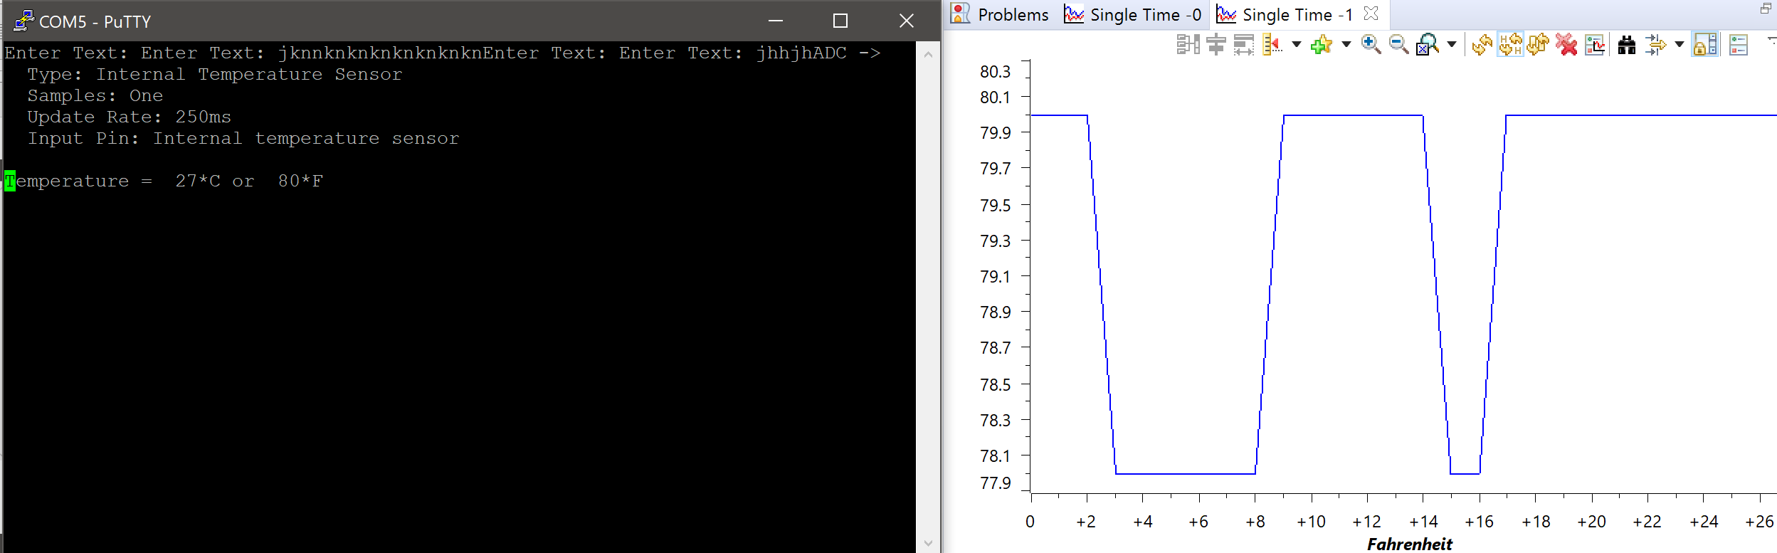

**The built-in graph measuring Fahrenheit**

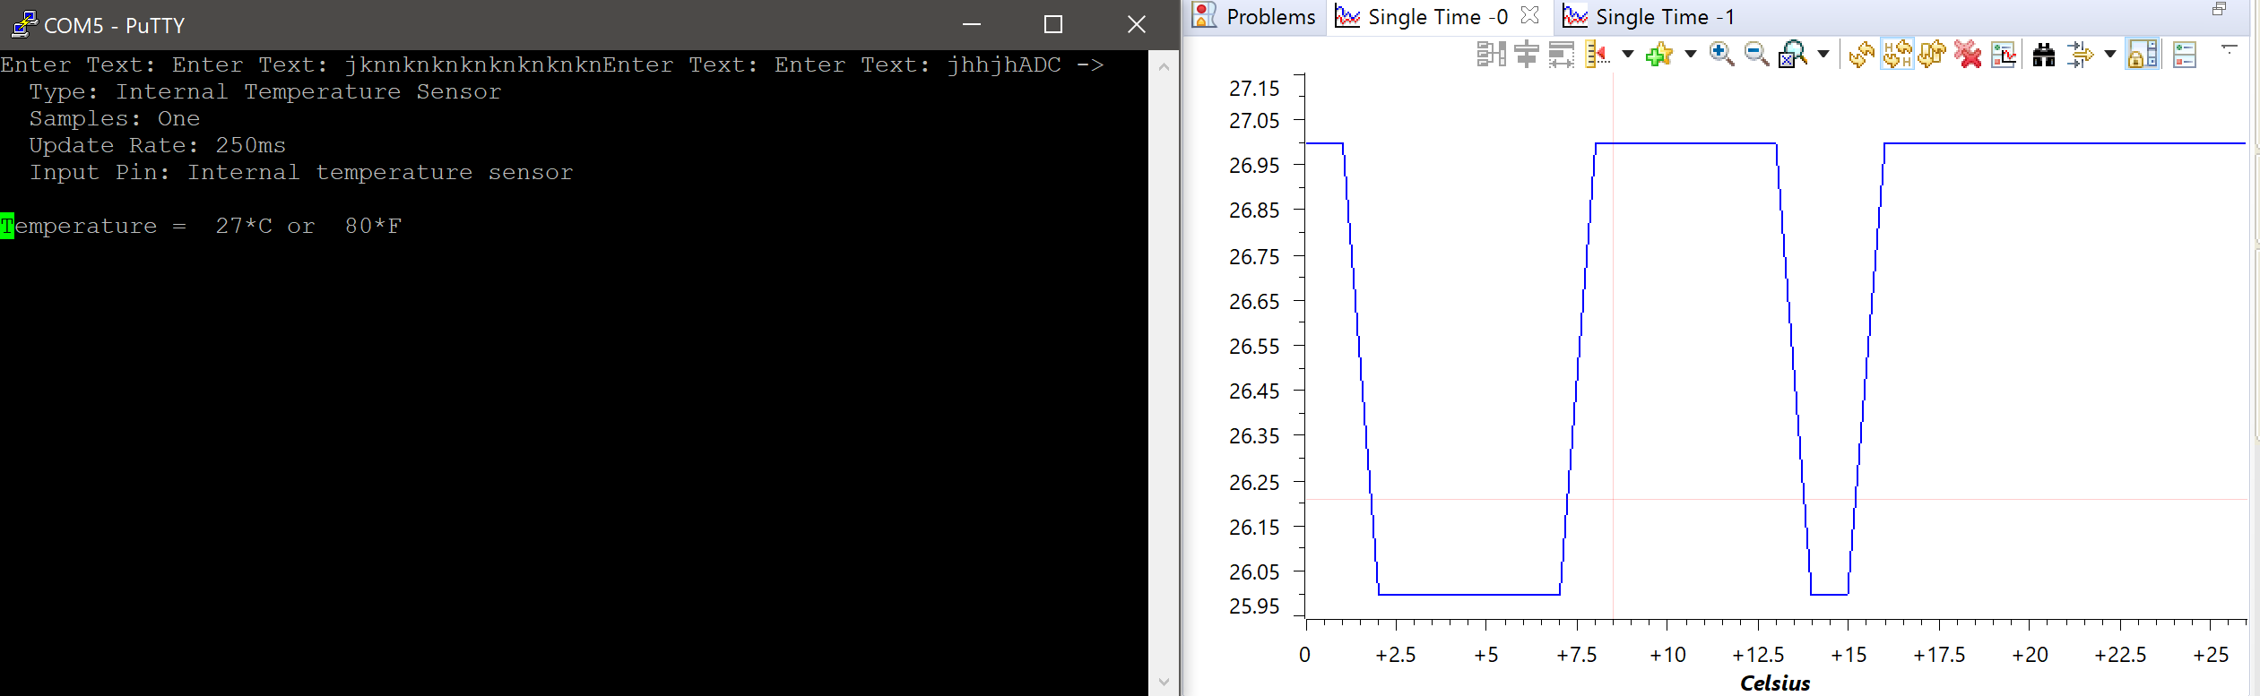

**The built-in graph measuring Celsius**

**Youtube Link: No Submission required for Task 00**

**------------------------------------------------------------------------------------**

**Task 01:** Continuously display the temperature of the device (internal temperature sensor) on the a) hyperterminal, and b) GUI Composer using a timer interrupt every 0.5s

Youtube Link: <https://www.youtube.com/watch?v=SCL_KCv4JKs>

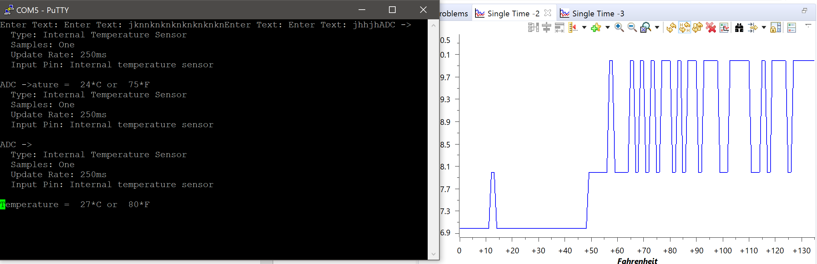

Above is the GUI Composer and the hyperterminal (PuTTy) for Fahrenheit and below is for Celsius. It is responsible for refreshing using a timer interrupt every 0.5s.

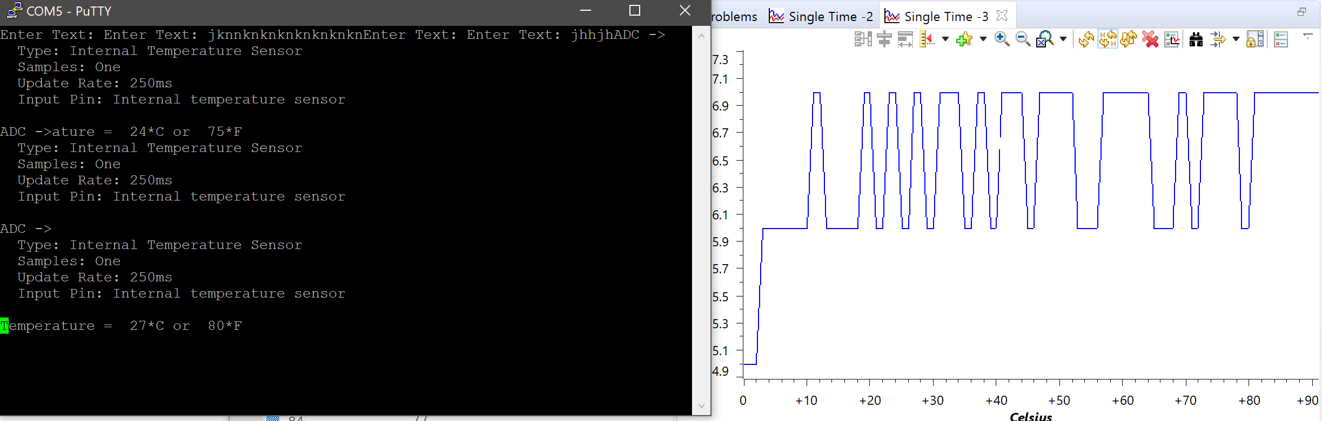

**Modified Code:**

**#define** PART_TM4C123GH6PM

**#include** <stdint.h>

**#include** <stdbool.h>

**#include** "stdlib.h"

**#include** "inc/hw_ints.h"

**#include** "inc/hw_memmap.h"

**#include** "inc/hw_uart.h"

**#include** "inc/hw_gpio.h"

**#include** "inc/hw_pwm.h"

**#include** "inc/hw_types.h"

**#include** "driverlib/adc.h"

**#include** "driverlib/timer.h"

**#include** "driverlib/gpio.h"

**#include** "driverlib/interrupt.h"

**#include** "driverlib/pin_map.h"

**#include** "driverlib/rom.h"

**#include** "driverlib/rom_map.h"

**#include** "driverlib/sysctl.h"

**#include** "driverlib/uart.h"

**#include** "driverlib/udma.h"

**#include** "driverlib/pwm.h"

**#include** "driverlib/ssi.h"

**#include** "driverlib/systick.h"

**#include** "driverlib/adc.h"

**#include** "utils/uartstdio.h"

**#include** "utils/uartstdio.c"

**#include** <string.h>

**#include** "inc/tm4c123gh6pm.h"

uint32_t ui32Period;

uint32_t ADCValues[1];

uint32_t TempValueC ;

uint32_t TempValueF ;

**void** **Timer1IntHandler**(**void**)

{

**int** clock;

clock = **SysCtlClockGet**();

SYSCTL_RCGCTIMER_R |= 2; //enable clock

TIMER1_CTL_R = 0; //disable Timer before initialization

TIMER1_CFG_R = 0x04; //16-bit option

TIMER1_TAMR_R = 0x02; //periodic mode and down-counter

TIMER1_TAILR_R = 80000-1; //TimerA interval load value reg

TIMER1_TAPR_R = 250 - 1; //TimerA prescaler 40MHz/250 = 16000Hz => 1/16000 = .0625ms => .5s/.0625ms = 80000

TIMER1_ICR_R = 0x01; //clear the TimerA timeout flag

TIMER1_CTL_R |= 0x01; //enable Timer A after initialization

// GPIOPinWrite(GPIO_PORTF_BASE, GPIO_PIN_2, 4) ;

**while**((TIMER1_RIS_R & 0x1) == 0)

; //turn off red LED

**ADCProcessorTrigger**(ADC0_BASE, 3);

//

// Wait for conversion to be completed.

//

**while**(!**ADCIntStatus**(ADC0_BASE, 3, false))

{

}

//

// Clear the ADC interrupt flag.

//

**ADCIntClear**(ADC0_BASE, 3);

//

// Read ADC Value.

//

**ADCSequenceDataGet**(ADC0_BASE, 3, ADCValues);

//

// Use non-calibrated conversion provided in the data sheet. I use floats in intermediate

// math but you could use intergers with multiplied by powers of 10 and divide on the end

// Make sure you divide last to avoid dropout.

//

TempValueC = (uint32_t)(147.5 - ((75.0*3.3 *(**float**)ADCValues[0])) / 4096.0);

//

// Get Fahrenheit value. Make sure you divide last to avoid dropout.

//

TempValueF = ((TempValueC * 9) + 160) / 5;

//

// Display the temperature value on the console.

//

**UARTprintf**("Temperature = %3d*C or %3d*F\r", TempValueC,

TempValueF);

//

// This function provides a means of generating a constant length

// delay. The function delay (in cycles) = 3 * parameter. Delay

// 250ms arbitrarily.

//

**SysCtlDelay**(80000000 / 12);

TIMER1_ICR_R = 0x1; //clear flag

}

//*****************************************************************************

//

// This function sets up UART0 to be used for a console to display information

// as the example is running.

//

//*****************************************************************************

**void**

**InitConsole**(**void**)

{

//

// Enable GPIO port A which is used for UART0 pins.

**SysCtlPeripheralEnable**(SYSCTL_PERIPH_GPIOA);

//

// Configure the pin muxing for UART0 functions on port A0 and A1.

**GPIOPinConfigure**(GPIO_PA0_U0RX);

**GPIOPinConfigure**(GPIO_PA1_U0TX);

// Enable UART0 so that we can configure the clock.

//

**SysCtlPeripheralEnable**(SYSCTL_PERIPH_UART0);

//

// Use the internal 16MHz oscillator as the UART clock source.

//

**UARTClockSourceSet**(UART0_BASE, UART_CLOCK_PIOSC);

//

// Select the alternate (UART) function for these pins.

**GPIOPinTypeUART**(GPIO_PORTA_BASE, GPIO_PIN_0 | GPIO_PIN_1);

//

// Initialize the UART for console I/O.

//

**UARTStdioConfig**(0, 115200, 16000000);

}

**int** **main**(){

**SysCtlClockSet**(SYSCTL_SYSDIV_2_5|SYSCTL_USE_PLL|SYSCTL_OSC_MAIN|SYSCTL_XTAL_16MHZ);

InitConsole();

//

// This array is used for storing the data read from the ADC FIFO. It

// must be as large as the FIFO for the sequencer in use. This example

// uses sequence 3 which has a FIFO depth of 1. If another sequence

// was used with a deeper FIFO, then the array size must be changed.

**SysCtlPeripheralEnable**(SYSCTL_PERIPH_TIMER1);

**TimerConfigure**(TIMER1_BASE, TIMER_CFG_PERIODIC);

ui32Period = (**SysCtlClockGet**() / 10) / 2;

**TimerLoadSet**(TIMER1_BASE, TIMER_A, ui32Period -1);

**IntEnable**(INT_TIMER1A);

**TimerIntEnable**(TIMER1_BASE, TIMER_TIMA_TIMEOUT);

**IntMasterEnable**();

**TimerEnable**(TIMER1_BASE, TIMER_A);

//

// Display the setup on the console.

//

**UARTprintf**("ADC ->\n");

**UARTprintf**(" Type: Internal Temperature Sensor\n");

**UARTprintf**(" Samples: One\n");

**UARTprintf**(" Update Rate: 250ms\n");

**UARTprintf**(" Input Pin: Internal temperature sensor\n\n");

//

// The ADC0 peripheral must be enabled for use.

//

**SysCtlPeripheralEnable**(SYSCTL_PERIPH_ADC0);

**SysCtlDelay**(3);

**ADCSequenceConfigure**(ADC0_BASE, 3, ADC_TRIGGER_PROCESSOR, 0);

**ADCSequenceStepConfigure**(ADC0_BASE, 3, 0, ADC_CTL_TS | ADC_CTL_IE |

ADC_CTL_END);

//

// Since sample sequence 3 is now configured, it must be enabled.

//

**ADCSequenceEnable**(ADC0_BASE, 3);

// Clear the interrupt status flag.

//

**ADCIntClear**(ADC0_BASE, 3);

// Sample the temperature sensor forever.

**while**(1)

{

//

// Trigger the ADC conversion.

//

}

}

**------------------------------------------------------------------------------------**

**Task 02:** Interaction/User interface: Develop a user interface using UART

Youtube Link: <https://www.youtube.com/watch?v=9wOHZZ9w924>

This program is responsible for creating a user interface for the components within the Tiva-C board. For example, when the ‘R’ button is pressed the RED LED will turn on, and when the ‘r’ button is pressed the RED LED will turn off.

**Modified Code:**

**#define** PART_TM4C123GH6PM

**#include** <stdint.h>

**#include** <stdbool.h>

**#include** "stdlib.h"

**#include** "inc/hw_ints.h"

**#include** "inc/hw_memmap.h"

**#include** "inc/hw_uart.h"

**#include** "inc/hw_gpio.h"

**#include** "inc/hw_pwm.h"

**#include** "inc/hw_types.h"

**#include** "driverlib/adc.h"

**#include** "driverlib/timer.h"

**#include** "driverlib/gpio.h"

**#include** "driverlib/interrupt.h"

**#include** "driverlib/pin_map.h"

**#include** "driverlib/rom.h"

**#include** "driverlib/rom_map.h"

**#include** "driverlib/sysctl.h"

**#include** "driverlib/uart.h"

**#include** "driverlib/udma.h"

**#include** "driverlib/pwm.h"

**#include** "driverlib/ssi.h"

**#include** "driverlib/systick.h"

**#include** "driverlib/adc.h"

**#include** "utils/uartstdio.h"

**#include** "utils/uartstdio.c"

**#include** <string.h>

**#include** "inc/tm4c123gh6pm.h"

**void**

**InitConsole**(**void**)

{

// Enable GPIO port A which is used for UART0 pins.

**SysCtlPeripheralEnable**(SYSCTL_PERIPH_GPIOA);

// Configure the pin muxing for UART0 functions on port A0 and A1.

**GPIOPinConfigure**(GPIO_PA0_U0RX);

**GPIOPinConfigure**(GPIO_PA1_U0TX);

// Enable UART0 so that we can configure the clock.

**SysCtlPeripheralEnable**(SYSCTL_PERIPH_UART0);

// Use the internal 16MHz oscillator as the UART clock source.

**UARTClockSourceSet**(UART0_BASE, UART_CLOCK_PIOSC);

// Select the alternate (UART) function for these pins.

**GPIOPinTypeUART**(GPIO_PORTA_BASE, GPIO_PIN_0 | GPIO_PIN_1);

// Initialize the UART for console I/O.

**UARTStdioConfig**(0, 115200, 16000000);

uint32_t ADCValues[1];

uint32_t TempValueC ;

uint32_t TempValueF ;

**SysCtlPeripheralEnable**(SYSCTL_PERIPH_ADC0);

**SysCtlDelay**(3);

**ADCSequenceConfigure**(ADC0_BASE, 3, ADC_TRIGGER_PROCESSOR, 0);

**ADCSequenceStepConfigure**(ADC0_BASE, 3, 0, ADC_CTL_TS | ADC_CTL_IE |

ADC_CTL_END);

**ADCSequenceEnable**(ADC0_BASE, 3);

**ADCIntClear**(ADC0_BASE, 3);

**while**(1)

{

**ADCProcessorTrigger**(ADC0_BASE, 3);

**while**(!**ADCIntStatus**(ADC0_BASE, 3, false))

{

}

**ADCIntClear**(ADC0_BASE, 3);

**ADCSequenceDataGet**(ADC0_BASE, 3, ADCValues);

TempValueC = (uint32_t)(147.5 - ((75.0*3.3 *(**float**)ADCValues[0])) / 4096.0);

TempValueF = ((TempValueC * 9) + 160) / 5;

**UARTprintf**("Temperature = %3d*C or %3d*F\n", TempValueC,

TempValueF); //print F and C for temperature

**SysCtlDelay**(800000000 / 12);

}

}

**void** **UARTIntHandler**(**void**)

{

uint32_t ui32Status;

ui32Status = **UARTIntStatus**(UART0_BASE, true); //get interrupt status

**UARTIntClear**(UART0_BASE, ui32Status); //clear the asserted interrupts

**while**(**UARTCharsAvail**(UART0_BASE)) //loop while there are chars

{

**if**(**UARTCharGet**(UART0_BASE) == 'R'){

**UARTCharPut**(UART0_BASE, 'R');

**GPIOPinWrite**(GPIO_PORTF_BASE, GPIO_PIN_1, GPIO_PIN_1); //turn on red LED

}

**if**(**UARTCharGet**(UART0_BASE) == 'r'){

**UARTCharPut**(UART0_BASE, 'r');

**GPIOPinWrite**(GPIO_PORTF_BASE, GPIO_PIN_1, 0); //turn off red

}

**if**(**UARTCharGet**(UART0_BASE) == 'G'){

**UARTCharPut**(UART0_BASE, 'G');

**GPIOPinWrite**(GPIO_PORTF_BASE, GPIO_PIN_3, GPIO_PIN_3); //turn on green LED

}

**if**(**UARTCharGet**(UART0_BASE) == 'g'){

**UARTCharPut**(UART0_BASE, 'g'); //turn off green

**GPIOPinWrite**(GPIO_PORTF_BASE, GPIO_PIN_3, 0);

}

**if**(**UARTCharGet**(UART0_BASE) == 'B'){

**UARTCharPut**(UART0_BASE, 'B');

**GPIOPinWrite**(GPIO_PORTF_BASE, GPIO_PIN_2, GPIO_PIN_2); //turn on blue LED

}

**if**(**UARTCharGet**(UART0_BASE) == 'b'){

**UARTCharPut**(UART0_BASE, 'b'); //turn off blue

**GPIOPinWrite**(GPIO_PORTF_BASE, GPIO_PIN_2, 0);

}

**if**(**UARTCharGet**(UART0_BASE) == 'T'){

**UARTCharPut**(UART0_BASE, 'T');

InitConsole(); //call function to run temperature

}

}

}

**int** **main**(**void**) {

**SysCtlClockSet**(SYSCTL_SYSDIV_4 | SYSCTL_USE_PLL | SYSCTL_OSC_MAIN | SYSCTL_XTAL_16MHZ);

**SysCtlPeripheralEnable**(SYSCTL_PERIPH_UART0);

**SysCtlPeripheralEnable**(SYSCTL_PERIPH_GPIOA);

**GPIOPinConfigure**(GPIO_PA0_U0RX);

**GPIOPinConfigure**(GPIO_PA1_U0TX);

**GPIOPinTypeUART**(GPIO_PORTA_BASE, GPIO_PIN_0 | GPIO_PIN_1);

**SysCtlPeripheralEnable**(SYSCTL_PERIPH_GPIOF); //enable GPIO port for LED

**GPIOPinTypeGPIOOutput**(GPIO_PORTF_BASE, GPIO_PIN_1 | GPIO_PIN_2 | GPIO_PIN_3); //enable pin for LED PF2

**UARTConfigSetExpClk**(UART0_BASE, **SysCtlClockGet**(), 115200,

(UART_CONFIG_WLEN_8 | UART_CONFIG_STOP_ONE | UART_CONFIG_PAR_NONE));

**IntMasterEnable**(); //enable processor interrupts

**IntEnable**(INT_UART0); //enable the UART interrupt

**UARTIntEnable**(UART0_BASE, UART_INT_RX | UART_INT_RT); //only enable RX and TX interrupts

**UARTCharPut**(UART0_BASE, 'E');

**UARTCharPut**(UART0_BASE, 'n');

**UARTCharPut**(UART0_BASE, 't');

**UARTCharPut**(UART0_BASE, 'e');

**UARTCharPut**(UART0_BASE, 'r');

**UARTCharPut**(UART0_BASE, ' ');

**UARTCharPut**(UART0_BASE, 'T');

**UARTCharPut**(UART0_BASE, 'e');

**UARTCharPut**(UART0_BASE, 'x');

**UARTCharPut**(UART0_BASE, 't');

**UARTCharPut**(UART0_BASE, ':');

**UARTCharPut**(UART0_BASE, ' ');

**while** (1) //let interrupt handler do the UART echo function

{

// if (UARTCharsAvail(UART0_BASE)) UARTCharPut(UART0_BASE, UARTCharGet(UART0_BASE));

}

}