**Date Submitted: 10/17/2018 11:38 PM**

**Task 01:** Modify the supplied code to transmit and receive the Internal Temperature and verify the results.

**Youtube Link:** [**https://www.youtube.com/watch?v=9ROVdqjZEPs**](https://www.youtube.com/watch?v=9ROVdqjZEPs)

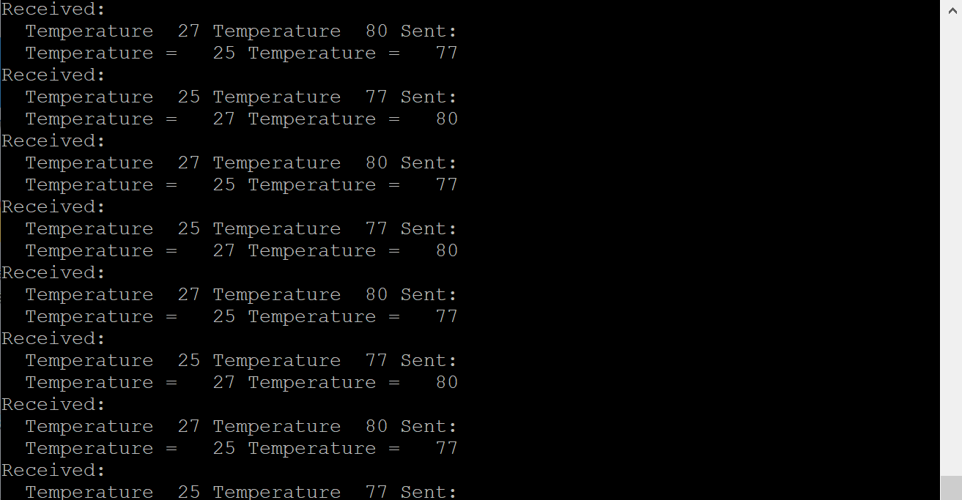

**Modified Code:**

/*#include <stdbool.h>

#include <stdint.h>

#include "inc/hw_memmap.h"

#include "driverlib/gpio.h"

#include "driverlib/pin_map.h"

#include "driverlib/ssi.h"

#include "driverlib/sysctl.h"

#include "driverlib/uart.h"

#include "utils/uartstdio.h"

#include "utils/uartstdio.c"

*/

**#define** PART_TM4C123GH6PM

**#include** <stdint.h>

**#include** <stdbool.h>

**#include** "stdlib.h"

**#include** "inc/hw_ints.h"

**#include** "inc/hw_memmap.h"

**#include** "inc/hw_uart.h"

**#include** "inc/hw_gpio.h"

**#include** "inc/hw_pwm.h"

**#include** "inc/hw_types.h"

**#include** "driverlib/adc.h"

**#include** "driverlib/timer.h"

**#include** "driverlib/gpio.h"

**#include** "driverlib/interrupt.h"

**#include** "driverlib/pin_map.h"

**#include** "driverlib/rom.h"

**#include** "driverlib/rom_map.h"

**#include** "driverlib/sysctl.h"

**#include** "driverlib/uart.h"

**#include** "driverlib/udma.h"

**#include** "driverlib/pwm.h"

**#include** "driverlib/ssi.h"

**#include** "driverlib/systick.h"

**#include** "driverlib/adc.h"

**#include** "utils/uartstdio.h"

**#include** "utils/uartstdio.c"

**#include** <string.h>

**#include** "inc/tm4c123gh6pm.h"

//

// Number of bytes to send and receive.

//

//*****************************************************************************

**#define** NUM_SSI_DATA 2

//*****************************************************************************

//

// This function sets up UART0 to be used for a console to display information

// as the example is running.

//

//*****************************************************************************

**void**

**InitConsole**(**void**)

{

//

// Enable GPIO port A which is used for UART0 pins.

// **TODO**: change this to whichever GPIO port you are using.

//

**SysCtlPeripheralEnable**(SYSCTL_PERIPH_GPIOA);

//

// Configure the pin muxing for UART0 functions on port A0 and A1.

// This step is not necessary if your part does not support pin muxing.

// **TODO**: change this to select the port/pin you are using.

//

**GPIOPinConfigure**(GPIO_PA0_U0RX);

**GPIOPinConfigure**(GPIO_PA1_U0TX);

//

// Enable UART0 so that we can configure the clock.

//

**SysCtlPeripheralEnable**(SYSCTL_PERIPH_UART0);

//

// Use the internal 16MHz oscillator as the UART clock source.

//

**UARTClockSourceSet**(UART0_BASE, UART_CLOCK_PIOSC);

//

// Select the alternate (UART) function for these pins.

// **TODO**: change this to select the port/pin you are using.

//

**GPIOPinTypeUART**(GPIO_PORTA_BASE, GPIO_PIN_0 | GPIO_PIN_1);

//

// Initialize the UART for console I/O.

//

**UARTStdioConfig**(0, 115200, 16000000);

}

//*****************************************************************************

//

// Configure SSI0 in master Freescale (SPI) mode. This example will send out

// 3 bytes of data, then wait for 3 bytes of data to come in. This will all be

// done using the polling method.

//

//*****************************************************************************

**int**

**main**(**void**)

{

**#if** defined(TARGET_IS_TM4C129_RA0) || \

defined(TARGET_IS_TM4C129_RA1) || \

defined(TARGET_IS_TM4C129_RA2)

uint32_t ui32SysClock;

**#endif**

uint32_t pui32DataTx[NUM_SSI_DATA];

uint32_t pui32DataRx[NUM_SSI_DATA];

uint32_t ui32Index;

//

// Set the clocking to run directly from the external crystal/oscillator.

// **TODO**: The SYSCTL_XTAL_ value must be changed to match the value of the

// crystal on your board.

//

**#if** defined(TARGET_IS_TM4C129_RA0) || \

defined(TARGET_IS_TM4C129_RA1) || \

defined(TARGET_IS_TM4C129_RA2)

ui32SysClock = SysCtlClockFreqSet((SYSCTL_XTAL_25MHZ |

SYSCTL_OSC_MAIN |

SYSCTL_USE_OSC), 25000000);

**#else**

//SysCtlClockSet(SYSCTL_SYSDIV_1 | SYSCTL_USE_OSC | SYSCTL_OSC_MAIN |

// SYSCTL_XTAL_16MHZ);

**SysCtlClockSet**(SYSCTL_SYSDIV_2_5|SYSCTL_USE_PLL|SYSCTL_OSC_MAIN|SYSCTL_XTAL_16MHZ);

**#endif**

//

// Set up the serial console to use for displaying messages. This is

// just for this example program and is not needed for SSI operation.

//

InitConsole();

//

// Display the setup on the console.

//

**UARTprintf**("SSI ->\n");

**UARTprintf**(" Mode: SPI\n");

**UARTprintf**(" Data: 8-bit\n\n");

//

// The SSI0 peripheral must be enabled for use.

//

**SysCtlPeripheralEnable**(SYSCTL_PERIPH_SSI0);

//

// For this example SSI0 is used with PortA[5:2]. The actual port and pins

// used may be different on your part, consult the data sheet for more

// information. GPIO port A needs to be enabled so these pins can be used.

// **TODO**: change this to whichever GPIO port you are using.

//

**SysCtlPeripheralEnable**(SYSCTL_PERIPH_GPIOA);

//

**GPIOPinConfigure**(GPIO_PA2_SSI0CLK);

**GPIOPinConfigure**(GPIO_PA3_SSI0FSS);

**GPIOPinConfigure**(GPIO_PA4_SSI0RX);

**GPIOPinConfigure**(GPIO_PA5_SSI0TX);

**GPIOPinTypeSSI**(GPIO_PORTA_BASE, GPIO_PIN_5 | GPIO_PIN_4 | GPIO_PIN_3 |

GPIO_PIN_2);

//

// Configure and enable the SSI port for SPI master mode. Use SSI0,

// system clock supply, idle clock level low and active low clock in

// freescale SPI mode, master mode, 1MHz SSI frequency, and 8-bit data.

// For SPI mode, you can set the polarity of the SSI clock when the SSI

// unit is idle. You can also configure what clock edge you want to

// capture data on. Please reference the datasheet for more information on

// the different SPI modes.

//

**#if** defined(TARGET_IS_TM4C129_RA0) || \

defined(TARGET_IS_TM4C129_RA1) || \

defined(TARGET_IS_TM4C129_RA2)

SSIConfigSetExpClk(SSI0_BASE, ui32SysClock, SSI_FRF_MOTO_MODE_0,

SSI_MODE_MASTER, 1000000, 8);

**#else**

**SSIConfigSetExpClk**(SSI0_BASE, **SysCtlClockGet**(), SSI_FRF_MOTO_MODE_0,

SSI_MODE_MASTER, 1000000, 8);

**#endif**

//

// Enable the SSI0 module.

//

**SSIEnable**(SSI0_BASE);

uint32_t ADCValues[1];

uint32_t TempValueC ;

uint32_t TempValueF ;

**SysCtlPeripheralEnable**(SYSCTL_PERIPH_ADC0);

**SysCtlDelay**(3);

// UARTprintf("HERE\n");

**ADCSequenceConfigure**(ADC0_BASE, 3, ADC_TRIGGER_PROCESSOR, 0);

//UARTprintf("HERE\n");

**ADCSequenceStepConfigure**(ADC0_BASE, 3, 0, ADC_CTL_TS | ADC_CTL_IE |

ADC_CTL_END);

**ADCSequenceEnable**(ADC0_BASE, 3);

**ADCIntClear**(ADC0_BASE, 3);

**while**(1){

**ADCProcessorTrigger**(ADC0_BASE, 3);

**while**(!**ADCIntStatus**(ADC0_BASE, 3, false))

{

}

**ADCIntClear**(ADC0_BASE, 3);

**ADCSequenceDataGet**(ADC0_BASE, 3, ADCValues);

TempValueC = (uint32_t)(147.5 - ((75.0*3.3 *(**float**)ADCValues[0])) / 4096.0);

TempValueF = ((TempValueC * 9) + 160) / 5;

\

**while**(**SSIDataGetNonBlocking**(SSI0_BASE, &pui32DataRx[0]))

{

}

//

// Initialize the data to send.

//

pui32DataTx[0] = TempValueC;

pui32DataTx[1] = TempValueF;

// pui32DataTx[2] = 'i';

//

// Display indication that the SSI is transmitting data.

//

**UARTprintf**("Sent:\n ");

//

// Send 3 bytes of data.

//

**for**(ui32Index = 0; ui32Index < NUM_SSI_DATA; ui32Index++)

{

//

// Display the data that SSI is transferring.

//

**UARTprintf**("Temperature = %3d ", pui32DataTx[ui32Index]);

//

// Send the data using the "blocking" put function. This function

// will wait until there is room in the send FIFO before returning.

// This allows you to assure that all the data you send makes it into

// the send FIFO.

//

**SSIDataPut**(SSI0_BASE, pui32DataTx[ui32Index]);

}

//

// Wait until SSI0 is done transferring all the data in the transmit FIFO.

//

**while**(**SSIBusy**(SSI0_BASE))

{

}

//

// Display indication that the SSI is receiving data.

//

**UARTprintf**("\nReceived:\n ");

//

// Receive 3 bytes of data.

//

**for**(ui32Index = 0; ui32Index < NUM_SSI_DATA; ui32Index++)

{

//

// Receive the data using the "blocking" Get function. This function

// will wait until there is data in the receive FIFO before returning.

//

**SSIDataGet**(SSI0_BASE, pui32DataRx[ui32Index]);

//

// Since we are using 8-bit data, mask off the MSB.

//

// pui32DataRx[ui32Index] &= 0x00FF;

//

// Display the data that SSI0 received.

//

**UARTprintf**("Temperature %3d ", pui32DataRx[ui32Index]);

}

}

//

// Return no errors

//

**return**(0);

}

**------------------------------------------------------------------------------------**

**Task 02:** Display the z-axis results in Nokia5110 GLCD. If task is not working, display the Lab 5 – Temperature on the LCD as: “Temperature: 72.92 F, 20.34 F”. Update every sec. using the timer.

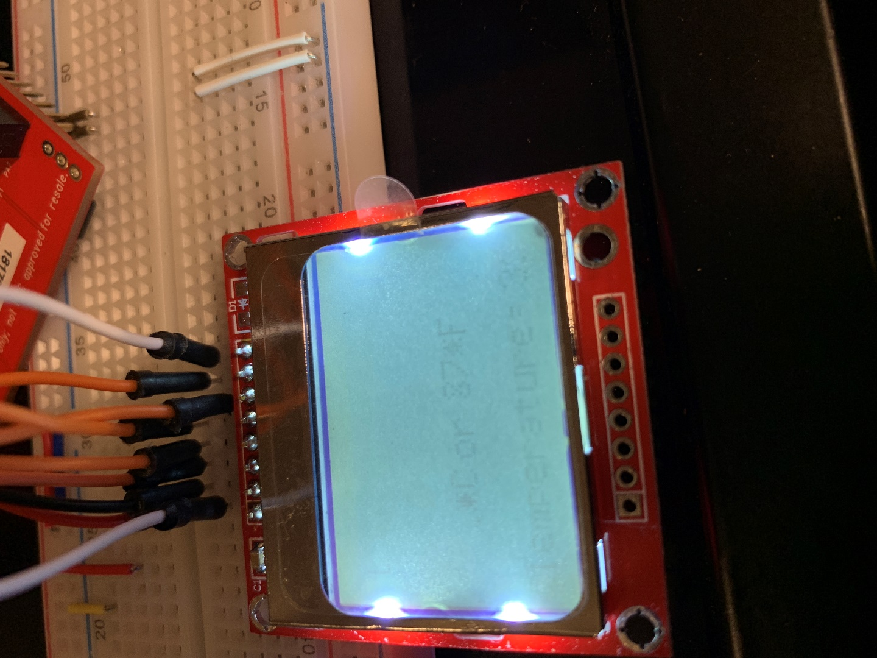

Youtube Link: <https://www.youtube.com/watch?v=ZFxclQuzh1Q>

**Modified Code:**

**#define** PART_TM4C123GH6PM

**#include** <stdint.h>

**#include** <stdbool.h>

**#include** "stdlib.h"

**#include** "inc/hw_ints.h"

**#include** "inc/hw_memmap.h"

**#include** "inc/hw_uart.h"

**#include** "inc/hw_gpio.h"

**#include** "inc/hw_pwm.h"

**#include** "inc/hw_types.h"

**#include** "driverlib/adc.h"

**#include** "driverlib/timer.h"

**#include** "driverlib/gpio.h"

**#include** "driverlib/interrupt.h"

**#include** "driverlib/pin_map.h"

**#include** "driverlib/rom.h"

**#include** "driverlib/rom_map.h"

**#include** "driverlib/sysctl.h"

**#include** "driverlib/uart.h"

**#include** "driverlib/udma.h"

**#include** "driverlib/pwm.h"

**#include** "driverlib/ssi.h"

**#include** "driverlib/systick.h"

**#include** "driverlib/adc.h"

**#include** "utils/uartstdio.h"

**#include** "utils/uartstdio.c"

**#include** <string.h>

**#include** "inc/tm4c123gh6pm.h"

**#include** "utils/Nokia5110.h"

**#include** "utils/Nokia5110.c"

**void**

**InitConsole**(**void**)

{

//

// Enable GPIO port A which is used for UART0 pins.

**SysCtlPeripheralEnable**(SYSCTL_PERIPH_GPIOA);

//

// Configure the pin muxing for UART0 functions on port A0 and A1.

// This step is not necessary if your part does not support pin muxing.

**GPIOPinConfigure**(GPIO_PA0_U0RX);

**GPIOPinConfigure**(GPIO_PA1_U0TX);

//

// Enable UART0 so that we can configure the clock.

//

**SysCtlPeripheralEnable**(SYSCTL_PERIPH_UART0);

//

// Use the internal 16MHz oscillator as the UART clock source.

//

**UARTClockSourceSet**(UART0_BASE, UART_CLOCK_PIOSC);

//

// Select the alternate (UART) function for these pins.

**GPIOPinTypeUART**(GPIO_PORTA_BASE, GPIO_PIN_0 | GPIO_PIN_1);

//

// Initialize the UART for console I/O.

//

**UARTStdioConfig**(0, 115200, 16000000);

}

**int** **main**(**void**)

{

**SysCtlClockSet**(SYSCTL_SYSDIV_2_5|SYSCTL_USE_PLL|SYSCTL_OSC_MAIN|SYSCTL_XTAL_16MHZ);

SysTick_Init();

InitConsole();

**startSSI0**();

**initialize_screen**(BACKLIGHT_ON,SSI0);

**int** i;

**char** buf[11];

**int** max=11,current_pos=0;

set_buttons_up_down();

**unsigned** **char** menu_elements[12][25];

menu_elements[0][0]='1';

menu_elements[0][1]=0x00;

menu_elements[1][0]='2';

menu_elements[1][1]=0x00;

menu_elements[2][0]='3';

menu_elements[2][1]=0x00;

menu_elements[3][0]='4';

menu_elements[3][1]=0x00;

menu_elements[4][0]='5';

menu_elements[4][1]=0x00;

menu_elements[5][0]='6';

menu_elements[5][1]=0x00;

menu_elements[6][0]='7';

menu_elements[6][1]=0x00;

menu_elements[7][0]='8';

menu_elements[7][1]=0x00;

menu_elements[8][0]='9';

menu_elements[8][1]=0x00;

menu_elements[9][0]='1';

menu_elements[9][1]='0';

menu_elements[9][2]=0x00;

menu_elements[10][0]='1';

menu_elements[10][1]='1';

menu_elements[10][2]=0x00;

menu_elements[11][0]='1';

menu_elements[11][1]='2';

menu_elements[11][2]=0x00;

set_menu(menu_elements);

**clear_screen**(SSI0);

**screen_write**("CPE\n403!",ALIGN_CENTRE_CENTRE,SSI0);

SysTick_Wait50ms(100);

uint32_t ADCValues[1];

uint32_t TempValueC ;

uint32_t TempValueF ;

**SysCtlPeripheralEnable**(SYSCTL_PERIPH_ADC0);

**SysCtlDelay**(3);

**ADCSequenceConfigure**(ADC0_BASE, 3, ADC_TRIGGER_PROCESSOR, 0);

**ADCSequenceStepConfigure**(ADC0_BASE, 3, 0, ADC_CTL_TS | ADC_CTL_IE |

ADC_CTL_END);

**ADCSequenceEnable**(ADC0_BASE, 3);

**ADCIntClear**(ADC0_BASE, 3);

**while**(1)

{

**clear_screen**(SSI0);

**ADCProcessorTrigger**(ADC0_BASE, 3);

**while**(!**ADCIntStatus**(ADC0_BASE, 3, false))

{

}

**ADCIntClear**(ADC0_BASE, 3);

**ADCSequenceDataGet**(ADC0_BASE, 3, ADCValues);

TempValueC = (uint32_t)(147.5 - ((75.0*3.3 *(**float**)ADCValues[0])) / 4096.0);

TempValueF = ((TempValueC * 9) + 160) / 5;

sprintf(buf, "Temperature = %3d*C or %3d*F\n", TempValueC, TempValueF);

**screen_write**(buf,ALIGN_CENTRE_CENTRE,SSI0);

SysTick_Wait50ms(100);

}

**return** 0;

}

// The delay parameter is in units of the 16 MHz core clock.

**void** **SysTick_Wait**(**unsigned** **long** delay){

NVIC_ST_RELOAD_R = delay-1; // number of counts to wait

NVIC_ST_CURRENT_R = 0; // any value written to CURRENT clears

**while**((NVIC_ST_CTRL_R&0x00010000)==0){ // wait for count flag

}

}

**void** **SysTick_Wait50ms**(**unsigned** **long** delay){

**unsigned** **long** i;

**for**(i=0; i<delay; i++){

SysTick_Wait(800000); // wait 50ms

}

}

**void** **SysTick_Init**(**void**){

NVIC_ST_CTRL_R = 0; // disable SysTick during setup

NVIC_ST_CTRL_R = 0x00000005; // enable SysTick with core clock

}