**Date Submitted: 11/09/18**

**Task 01:**

Youtube Link: <https://www.youtube.com/watch?v=ZBHuc8AtVhM>

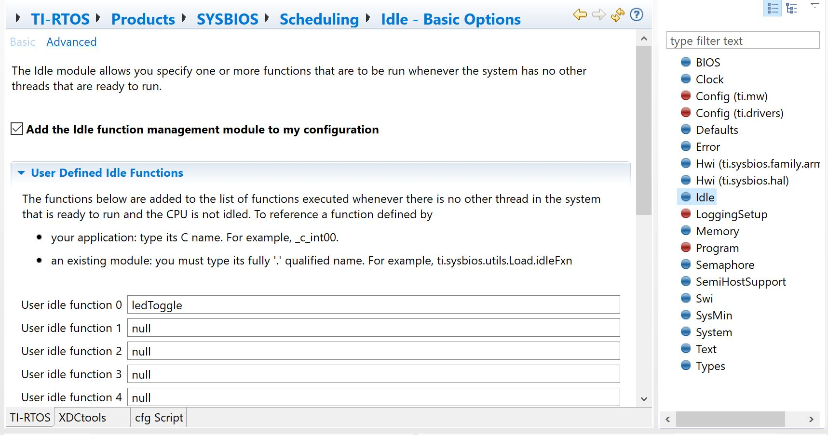

Above is the empty.cfg file and shows that the function “ledToggle” has been instantiated as an idle function.

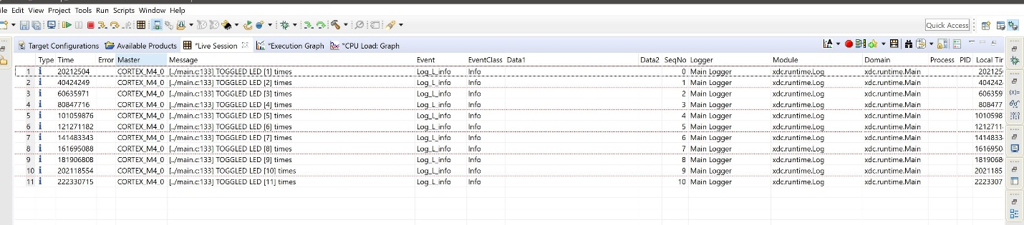

Stack Usage

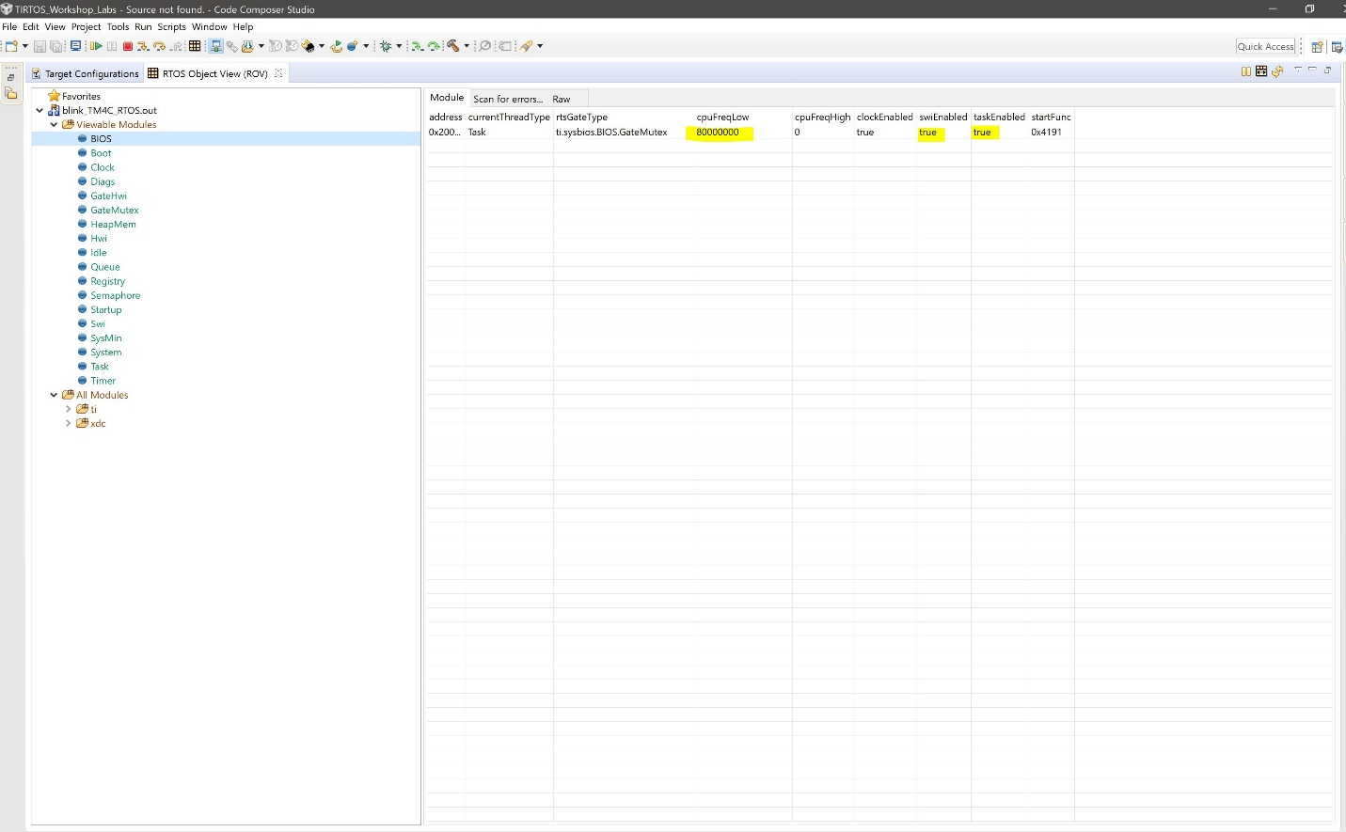

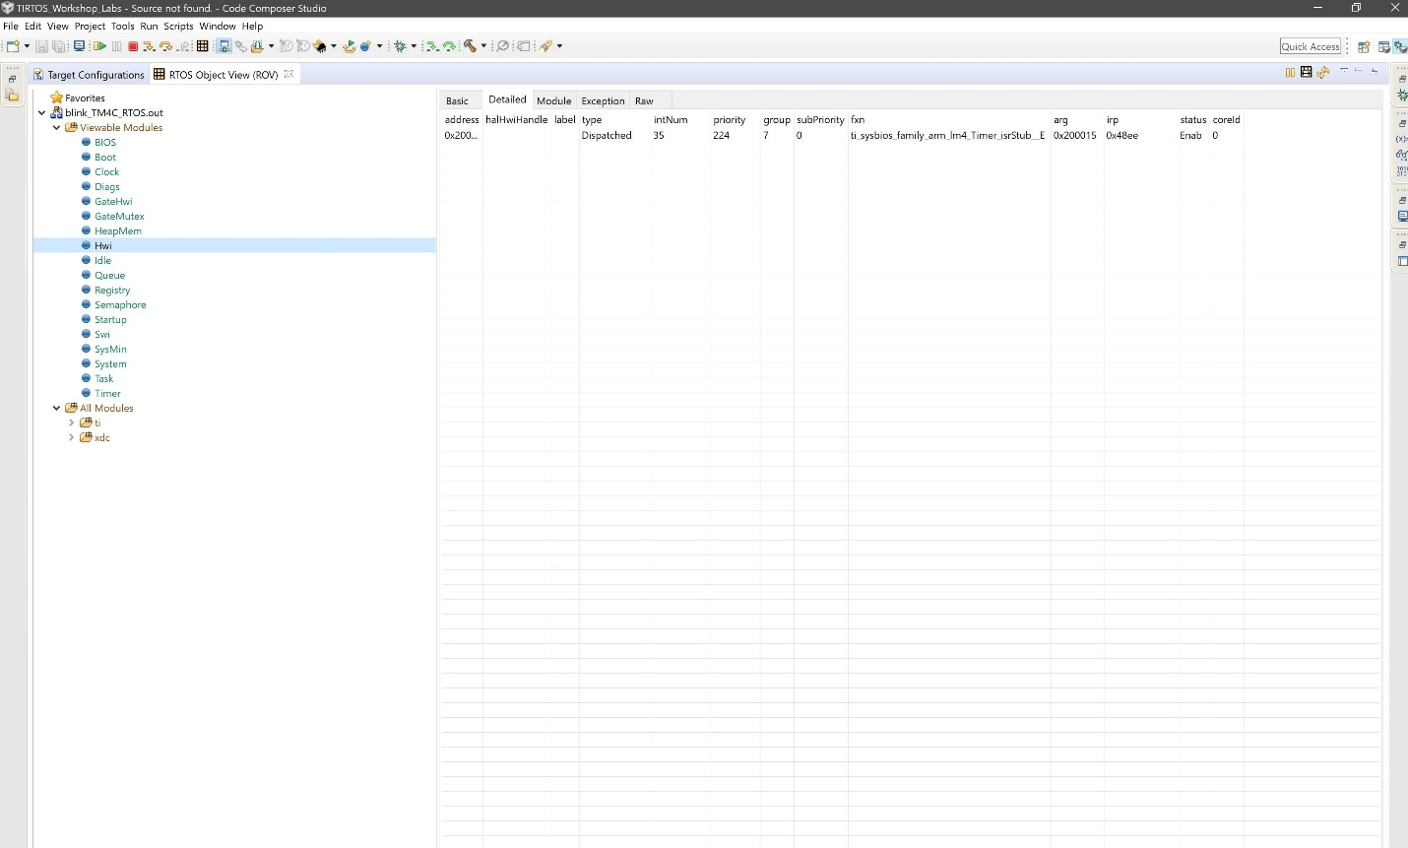

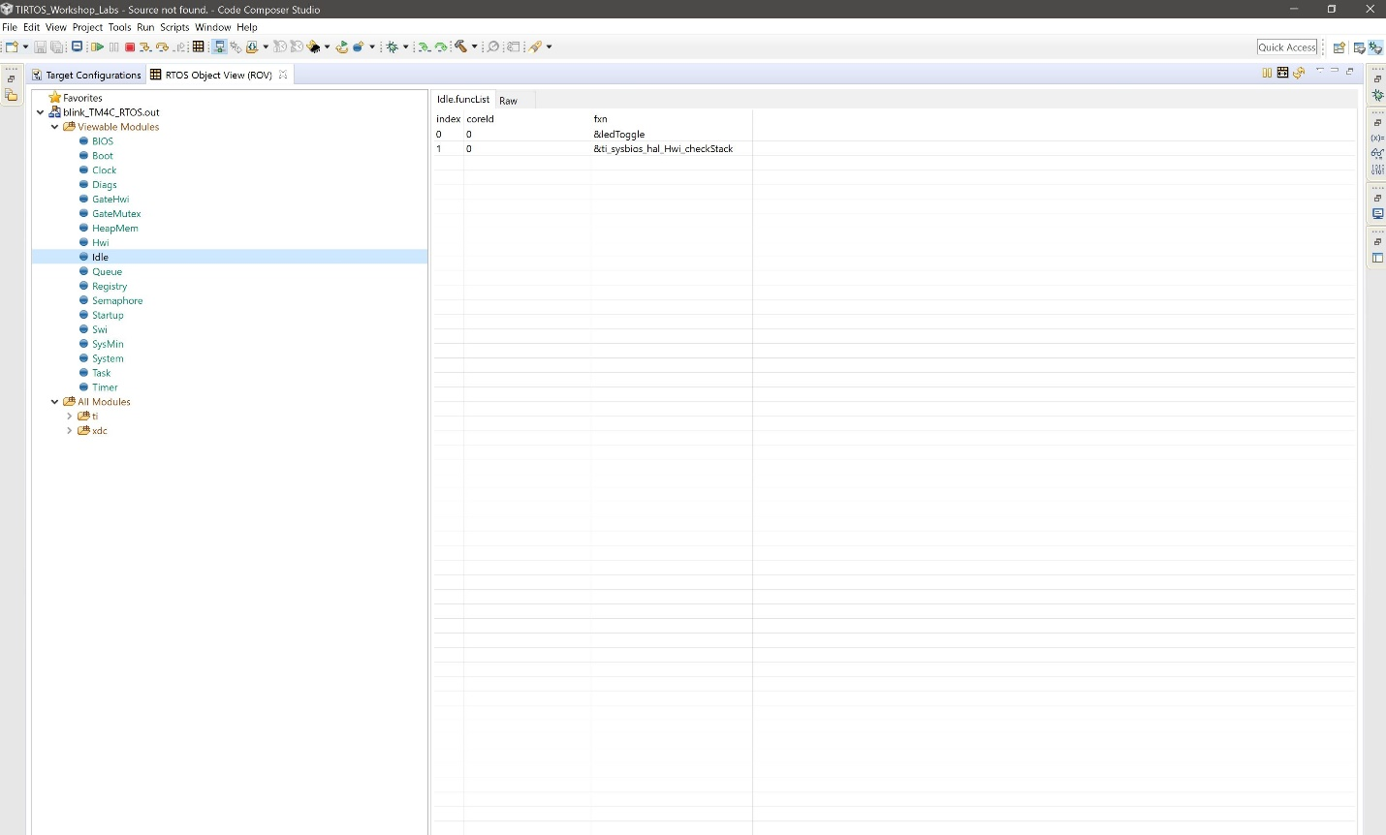

Above are three screenshots that display the log variables from ROV.



Above is the visualization of the Execution Graph using the RTOS Analyzer.

**Modified Code:**

//----------------------------------------

// BIOS header files

//----------------------------------------

**#include** <xdc/std.h> //mandatory - have to include first, for BIOS types

**#include** <ti/sysbios/BIOS.h> //mandatory - if you call APIs like BIOS_start()

**#include** <xdc/runtime/Log.h> //needed for any Log_info() call

**#include** <xdc/cfg/global.h> //header file for statically defined objects/handles

//------------------------------------------

// TivaWare Header Files

//------------------------------------------

**#include** <stdint.h>

**#include** <stdbool.h>

**#include** "inc/hw_types.h"

**#include** "inc/hw_memmap.h"

**#include** "driverlib/sysctl.h"

**#include** "driverlib/gpio.h"

**#include** "inc/hw_ints.h"

**#include** "driverlib/interrupt.h"

**#include** "driverlib/timer.h"

**#include** <time.h>

//----------------------------------------

// Prototypes

//----------------------------------------

**void** **hardware_init**(**void**);

**void** **ledToggle**(**void**);

**void** **delay**(**void**);

//---------------------------------------

// Globals

//---------------------------------------

**volatile** int16_t i16ToggleCount = 0;

//---------------------------------------------------------------------------

// main()

//---------------------------------------------------------------------------

**void** **main**(**void**)

{

hardware_init(); // init hardware via Xware

BIOS_start();

}

//---------------------------------------------------------------------------

// hardware_init()

//

// inits GPIO pins for toggling the LED

//---------------------------------------------------------------------------

**void** **hardware_init**(**void**)

{

//Set CPU Clock to 40MHz. 400MHz PLL/2 = 200 DIV 5 = 40MHz

**SysCtlClockSet**(SYSCTL_SYSDIV_5|SYSCTL_USE_PLL|SYSCTL_XTAL_16MHZ|SYSCTL_OSC_MAIN);

// ADD Tiva-C GPIO setup - enables port, sets pins 1-3 (RGB) pins for output

**SysCtlPeripheralEnable**(SYSCTL_PERIPH_GPIOF);

**GPIOPinTypeGPIOOutput**(GPIO_PORTF_BASE, GPIO_PIN_1|GPIO_PIN_2|GPIO_PIN_3);

// Turn on the LED

**GPIOPinWrite**(GPIO_PORTF_BASE, GPIO_PIN_1|GPIO_PIN_2|GPIO_PIN_3, 4);

}

//---------------------------------------------------------------------------

// ledToggle()

//

// toggles LED on Tiva-C LaunchPad

//---------------------------------------------------------------------------

**void** **ledToggle**(**void**)

{

// LED values - 2=RED, 4=BLUE, 8=GREEN

**if**(**GPIOPinRead**(GPIO_PORTF_BASE, GPIO_PIN_2))

{

**GPIOPinWrite**(GPIO_PORTF_BASE, GPIO_PIN_1|GPIO_PIN_2|GPIO_PIN_3, 0);

}

**else**

{

**GPIOPinWrite**(GPIO_PORTF_BASE, GPIO_PIN_2, 4);

}

delay(); // create a delay of ~1/2sec

i16ToggleCount += 1; // keep track of #toggles

Log_info1("TOGGLED LED [%u] times", i16ToggleCount);

}

//---------------------------------------------------------------------------

// delay()

//

// Creates a 500ms delay via TivaWare fxn

//---------------------------------------------------------------------------

**void** **delay**(**void**)

{

**SysCtlDelay**(6700000); // creates ~500ms delay - TivaWare fxn

}