**Date Submitted: 11/10/18 2:52 PM**

**Task 01:**

Youtube Link: <https://www.youtube.com/watch?v=NPuNQk14Nmg>

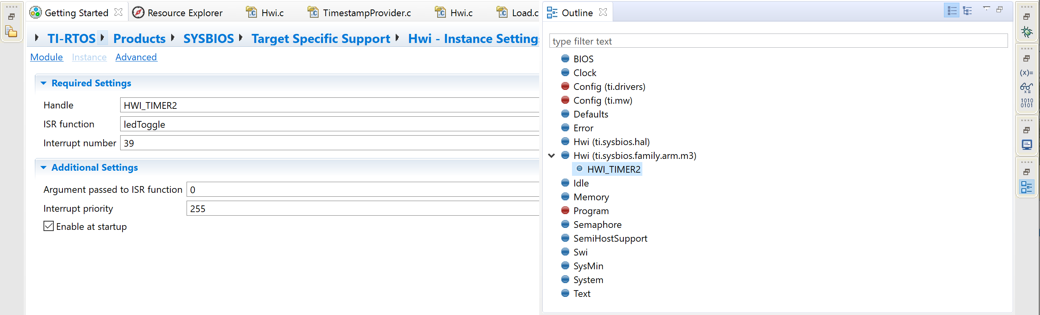

Modified empty.cfg file adding the HWI_TIMER2 instance.

Below are the variables displayed by ROV:

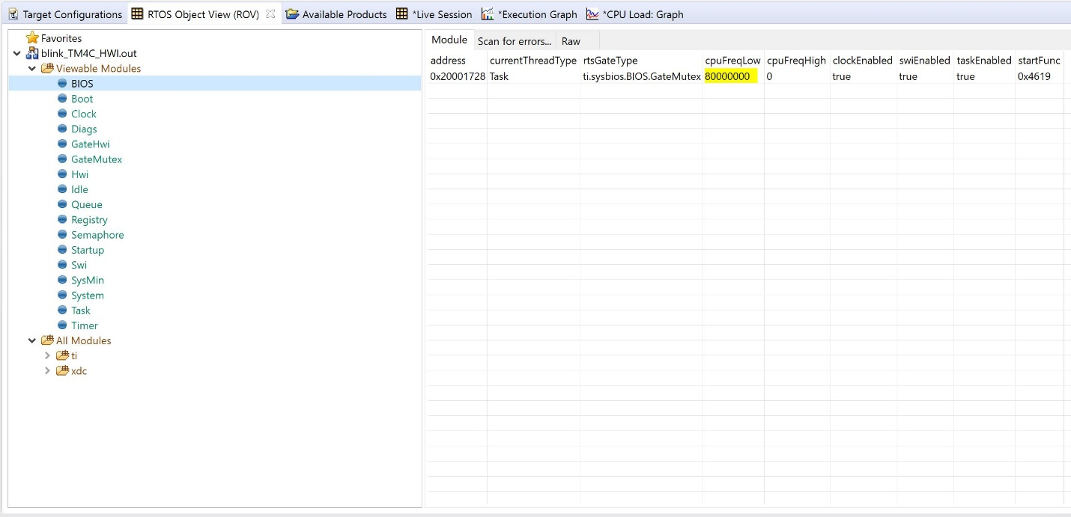

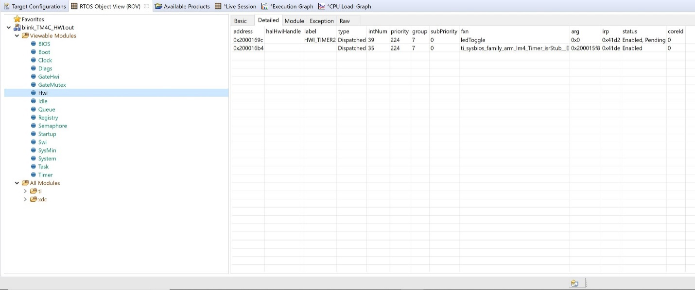

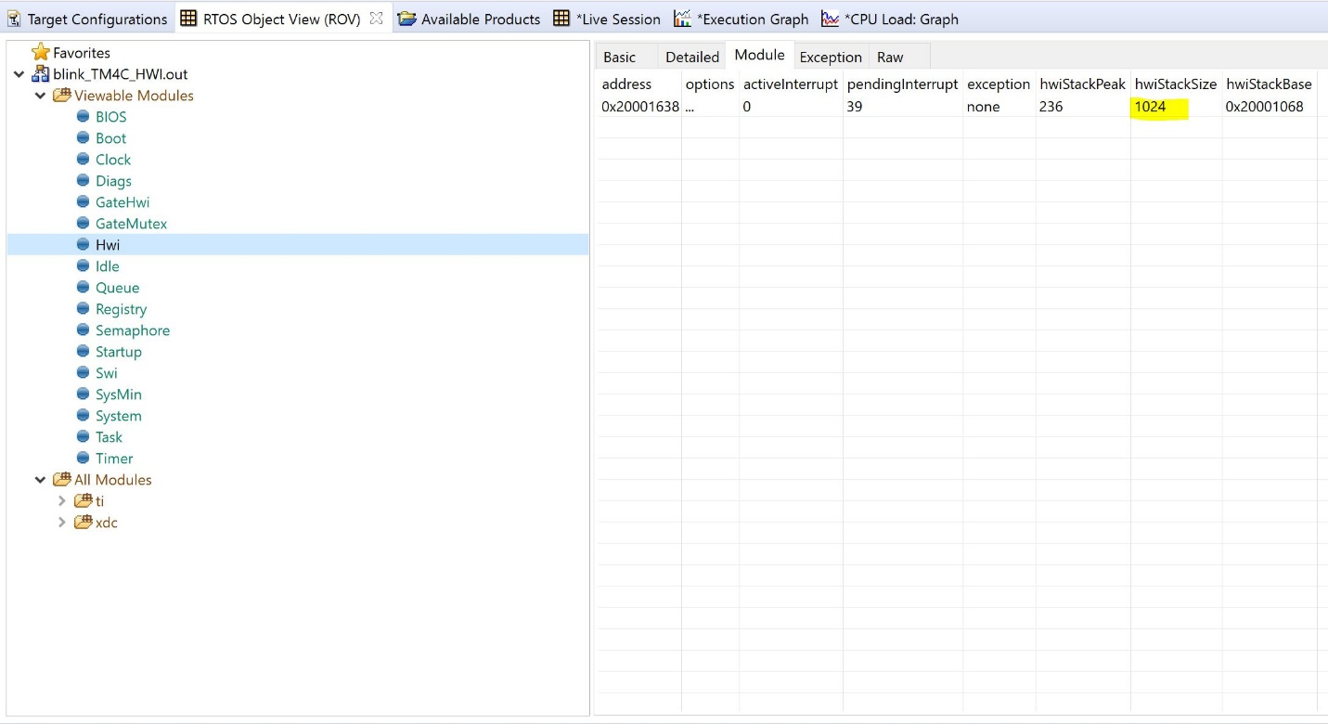

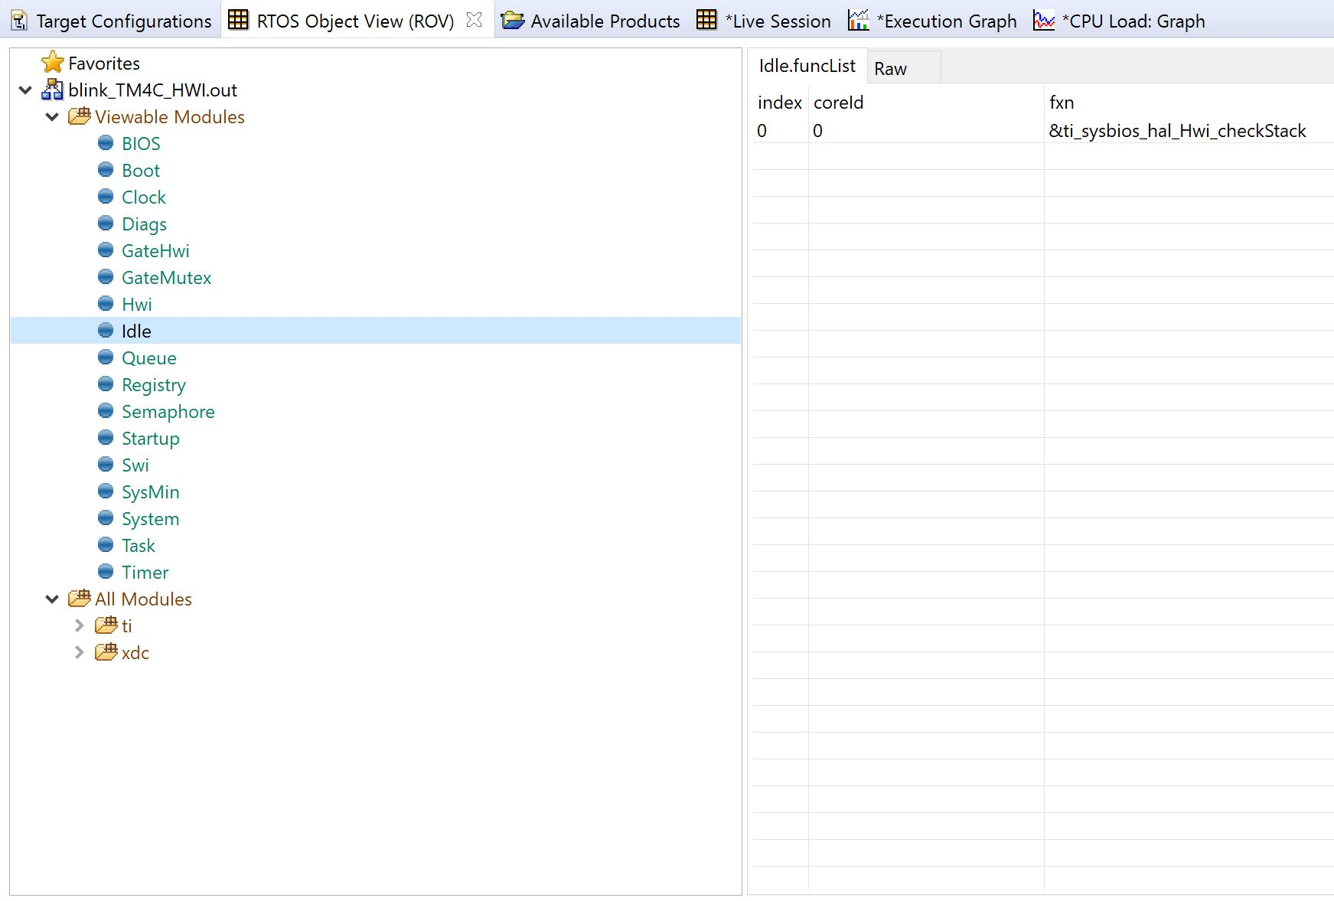

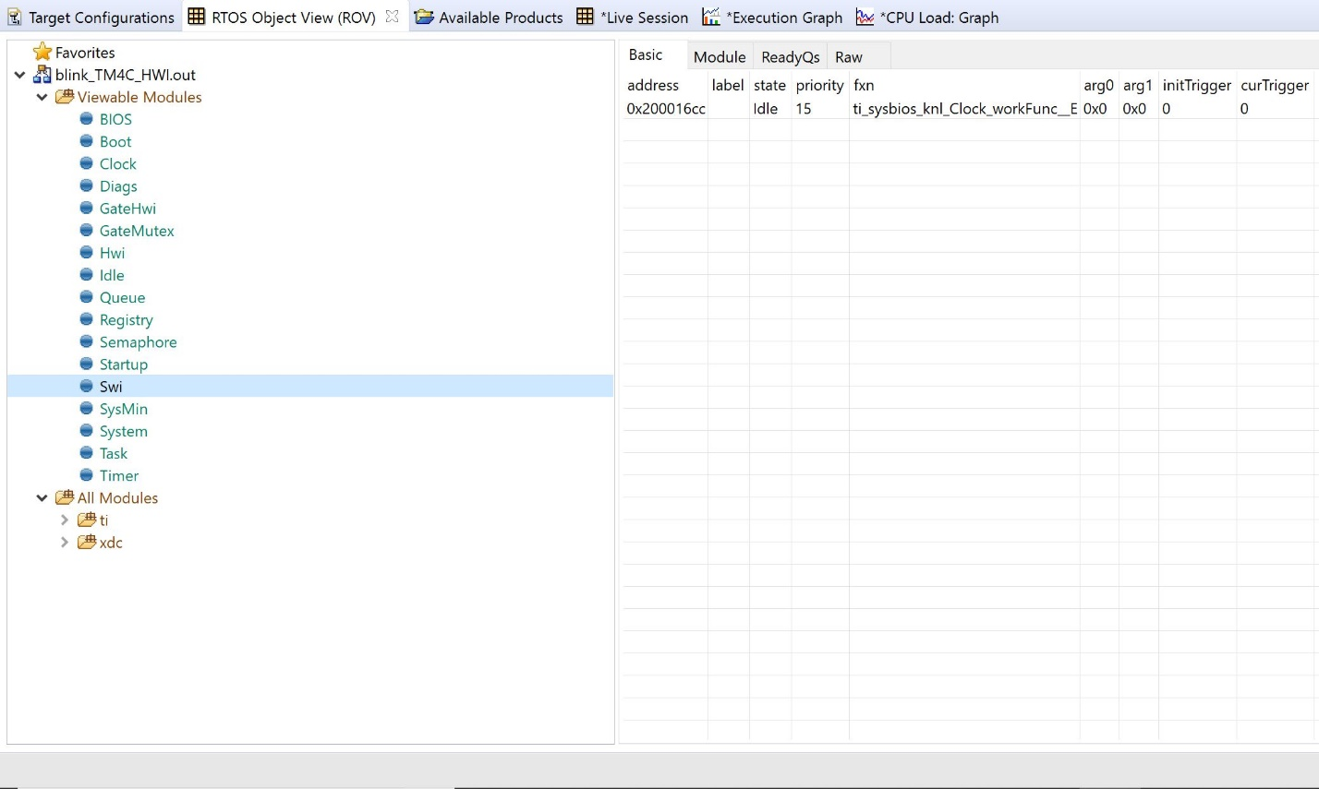

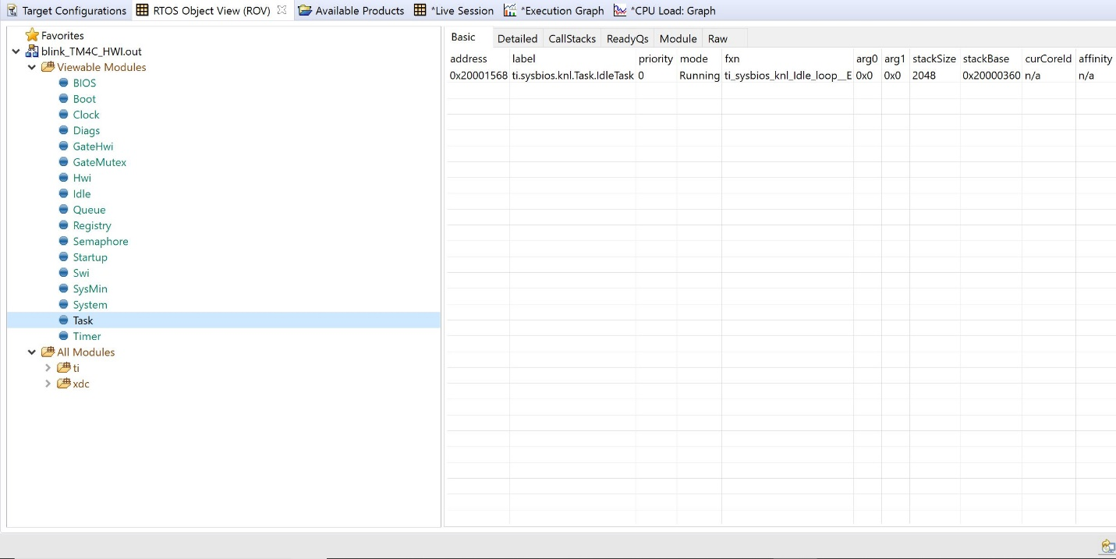

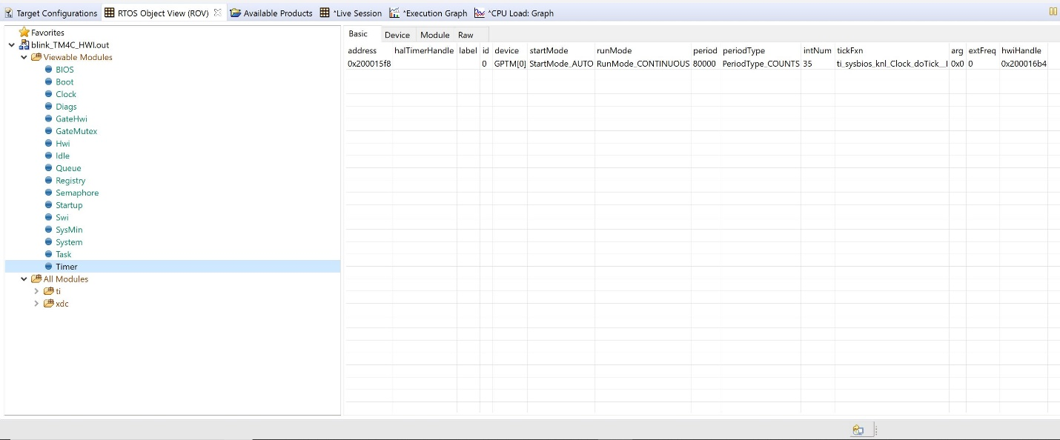

There is not an execution graph to display. Due to the fact that in Lab 5, we aren’t logging HWIs and all the information is being logged in the HWI.

Modified Code:

//---------------------------------------------------------------------------------

// Project: Blink TM4C BIOS Using Hwi (STARTER)

// Author: Eric Wilbur

// Date: June 2014

//

// Note: The function call TimerIntClear(TIMER2_BASE, TIMER_TIMA_TIMEOUT) HAS

// to be in the ISR. This fxn clears the TIMER's interrupt flag coming

// from the peripheral - it does NOT clear the CPU interrupt flag - that

// is done by hardware. The author struggled figuring this part out - hence

// the note. And, in the Swi lab, this fxn must be placed in the

// Timer_ISR fxn because it will be the new ISR.

//

// Follow these steps to create this project in CCSv6.0:

// 1. Project -> New CCS Project

// 2. Select Template:

// - TI-RTOS for Tiva-C -> Driver Examples -> EK-TM4C123 LP -> Example Projects ->

// Empty Project

// - Empty Project contains full instrumentation (UIA, RTOS Analyzer) and

// paths set up for the TI-RTOS version of MSP430Ware

// 3. Delete the following files:

// - Board.h, empty.c, EK_TM4C123GXL.c/h, empty_readme.txt

// 4. Add main.c from TI-RTOS Workshop Solution file for this lab

// 5. Edit empty.cfg as needed (to add/subtract) BIOS services, delete given Task

// 6. Build, load, run...

//----------------------------------------------------------------------------------

//----------------------------------------

// BIOS header files

//----------------------------------------

**#include** <xdc/std.h> //mandatory - have to include first, for BIOS types

**#include** <ti/sysbios/BIOS.h> //mandatory - if you call APIs like BIOS_start()

**#include** <xdc/runtime/Log.h> //needed for any Log_info() call

**#include** <xdc/cfg/global.h> //header file for statically defined objects/handles

//------------------------------------------

// TivaWare Header Files

//------------------------------------------

**#include** <stdint.h>

**#include** <stdbool.h>

**#include** "inc/hw_types.h"

**#include** "inc/hw_memmap.h"

**#include** "driverlib/sysctl.h"

**#include** "driverlib/gpio.h"

**#include** "inc/hw_ints.h"

**#include** "driverlib/interrupt.h"

**#include** "driverlib/timer.h"

//----------------------------------------

// Prototypes

//----------------------------------------

**void** **hardware_init**(**void**);

**void** **ledToggle**(**void**);

//void delay(void);

//---------------------------------------

// Globals

//---------------------------------------

**volatile** int16_t i16ToggleCount = 0;

//---------------------------------------------------------------------------

// main()

//---------------------------------------------------------------------------

**void** **main**(**void**)

{

hardware_init(); // init hardware via Xware

BIOS_start();

}

//---------------------------------------------------------------------------

// hardware_init()

//

// inits GPIO pins for toggling the LED

//---------------------------------------------------------------------------

**void** **hardware_init**(**void**)

{

uint32_t ui32Period;

//Set CPU Clock to 40MHz. 400MHz PLL/2 = 200 DIV 5 = 40MHz

**SysCtlClockSet**(SYSCTL_SYSDIV_5|SYSCTL_USE_PLL|SYSCTL_XTAL_16MHZ|SYSCTL_OSC_MAIN);

// ADD Tiva-C GPIO setup - enables port, sets pins 1-3 (RGB) pins for output

**SysCtlPeripheralEnable**(SYSCTL_PERIPH_GPIOF);

**GPIOPinTypeGPIOOutput**(GPIO_PORTF_BASE, GPIO_PIN_1|GPIO_PIN_2|GPIO_PIN_3);

// Turn on the LED

**GPIOPinWrite**(GPIO_PORTF_BASE, GPIO_PIN_1|GPIO_PIN_2|GPIO_PIN_3, 4);

// Timer 2 setup code

**SysCtlPeripheralEnable**(SYSCTL_PERIPH_TIMER2); // enable Timer 2 periph clks

**TimerConfigure**(TIMER2_BASE, TIMER_CFG_PERIODIC); // cfg Timer 2 mode - periodic

ui32Period = (**SysCtlClockGet**() /2); // period = CPU clk div 2 (500ms)

**TimerLoadSet**(TIMER2_BASE, TIMER_A, ui32Period); // set Timer 2 period

**TimerIntEnable**(TIMER2_BASE, TIMER_TIMA_TIMEOUT); // enables Timer 2 to interrupt CPU

**TimerEnable**(TIMER2_BASE, TIMER_A); // enable Timer 2

}

//---------------------------------------------------------------------------

// ledToggle()

//

// toggles LED on Tiva-C LaunchPad

//---------------------------------------------------------------------------

**void** **ledToggle**(**void**)

{

**TimerIntClear**(TIMER2_BASE, TIMER_TIMA_TIMEOUT); // must clear timer flag FROM timer

// LED values - 2=RED, 4=BLUE, 8=GREEN

**if**(**GPIOPinRead**(GPIO_PORTF_BASE, GPIO_PIN_2))

{

**GPIOPinWrite**(GPIO_PORTF_BASE, GPIO_PIN_1|GPIO_PIN_2|GPIO_PIN_3, 0);

}

**else**

{

**GPIOPinWrite**(GPIO_PORTF_BASE, GPIO_PIN_2, 4);

}

// delay(); // create a delay of ~1/2sec

i16ToggleCount += 1; // keep track of #toggles

Log_info1("LED TOGGLED [%u] TIMES",i16ToggleCount); // send toggle count to UIA

}

//---------------------------------------------------------------------------

// delay()

//

// Creates a 500ms delay via TivaWare fxn

//---------------------------------------------------------------------------

/*void delay(void)

{

SysCtlDelay(6700000); // creates ~500ms delay - TivaWare fxn

}*/