Take t300.exe calling a Dll for example

1. Add additional dependencies

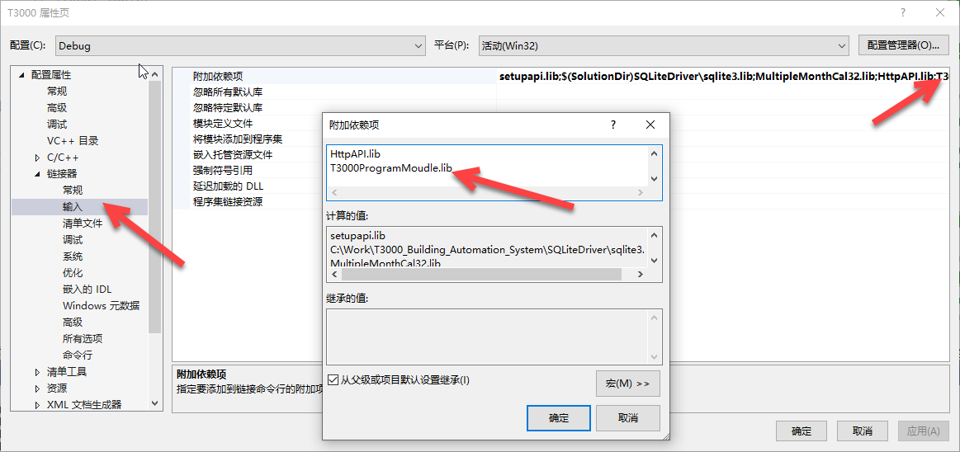

Place the dynamic library in the T3000 run directory

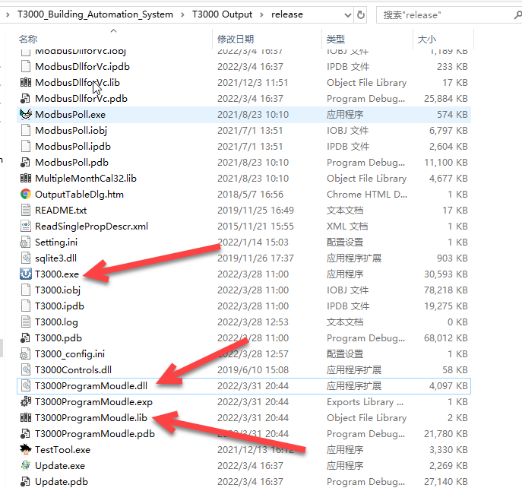

* Include dllmain.h header file , This allows you to use the functions in the library

typedef struct

{

int errorcode;

char encode_array[2000];

char encode_message[255];

}encode_str;

typedef struct

{

int errorcode;

char decode_text[4000];

char decode_message[255];

}decode_str;

extern "C" __declspec(dllexport) int Encode_function(char* input_text, encode_str * encodestr);

extern "C" __declspec(dllexport) char* Decode_function(char* input_code, decode_str * decodestr);

Function Usage Examples

#include "..\T3000ProgramMoudle\dllmain.h"

char test_program[] = "10 REM TEST PROGRAM \r\n20 VAR = VAR1 + 1\r\n";

char ret_value[2000] = { 0 };

encode_str Myencodestr ;

int encode_ret=0;

encode_ret = Encode_function(test_program, &Myencodestr);

if (encode_ret != -1)

{

MessageBox(_T("Decode error!"));

}

char* decode_ret =NULL;

decode_str Mydecode_str;

decode_ret = Decode_function(Myencodestr.encode_array, &Mydecode_str);

if (decode_ret == NULL)

{

MessageBox(_T("Decode Failed!"));

}