Key notes: Shock controller must be in 8-pole scanned mode + remote + subject + high.

Verify prior that with set/test toggled and manual that it goes up to 1mA!

Troubleshooting

**Can’t trigger recording start from Motive**

1. Make sure Sync out from Motive hub is connected to ground/trig pins on Arduino breakout board
2. Restart python, run trace_conditioning.shutdown_arduino() first.
3. Restart computer!
4. Check that sync out from Motive is actually sending a TTL when you hit record using the multimeter. Should be 3.3V. If it isn’t, click on the hub (highlighted in yellow below) and then toggle all the drop down menus in “Sync Input Settings” and “OIutput 1” below it (e.g. select another option, wait a hot second, then toggle back”
5. 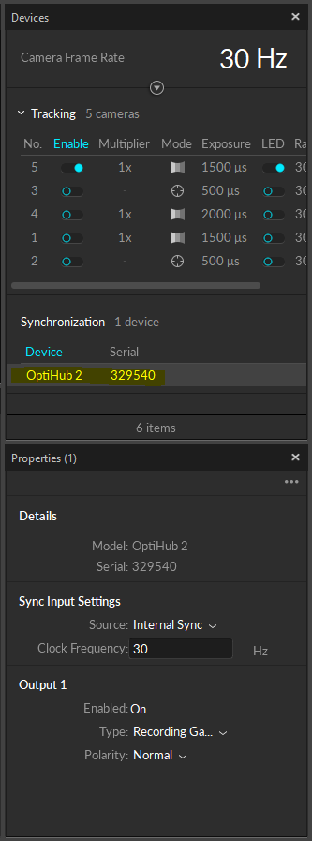
6. Make sure that StandardFirmata is uploaded to the Arduino. (This is an unlikely source of the above error since you should not even be able to see the Arduino in python without doing this first, but showing here nonetheless.) Open the Arduino IDE from the start menu and select File->Examples->Firmata->StandardFirmata (see below). Then hit upload (see yellow below):
7. 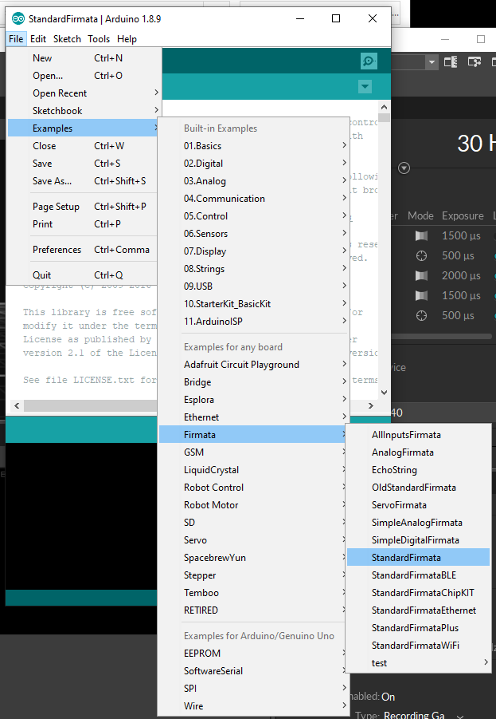
8. 