CSEE5590/CS490 APS

Programming for Web/Cloud / Mobile Applications

Part - Mobile Development

Lab

# ASSIGNMENT - 1

BALACHANDAR KULALA

## (Student ID:12543027)

**Goal of the Assignment:**

To provide good practice on fetching data from APIs, parsing the JSON response, using Async task, updating information regularly, handling errors, creating a customized list and other views and

layouts

**Part1: Login, Signup and Social Login Activities**

**Aim:**

To understand the creating login, register pages and exploring the feature of social login.

**Description of Work:**

Design a mobile application that contains the login page, registration page and provide the social login.

### Technical Section:

Majorly used technical skills.

* Android technology
* Core Java
* XML
* JSON

### Development Section

This Application contains mainly 3 pages:

1. LogIn Page:

This starting page of the application, this page displays the option for user to enter user name and password for login.

This page also provides facility to user to login with Facebook account into this application. And Create new user account.

Screenshot:

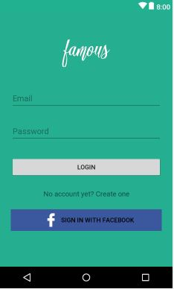

The user enters the UserName and Password and clicks on LOGIN button.

The corresponding code for this logic is shown in following screen:

It authenticates the user credentials, if it exists allows to the home page else denies.

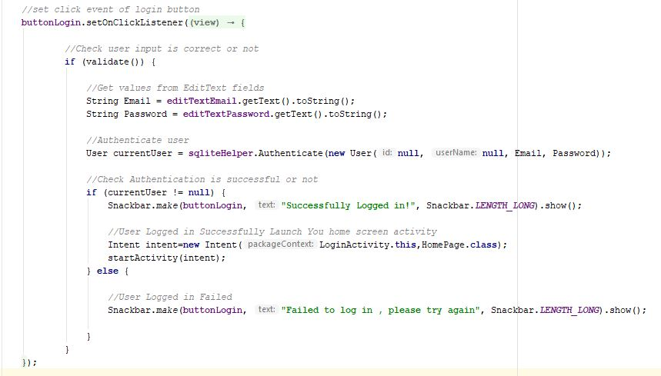

ii) Registration Page:

If user doesn’t have an account, allows to create new account in this page.

This page asks user to enter name, email and password details.

Once user clicks on the Create Account button, it redirects to the Log in page for logging into the account.

Screenshot:

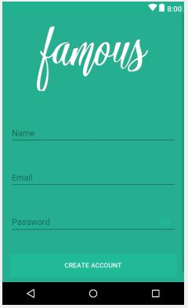

The code snippet for this registration page is shown below:

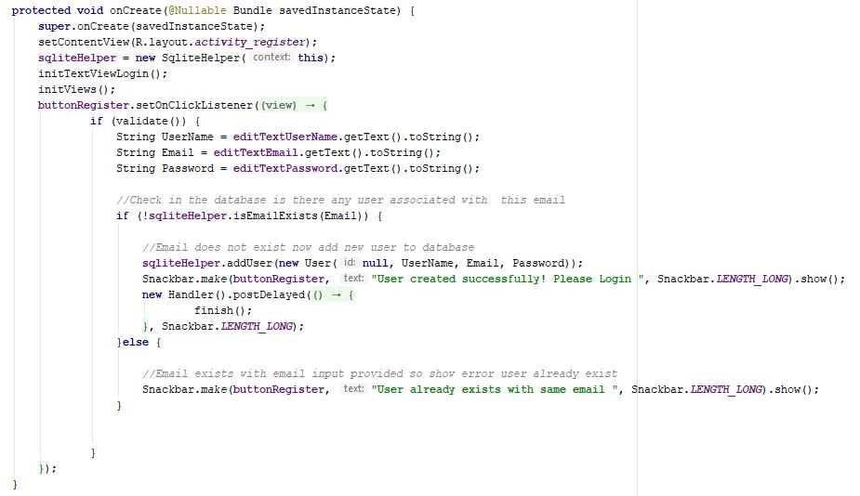

iii) Social LogIn:

It allows user to use the application by using social login feature. This can be accomplished here by using the facebook login.

Screenshot:

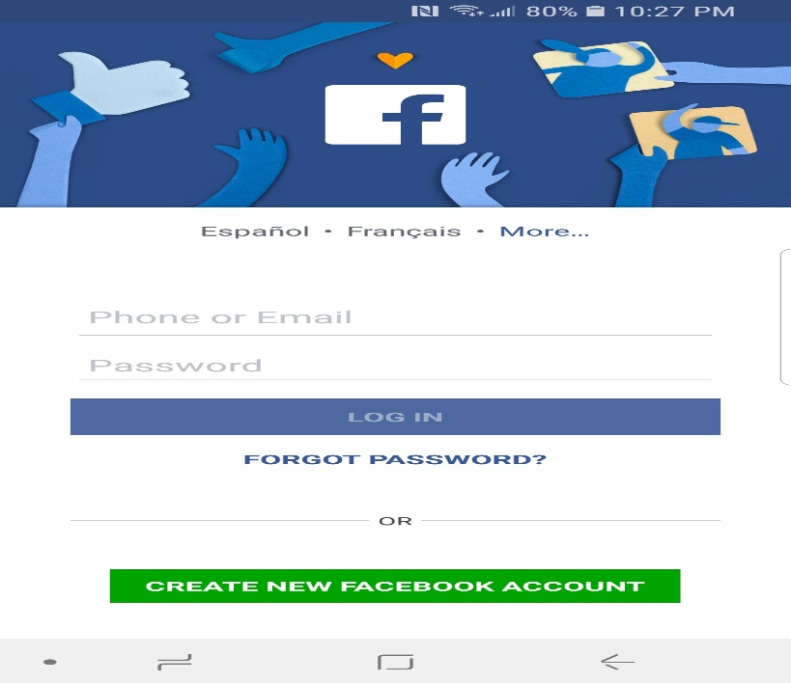

The corresponding logic is shown in below snippet:

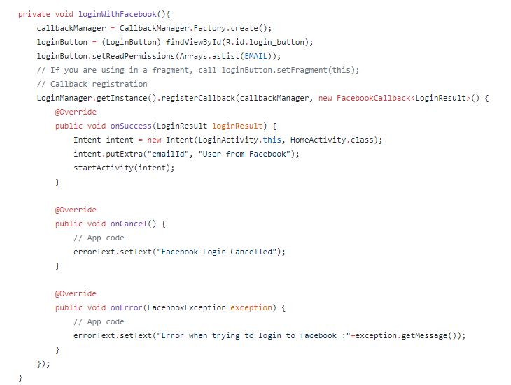

**Part2: Utilizing phone hardware features**

**Aim:**

To gain the knowledge in exploring the usage of phone hardware features like sensors, Camera, Maps, scanners etc.

**Description of Work:**

Design a mobile application that utilizes the hardware parts of the mobile phone such as Camera, sensors, Maps. In this case we developed the application using Camera and google maps.

### Technical Section:

Majorly used technical skills.

* Android technology
* Core Java
* XML
* JSON

### Development of Work:

It is developed by using two hardware features of the phone, so that we created the two activities for this task.

Task1: Camera Usage:

This section uses the basic usage of camera feature of the android phone. It captures the phone and display the image once it is done.

The following two screens shows the design view and Code snippet for that logic.

Design view:

When the user clicks on the “Take A photo” button, camera starts capturing.



The corresponding logic is shown below.

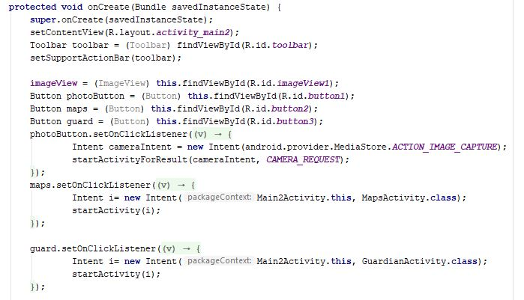

The output screen shown below.

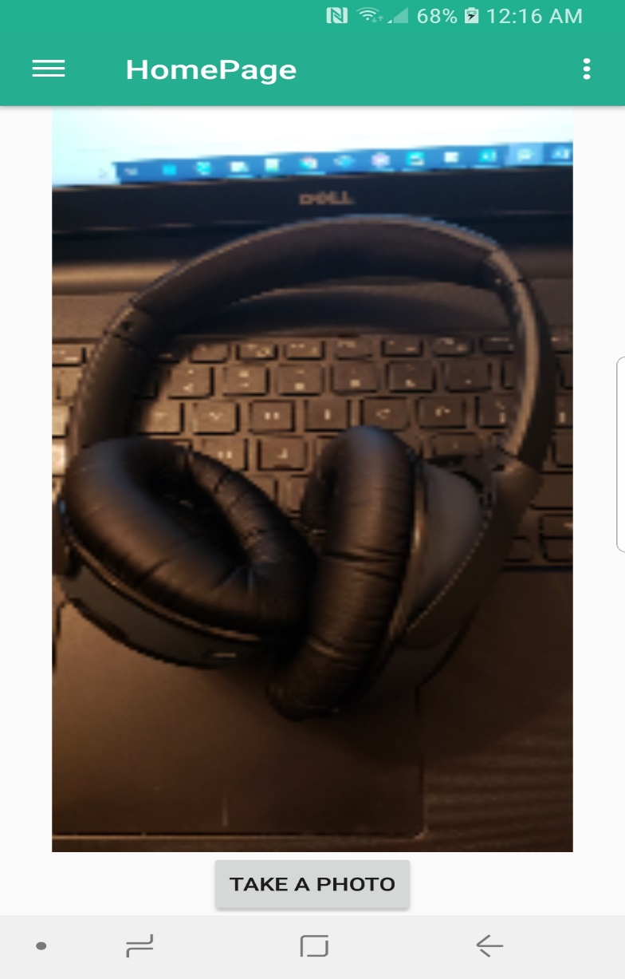

Task2: Google Maps:

This section uses the google maps feature of the android phone. When the user clicks on the Google Maps button it displays the current location of the user.

The following two screens displays the Output screen and Functional logic of implementation.

Output screen:

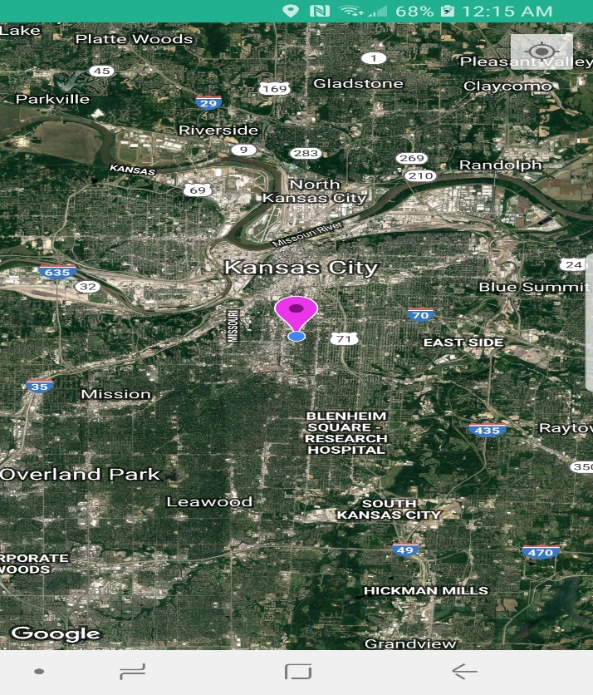

The corresponding code is shown below:

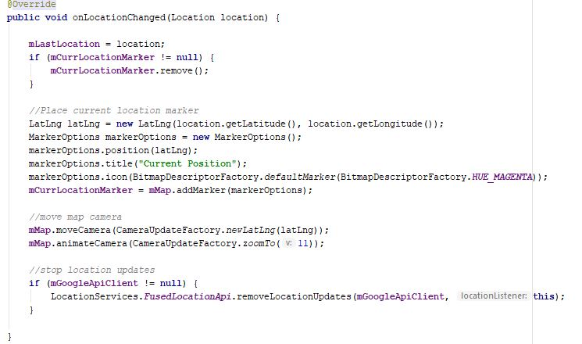

**Part3: Utilizing Machine Learning Features**

**Aim:**

To gain the knowledge in exploring machine learning APIs in android to implement the machine learning activities.

**Description of Work:**

Design a mobile application that utilizes Machine learning APIs such as AWS, Google ML and Watson APIs in android application to develop any Machine learning activity.

### Technical Section:

Majorly used technical skills.

* Android technology
* Core Java
* XML
* JSON
* Using WEB APIs (Watson, AWS, Google ML)

### Development of Work:

Here we developed an application that checks the entered text is either positive gesture or negative gesture. We have used ML API to detect this activity.

The following page is the login page:

When the user enters User name and password and clicks on login it takes him to the main page of the activity.

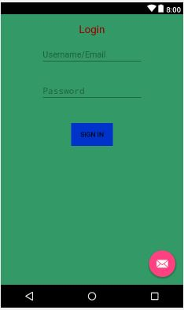

The corresponding Logic for this activity is shown below.

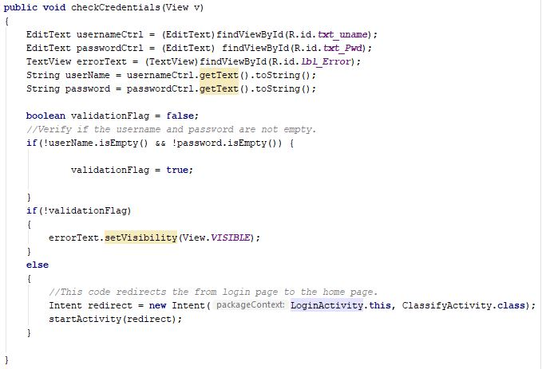

When the user credentials are verified successfully it allows him to take to the main page of the application.

Main page of the activity is shown below.

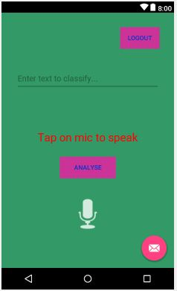

Here user can either enter the text in textbox or can use the mic to speak. The spoken words are displayed in the text box.

By clicking the Analyze button it displays the Positivity or negativity of the code.

When the user wishes to logout from the screen, he clicks on the LOGOUT button.

The corresponding logic is shown below:

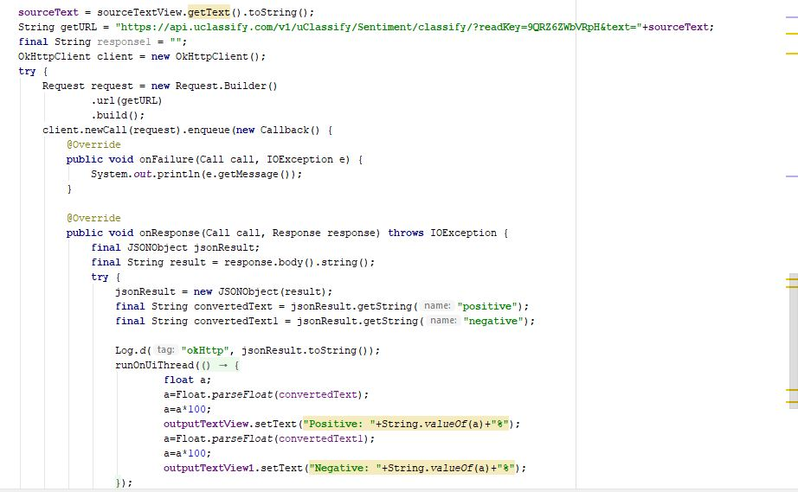

The output screen is displayed below:

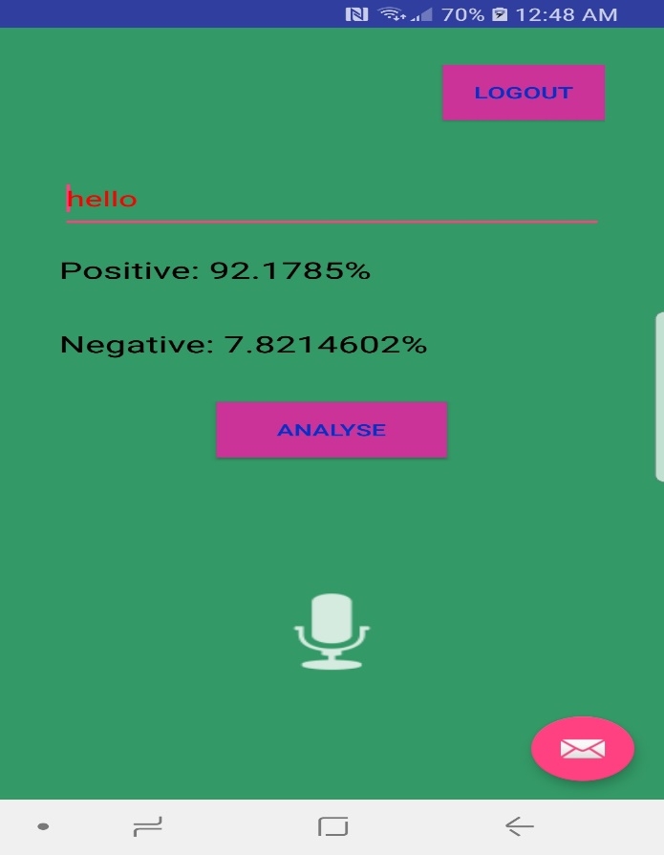

Here the entered word is “hello”, when user clicks on the Analyze button, it displays the positivity and negativity of the text.

**Part4: Displaying the Latest NEWS using Guardian API**

**Aim:**

To gain the knowledge by exploring Guardian API to get the latest new about the entered text.

**Description of Work:**

Design a mobile application that utilizes Guardian API to get the latest new about the entered text.

### Technical Section:

Majorly used technical skills.

* Android technology
* Core Java
* XML
* JSON
* Guardian API

### Development of Work:

This application uses the Guardian API to get the latest news about the entered text.

The app contains one home scree, this screen is shown below:

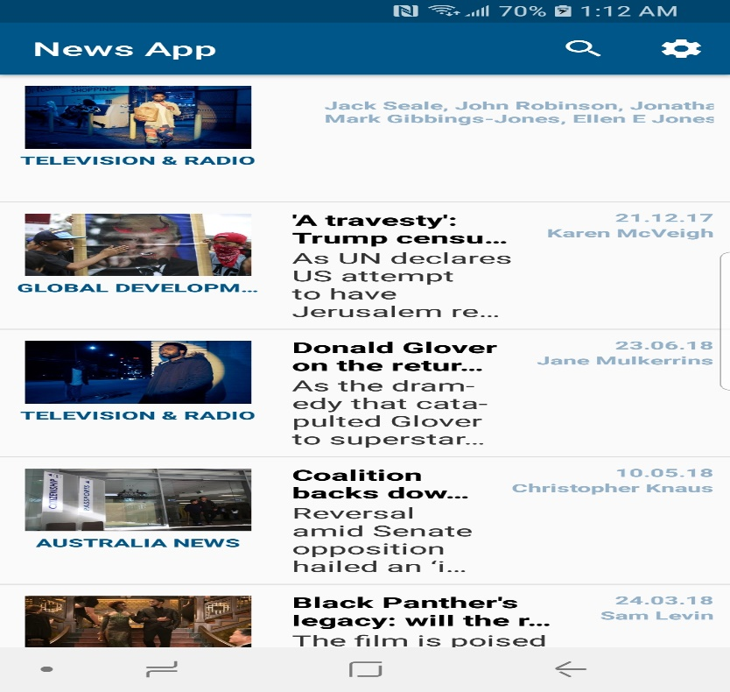

The corresponding Guardian API usage is shown below:

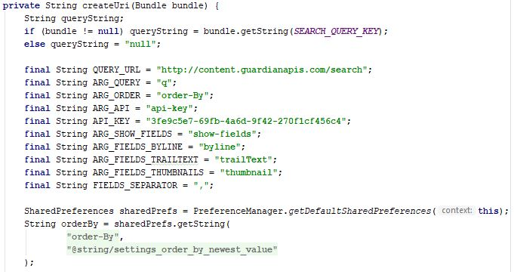

Here the user need to generate the API key to access this API, the complete usage of the guardian API usage is shown in above code.s

The search screen is shown below:

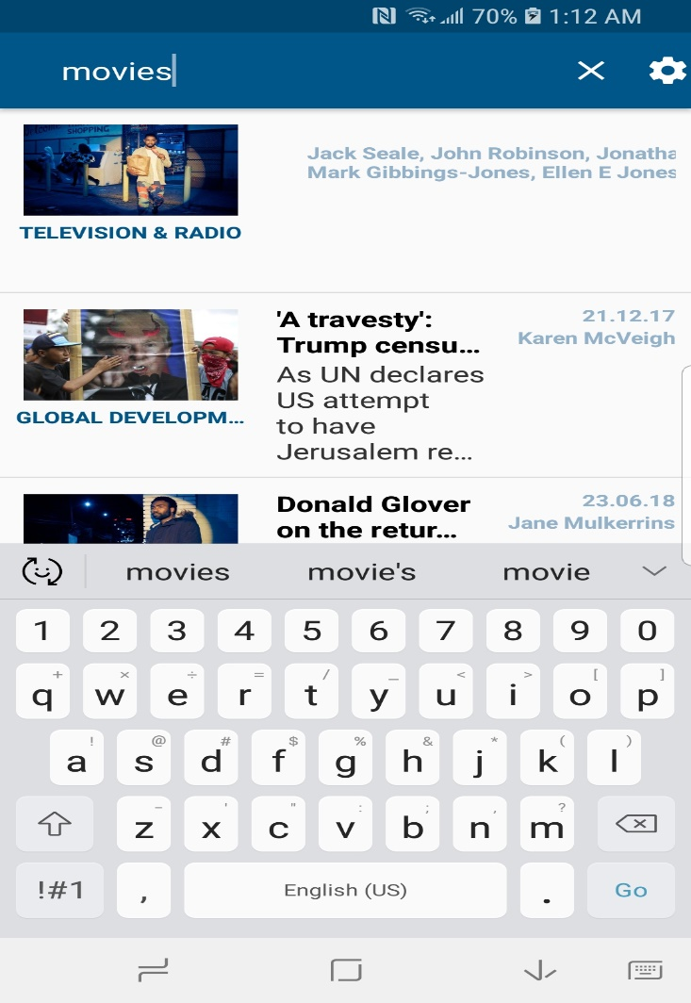

Here the user is searching for the news about movies.

The search results are shown below.

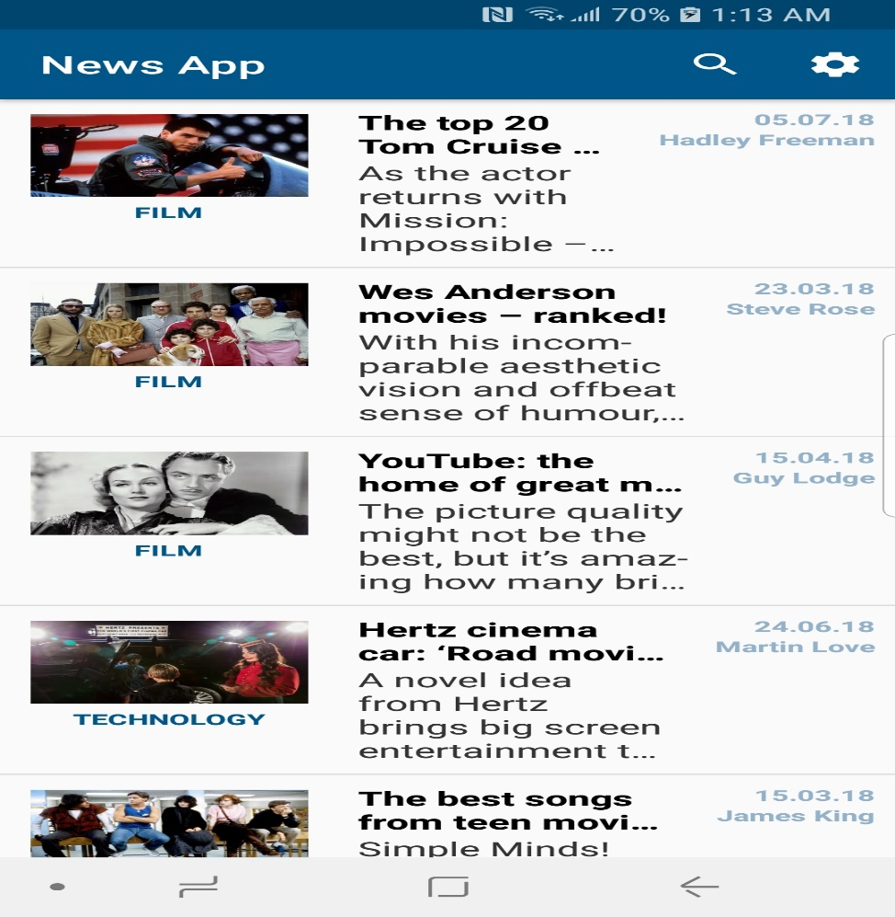

## GitHub LINK

<https://github.com/bkkhf/Mobilelab1>

**DEMO LINK**

<https://youtu.be/GCPkfDoPVZg>

References:

* [https://www.w3schools.com](https://www.w3schools.com/)
* <https://www.udacity.com/>
* <http://developer.android.com/guide/index.html>.

<https://www.coursera.org/courses?languages=en&query=android>

<https://developer.android.com/docs/>