CSEE5590/CS490 APS

Programming for Web/Cloud / Mobile Applications

Part - Mobile Development

Lab

# ASSIGNMENT - 2

BALACHANDAR KULALA

## (Student ID:12543027)

**Goal of the Assignment:**

To provide good practice on android development using the Services, Storage usage, API usage, Grid layout design

**Section-1: Storage usage**

**Aim:**

To get in practice of Storage usage in Android system. Mainly focus on SQLite/ Firebase or Storage usages.

**Description of Work:**

Here We tried to use the Storage usage by consuming SQLite or Firebase database.

### Technical Section:

Majorly used technical skills.

* Android technology
* Core Java
* XML, Firebase, SQLite Databases
* JSON

### Development Section

This section contains 2 buttons “FIREBASE DATE” AND “SQLITE DATA”:

i) Firebase Data:

When the user clicks on this button it displays the data from firebase database.

The input screen is shown below:

When user clicks on Firebase data button, it grabs the data from firebase database and displays in the new activity.

Screenshot:

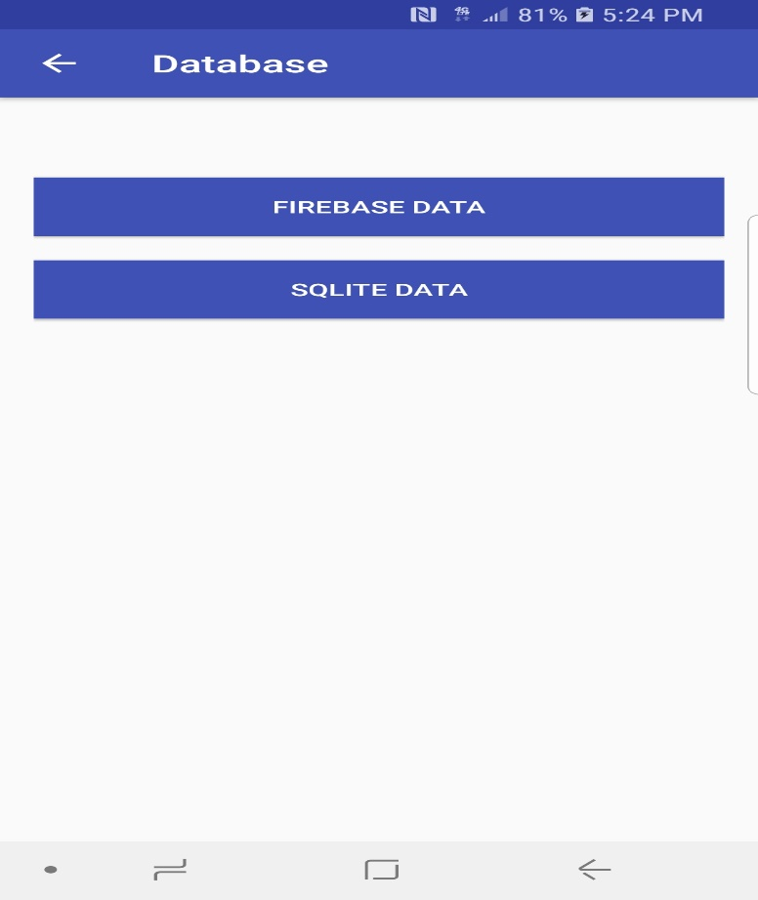

After successful click on the “FIREBASE DATA” button, it collects the data from database and displays in next activity.

The corresponding output screen shown below.

The corresponding code for this logic is shown in following screen:

It authenticates the user credentials, if it exists allows to the home page else denies.

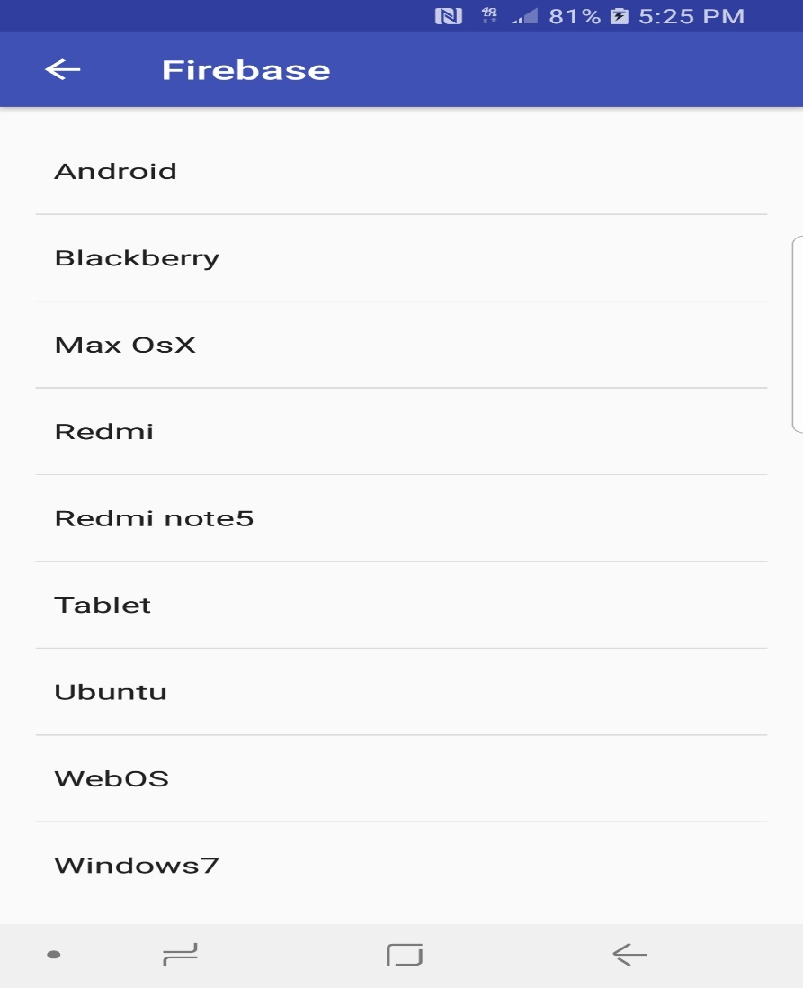

The corresponding code logic is shown below from android studio.

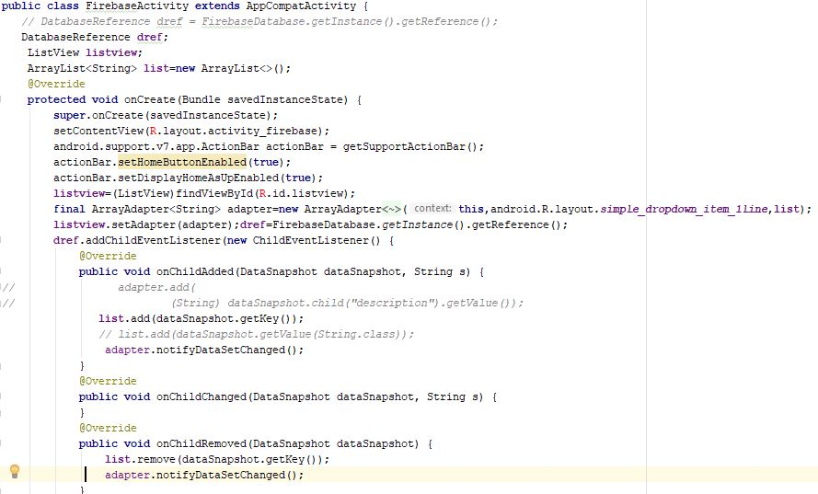

ii) Open SQLite database:

In this case we have tried to implement Open SQLite database to store the employee data entered and, we display the data from the database in the TextView.

The input screen shown below:

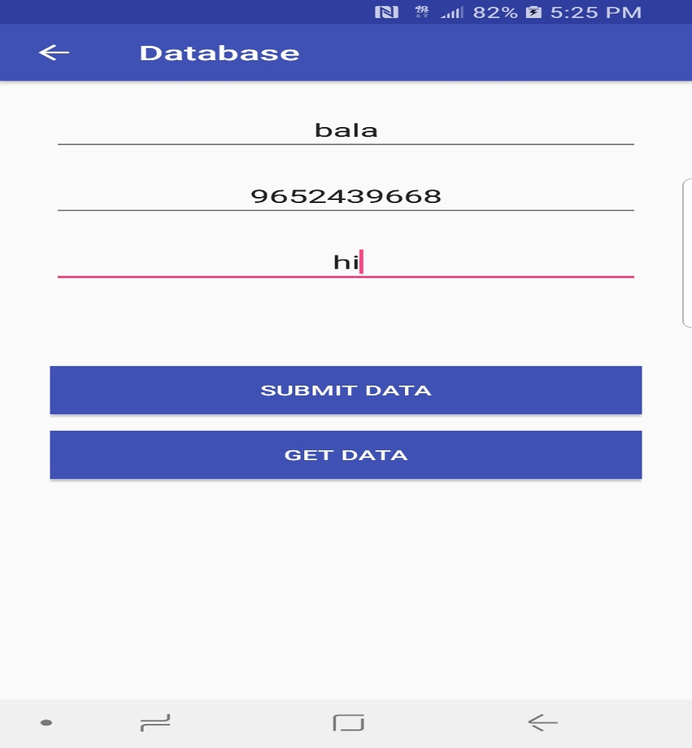

This screen asks user to enter the employee details like, name, phone number and description of work. When we click on Submit button with proper input data. It successfully inserts the data into SQLite database.

This screen also validates the user inputs and emptiness of the inputs and some basic validations. When user clicks on the Get data button it displays the data in TextView.

Output Screen:

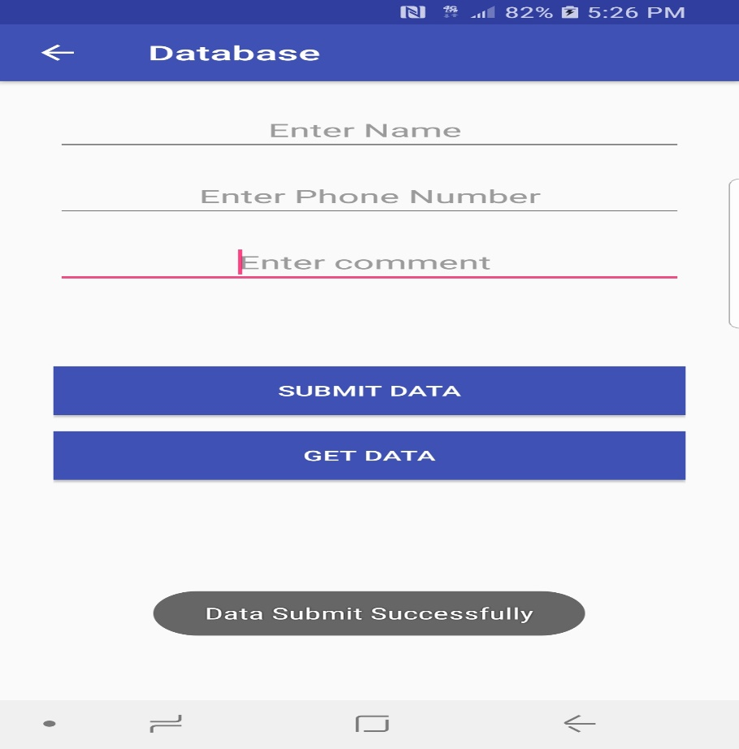

The corresponding code logic from android studio is displayed below.

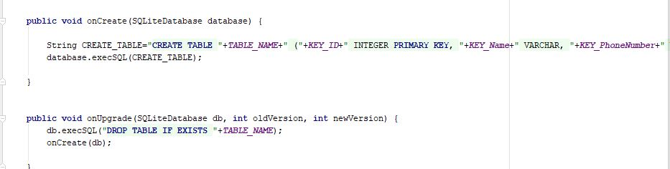

The above code shows us, how we created the data table with required column parameters.

Bottom block shows, how we drop the table if we wish to or if already exist with wrong data.

The following code snippet explains the insertion query and its results.

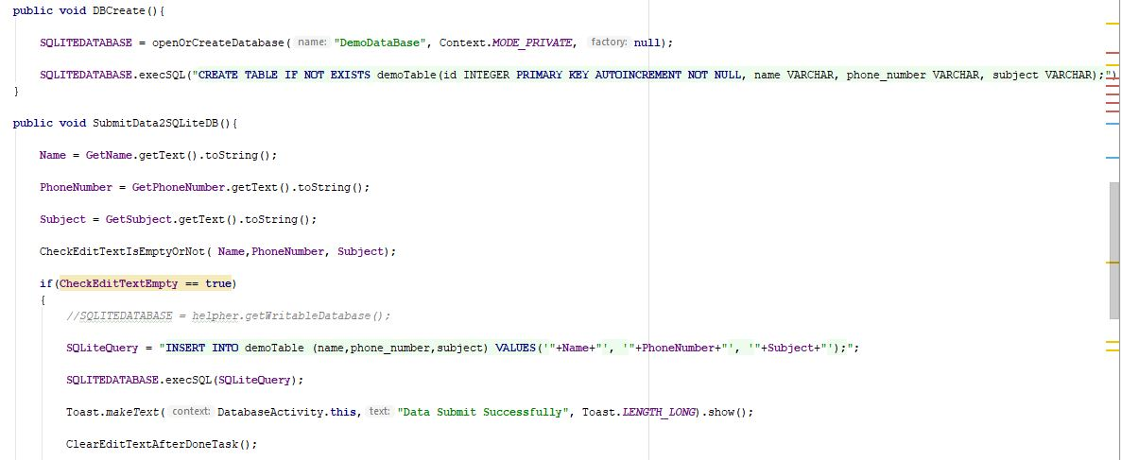

**Section-2: Service usage**

**Aim:**

To get in practice of consuming services given by third party entities or inbuilt/default services.

**Description of Work:**

Here We tried to implement sensor-based service especially touch sensor of the android device.

### Technical Section:

Majorly used technical skills.

* Android technology
* Core Java
* XML
* JSON

### Development Section

Here we have developed an activity that uses the service related to touch sensor. Actual implementation shows how the touch sensor works by drawing a line on the screen along with the fingertip.

The corresponding output screen shown below:

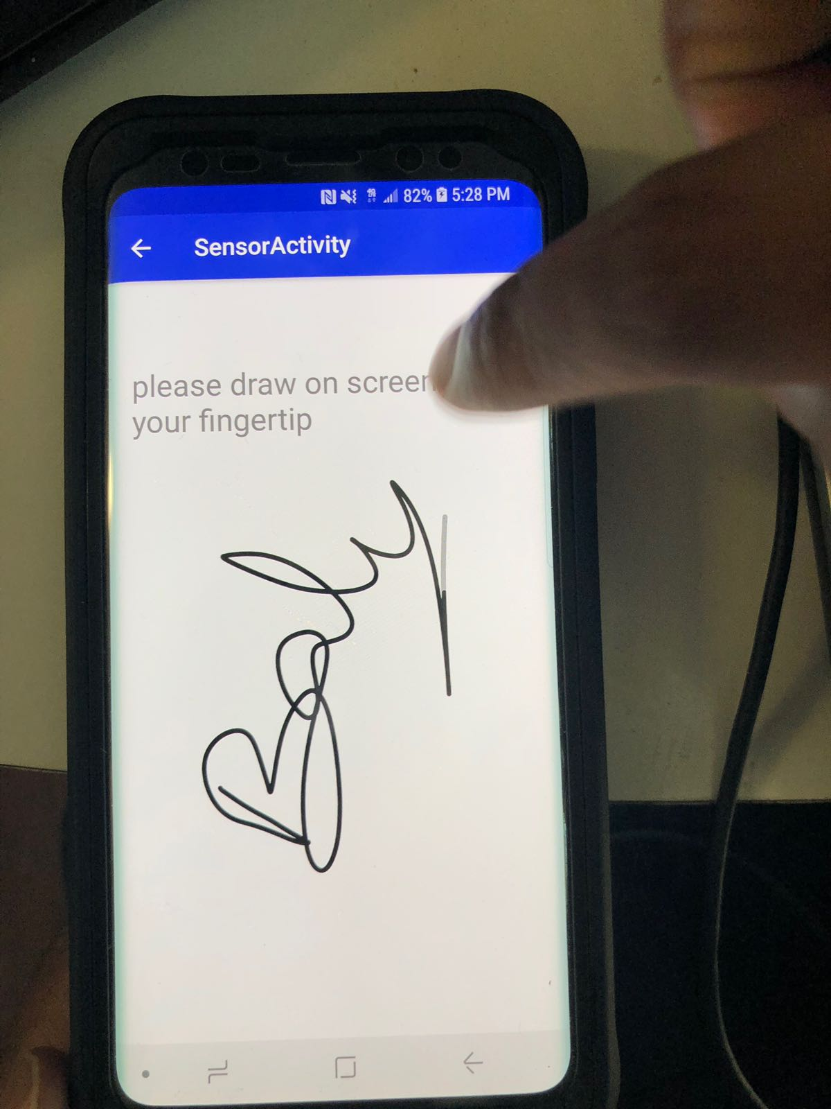

The corresponding code snippet from android studio is shown below:

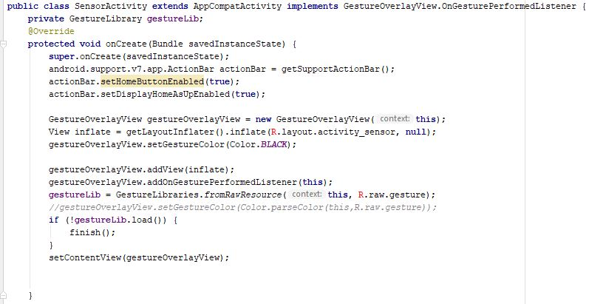

**Section-3: API usage**

**Aim:**

To get in practice of the Machine Learning/ Social Media

related API with android studio.

**Description of Work:**

Here We tried to implement Machine learning activities using API. This describes the usage of text recognition, facial expression recognition, barcode reader, label detector.

### Technical Section:

Majorly used technical skills.

* Android technology
* Core Java
* XML
* Machine Learning API

**Development Section:**

This activity contains a screen which will open the back camera first and based on our selection it performs the actions. If we selected the text recognition it displays the text found in the back camera, similarly if we try to use bar code scanner, it displays the bar code value, if we chosen the facial expression option it displays like smile, anger and more.

The input screen contains the text to touch, when user touches the text, it opens the camera to capture the background. Then at the bottom we can select the option that we need to experience.

The input screen:

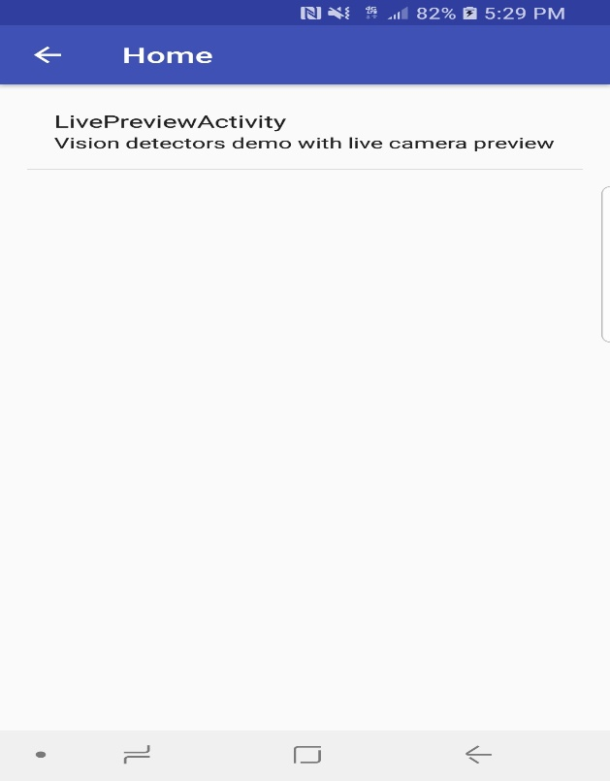

The following are the output screens and corresponding code logic snippet.

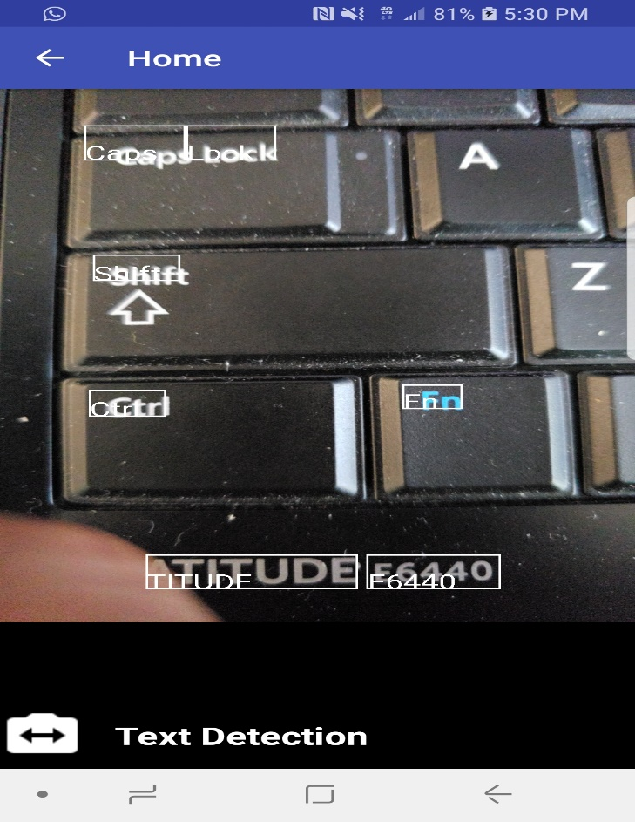

This is the text recognition output screen.

The following screen shows the barcode detection output screen:

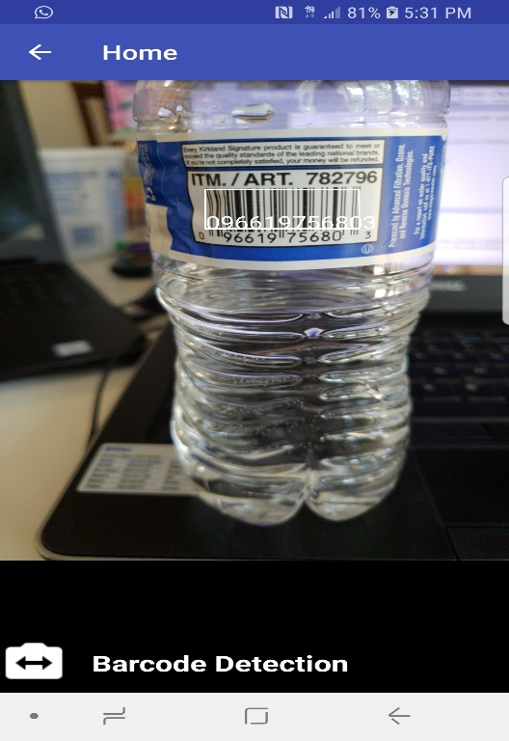

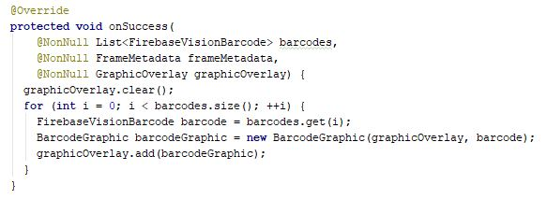

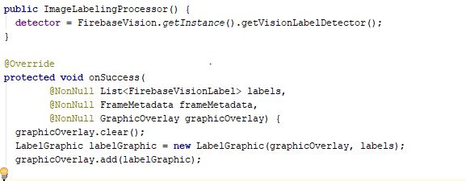

**Section-4: Layout usage**

**Aim:**

To get in practice of different layouts usage like implementing Grid layout, relational, inline and web layout.

**Description of Work:**

Here We tried to implement Grid layout in new activity, it displays the grid with full of default images, when user clicks on the any one of the grid image it displays the image in full screen.

### Technical Section:

Majorly used technical skills.

* Android technology
* Core Java
* XML
* GRID layout

**Development Section:**

This screen contains grid full of images, when user clicks on the grid image it is displayed in the new window.

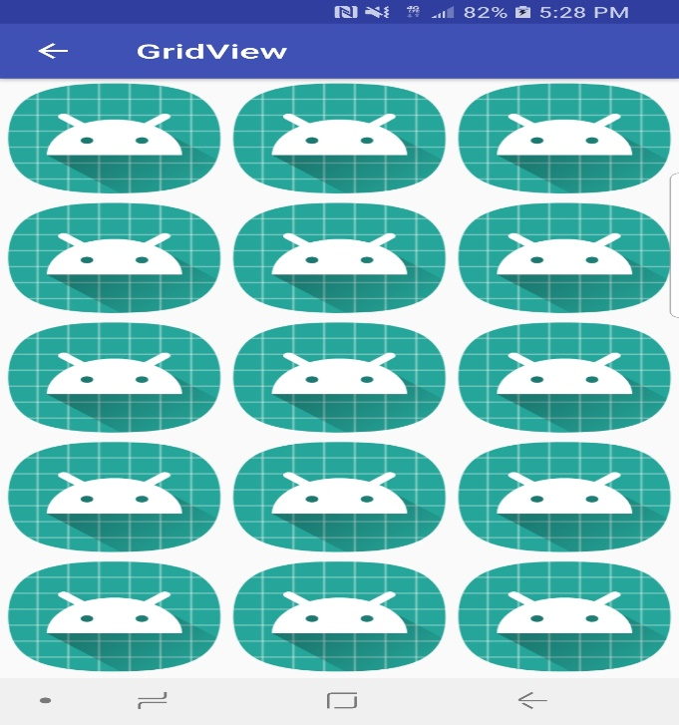

## The output screen shown below:

When the user clicks on individual image it displays in new activity.

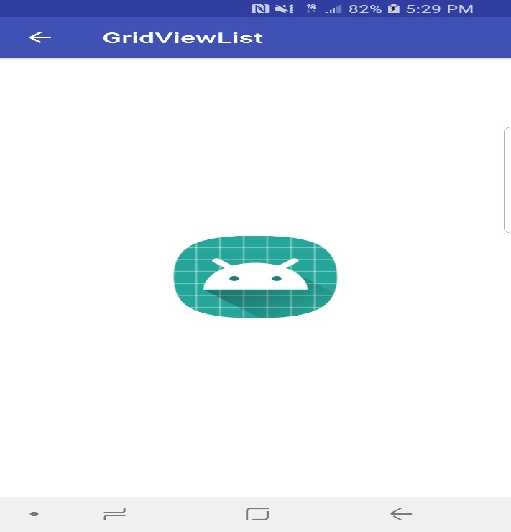

The corresponding code snippet from android studio shown below:

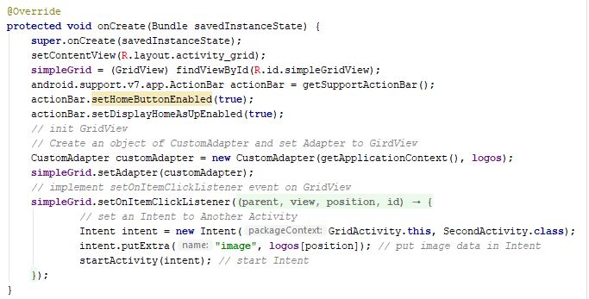

## GitHub LINK

[**https://github.com/bkkhf/Mobilelab2**](https://github.com/bkkhf/Mobilelab2)

**DEMO LINK**

[**https://youtu.be/xu3iUOdUcy8**](https://youtu.be/xu3iUOdUcy8)

References:

* [https://www.w3schools.com](https://www.w3schools.com/)
* <https://www.udacity.com/>
* <http://developer.android.com/guide/index.html>.

<https://www.coursera.org/courses?languages=en&query=android>

<https://developer.android.com/docs/>