CSEE5590/CS490 APS

Programming for Web/Cloud / Mobile Applications Lab Assignment 1

# COURSE REGISTRATION APPLICATION

BALACHANDAR KULALA

## (Student ID:12543027)

**Problem Definition**

The basic idea of the problem is to display the available courses in the school based on user selections. Also provide a registration for to enroll for the course.

**Aim of the problem**

The main goal of this application is, provide the ability to the students to assess the course before register to the it.

**Description of Work**

Creating a new web page that provides different levels of educational options such as semester wise(Spring/Fall/Summer), qualification wise (Bachelors/Master) and course wise (Computer science/Law) to display the entire details of the course work such as instructors, course description, prerequisites, credit hours, duration. Also provides the course rating based on previous semester students feedback. Provides the options for register the course. For this page provides two options like registration link and image that shows the course. The registration page displays total available seats and total seats. And it asks for student details such as first name, last name, student id, email address. After entering all these details, if you click on register button you will be registered for the course.

### Technical Section

**Majorly used technical skills.**

* HTML
* JavaScript
* jQuery
* CSS
* Bootstrap

### Development Section

This Application contains two main pages:

1. Index.html :

This the starting page of the application, this page displays the user selection options and results to the user.

The following image shows the home section of the application.

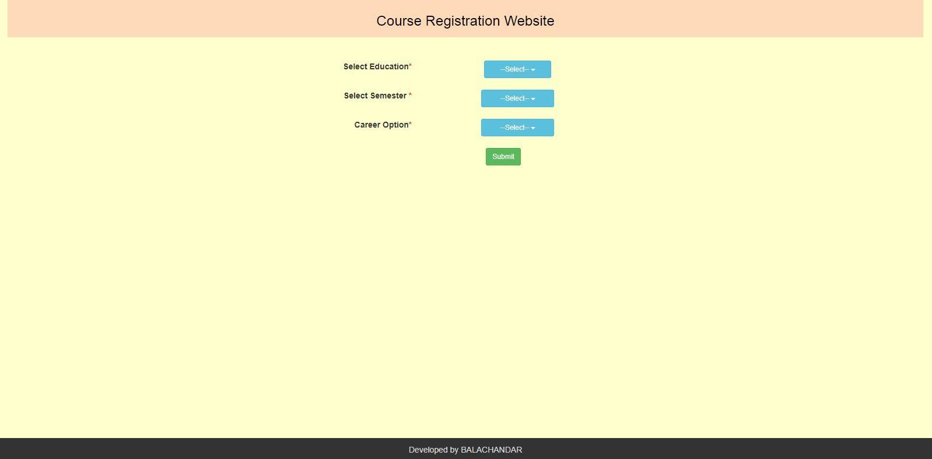

The sample code for this index page is displayed in following image.

The following code adds the values to Select Education, select semester dropdown lists. This is written in HTML. Each directive here includes css classes and styles.

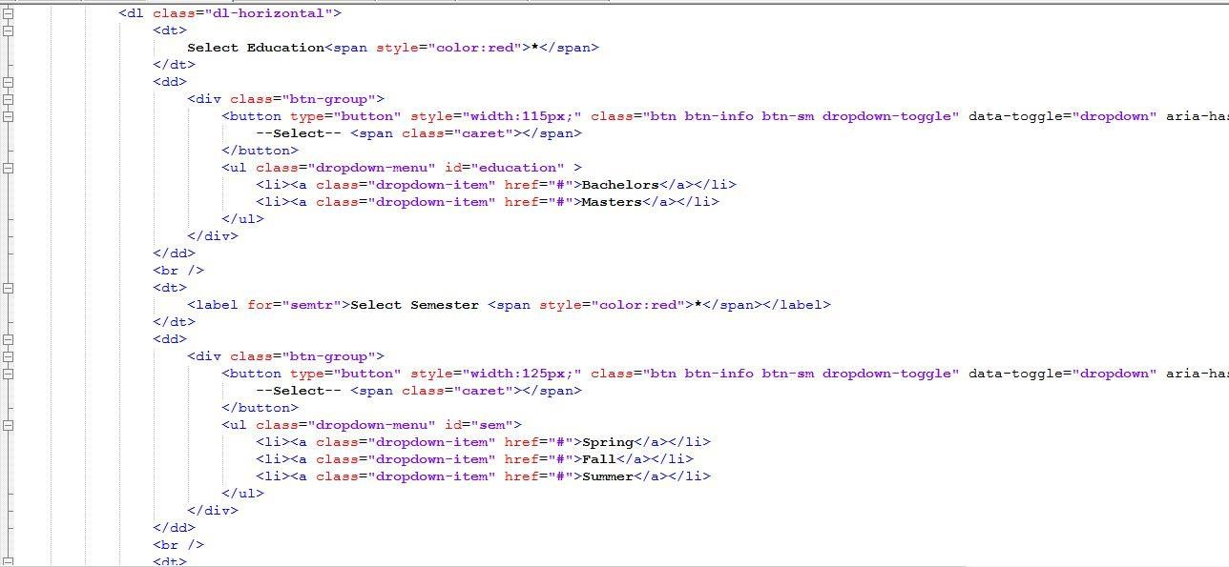

User need to select the three options to get the proper details. If not, it displays the error message as follows. To get proper results user should display all options properly.

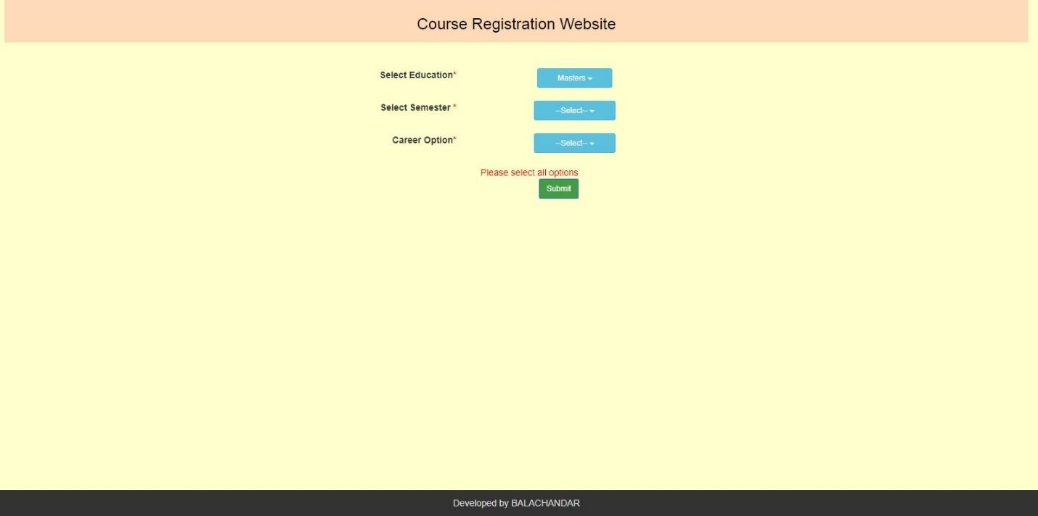

The jQuery and java script validation for this error message is shown below.

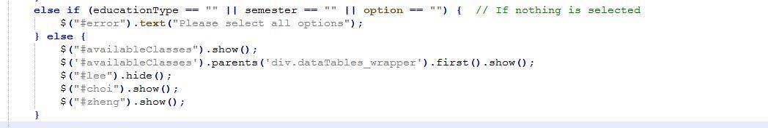

When the user enters all the details it displays the complete information about the selected course. The following image shows the complete results of selected course.

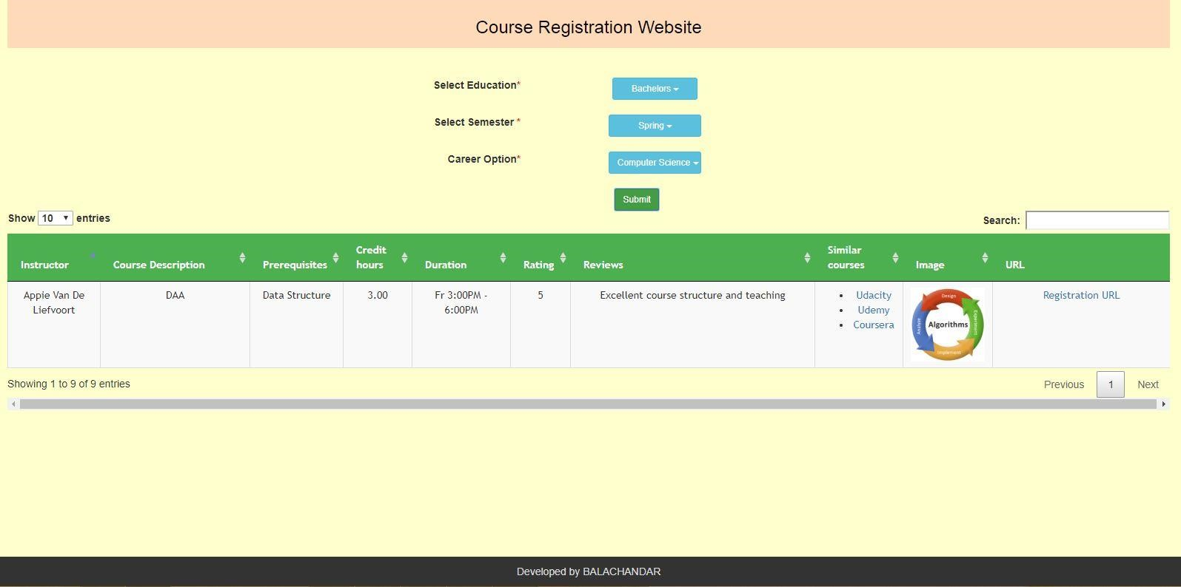

Here user selected the Bachelors, Spring, Computer Science options and clicked on Submit button it displayed the details. As part of testing entered the single record of values only. But the page can display 10 records by default. Also it has the ability to display 10,25,50 and 100 records as well by selecting the “Show” option in the left top corner of the grid view.

The following java script/jQuery function decides the display of the results.

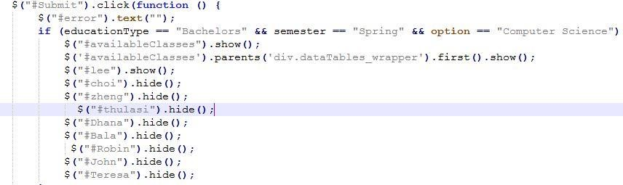

The following html section displays the exact results.

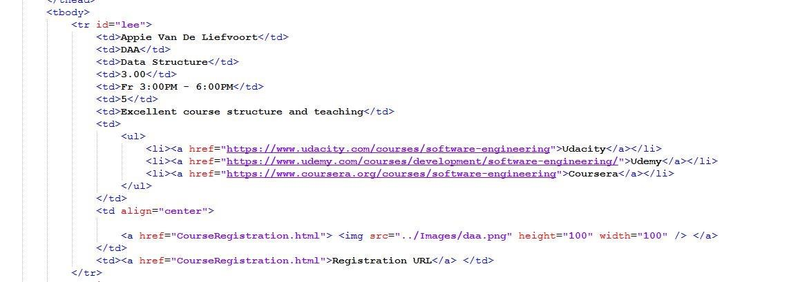

The displayed results have student registration links as well. Those links are available at the “Image and URL” section of the displayed results. (i.e. last two columns of the results).

This is shown in below figure.

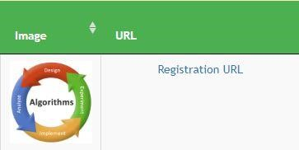

When the student clicks on either of these links, he/she will be redirected to registration page of that course.

2. Registration.html:

The registration page is shown below:

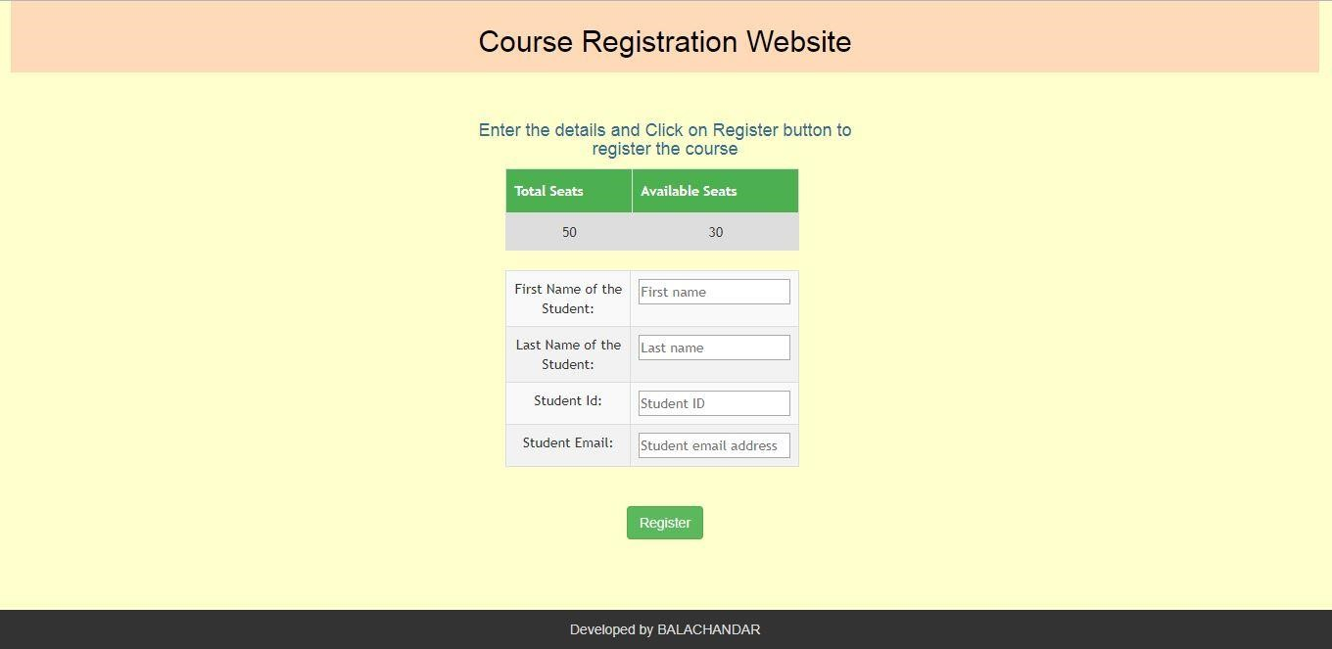

The registration page displays total seats and available seats count and asks to enter the student information for doing registration.

The following html code displays the registration table details, where students are required to enter their details for registration.

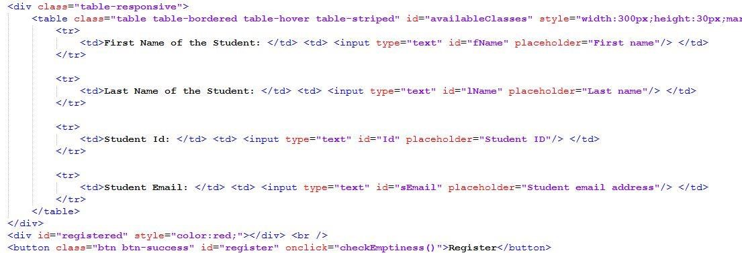

If he/she wish to register for the course, then they can enter all the details and finally click on submit button. It displays the success message and decreases the “available seats” count by one.

This is shown in below figure.

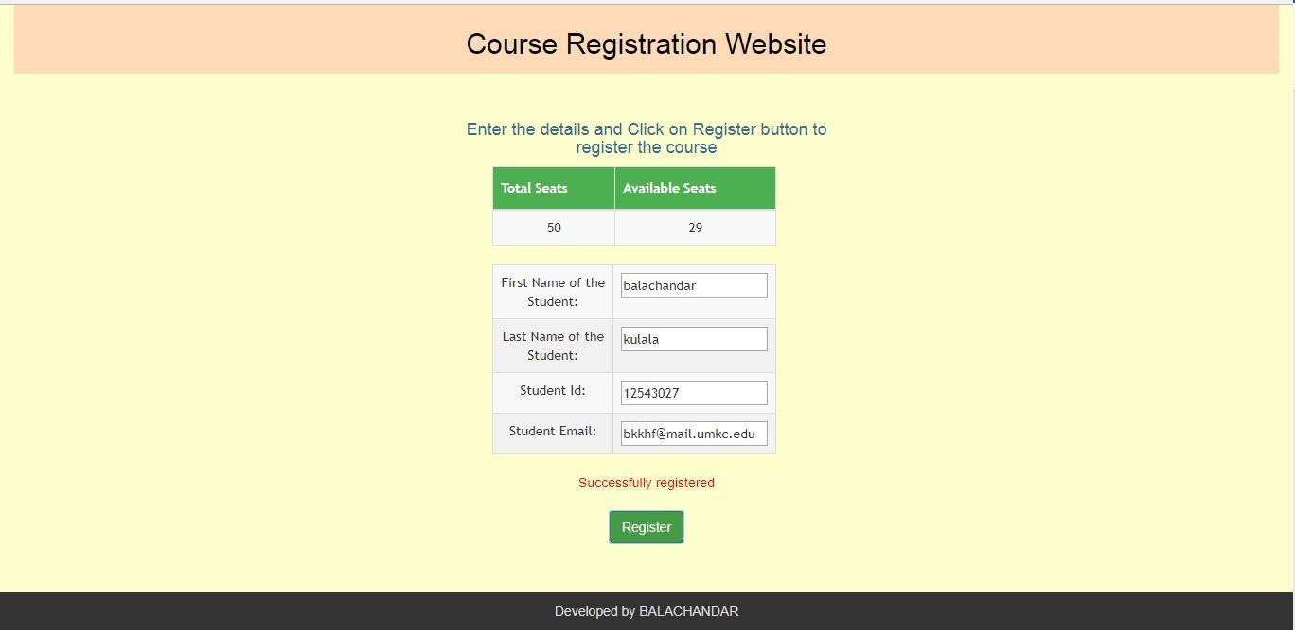

If user misses any one of the input details it shows an alert message saying that “enter required fields”.

This error message is shown below.

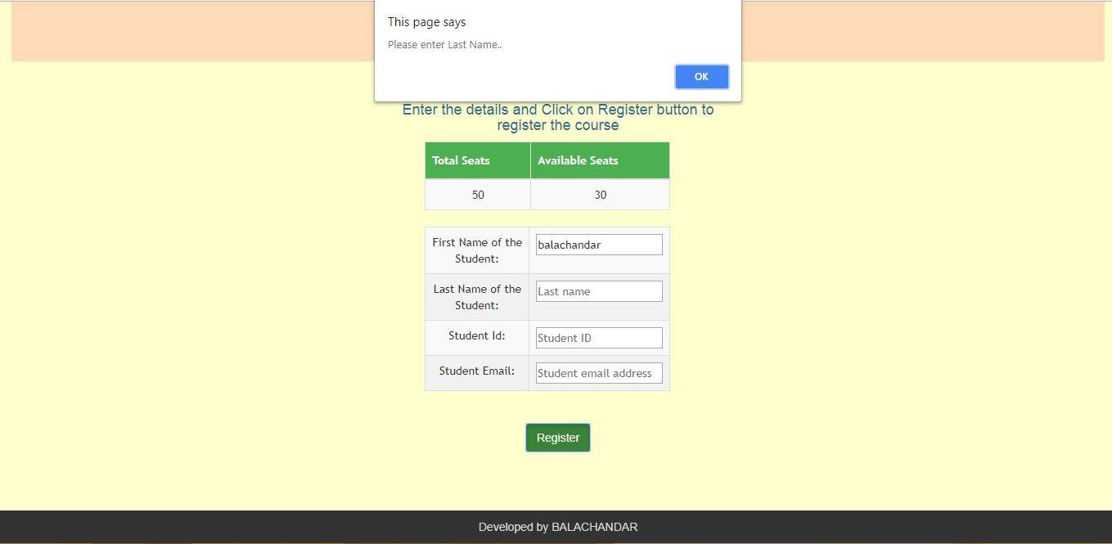

These validations are done using jQuery, which is shown in below image.

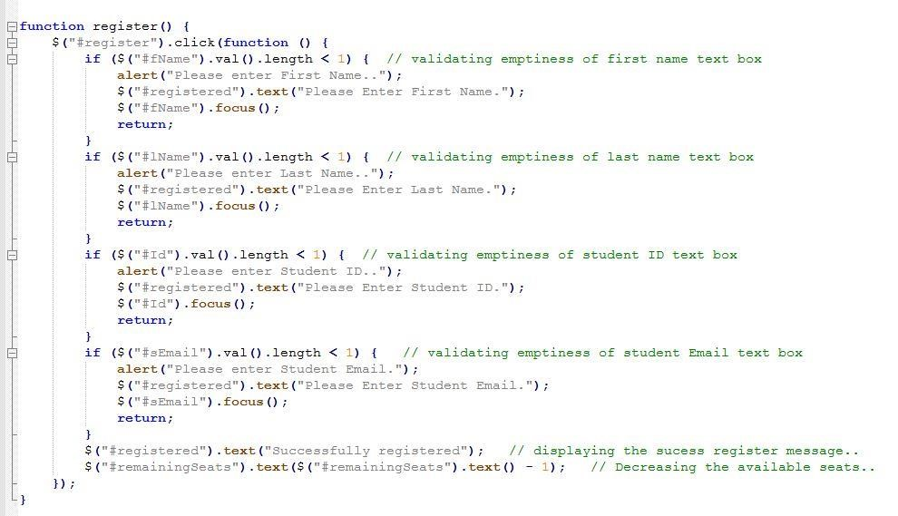

## GitHub LINK

<https://github.com/bkkhf/WebMobileProgramming/tree/master/Source/LabAssignmentWeb_1>

**DEMO LINK**

<https://youtu.be/udu-0yqlZ6Y>

References:

* [https://www.w3schools.com](https://www.w3schools.com/)
* <https://www.udacity.com/>
* [http://www.hongkiat.com](http://www.hongkiat.com/)
* [https://ariya.io](https://ariya.io/)
* [https://css-tricks.com](https://css-tricks.com/)
* [http://www.corelangs.com](http://www.corelangs.com/)
* <http://getbootstrap.com/>
* <https://jquery.com/>
* https://www.javascript.com/