Appendix A

Proportion of students in TWDL strands compared to other sectors in LAUSD
Overall, across the 144 schools with TWDL programs, enrollment in TWDL programs has lower proportions of Hispanic and Black students compared to non-TWDL strands in TWDL schools. However, the Hispanic proportion of TWDL enrollment (79.4%) is still larger than their share of the district enrollment (72.1%) because non-TWDL schools have lower percentages of Hispanic students (68%). Non-TWDL schools also enroll the greatest proportion of white students (13.3%). TWDL strands have greater proportions of Asian, white and multiracial students compared to their non-TWDL strands. Filipino students made up a very small percentage of TWDL enrollment (0.3%), smaller than the non-TWDL strands in their schools (0.9%) or in non-TWDL schools (1.9%). (Patterns are similar for 1st grade, see Figure A-2 below.)
In supplemental analyses to further understand the TWDL enrollment of Black students, we found there were fewer Black kindergarteners enrolling in TWDL each year, and many students enrolled in 2020-21 didn’t remain. In 2021-22, slightly fewer Black students entered TWDL compared to the year prior (162 compared to 174). However, many more Black students left TWDL between 2020-21 and 2021-22 (140) compared to the year prior (83). Of the 140 African American students who left a TWDL program between 2020-21 and 2021-22, half left the TWDL school altogether, and half remained in their school but left the program. Those 140 students left 53 different TWDL programs, illustrating that this decline in Black students is widespread, not limited to a few programs. These data may reflect the effects of the COVID-19 pandemic and its disproportionate effects on Black households and Black student decline in LAUSD generally.
In data not shown, the percentage of FRL students, and students whose parents had low educational attainment in TWDL programs remained similar over time. Because the TWDL enrollment overall was increasing, the number of students increased as did the share of students in TWDL programs in these groups. The percentages of FRPL students in TWDL was not statistically different from those in non-TWDL programs in their schools, but they were different (e.g., higher) than in non-TWDL schools. TWDL strands had lower percentages of students from households with low educational attainment.
In terms of EL status, while a slightly higher number of students, RFEP & EL are a lower percentage of TWDL in 2021-22 than two years prior. However, they still comprised 51.4% of TWDL students in 2022 compared to 44.4% in non-TWDL strands in TWDL schools and 35.1% in non-TWDL schools. Notably, while EL & RFEP were increasing in TWDL strands, they were declining in non-TWDL strands and non-TWDL schools.

Figure A-1: Proportion of school sector by race, all grades, 2022
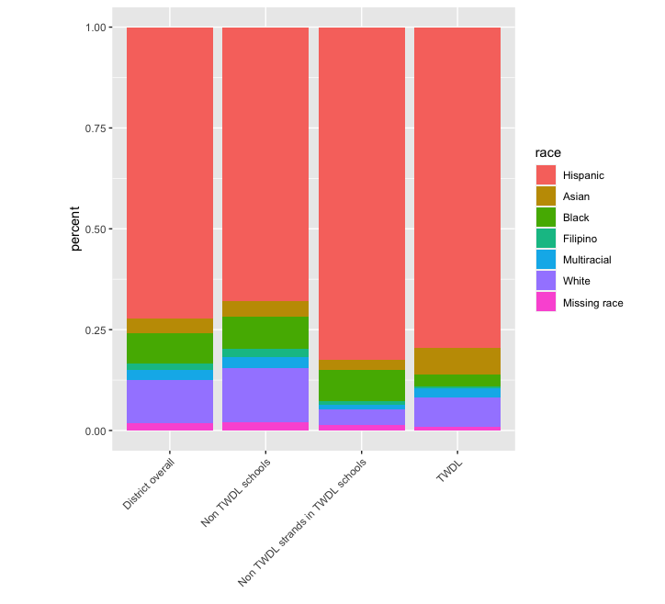

Figure A-2: Proportion of school sector by race, 1st grade, 2022
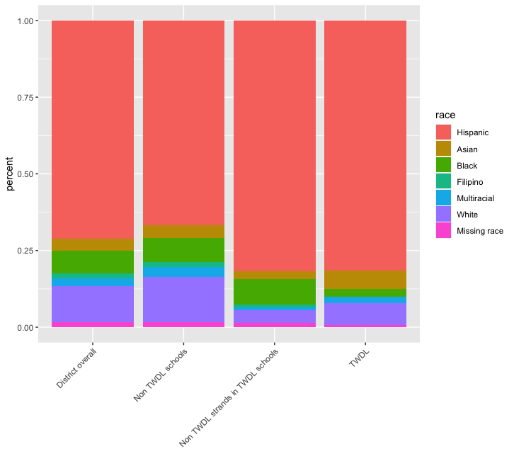

Table A-1: Number of students in group enrolled in TWDL programs, all elementary and 1st grade, 2019-20 to 2021-22
 | Number of group enrolled in TWDL |  |  | Number of 1st grade group enrolled in TWDL
 | 2019-2020 | 2020-2021 | 2021-2022 | 2019-2020 | 2020-2021 | 2021-2022
Hispanic | 12,501 | 13,945 | 13,582 | 2,846 | 3,206 | 2,711
Non-Hispanic White | 1,001 | 1,094 | 1,234 | 230 | 248 | 238
Asian-American | 1,187 | 1,263 | 1,143 | 225 | 217 | 197
African-American | 566 | 599 | 517 | 164 | 159 | 88
Filipino | 69 | 63 | 55 | <21 | <21 | <21
Multiracial | 358 | 424 | 404 | 58 | 84 | 67
English Learner | 5,626 | 6,181 | 5,921 | 1,403 | 1,576 | 1,277
Non-English Learner | 10,117 | 11,287 | 11,188 | 2,150 | 2,375 | 2,065
English-only | 5,983 | 6,939 | 6,846 | 1,434 | 1,727 | 1,451
Reclassified Fluent English Proficient | 2,848 | 2,833 | 2,870 | 407 | 247 | 298
Initially Fluent English Proficient | 1,277 | 1,484 | 1,460 | 307 | 400 | 315
FRPL | 13,054 | 14,696 | 14,191 | 3,029 | 3,343 | 2,795
Non-FRPL | 2,690 | 2,774 | 2,925 | 524 | 608 | 547
Homeless | 150 | 175 | 57 | 35 | 50 | <21
Total Count | 15,744 | 17,470 | 17,116 | 3,553 | 3,951 | 3,342

Table A-2: Percent of each group enrolling in Spanish and non-Spanish TWDL programs
 | % of group enrolled in Spanish TWDL |  |  | % of group enrolled in non-Spanish TWDL
 | 2019-2020 | 2020-2021 | 2021-2022 | 2019-2020 | 2020-2021 | 2021-2022
Hispanic | 6.17 | 7.50 | 7.51 | 0.49 | 0.56 | 0.56
Non-Hispanic White | 1.69 | 1.79 | 1.76 | 1.57 | 2.04 | 3.17
Asian-American | 2.16 | 2.47 | 2.04 | 9.64 | 11.10 | 11.05
African-American | 2.45 | 2.85 | 2.48 | 0.27 | 0.40 | 0.45
Filipino | 1.11 | 1.14 | 1.05 | 0.52
Multiracial | 1.84 | 2.20 | 1.91 | 3.89 | 4.97 | 5.36
English Learner | 7.11 | 8.69 | 8.34 | 1.03 | 1.10 | 1.13
Non-English Learner | 4.23 | 5.05 | 5.14 | 1.04 | 1.30 | 1.45
English-only | 3.47 | 4.19 | 4.08 | 0.85 | 1.07 | 1.24
Reclassified Fluent English Proficient | 6.36 | 7.67 | 8.86 | 1.25 | 1.56 | 1.66
Initially Fluent English Proficient | 5.99 | 7.46 | 7.89 | 2.28 | 2.81 | 3.10
FRPL | 5.67 | 6.77 | 7.15 | 0.78 | 0.91 | 1.03
Non-FRPL | 2.64 | 3.01 | 2.54 | 1.89 | 2.50 | 2.33
Homeless | 3.19 | 4.11 | 4.45 |  | 0.00 | 0.00
Total Count | 4.98 | 5.99 | 5.96 | 1.04 | 1.24 | 1.36
Note: Four schools have two TWDL strands: a Spanish strand and a strand serving another language. Our data do not distinguish which language program a student is enrolled in. This table considers all TWDL students in these strands as being in “Non-Spanish” programs so that numbers for “Non-Spanish” and “Spanish” TWDL programs sum to the total.

Table A-3: Number and percent of each group enrolling in TWDL by student FRPL status
 | FRPL |  |  | Non-FRPL
 | 2019-2020 | 2020-2021 | 2021-2022 | 2019-2020 | 2020-2021 | 2021-2022
Hispanic | 11,225 | 12,707 | 12,355 | 1,276 | 1,238 | 1,227
Hispanic | 6.85% | 8.20% | 8.70% | 5.36% | 6.86% | 4.69%
Non-Hispanic White | 556 | 635 | 663 | 445 | 459 | 571
Non-Hispanic White | 4.99 | 5.94 | 7.60 | 2.28 | 2.57 | 3.50
Asian-American | 642 | 656 | 563 | 545 | 607 | 580
Asian-American | 14.66 | 15.36 | 14.84 | 9.60 | 12.05 | 11.75
African-American | 450 | 481 | 378 | 116 | 118 | 139
African-American | 2.66 | 3.13 | 2.90 | 2.98 | 3.86 | 3.02
Filipino | 35 | 32 | 28 | 34 | 31 | 27
Filipino | 1.50 | 1.43 | 1.43 | 1.78 | 1.81 | 1.62
Multiracial | 97 | 123 | 102 | 261 | 301 | 302
Multiracial | 4.02 | 5.36 | 5.23 | 6.81 | 8.31 | 8.37
English Learner | 5,293 | 5,918 | 5,632 | 333 | 263 | 289
English Learner | 8.42 | 9.95 | 10.39 | 5.34 | 7.16 | 3.48
Non-English Learner | 7,761 | 8,778 | 8,559 | 2,357 | 2,511 | 2,636
Non-English Learner | 5.57 | 6.67 | 7.17 | 4.44 | 5.38 | 5.09
Total Count by FRPL status | 13,054 | 14,696 | 14,191 | 2,690 | 2,774 | 2,925
Total Count by FRPL status | 6.46 | 7.69 | 8.17 | 4.53 | 5.51 | 4.87

Table A-4: Number and percent of each group enrolling in TWDL by student EL status
 | EL |  |  | Non-EL
 | 2019-2020 | 2020-2021 | 2021-2022 | 2019-2020 | 2020-2021 | 2021-2022
Hispanic | 4,972 | 5,576 | 5,311 | 7,529 | 8,369 | 8,269
Hispanic | 7.99 | 9.71 | 9.40 | 6.02 | 7.25 | 7.46
Non-Hispanic White | 242 | 256 | 281 | 759 | 838 | 952
Non-Hispanic White | 7.25 | 8.98 | 9.94 | 2.79 | 3.26 | 4.31
Asian-American | 361 | 297 | 277 | 826 | 966 | 865
Asian-American | 14.66 | 15.48 | 15.01 | 10.91 | 13.09 | 12.65
African-American |  |  |  | 557 | 590 | 512
African-American |  |  |  | 2.71 | 3.24 | 2.95
Filipino |  |  |  | 61 | 58 | 55
Filipino |  |  |  | 1.60 | 1.61 | 1.66
Multiracial |  |  |  | 348 | 413 | 394
Multiracial |  |  |  | 5.70 | 7.10 | 7.24
FRPL | 5,293 | 5,918 | 5,632 | 7,761 | 8,778 | 8,559
FRPL | 8.42 | 9.95 | 10.39 | 5.57 | 6.67 | 7.17
Non-FRPL | 333 | 263 | 289 | 2,357 | 2,511 | 2,636
Non-FRPL | 5.34 | 7.16 | 3.48 | 4.44 | 5.38 | 5.09
Total Count by EL status | 5,626 | 6,181 | 5,921 | 10,117 | 11,287 | 11,188
Total Count by EL status | 8.14 | 9.78 | 9.47 | 5.28 | 6.35 | 6.59
Note: gray shading indicates sub-group did not total 21 students to meet data disclosure minimums.

Figure A-3: Percentage of students in the TWDL and non-TWDL strands of TWDL schools with multiple programs, 2022
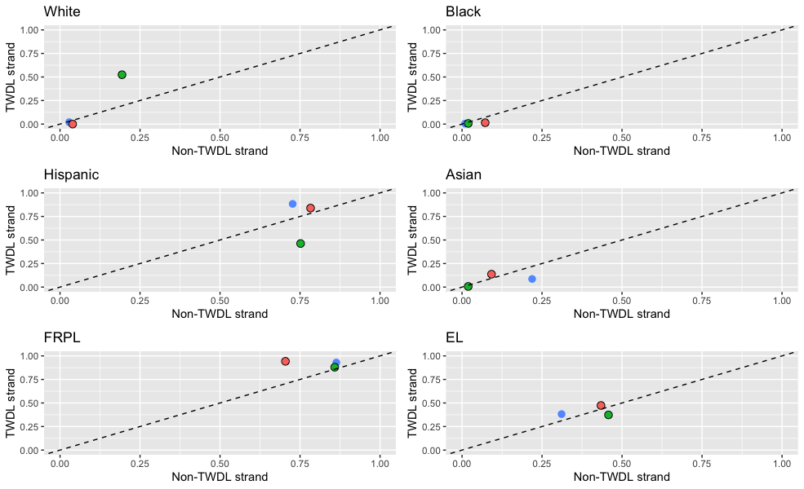
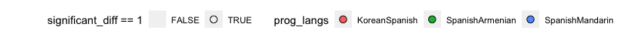

Appendix B: Exposure
Among all elementary students in LAUSD, reflecting national trends, students had differential exposure to students of their own race or other races (Author, 2019; authors, 2025). In 2022, white students, for example, were in schools that were 40% white, almost four times higher than their share of elementary enrollment (10.7%); Asian students also had disproportionately higher exposure to white students (24%) while Hispanic and Black students had much lower percentages of white students in their schools. By contrast, Black and especially Hispanic students had majorities of the enrollment who were Hispanic; Black students also, on average, were in schools with more than a quarter of students who were also Black, while the typical white or Asian student had just 5% of students in their schools who were white.
With this context, we sought to understand whether and how students’ racial exposure varied if they were in TWDL programs compared to non-TWDL students in their school, and as seen in Figure B-1, it does vary by TWDL program status and whether Spanish or non-Spanish focused TWDL program. At 72% of the enrollment, there was relatively less variation for Hispanic students among strands. As noted, they have high isolation districtwide, but especially so in Spanish TWDL strands (93% are Hispanic, on average). Hispanic students have lower exposure to Black students in TWDL strands compared to the non-TWDL strands in their schools. In non-Spanish focused TWDL strands, Hispanic students had higher exposure to white, multiracial and Asian students, while lower exposure to these groups in the non-TWDL strands of the schools (e.g., 20% Asian in TWDL compared to 8% in non-TWDL). Notably, this exposure, even in the non-TWDL strands, is higher than their share districtwide, suggesting differences exist at both the school and program level among schools housing TWDL programs.
Among Asian and white students, there were substantial differences in exposure for TWDL students, particularly in TWDL programs that were not Spanish, reflecting programs that had Asian languages (Mandarin, Korean, and Japanese) and the largely white Armenian population. In particular, both groups had high isolation in non-Spanish TWDL programs, 59% and 70%, respectively for Asian and white students. Interestingly, for Asian students, there were also differences in Spanish-focused TWDL programs as well (e.g., isolation at 40%, considerably higher than their 4% of enrollment) but much lower isolation in the non-TWDL strands of these schools. White isolation is also higher in Spanish-focused TWDL programs than the non-TWDL strands, where it is quite low, and both are lowest among all sectors, including non-TWDL schools, indicating greater exposure to students of other races. Asian and white students have lower exposure to Hispanic students in the TWDL strands than the non-TWDL strands in TWDL schools; Asian students’ exposure to Hispanic students was lower overall and for both, lower in non-Spanish TWDL programs. Exposure to Black students was low, but moreso in TWDL strands compared to their respective non-TWDL strands. Exposure to multiracial students was higher for both groups in non-Spanish TWDL strands than in non-TWDL strands (less so for Spanish TWDL strands). And, Asian students had somewhat high exposure to white students in non-TWDL strands of non-Spanish schools (21%).
Finally, among Black students, a relatively smaller group of TWDL students, they have the highest exposure to white students (as well as multiracial and Asian students) in non-Spanish TWDL programs, but very low isolation or exposure to Hispanic students in these programs compared to the non-TWDL strands in these schools. For Black students, there are less substantial differences in exposure between strands in Spanish-focused TWDL schools. Black isolation is highest in TWDL schools with a Spanish focus, and slightly higher in the non-TWDL strands of those schools with minimal exposure to Asian students. Exposure to white and Hispanic students is slightly higher in Spanish TWDL strands compared to these schools’ non-TWDL strands.
Taken together, in 2022, exposure varies between TWDL schools and not TWDL schools, by focus of TWDL program, and by strand within TWDL schools.
Figure B-1: Exposure rates by students’ race/ethnicity and strand type, 2022
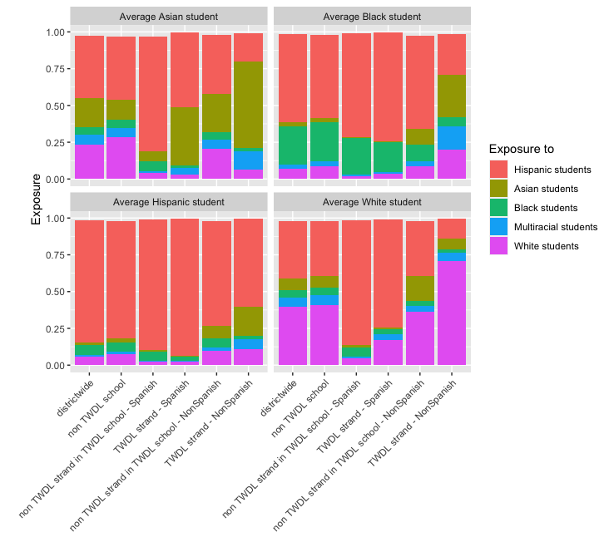
Note: Four schools have two TWDL strands: a Spanish strand and a strand serving another language. Our data do not distinguish which language program a student is enrolled in. This figure considers all TWDL students in these strands as being in “Non-Spanish” TWDL strands so that numbers for “Non-Spanish” and “Spanish” TWDL strands sum to the TWDL population.

Nearly 27% of students in 2022 were classified as English Learners. In each strand and the district overall, EL exposure to EL-classified students is higher than for non-ELs (Figure B-2). EL isolation in TWDL strand is highest (.42) compared to EL in non-TWDL strand (.35) or non-TWDL school (.34). Within TWDL strands, however, there is variation by linguistic focus: In non-Spanish schools, EL-classified students’ isolation is lower (.36), comparable to EL-classified isolation in the non-TWDL strands of those schools (.35). By contrast, EL-classified students’ isolation in Spanish TWDL strands is .43, considerably higher than .36 in non-TWDL strands of Spanish-focused schools. Overall, non-EL exposure to EL-classified students appears similar among TWDL and non-TWDL strands (.31) and is considerably higher than in non-TWDL schools (.21). However, this too masks differences by linguistic focus, where in non-Spanish schools, the EL-classified exposure in TWDL strands is quite low (.18) and is actually lower than EL exposure in the non-TWDL strands (.24), suggesting these programs may have fewer EL-classified students in them. EL-classified exposure for non-ELs in Spanish-language TWDL schools was similar between strands, and considerably higher than for non-Spanish schools; TWDL strands had slightly higher EL-classified exposure.

Figure B-2: Exposure rates by students’ language status and strand type, 2022
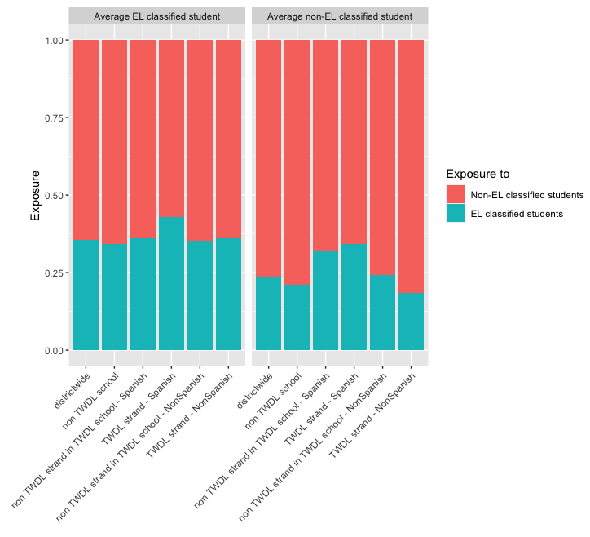
Note: Four schools have two TWDL strands: a Spanish strand and a strand serving another language. Our data do not distinguish which language program a student is enrolled in. This figure considers all TWDL students in these strands as being in “Non-Spanish” TWDL strands so that numbers for “Non-Spanish” and “Spanish” TWDL strands sum to the TWDL population.

In 2022, 74% of the district’s elementary enrollment was FRPL students. Districtwide, and in every school sector, FRL students have higher exposure to other students from low-income households than do their non-FRL peers (Figure B-3). The average FRL and non-FRL student in non-Spanish TWDL strands have lower exposure to low-income students than their peers in the non-TWDL strands in these schools. In Spanish-language TWDL strands, FRL students have higher exposure to low-income students—indeed the highest of any sector at 91% of students, on average—and higher than their FRL peers in the non-TWDL strands of their schools, 86%, on average. By contrast, the average non-FRL student in Spanish-language TWDL strands has lower exposure to low-income students compared to their peers in the non-TWDL strands, 71% and 83%, respectively. Students in TWDL strands that are Spanish language have higher exposure to low-income students than do students in non-TWDL schools, while students in non-Spanish TWDL strands have lower exposure. The variation is more pronounced for non-FRL students than FRL students. In data not shown because of the relative consistency of patterns over the three years examined, there were modest increases in exposure for low-income students in TWDL Spanish strands while exposure for low-income students to other low-income students in the non-TWDL strands in Spanish-language schools has declined.

Figure B-3: Exposure rates by students’ economic status and strand type, 2022
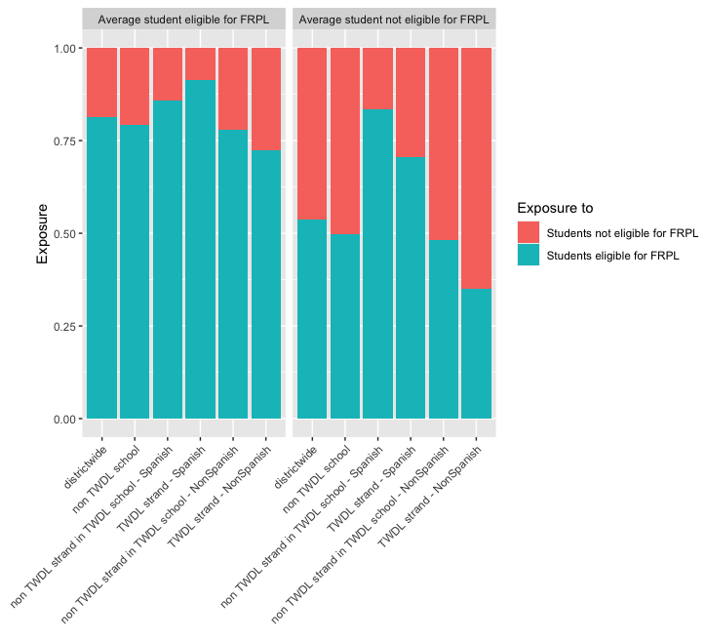
Note: Four schools have two TWDL strands: a Spanish strand and a strand serving another language. Our data do not distinguish which language program a student is enrolled in. This figure considers all TWDL students in these strands as being in “Non-Spanish” TWDL strands so that numbers for “Non-Spanish” and “Spanish” TWDL strands sum to the TWDL population.

