**1.5 Upload your first program**

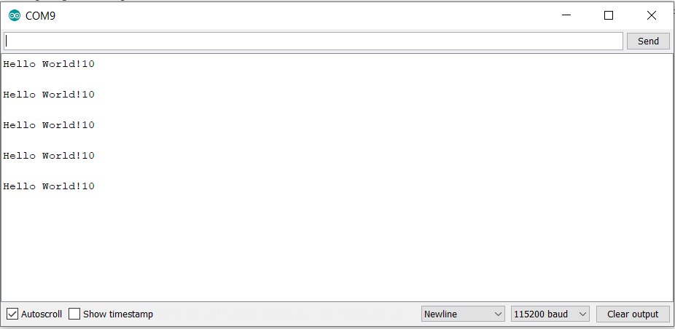

It pauses the program for the time specified, in milliseconds. During this time, no code is executed. A better alternative will be to use the millis() function instead. This function has more accurate timing, as it ensures the loop runs regardless of execution time, which is not possible with delay(). Another reason to use millis() is that it allows other code to be run at the same time, without pausing the entire code.

**2.3 Connect the electronics**

Diodes like LED have very small internal resistance, and if no external resistor is added to the circuit, the overall resistance is very small. Hence, if excess voltage is supplied above the LED’s roughly constant voltage, current will be very large as well, which will overload the circuit and cause the LED to blow. Hence, when a resistor is added, overall resistance increases, decreasing the current with the same constant voltage supply.

The equation to calculate the resistance of a resistor is given by:

**Resistance of resistor = (Voltage supplied – LED Voltage rating) / Desired Current level**

The potentiometer acts as a variable resistor, hence there is no need for another resistor. A potentiometer is not the same as a button switch. A potentiometer allows for a range of values as you slide or turn it from one end to another, while a switch only has 2 values, which is HIGH or LOW.

**2.5 Chatter and hysteresis**

An analog signal is a continuous signal represented by a continuous range of values while a digital signal is a time-separated discontinuous signal represented by discrete 0 and 1 values. An analog signal is represented by sine waves while a digital signal is represented by square waves. Analog signal bandwidth is low and gives observational errors, but digital signal bandwidth is high and does not cause any observational error.