Here is Module # 3 course project.

Here are the screen shots of the sample database and table using phpMyAdmin in your Microsoft Azure account. The screen shot shows the database with data that is related to your website. It also includes 4 columns and a primary key.

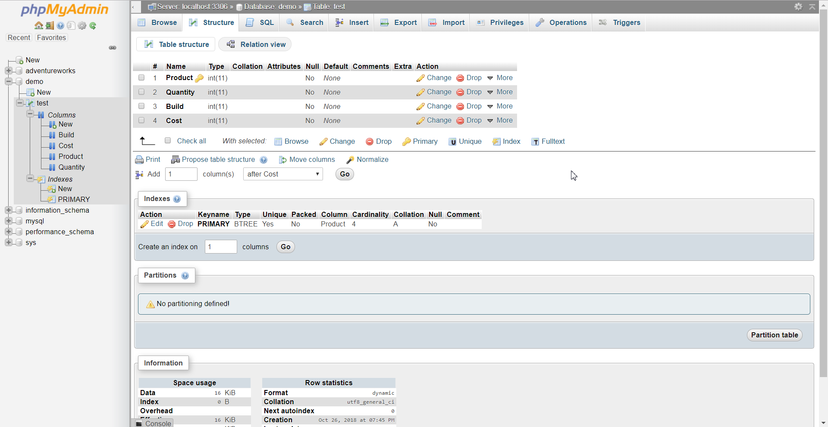

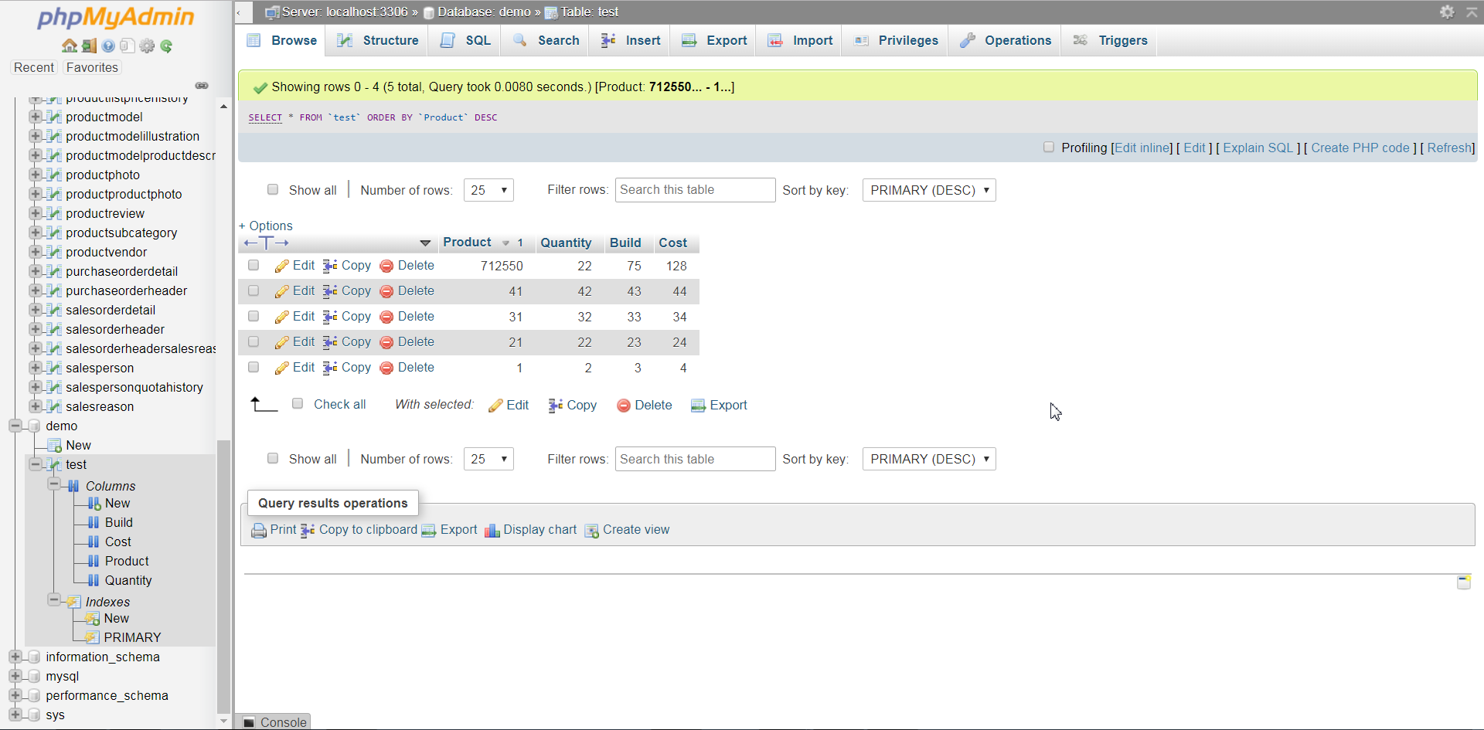

Here is the web page with responsive styling that displays the results of a query. This page displays the data from the demo database in phpMyAdmin with the sample table that was created.

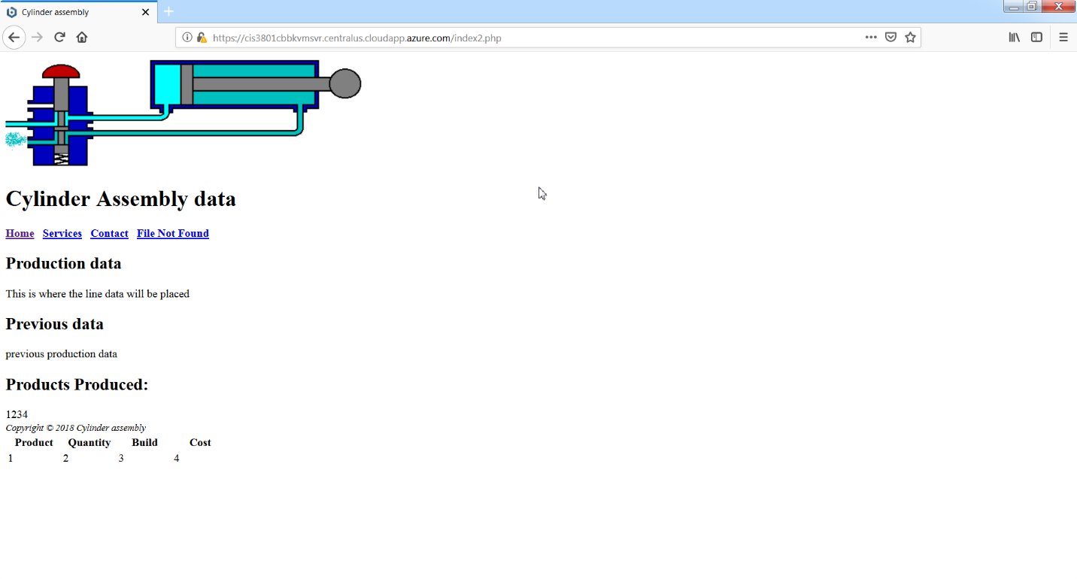

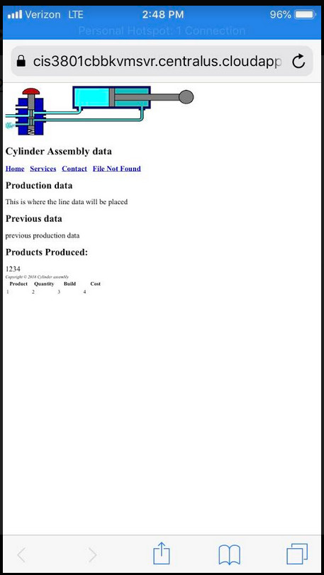

Here is the URL to the website. <https://cis3801cbbkvmsvr.centralus.cloudapp.azure.com/index2.php>