Module 4 screen shots

Here is the URL to the website. <https://cis3801cbbkvmsvr.centralus.cloudapp.azure.com/index.html>

Pc screen shot

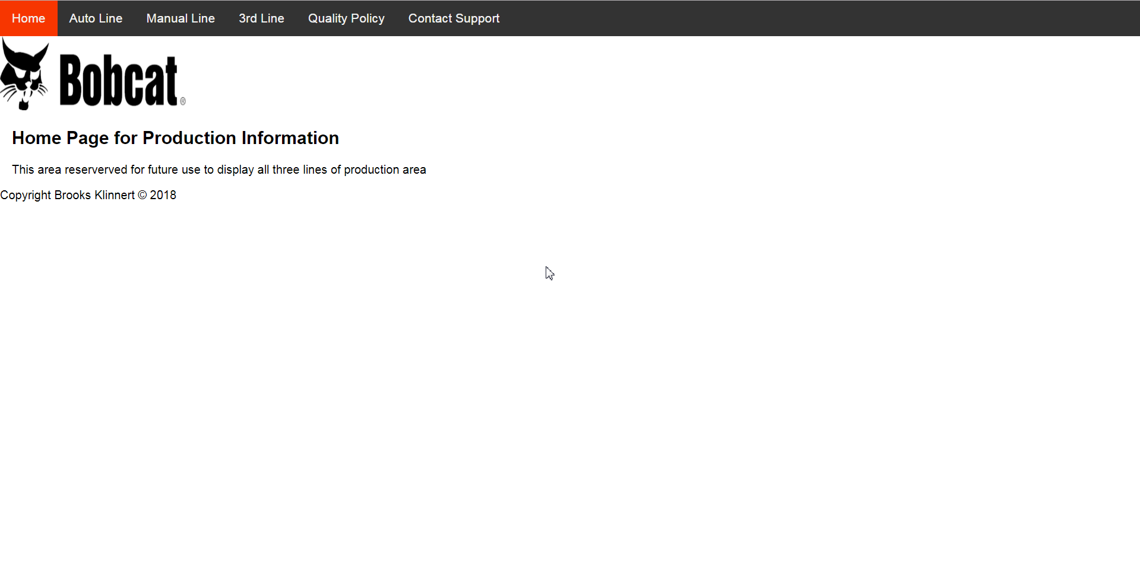

GalaxyS5 screen shot

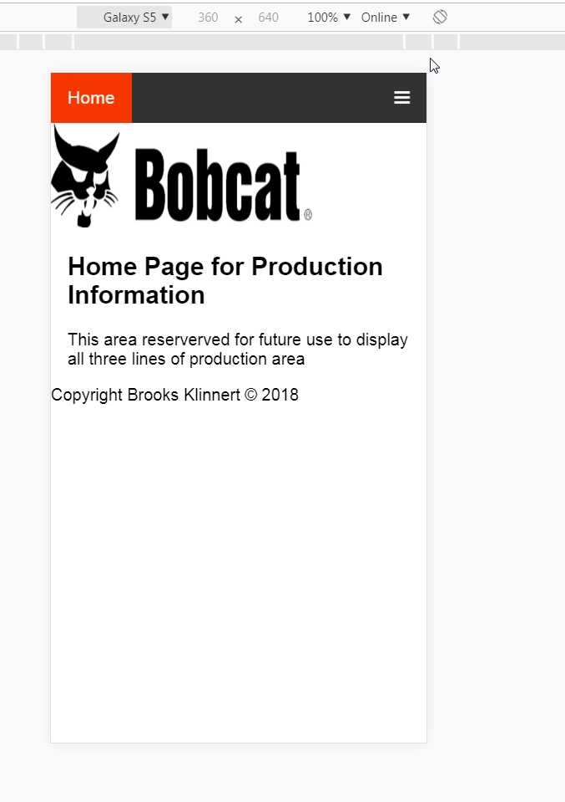

iPhone 6 screen shot.

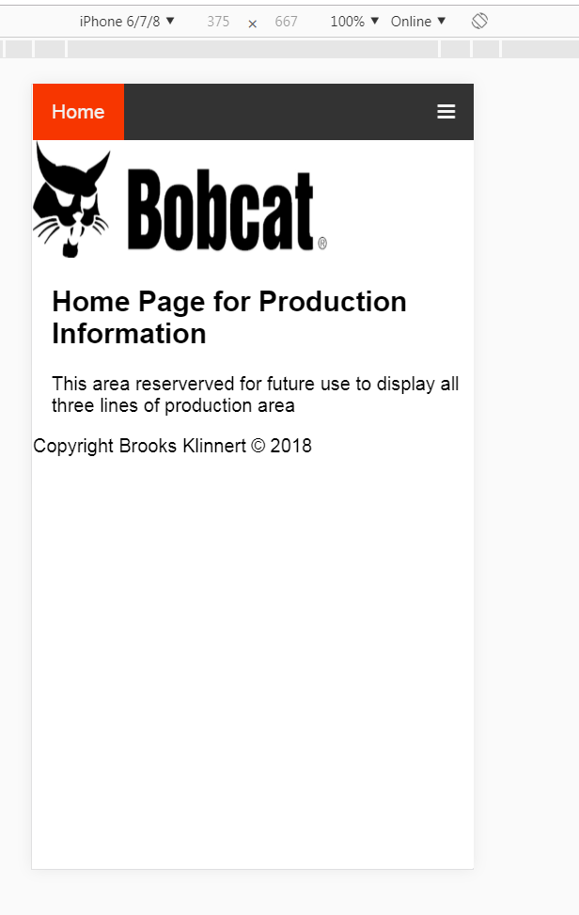

iPad Pro screen shot

