Benjamin Knauth

CMSC 405

Final Project

14 December 2014

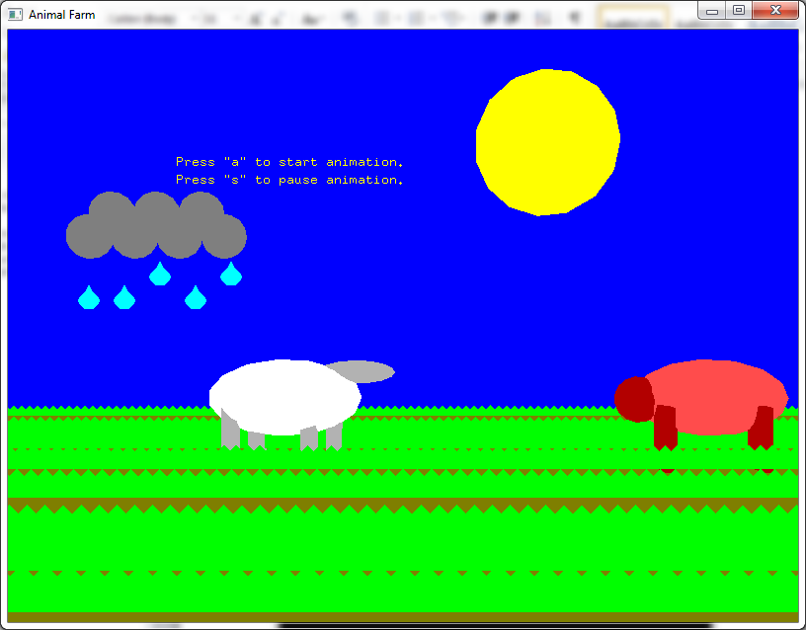

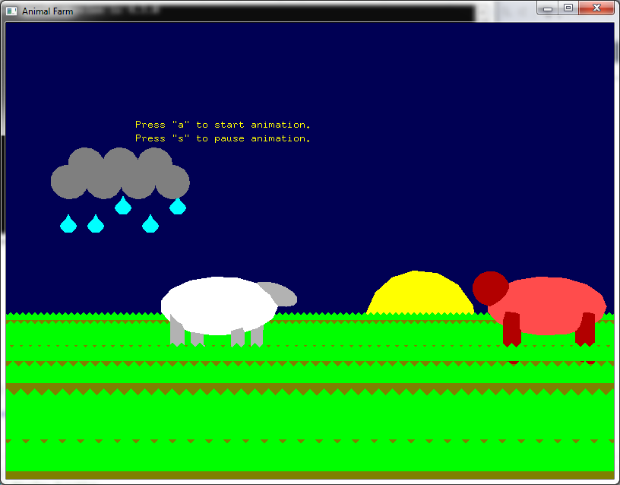

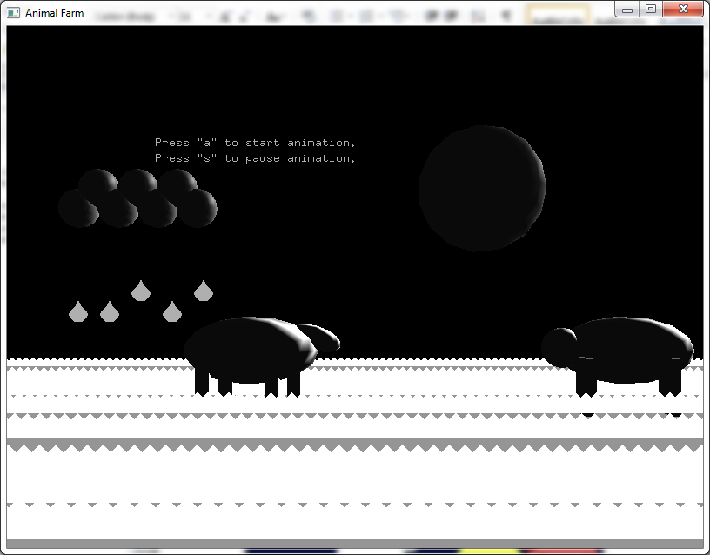

Description:

This is a simple animation to display various lessons learned during this course. Triangles were used on top of a 2D square as learned early in the course to portray grass in a 3D environment. A Bitmap was used to create a 2D raindrop. I used the equation for gravity to display these rain drops falling from clouds. I created a sheep and a pig to display their heads moving to exemplify transformations. I used the sun to display a shift in night and day. This allowed me to show a simple transformation, and incorporate lighting effects at night. I came up with this idea piece by piece using past projects as guides. I started with the idea of showing the sun setting and shifting to night fall. This would cover many of the transformation requirements and allow for a shift in colors. Next I needed something to represent a physics equation and a bitmap item to show this equation in action. Raindrops seemed appropriate. So I created clouds and a bitmap raindrop that repeatedly drops from these clouds. Next I wanted to show 2D shapes, so I came up with the idea of a rectangle with triangles used to represent grass. In a previous project I tried to create a 2d rectangle at an angle against the z-plane. This created headaches, so I decided this rectangle would stay perpendicular to the z-axis. Next I wanted to show rotational transformations, as these are the most difficult transformations to pull off. I created a pig first as a template, then created a sheep whose head I could rotate before lowering to eat grass. The last thing I worked on was lighting. The fact that enabling lighting kills all the color settings made this challenging. Then I realized I could enable lighting when the sky turns completely black to simulate the black and white look of nightfall. The light source is meant to move with the moon. I couldn’t figure out how to light up the moon itself, which I am frustrated by. Future enhancements would include making each raindrop move independently, adding a bit more detail to the pig, and figuring out how to light the moon up so it doesn’t look like it’s in a lunar eclipse.

Running animation:

Load the code up in Visual Studio, compile and run the code. “a” starts the animation and “s” pauses the animations. The animation will continue with the sun turning into the moon and back again indefinitely.