1. *Given the 2 end points shown on the graph below, determine the slope, y-intercept and give the slope-intercept formula. Determine one additional point that would be on that line using the slope-intercept formula where the x value would be greater than 6.*

(3, -10), (6,4)

Slope = m = (4 – -10 / 6 - 3) = 14 / 3

y = 14/3x + b

4 = 14/3(6) + b

b = -24

y = 14/3x – 24

y = 14/3(9) – 24

= 18

(9, 18) is a point on this line.

2.



It is important to know the location of objects in relation to each other. The world plane in essentially be considered the plane separating the real world outside of the monitor from the virtual world behind the monitor (not trying to be sci fi with my explanation). Knowing P4 is behind the plane is important, because otherwise the P4 will not be visible to the user.

3.

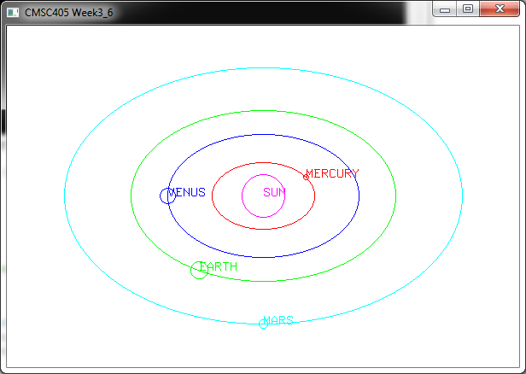

<http://www.solarviews.com/eng/solarsys.htm>

I used this website (cited in the class pdf) for determining the radius’ representing the rotations for each planet and the size of each planet. Both the size of the planets and the size of their orbits are based off the Earth (except the Sun). For example, I set the Earth’s orbital radius to 100.0 from the center of the sun. Mercury is .39 of Earth’s distance from the Sun, so I set its orbital radius to 39. Similarly, I set the radius of the size of Earth to 10. Mercury is .38 the size of Earth, so I set its radius size to 3.8. I originally tried to make the picture twice as large, but the elliptical orbits turned into strange shapes on a larger scale, and I could not figure out why.

4.

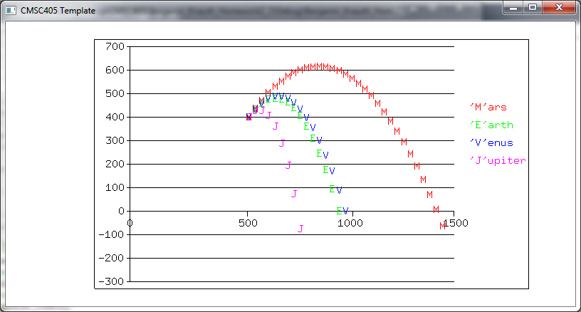

http://www.smartconversion.com/otherInfo/gravity_of_planets_and_the_sun.aspx

This site was used to determine gravities for each planet.