

2.

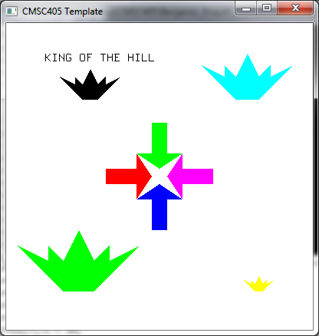

3.

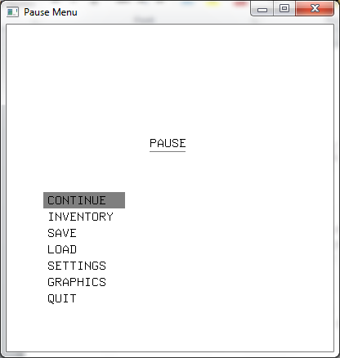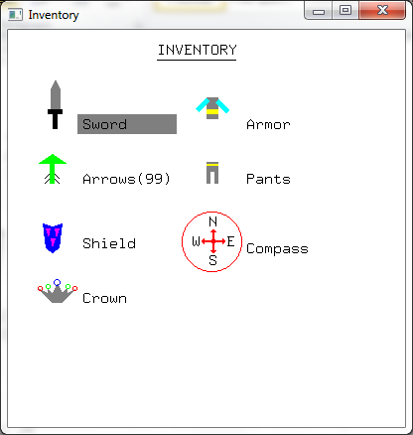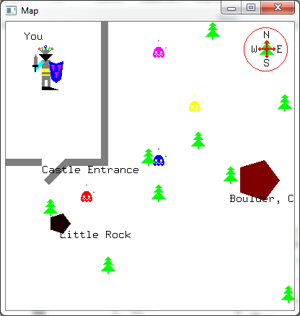

Game Concept:

This game will essentially be a Legend of Zelda clone called *King Knuth.* Like Zelda, the game will involve exploring and killing monsters around King Knuth’s kingdom. Unlike Zelda, the inventory will focus on replacing old items with new items instead of simply trying to collect more and more items (boomerang, grappling hooks, etc). The King will always have a sword, armor, pants, shield, and crown, and arrows. The bow never changes, but the types of arrows do. The game is more like Diablo than Zelda in this respect, as the goal is to constantly try to upgrade these items. There are even different types of compasses that reveal different aspects of the map. Some will reveal enemies, some will reveal location names, some will reveal locations for rare items. This is not a rogue-like. Like Zelda, it will feature a permanent map, with specific locations for items. The map will be critical for navigating the landscape, but never reveal too much. The idea is that is points out specific items nearby the player, not give a world view. This example shows enemies and locations which may hold items, but an actual game compass would only reveal one of these. The King can store items in his castle that he is not using, but he cannot carry extra items on his body while out exploring. Any time he finds a new item, he will have to choose which to carry, and the unchosen item will magically go back to his castle.