Benjamin Knauth

CMSC412 - Alin Suciu

Final Project

10May2014

This project simulates a Demand Paging Virtual Memory (DVPM) machine in Java. It allows the user to input a number of variables representing pages into a reference string (a virtual representation of a sequence of pages), then swaps these pages into virtual representations of physical frames, using various algorithms that are similarly used in demand paging. The three algorithms used are First In First Out(FIFO), Optimum page replacement(OPT), and Least Recently Used(LRU). There are 5 physical frames labelled 0-4 and 10 virtual memory frames labelled 0-9. The FIFO algorithm uses a Linked List to accurately simulate the algorithm. It proved to be the simplest data structure for adding pages to the top of the queue and removing from the bottom. An Array List was used for the OPT and LRU algorithms, as this was the simplest data structure for filling in null physical frames, then swapping out specified frames within the list for frames in the reference string. OPT and LRU use very similar algorithms, as LRU essentially does the same thing as OPT except looks backwards instead of forwards.

The program itself is based off a loop that allows the user to switch between 6 options. 0 Exits out of the program safely. 1 allows the user to create a reference string. First it asks for the length of the reference string. Then it loops through this length until all the user’s pages are entered. Selecting 1 again overwrites any old reference string. 2 generates a random reference string. Like 1, it asks for a number of pages from the user. 2 loops through this number, generating a new random page for each iteration, and storing it in the reference string. Like 1, using 2 more than once erases the old reference string. Whatever pages exist in the reference string, 3 will display it for the user in a readable format. 4-6 are the FIFO, OPT, and LRU algorithms, respectively. They commit nothing to memory, so they can be used over and interchangeably on the same reference string without having to reenter the reference string.

What follows are screenshots of the program. The pages 0 1 2 3 4 5 6 7 8 9 0 9 1 8 2 7 3 6 4 5 are entered into the reference string. This reference string is run through all three algorithms. Also, functionality is stressed by testing the program’s input validation throughout the program.

**Test Read Input**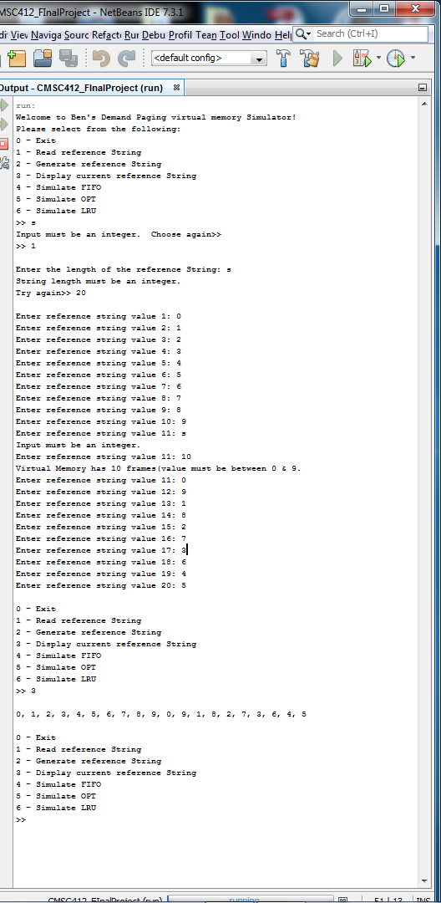

**Test FIFO**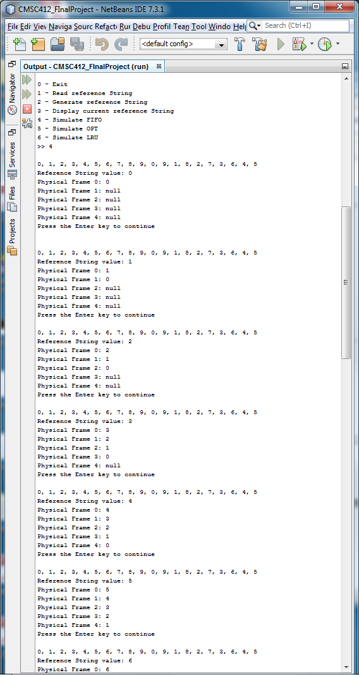

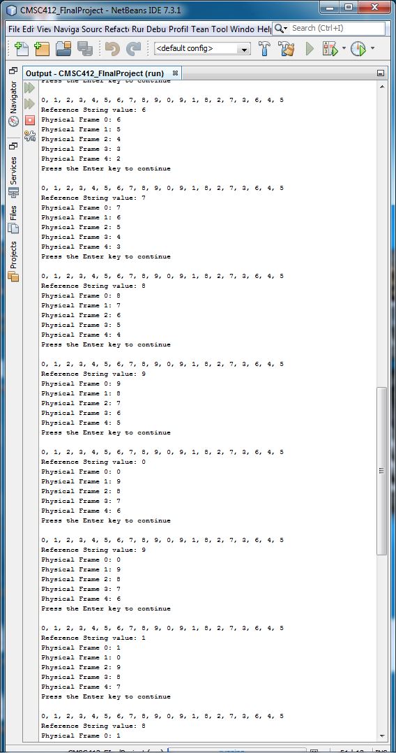

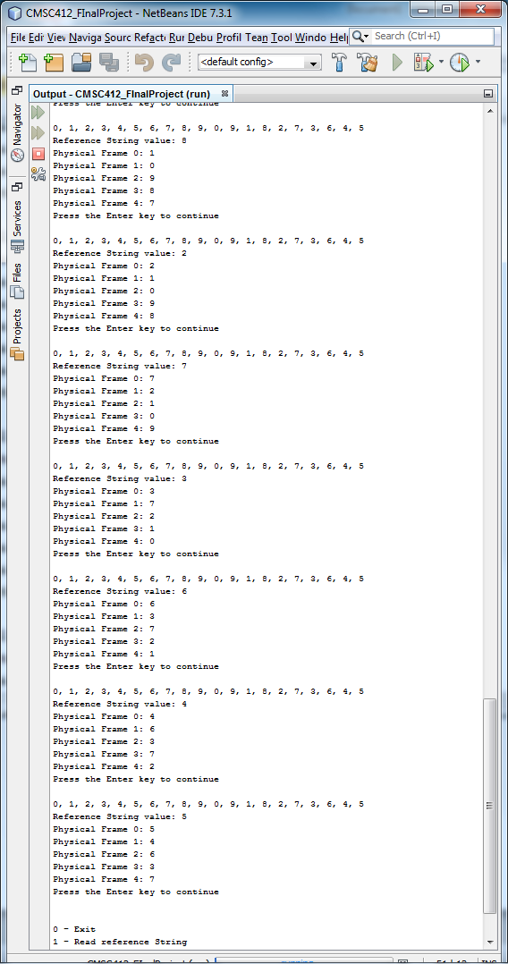

**Test OPT**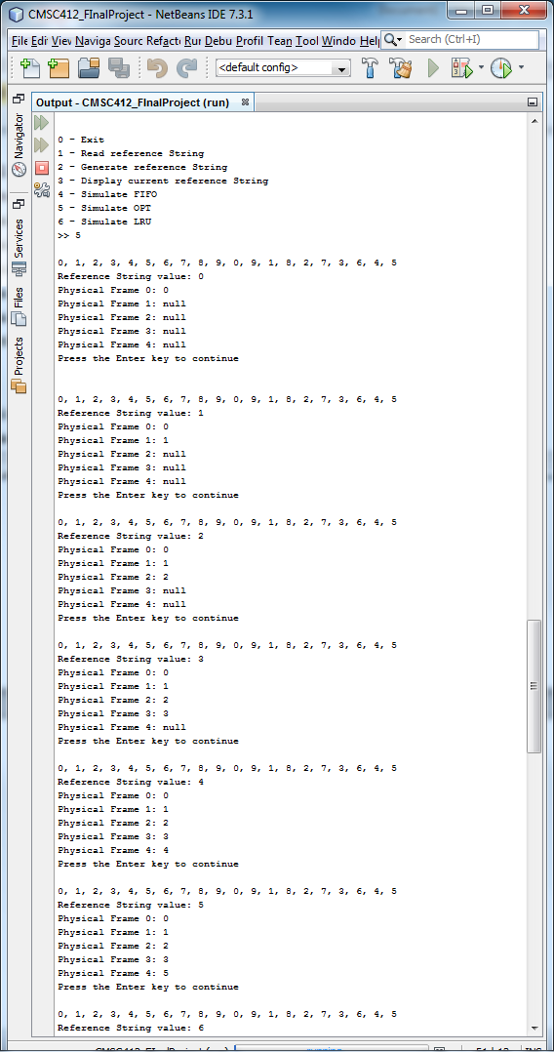

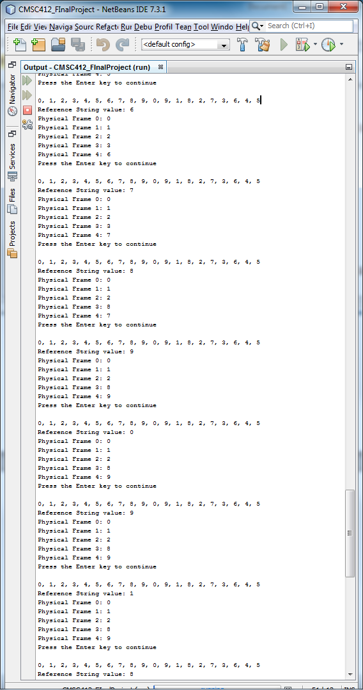

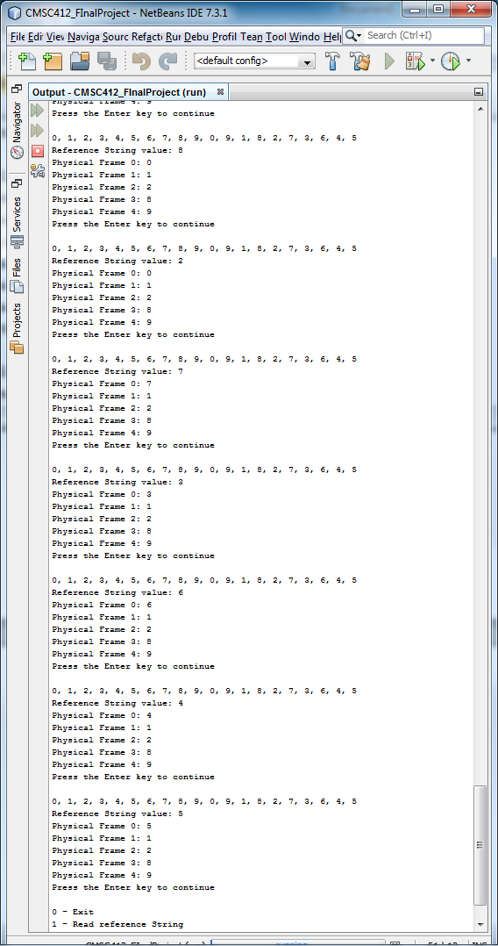

**Test LRU**