# Book Popularity System App

**SWEN 5239 - Agile Software Development**

Sadia Alam

Eric Prieto

Stefan Gamero

Angel Vazquez

**Feature 1 Documentation**

## UNIVERSITY OF HOUSTON CLEAR LAKE

02/17/2023

## Table of Contents

Introduction ………………………………………………………………… 2

Statement of the Problem ………………………………………………………………… 2

Research Questions ………………………………………………………………… 2-4

Intent of the Study ………………………………………………………………… 5

Methodology ………………………………………………………………… 5

Timeline ………………………………………………………………… 5-6

References ………………………………………………………………… 6

## List of Tables

Table 1. Description of attributes …………………………………………………………. 3

Table 2. Sample Data Example ………………………………………………………… 4

Table 3. Defined project timeline ……………………………………………...………….. 5

## List of Figures

Figure 1. Scrum board assignment of tasks ………………………………………………… 6

## Introduction

Physical libraries and bookstores lack the ability to provide clients with access to other readers' reviews. This application enhances the ability for readers to close the gap between a popular book and a non-popular book. Book Review System will also display readers when a book is available and in what format (see Format Example Values). This application can serve as a companion application for people that frequent local bookstores and online readers.

## Statement of the Problem

The increasing demand to conduct all things from the comfort of your home has resulted in the need for an application that can efficiently recommend books of interest based on certain search criteria. Globally, due to the Coronavirus disease-19, 35% of people are reading more, and 75% of Americans are reading at least one book annually (Basmo, 2023). Furthermore, between 2019 and 2020, over 250 million apps were downloaded daily, and it is expected that by 2024 there could be over 500 million apps downloaded daily (Flynn, 2022). The application will address the availability, format, and review ratings of the recommended books. It will meet the growing needs of the digital community with recommendations in a continuously expanding library.

## Research Questions

What are we trying to predict?

Which book is most popular/best seller using various attributes given in the dataset? Popular

Which book is not popular or best seller using various attributes given in the dataset? Unpopular.

What are the attributes and its variable types?

| **Attributes** | **Data Type** | **Example Values** |
| --- | --- | --- |
| BookTitle | String | “Memoirs of a Geisha” |
| BookRating | Double | 4 out of five  (Rating system:  1 star - “didn’t like it”,  2 stars - “it was OK”,  3 stars - “liked it”,  4 stars - “really liked it”,  5 stars - “it was amazing”) |
| AuthorRating | Double | 4.32 out of 5 |
| Genre | String | Fiction, Historical Fiction, Romance, Historical, Classics, Novels. |
| Format | String | Audiobook, Hard Copy, eBook |
| Availability | Bool | True |
| Number of Reviews | Int | 33871 |

Table 1. Description of attributes

**DATA SAMPLE:**

| **Id** | **Book Title** | **Book Rating** | **Author Overall Rating** | **Genre** | **Format** | **Availability** | **Number of Reviews** |
| --- | --- | --- | --- | --- | --- | --- | --- |
| 1 | Why Has Nobody Told Me This Before? | 3.98 | 3.95 | Nonfiction | Audiobook | True | 33000 |
| 2 | The Maid | 3.84 | 3.54 | Mystery | Audiobook, Hard copy | True | 30453 |
| 3 | Lessons In Chemistry | 4.37 | 4.37 | Fiction | Audiobook,Hard copy, eBook | True | 35323 |
| 4 | All Good People Here | 3.91 | 3.85 | Fiction | Audiobook, eBook, Hard copy | False | 10357 |
| 5 | Thistlefoot | 4.02 | 3.99 | Fantasy | Audiobook.eBook | True | 1492 |
| 6 | The Measure | 4.09 | 4.01 | Fiction | Hard copy | True | 7266 |
| 7 | The Trayvon Generation | 4.38 | 4.11 | Nonfiction | eBook, Hard copy | False | 1225 |
| 8 | Jackal | 3.65 | 3.98 | Horror | eBook | False | 1000 |
| 9 | Call Us What We Carry | 4.35 | 4.30 | Poetry | Audiobook, Hard copy | True | 2634 |

Table 2. Sample data example

**SAMPLE RULES:**

**Popular List:** BookTitle = Not Null, BookRating >= 4 & AuthorRating >= 4, Genre = Not null, Format = AB & HC || AB & EB || HC & EB || AB & HC & EB, Availability = TRUE, Number of Reviews >1000.

**Unpopular List:** BookTitle = Null || Not Null, BookRating < 4 & AuthorRating < 4, Genre = Null || Not Null, Format = AB || EB || HC, Availability = FALSE, Number of Reviews <=1000.

Where

AB = AudioBook

EB = eBook

HC = Hard Copy

## Intent of the study

The purpose of this study is to determine which books are popular based on the book rating, the overall author rating, genre, format, availability, and the number of reviews it has received.

## Methodology

SCRUM Process

APPLICATION: Windows Forms App

IDE: Visual Studio 2022

PROGRAMMING LANGUAGE: C#

DATABASE: CSV file

TECHNIQUES: Object oriented programming & Functional programming

## Timeline

A tentative schedule for the research is given below

| **Milestone** | **Start Date** | **End Date** |
| --- | --- | --- |
| Data Attributes | 02/04/2023 | 02/05/2023 |
| Project Proposal | 02/04/2023 | 02/08/2023 |
| User Stories | 02/08/2023 | 02/18/2023 |
| Feature 1 | 02/08/2023 | 02/18/2023 |
| Feature 2 | 02/18/2023 | 02/25/2023 |
| Final Delivery | 02/25/2023 | 03/11/2023 |

## Table 3. Defined project timeline

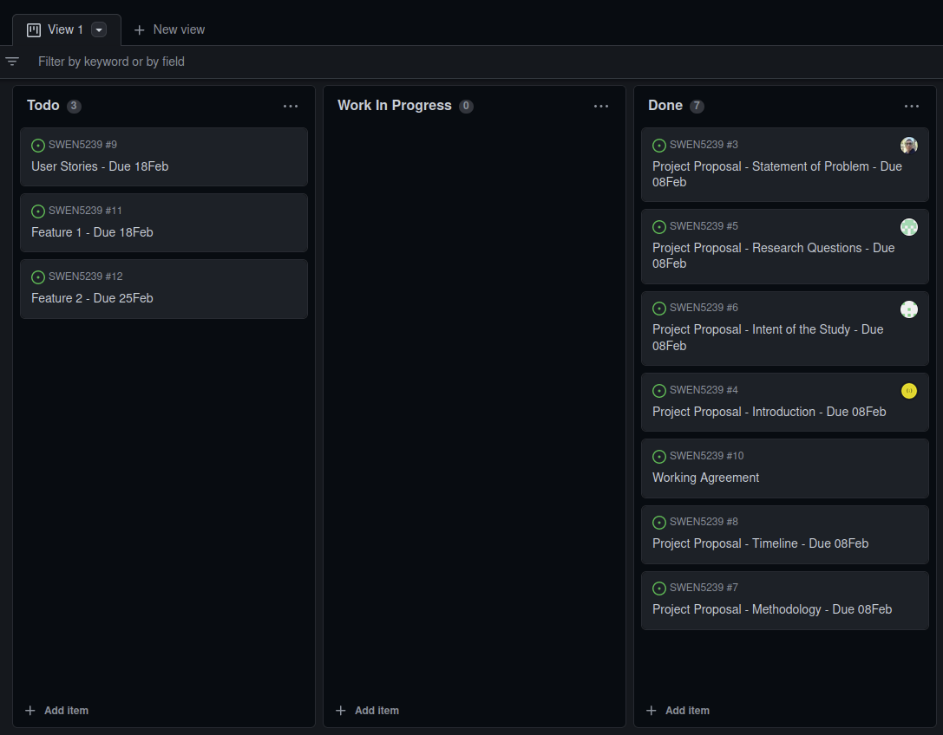

Figure 1. Scrum board assignment of tasks

## References

Basmo. (2023). *15 statistics about reading books you must know in 2023.*

https://basmo.app/reading-statistics/

Flynn, J. (2022, October 19). *40 fascinating mobile app industry statistics [2023]: The success of mobile*

*apps in the U.S.* Zippia. https://www.zippia.com/advice/mobile-app-industry-statistics/

https://www.goodreads.com/api

## Feature 1

In this feature, Team’s main focus was on UI design & development, creating CSV datasets for testing, and implementing backend codes for reading the CSV file and displaying the data in a DataGridView. The QA team has tested 3 separate CSV files to test the application to ensure that code is reading the file accurately.

Front End: Developed UI, Created a button for users to browse local files, a button for users to upload files, a search bar for users to confirm the correct file for upload.

Back End: Implemented codes for reading the CSV file and displaying the data in a DataGridView, combining all the pieces of code together to build the 1st feature, and allow users to enter sample data for testing.

## Feature 1: User stories

Stories colored in blue below are part of the feature 1.

**User Stories:**

| **Issue Type** | **Key** | **Summary** | **Assignee** | **Story Points** | **Priority** |
| --- | --- | --- | --- | --- | --- |
| **Story** | BOOK-1 | Develop UI for friendly user experience. | Eric Prieto  Angel Vazquez | 5 | High |
| **Story** | BOOK-2 | Create a button for users to browse local files. | Eric Prieto  Angel Vazquez | 3 | Medium |
| **Story** | BOOK-3 | Create a button for users to upload files. | Eric Prieto  Angel Vazquez | 3 | High |
| **Story** | BOOK-4 | Create a search bar for users to confirm the correct file for upload. | Eric Prieto  Angel Vazquez | 4 | Medium |
| **Story** | BOOK-5 | Create a few different CSV dataset files for testing purposes. | Stefan Gamero  Sadia Alam | 5 | High |
| **Story** | BOOK-6 | Implement codes for reading the CSV file and displaying the data in a DataGridView | Stefan Gamero  Sadia Alam | 5 | High |
| **Story** | BOOK-7 | Combine all the pieces of codes together to build the 1st feature. | All | 5 | High |
| **Story** | BOOK-8 | Allow user to enter sample data for testing | Stefan Gamero  Sadia Alam | 3 | Medium |
| **Story** | BOOK-9 | Create rules for the application | Stefan Gamero  Sadia Alam | 3 | Medium |
| Story | BOOK-10 | Create buttons for each rules | Eric Prieto  Angel Vazquez | 3 | Low |
| Story | BOOK-11 | Implement the popular book list rule | Stefan Gamero  Sadia Alam | 5 | High |
| Story | BOOK-12 | Implement the Unpopular book list rule | Stefan Gamero  Sadia Alam | 5 | High |
| Story | BOOK-13 | Allow user to filter thru different rules option | Stefan Gamero  Sadia Alam | 2 | Medium |
| Story | BOOK-14 | Create another DataGridView to display the requested rules that the user selects. | Eric Prieto  Angel Vazquez | 3 | Medium |
| Story | BOOK-15 | Create a list of testing criteria/test plan for both frontend & backend codes. | ALL | 3 | High |
| **Story** | BOOK-16 | Create demo video of feature 1 | Eric Prieto  Angel Vazquez | 1 | Low |
| Story | BOOK-17 | Create demo video of feature 2 | Stefan Gamero  Sadia Alam | 1 | Low |
| Story | BOOK-18 | Documentation & user stories update | ALL | 1 | Low |

## Feature 1: App screen prints

