Weather-based Watering

The Irricloud system has collects local weather information including temperature, humidity, wind speed and solar radiation and combines that data to determine a scaling factor to apply to your watering programs.

The scaling factor is a percentage so a value of 100 means that a watering schedule that has a zone operating for 40 minutes will actually operate that zone for a full for minutes. A scaling factor of 200 will operate that zone for 80 minutes and a scaling factor of 50 will operate that zone for 20 minutes.

In order to configure the weather-based watering capability you must first set your location on the “Options” page (and click “Submit Changes” at the bottom):

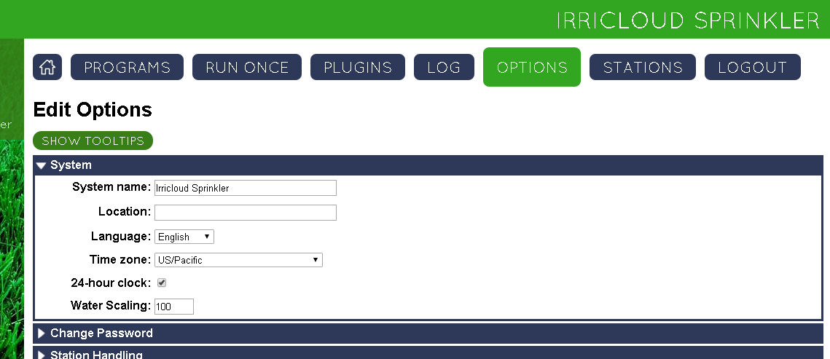

Then click on “Plugins” and then on “Evapotranspiration-based Water Level”.

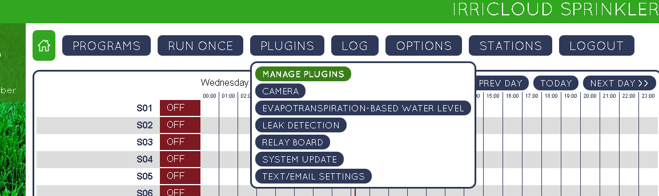

This will bring you to the evapotranspiration based screen.

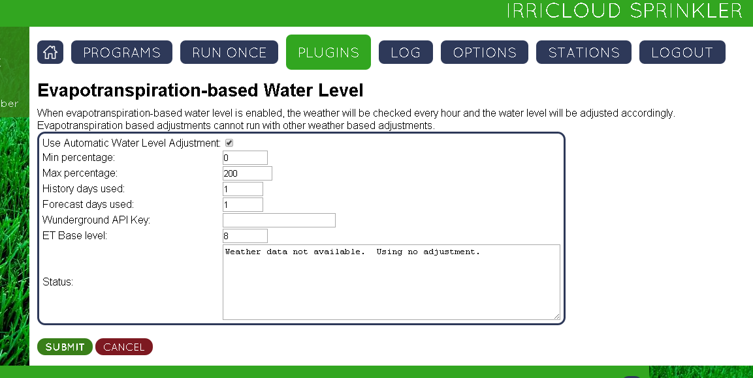

The checkbox labeld “Use Automatic Water Level Adjustment” is a way to enable/disable weather based watering. By default it is enabled.

The “Min percentage” and “Max percentage” entries allow you to put limits on how little or how much weather based scaling is allowed. A “Min percentage” value of 0 would mean that a zone that is scheduled may actually not water at all, while a “Min percentage” of 50 would mean that it will always water at least half of what was programmed. Similarly a “Max percentage” of 500 would mean a zone could water up to 5 times as much as what is programmed. Setting “Min percentage” and “Max percentage” both to 100 would also effectively disable weather based watering.

“History days used” and “Forecast days used” tells the program to look back *history* days and forward *forecast* days and consider that information when determining today’s water schedule. If both “History days used” and “Forecast days used” are 0, then only the current day’s weather is considered. Some historical data is collected from actual current weather observations as the program runs while other historical data is pulled from summary information. This means the program may take a few days to build up some of its historical information. If internet access is not available and insufficient data is available, then the Irricloud device will continue to operate but it will tend to water using a scaling factor of 100.

The “Wunderground API Key” is a special key provided by Weather Underground and is specific and private to each customer. This key allows the Irricloud device to get accurate weather information for your location. In order to get a key and use this feature you need to go to the Weather Underground site: http://www.wunderground.com/weather/api/d/pricing.html.

Select the Anvil plan and lower down on the page select developer and “Purchase Key”. There is no cost for this usage.

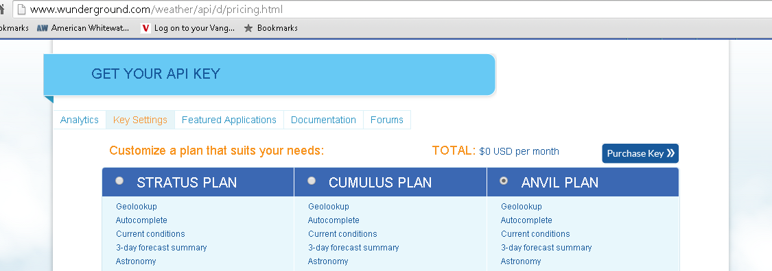

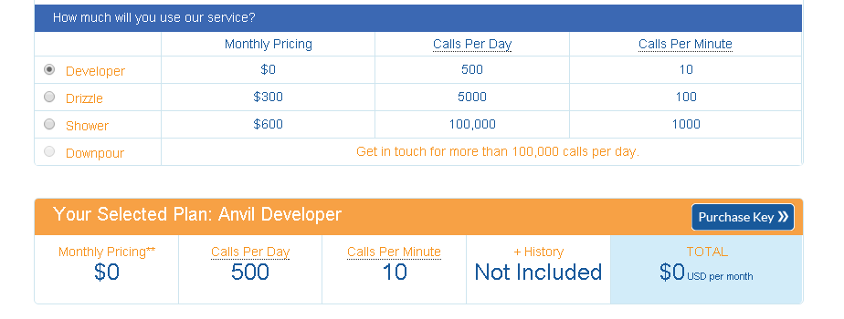

You will then need to fill in some specific personal or commercial information, accept the terms and conditions and then you will get your key (a long string of numbers and letters). Enter that key in the “Wunderground API key” box and click “Submit” and you should be good to go. You will be redirected to the Home page after submission, but if you go back to the Evapotranspiration page you will see the Status updated if the system was able to access Weather Underground.

The “ET Base Level” is a bit of magic and allows you to “tune” the weather feedback. If you are finding that you are getting more watering than desired, then you can increase “ET Base level” and the status will update to reflect how watering will now be scaled. Similarly, if you are not getting sufficient watering based on your programs you can decrease “ET Base level”. This will tune your watering program times to the weather.

Note that back on the “Options” page there is a “Water Scaling” value (default: 100) which is another scaling factor applied after the weather-based scaling has been computed. A value of 100 means take the watering time from the weather, while a value of 50 says take that weather-based time and further reduce it by half. In general, this value should be left unchanged.

Finally, note that any given station can opt out of using the weather-based adjustments. For example, you might have a station that operates a light and you don’t want the amount of time the light is on to be affected by the weather. This is configured on the “Stations” page.