Network Configuration

In general, the system runs in one of two modes. Either it is operating as an irrigation controller or it is waiting for a network configuration so that it can start operating as an irrigation controller. When a valid network has been configured the system will automatically start operating as a controller and use of the web interface will be available.

The network configuration mode is used to initialize master stations, substations, as well as any connected radios used for communication or remote sensor and valve control. Only wireless connectivity is supported for Irricloud system configurations.

When the device is powered on and waiting for a network configuration it will broadcast a wireless signal on SSID: IrricloudAP. This can take a full minute or more, so please be patient. If you do not see the SSID, press and hold the “reset” button on the device until the LED lights and try again waiting at least two minutes. If you are still stuck, power cycle the device and repeat the steps just described. Use your phone or nearby computer to connect to the IrricloudAP network. It is an unsecured access point with no password.

**Configuring System Type**

Once connected to IrricloudAP access point, go to <http://10.0.0.1/> and you will come to an initial configuration screen similar to the following:

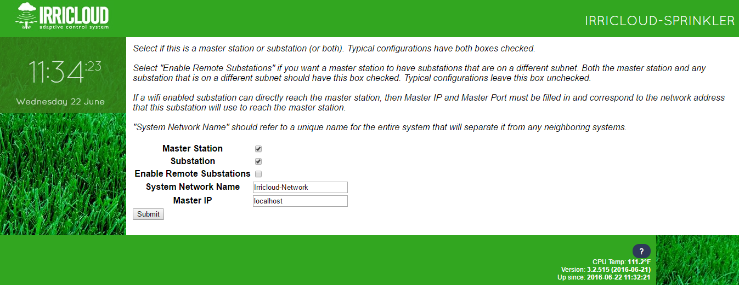

If this station is the only Irricloud system you have, or it is the primary interface to a more complex Irricloud network, then make sure the “Master Station” box is checked. If this Irricloud system also does watering or control sensors (typical), then ensure the “Substation” box is also checked. An Irricloud system that is a substation to another Irricloud master station located elsewhere on the internet should have only the “Substation” box checked.

“Enable Remote Substations” is checked only if there will be substations on a subnet that is different than the master station. In this case, both the master station and the substations on different subnets must have this box checked. Typically this box is left unchecked.

The “System Network Name” is a unique name that will be shared by the master station all substations comprising the broader system. All stations in a system must have the same “System Network Name” to communicate; the “System Network Name” is like a password. This name should be changed from “Irricloud Network” even for single system based configurations.

For most systems comprising of a single Irricloud system, “Master IP” can remain as “localhost”. However, if you are configuring a substation and not a master station, then “Master IP” is the IP address which enables the substation to reach the master station. If the master and substation are located on the same network, then “Master IP” should be the IP address of the master station. However, if the master station is located on a separate network, then “Master IP” must correspond to the externally visible IP address that will allow access to the master station.

**Substation Configuration**

Once you have submitted the above information you are brought to a secondary configuration page a minute later which details the specific details of this substation. Descriptions of the specific fields are outlined below.

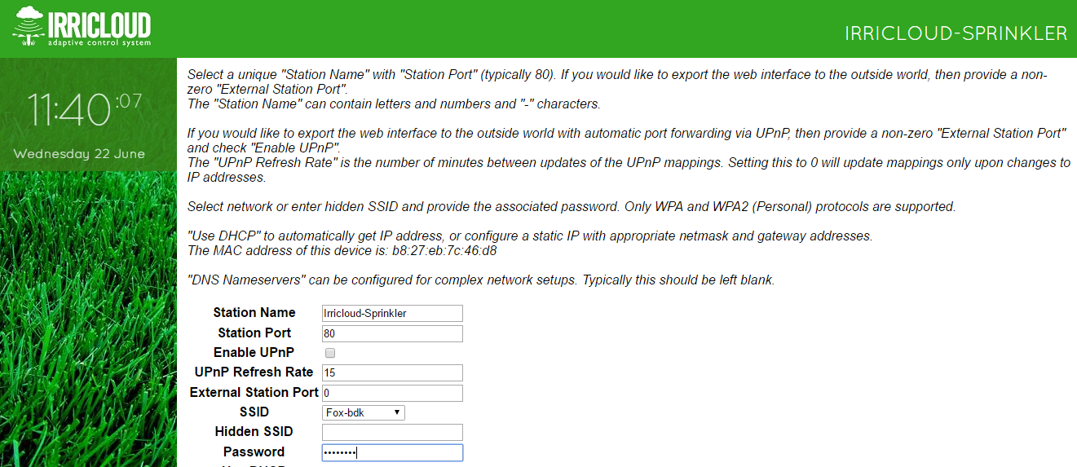

“Station Name” must be a unique name for the master station or substation. The user interface when accessing the master system will provide a list of available substations in the upper right allowing you to easily access any substation by its unique “Station Name”.

“Station Port” is the port that will be used by an http access on the same network and should typically be left as 80.

“External Station Port” is the port number that will be used when accessing the master station from outside the local network. Assuming you would like to access your Irricloud system when away from home it is necessary to set up “port forwarding” from the externally visible network address and external port, to the internal IP address of this Irricloud device with its “Station Port” (see “Port Forwarding and External IP Address” setup below). A preferred and hopefully simpler approach is to use the provided UPnP capability assuming you have a UPnP enabled router that is connected to the internet.

Most routers today support UPnP which stands for “Universal Plug and Play”. It is a protocol that allows a device that is already inside a local network (like your home network) to export an interface so it can be visible from outside your local network. If you check the “Enable UPnP” box, this substation will try to use UPnP to automatically create a mapping from your externally visible IP address with “External Station Port” to the Irricloud station with “Station Port”. That mapping will be refreshed every “UPnP Refresh Rate” minutes. If “UPnP Refresh Rate” is 0, then the UPnP settings will only be updated on reboots and when addressing changes.

As an example, the UPnP configuration on an ASUS RT-N66U can be found in the WAN section under basic config:

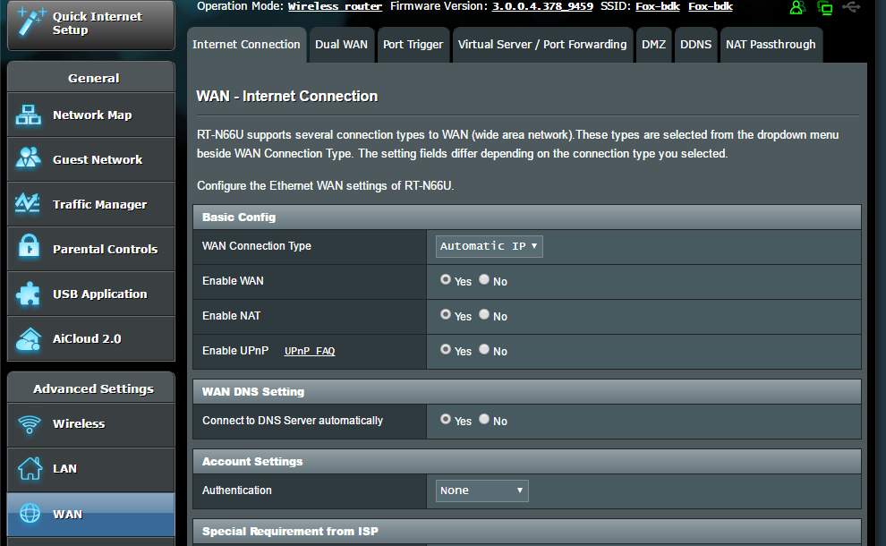

**Connecting a system to the Network**

Any wireless networks that are visible will be in the SSID list and they are ordered based on decreasing signal strength. Presumably selecting the first entry from the SSID list will be your best choice. Only networks using WPA and WPA-2 Personal encryption schemes are supported. You can select the network of choice, or you can enter your own network name in the “Hidden SSID” field. Enter your appropriate password to allow you to connect to that network.

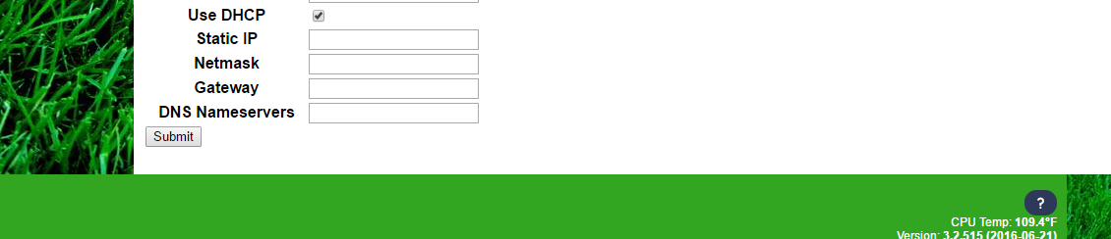

Most connections to an access point (WAP) will use DHCP to get a local IP address. If this is the case, keep the “Use DHCP” box checked and click “Submit”. Your network connection to IrricloudAP should drop and after about one minute your device will now be connected to your selected wireless access point.

If you want to define a fixed IP address for your device, you can uncheck the “Use DHCP” box, and enter the IP address you want to use, a corresponding Netmask and Gateway. Click “Submit” and you should be connected.

If there is trouble getting connected, the system will bring you back to the Network Configuration mode and start broadcasting the IrricloudAP SSID again.

If you are using “UPnP” you may never need to know the local IP address of the system. As long as you are outside of the local network (ie, turn wireless off on your phone if you are at home), you can reference the externally visible IP address (see “Port Forwarding and External IP Address” below) with the “External Station Port” that you configured earlier. Type that into the preferred Chrome browser interface and you should be able to log onto your system.

If you want to find the new IP address of your controller from within your local network you need to log into your wireless access point and find a device whose name starts with Irricloud. You should be able to open a web page at that IP address and see a login screen from where you can access the controller.

This should continue to work indefinitely as long as your router and controller run interrupted. If one or both of them reboots most routers will continue to use the same IP addresses when the device reboots but that is not guaranteed. In order to ensure that your controller always has the same IP address you will need to either assign a static IP address in the network configuration described above (and ensure that your router will not use that for any other purpose) or make your router always assign the same IP address to your specific device. Each router’s management interface is different, but this static assignment is generally found associated with the LAN and DHCP Server sections of your router. You will match the IP address with the MAC address from the controller. That MAC address (typically 6 groups of 2 characters separated by colons) should be visible on your router and associated with the IP address of the controller.

**Port Forwarding and External IP Address**

Once you have a fixed IP address for your controller you may want to access your controller from outside of your local network. In order to do that, you will need to add some port forwarding to your router and know the external IP address of your router.

The routers external IP address can be found by asking your ISP (Internet Service Provider) or by going to <https://www.whatismyip.com/> from any device connected to the local network. The IP address shown by that website will typically be your externally visible IP address. Typical output from whatismyip looks like (with some obscuring of the numbers):

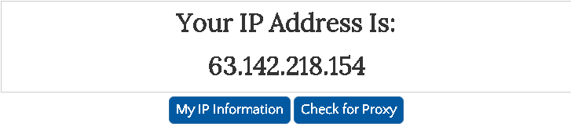

Port forwarding is typically found in the WAN / Port forwarding management section of your router. The external reference 63.X.X.X:31080 will be forwarded to your actual device 192.168.1.140:80.

Once the port forward is set up and you are not on your local network, you can still get to your controller by typing <http://63.X.X.X:31080> into a browser.

Similarly, if you are using the OSPi Sprinkler app you will want to use an IP address like 63.X.X.X:31080 to access your controller remotely. You can still use 192.168.1.140 (or 192.168.1.140:80) to access it locally.

**Radio Configuration**

If you have RF Radios as part of your Irricloud system configuration (and connected to the USB port of the Irricloud system), the basic configuration pages described above are slightly modified and include radio parameters.

The “Radio Only Substation” box is checked if and only if this radio is being used for remote sensing (sensors off the radio) or remote valve control. In this scenario, the radio is a standalone subcomponent of an Irricloud base station of substation. These standalone radios require a unique “Radio Only Substation Name” which is used to identify and control the sensors and valves connected to the radio. For radios connected to a standard base station or substation to facilitate remote communication where wifi is unavailable, then “Radio Only Substation” should NOT be checked.

“Radio Power” is a value between 0 and 4 inclusive which describes how strongly the radio will transmit its outgoing messages. There is a factor of 1000 in terms of how much power is used at 0 vs 4. For distances of less than ½ mile 3 will usually suffice. A value of 4 is close to 27db, 3 is 24db, 2 is 18db. Radios should never be closer than 2m and the higher the power, the further apart they must be.

“Radio Network Name” is a unique name used by all radios that are communicating on a subnet. Radios that are part of different “Radio Network Name”s will not be able to link and communicate with each other. There is no checking that you have typed these names correctly, so please be careful. Radio transmissions are encrypted based on the “Radio Network Name” as well.

“Radio Router Number” should generally be left as 0. Sometimes it is necessary to have an intermediate radio between the substation and a far away remote radio. That intermediate radio is called a router and every router radio on a single “Radio Network Name” must have a unique router number between 1 and 63. Again, there is no check to ensure uniqueness and one can create a pretty broken network pretty quickly if careful attention is not paid during configuration.

When configuring radio only substations the radio must be hooked up to a valid Irricloud system for configuration and once the radio is configured a “Successful Configuration” page will show prior to returning to do more “Radio Only Substation” configuration or finish configuring the Irricloud system.