Program Configuration

The Irricloud system has support for many different styles of watering programs to support both commercial and residential needs. In general, residential systems water only one zone at a time and the Irricloud system supports that. Commercial and agricultural systems frequently water many zones concurrently and that too is supported. Furthermore, sometimes there are times there are watering restrictions or bans and that too can be described in a program. In fact all of these capabilities can work together which creates some complexity but most people will use just one or two of these capabilities and the programming is straightforward.

Programs are created viewed, and modified by clicking on the “Programs” button located on the Home Page once you have logged onto the system. The Home Page also shows you a history and preview of when your programs will run. This aids in ensuring that what you are programming is what you want. We will see this preview update as we create some programs in the description below.

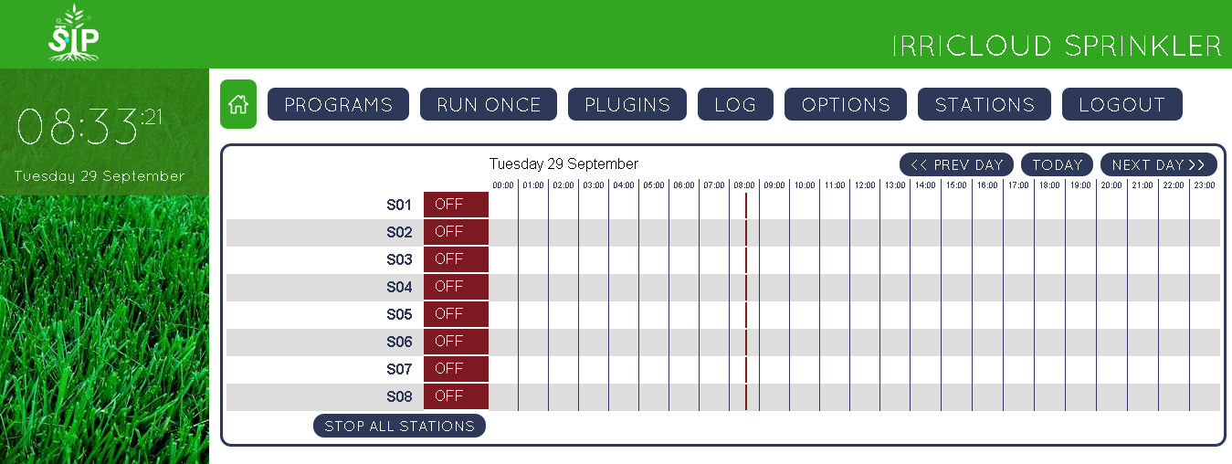

After clicking on the “Programs” button you will see all of your existing programs. Many programs can be created so you shouldn’t worry about running out. Programs descriptions will persist across reboots and power outages because they are saved in non-volatile memory; no battery backup is required to keep your programs. However, any existing watering schedules that have already started but not yet completed are lost across a power outage or reboot.

**Creating a Program**

The following steps will describe how to create a new program. Modifying an existing program is similar to creating a new program, except the information from the existing program is already populated into the editing window.

Each program describes a set of days on which it operates as well, the time(s) during the selected days that it will be active and the stations or zones that are actually affected by the program. We will describe setting up each of these below.

We create a new program by clicking the “Add A New Program” button.



A program editing window will show up where the various aspects of the program can be filled in.

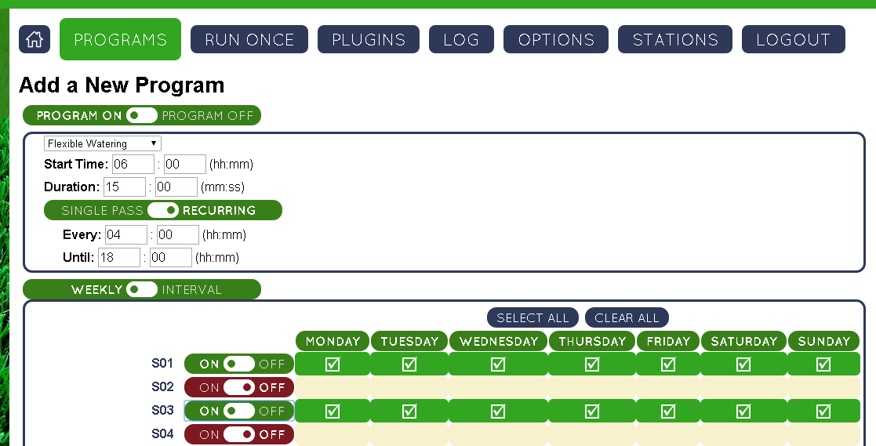

The “Program On”/”Program Off” button enables/disables your program. If a program is disabled, it is effectively ignored for watering, but the underlying data is maintained in case you wish to reenable it in the future; you will not find disabled programs in your watering preview on the Home Page. A program that is enabled is colored green while one that is disabled is rust colored like the S02 “Off” button shown above.

**Watering During a Day**

The program describes when during the day watering should occur and what kind of watering takes place.

Each program has a “Start Time” (We are using a 24hour clock in our examples.) and a “Duration” that describe when, within a selected day, the program will operate. The “Start Time” describes when the program becomes active and is represented in hours and minutes. The “Duration” describes how long the watering will take place and it is represented in minutes and seconds.

Each program can run once during the selected days or can be repeated at a set interval. Repeating a program allows you to create Cycle and Soak intervals where the watering of one “Duration” (cycle) has (“Every”) time to absorb (soak) into the ground before the next “Duration” (cycle) starts. The example above will water for 15 minutes every 4 hours starting at 6AM until 6PM (i.e. 6AM, 10AM, 2PM). The “Until” time is the first time the program will no longer be considered active so the program will not water at 6PM. If it is desirable to water at 6PM, the “Until” time can be represented as 18:01. Watering that is initiated before the “Until” time will continue (if needed) past the “Until” time. If there is no need to repeat a watering cycle for a program, click on the “Single Pass”/”Recurring” button and the “Every” and “Until” boxes will disappear/reappear.

The menu located above the “Start Time” describes what kind of watering should take place when the program is active. The default value is “Flexible Watering” which is appropriate for most residential setups. “Flexible Watering” means that each station that is selected for this program will water in sequence and each will receive the “Duration” amount of water. Furthermore, if stations associated with other “Flexible Watering” programs are still running when this program is supposed to have another cycle, then these stations are delayed until those other stations have completed. In other words, all stations associated with “Flexible Watering” schedules will run in sequence and not overlap.

In the example above, stations S01 and S03 are selected for this “Flexible Watering” program. After clicking on the “Save” button to save the program you can see on the Home Page that S01 will water at the “Start Time” and repeat every 4 hours and S03 will start watering when S01 has completed.

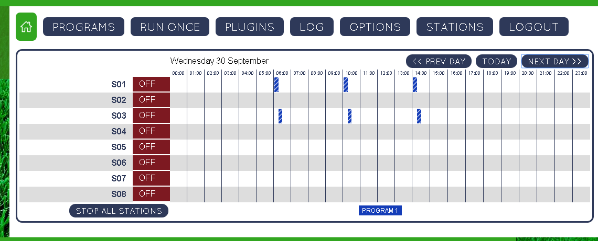

Hovering over the program boxes on the Home Page will show you the start time and duration for that snippet.

“Fixed Watering” ensures that the selected stations will start at the “Start Time” and all stations associated with the program will water concurrently. Changing our example program from “Flexible Watering” to “Fixed Watering” and then looking at the preview shows that stations S01 and S03 are running together at each of 6AM, 10AM, and 2PM.

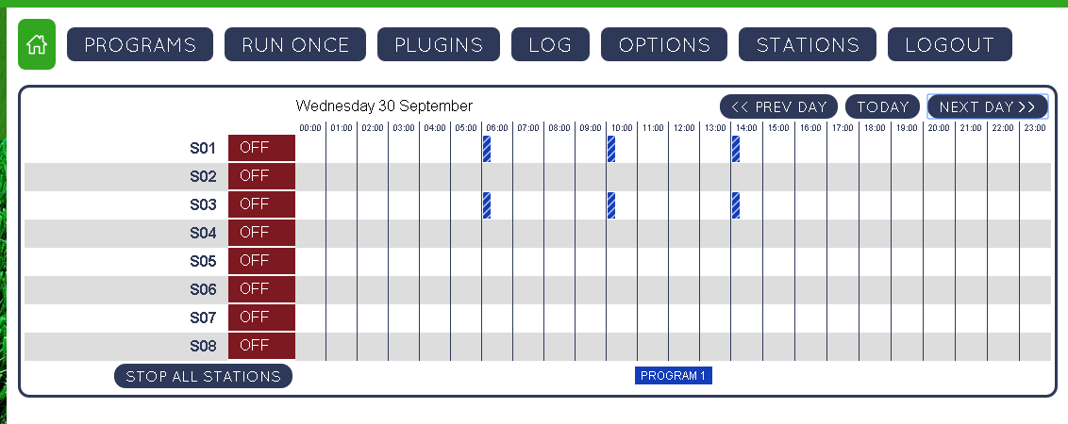

There are two more menu options associated with programs. “Fixed Ban with Stop” and “Fixed Ban with Delay”. Unlike the other program options that enable watering, these options prevent watering. Their schedule is always fixed meaning they will always start at their “Start Time” and run for their “Duration”. They affect only the stations that are selected with the program. Both ban designations will take any existing (selected) station that is watering or whose cycle start time has passed, but might be waiting due to the sequential nature of “Flexible Watering” and stop that station from watering until the ban “Duration” has passed. For the “Fixed Ban with Stop” designation, any station that was stopped will not be restarted after the ban until another program or cycle tells that station to water. With the “Fixed Ban with Delay”, any remaining time that was cut short will start once the ban is completed. Stations that were delayed and part of a “Flexible Watering” program will still run sequentially after the delay. Stations that were delayed that were part of a “Fixed Watering” program will operate concurrently after the delay. “Flexible Watering” stations that restart after a ban delay may not start immediately after the ban is completed due to interactions with other “Flexible Watering” constraints. Finally, if a station is delayed to start into the next day, that restart is ignored.

**Watering Day Selection**

In addition to specifying what kind of watering is desired, when during the day the watering occurs, and what stations are selected by the program, it is also necessary to specify on what days the program is active.

Most people with use “Weekly” scheduling where the program runs on selected days during the week. Days can be disabled (and reenabled) by clicking the day name as shown below.

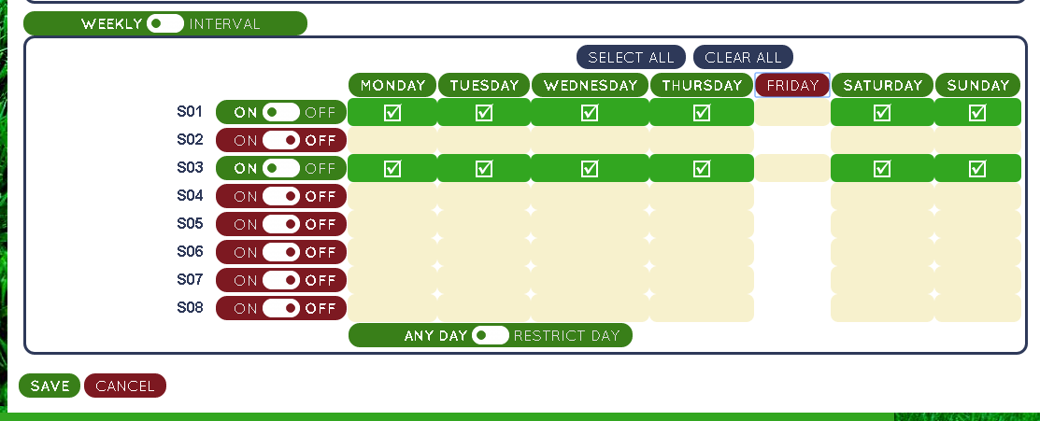

If only “Even Days” or “Odd Days” are desired, the “Any Day”/“Restrict Day” button can be toggled. Note that the 31st and February 29th are not treated as odd days (or even days!). The program below will water stations S01 and S03 on odd days that do not fall on a Friday.

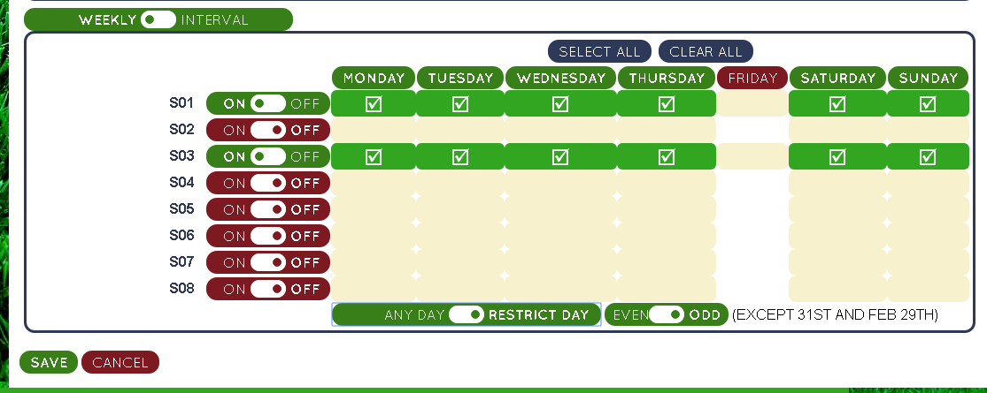

Some watering schedules do not fit nicely into a weekly paradigm. For example, some drought tolerant plants may only want to be watered once every two weeks. To support that, instead of having a “Weekly” watering schedule, we have an “Interval” watering schedule. Once the “Weekly”/”Interval” button is toggled to select “Interval” watering, one can select the number of days between program watering (14 in the example below), and the number of days from now when that interval should start (4 in the example below). If today is Friday, then the interval below describes a program that waters once every two weeks starting this coming Tuesday.

Note that for any program changes to be made permanent, the “Save” button must be clicked after making the changes.

