Thanks to Kris Kanyon for providing the description below.

Connect the sprinkler valves and power to the relay board as shown in the diagram below.

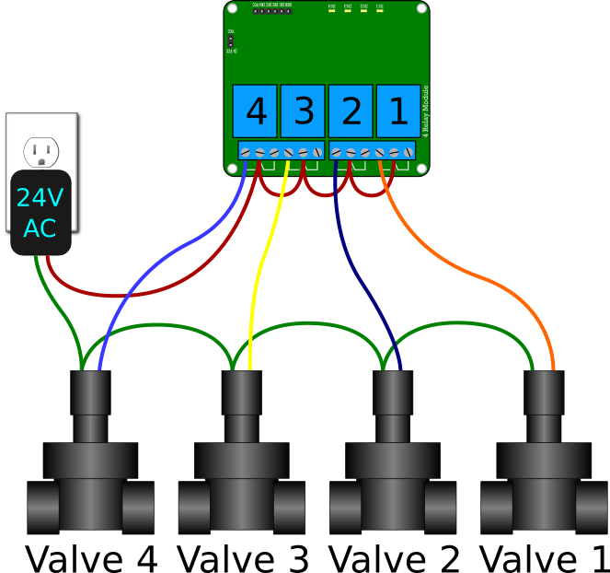

**Step 1** Connect one wire of the 24 Volt AC power supply to one wire of all the sprinkler valves (green wires in diagram above). Usually the sprinkler valves are together in a box and one wire from each sprinkler valve is connected together (often with a wire nut or crimp connector) with a single wire that is run from the valves back to the sprinkler controller.

**Step 2** Connect the other power supply wire to the common terminal (usually the center) of all of the relays (red wires in diagram above).

**Step 3** Connect each sprinkler valve to the normally open terminal of each relay (blue, yellow, violet and orange wires in diagram above). When the Raspberry Pi activates a relay, the normally open terminal is connected to the common terminal to turn the sprinkler valve on. The normally open terminal is usually on the left, but it's a good idea to verify with a multi-meter. The other terminal is normally closed and is connected to the common terminal until the relay is activated, then it becomes open.  
***TIP:***Connect only the first relay and make sure everything works properly, then connect the rest of the relays.