CPE301 – FALL 2019

Design Assignment 1A

Student Name: Brysen Kokubun

Student #: 2001009068

Student Email: brysenkokubun96@gmail.com

Primary Github address: https://github.com/bkokubun99

Directory: https://github.com/bkokubun99/Submission_DesignAssignments/tree/master/DesignAssignment_1A

Submit the following for all Labs:

1. In the document, for each task submit the modified or included code (only) with highlights and justifications of the modifications. Also, include the comments.
2. Use the previously create a Github repository with a random name (no CPE/301, Lastname, Firstname). Place all labs under the root folder ESD301/DA, sub-folder named LABXX, with one document and one video link file for each lab, place modified asm/c files named as LabXX-TYY.asm/c.
3. If multiple asm/c files or other libraries are used, create a folder LabXX-TYY and place these files inside the folder.
4. The folder should have a) Word document (see template), b) source code file(s) and other include files, c) text file with youtube video links (see template).

1. **COMPONENTS LIST AND CONNECTION BLOCK DIAGRAM w/ PINS**

Atmel Studio 7.0

* + Assembler
  + Simulator
  + Debugger

1. **INITIAL/MODIFIED/DEVELOPED CODE OF TASK 1/A**

1. **DEVELOPED MODIFIED CODE OF TASK 2/A from TASK 1/A**

N/A

1. **SCHEMATICS**

N/A

1. **SCREENSHOTS OF EACH TASK OUTPUT (ATMEL STUDIO OUTPUT)**

This picture shows the initial values of the 4 registers.

(Multiplicand)

R25&R24 = 0x1001(hex)

0x1001(hex) = 4097

(Multiplier)

R23&R22 = 0x0101(hex)

0x0101(hex) = 257

This picture shows the values in the 4 registers that hold the result for the multiplication.

(Result)

R20 R19 R18 R17

4097 x 257 = 1,052,929

0x00101101(hex) = 1,052,929

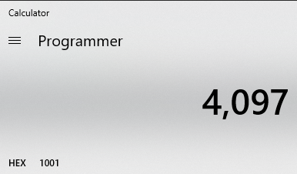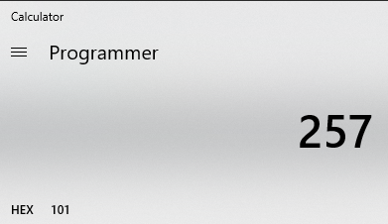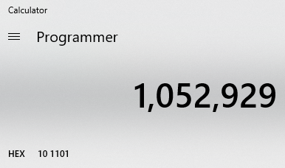

Result Value in R20, R19, R18, R17

Value in R23 & R22

Value in R25 & R24

Here is the verification of the Initial & Result registers in Decimal Form and Hexadecimal Form.

1. **SCREENSHOT OF EACH DEMO (BOARD SETUP)**

N/A

1. **VIDEO LINKS OF EACH DEMO**

N/A

1. **GITHUB LINK OF THIS DA**

https://github.com/bkokubun99/Submission_DesignAssignments/tree/master/DesignAssignment_1A

**Student Academic Misconduct Policy**

<http://studentconduct.unlv.edu/misconduct/policy.html>

“This assignment submission is my own, original work”.

Brysen Kokubun